D17108GC30

Edition 3.0

January 2009

D57870



**Oracle Database 10*g*: SQL**

**Fundamentals I**

**Student Guide • Volume 1**

|  |
| --- |
| Oracle Internal & Oracle Academy Use Only |

**Authors**

Salome Clement Chaitanya Koratamaddi Nancy Greenberg

**Technical Contributors**

**and Reviewers**

Wayne Abbott

Christian Bauwens

Claire Bennett

Perry Benson

Brian Boxx

Zarko Cesljas

Dairy Chan

Laszlo Czinkoczki

Joel Goodman

Matthew Gregory

Sushma Jagannath

Yash Jain

Angelika Krupp

Isabelle Marchand

Malika Marghadi

Valli Pataballa

Narayanan Radhakrishnan

Bryan Roberts

Helen Robertson

Lata Shivaprasad

John Soltani

James Spiller

Priya Vennapusa

**Editors**

Arijit Ghosh

Raj Kumar

**Graphic Designer**

Rajiv Chandrabhanu

**Publisher**

Giri Venugopal

**Copyright © 2009, Oracle. All rights reserved.**

**Disclaimer**

This document contains proprietary information and is protected by copyright and other intellectual property laws. You may copy and print this document solely for your own use in an Oracle training course. The document may not be modified or altered in any way. Except where your use constitutes "fair use" under copyright law, you may not use, share, download, upload, copy, print, display, perform, reproduce, publish, license, post, transmit, or distribute this document in whole or in part without the express authorization of Oracle.

The information contained in this document is subject to change without notice. If you find any problems in the document, please report them in writing to: Oracle University, 500 Oracle Parkway, Redwood Shores, California 94065 USA. This document is not warranted to be error-free.

**Restricted Rights Notice**

If this documentation is delivered to the United States Government or anyone using the documentation on behalf of the United States Government, the following notice is applicable:

U.S. GOVERNMENT RIGHTS

The U.S. Government’s rights to use, modify, reproduce, release, perform, display, or disclose these training materials are restricted by the terms of the applicable Oracle license agreement and/or the applicable U.S. Government contract.

**Trademark Notice**

Oracle is a registered trademark of Oracle Corporation and/or its affiliates. Other names may be trademarks of their respective owners.

|  |
| --- |
| Oracle Internal & Oracle Academy Use Only |

**Contents**

**Preface**

1. **Introduction**

Lesson Objectives I-2 Goals of the Course I-3 Oracle10*g* I-4

Oracle Database 10*g* I-6

Oracle Application Server 10*g* I-7

|  |  |  |  |  |
| --- | --- | --- | --- | --- |
| Oracle Enterprise Manager 10*g* Grid Control | | | | I-8 |
| Relational and Object Relational Database Management Systems I-9 | | | | |
| Oracle Internet Platform | I-10 |  |  |  |
| System Development Life Cycle | | I-11 | |  |
| Data Storage on Different Media | | I-13 | |  |
| Relational Database Concept I-14 | | |  |  |
| Definition of a Relational Database | | | I-15 |  |
| Data Models I-16 |  |  |  |  |
| Entity Relationship Model | I-17 |  |  |  |
| Entity Relationship Modeling Conventions I-19 | | | | |
| Relating Multiple Tables | I-21 |  |  |  |
| Relational Database Terminology | | | I-23 |  |
| Relational Database Properties | | I-25 | |  |
| Communicating with an RDBMS Using SQL | | | | I-26 |

Oracle’s Relational Database Management System I-27

SQL Statements I-28

Tables Used in the Course I-29

Summary I-30

1. **Retrieving Data Using the SQL SELECT Statement** Objectives 1-2

Capabilities of SQL SELECT Statements 1-3 Basic SELECT Statement 1-4

Selecting All Columns 1-5 Selecting Specific Columns 1-6 Writing SQL Statements 1-7 Column Heading Defaults 1-8

**iii**

|  |
| --- |
| Oracle Internal & Oracle Academy Use Only |

Arithmetic Expressions 1-9

Using Arithmetic Operators 1-10

Operator Precedence 1-11

Defining a Null Value 1-12

Null Values in Arithmetic Expressions 1-13

Defining a Column Alias 1-14

Using Column Aliases 1-15

Concatenation Operator 1-16

Literal Character Strings 1-17

Using Literal Character Strings 1-18

Alternative Quote (q) Operator 1-19

Duplicate Rows 1-20

Development Environments for SQL 1-21

What Is Oracle SQL Developer? 1-22

Oracle SQL Developer Interface 1-23

Creating a Database Connection 1-24

Browsing Database Objects 1-27

Using the SQL Worksheet 1-28

Executing SQL Statements 1-31

Formatting the SQL Code 1-32

Saving SQL Statements 1-33

Running Script Files 1-34

Displaying the Table Structure 1-35

Using the DESCRIBE Command 1-36

Summary 1-37

Practice 1: Overview 1-38

1. **Restricting and Sorting Data** Objectives 2-2

Limiting Rows Using a Selection 2-3

Limiting the Rows That Are Selected 2-4

Using the WHERE Clause 2-5

Character Strings and Dates 2-6

Comparison Conditions 2-7

Using Comparison Conditions 2-8

Using the BETWEEN Condition 2-9

Using the IN Condition 2-10

Using the LIKE Condition 2-11

Using the NULL Conditions 2-13

Logical Conditions 2-14

**iv**

|  |
| --- |
| Oracle Internal & Oracle Academy Use Only |

Using the AND Operator 2-15

Using the OR Operator 2-16

Using the NOT Operator 2-17

Rules of Precedence 2-18

Using the ORDER BY Clause 2-20

Sorting 2-21

Substitution Variables 2-22

Using the & Substitution Variable 2-24

Character and Date Values with Substitution Variables 2- 26 Specifying Column Names, Expressions, and Text 2-27 Using the && Substitution Variable 2-28

Using the DEFINE Command 2-29

Using the VERIFY Command 2-30

Summary 2-31

Practice 2: Overview 2-32

1. **Using Single-Row Functions to Customize Output** Objectives 3-2

SQL Functions 3-3

Two Types of SQL Functions 3-4 Single-Row Functions 3-5 Character Functions 3-7 Case-Manipulation Functions 3-9 Using Case-Manipulation Functions 3-10 Character-Manipulation Functions 3-11

Using the Character-Manipulation Functions 3-12 Number Functions 3-13

Using the ROUND Function 3-14 Using the TRUNC Function 3-15 Using the MOD Function 3-16

Working with Dates 3-17 Arithmetic with Dates 3-20

Using Arithmetic Operators with Dates 3-21 Date Functions 3-22

|  |  |
| --- | --- |
| Using Date Functions 3-23 |  |
| Practice 3: Overview of Part 1 | 3-25 |
| Conversion Functions 3-26 |  |
| Implicit Data Type Conversion | 3-27 |
| Explicit Data Type Conversion | 3-29 |

Using the TO_CHAR Function with Dates 3-32

**v**

|  |
| --- |
| Oracle Internal & Oracle Academy Use Only |

Elements of the Date Format Model 3-33 Using the TO_CHAR Function with Dates 3-37 Using the TO_CHAR Function with Numbers 3-38 Using the TO_NUMBER and TO_DATE Functions 3-41

1. Date Format 3-43
2. Date Format: Example 3-44 Nesting Functions 3-45 General Functions 3-47

NVL Function 3-48

Using the NVL Function 3-49 Using the NVL2 Function 3-50 Using the NULLIF Function 3-51 Using the COALESCE Function 3-52 Conditional Expressions 3-54 CASE Expression 3-55

Using the CASE Expression 3-56 DECODE Function 3-57

Using the DECODE Function 3-58 Summary 3-60

Practice 3: Overview of Part 2 3-61

1. **Reporting Aggregated Data Using the Group Functions** Objectives 4-2

What Are Group Functions? 4-3 Types of Group Functions 4-4 Group Functions: Syntax 4-5

Using the AVG and SUM Functions 4-6 Using the MIN and MAX Functions 4-7 Using the COUNT Function 4-8 Using the DISTINCT Keyword 4-9 Group Functions and Null Values 4-10 Creating Groups of Data 4-11

Creating Groups of Data: GROUP BY Clause Syntax 4-12

|  |  |  |
| --- | --- | --- |
| Using the GROUP BY Clause 4-13 |  |  |
| Grouping by More Than One Column | 4-15 |  |
| Using the GROUP BY Clause on Multiple Columns | | 4-16 |
| Illegal Queries Using Group Functions | 4-17 |  |
| Restricting Group Results 4-19 |  |  |
| Restricting Group Results with the HAVING Clause | | 4-20 |

**vi**

|  |
| --- |
| Oracle Internal & Oracle Academy Use Only |

Using the HAVING Clause 4-21

Nesting Group Functions 4-23

Summary 4-24

Practice 4: Overview 4-25

1. **Displaying Data from Multiple Tables** Objectives 5-2

Obtaining Data from Multiple Tables 5-3 Types of Joins 5-4

Joining Tables Using SQL:1999 Syntax 5-5 Creating Natural Joins 5-6

|  |  |
| --- | --- |
| Retrieving Records with Natural Joins | 5-7 |
| Creating Joins with the USING Clause | 5-8 |

Joining Column Names 5-9

Retrieving Records with the USING Clause 5-10

|  |  |
| --- | --- |
| Qualifying Ambiguous Column Names | 5-11 |
| Using Table Aliases 5-12 |  |
| Creating Joins with the ON Clause 5-13 | |
| Retrieving Records with the ON Clause | 5-14 |

Self-Joins Using the ON Clause 5-15 Applying Additional Conditions to a Join 5-17 Creating Three-Way Joins with the ON Clause 5-18

|  |  |  |  |
| --- | --- | --- | --- |
| Nonequijoins 5-19 | |  |  |
| Retrieving Records with Nonequijoins | | | 5-20 |
| Outer Joins 5-21 |  |  |  |
| INNER Versus OUTER Joins 5-22 | | |  |
| LEFT OUTER JOIN |  | 5-23 |  |
| RIGHT OUTER JOIN | | 5-24 |  |
| FULL OUTER JOIN |  | 5-25 |  |
| Cartesian Products | | 5-26 |  |
| Generating a Cartesian Product 5-27 | | |  |
| Creating Cross Joins 5-28 | | |  |
| Summary 5-29 |  |  |  |
| Practice 5: Overview 5-30 | | |  |
| **6 Using Subqueries to Solve Queries** | | |  |
| Objectives 6-2 |  |  |  |
| Using a Subquery to Solve a Problem | | | 6-3 |
| Subquery Syntax | 6-4 | |  |
| Using a Subquery | 6-5 | |  |

**vii**

|  |
| --- |
| Oracle Internal & Oracle Academy Use Only |

|  |  |  |  |
| --- | --- | --- | --- |
| Guidelines for Using Subqueries | 6-6 |  |  |
| Types of Subqueries 6-7 |  |  |  |
| Single-Row Subqueries 6-8 |  |  |  |
| Executing Single-Row Subqueries | 6-9 | |  |
| Using Group Functions in a Subquery | | 6-10 |  |
| The HAVING Clause with Subqueries | | 6-11 |  |
| What Is Wrong with This Statement? 6-12 | | |  |
| Will This Statement Return Rows? 6-13 | | |  |
| Multiple-Row Subqueries 6-14 |  |  |  |
| Using the ANY Operator in Multiple-Row Subqueries | | | 6 -15 |
| Using the ALL Operator in Multiple-Row Subqueries | | | 6-16 |
| Null Values in a Subquery 6-17 |  |  |  |

Summary 6-19

Practice 6: Overview 6-20

1. **Using the Set Operators** Objectives 7-2

Set Operators 7-3

Tables Used in This Lesson 7-4 UNION Operator 7-8

Using the UNION Operator 7-9 UNION ALL Operator 7-11

Using the UNION ALL Operator 7-12 INTERSECT Operator 7-13

Using the INTERSECT Operator 7-14 MINUS Operator 7-15

Set Operator Guidelines 7-17

The Oracle Server and Set Operators 7-18 Matching the SELECT Statements 7-19 Matching the SELECT Statement: Example 7-20 Controlling the Order of Rows 7-21 Summary 7-22

Practice 7: Overview 7-23

1. **Manipulating Data** Objectives 8-2

Data Manipulation Language 8-3 Adding a New Row to a Table 8-4 INSERT Statement Syntax 8-5 Inserting New Rows 8-6

**viii**

|  |
| --- |
| Oracle Internal & Oracle Academy Use Only |

Inserting Rows with Null Values 8-7

Inserting Special Values 8-8

Inserting Specific Date Values 8-9

Creating a Script 8-10

Copying Rows from Another Table 8-11

Changing Data in a Table 8-12

UPDATE Statement Syntax 8-13

Updating Rows in a Table 8-14

Updating Two Columns with a Subquery 8- 15

Updating Rows Based on Another Table 8- 16

Removing a Row from a Table 8-17

DELETE Statement 8-18

Deleting Rows from a Table 8-19

Deleting Rows Based on Another Table 8-20

TRUNCATE Statement 8-21

Using a Subquery in an INSERT Statement 8-22

Database Transactions 8-24

Advantages of COMMIT and ROLLBACK Statements 8-26 Controlling Transactions 8-27

Rolling Back Changes to a Marker 8-28

Implicit Transaction Processing 8-29

State of the Data Before COMMIT or ROLLBACK 8-31 State of the Data After COMMIT 8-32

Committing Data 8-33

State of the Data After ROLLBACK 8-34

Statement-Level Rollback 8-36

Read Consistency 8-37

Implementation of Read Consistency 8-38

Summary 8-39

Practice 8: Overview 8-40

1. **Using DDL Statements to Create and Manage Tables** Objectives 9-2

Database Objects 9-3 Naming Rules 9-4

CREATE TABLE Statement 9-5 Referencing Another User’s Tables 9-6 DEFAULT Option 9-7

Creating Tables 9-8 Data Types 9-9

**ix**

|  |
| --- |
| Oracle Internal & Oracle Academy Use Only |

|  |  |  |  |  |  |
| --- | --- | --- | --- | --- | --- |
| Datetime Data Types | | 9-11 | |  |  |
| Including Constraints | | 9-17 | |  |  |
| Constraint Guidelines | | 9-18 | |  |  |
| Defining Constraints 9-19 | | |  |  |  |
| NOT NULL Constraint | | 9-21 | |  |  |
| UNIQUE Constraint 9-22 | | |  |  |  |
| PRIMARY KEY Constraint | | | 9-24 |  |  |
| FOREIGN KEY Constraint | | | 9-25 |  |  |
| FOREIGN KEY Constraint: Keywords | | | | 9 -27 | |
| CHECK Constraint | 9-28 | |  |  |  |
| CREATE TABLE: Example 9-29 | | | |  |  |
| Violating Constraints | | 9-30 |  |  |  |
| Creating a Table by Using a Subquery | | | | 9-32 | |
| ALTER TABLE Statement | | | 9-34 |  |  |
| Dropping a Table | 9-35 | |  |  |  |
| Summary 9-36 |  |  |  |  |  |
| Practice 9: Overview | | 9-37 |  |  |  |
| **10 Creating Other Schema Objects** | | | |  |  |
| Objectives 10-2 |  |  |  |  |  |
| Database Objects | 10-3 | |  |  |  |
| What Is a View? | 10-4 | |  |  |  |
| Advantages of Views | | 10-5 | |  |  |
| Simple Views and Complex Views 10-6 | | | | |  |
| Creating a View 10-7 | |  |  |  |  |
| Retrieving Data from a View 10-10 | | | |  |  |
| Modifying a View | 10-11 | |  |  |  |
| Creating a Complex View | | | 10-12 |  |  |
| Rules for Performing DML Operations on a View 10-13 | | | | | |
| Using the WITH CHECK OPTION Clause | | | | | 10-16 |
| Denying DML Operations | | | 10-18 |  |  |
| Removing a View | 10-20 | |  |  |  |
| Practice 10: Overview of Part 1 10-21 | | | |  |  |
| Sequences 10-22 | |  |  |  |  |
| CREATE SEQUENCE Statement: Syntax | | | | | 10-24 |
| Creating a Sequence | | 10-25 | |  |  |
| NEXTVAL and CURRVAL Pseudocolumns | | | | | 10-26 |
| Using a Sequence 10-28 | | |  |  |  |
| Caching Sequence Values | | | 10-29 |  |  |
| Modifying a Sequence | | 10-30 | |  |  |

**x**

|  |
| --- |
| Oracle Internal & Oracle Academy Use Only |

Guidelines for Modifying a Sequence 10-31

Indexes 10-33

How Are Indexes Created? 10-35

Creating an Index 10-36

Index Creation Guidelines 10-37

Removing an Index 10-38

Synonyms 10-39

Creating and Removing Synonyms 10-41

Summary 10-42

Practice 10: Overview of Part 2 10-43

1. **Managing Objects with Data Dictionary Views** Objectives 11-2

The Data Dictionary 11-3 Data Dictionary Structure 11-4

How to Use the Dictionary Views 11-6

USER_OBJECTS and ALL_OBJECTS Views 11-7 USER_OBJECTS View 11-8

Table Information 11-9 Column Information 11-10 Constraint Information 11-12 View Information 11-15 Sequence Information 11-16 Synonym Information 11-18 Adding Comments to a Table 11-19 Summary 11-20

Practice 11: Overview 11-21

1. **Practice Solutions**
2. **Table Descriptions and Data**
3. **Oracle Join Syntax**
4. **Using SQL*Plus**
5. **Using SQL Developer**

**Index**

**xi**

|  |
| --- |
| Oracle Internal & Oracle Academy Use Only |

**Additional Practices**

**Additional Practices: Table Descriptions and Data**

**Additional Practices: Solutions**

|  |
| --- |
| Oracle Internal & Oracle Academy Use Only |

**xii**



|  |
| --- |
| **Preface** |

Oracle Internal & Oracle Academy Use Only

Oracle Internal & Oracle Academy Use Only

**Profile**

**Before You Begin This Course**

Before you begin this course, you should be able to use a graphical user interface (GUI)*.* The prerequisite is a familiarity with data processing concepts and techniques.

**How This Course Is Organized**

*Oracle Database 10g: SQL Fundamentals I* is an instructor-led course featuringlectures and hands-on exercises. Online demonstrations and written practice sessions reinforce the concepts and skills that are introduced.

|  |
| --- |
| Oracle Internal & Oracle Academy Use Only |

**Preface - 3**

|  |  |
| --- | --- |
| **Related Publications** |  |
| **Oracle Publications** |  |
| **Title** | **Part Number** |
| *Oracle® Database Reference 10g Release 2 (10.2)* | B14237-02 |
| *Oracle® Database SQL Reference 10g Release 2 (10.2)* | B14200-02 |
| Oracle® Database Concepts 10*g* Release *2 (10.2)* | B14220-02 |
| *Oracle® Database Application Developer's Guide -* |  |
| *Fundamentals 10g Release 2 (10.2)* | B14251-01 |
| *SQL*Plus® User's Guide and Reference* | B14357-01 |

**Additional Publications**

* System release bulletins
* Installation and user’s guides
* *read.me* files
* International Oracle User’s Group (IOUG) articles
* *Oracle Magazine*

|  |
| --- |
| Oracle Internal & Oracle Academy Use Only |

**Preface - 4**

**Typographic Conventions**

The following two lists explain Oracle University typographical conventions for words that appear within regular text or within code samples.

**1. Typographic Conventions for Words Within Regular Text**

|  |  |  |  |
| --- | --- | --- | --- |
| **Convention** | **Object or Term** | **Example** |  |
| Courier New | User input; | Use the SELECT command to view |  |
|  | commands; | information stored in the LAST_NAME |  |
|  | column, table, and | column of the EMPLOYEES table. |  |
|  | schema names; |  |  |
|  | functions; | Enter 300. |  |
|  | PL/SQL objects; |  |  |
|  | paths | Log in as scott |  |
| Initial cap | Triggers; | Assign a When-Validate-Item trigger to |  |
|  | user interface object | the ORD block. |  |
|  | names, such as |  |  |
|  | button names | Click the Cancel button. |  |
| Italic | Titles of | For more information on the subject see |  |
|  | courses and | *Oracle SQL Reference* |  |
|  | manuals; | *Manual* |  |
|  | emphasized | Do *not* save changes to the database. |  |
|  | words or phrases; |  |
|  | placeholders or |  |  |
|  | variables | Enter *hostname*, where |  |
|  |  | *hostname* is the host on which the |  |
|  |  | password is to be changed. |  |
| Quotation marks | Lesson or module | This subject is covered in Lesson 3, |  |
|  | titles referenced | “Working with Objects.” |  |
|  | within a course |  |  |

|  |
| --- |
| Oracle Internal & Oracle Academy Use Only |

**Preface - 5**

**Typographic Conventions (continued)**

**2. Typographic Conventions for Words Within Code Samples**

|  |  |  |  |
| --- | --- | --- | --- |
| **Convention** | **Object or Term** | **Example** | |
| Uppercase | Commands, | SELECT employee_id | |
|  | functions | FROM | employees; |
| Lowercase, | Syntax variables | CREATE ROLE *role*; | |
| italic |  |  |  |
| Initial cap | Forms triggers | Form module: ORD | |
|  |  | Trigger level: S _ITEM.QUANTITY | |
|  |  | item |  |
|  |  | Trigger name: When-Validate-Item | |
|  |  | . . . |  |
| Lowercase | Column names, | . . . |  |
|  | table names, | OG_ACTIVATE_LAYER | |
|  | filenames, | (OG_GET_LAYER ('prod_pie_layer')) | |
|  | PL/SQL objects | . . . |  |
|  |  | SELECT last_name | |
|  |  | FROM | employees; |
| Bold | Text that must | CREATE USER **scott** | |
|  | be entered by a | IDENTIFIED BY **tiger**; | |
|  | user |  |  |

|  |
| --- |
| Oracle Internal & Oracle Academy Use Only |

**Preface - 6**



**Introduction**

Copyright © 2009, Oracle. All rights reserved.

|  |
| --- |
| Oracle Internal & Oracle Academy Use Only |

**Lesson Objectives**

After completing this lesson, you should be able to do the following:

* List the features of Oracle10*g*
* Discuss the theoretical and physical aspects of a relational database
* Describe the Oracle implementation of RDBMS and

ORDBMS

* Understand the goals of the course

Copyright © 2009, Oracle. All rights reserved.

**Objectives**

In this lesson, you gain an understanding of the relational database management system (RDBMS) and the object relational database management system (ORDBMS). You are also introduced to the following:

* SQL statements that are specific to Oracle
* SQL Developer, which is an environment used for executing SQL statements and for formatting and reporting purposes

|  |
| --- |
| Oracle Internal & Oracle Academy Use Only |

**Oracle Database 10*g*: SQL Fundamentals I I - 2**

**Goals of the Course**

After completing this course, you should be able to do the following:

* Identify the major structural components of Oracle Database 10*g*
* Retrieve row and column data from tables with the SELECT statement
* Create reports of sorted and restricted data
* Employ SQL functions to generate and retrieve customized data
* Run data manipulation language (DML) statements to update data in Oracle Database 10*g*
* Obtain metadata by querying the dictionary views

Copyright © 2009, Oracle. All rights reserved.

**Goals of the Course**

This course offers you an introduction to Oracle Database 10*g* database technology. In this class, you learn the basic concepts of relational databases and the powerful SQL programming language. This course provides the essential SQL skills that enable you to write queries against single and multiple tables, manipulate data in tables, create database objects, and query metadata.

|  |
| --- |
| Oracle Internal & Oracle Academy Use Only |

**Oracle Database 10*g*: SQL Fundamentals I I - 3**

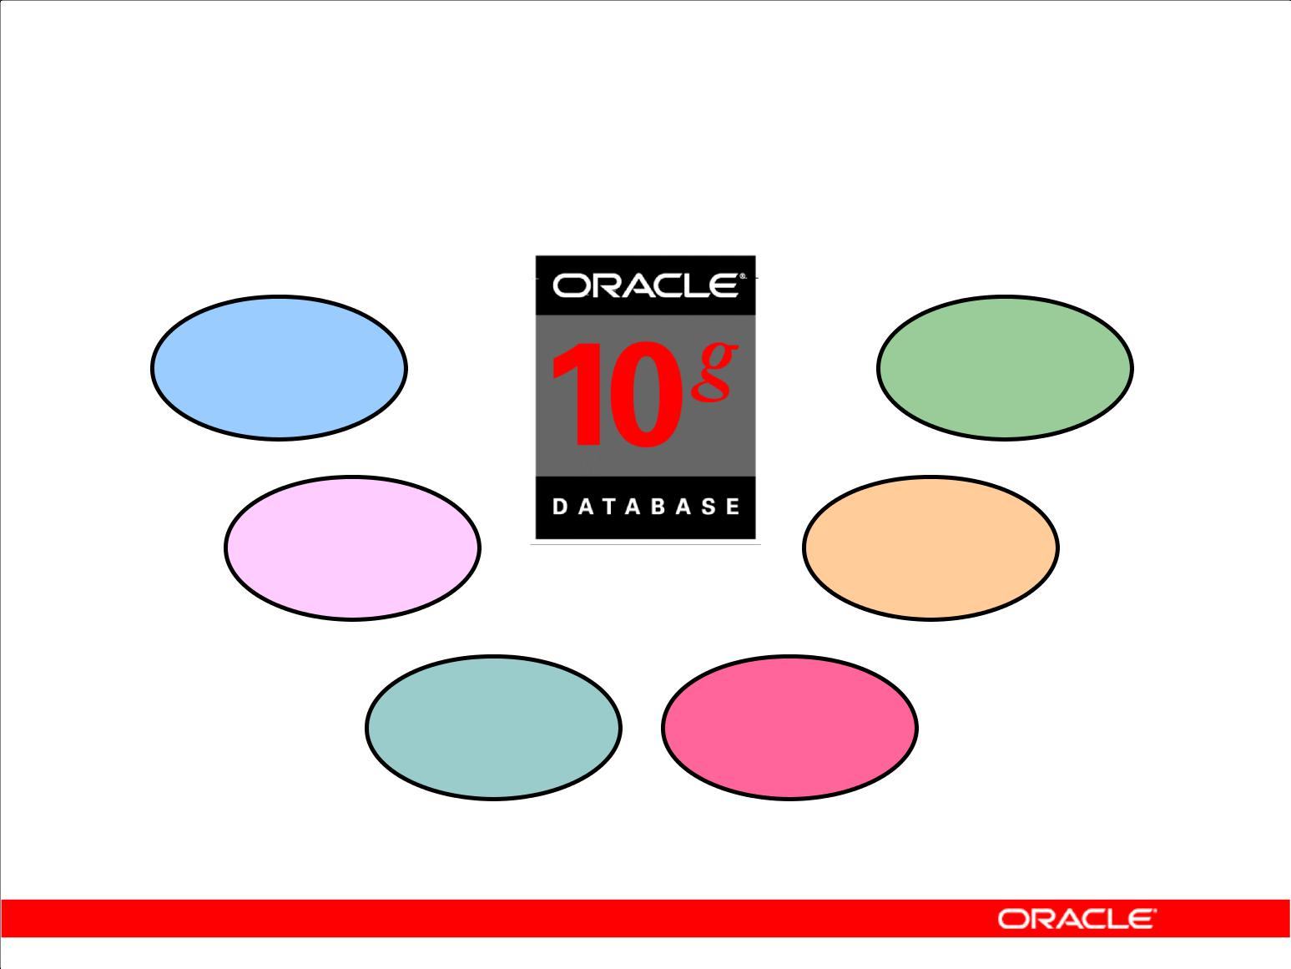**Oracle10*g***

|  |  |  |
| --- | --- | --- |
| **Scalability** | **One** |  |
| **vendor** |  |
|  |  |

|  |  |  |
| --- | --- | --- |
| **Reliability** | **Unified** |  |
| **management** |  |
|  |  |

**Single** **Common**

**development** **skillsets**

**model**

Copyright © 2009, Oracle. All rights reserved.

**Oracle10*g* Features**

The Oracle10*g* release offers a comprehensive high-performance infrastructure, including:

* Scalability from departments to enterprise e-business sites
* Robust, reliable, available, and secure architecture
* One development model; easy deployment options
* Leverage an organization’s current skillset throughout the Oracle platform (including SQL, PL/SQL, Java, and XML)
* One management interface for all applications
* Industry-standard technologies; no proprietary lock-in

In addition to providing the benefits listed above, the Oracle10*g* release contains the database for the grid. Grid computing can dramatically lower the cost of computing, extend the availability of computing resources, and deliver higher productivity and quality.

The basic idea of grid computing is the notion of computing as a utility, analogous to the electric power grid or the telephone network. As a client of the grid, you do not care where your data is or where your computation is done. You want to have your computation done and to have your information delivered to you when you want it. From the server side, grid is about virtualization and provisioning. You pool all your resources together and provision these resources dynamically based on the needs of your business, thus achieving better resource utilization at the same time.

|  |
| --- |
| Oracle Internal & Oracle Academy Use Only |

**Oracle Database 10*g*: SQL Fundamentals I I - 4**

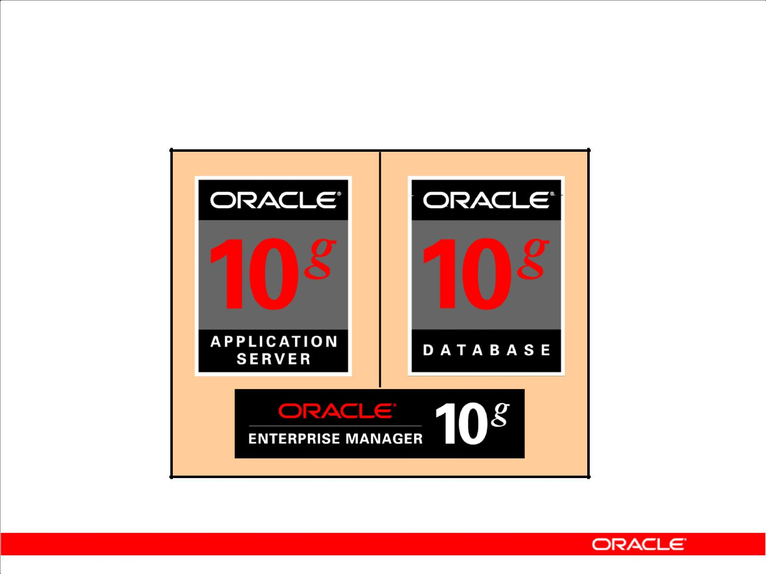**Oracle10*g***

Copyright © 2009, Oracle. All rights reserved.

**Oracle10*g***

The three grid-infrastructure products of the Oracle10*g* release are:

* Oracle Database 10*g*
* Oracle Application Server 10*g*
* Oracle Enterprise Manager 10*g* Grid Control

|  |
| --- |
| Oracle Internal & Oracle Academy Use Only |

**Oracle Database 10*g*: SQL Fundamentals I I - 5**

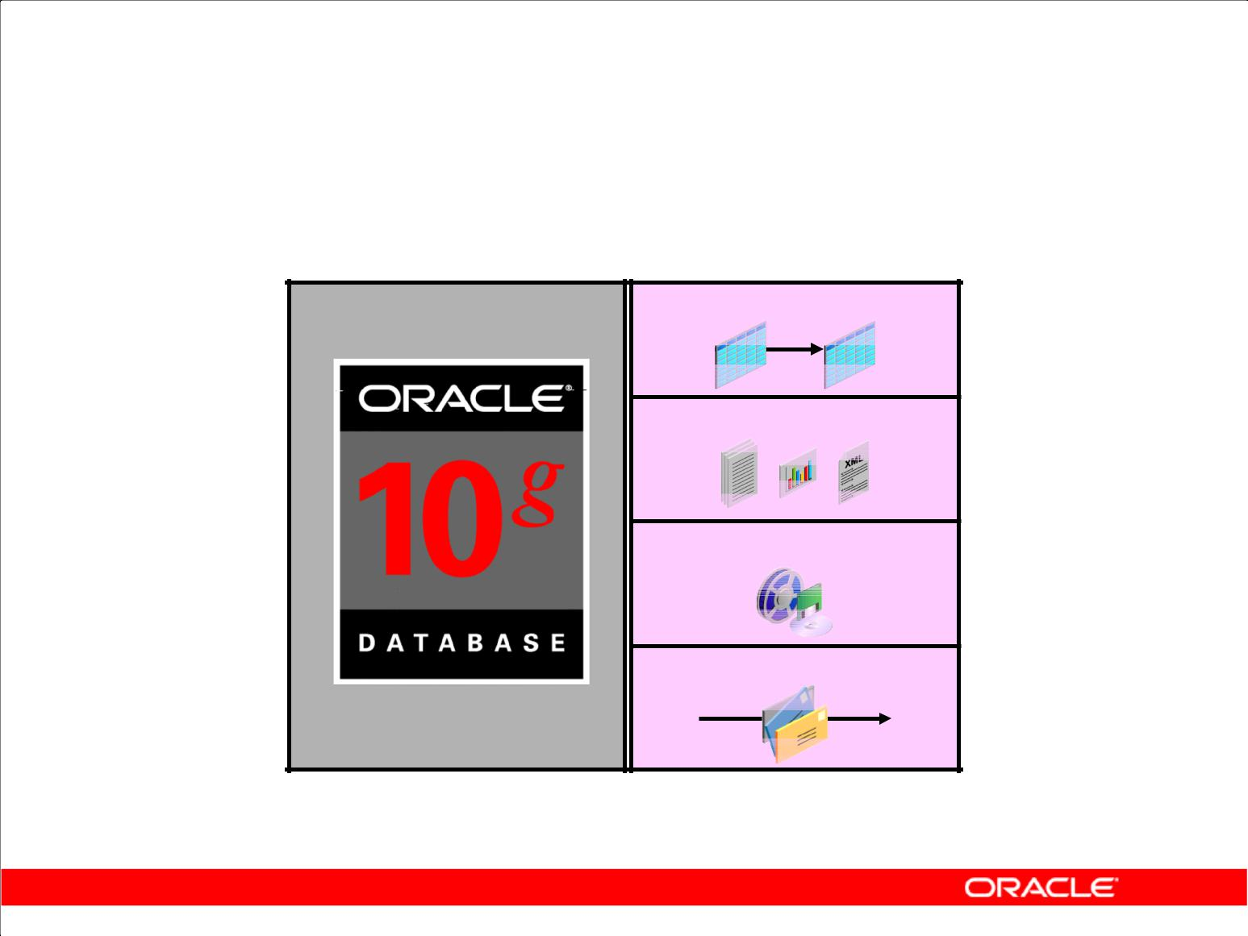**Oracle Database 10*g***

**Object-relational data**

**Documents**

**Multimedia**

**Messages**

Copyright © 2009, Oracle. All rights reserved.

**Oracle Database 10*g***

Oracle Database 10*g* is designed to store and manage enterprise information. Oracle Database 10*g* cuts management costs and provides a high quality of service. Reduced configuration and management requirements and automatic SQL tuning have significantly reduced the cost of maintaining the environment.

Oracle Database 10*g* contributes to the grid-infrastructure products of the Oracle 10*g* release. Grid computing is all about computing as a utility. If you are a client, you need not know where your data resides and which computer stores it. You should be able to request information or computation on your data and have it delivered to you.

Oracle Database 10*g* manages all your data. This is not just the object-relational data that you expect an enterprise database to manage. It can also be unstructured data such as:

* Spreadsheets
* Word documents
* PowerPoint presentations
* XML
* Multimedia data types like MP3, graphics, video, and more

The data does not even have to be in the database. Oracle Database 10*g* has services through which you can store metadata about information stored in file systems. You can use the database server to manage and serve information wherever it is located.

|  |
| --- |
| Oracle Internal & Oracle Academy Use Only |

**Oracle Database 10*g*: SQL Fundamentals I I - 6**

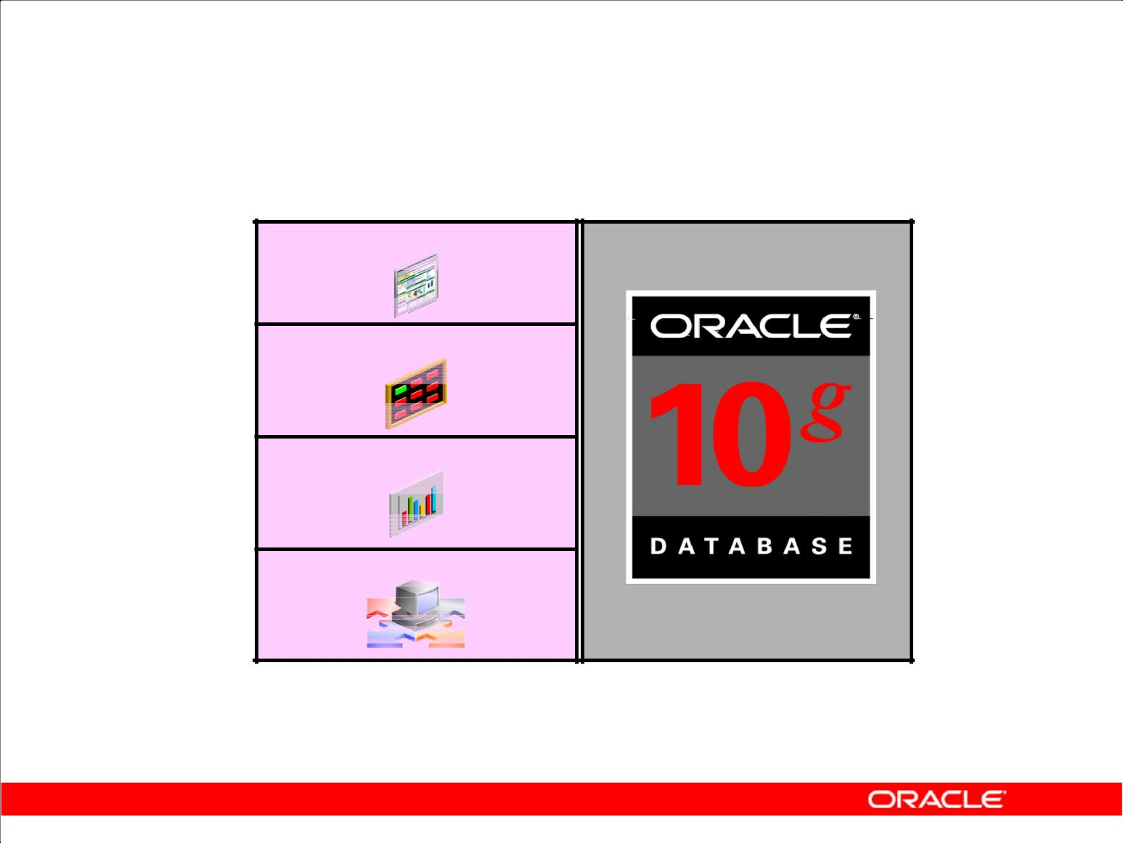**Oracle Application Server 10*g***

**Portals**

**Transactional applications**

**Business intelligence**

**Integration**

**Application** **Application**

**development** **server**

**framework**

Copyright © 2009, Oracle. All rights reserved.

**Oracle Application Server 10*g***

Oracle Application Server 10*g* provides a complete infrastructure platform for developing and deploying enterprise applications, integrating many functions including a J2EE and Web services run-time environment, an enterprise portal, an enterprise integration broker, business intelligence, Web caching, and identity management services.

Oracle Application Server 10*g* adds new grid computing features, building on the success of Oracle9*i* Application Server, which has hundreds of customers running production enterprise applications.

Oracle Application Server 10*g* is the only application server to include services for all the different server applications that you might want to run, including:

* Portals or Web sites
* Java transactional applications
* Business intelligence applications

It also provides integration among users, applications, and data throughout your organization.

|  |
| --- |
| Oracle Internal & Oracle Academy Use Only |

**Oracle Database 10*g*: SQL Fundamentals I I - 7**

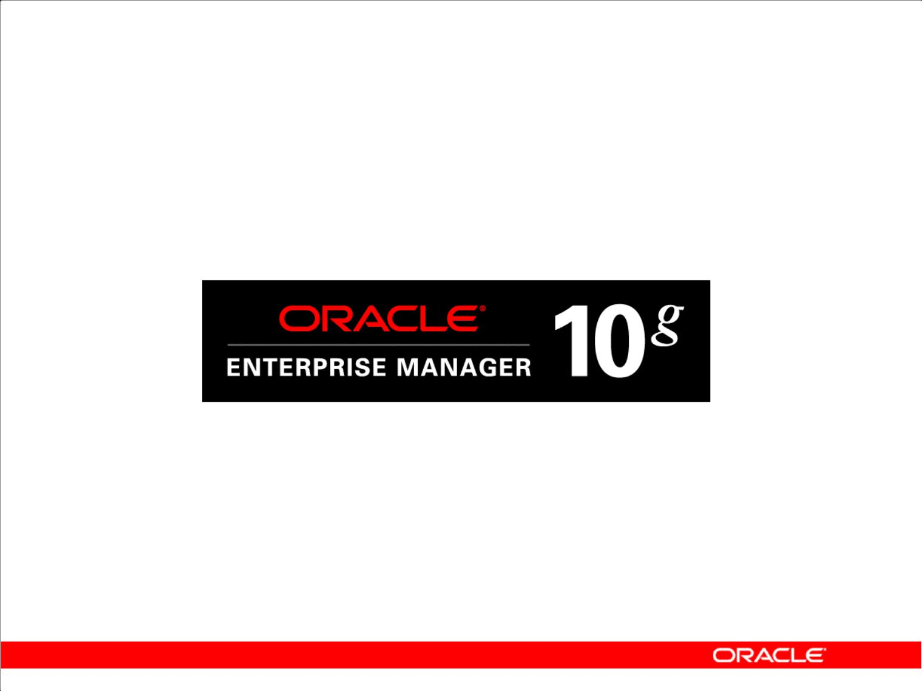**Oracle Enterprise Manager 10*g***

**Grid Control**

* Software provisioning
* Application service level monitoring

Copyright © 2009, Oracle. All rights reserved.

**Oracle Enterprise Manager 10*g* Grid Control**

Oracle Enterprise Manager 10*g* Grid Control is the complete, integrated, central management console and underlying framework that automates administrative tasks across sets of systems in a grid environment. With Oracle Grid Control, you can group multiple hardware nodes, databases, application servers, and other targets into single logical entities. By executing jobs, enforcing standard policies, monitoring performance, and automating many other tasks across a group of targets instead of on many systems individually, Grid Control enables scaling with a growing grid.

**Software Provisioning**

With Grid Control, Oracle 10*g* automates installation, configuration, and cloning of Application Server 10*g* and Database 10*g* across multiples nodes. Oracle Enterprise Manager provides a common framework for software provisioning and management, enabling administrators to create, configure, deploy, and utilize new servers with new instances of the application server and database as they are needed.

**Application Service Level Monitoring**

Oracle Grid Control views the availability and performance of the grid infrastructure as a unified whole, as a user would experience it, rather than as isolated storage units, processing boxes, databases, and application servers.

|  |
| --- |
| Oracle Internal & Oracle Academy Use Only |

**Oracle Database 10*g*: SQL Fundamentals I I - 8**

**Relational and Object Relational**

**Database Management Systems**

* Relational model and object relational model
* User-defined data types and objects
* Fully compatible with relational database
* Support of multimedia and large objects
* High-quality database server features

Copyright © 2009, Oracle. All rights reserved.

**About the Oracle Server**

The Oracle server supports both the relational and object relational models.

The Oracle server extends the data-modeling capabilities to support an object relational database model that brings object-oriented programming, complex data types, complex business objects, and full compatibility with the relational world.

It includes several features for improved performance and functionality of online transaction processing (OLTP) applications, such as better sharing of run-time data structures, larger buffer caches, and deferrable constraints. Data warehouse applications benefit from enhancements such as parallel execution of insert, update, and delete operations; partitioning; and parallel-aware query optimization. Operating within the Network Computing Architecture (NCA) framework, the Oracle model supports client/server and Web-based applications that are distributed and multitiered.

For more information about the relational and object relational model, see the *Database Concepts* manual.

|  |
| --- |
| Oracle Internal & Oracle Academy Use Only |

**Oracle Database 10*g*: SQL Fundamentals I I - 9**

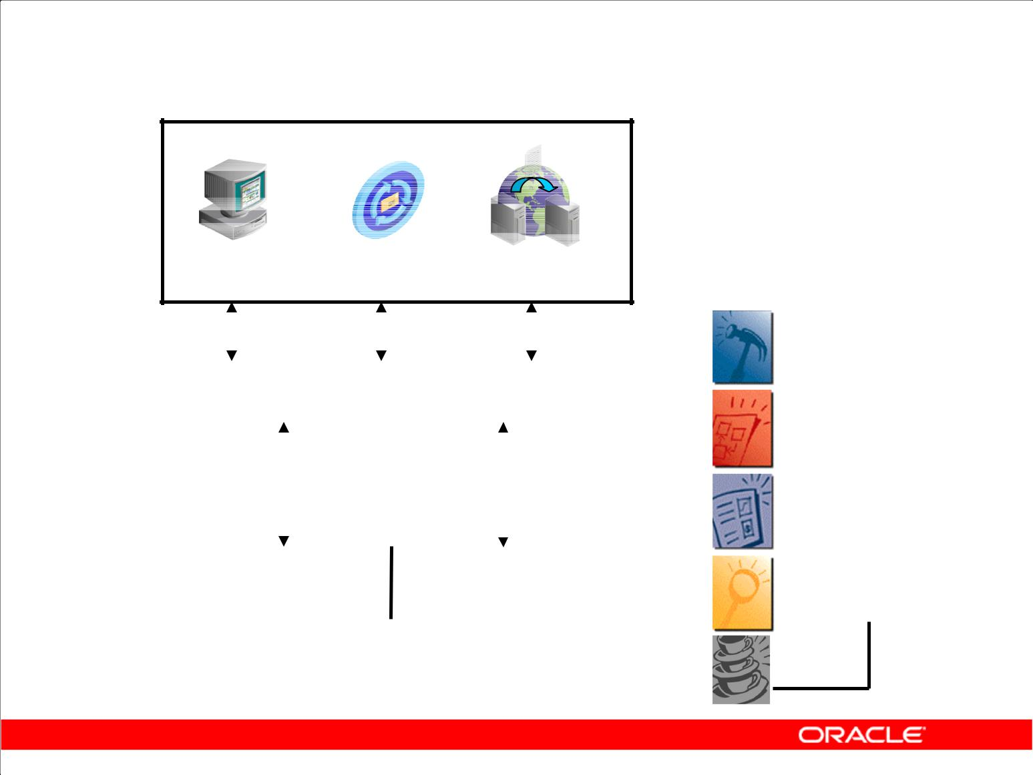**Oracle Internet Platform**

**Clients**

**Any** **Any** **Any**

**browser mail client** **FTP client**

|  |  |  |  |  |  |  |  |  |  |  |  |  |  |  |  |  |  |  |  |
| --- | --- | --- | --- | --- | --- | --- | --- | --- | --- | --- | --- | --- | --- | --- | --- | --- | --- | --- | --- |
|  |  |  |  |  |  |  |  |  |  |  |  |  |  |  |  |  |  |  |  |
| **management** |  |  |  |  |  |  |  |  |  |  |  | **Development** |  |  |  |  |  |  |  |
|  |  |  |  |  |  |  |  |  |  |  |  |  |  |  |  |  |  |
|  |  |  | **Internet applications** | | | | | |  |  |  |  |  |  |  | **PL/SQL** |  |
|  |  |  |  |  |  |  |  |  |  |  |  |  |  |
|  |  |  |  |  |  |  |  |  |  |  |  |  |  |  |  |  |  |  |  |
|  |  |  |  |  |  | **logic** |  |  |  |  |  |  |  |  |  |  |  | **SQL** |  |
|  |  |  |  |  |  |  |  |  |  |  |  |  |  |  |  |  |  |
|  | **Business** | | | |  | **Presentation and** | | | | |  |  |  |  |  |  |  |  |
| **System** |  |  | **and** | | | **data** | **business logic** | | | | | **tools** |  |  |  |  |  |  |  |
|  |  |  |  |  |  |  |  |
|  |  |  |  |  |  |  |  |  |  |  |  |  |  |  |  |  |  |
|  | **Databases** | | | | | **Application** | | |  |  |  |  |  |  |  | **Java** |  |
|  |  |  |  |  |  |  |  |  |  |  |  |
|  |  | **servers** | | |  |  |  |  |  |  |  |  |  |  |
|  |  |  |  |  |  |  |  |  |  |  |  |  |  |  |  |  |
|  |  |  |  |  |  |  |  |  |  |  | |  |  |  |  |  |  |  |  |
|  |  |  |  |  |  |  |  |  |  |  |  |  |  |  |  |  |  |  |  |
|  |  |  |  |  |  | **Network services** | | | |  |  |  |  |  |  |  |  |  |  |
|  |  |  |  |  |  |  |  |  |
|  |  |  |  |  |  |  |  |  |  |  |  |  |  |  |  |  |  |  |  |

Copyright © 2009, Oracle. All rights reserved.

**Oracle Internet Platform**

To develop an e-commerce application, you need a product that can store and manage the data, a product that can provide a run-time environment for your applications implementing business logic, and a product that can monitor and diagnose the application after it is integrated. The Oracle 10*g* products provide all the necessary components to develop your application.

Oracle offers a comprehensive high-performance Internet platform for e-commerce and data warehousing. The integrated Oracle Internet Platform includes everything needed to develop, deploy, and manage Internet applications, including these three core pieces:

* Browser-based clients to process presentation
* Application servers to execute business logic and serve presentation logic to browser-based clients
* Databases to execute database-intensive business logic and serve data

Oracle offers a wide variety of the most advanced graphical user interface (GUI)–driven development tools to build business applications, as well as a large suite of software applications for many areas of business and industry. Oracle Developer Suite includes tools to develop forms and reports and to build data warehouses. Stored procedures, functions, and packages can be written using SQL, PL/SQL, or Java.

|  |
| --- |
| Oracle Internal & Oracle Academy Use Only |

**Oracle Database 10*g*: SQL Fundamentals I I - 10**

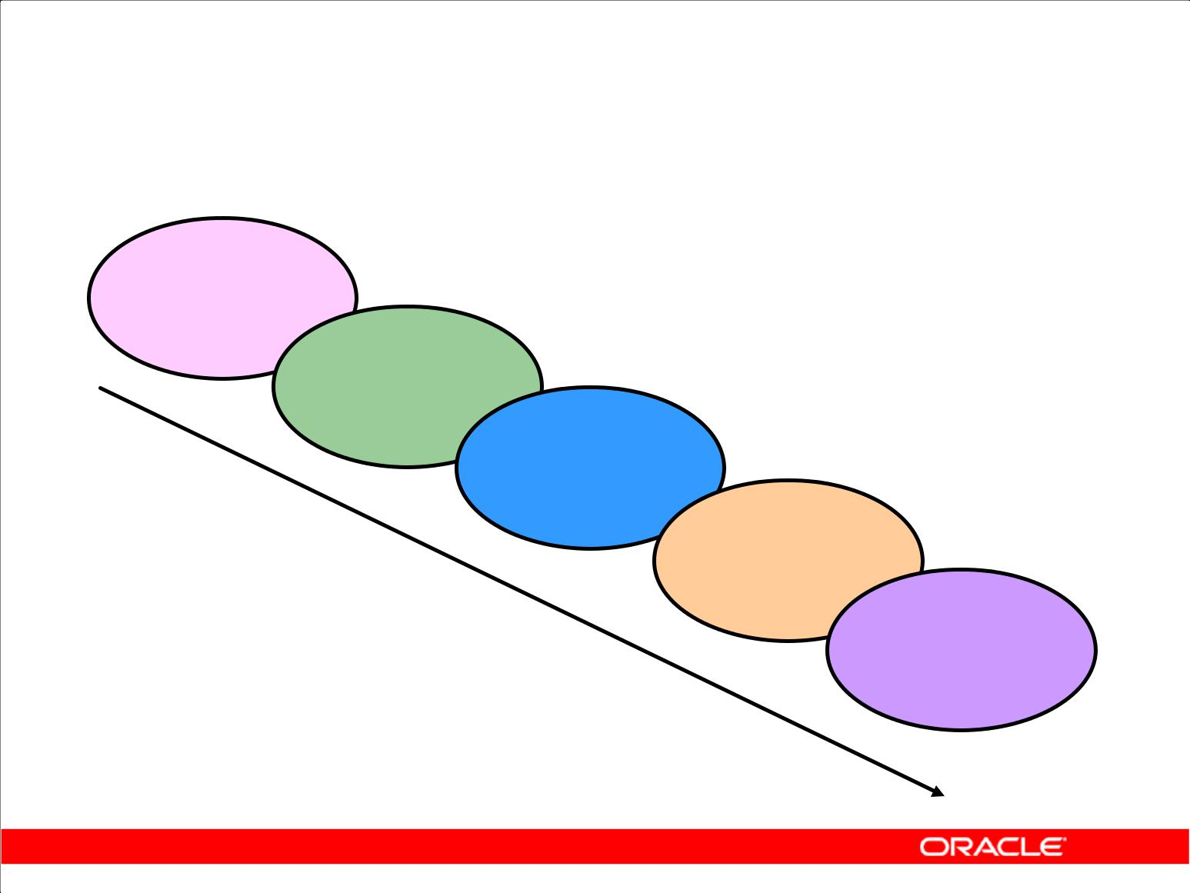**System Development Life Cycle**

**Strategy**

**and**

**analysis**

**Design**

**Build**

**and**

**document**

**Transition**

**Production**

Copyright © 2009, Oracle. All rights reserved.

**System Development Life Cycle**

From concept to production, you can develop a database by using the system-development life cycle, which contains multiple stages of development. This top-down, systematic approach to database development transforms business information requirements into an operational database.

**Strategy and Analysis Phase**

* Study and analyze the business requirements. Interview users and managers to identify the information requirements. Incorporate the enterprise and application mission statements as well as any future system specifications.
* Build models of the system. Transfer the business narrative into a graphical representation of business information needs and rules. Confirm and refine the model with the analysts and experts.

**Design Phase**

Design the database based on the model developed in the strategy and analysis phase.

**Build and Documentation Phase**

* Build the prototype system. Write and execute the commands to create the tables and supporting objects for the database.
* Develop user documentation, help text, and operations manuals to support the use and operation of the system.

|  |
| --- |
| Oracle Internal & Oracle Academy Use Only |

**Oracle Database 10*g*: SQL Fundamentals I I - 11**

**System Development Life Cycle**

**Strategy**

**and**

**analysis**

**Design**

**Build**

**and**

**document**

**Transition**

**Production**

Copyright © 2009, Oracle. All rights reserved.

**System Development Life Cycle (continued)**

**Transition Phase**

Refine the prototype. Move an application into production with user-acceptance testing, conversion of existing data, and parallel operations. Make any modifications required.

**Production Phase**

Roll out the system to the users. Operate the production system. Monitor its performance, and enhance and refine the system.

**Note:** The various phases of the system development life cycle can be carried out iteratively. Thiscourse focuses on the Build phase of the system development life cycle.

|  |
| --- |
| Oracle Internal & Oracle Academy Use Only |

**Oracle Database 10*g*: SQL Fundamentals I I - 12**

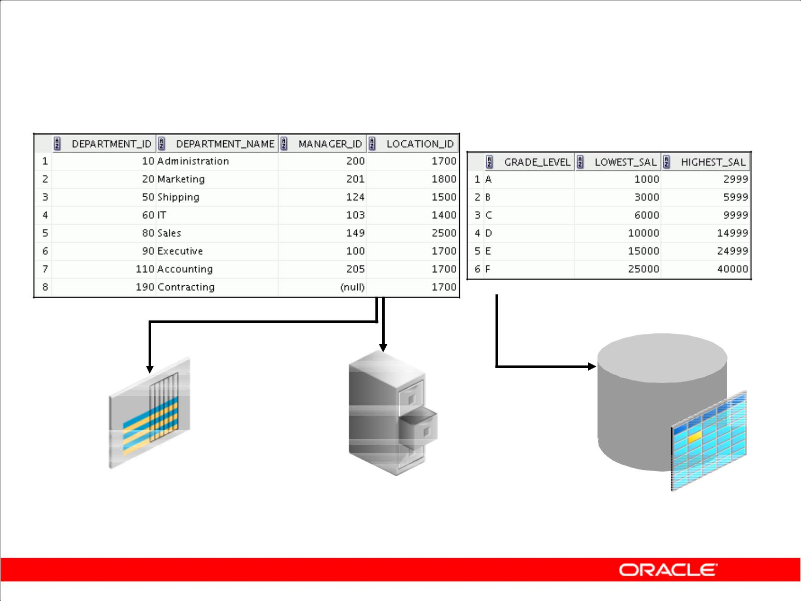**Data Storage on Different Media**

**Electronic spreadsheet** **Filing cabinet** **Database**

Copyright © 2009, Oracle. All rights reserved.

**Storing Information**

Every organization has some information needs. A library keeps a list of members, books, due dates, and fines. A company needs to save information about employees, departments, and salaries. These pieces of information are called *data*.

Organizations can store data on various media and in different formats, such as a hard-copy document in a filing cabinet or data stored in electronic spreadsheets or in databases.

A *database* is an organized collection of information.

To manage databases, you need a database management system (DBMS). A DBMS is a program that stores, retrieves, and modifies data in databases on request. There are four main types of databases: *hierarchical*, *network*, *relational*, and (most recently) *object relational*.

|  |
| --- |
| Oracle Internal & Oracle Academy Use Only |

**Oracle Database 10*g*: SQL Fundamentals I I - 13**

**Relational Database Concept**

* Dr. E. F. Codd proposed the relational model for database systems in 1970.
* It is the basis for the relational database management system (RDBMS).
* The relational model consists of the following:

– Collection of objects or relations

– Set of operators to act on the relations

– Data integrity for accuracy and consistency

Copyright © 2009, Oracle. All rights reserved.

**Relational Model**

The principles of the relational model were first outlined by Dr. E. F. Codd in a June 1970 paper titled “A Relational Model of Data for Large Shared Data Banks.” In this paper, Dr. Codd proposed the relational model for database systems.

The common models used at that time were hierarchical and network, or even simple flat-file data structures. Relational database management systems (RDBMS) soon became very popular, especially for their ease of use and flexibility in structure. In addition, a number of innovative vendors, such as Oracle, supplemented the RDBMS with a suite of powerful application development and user products, providing a total solution.

**Components of the Relational Model**

* Collections of objects or relations that store the data
* A set of operators that can act on the relations to produce other relations
* Data integrity for accuracy and consistency

For more information, see *An Introduction to Database Systems, Eighth Edition* (Addison-Wesley:

2004), written by Chris Date.

|  |
| --- |
| Oracle Internal & Oracle Academy Use Only |

**Oracle Database 10*g*: SQL Fundamentals I I - 14**

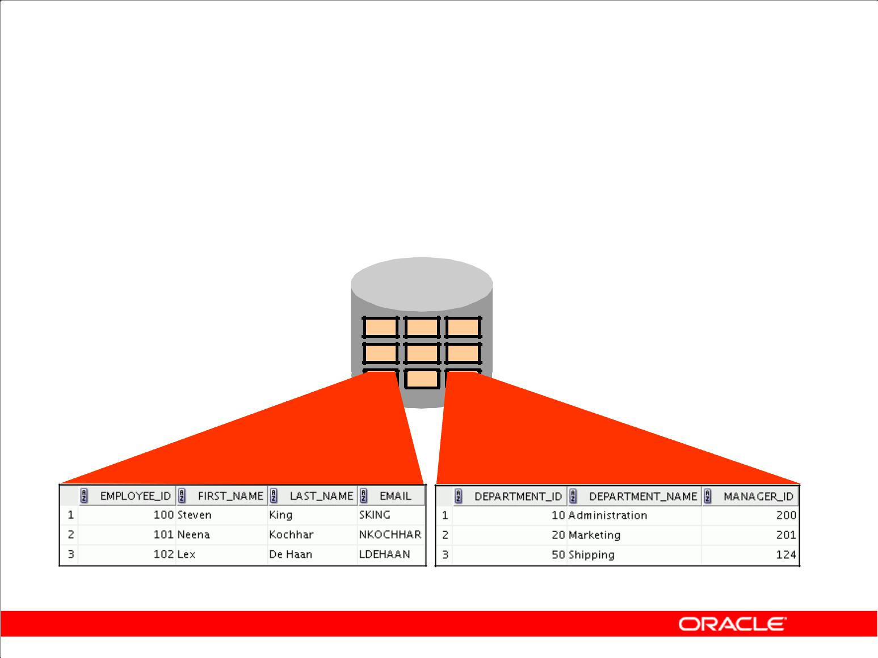**Definition of a Relational Database**

A relational database is a collection of relations or two-dimensional tables.

**Oracle**

**server**

**Table name: EMPLOYEES** **Table name: DEPARTMENTS**

**…** **…**

Copyright © 2009, Oracle. All rights reserved.

**Definition of a Relational Database**

A relational database uses relations or two-dimensional tables to store information.

For example, you might want to store information about all the employees in your company. In a relational database, you create several tables to store different pieces of information about your employees, such as an employee table, a department table, and a salary table.

|  |
| --- |
| Oracle Internal & Oracle Academy Use Only |

**Oracle Database 10*g*: SQL Fundamentals I I - 15**

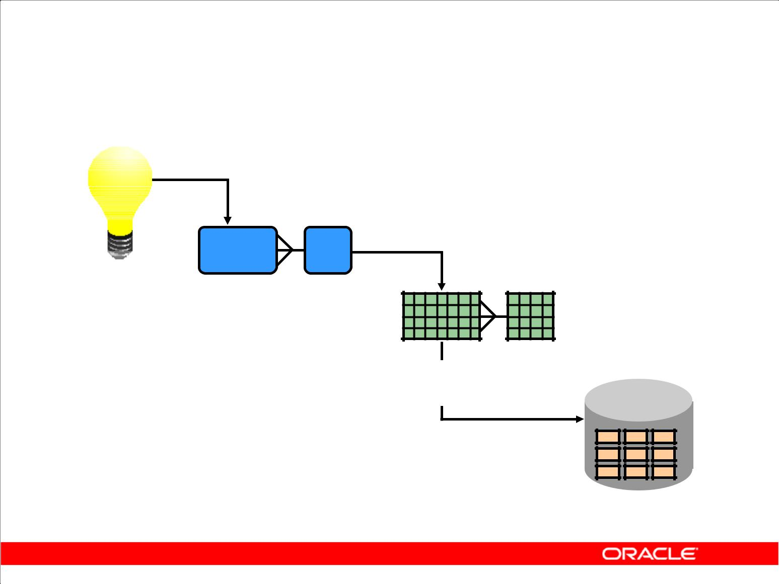**Data Models**

|  |  |  |
| --- | --- | --- |
| **Model of** |  |  |
| **system** | **Entity model of** |  |
| **in client’s** |  |
| **client’s model** |  |
| **mind** |  |
|  |  |

**Table model**

**of entity model** **Oracle**

**server**

**Tables on disk**

Copyright © 2009, Oracle. All rights reserved.

**Data Models**

Models are a cornerstone of design. Engineers build a model of a car to work out any details before putting it into production. In the same manner, system designers develop models to explore ideas and improve the understanding of database design.

**Purpose of Models**

Models help communicate the concepts that are in people’s minds. They can be used to do the following:

* Communicate
* Categorize
* Describe
* Specify
* Investigate
* Evolve
* Analyze
* Imitate

The objective is to produce a model that fits a multitude of these uses, can be understood by an end user, and contains sufficient detail for a developer to build a database system.

|  |
| --- |
| Oracle Internal & Oracle Academy Use Only |

**Oracle Database 10*g*: SQL Fundamentals I I - 16**

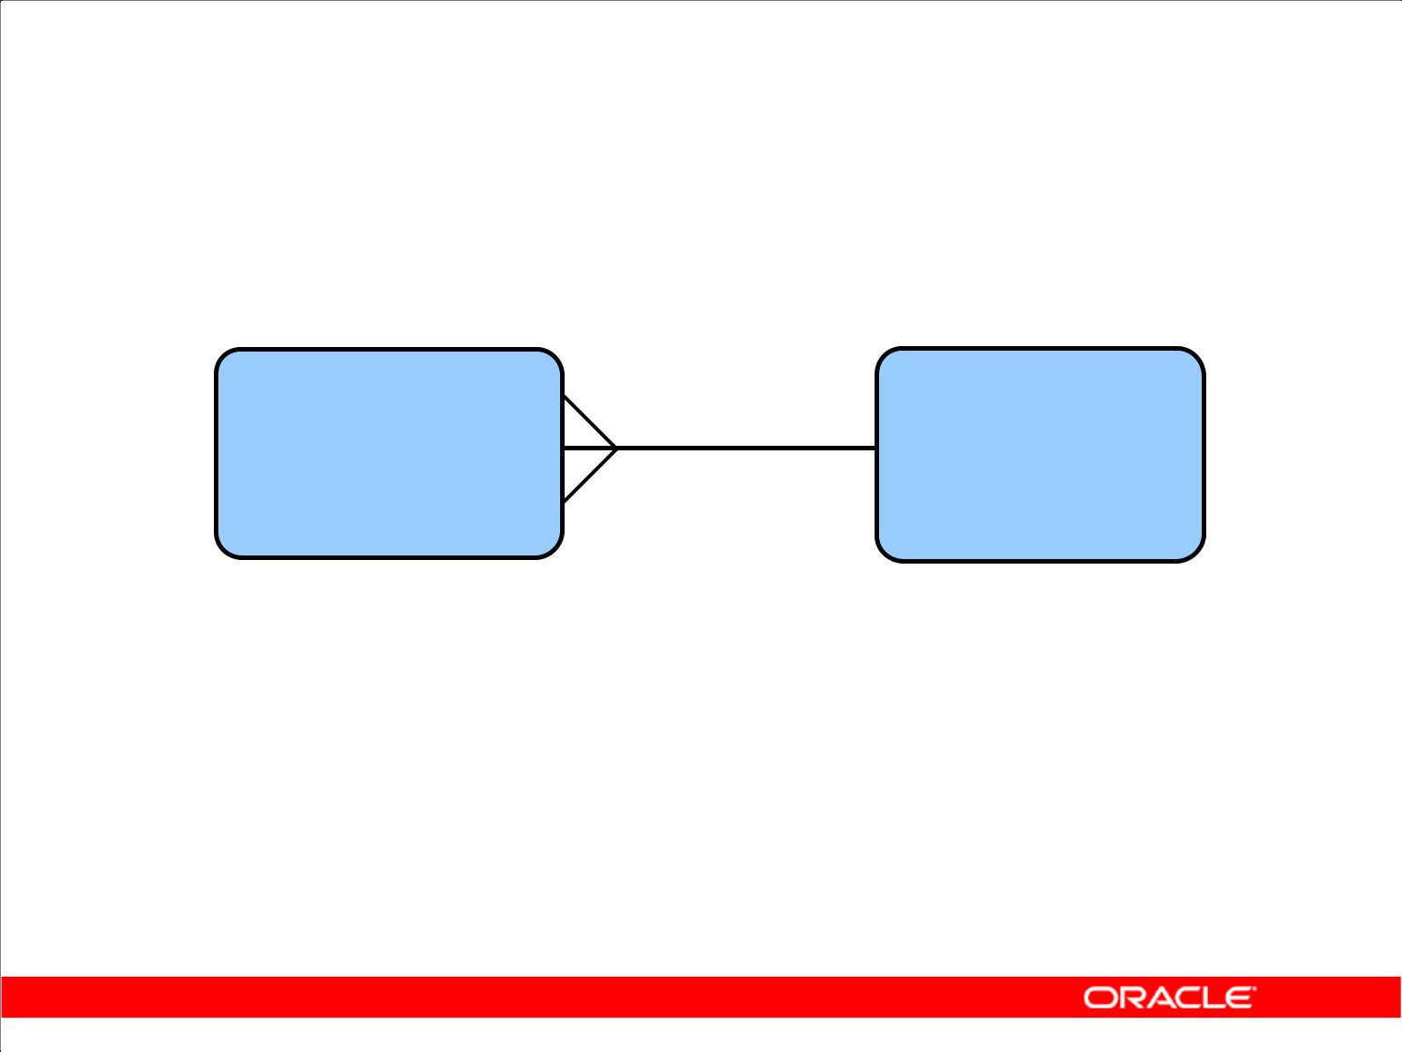**Entity Relationship Model**

* Create an entity relationship diagram from business specifications or narratives:

|  |  |  |  |  |  |
| --- | --- | --- | --- | --- | --- |
| **EMPLOYEE** | | **assigned to** | **DEPARTMENT** | |  |
| **#\*** | **number** | **#\*** | **number** |  |
|  |  |
| **\*** | **name** | **composed of** | **\*** | **name** |  |
| **o** | **job title** | **o** | **location** |  |

* Scenario

– “. . . Assign one or more employees to a department . . .”

– “. . . Some departments do not yet have assigned employees

. . .”

Copyright © 2009, Oracle. All rights reserved.

**ER Modeling**

In an effective system, data is divided into discrete categories or entities. An entity relationship (ER) model is an illustration of various entities in a business and the relationships among them. An ER model is derived from business specifications or narratives and built during the analysis phase of the system development life cycle. ER models separate the information required by a business from the activities performed within a business. Although businesses can change their activities, the type of information tends to remain constant. Therefore, the data structures also tend to be constant.

**Benefits of ER Modeling**

* Documents information for the organization in a clear, precise format
* Provides a clear picture of the scope of the information requirement
* Provides an easily understood pictorial map for database design
* Offers an effective framework for integrating multiple applications

|  |
| --- |
| Oracle Internal & Oracle Academy Use Only |

**Oracle Database 10*g*: SQL Fundamentals I I - 17**

**ER Modeling (continued)**

**Key Components**

* **Entity:** A thing of significance about which information needs to be known. Examples aredepartments, employees, and orders.
* **Attribute:** Something that describes or qualifies an entity. For example, for the employee entity,the attributes would be the employee number, name, job title, hire date, department number, and so on. Each of the attributes is either required or optional. This state is called *optionality*.
* **Relationship:** A named association between entities showing optionality and degree. Examplesare employees and departments, and orders and items.

|  |
| --- |
| Oracle Internal & Oracle Academy Use Only |

**Oracle Database 10*g*: SQL Fundamentals I I - 18**

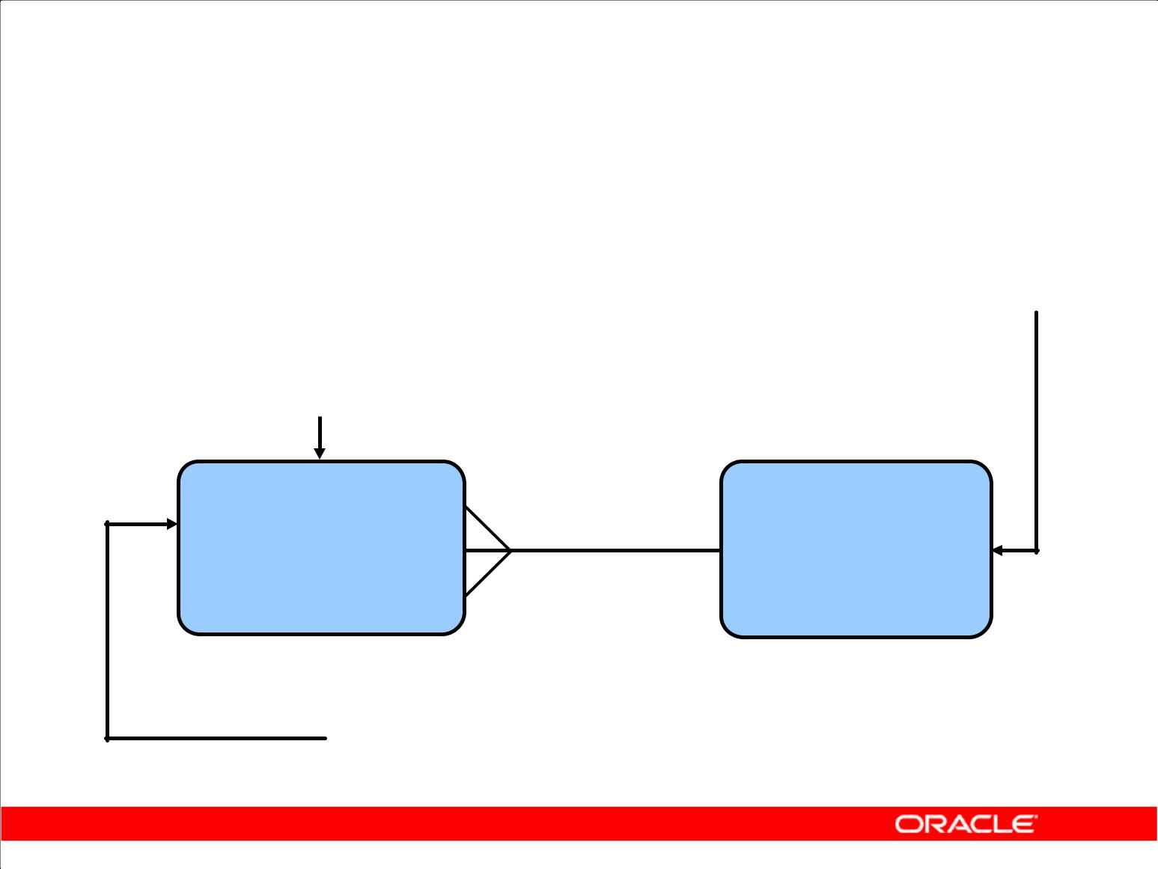**Entity Relationship**

**Modeling Conventions**

|  |  |  |  |
| --- | --- | --- | --- |
| Entity | | Attribute | |
| • | Singular, unique name | • | Singular name |
| • | Uppercase | • | Lowercase |
| • | Soft box | • Mandatory marked with * | |
| • | Synonym in parentheses | • Optional marked with “o” | |

|  |  |  |  |  |  |
| --- | --- | --- | --- | --- | --- |
| **EMPLOYEE** | | **assigned to** | **DEPARTMENT** | |  |
| **#\*** | **number** | **#\*** | **number** |  |
|  |  |
| **\*** | **name** |  | **\*** | **name** |  |
| **o** | **job title** | **composed of o** | | **location** |  |

**Unique identifier (UID)**

**Primary marked with “#”**

**Secondary marked with “(#)”**

Copyright © 2009, Oracle. All rights reserved.

**ER Modeling Conventions**

**Entities**

To represent an entity in a model, use the following conventions:

* Singular, unique entity name
* Entity name in uppercase
* Soft box
* Optional synonym names in uppercase within parentheses: ( )

**Attributes**

To represent an attribute in a model, use the following conventions:

* Singular name in lowercase
* Asterisk (*) tag for mandatory attributes (that is, values that *must* be known)
* Letter “o” tag for optional attributes (that is, values that *may* be known)

**Relationships**

|  |  |
| --- | --- |
| **Symbol** | **Description** |
|  |  |
| Dashed line | Optional element indicating “maybe” |
|  |  |
| Solid line | Mandatory element indicating “must be” |
|  |  |
| Crow’s foot | Degree element indicating “one or more” |
|  |  |
| Single line | Degree element indicating “one and only one” |
|  |  |

|  |
| --- |
| Oracle Internal & Oracle Academy Use Only |

**Oracle Database 10*g*: SQL Fundamentals I I - 19**

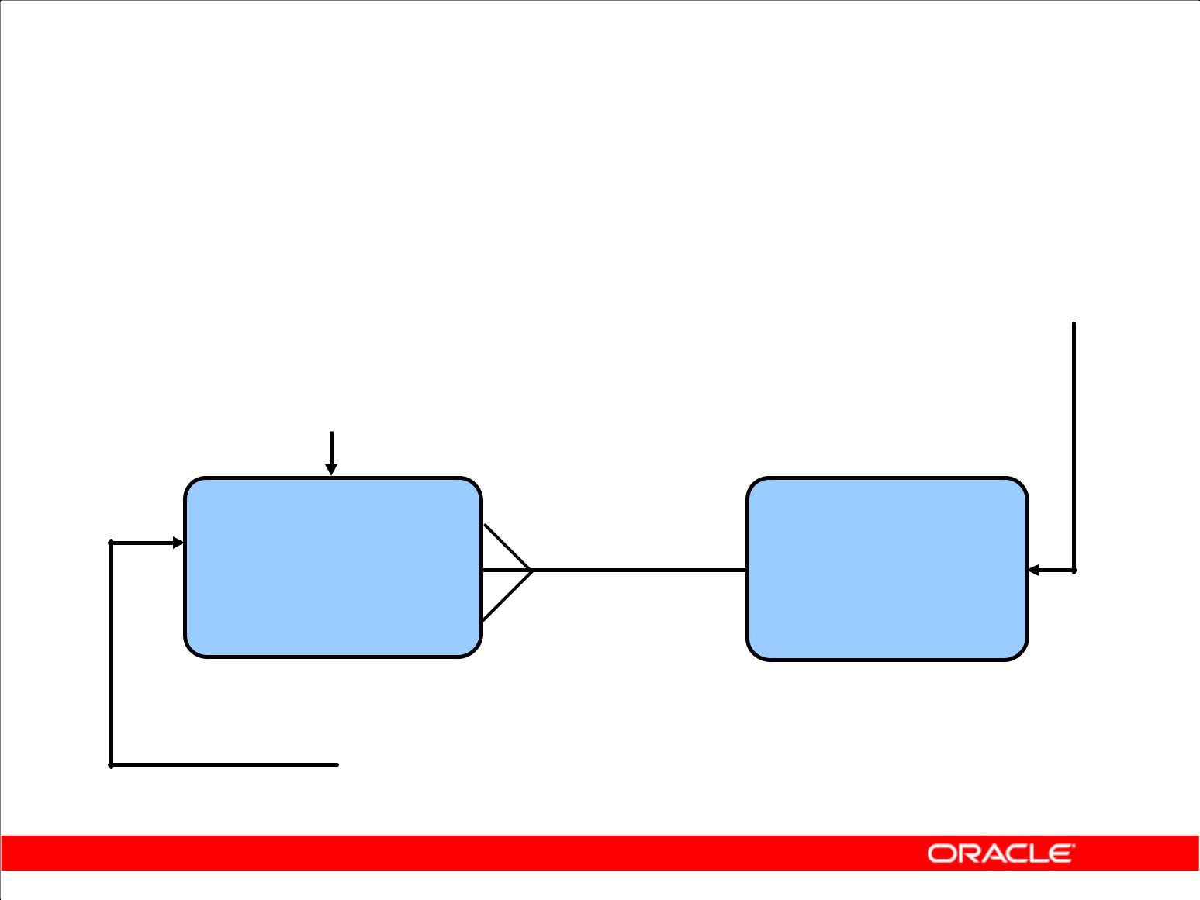**Entity Relationship**

**Modeling Conventions**

|  |  |  |  |
| --- | --- | --- | --- |
| Entity | | Attribute | |
| • | Singular, unique name | • | Singular name |
| • | Uppercase | • | Lowercase |
| • | Soft box | • Mandatory marked with * | |
| • | Synonym in parentheses | • Optional marked with “o” | |

|  |  |  |  |  |  |
| --- | --- | --- | --- | --- | --- |
| **EMPLOYEE** | | **assigned to** | **DEPARTMENT** | |  |
| **#\*** | **number** | **#\*** | **number** |  |
|  |  |
| **\*** | **name** |  | **\*** | **name** |  |
| **o** | **job title** | **composed of o** | | **location** |  |

**Unique identifier (UID)**

**Primary marked with “#”**

**Secondary marked with “(#)”**

Copyright © 2009, Oracle. All rights reserved.

**ER Modeling Conventions (continued)**

**Relationships**

Each direction of the relationship contains:

* **A label:** for example,*taught by*or*assigned to*
* **An optionality:** either*must be*or*maybe*
* **A degree:** either*one and only one*or*one or more*

**Note:** The term*cardinality*is a synonym for the term*degree*.

Each source entity {may be | must be} relationship name {one and only one | one or more} destination entity.

**Note:** The convention is to read clockwise.

**Unique Identifiers**

A unique identifier (UID) is any combination of attributes or relationships, or both, that serves to distinguish occurrences of an entity. Each entity occurrence must be uniquely identifiable.

* **Tag each attribute that is part of the UID with a number sign:** #
* **Tag secondary UIDs with a number sign in parentheses:** (#)

|  |
| --- |
| Oracle Internal & Oracle Academy Use Only |

**Oracle Database 10*g*: SQL Fundamentals I I - 20**

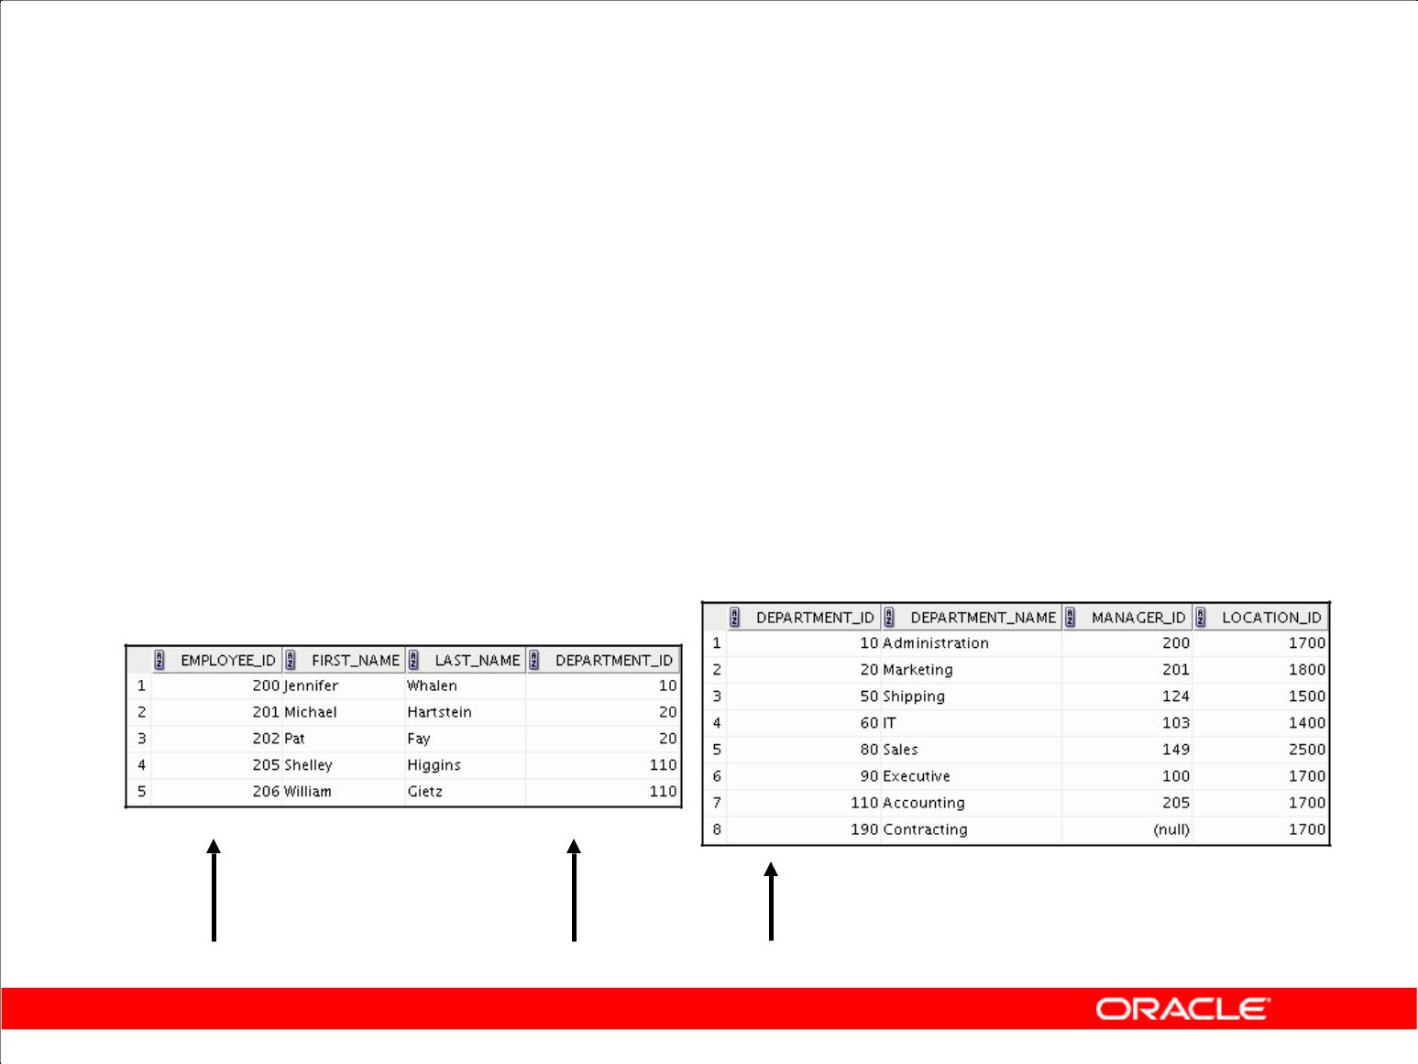**Relating Multiple Tables**

* Each row of data in a table is uniquely identified by a primary key (PK).
* You can logically relate data from multiple tables using foreign keys (FK).

**Table name: DEPARTMENTS**

**Table name: EMPLOYEES**

**…**

**Primary key** **Foreign key Primary key**

Copyright © 2009, Oracle. All rights reserved.

**Relating Multiple Tables**

Each table contains data that describes exactly one entity. For example, the EMPLOYEES table contains information about employees. Categories of data are listed across the top of each table, and individual cases are listed below. Using a table format, you can readily visualize, understand, and use information.

Because data about different entities is stored in different tables, you may need to combine two or more tables to answer a particular question. For example, you may want to know the location of the department where an employee works. In this scenario, you need information from the EMPLOYEES table (which contains data about employees) and the DEPARTMENTS table (which contains information about departments). With an RDBMS, you can relate the data in one table to the data in another by using the foreign keys. A foreign key is a column (or a set of columns) that refers to a primary key in the same table or another table.

You can use the ability to relate data in one table to data in another to organize information in separate, manageable units. Employee data can be kept logically distinct from department data by storing it in a separate table.

|  |
| --- |
| Oracle Internal & Oracle Academy Use Only |

**Oracle Database 10*g*: SQL Fundamentals I I - 21**

**Relating Multiple Tables (continued)**

**Guidelines for Primary Keys and Foreign Keys**

* You cannot use duplicate values in a primary key.
* Primary keys generally cannot be changed.
* Foreign keys are based on data values and are purely logical (not physical) pointers.
* A foreign key value must match an existing primary key value or unique key value, or else it must be null.
* A foreign key must reference either a primary key or a unique key column.

|  |
| --- |
| Oracle Internal & Oracle Academy Use Only |

**Oracle Database 10*g*: SQL Fundamentals I I - 22**

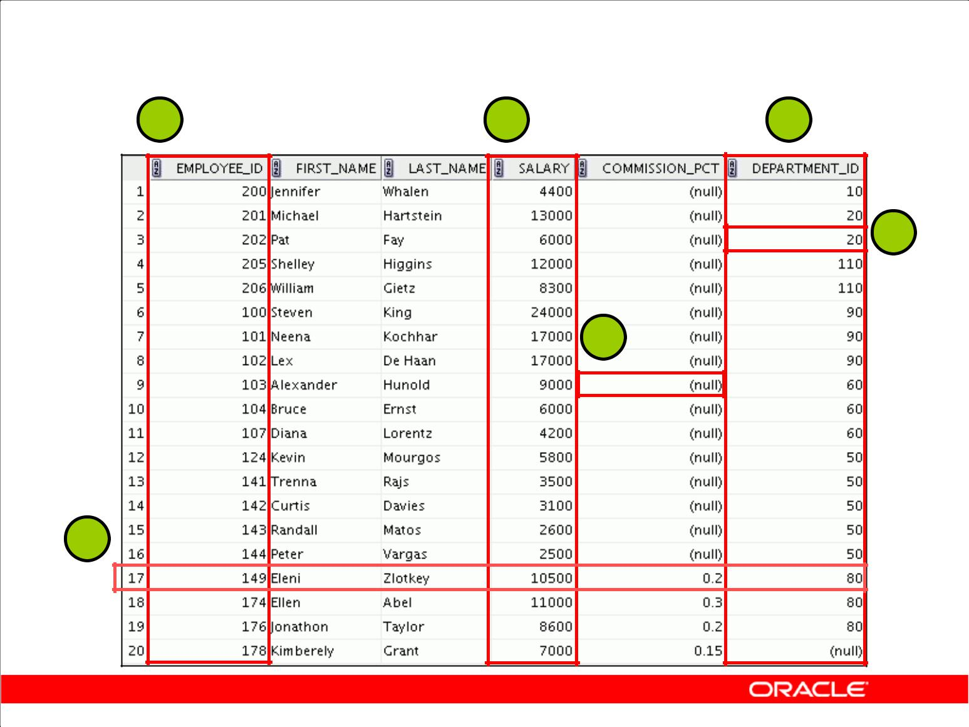**Relational Database Terminology**

**2** **3** **4**

**5**

**6**

**1**

Copyright © 2009, Oracle. All rights reserved.

**Terminology Used in a Relational Database**

A relational database can contain one or many tables. A *table* is the basic storage structure of an RDBMS. A table holds all the data necessary about something in the real world, such as employees, invoices, or customers.

The slide shows the contents of the EMPLOYEES *table* or *relation*. The numbers indicate the following:

1. A single *row* (or *tuple*) representing all data required for a particular employee. Each row in a table should be identified by a primary key, which permits no duplicate rows. The order of rows is insignificant; specify the row order when the data is retrieved.
2. A *column* or attribute containing the employee number. The employee number identifies a *unique* employee in theEMPLOYEEStable. In this example, the employee number column isdesignated as the *primary key*. A primary key must contain a value, and the value must be unique.
3. A column that is not a key value. A column represents one kind of data in a table; in this example, the data is the salaries of all the employees. Column order is insignificant when storing data; specify the column order when the data is retrieved.

|  |
| --- |
| Oracle Internal & Oracle Academy Use Only |

**Oracle Database 10*g*: SQL Fundamentals I I - 23**

**Terminology Used in a Relational Database (continued)**

1. A column containing the department number, which is also a *foreign key*. A foreign key is a column that defines how tables relate to each other. A foreign key refers to a primary key or a unique key in the same table or in another table. In the example, DEPARTMENT_ID *uniquely* identifies a department in the DEPARTMENTS table.
2. A *field* can be found at the intersection of a row and a column. There can be only one value in it.
3. A field may have no value in it. This is called a null value. In the EMPLOYEES table, only those employees who have the role of sales representative have a value in the COMMISSION_PCT (commission) field.

|  |
| --- |
| Oracle Internal & Oracle Academy Use Only |

**Oracle Database 10*g*: SQL Fundamentals I I - 24**

**Relational Database Properties**

A relational database:

* Can be accessed and modified by executing structured query language (SQL) statements
* Contains a collection of tables with no physical pointers
* Uses a set of operators

Copyright © 2009, Oracle. All rights reserved.

**Properties of a Relational Database**

In a relational database, you do not specify the access route to the tables, and you do not need to know how the data is arranged physically.

To access the database, you execute a structured query language (SQL) statement, which is the American National Standards Institute (ANSI) standard language for operating relational databases. The language contains a large set of operators for partitioning and combining relations. The database can be modified by using the SQL statements.

|  |
| --- |
| Oracle Internal & Oracle Academy Use Only |

**Oracle Database 10*g*: SQL Fundamentals I I - 25**

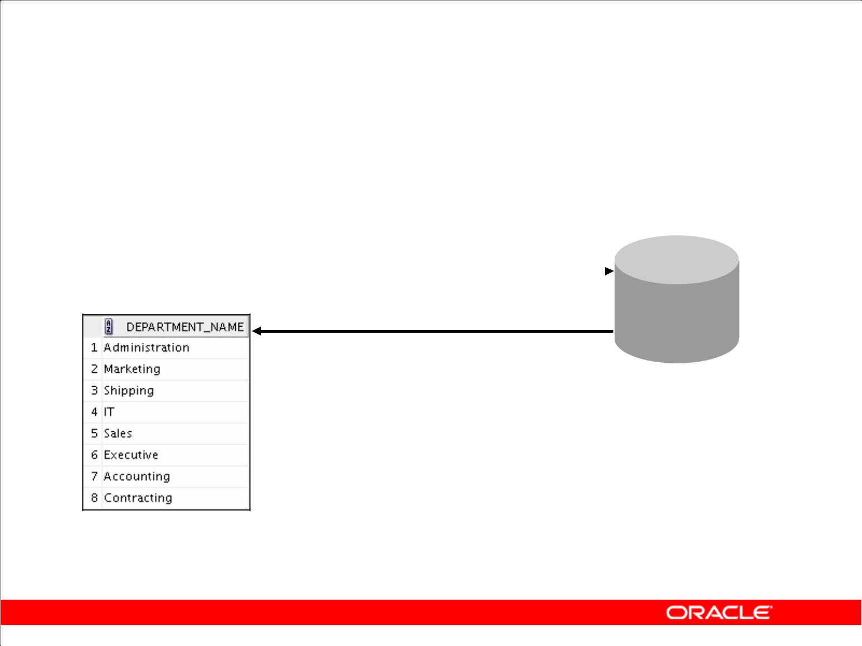**Communicating with an RDBMS**

**Using SQL**

|  |  |  |  |  |  |
| --- | --- | --- | --- | --- | --- |
| **SQL statement is entered.** | | | **Statement is sent to** | |  |
|  |  |  | **Oracle server.** | |  |
| **SELECT** | **department_name** |  |  |  |  |
| **FROM** | **departments;** |  |  |  |  |
|  |  |  |  |
|  |  |  |  |  |  |

**Oracle**

**server**

Copyright © 2009, Oracle. All rights reserved.

**Structured Query Language**

Using SQL, you can communicate with the Oracle server. SQL has the following advantages:

* Efficient
* Easy to learn and use
* Functionally complete (With SQL, you can define, retrieve, and manipulate data in the tables.)

|  |
| --- |
| Oracle Internal & Oracle Academy Use Only |

**Oracle Database 10*g*: SQL Fundamentals I I - 26**

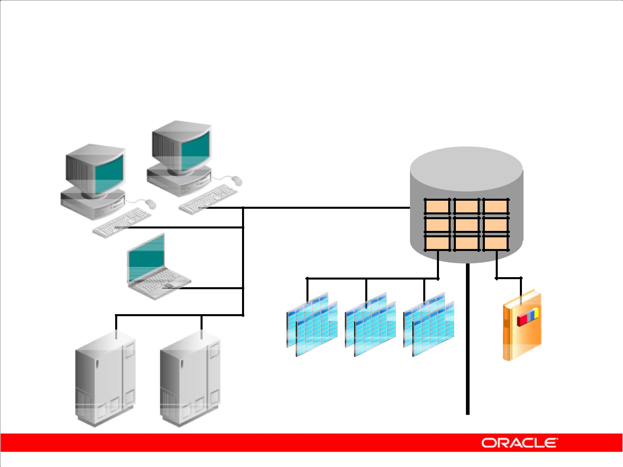**Oracle’s Relational Database Management**

**System**

**Oracle**

**server**

|  |  |  |
| --- | --- | --- |
| **User tables** | **Data** |  |
| **dictionary** |  |
|  |  |

Copyright © 2009, Oracle. All rights reserved.

**Oracle’s Relational Database Management System**

Oracle provides a flexible RDBMS called Oracle Database 10*g*. Using its features, you can store and manage data with all the advantages of a relational structure plus PL/SQL, an engine that provides you with the ability to store and execute program units. Oracle Database 10*g* also supports Java and XML. The Oracle server offers the options of retrieving data based on optimization techniques. It includes security features that control how a database is accessed and used. Other features include consistency and protection of data through locking mechanisms.

The Oracle10*g* release provides an open, comprehensive, and integrated approach to information management. An Oracle server consists of an Oracle Database and an Oracle server instance. Every time a database is started, a system global area (SGA) is allocated and Oracle background processes are started. The SGA is an area of memory that is used for database information shared by the database users. The combination of the background processes and memory buffers is called an Oracle *instance*.

|  |
| --- |
| Oracle Internal & Oracle Academy Use Only |

**Oracle Database 10*g*: SQL Fundamentals I I - 27**

**SQL Statements**

|  |  |  |  |  |
| --- | --- | --- | --- | --- |
|  |  |  |  |  |
|  | SELECT |  |  |  |
|  | INSERT | **Data manipulation language (DML)** |  |  |
|  | UPDATE |  |  |
|  | DELETE |  |  |  |
|  | MERGE |  |  |  |
|  |  |  |  |  |
|  | CREATE |  |  |  |
|  | ALTER |  |  |  |
|  | DROP | **Data definition language (DDL)** |  |  |
|  | RENAME |  |  |
|  |  |  |  |
|  | TRUNCATE |  |  |  |
|  | COMMENT |  |  |  |
|  | GRANT | **Data control language (DCL)** |  |  |
|  | REVOKE |  |  |  |
|  | COMMIT | **Transaction control** |  |  |
|  | ROLLBACK |  |  |
|  | SAVEPOINT |  |  |  |
|  |  |  |  |  |

Copyright © 2009, Oracle. All rights reserved.

**SQL Statements**

Oracle SQL complies with industry-accepted standards. Oracle Corporation ensures future compliance with evolving standards by actively involving key personnel in SQL standards committees. Industry-accepted committees are American National Standards Institute (ANSI) and International Standards Organization (ISO). Both ANSI and ISO have accepted SQL as the standard language for relational databases.

|  |  |
| --- | --- |
| **Statem ent** | **Description** |
|  |  |
| SELECT | Retrieves data from the database, enters new rows, changes existing rows, and |
| INSERT | removes unwanted rows from tables in the database, respectively. Collectively |
| UPDATE | known as *data manipulation language* (DM L). |
| DELETE |  |
| MERGE |  |
| CREATE | Sets up, changes, and removes data structures from tables. Collectively known as |
| ALTER | *data definition language* (DDL). |
| DROP |  |
| RENAME |  |
| TRUNCATE |  |
| COMMENT |  |
|  |  |
| GRANT | Gives or removes access rights to both the Oracle database and the structures |
| REVOKE | within it. |
|  |  |
| COMMIT | M anages the changes made by DM L statements. Changes to the data can be |
| ROLLBACK | grouped together into logical transactions. |
| SAVEPOINT |  |
|  | **Oracle Database 10*g*: SQL Fundamentals I I - 28** |

|  |
| --- |
| Oracle Internal & Oracle Academy Use Only |

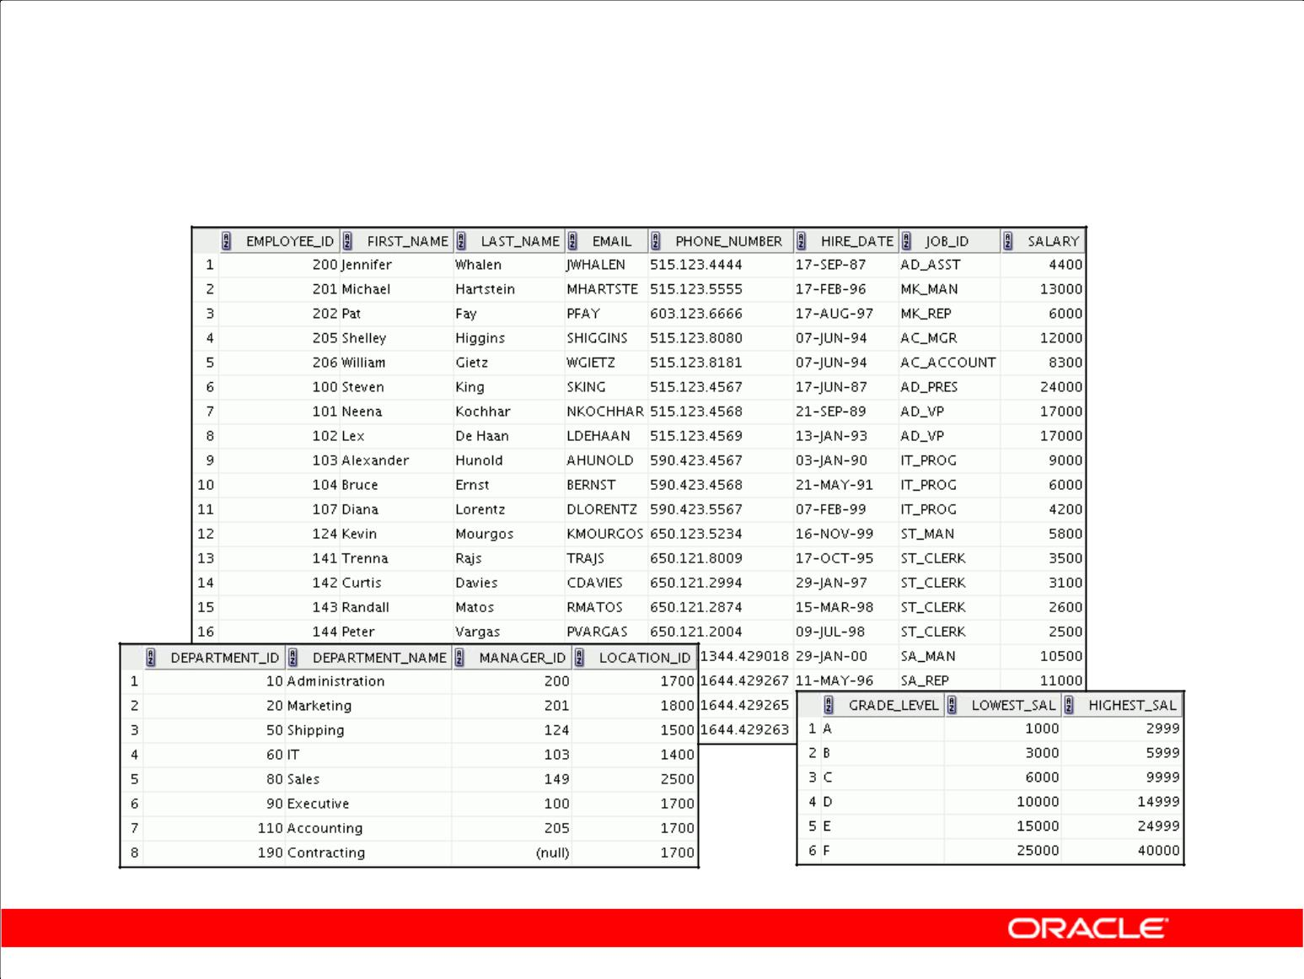**Tables Used in the Course**

**EMPLOYEES**

**DEPARTMENTS** **JOB_GRADES**

Copyright © 2009, Oracle. All rights reserved.

**Tables Used in the Course**

The following main tables are used in this course:

* EMPLOYEES table: Gives details of all the employees
* DEPARTMENTS table: Gives details of all the departments
* JOB_GRADES table: Gives details of salaries for various grades

**Note:** The structure and data for all the tables are provided in Appendix B.

|  |
| --- |
| Oracle Internal & Oracle Academy Use Only |

**Oracle Database 10*g*: SQL Fundamentals I I - 29**

**Summary**

* Oracle Database 10*g* is the database for grid computing.
* The database is based on the object relational database management system.
* Relational databases are composed of relations, managed by relational operations, and governed by data integrity constraints.
* With the Oracle server, you can store and manage information by using the SQL language and PL/SQL engine.

Copyright © 2009, Oracle. All rights reserved.

**Summary**

Relational database management systems are composed of objects or relations. They are managed by operations and governed by data integrity constraints.

Oracle Corporation produces products and services to meet your RDBMS needs. The main products are the following:

* Oracle Database 10*g*, with which you store and manage information by using SQL
* Oracle Application Server 10*g,* with which you run all of your applications
* Oracle Enterprise Manager 10*g* Grid Control, which you use to manage and automate administrative tasks across sets of systems in a grid environment

**SQL**

The Oracle server supports ANSI-standard SQL and contains extensions. SQL is the language that is used to communicate with the server to access, manipulate, and control data.

|  |
| --- |
| Oracle Internal & Oracle Academy Use Only |

**Oracle Database 10*g*: SQL Fundamentals I I - 30**



**Retrieving Data Using**

**the SQL SELECT Statement**

Copyright © 2009, Oracle. All rights reserved.

|  |
| --- |
| Oracle Internal & Oracle Academy Use Only |

**Objectives**

After completing this lesson, you should be able to do the following:

* List the capabilities of SQL SELECT statements
* Execute a basic SELECT statement
* Identify and use the key features of Oracle SQL Developer

Copyright © 2009, Oracle. All rights reserved.

**Objectives**

To extract data from the database, you need to use the structured query language (SQL) SELECT

statement. You may need to restrict the columns that are displayed. This lesson describes all the SQL statements that are needed to perform these actions. You may want to create SELECT statements that

can be used more than once.

This lesson also covers the SQL Developer environment in which you execute SQL statements.

|  |
| --- |
| Oracle Internal & Oracle Academy Use Only |

**Oracle Database 10*g*: SQL Fundamentals I 1 - 2**

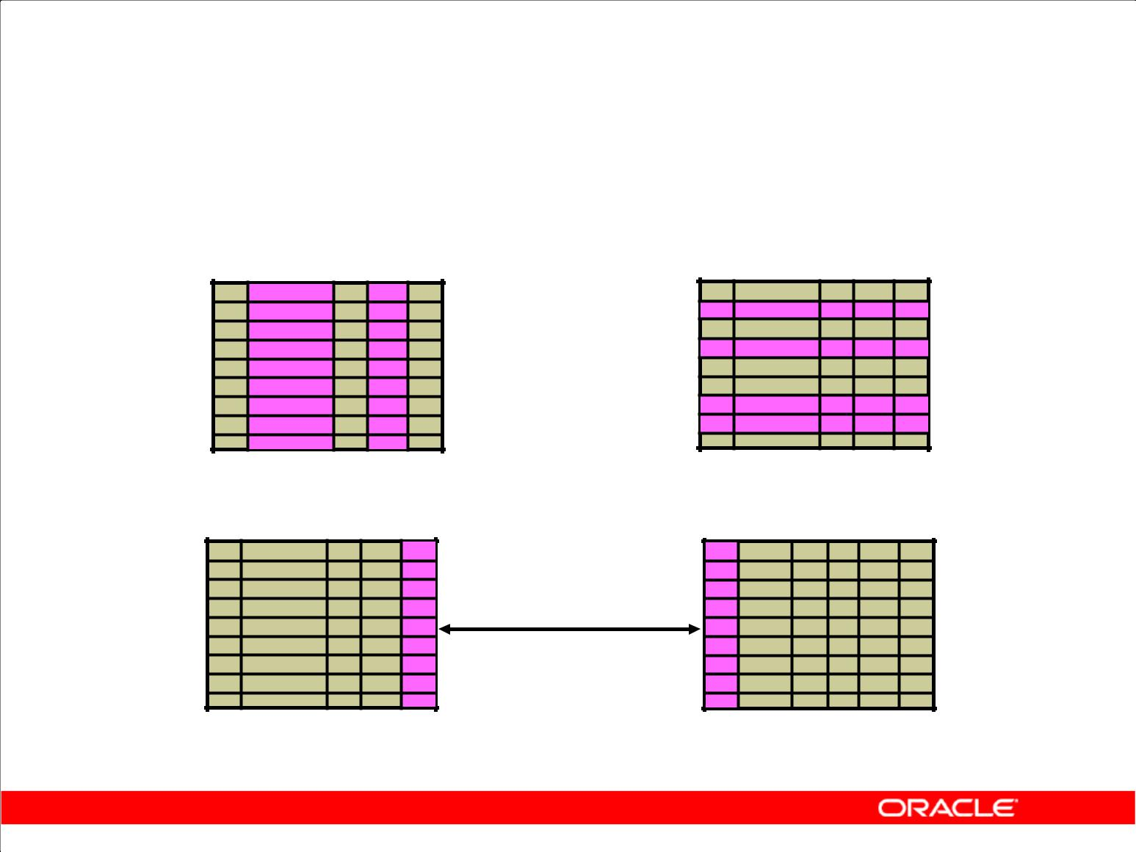**Capabilities of SQL SELECT Statements**

**Projection** **Selection**

**Table 1** **Table 1**

**Join**

**Table 1** **Table 2**

Copyright © 2009, Oracle. All rights reserved.

**Capabilities of SQL SELECT Statements**

A SELECT statement retrieves information from the database. With a SELECT statement, you can use the following capabilities:

* **Projection:** Choose the columns in a table that are returned by a query. Choose as few or asmany of the columns as needed.
* **Selection:** Choose the rows in a table that are returned by a query. Various criteria can be usedto restrict the rows that are retrieved.
* **Joining:** Bring together data that is stored in different tables by specifying the link betweenthem. SQL joins are covered in more detail in the lesson titled “Displaying Data

from Multiple Tables.”

|  |
| --- |
| Oracle Internal & Oracle Academy Use Only |

**Oracle Database 10*g*: SQL Fundamentals I 1 - 3**

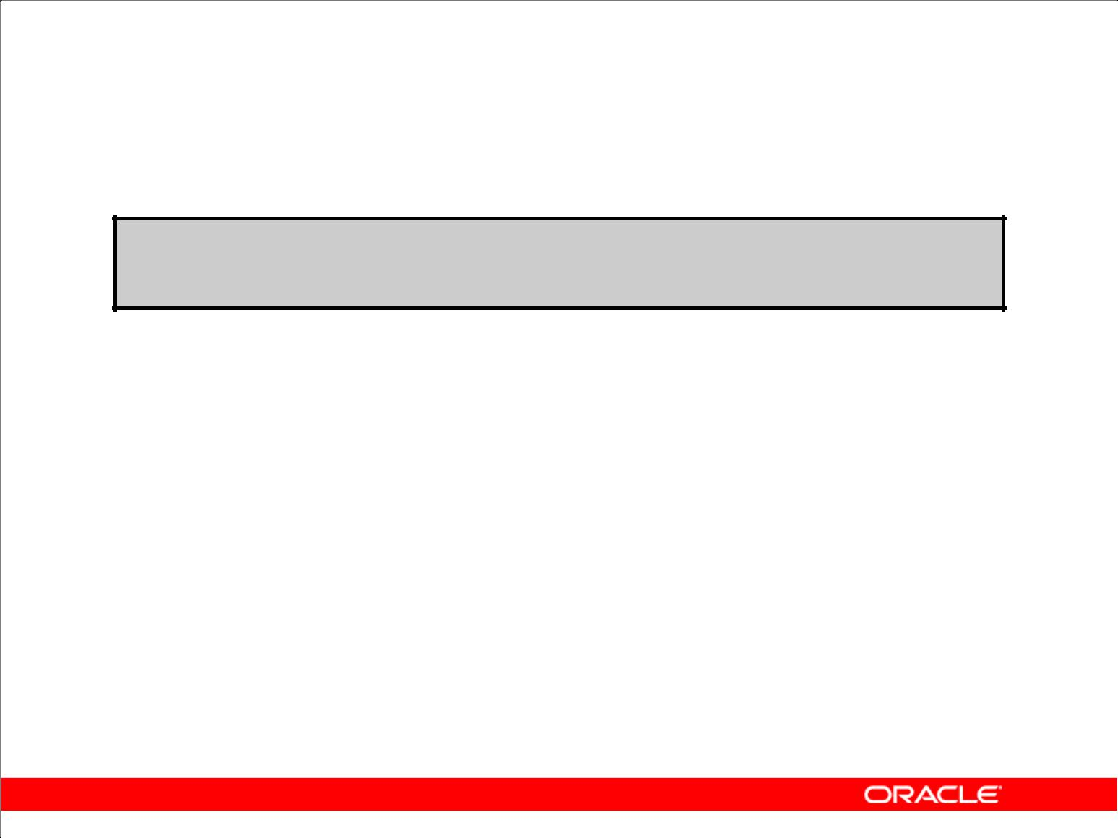**Basic SELECT Statement**

**SELECT *|{[DISTINCT] *column*|*expression* [*alias*],...}**

**FROM** ***table;***

* SELECT identifies the columns to be displayed.
* FROM identifies the table containing those columns.

Copyright © 2009, Oracle. All rights reserved.

**Basic SELECT Statement**

In its simplest form, a SELECT statement must include the following:

* A SELECT clause, which specifies the columns to be displayed
* A FROM clause, which identifies the table containing the columns that are listed in the SELECT clause

In the syntax:

SELECT is a list of one or more columns

* selects all columns

DISTINCT suppresses duplicates

*column|expression* selects the named column or the expression

*alias* gives selected columns different headings

FROM *table* specifies the table containing the columns

**Note:** Throughout this course, the words*keyword*,*clause*, and*statement*are used as follows:

* A *keyword* refers to an individual SQL element. For example, SELECT and FROM are keywords.
* A *clause* is a part of a SQL statement.

For example, SELECT employee_id, last_name, ... is a clause.

* A *statement* is a combination of two or more clauses.

For example, SELECT * FROM employees is a SQL statement.

|  |
| --- |
| Oracle Internal & Oracle Academy Use Only |

**Oracle Database 10*g*: SQL Fundamentals I 1 - 4**

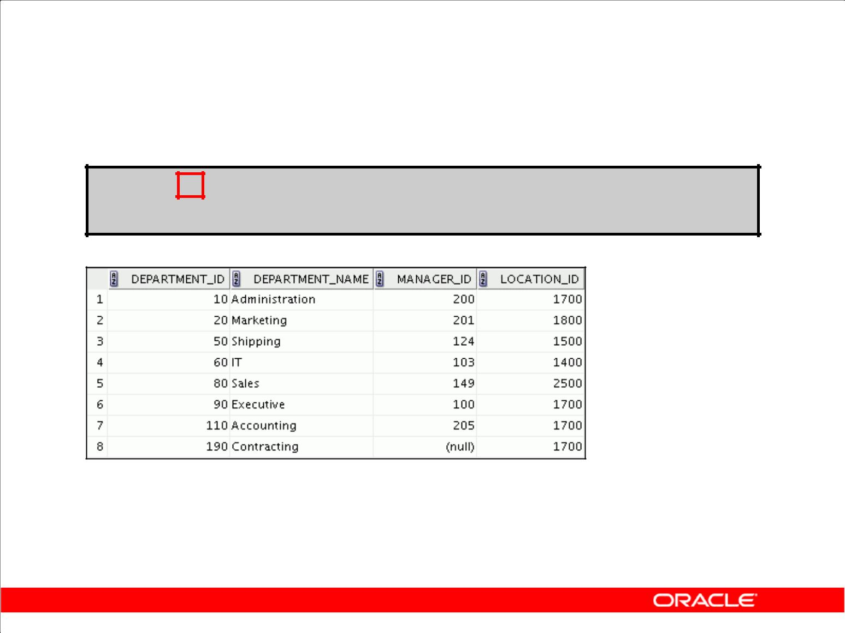**Selecting All Columns**

**SELECT \***

**FROM departments;**

Copyright © 2009, Oracle. All rights reserved.

**Selecting All Columns of All Rows**

You can display all columns of data in a table by following the SELECT keyword with an asterisk (*). In the example in the slide, the department table contains four columns: DEPARTMENT_ID, DEPARTMENT_NAME, MANAGER_ID, and LOCATION_ID. The table contains eight rows, one for each department.

You can also display all columns in the table by listing all the columns after the SELECT keyword.

For example, the following SQL statement (like the example in the slide) displays all columns and all rows of the DEPARTMENTS table:

SELECT department_id, department_name, manager_id, location_id

FROM departments**;**

|  |
| --- |
| Oracle Internal & Oracle Academy Use Only |

**Oracle Database 10*g*: SQL Fundamentals I 1 - 5**

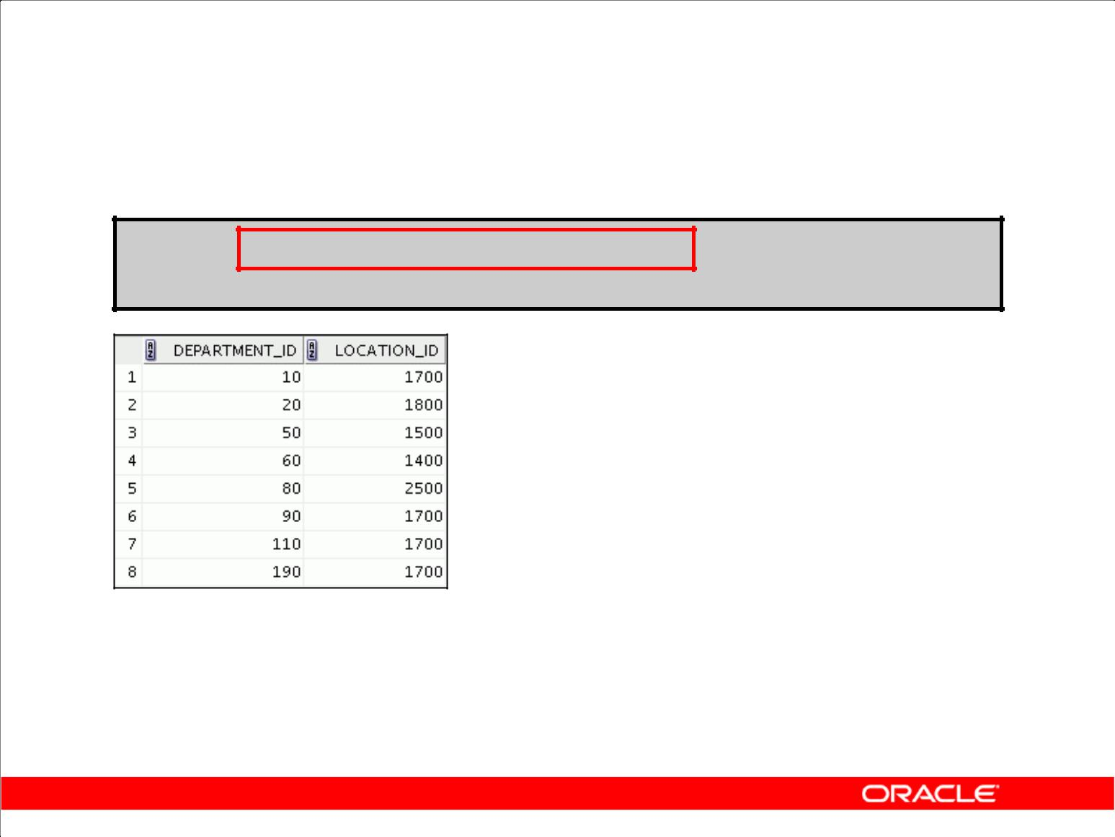**Selecting Specific Columns**

**SELECT department_id, location_id**

**FROM departments;**

Copyright © 2009, Oracle. All rights reserved.

**Selecting Specific Columns of All Rows**

You can use the SELECT statement to display specific columns of the table by specifying the column

names, separated by commas. The example in the slide displays all the department numbers and location numbers from the DEPARTMENTS table.

In the SELECT clause, specify the columns that you want, in the order in which you want them to appear in the output. For example, to display location before department number going from left to right, you use the following statement:

SELECT location_id, department_id

FROM departments;

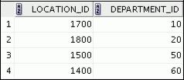

|  |
| --- |
| Oracle Internal & Oracle Academy Use Only |

**…**

**Oracle Database 10*g*: SQL Fundamentals I 1 - 6**

**Writing SQL Statements**

* SQL statements are not case-sensitive.
* SQL statements can be on one or more lines.
* Keywords cannot be abbreviated or split across lines.
* Clauses are usually placed on separate lines.
* Indents are used to enhance readability.
* In SQL Developer, SQL statements can optionally be terminated by a semicolon (;). Semicolons are required if you execute multiple SQL statements.
* In SQL*Plus, you are required to end each SQL statement with a semicolon (;).

Copyright © 2009, Oracle. All rights reserved.

**Writing SQL Statements**

Using the following simple rules and guidelines, you can construct valid statements that are both easy to read and easy to edit:

* SQL statements are not case-sensitive (unless indicated).
* SQL statements can be entered on one or many lines.
* Keywords cannot be split across lines or abbreviated.
* Clauses are usually placed on separate lines for readability and ease of editing.
* Indents should be used to make code more readable.
* Keywords typically are entered in uppercase; all other words, such as table names and columns, are entered in lowercase.

**Executing SQL Statements**

Using SQL Developer, click the Execute button to run the command or commands in the editing window.

Using SQL*Plus, terminate the SQL statement with a semicolon and then press the Enter key to run the command.

|  |
| --- |
| Oracle Internal & Oracle Academy Use Only |

**Oracle Database 10*g*: SQL Fundamentals I 1 - 7**

**Column Heading Defaults**

* SQL Developer:

– Default heading alignment: Center

– Default heading display: Uppercase

* SQL*Plus:

– Character and Date column headings are left-aligned

– Number column headings are right-aligned

– Default heading display: Uppercase

Copyright © 2009, Oracle. All rights reserved.

**Column Heading Defaults**

In SQL Developer, column headings are displayed in uppercase and centered.

SELECT last_name, hire_date, salary

FROM employees;

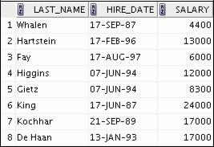

**…**

You can override the column heading display with an alias. Column aliases are covered later in this lesson.

|  |
| --- |
| Oracle Internal & Oracle Academy Use Only |

**Oracle Database 10*g*: SQL Fundamentals I 1 - 8**

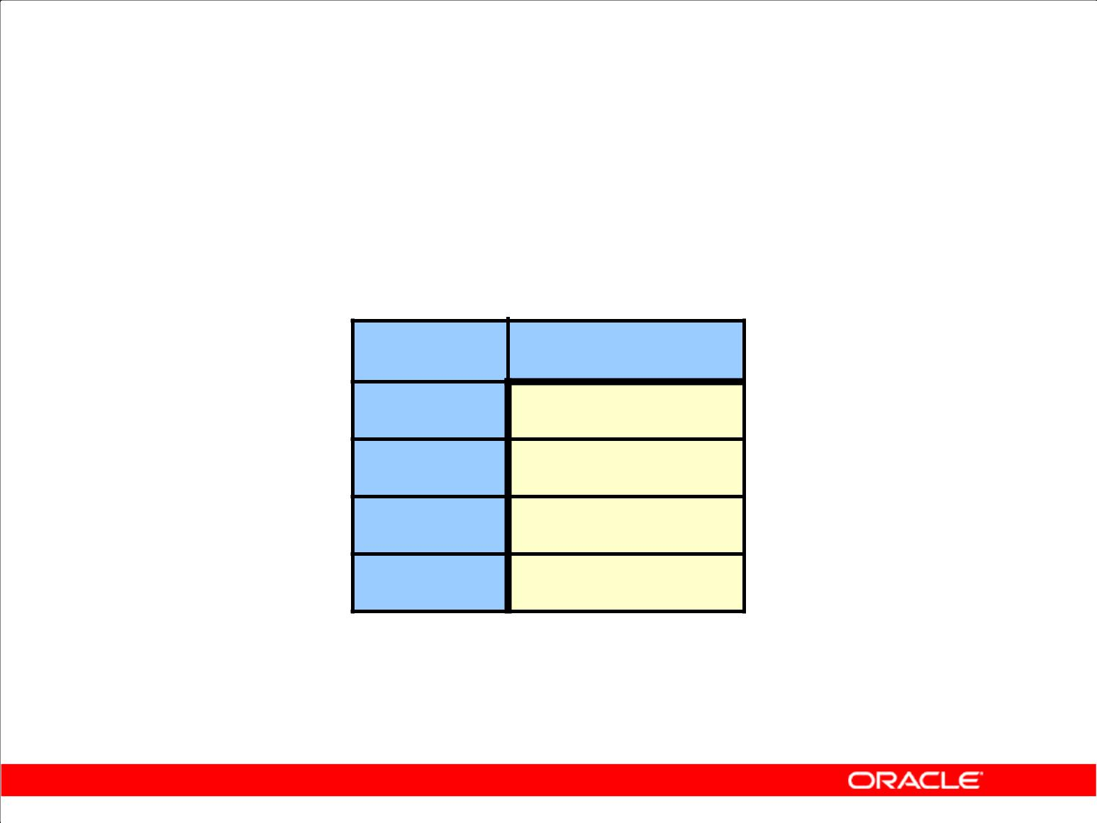**Arithmetic Expressions**

Create expressions with number and date data by using arithmetic operators.

**Operator Description**

* Add
  + Subtract
* Multiply
* Divide

Copyright © 2009, Oracle. All rights reserved.

**Arithmetic Expressions**

You may need to modify the way in which data is displayed, or you may want to perform calculations or look at what-if scenarios. These are all possible using arithmetic expressions. An arithmetic expression can contain column names, constant numeric values, and the arithmetic operators.

**Arithmetic Operators**

The slide lists the arithmetic operators that are available in SQL. You can use arithmetic operators in any clause of a SQL statement (except the FROM clause).

**Note:** With theDATEandTIMESTAMPdata types, you can use the addition and subtractionoperators only.

|  |
| --- |
| Oracle Internal & Oracle Academy Use Only |

**Oracle Database 10*g*: SQL Fundamentals I 1 - 9**

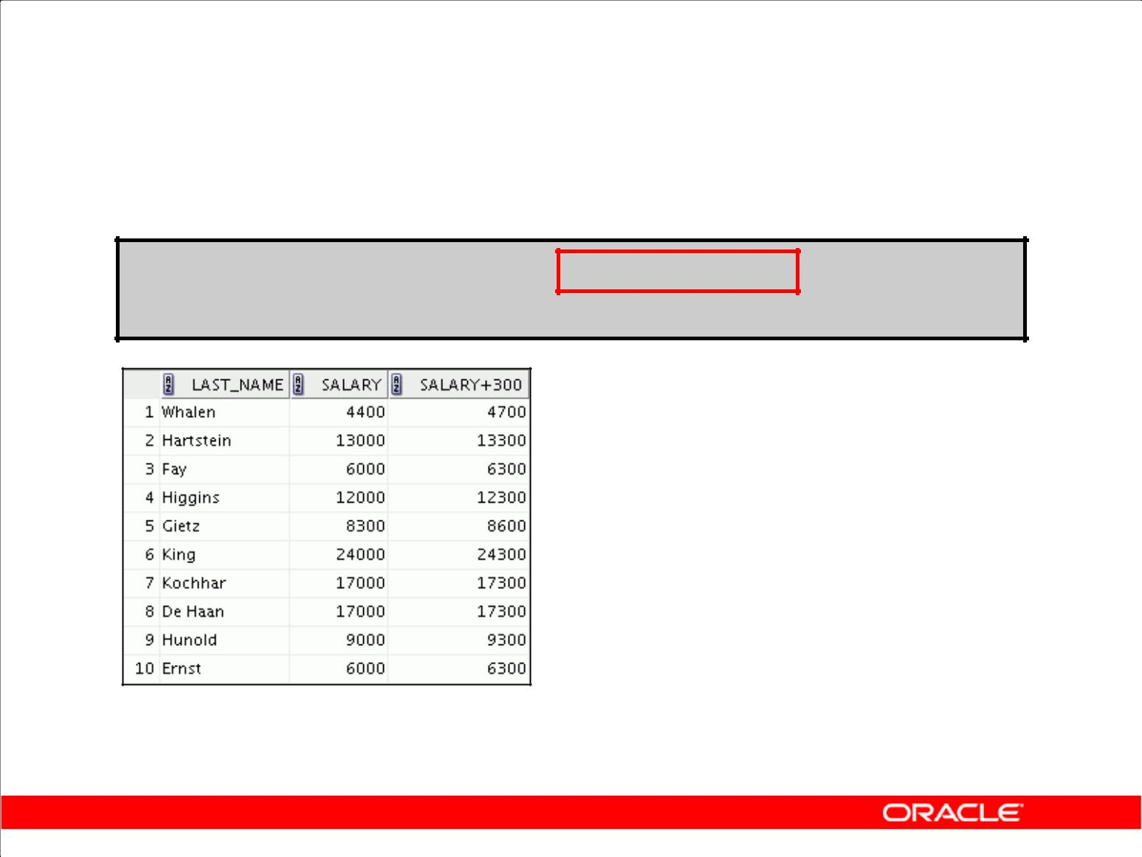**Using Arithmetic Operators**

**SELECT last_name, salary, salary + 300 FROM employees;**

**…**

Copyright © 2009, Oracle. All rights reserved.

**Using Arithmetic Operators**

The example in the slide uses the addition operator to calculate a salary increase of $300 for all employees. The slide also displays a SALARY+300 column in the output.

Note that the resultant calculated column SALARY+300 is not a new column in the EMPLOYEES

table; it is for display only. By default, the name of a new column comes from the calculation that generated it—in this case, salary+300.

**Note:** The Oracle server ignores blank spaces before and after the arithmetic operator. **Operator Precedence**

If an arithmetic expression contains more than one operator, multiplication and division are evaluated first. If operators in an expression are of the same priority, then evaluation is done from left to right.

You can use parentheses to force the expression that is enclosed by parentheses to be evaluated first.

**Rules of Precedence:**

* Multiplication and division occur before addition and subtraction.
* Operators of the same priority are evaluated from left to right.
* Parentheses are used to override the default precedence or to clarify the statement.

|  |
| --- |
| Oracle Internal & Oracle Academy Use Only |

**Oracle Database 10*g*: SQL Fundamentals I 1 - 10**

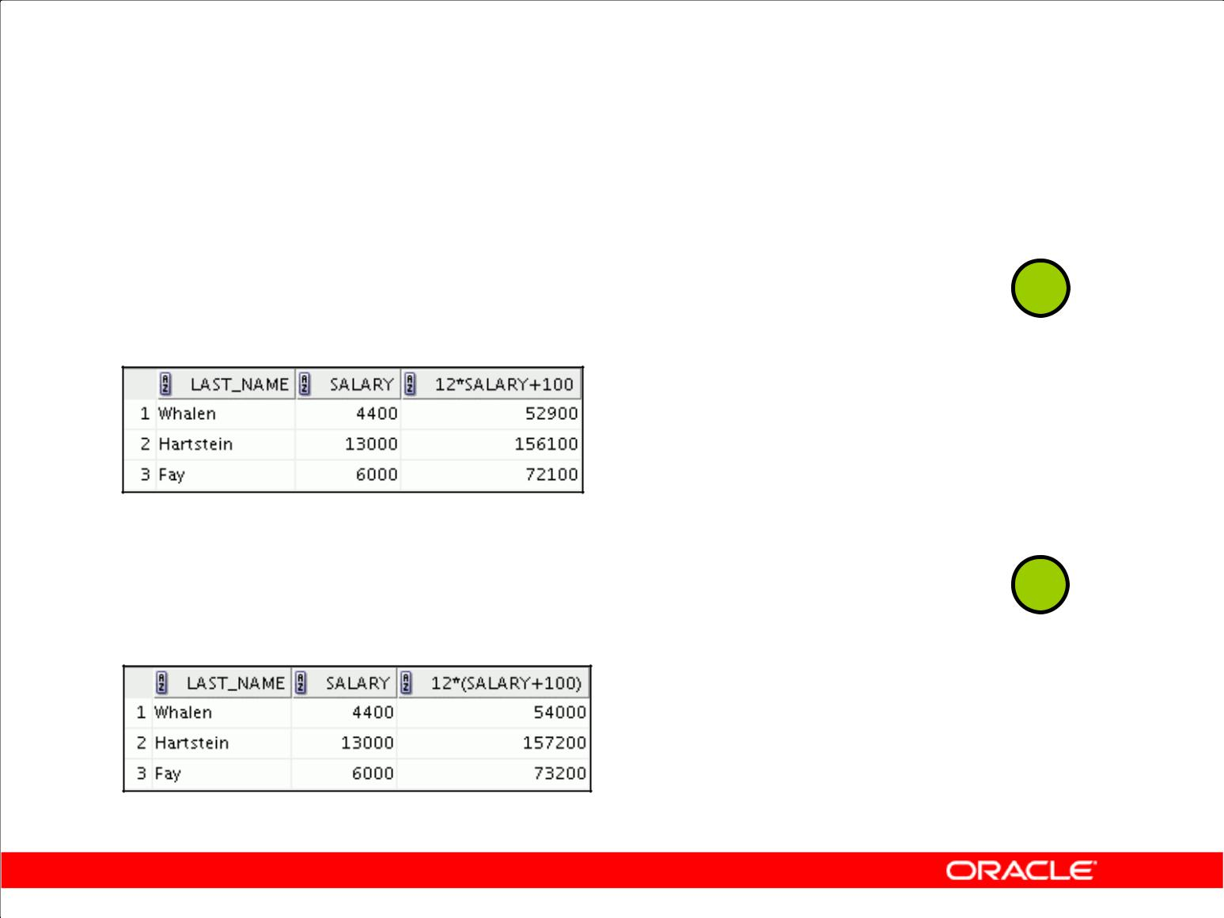**Operator Precedence**

|  |  |  |  |
| --- | --- | --- | --- |
|  |  |  |  |
| **SELECT last_name, salary,** | **12*salary+100** | **1** |  |
| **FROM employees;** |  |  |
|  |  |
|  |  |  |  |

**…**

|  |  |  |
| --- | --- | --- |
|  |  |  |
| **SELECT last_name, salary,** | **12*(salary+100)** | **2** |
| **FROM employees;** |  |  |
|  |  |  |

**…**

Copyright © 2009, Oracle. All rights reserved.

**Operator Precedence (continued)**

The first example in the slide displays the last name, salary, and annual compensation of employees. It calculates the annual compensation by multiplying the monthly salary by 12, plus a one-time bonus of $100. Note that multiplication is performed before addition.

**Note:** Use parentheses to reinforce the standard order of precedence and to improve clarity. Forexample, the expression in the slide can be written as (12*salary)+100 with no change in the

result.

**Using Parentheses**

You can override the rules of precedence by using parentheses to specify the desired order in which operators are to be executed.

The second example in the slide displays the last name, salary, and annual compensation of employees. It calculates the annual compensation as follows: adding a monthly bonus of $100 to the monthly salary, and then multiplying that subtotal by 12. Because of the parentheses, addition takes priority over multiplication.

|  |
| --- |
| Oracle Internal & Oracle Academy Use Only |

**Oracle Database 10*g*: SQL Fundamentals I 1 - 11**

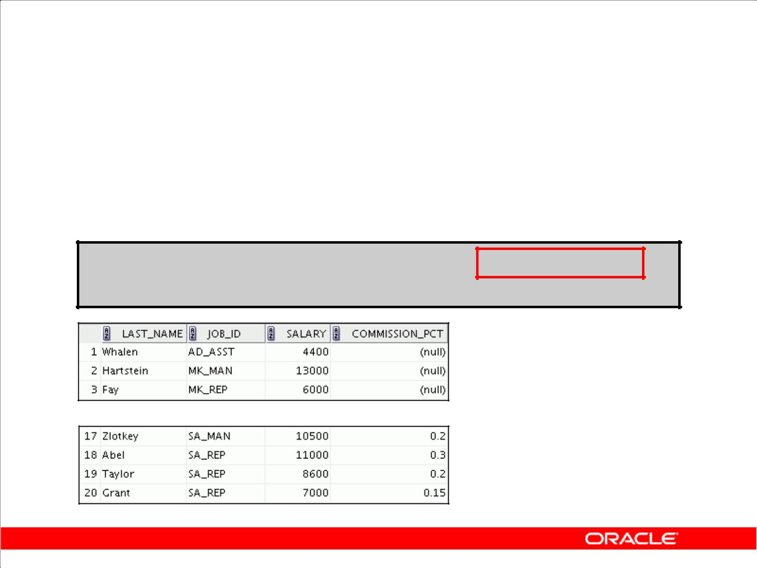**Defining a Null Value**

* A null is a value that is unavailable, unassigned, unknown, or inapplicable.
* A null is not the same as a zero or a blank space.

**SELECT last_name, job_id, salary, commission_pct FROM employees;**

**…**

Copyright © 2009, Oracle. All rights reserved.

**Null Values**

If a row lacks a data value for a particular column, that value is said to be *null* or to contain a null.

A null is a value that is unavailable, unassigned, unknown, or inapplicable. A null is not the same as a zero or a space. Zero is a number, and a space is a character.

Columns of any data type can contain nulls. However, some constraints (NOT NULL and PRIMARY KEY) prevent nulls from being used in the column.

In the COMMISSION_PCT column in the EMPLOYEES table, notice that only a sales manager or sales representative can earn a commission. Other employees are not entitled to earn commissions. A null represents that fact.

|  |
| --- |
| Oracle Internal & Oracle Academy Use Only |

**Oracle Database 10*g*: SQL Fundamentals I 1 - 12**

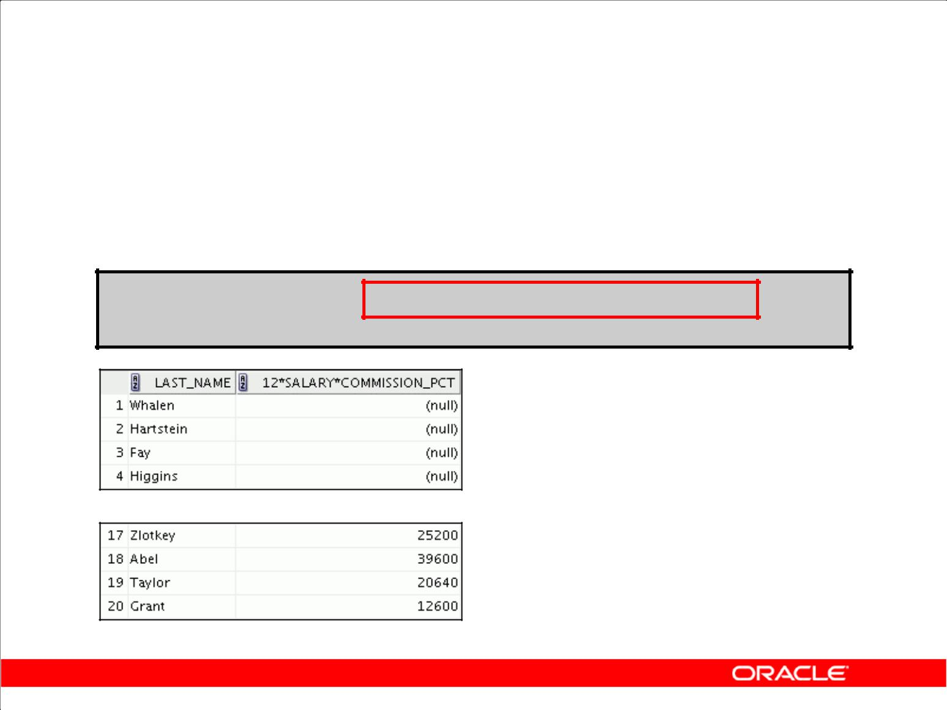**Null Values**

**in Arithmetic Expressions**

Arithmetic expressions containing a null value evaluate to null.

**SELECT last_name, 12*salary*commission_pct FROM employees;**

**…**

Copyright © 2009, Oracle. All rights reserved.

**Null Values in Arithmetic Expressions**

If any column value in an arithmetic expression is null, the result is null. For example, if you attempt to perform division by zero, you get an error. However, if you divide a number by null, the result is a null or unknown.

In the example in the slide, employee King does not get any commission. Because the COMMISSION_PCT column in the arithmetic expression is null, the result is null.

For more information, see “Basic Elements of SQL” in *SQL Reference*.

|  |
| --- |
| Oracle Internal & Oracle Academy Use Only |

**Oracle Database 10*g*: SQL Fundamentals I 1 - 13**

**Defining a Column Alias**

A column alias:

* Renames a column heading
* Is useful with calculations
* Immediately follows the column name (There can also be the optional AS keyword between the column name and alias.)
* Requires double quotation marks if it contains spaces or special characters, or if it is case-sensitive

Copyright © 2009, Oracle. All rights reserved.

**Column Aliases**

When displaying the result of a query, SQL Developer normally uses the name of the selected column as the column heading. This heading may not be descriptive and, therefore, maybe difficult to understand. You can change a column heading by using a column alias.

Specify the alias after the column in the SELECT list using a space as a separator. By default, alias headings appear in uppercase. If the alias contains spaces or special characters (such as # or $), or if it is case-sensitive, enclose the alias in double quotation marks (" ").

|  |
| --- |
| Oracle Internal & Oracle Academy Use Only |

**Oracle Database 10*g*: SQL Fundamentals I 1 - 14**

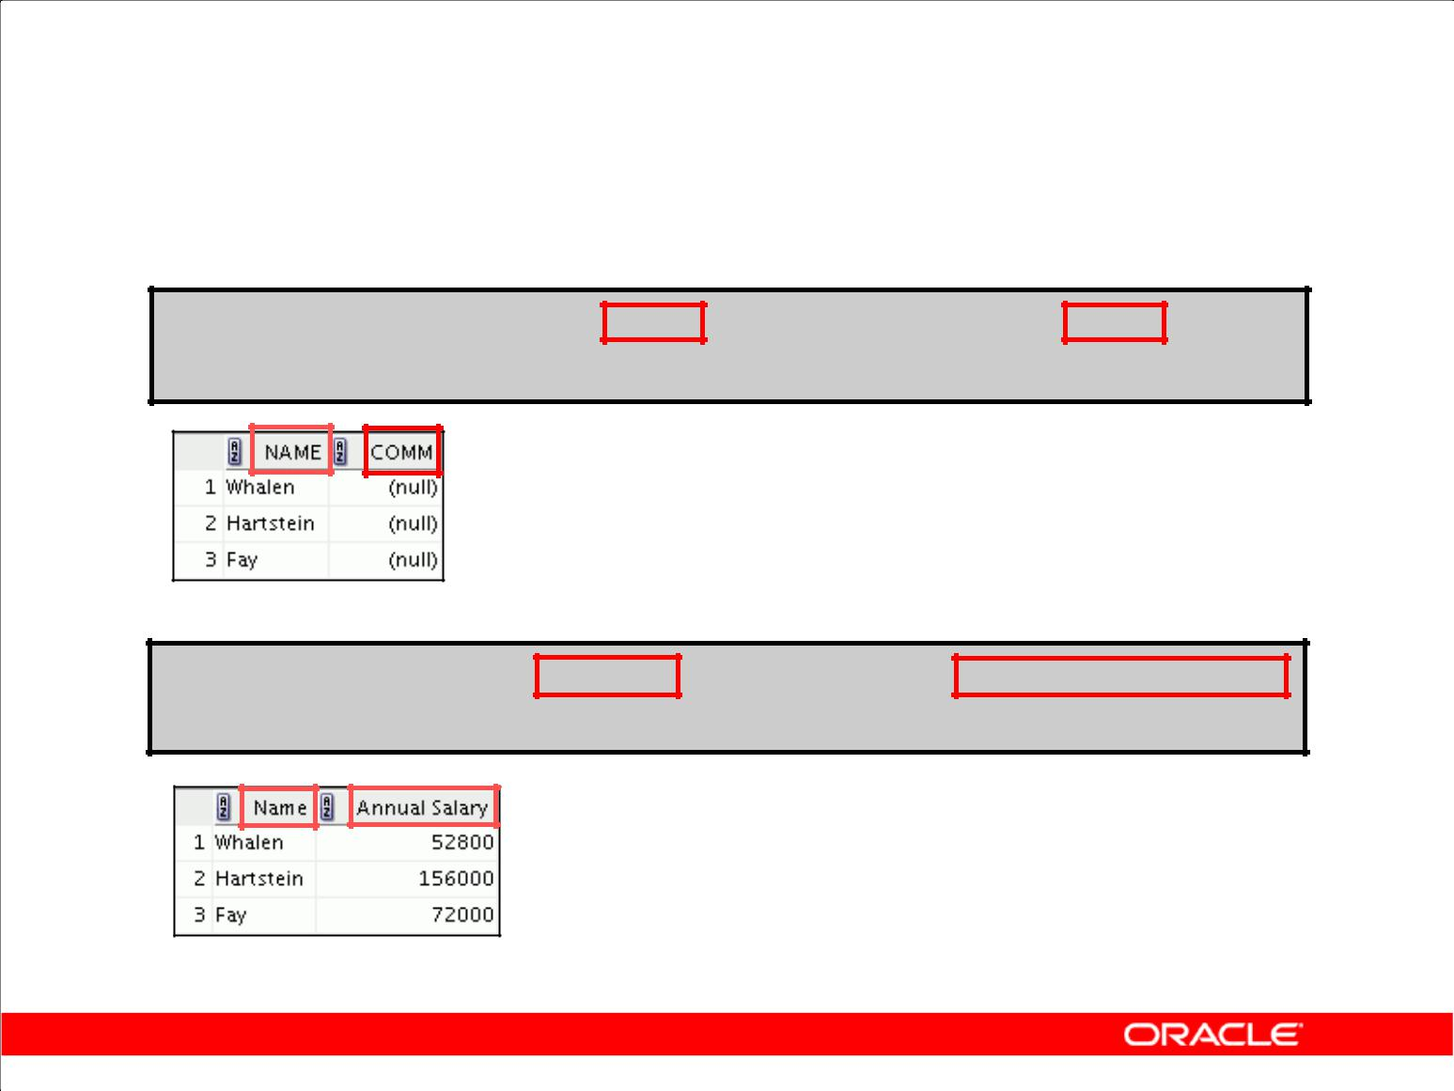**Using Column Aliases**

**SELECT last_name AS name, commission_pct comm FROM employees;**

**…**

**SELECT last_name "Name" , salary*12 "Annual Salary"**

**FROM employees;**

**…**

Copyright © 2009, Oracle. All rights reserved.

**Column Aliases (continued)**

The first example displays the names and the commission percentages of all the employees. Notice that the optional AS keyword has been used before the column alias name. The result of the query is the same whether the AS keyword is used or not. Also notice that the SQL statement has the column aliases, name and comm, in lowercase, whereas the result of the query displays the column headings in uppercase. As mentioned in a previous slide, column headings appear in uppercase by default.

The second example displays the last names and annual salaries of all the employees. Because Annual Salary contains a space, it has been enclosed in double quotation marks. Notice that the

column heading in the output is exactly the same as the column alias.

|  |
| --- |
| Oracle Internal & Oracle Academy Use Only |

**Oracle Database 10*g*: SQL Fundamentals I 1 - 15**

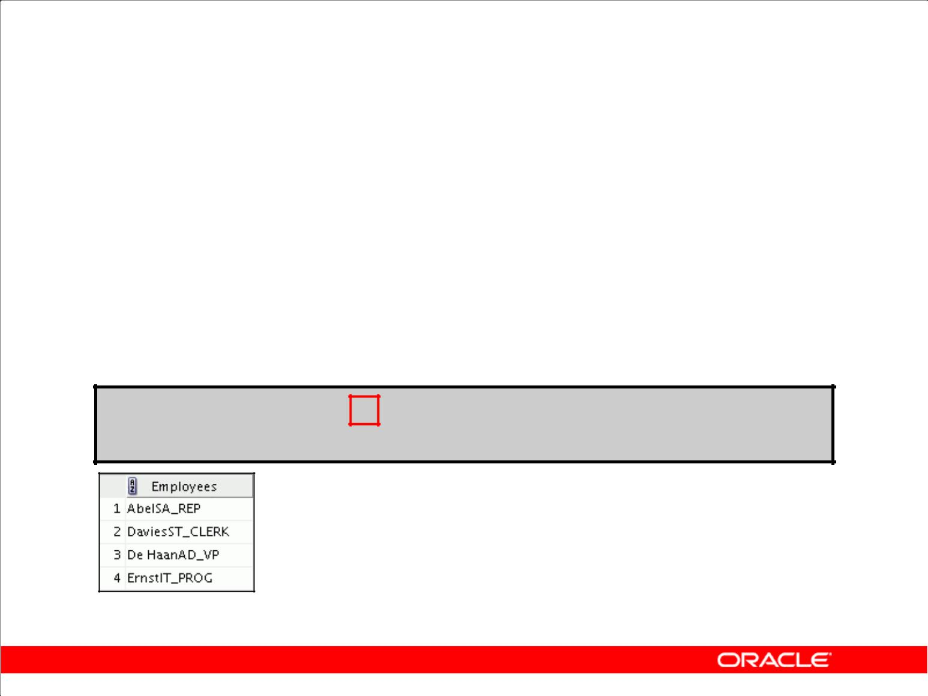**Concatenation Operator**

A concatenation operator:

* Links columns or character strings to other columns
* Is represented by two vertical bars (||)
* Creates a resultant column that is a character expression

**SELECT last_name||job_id AS "Employees"**

**FROM** **employees;**

**…**

Copyright © 2009, Oracle. All rights reserved.

**Concatenation Operator**

You can link columns to other columns, arithmetic expressions, or constant values to create a character expression by using the *concatenation operator* (||). Columns on either side of the operator are combined to make a single output column.

In the example, LAST_NAME and JOB_ID are concatenated, and they are given the alias Employees. Notice that the employee last name and job code are combined to make a single output column.

The AS keyword before the alias name makes the SELECT clause easier to read.

**Null Values with the Concatenation Operator**

If you concatenate a null value with a character string, the result is a character string. LAST_NAME || NULL results in LAST_NAME.

|  |
| --- |
| Oracle Internal & Oracle Academy Use Only |

**Oracle Database 10*g*: SQL Fundamentals I 1 - 16**

**Literal Character Strings**

* A literal is a character, a number, or a date that is included in the SELECT statement.
* Date and character literal values must be enclosed by single quotation marks.
* Each character string is output once for each row returned.

Copyright © 2009, Oracle. All rights reserved.

**Literal Character Strings**

A literal is a character, a number, or a date that is included in the SELECT list and that is not a

column name or a column alias. It is printed for each row returned. Literal strings of free-format text can be included in the query result and are treated the same as a column in the SELECT list.

Date and character literals *must* be enclosed by single quotation marks (' '); number literals need not be so enclosed.

|  |
| --- |
| Oracle Internal & Oracle Academy Use Only |

**Oracle Database 10*g*: SQL Fundamentals I 1 - 17**

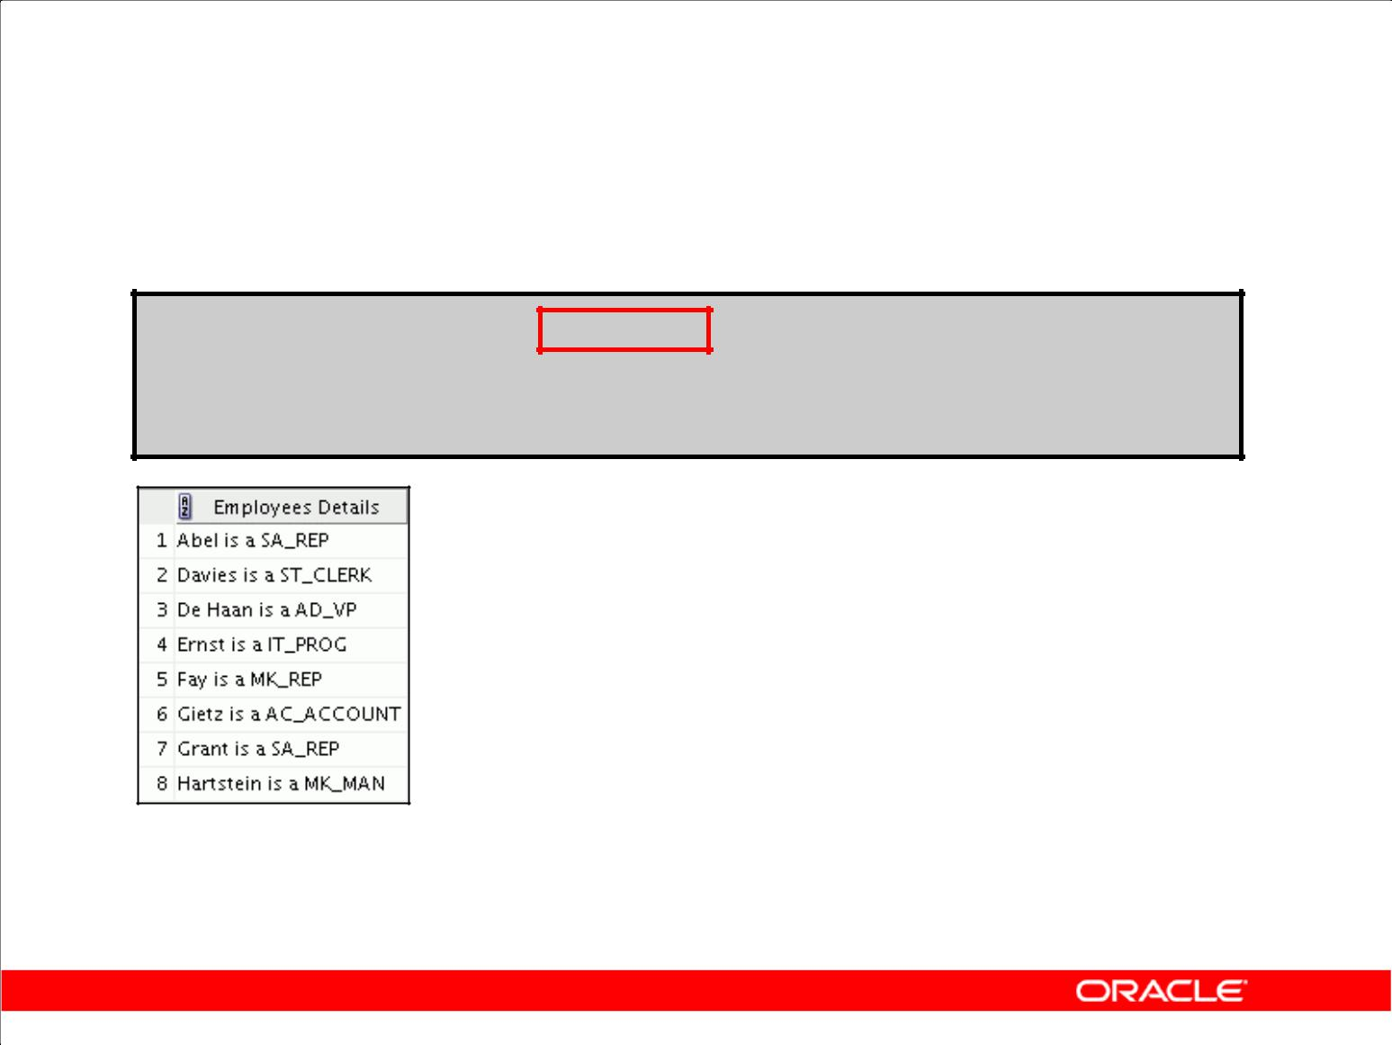**Using Literal Character Strings**

**SELECT last_name ||' is a '||job_id**

**AS "Employee Details"**

**FROM employees;**

**…**

Copyright © 2009, Oracle. All rights reserved.

**Literal Character Strings (continued)**

The example in the slide displays last names and job codes of all employees. The column has the heading Employee Details. Notice the spaces between the single quotation marks in the SELECT

statement. The spaces improve the readability of the output.

In the following example, the last name and salary for each employee are concatenated with a literal to give the returned rows more meaning:

SELECT last_name ||': 1 Month salary = '||salary Monthly FROM employees;

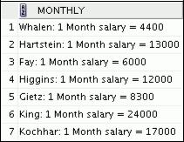

|  |
| --- |
| Oracle Internal & Oracle Academy Use Only |

**…**

**Oracle Database 10*g*: SQL Fundamentals I 1 - 18**

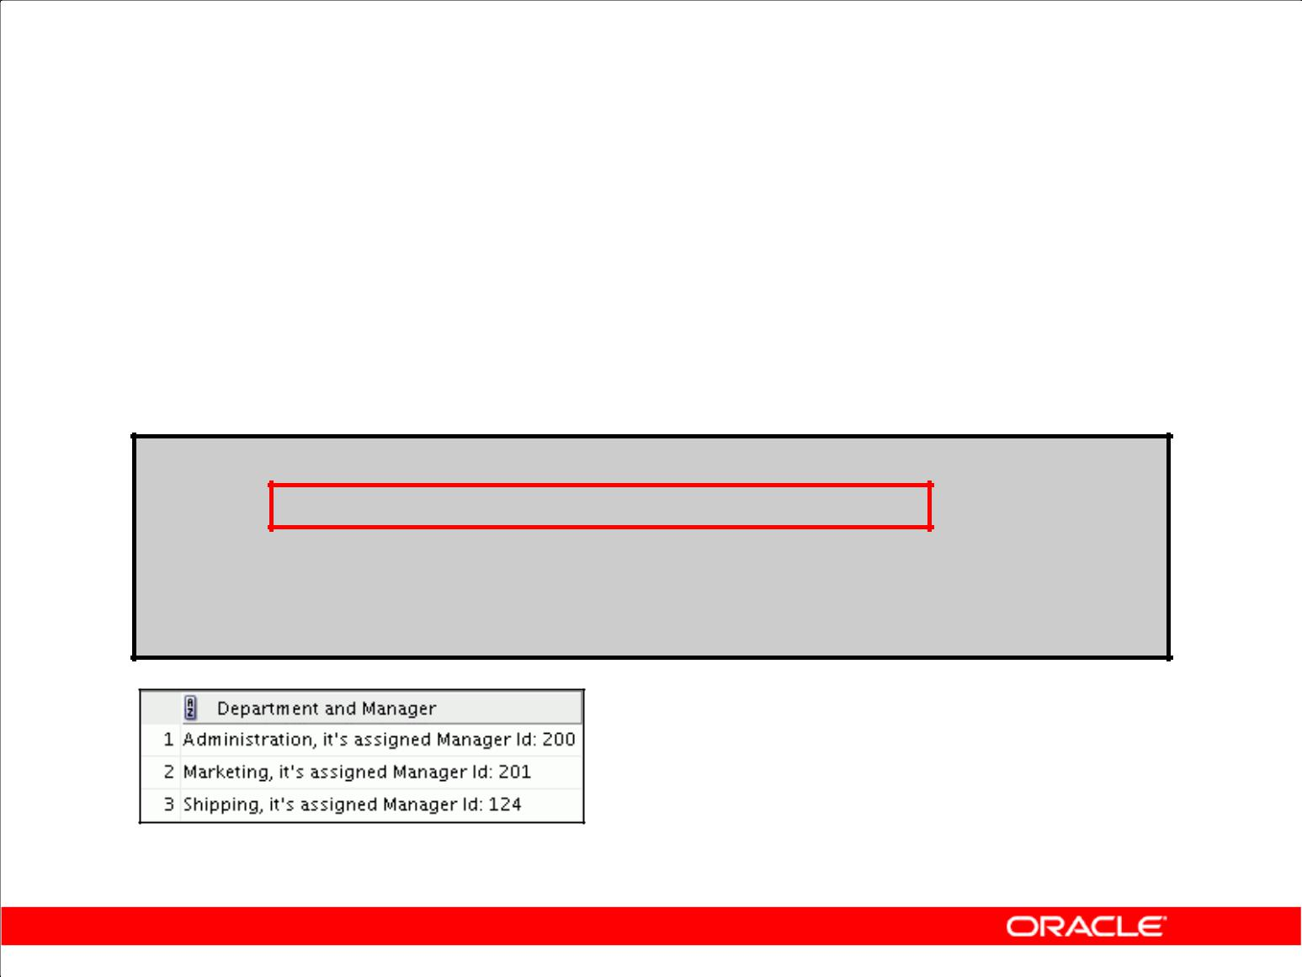**Alternative Quote (q) Operator**

* Specify your own quotation mark delimiter.
* Choose any delimiter.
* Increase readability and usability.

**SELECT department_name ||**

**q'[, it's assigned Manager Id: ]'**

**|| manager_id**

**AS "Department and Manager"**

**FROM departments;**

**…**

Copyright © 2009, Oracle. All rights reserved.

**Alternative Quote (q) Operator**

Many SQL statements use character literals in expressions or conditions. If the literal itself contains a single quotation mark, you can use the quote (q) operator and choose your own quotation mark

delimiter.

You can choose any convenient delimiter, single-byte or multibyte, or any of the following character pairs: [ ], { }, ( ), or < >.

In the example shown, the string contains a single quotation mark, which is normally interpreted as a delimiter of a character string. By using the q operator, however, the brackets [] are used as the

quotation mark delimiter. The string between the brackets delimiters is interpreted as a literal character string.

|  |
| --- |
| Oracle Internal & Oracle Academy Use Only |

**Oracle Database 10*g*: SQL Fundamentals I 1 - 19**

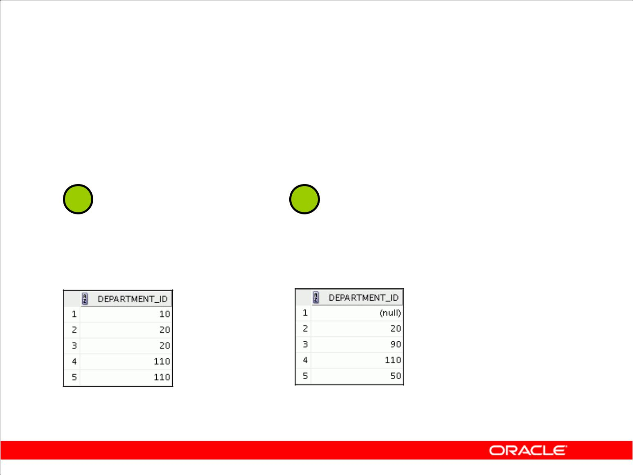**Duplicate Rows**

The default display of queries is all rows, including duplicate rows.

|  |  |  |  |  |
| --- | --- | --- | --- | --- |
| **1** | **2** | |  |  |
|  |  |  |  |  |
| **SELECT department_id** |  | **SELECT** | **DISTINCT** | **department_id** |
| **FROM employees;** |  | **FROM employees;** | | |
|  |  |  |  |  |

**…** **…**

Copyright © 2009, Oracle. All rights reserved.

**Duplicate Rows**

Unless you indicate otherwise, SQL Developer displays the results of a query without eliminating duplicate rows. The first example in the slide displays all the department numbers from the EMPLOYEES table. Notice that the department numbers are repeated.

To eliminate duplicate rows in the result, include the DISTINCT keyword in the SELECT clause immediately after the SELECT keyword. In the second example in the slide, the EMPLOYEES table actually contains 20 rows, but there are only seven unique department numbers in the table.

You can specify multiple columns after the DISTINCT qualifier. The DISTINCT qualifier affects all the selected columns, and the result is every distinct combination of the columns.

SELECT DISTINCT department_id, job_id

FROM employees;

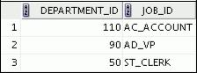

|  |
| --- |
| Oracle Internal & Oracle Academy Use Only |

**…**

**Oracle Database 10*g*: SQL Fundamentals I 1 - 20**

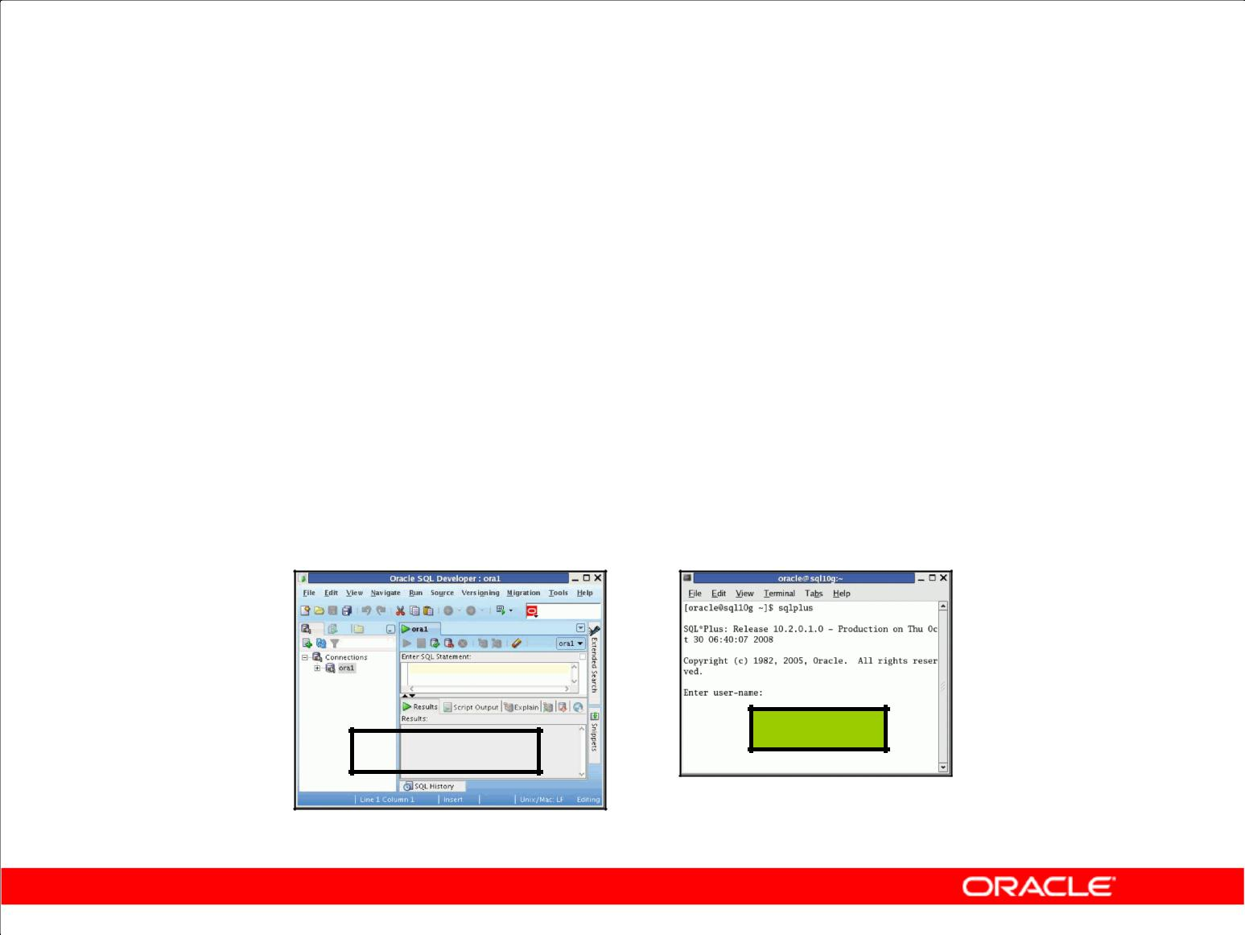**Development Environments for SQL**

In this course:

* Primarily use Oracle SQL Developer 1.5.1
* Use SQL*Plus:

– In case you do not have access to Oracle SQL Developer

– Or when any command does not run in Oracle SQL Developer

**SQL *Plus**

**SQL Developer**

Copyright © 2009, Oracle. All rights reserved.

**Development Environments for SQL**

This course has been developed using Oracle SQL Developer as the tool for running the SQL statements discussed in the examples in the slide and the practices. For commands that are not supported by Oracle SQL Developer, use the SQL*Plus environment.

|  |
| --- |
| Oracle Internal & Oracle Academy Use Only |

**Oracle Database 10*g*: SQL Fundamentals I 1 - 21**

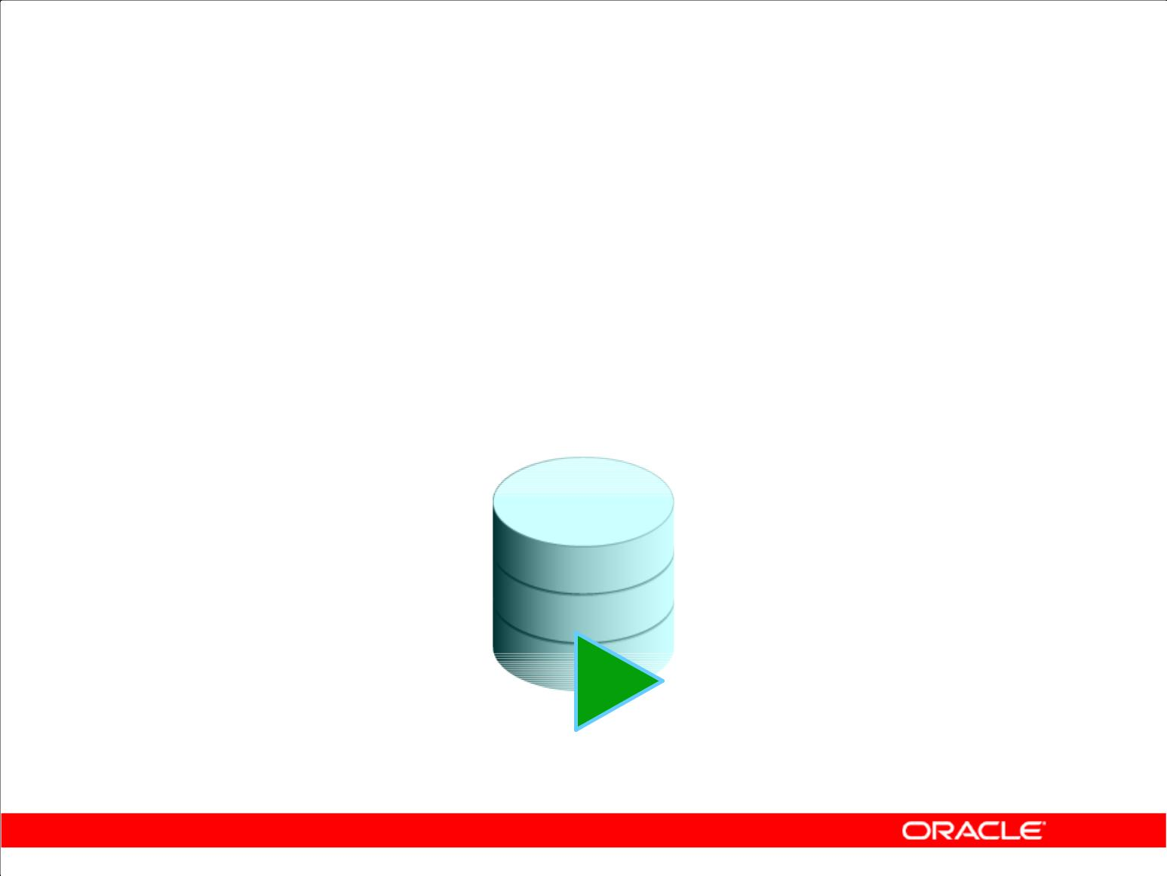**What Is Oracle SQL Developer?**

* Oracle SQL Developer is a graphical tool that enhances productivity and simplifies database development tasks.
* You can connect to any target Oracle Database schema by using the standard Oracle Database authentication.

**SQL Developer**

Copyright © 2009, Oracle. All rights reserved.

**What Is Oracle SQL Developer?**

Oracle SQL Developer is a free graphical tool designed to improve your productivity and simplify the development of everyday database tasks. With just a few clicks, you can easily create and debug stored procedures, test SQL statements, and view optimizer plans.

Oracle SQL Developer, the visual tool for database development, simplifies the following tasks:

* Browsing and managing database objects
* Executing SQL statements and scripts
* Editing and debugging PL/SQL statements
* Creating reports

You can connect to any target Oracle Database schema by using the standard Oracle Database authentication. When connected, you can perform operations on objects in the database.

|  |
| --- |
| Oracle Internal & Oracle Academy Use Only |

**Oracle Database 10*g*: SQL Fundamentals I 1 - 22**

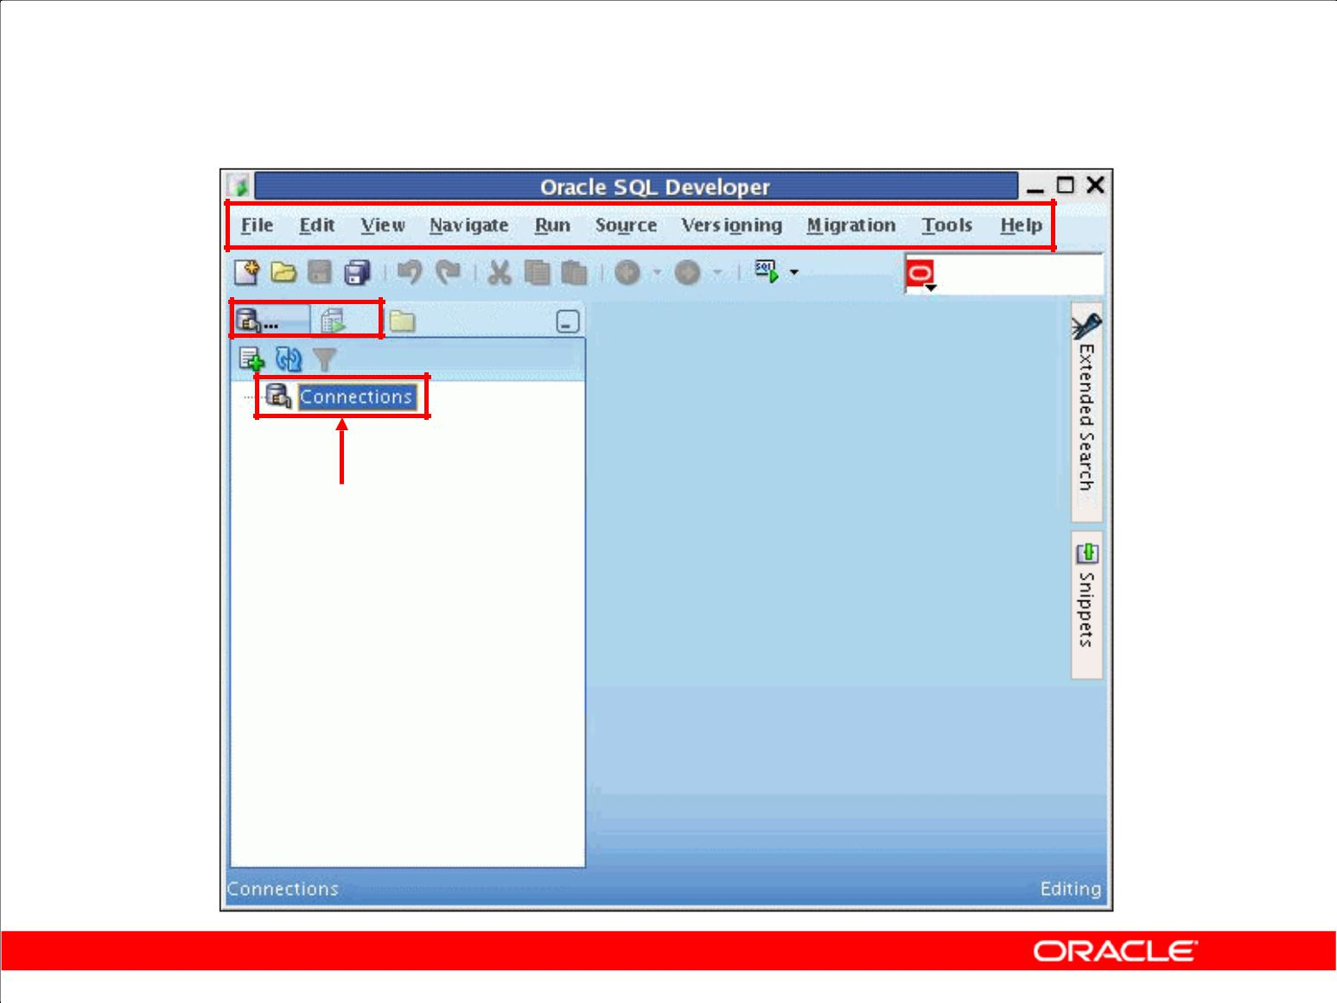**Oracle SQL Developer Interface**

**You must define a**

**connection to start**

**using SQL Developer for**

**running SQL queries on**

**a database schema.**

Copyright © 2009, Oracle. All rights reserved.

**Oracle SQL Developer Interface**

Oracle SQL Developer has two main navigation tabs:

* **Connections tab:** By using this tab, you can browse database objects and users to which youhave access.
* **Reports tab:** By using this tab, you can run predefined reports, or create and add your ownreports.

Oracle SQL Developer uses the left pane for navigation to find and select objects, and the right pane to display information about selected objects. You can customize many aspects of the appearance and behavior of Oracle SQL Developer by setting preferences. The menus at the top contain standard entries, plus entries for features specific to Oracle SQL Developer.

**Note:** You must define at least one connection to be able to connect to a database schema and issueSQL queries or run procedures/functions.

|  |
| --- |
| Oracle Internal & Oracle Academy Use Only |

**Oracle Database 10*g*: SQL Fundamentals I 1 - 23**

**Creating a Database Connection**

* You must have at least one database connection to use Oracle SQL Developer.
* You can create and test connections for:

– Multiple databases

– Multiple schemas

* Oracle SQL Developer automatically imports any connections defined in the tnsnames.ora file on your system.
* You can export connections to an XML file.
* Each additional database connection created is listed in the Connections Navigator hierarchy.

Copyright © 2009, Oracle. All rights reserved.

**Creating a Database Connection**

A connection is an Oracle SQL Developer object that specifies the necessary information for connecting to a specific database as a specific user of that database. To use Oracle SQL Developer, you must have at least one database connection, which may be existing, created, or imported.

You can create and test connections for multiple databases and for multiple schemas.

By default, the tnsnames.ora file is located in the $ORACLE_HOME/network/admin directory. But, it can also be in the directory specified by the TNS_ADMIN environment variable or the registry value. When you start Oracle SQL Developer and display the Database Connections dialog box, Oracle SQL Developer automatically imports any connections defined in the tnsnames.ora file on your system.

**Note:** On Windows systems, if thetnsnames.orafile exists but Oracle SQL Developer is notusing its connections, define TNS_ADMIN as a system environment variable.

You can export connections to an XML file so that you can reuse it later.

You can create additional connections as different users to the same database or to connect to the different databases.

|  |
| --- |
| Oracle Internal & Oracle Academy Use Only |

**Oracle Database 10*g*: SQL Fundamentals I 1 - 24**

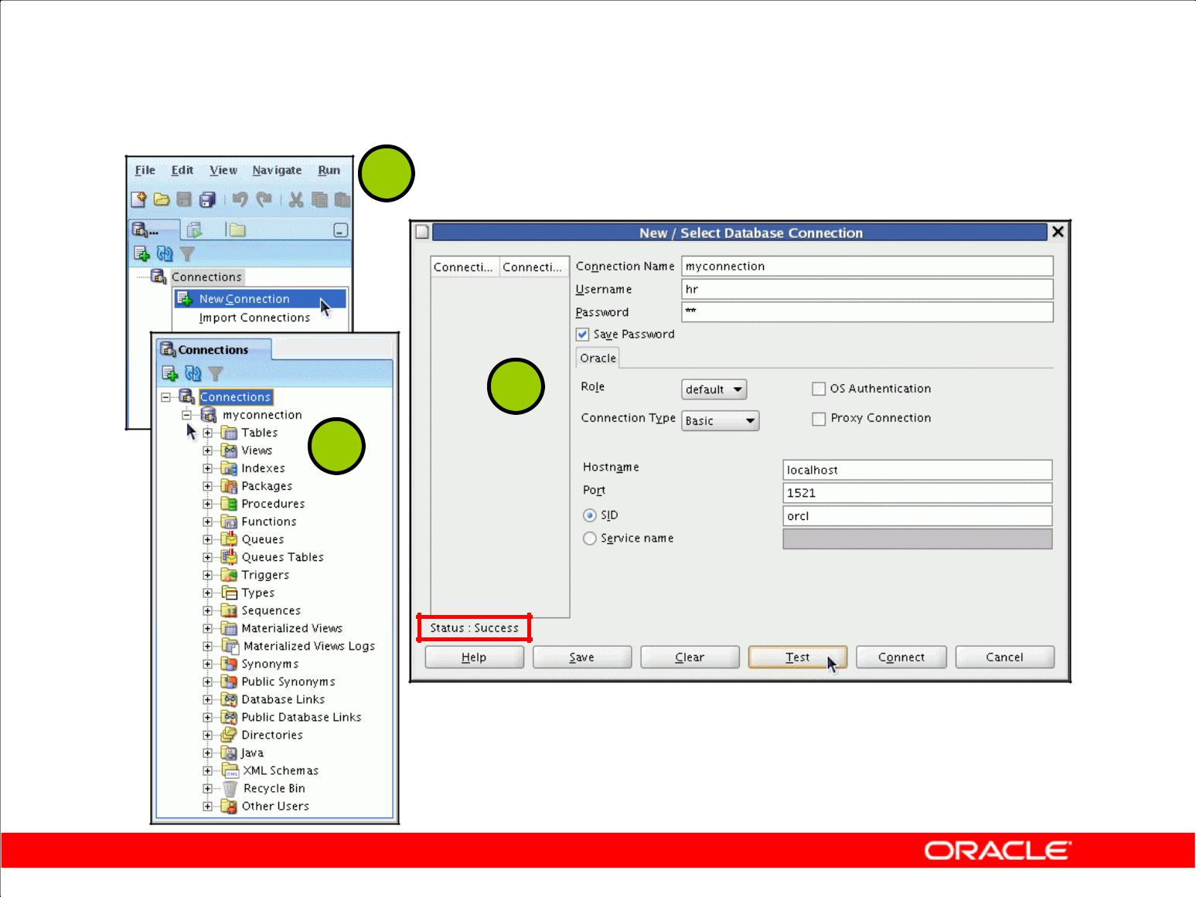**Creating a Database Connection**

**1**

**2**

**3**

Copyright © 2009, Oracle. All rights reserved.

**Creating a Database Connection (continued)**

To create a database connection, perform the following steps:

1. On the Connections tabbed page, right-click Connections and select New Connection.
2. In the New/Select Database Connection window, enter the connection name. Enter the username and password of the schema that you want to connect to.
   1. From the Role drop-down list, you can select either *default* or SYSDBA (you will select SYSDBA for the sys user or any user with DBA privileges).
   2. You can select the connection type as:
      * **Basic:** In this type, you enter the host name and system identifier (SID) for thedatabase that you want to connect to. The Port is already set to 1521. Or, you can also enter the Service name directly if you are using a remote database connection.
      * **TNS:** You select any one of the database aliases imported from thetnsnames.ora

file

* + - **Advanced:** You define a custom JDBC URL to connect to the database.
  1. Click Test to make sure that the connection has been set correctly.
  2. Click Connect.

If you select the Save Password check box, the password is saved to an XML file. So, after you close the Oracle SQL Developer connection and open it again, you will not be prompted for the password.

|  |
| --- |
| Oracle Internal & Oracle Academy Use Only |

**Oracle Database 10*g*: SQL Fundamentals I 1 - 25**

**Creating a Database Connection (continued)**

1. The connection gets added in the Connections Navigator. You can expand the connection to view the database objects and view object definitions, for example, dependencies, details, statistics, and so on.

|  |
| --- |
| Oracle Internal & Oracle Academy Use Only |

**Oracle Database 10*g*: SQL Fundamentals I 1 - 26**

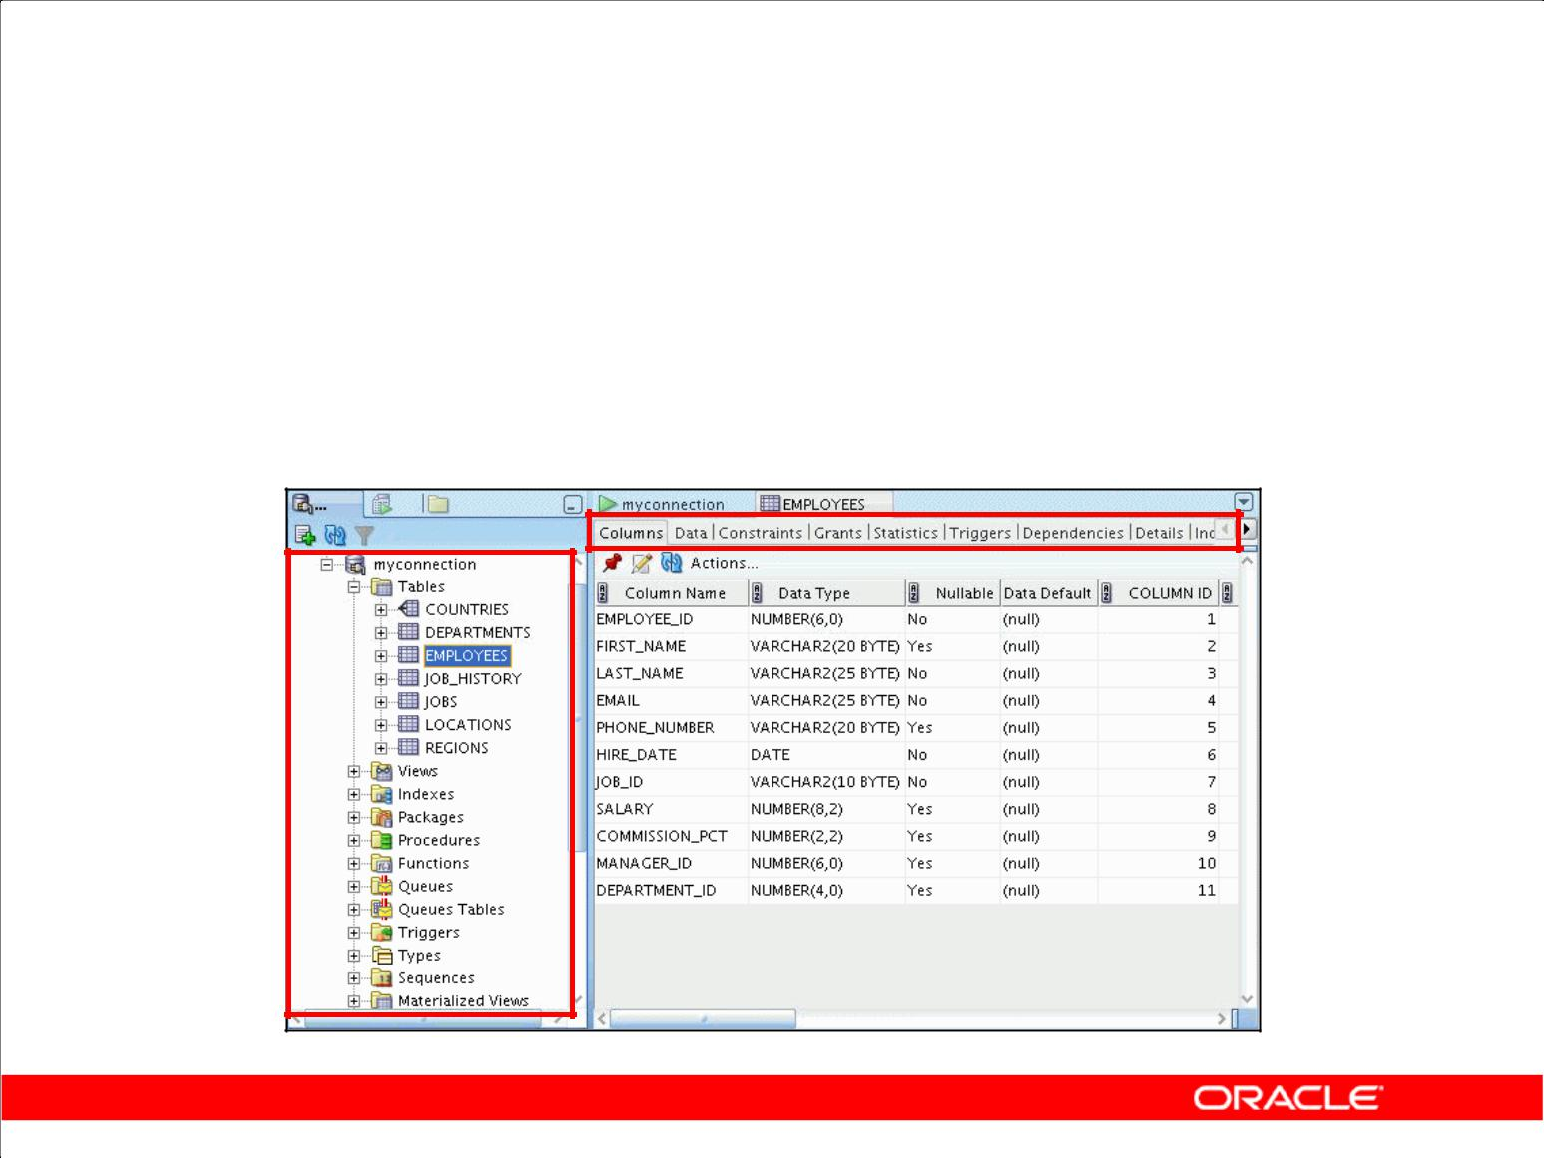**Browsing Database Objects**

Use the Connections Navigator to:

* Browse through many objects in a database schema
* Review the definitions of objects at a glance

Copyright © 2009, Oracle. All rights reserved.

**Browsing Database Objects**

After you have created a database connection, you can use the Connections Navigator to browse through many objects in a database schema including Tables, Views, Indexes, Packages, Procedures, Triggers, Types, and so on.

Oracle SQL Developer uses the left pane for navigation to find and select objects and the right pane to display information about the selected objects. You can customize many aspects of the appearance of Oracle SQL Developer by setting preferences.

You can see the definition of the objects broken into tabs of information that is pulled out of the data dictionary. For example, if you select a table in the Navigator, the details about columns, constraints, grants, statistics, triggers, and so on are displayed in an easy-to-read tabbed page.

If you want to see the definition of the EMPLOYEES table as shown in the slide, perform the following steps:

1. Expand the Connections node in the Connections Navigator.
2. Expand Tables.
3. Click EMPLOYEES. By default, the Columns tab is selected. It shows the column description of the table. By using the Data tab, you can view the data in the table and also enter new rows, update data, and commit these changes to the database.

|  |
| --- |
| Oracle Internal & Oracle Academy Use Only |

**Oracle Database 10*g*: SQL Fundamentals I 1 - 27**

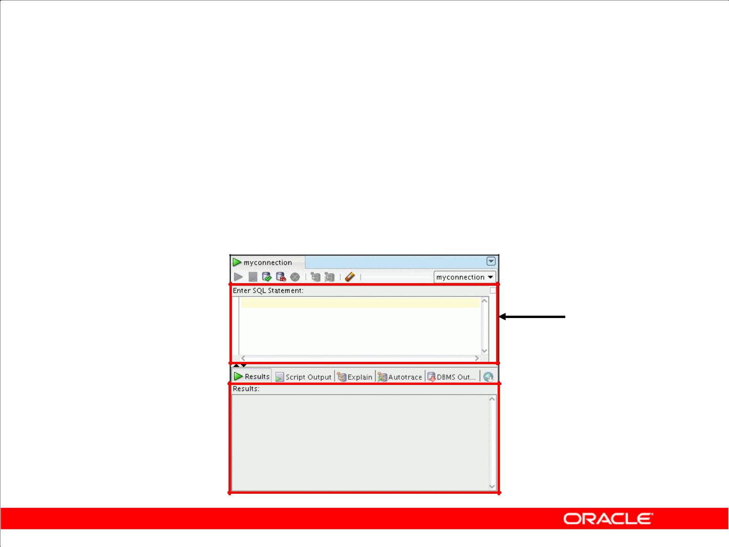**Using the SQL Worksheet**

* Use the SQL Worksheet to enter and execute SQL, PL/SQL, and SQL*Plus statements.
* Specify any actions that can be processed by the database connection associated with the Worksheet.

**Enter SQL**

**Statements.**

 **Results are**

**shown here.**

Copyright © 2009, Oracle. All rights reserved.

**Using the SQL Worksheet**

When you connect to a database, a SQL Worksheet window for that connection is automatically opened. You can use the SQL Worksheet to enter and execute SQL, PL/SQL, and SQL*Plus statements. All SQL and PL/SQL commands are supported as they are passed directly from the SQL Worksheet to the Oracle Database. However, the SQL*Plus commands used in Oracle SQL Developer have to be interpreted by the SQL Worksheet before being passed to the database.

The SQL Worksheet currently supports a number of SQL*Plus commands. Those commands that are not supported by the SQL Worksheet are ignored and not sent to the Oracle Database. Through the SQL Worksheet, you can execute SQL statements and some of the SQL*Plus commands.

You can display a SQL Worksheet by using any of the following two options:

* Select Tools > SQL Worksheet.
* Click the Open SQL Worksheet icon available on the main toolbar.

|  |
| --- |
| Oracle Internal & Oracle Academy Use Only |

**Oracle Database 10*g*: SQL Fundamentals I 1 - 28**

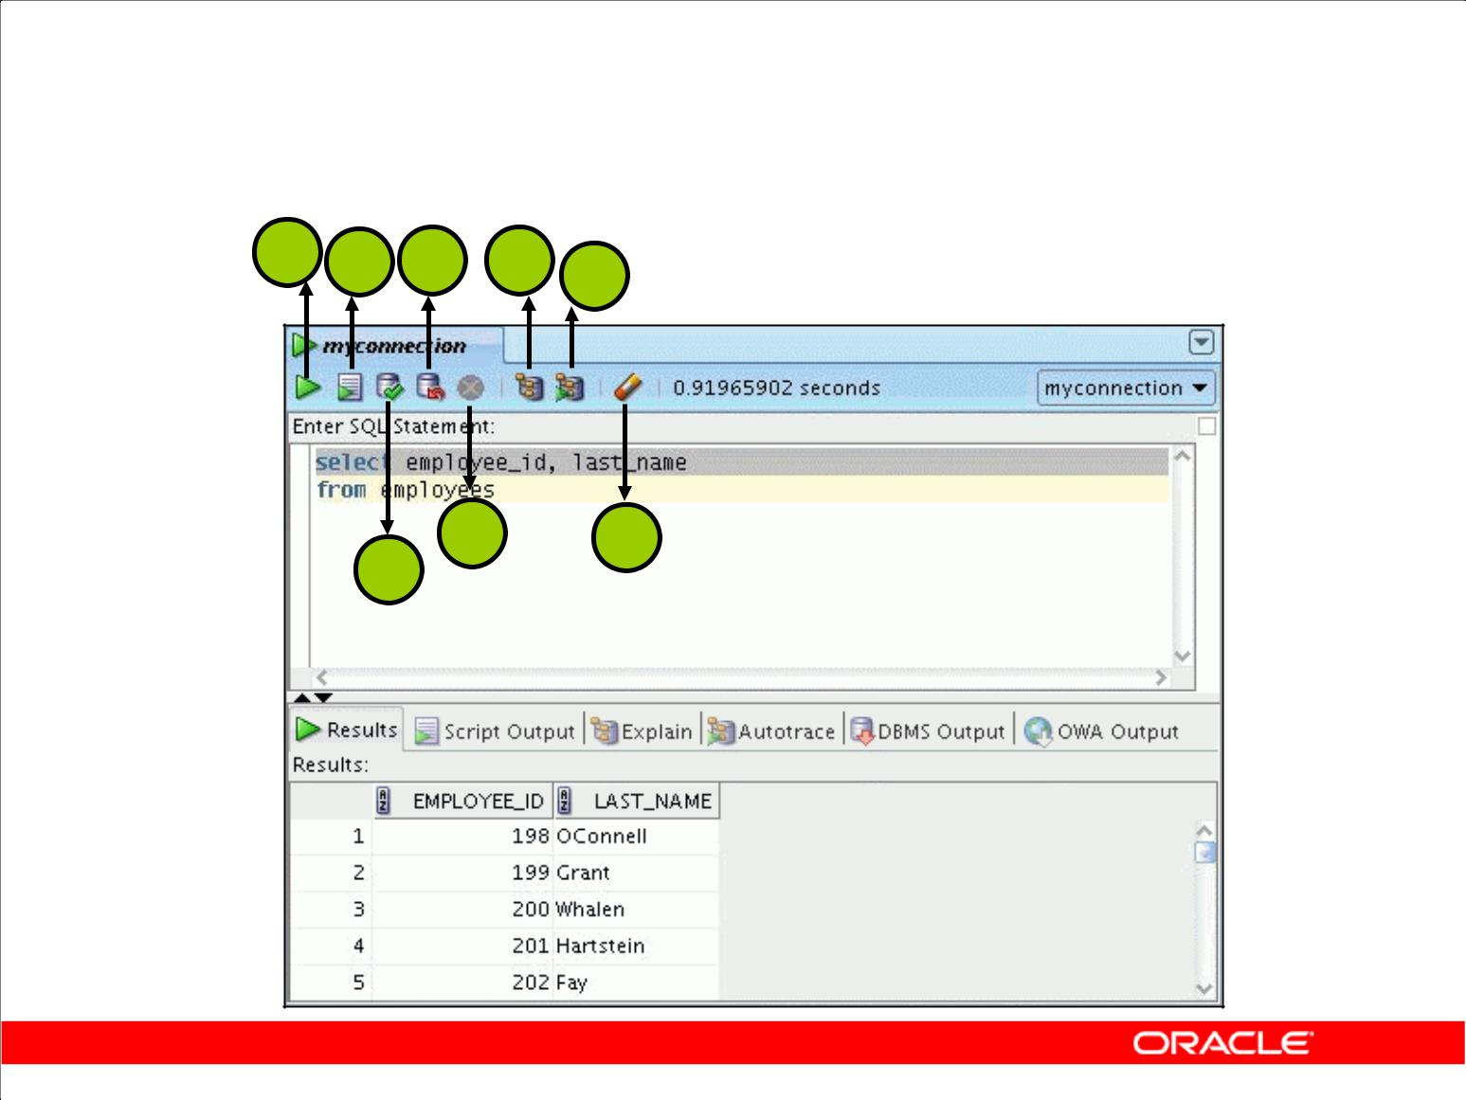**Using the SQL Worksheet**

**1** **2 4 6** **7**

**3**

**5** **8**

Copyright © 2009, Oracle. All rights reserved.

|  |
| --- |
| & Oracle Academy Use Only |

**Using the SQL Worksheet (continued)**

You may want to use shortcut keys or icons to perform certain tasks, such as executing a SQL statement, running a script, or viewing the history of the SQL statements that you have executed.

You can use the SQL Worksheet toolbar that contains icons to perform the following tasks:

1. **Execute Statement:** This executes the statement at the cursor in the Enter SQL Statement box.Alternatively, you can press [F9]. The output is generally shown in a formatted manner in the Results tab page.
2. **Run Script:** This executes all statements in the Enter SQL Statement box using the ScriptRunner. The output is generally shown in the conventional script format in the Scripts tab page.
3. **Commit:** This writes any changes to the database and ends the transaction.
4. **Rollback:** This discards any changes to the database, without writing them to the database, andends the transaction.
5. **Cancel:** This stops the execution of any statements currently being executed.
6. **Execute Explain Plan:** This generates the execution plan, which you can see by clicking theExplain tab.

|  |
| --- |
| Oracle Internal |

**Oracle Database 10*g*: SQL Fundamentals I 1 - 29**

**Using the SQL Worksheet (continued)**

1. **Autotrace:** This displays trace-related information when you execute the SQL statement byclicking the Autotrace icon. This information can help you to identify the SQL statements that will benefit from tuning.
2. **Clear:** This erases the statement or statements in the Enter SQL Statement box. Alternatively,press and hold [Ctrl] + [D] to erase the statements.

|  |
| --- |
| Oracle Internal & Oracle Academy Use Only |

**Oracle Database 10*g*: SQL Fundamentals I 1 - 30**

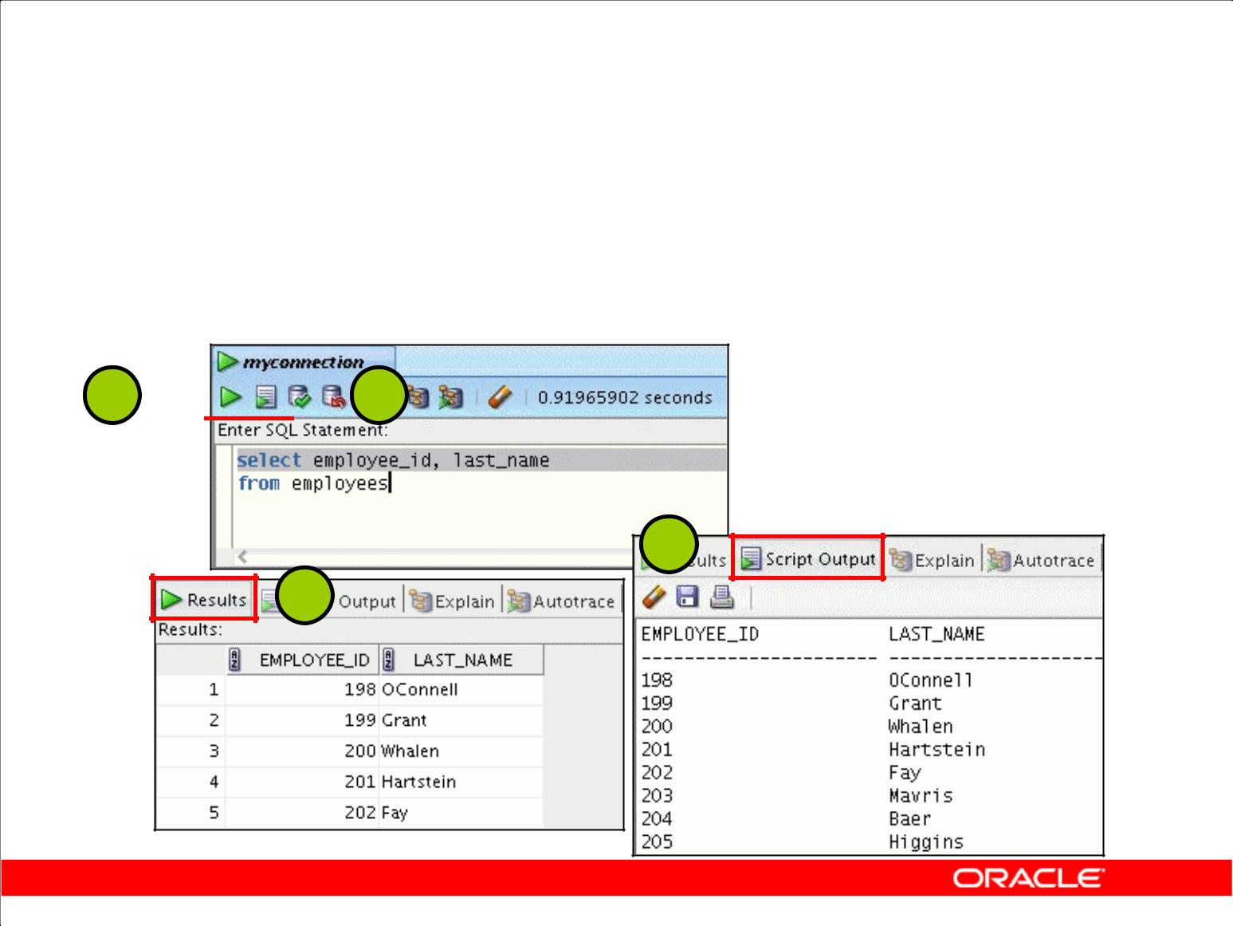**Executing SQL Statements**

Use the Enter SQL Statement box to enter single or multiple SQL statements.

**F9** **F5**

**F5**

**F9**

Copyright © 2009, Oracle. All rights reserved.

**Executing SQL Statements**

In the SQL Worksheet, you can use the Enter SQL Statement box to enter a single or multiple SQL statements. For a single statement, the semicolon at the end is optional.

When you enter the statement, the SQL keywords are automatically highlighted. To execute a SQL statement, ensure that your cursor is within the statement and click the Execute Statement icon. Alternatively, you can press [F9].

To execute multiple SQL statements and see the results, click the Run Script icon. Alternatively, you can press [F5].

The example in the slide shows the difference in output for the same query when F9 key or Execute Statement is used versus the output when F5 or Run Script is used.

|  |
| --- |
| Oracle Internal & Oracle Academy Use Only |

**Oracle Database 10*g*: SQL Fundamentals I 1 - 31**

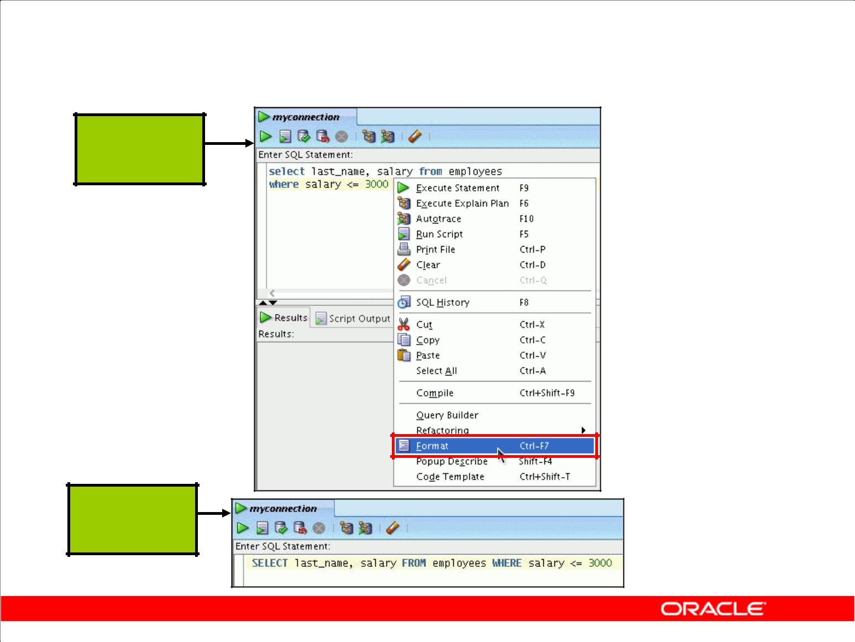**Formatting the SQL Code**

**Before**

**formatting**

**After**

**formatting**

Copyright © 2009, Oracle. All rights reserved.

**Formatting the SQL Code**

You may want to beautify the indentation, spacing, capitalization, and the line separation of the SQL code. Oracle SQL Developer has the feature for formatting the SQL code.

To format the SQL code, right-click in the statement area, and select Format SQL.

In the example in the slide, before formatting, the keywords are not capitalized and the statement is not properly indented in the SQL code. After formatting, the SQL code is beautified with the keywords capitalized and the statement properly indented, if needed.

|  |
| --- |
| Oracle Internal & Oracle Academy Use Only |

**Oracle Database 10*g*: SQL Fundamentals I 1 - 32**

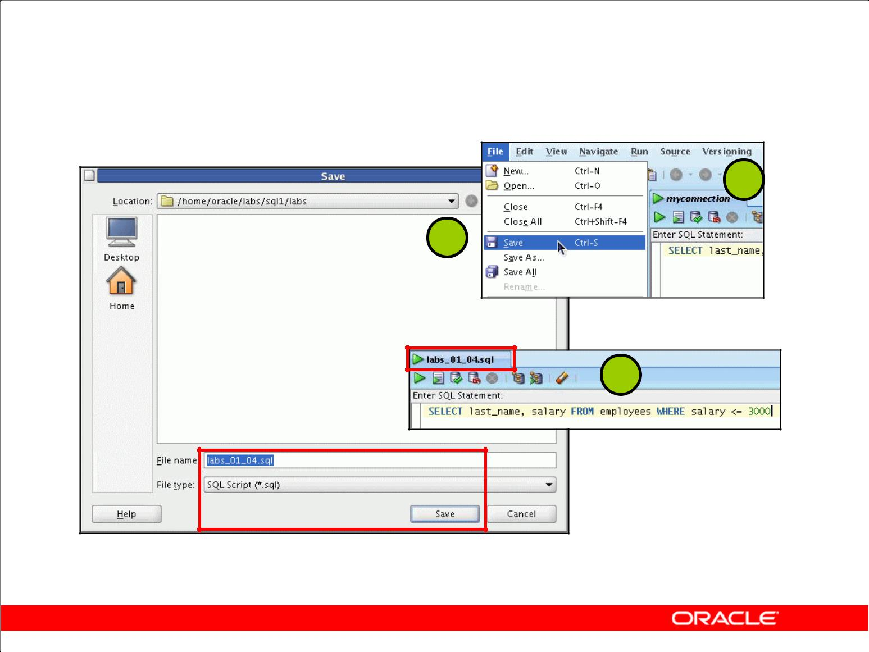**Saving SQL Statements**

**1**

**2**

**3**

Copyright © 2009, Oracle. All rights reserved.

**Saving SQL Statements**

In most of the practices that you will perform, you will need to save a particular query in the SQL Worksheet as a .sql file. To do so, perform the following:

1. From the File menu, select Save or Save As (if you are renaming a current .sql script). Alternatively, you can press and hold [CTRL] + [S].
2. In the Save dialog box, enter the appropriate filename. Make sure the extension is .sql or the File type is selected as SQL Script (*.sql). Click Save.

**Note:** For this course, you need to save yoursqlscripts in the

\home\oracle\labs\sql1\labs folder.

1. The SQL Worksheet is renamed to the filename that you saved the script as. Make sure you do not enter any other SQL statements in the same worksheet. To continue with other SQL queries, open a new worksheet.

|  |
| --- |
| Oracle Internal & Oracle Academy Use Only |

**Oracle Database 10*g*: SQL Fundamentals I 1 - 33**

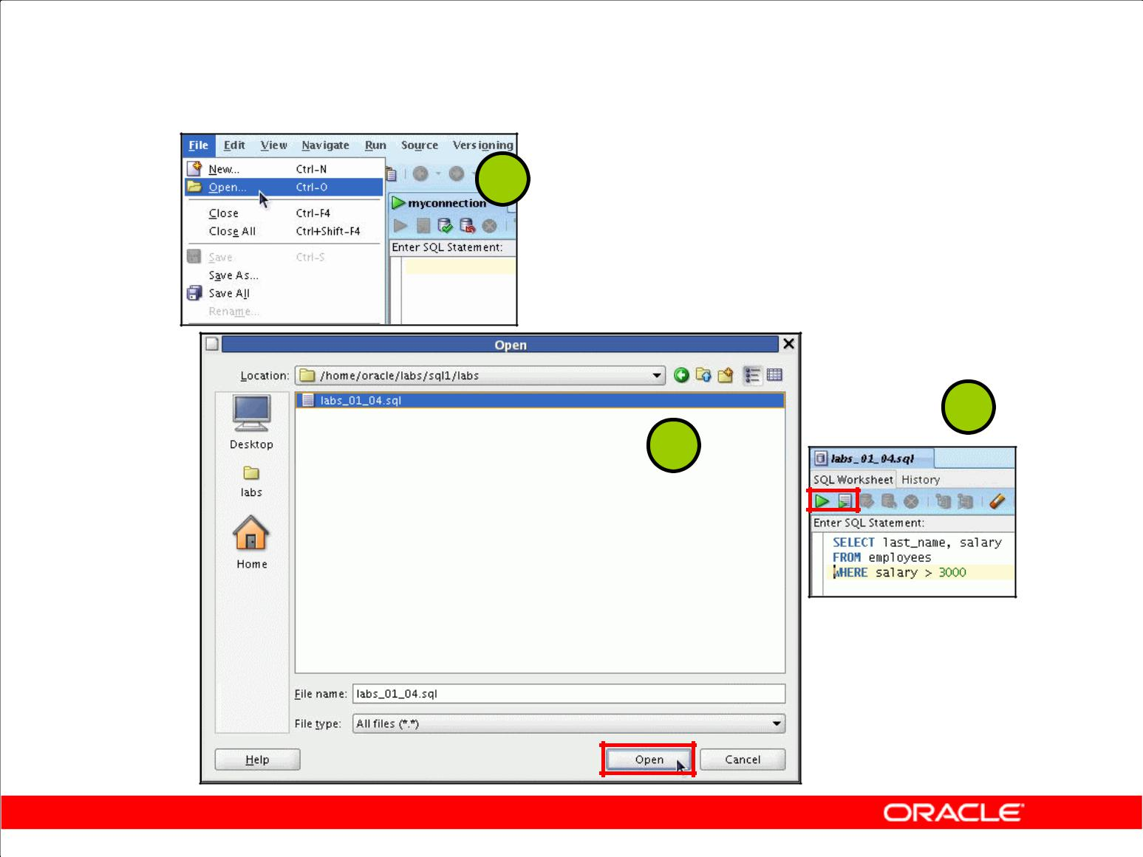**Running Script Files**

**1**

**3**

**2**

Copyright © 2009, Oracle. All rights reserved.

**Running Script Files**

To run the saved .sql script files, perform the following:

1. From the File menu, select Open. Alternatively, you can press and hold [CTRL] + [O].
2. In the Open dialog box, move to the \home\oracle\labs\sql1\labs folder, or to the location in which you saved the script file, select the file and click Open.
3. The script file opens in a new worksheet. Now, you can run the script by either clicking the Execute Statement icon or the Run Script icon. Again, make sure you do not enter any other SQL statements in the same worksheet. To continue with other SQL queries, open a new worksheet.

**Note:** You may want to set the default directory to\home\oracle\labs\sql1folder, sothat every time you try to open or save a script, SQL Developer chooses the same path to look for scripts. From Tools menu, select Preferences. In the Preferences dialog box, expand Database and select Worksheet Parameters. In the right pane, click Browse to set the default path to look for scripts and click OK.

**Note:** For more details on how to use the Oracle SQL Developer GUI interface for other data objectscreation and data retrieval tasks, refer to Appendix E “Using SQL Developer.”

|  |
| --- |
| Oracle Internal & Oracle Academy Use Only |

**Oracle Database 10*g*: SQL Fundamentals I 1 - 34**

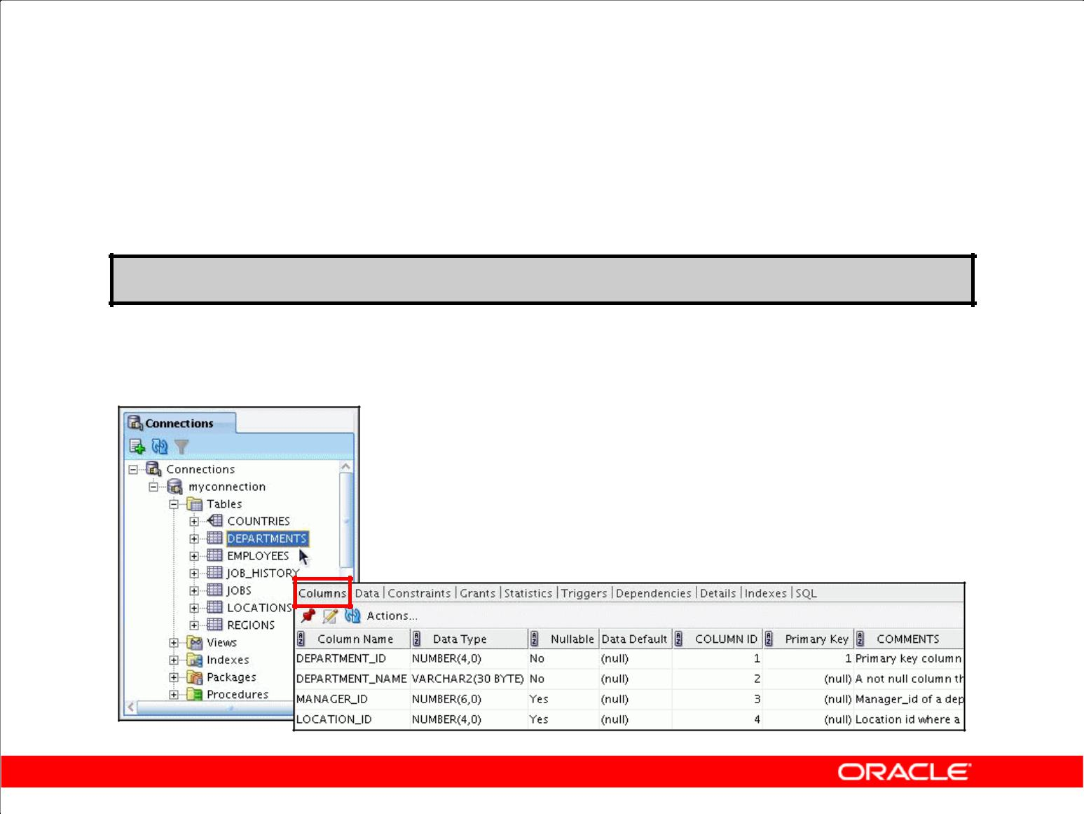**Displaying the Table Structure**

* Use the DESCRIBE command to display the structure of a

table.

**DESC[RIBE] *tablename***

* Or, select the table in the Connections tree and use the Columns tab to view the table structure.

Copyright © 2009, Oracle. All rights reserved.

**Displaying the Table Structure**

In SQL Developer, you can display the structure of a table by using the DESCRIBE command. The

command displays the column names and the data types, and it shows you whether a column *must* contain data (that is, whether the column has a NOT NULL constraint).

In the syntax, *table name* is the name of any existing table, view, or synonym that is accessible to the user.

Using the SQL Developer GUI interface, you can select the table in the Connections tree and use the Columns tab to view the table structure.

**Note:** TheDESCRIBEcommand is supported by both SQL*Plus and SQL Developer.

|  |
| --- |
| Oracle Internal & Oracle Academy Use Only |

**Oracle Database 10*g*: SQL Fundamentals I 1 - 35**

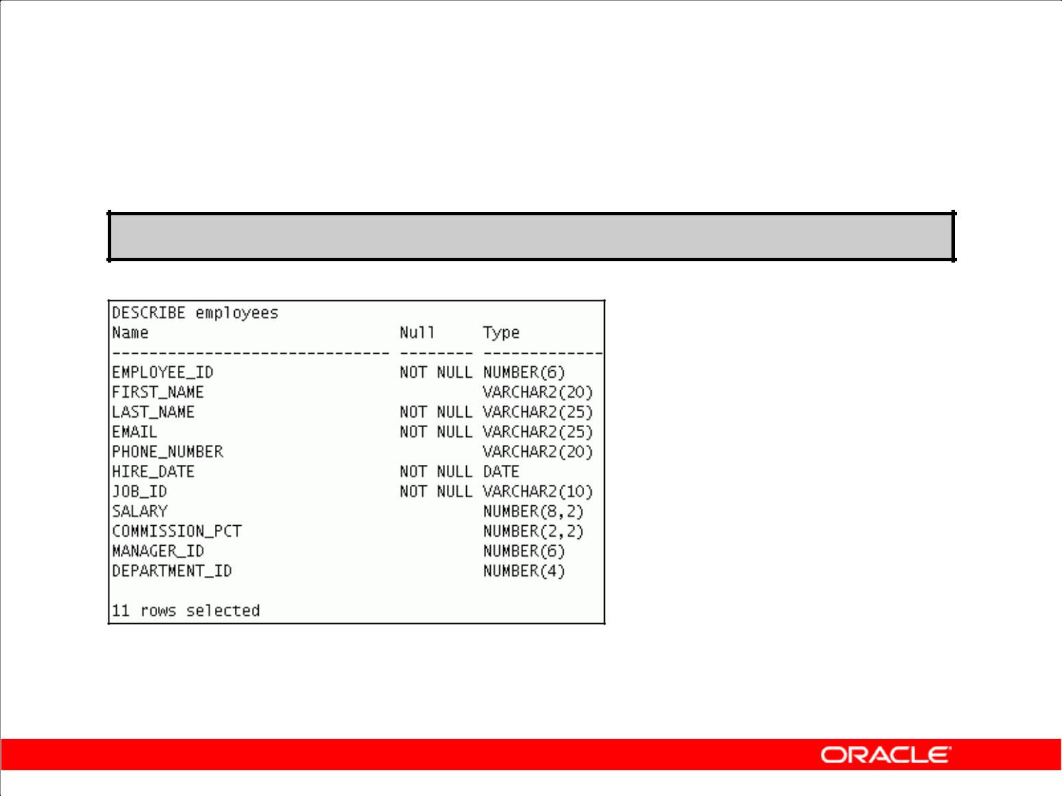**Using the DESCRIBE Command**

**DESCRIBE employees**

Copyright © 2009, Oracle. All rights reserved.

**Using the DESCRIBE Command**

The example in the slide displays information about the structure of the EMPLOYEES table using the DESCRIBE command.

In the resulting display, *Null* indicates that the values for this column may be unknown. NOT NULL indicates that a column must contain data. *Type* displays the data type for a column.

The data types are described in the following table:

|  |  |
| --- | --- |
| **Data Type** | **Description** |
|  |  |
| NUMBER(*p*,*s*) | Number value having a maximum number of digits *p*, with *s* |
|  | digits to the right of the decimal point |
|  |  |
| VARCHAR2(*s*) | Variable-length character value of maximum size *s* |
|  |  |
| DATE | Date and time value between January 1, 4712 B.C. and |
|  | December 31, A.D. 9999. |
|  |  |
| CHAR(*s*) | Fixed-length character value of size *s* |

|  |
| --- |
| Oracle Internal & Oracle Academy Use Only |

**Oracle Database 10*g*: SQL Fundamentals I 1 - 36**

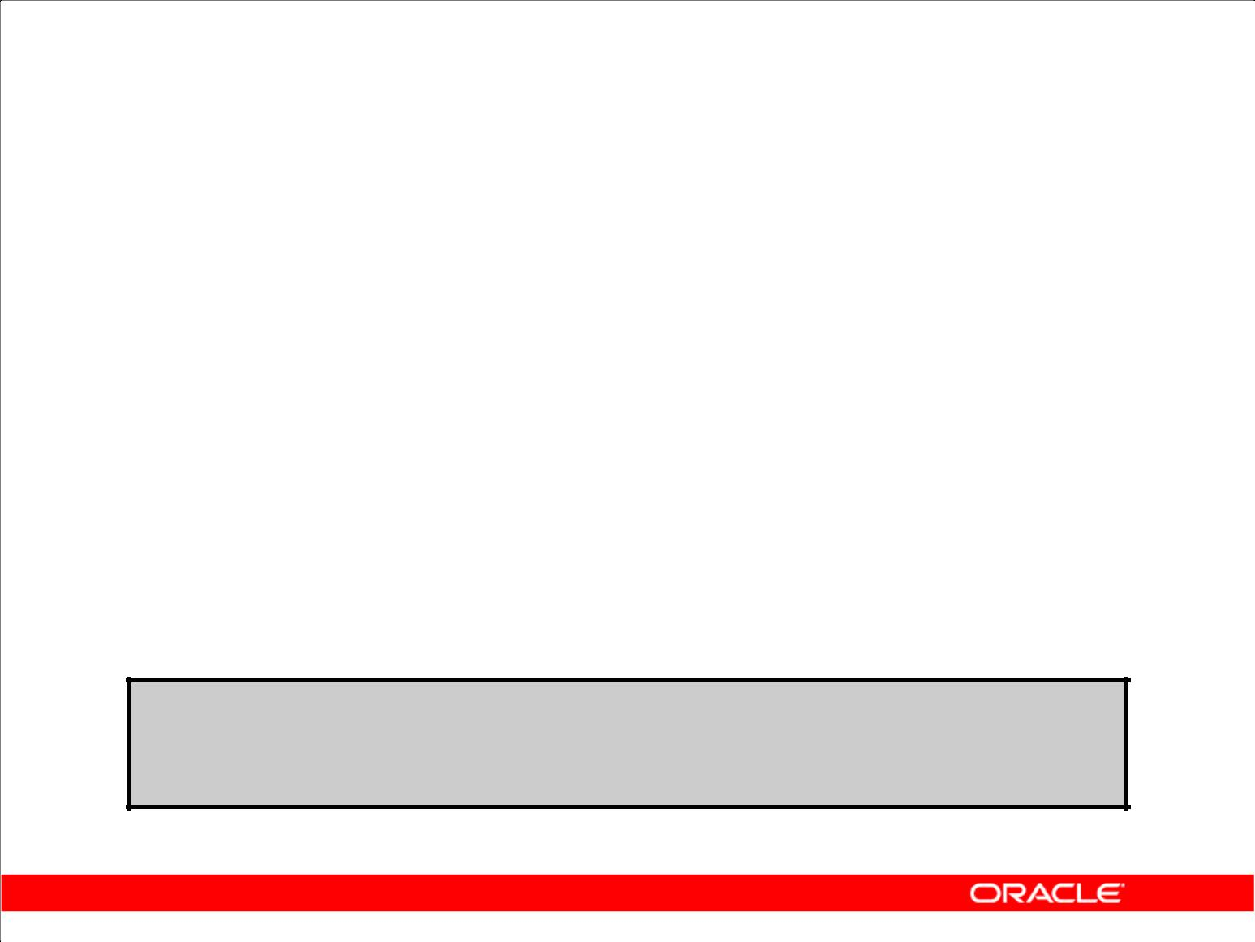**Summary**

In this lesson, you should have learned how to:

* Write a SELECT statement that:

– Returns all rows and columns from a table

– Returns specified columns from a table

– Uses column aliases to display more descriptive column headings

* Use the SQL Developer environment to write, save, and execute SQL statements

**SELECT *|{[DISTINCT] *column|expression* [*alias*],...} FROM *table;***

Copyright © 2009, Oracle. All rights reserved.

**Summary**

In this lesson, you should have learned how to retrieve data from a database table with the SELECT statement.

|  |  |  |
| --- | --- | --- |
| SELECT | *|{[DISTINCT] *column* [*alias*],...} | |
| FROM | *table*; |  |
| In the syntax: |  |  |
| SELECT |  | is a list of one or more columns |
| * |  | selects all columns |
| DISTINCT |  | suppresses duplicates |
| *column|expression* | | selects the named column or the expression |
| *alias* |  | gives selected columns different headings |
| FROM *table* |  | specifies the table containing the columns |

**SQL Developer**

SQL Developer is an execution environment that you can use to send SQL statements to the database server and to edit and save SQL statements. Statements can be executed from the SQL prompt or from a script file.

|  |
| --- |
| Oracle Internal & Oracle Academy Use Only |

**Oracle Database 10*g*: SQL Fundamentals I 1 - 37**

**Practice 1: Overview**

This practice covers the following topics:

* Using SQL Developer
* Selecting all data from different tables
* Describing the structure of tables
* Performing arithmetic calculations and specifying column names

Copyright © 2009, Oracle. All rights reserved.

**Practice 1: Overview**

This is the first of many practices in this course. The solutions (if you require them) can be found in Appendix A. The practices are intended to cover all the topics that are presented in the corresponding lesson.

*Note the following location for the lab files:*

*\home\oracle\labs\SQL1\labs*

*If you are asked to save any lab files, save them at this location.*

In any practice, there may be exercises that are prefaced with the phrases “If you have time” or “If you want an extra challenge.” Work on these exercises only if you have completed all other exercises in the allocated time and would like a further challenge to your skills.

Perform the practices slowly and precisely. You can experiment with saving and running command files. If you have any questions at any time, ask your instructor.

**Note:** All written practices use Oracle SQL Developer as the development environment. Although itis recommended that you use Oracle SQL Developer, you can also use SQL*Plus that is available in this course.

|  |
| --- |
| Oracle Internal & Oracle Academy Use Only |

**Oracle Database 10*g*: SQL Fundamentals I 1 - 38**

**Practice 1**

**Part 1**

Test your knowledge:

1. The following SELECT statement executes successfully:

SELECT last_name, job_id, salary AS Sal FROM employees;

True/False

1. The following SELECT statement executes successfully:

SELECT *

FROM job_grades;

True/False

3. There are four coding errors in the following statement. Can you identify them?

SELECT employee_id, last_name

sal x 12 ANNUAL SALARY

FROM employees;

**Part 2**

*Note the following location for the lab files:*

*\home\oracle\labs\SQL1\labs*

*If you are asked to save any lab files, save them at this location.*

To start Oracle SQL Developer, double-click the SQL Developer desktop icon.

Before you begin with the practices, you need a database connection to be able to connect to the database and issue SQL queries.

1. To create a new database connection in the Connections Navigator, right-click Connections. Select New Connection from the shortcut menu. The New/Select Database Connection dialog box appears.
2. Create a database connection using the following information:
   1. Connection Name: myconnection
   2. Username: ora1
   3. Password: ora1
   4. Hostname: localhost
   5. Port: 1521
   6. SID: ORCL
   7. Ensure that you select the Save Password check box.

|  |
| --- |
| Oracle Internal & Oracle Academy Use Only |

**Oracle Database 10*g*: SQL Fundamentals I 1 - 39**

**Practice 1 (continued)**

You have been hired as a SQL programmer for Acme Corporation. Your first task is to create some reports based on data from the Human Resources tables.

6. Your first task is to determine the structure of the DEPARTMENTS table and its contents.

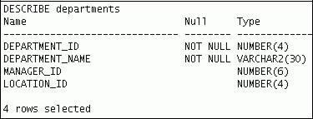

7. You need to determine the structure of the EMPLOYEES table.

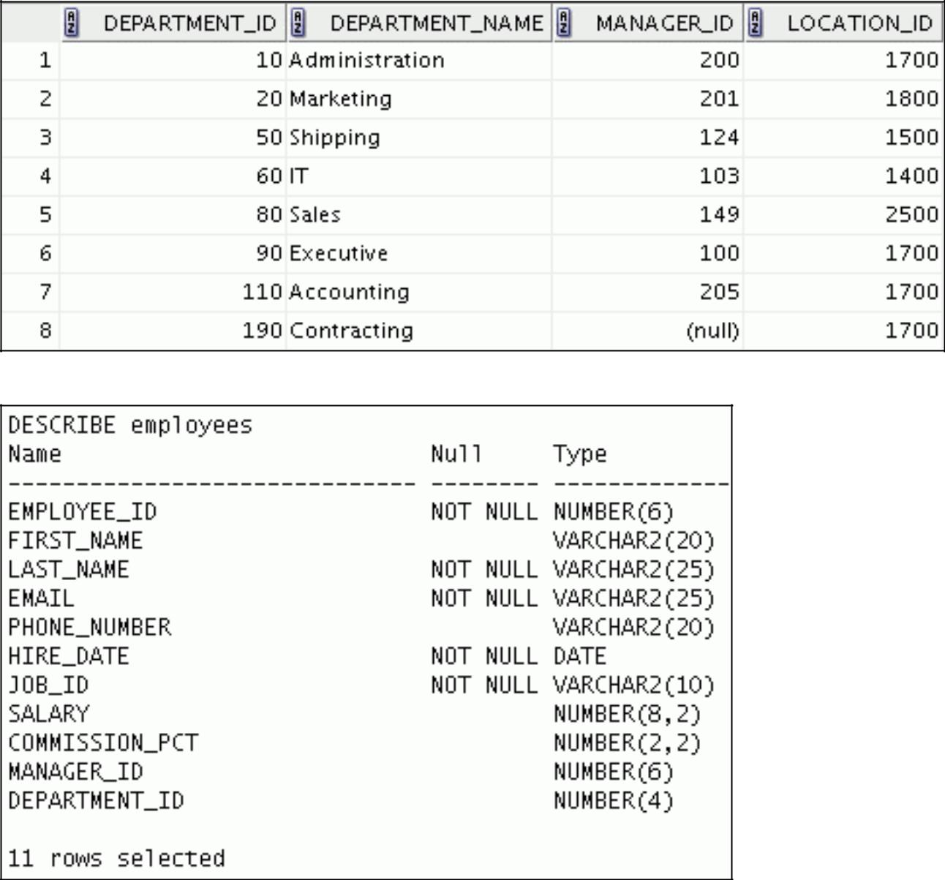

|  |
| --- |
| Oracle Internal & Oracle Academy Use Only |

The HR department wants a query to display the last name, job code, hire date, and employee number for each employee, with the employee number appearing first. Provide an alias STARTDATE for the HIRE_DATE column. Save your SQL statement to a file named lab_01_07.sql so that you can dispatch this file to the HR department.

**Oracle Database 10*g*: SQL Fundamentals I 1 - 40**

**Practice 1 (continued)**

8. Test your query in the lab_01_07.sql file to ensure that it runs correctly.

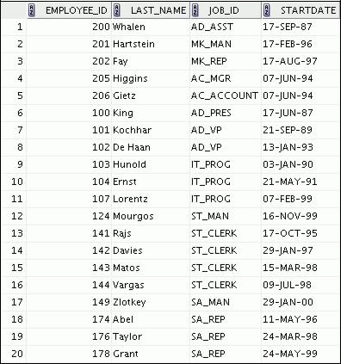

9. The HR department needs a query to display all unique job codes from the EMPLOYEES table.

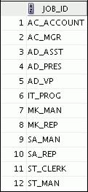

|  |
| --- |
| Oracle Internal & Oracle Academy Use Only |

**Oracle Database 10*g*: SQL Fundamentals I 1 - 41**

**Practice 1 (continued)**

**Part 3**

If you have time, complete the following exercises:

1. The HR department wants more descriptive column headings for its report on employees. Copy the statement from lab_01_07.sql to the SQL Developer text box. Name the column headings Emp #, Employee, Job, and Hire Date, respectively. Then run your query again.

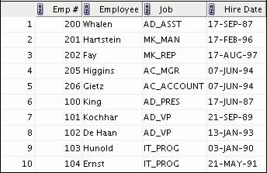

**…**



1. The HR department has requested a report of all employees and their job IDs. Display the last name concatenated with the job ID (separated by a comma and space) and name the column

Employee and Title.

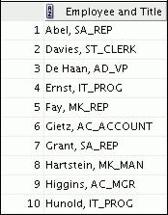

**…**



|  |
| --- |
| Oracle Internal & Oracle Academy Use Only |

**Oracle Database 10*g*: SQL Fundamentals I 1 - 42**

**Practice 1 (continued)**

If you want an extra challenge, complete the following exercise:

1. To familiarize yourself with the data in the EMPLOYEES table, create a query to display all the data from that table. Separate each column output with a comma. Name the column

THE_OUTPUT.

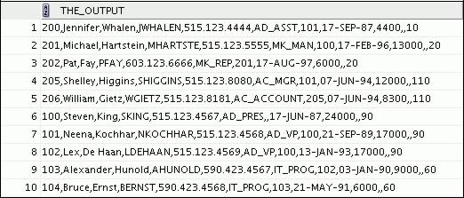

**…**



|  |
| --- |
| Oracle Internal & Oracle Academy Use Only |

**Oracle Database 10*g*: SQL Fundamentals I 1 - 43**

Oracle Internal & Oracle Academy Use Only



**Restricting and Sorting Data**

Copyright © 2009, Oracle. All rights reserved.

|  |
| --- |
| Oracle Internal & Oracle Academy Use Only |

**Objectives**

After completing this lesson, you should be able to do the following:

* Limit the rows that are retrieved by a query
* Sort the rows that are retrieved by a query
* Use ampersand substitution to restrict and sort output at run time

Copyright © 2009, Oracle. All rights reserved.

**Objectives**

When retrieving data from the database, you may need to do the following:

* Restrict the rows of data that are displayed
* Specify the order in which the rows are displayed

This lesson explains the SQL statements that you use to perform these actions.

|  |
| --- |
| Oracle Internal & Oracle Academy Use Only |

**Oracle Database 10*g*: SQL Fundamentals I 2 - 2**

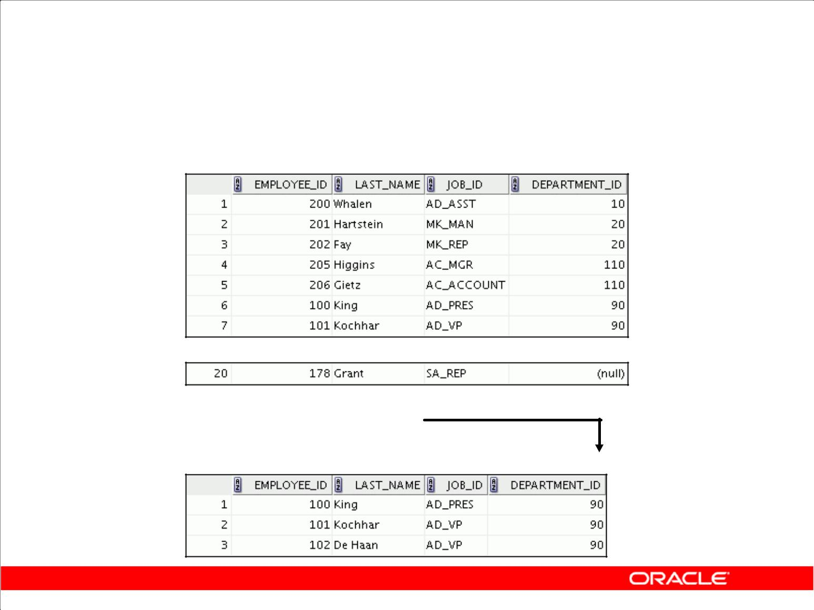**Limiting Rows Using a Selection**

**EMPLOYEES**

**…**

**“retrieve all**

**employees in**

**department 90”**

Copyright © 2009, Oracle. All rights reserved.

**Limiting Rows Using a Selection**

In the example in the slide, assume that you want to display all the employees in department 90. The rows with a value of 90 in the DEPARTMENT_ID column are the only ones that are returned. This method of restriction is the basis of the WHERE clause in SQL.

|  |
| --- |
| Oracle Internal & Oracle Academy Use Only |

**Oracle Database 10*g*: SQL Fundamentals I 2 - 3**

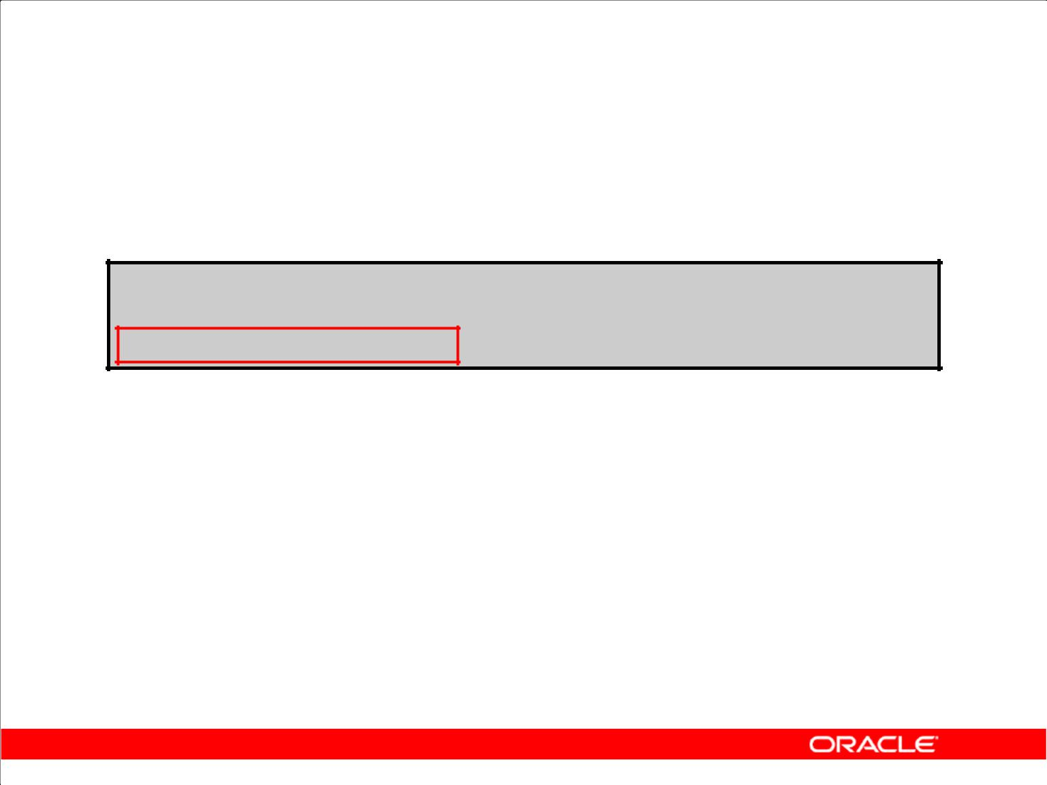**Limiting the Rows That Are Selected**

* Restrict the rows that are returned by using the WHERE clause:

**SELECT *|{[DISTINCT] *column|expression* [*alias*],...}**

**FROM** ***table***

**[WHERE *condition(s)*];**

* The WHERE clause follows the FROM clause.

Copyright © 2009, Oracle. All rights reserved.

**Limiting the Rows That Are Selected**

You can restrict the rows that are returned from the query by using the WHERE clause. A WHERE clause contains a condition that must be met, and it directly follows the FROM clause. If the condition is true, the row meeting the condition is returned.

|  |  |  |
| --- | --- | --- |
| In the syntax: | restricts the query to rows that meet a condition |  |
| WHERE |  |
| *condition* | is composed of column names, expressions, |  |
|  | constants, and a comparison operator |  |

The WHERE clause can compare values in columns, literal values, arithmetic expressions, or functions. It consists of three elements:

* Column name
* Comparison condition
* Column name, constant, or list of values

|  |
| --- |
| Oracle Internal & Oracle Academy Use Only |

**Oracle Database 10*g*: SQL Fundamentals I 2 - 4**

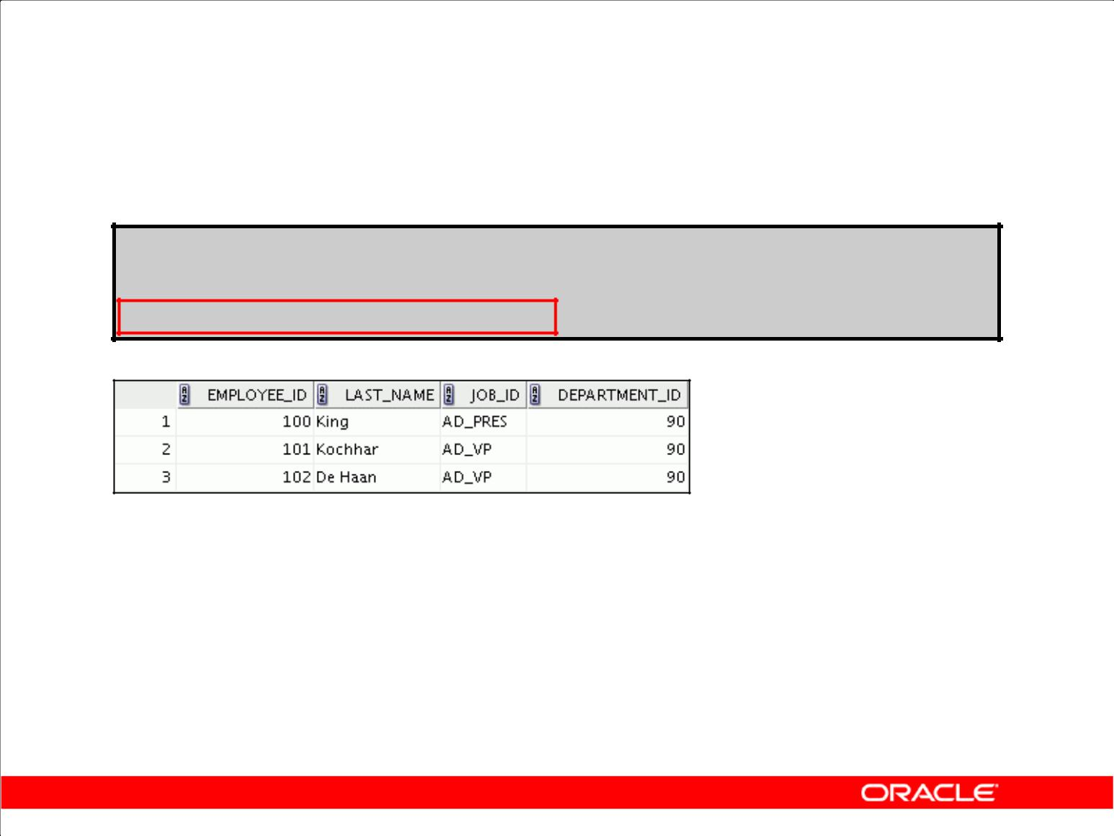**Using the WHERE Clause**

**SELECT employee_id, last_name, job_id, department_id FROM employees**

**WHERE** **department_id = 90 ;**

Copyright © 2009, Oracle. All rights reserved.

**Using the WHERE Clause**

In the example, the SELECT statement retrieves the employee ID, name, job ID, and department number of all employees who are in department 90.

|  |
| --- |
| Oracle Internal & Oracle Academy Use Only |

**Oracle Database 10*g*: SQL Fundamentals I 2 - 5**

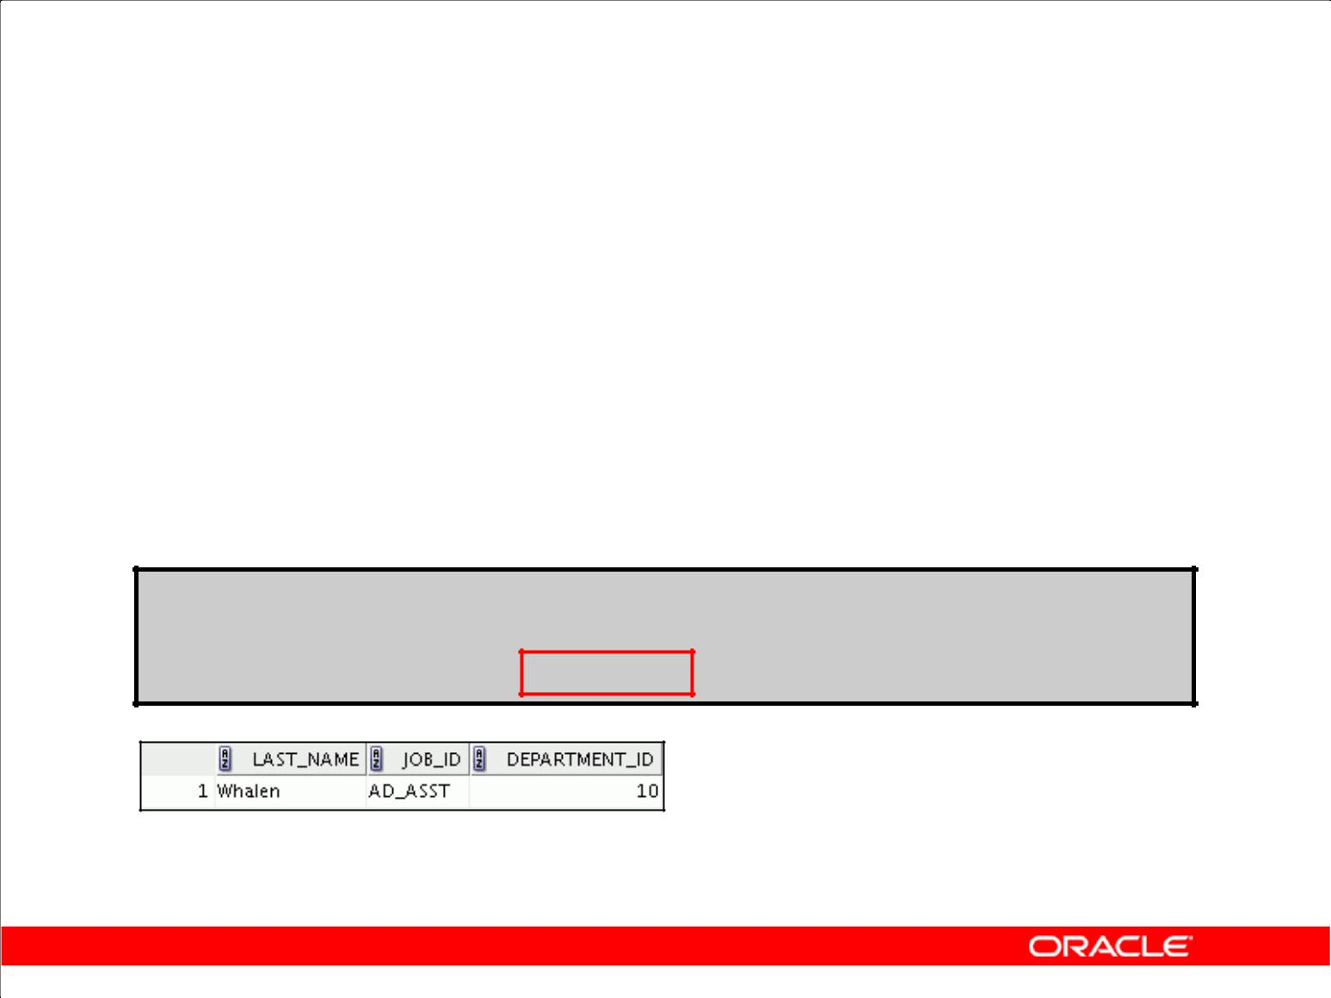**Character Strings and Dates**

* Character strings and date values are enclosed in single quotation marks.
* Character values are case sensitive, and date values are format sensitive.
* The default date format is DD-MON-RR.

**SELECT last_name, job_id, department_id**

**FROM employees**

**WHERE** **last_name = 'Whalen' ;**

Copyright © 2009, Oracle. All rights reserved.

**Character Strings and Dates**

Character strings and dates in the WHERE clause must be enclosed in single quotation marks ('').

Number constants, however, should not be enclosed in single quotation marks.

All character searches are case sensitive. In the following example, no rows are returned because the

EMPLOYEES table stores all the last names in mixed case:

SELECT last_name, job_id, department_id

FROM employees

WHERE last_name = 'WHALEN';

The Oracle Database stores dates in an internal numeric format, representing the century, year, month, day, hours, minutes, and seconds. The default date display is DD-MON-RR.

**Note:** For details about the RR format and about changing the default date format, see the lessontitled “Using Single-Row Functions to Customize Output.”

|  |
| --- |
| Oracle Internal & Oracle Academy Use Only |

**Oracle Database 10*g*: SQL Fundamentals I 2 - 6**

**Comparison Conditions**

|  |  |
| --- | --- |
| **Operator** | **Meaning** |
|  |  |
| = | Equal to |
| > | Greater than |
| >= | Greater than or equal to |
| < | Less than |
| <= | Less than or equal to |
| <> | Not equal to |
| BETWEEN | Between two values (inclusive) |
| ...AND... |  |
| IN(set) | Match any of a list of values |
|  |  |
| LIKE | Match a character pattern |
|  |  |
| IS NULL | Is a null value |
|  |  |

Copyright © 2009, Oracle. All rights reserved.

**Comparison Conditions**

Comparison conditions are used in conditions that compare one expression to another value or expression. They are used in the WHERE clause in the following format:

**Syntax**

... WHERE *expr operator value*

**Example**

... WHERE hire_date = '01-JAN-95'

... WHERE salary >= 6000

... WHERE last_name = 'Smith'

An alias cannot be used in the WHERE clause.

**Note:** The symbols!=and^=can also represent the*not equal to*condition.

|  |
| --- |
| Oracle Internal & Oracle Academy Use Only |

**Oracle Database 10*g*: SQL Fundamentals I 2 - 7**

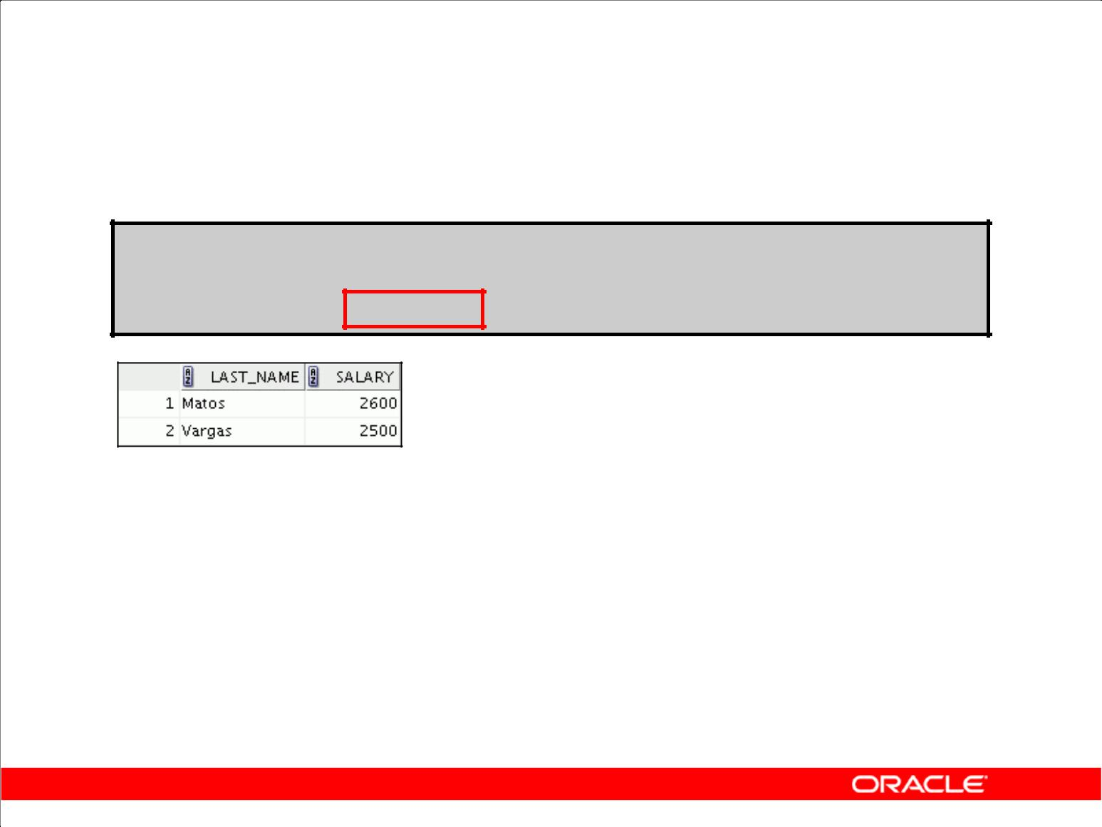**Using Comparison Conditions**

**SELECT last_name, salary**

**FROM employees**

**WHERE** **salary <= 3000 ;**

Copyright © 2009, Oracle. All rights reserved.

**Using Comparison Conditions**

In the example, the SELECT statement retrieves the last name and salary from the EMPLOYEES

table for any employee whose salary is less than or equal to $3,000. Note that there is an explicit value supplied to the WHERE clause. The explicit value of 3000 is compared to the salary value in the SALARY column of the EMPLOYEES table.

|  |
| --- |
| Oracle Internal & Oracle Academy Use Only |

**Oracle Database 10*g*: SQL Fundamentals I 2 - 8**

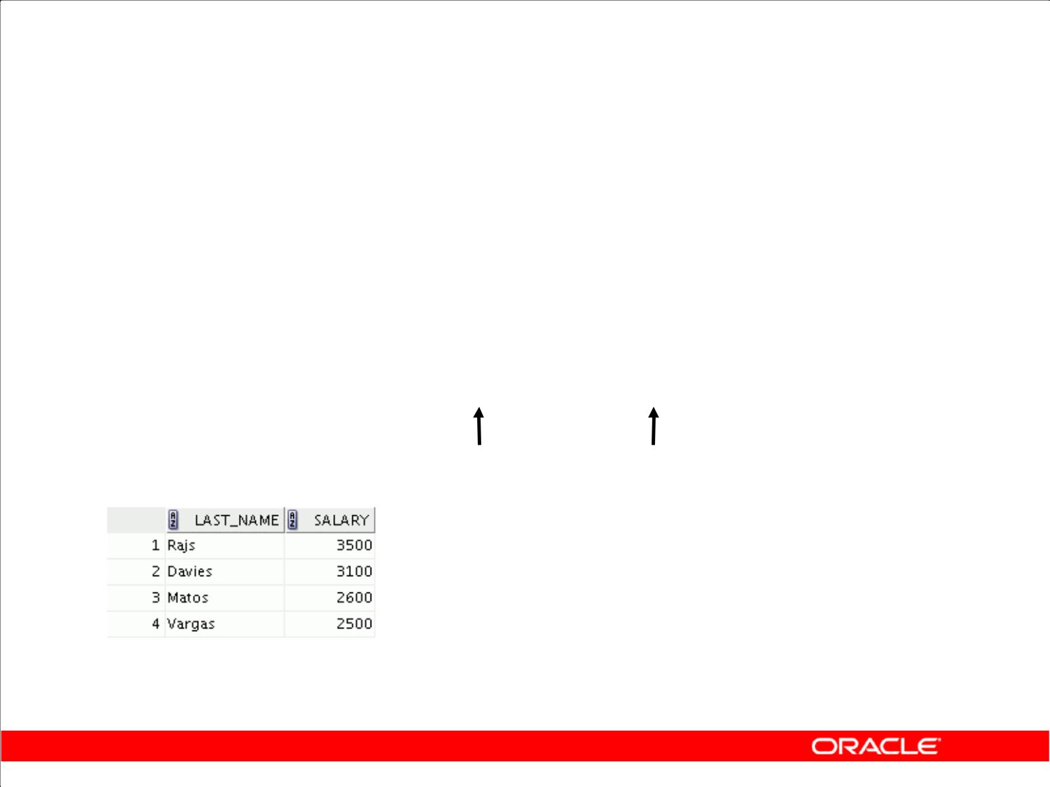**Using the BETWEEN Condition**

Use the BETWEEN condition to display rows based on a range of values:

|  |  |  |  |  |  |  |
| --- | --- | --- | --- | --- | --- | --- |
|  | **SELECT** | **last_name, salary** | | |  |  |
|  | **FROM** | **employees** | | |  |  |
|  | **WHERE** | **salary** | **BETWEEN 2500 AND 3500** | | | **;** |
|  |  |  |  | **Lower limit** | **Upper limit** | |
|  |  |  |  |  |  |  |
|  |  |  |  |  |  |  |

Copyright © 2009, Oracle. All rights reserved.

**Using the BETWEEN Condition**

You can display rows based on a range of values using the BETWEEN range condition. The range that you specify contains a lower limit and an upper limit.

The SELECT statement in the slide returns rows from the EMPLOYEES table for any employee whose salary is between $2,500 and $3,500.

Values that are specified with the BETWEEN condition are inclusive. You must specify the lower limit first.

You can also use the BETWEEN condition on character values:

SELECT last_name

FROM employees

WHERE last_name BETWEEN 'King' AND 'Smith';

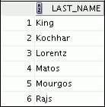

|  |
| --- |
| Oracle Internal & Oracle Academy Use Only |

**Oracle Database 10*g*: SQL Fundamentals I 2 - 9**

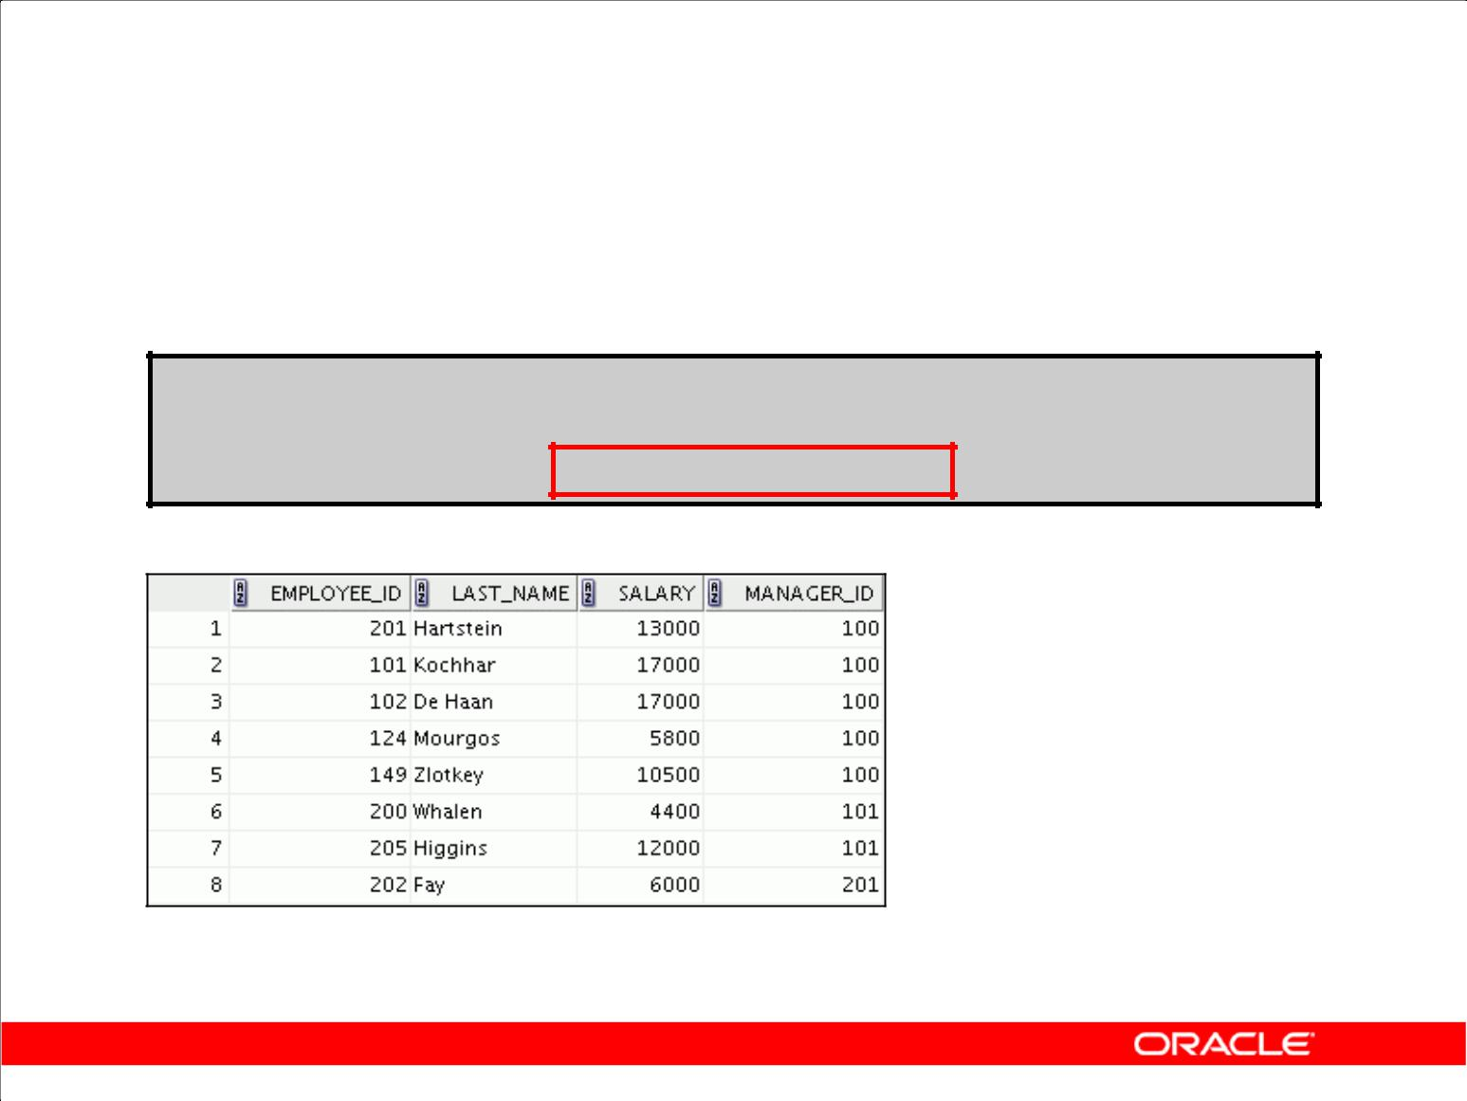**Using the IN Condition**

Use the IN membership condition to test for values in a list:

**SELECT employee_id, last_name, salary, manager_id**

**FROM employees**

**WHERE** **manager_id IN (100, 101, 201) ;**

Copyright © 2009, Oracle. All rights reserved.

**Using the IN Condition**

To test for values in a specified set of values, use the IN condition. The IN condition is also known as the *membership condition*.

The slide example displays employee numbers, last names, salaries, and manager’s employee numbers for all the employees whose manager’s employee number is 100, 101, or 201.

The IN condition can be used with any data type. The following example returns a row from the EMPLOYEES table for any employee whose last name is included in the list of names in the WHERE clause:

SELECT employee_id, manager_id, department_id

FROM employees

WHERE last_name IN ('Hartstein', 'Vargas');

If characters or dates are used in the list, they must be enclosed in single quotation marks ('').

|  |
| --- |
| Oracle Internal & Oracle Academy Use Only |

**Oracle Database 10*g*: SQL Fundamentals I 2 - 10**

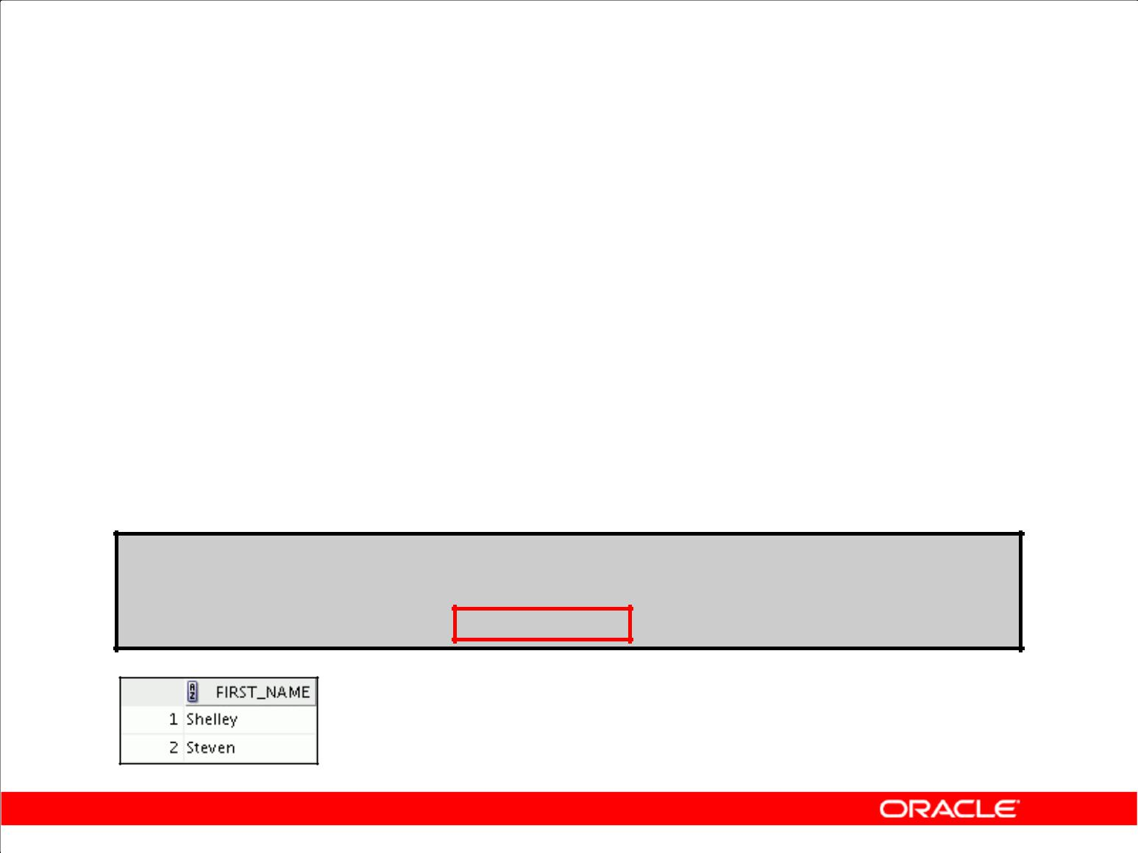**Using the LIKE Condition**

* Use the LIKE condition to perform wildcard searches of valid search string values.
* Search conditions can contain either literal characters or numbers:

– % denotes zero or many characters.

– _ denotes one character.

**SELECT first_name**

**FROM** **employees**

**WHERE** **first_name LIKE 'S%' ;**

Copyright © 2009, Oracle. All rights reserved.

**Using the LIKE Condition**

You may not always know the exact value to search for. You can select rows that match a character pattern by using the LIKE condition. The character pattern–matching operation is referred to as a

*wildcard* search. Two symbols can be used to construct the search string.

|  |  |
| --- | --- |
| **Symbol** | **Description** |
|  |  |
| % | Represents any sequence of zero or more characters |
|  |  |
| _ | Represents any single character |
|  |  |

The SELECT statement in the slide returns the employee first name from the EMPLOYEES table for any employee whose first name begins with the letter *S*. Note the uppercase *S*. Names beginning with an *s* are not returned.

The LIKE condition can be used as a shortcut for some BETWEEN comparisons. The following

example displays the last names and hire dates of all employees who joined between January 1995 and December 1995:

SELECT last_name, hire_date

FROM employees

WHERE hire_date LIKE '%95';

|  |
| --- |
| Oracle Internal & Oracle Academy Use Only |

**Oracle Database 10*g*: SQL Fundamentals I 2 - 11**

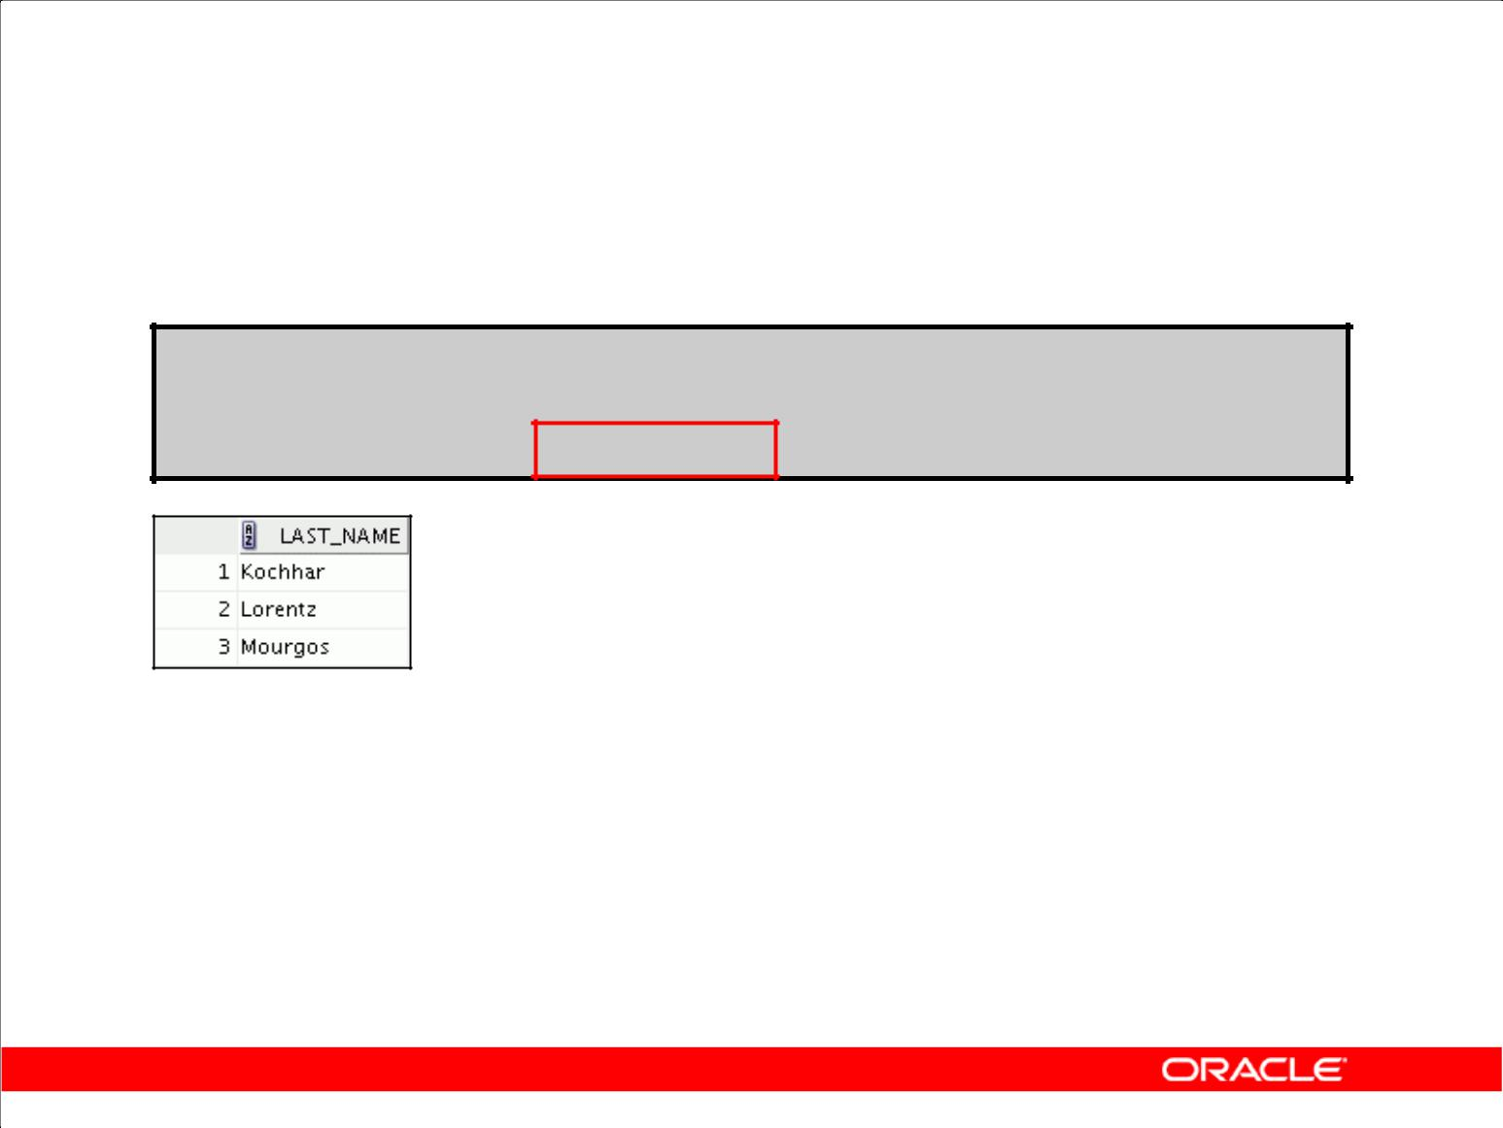**Using the LIKE Condition**

* You can combine pattern-matching characters:

**SELECT last_name**

**FROM** **employees**

**WHERE** **last_name LIKE '_o%' ;**

* You can use the ESCAPE identifier to search for the actual % and _ symbols.

Copyright © 2009, Oracle. All rights reserved.

**Combining Wildcard Characters**

The % and _ symbols can be used in any combination with literal characters. The example in the slide displays the names of all employees whose last names have the letter *o* as the second character.

**ESCAPE Option**

When you need to have an exact match for the actual *%* and *_* characters, use the ESCAPE option. This option specifies what the escape character is. If you want to search for strings that contain SA_, you can use the following SQL statement:

SELECT employee_id, last_name, job_id

FROM employees WHERE job_id LIKE '%SA\_%' ESCAPE '\';

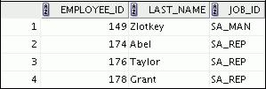

The ESCAPE option identifies the backslash (\) as the escape character. In the pattern, the escape character precedes the underscore (_). This causes the Oracle Server to interpret the underscore literally.

|  |
| --- |
| Oracle Internal & Oracle Academy Use Only |

**Oracle Database 10*g*: SQL Fundamentals I 2 - 12**

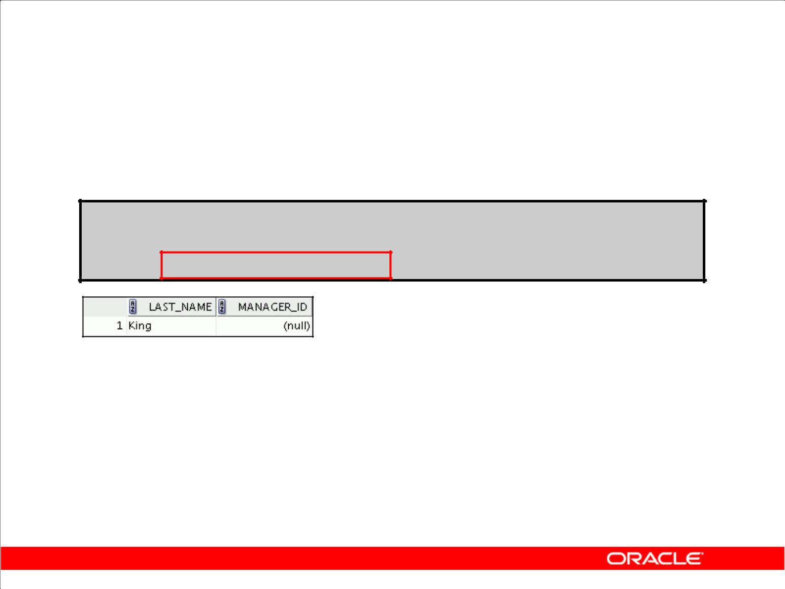**Using the NULL Conditions**

Test for nulls with the IS NULL operator.

**SELECT last_name, manager_id**

**FROM employees**

**WHERE** **manager_id IS NULL ;**

Copyright © 2009, Oracle. All rights reserved.

**Using the NULL Conditions**

The NULL conditions include the IS NULL condition and the IS NOT NULL condition.

The IS NULL condition tests for nulls. A null value means the value is unavailable, unassigned, unknown, or inapplicable. Therefore, you cannot test with = because a null cannot be equal or unequal to any value. The slide example retrieves the last names and managers of all employees who do not have a manager.

Here is another example: To display last name, job ID, and commission for all employees who are *not* entitled to receive a commission, use the following SQL statement:

SELECT last_name, job_id, commission_pct

FROM employees

WHERE commission_pct IS NULL;

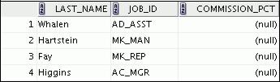

|  |
| --- |
| Oracle Internal & Oracle Academy Use Only |

**…**



**Oracle Database 10*g*: SQL Fundamentals I 2 - 13**

**Logical Conditions**

|  |  |
| --- | --- |
| **Operator** | **Meaning** |
|  |  |
| AND | Returns TRUE if *both* component conditions |
|  | are true |
| OR | Returns TRUE if *either* component condition |
|  | is true |
| NOT | Returns TRUE if the following condition is |
|  | false |

Copyright © 2009, Oracle. All rights reserved.

**Logical Conditions**

A logical condition combines the result of two component conditions to produce a single result based on those conditions, or it inverts the result of a single condition. A row is returned only if the overall result of the condition is true.

Three logical operators are available in SQL:

* AND
* OR
* NOT

All the examples so far have specified only one condition in the WHERE clause. You can use several conditions in one WHERE clause using the AND and OR operators.

|  |
| --- |
| Oracle Internal & Oracle Academy Use Only |

**Oracle Database 10*g*: SQL Fundamentals I 2 - 14**

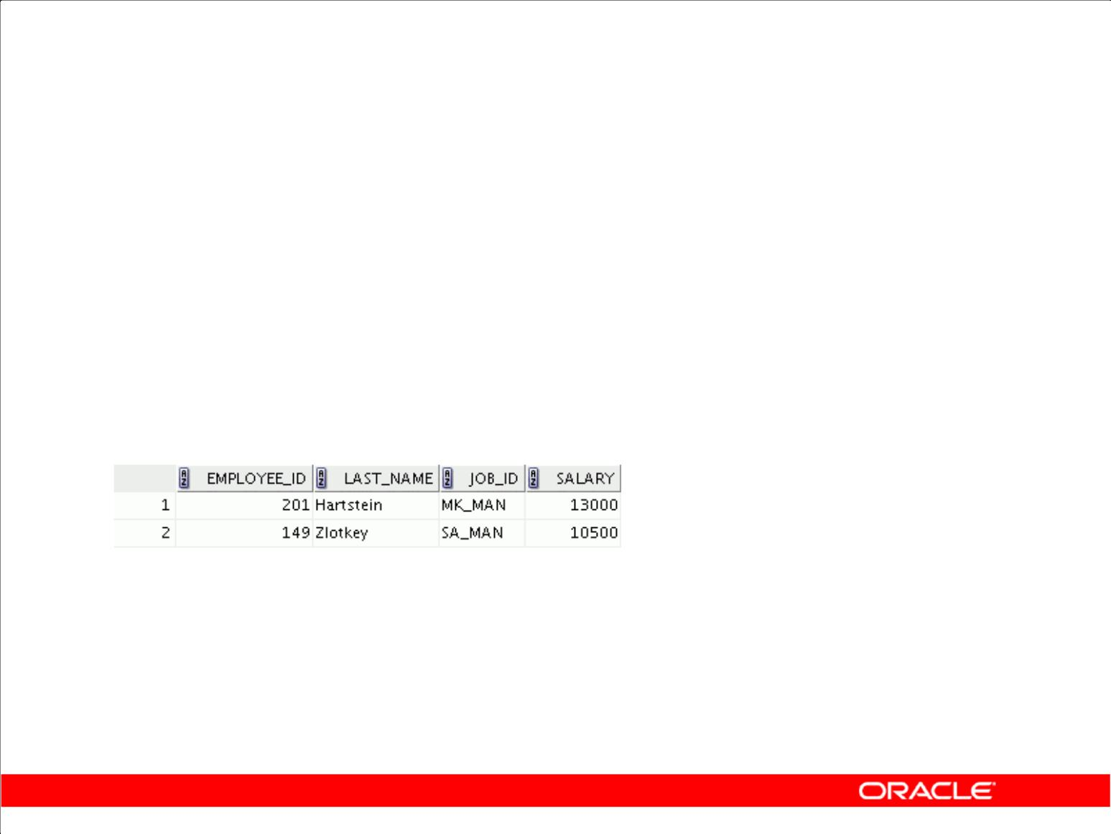**Using the AND Operator**

AND requires both conditions to be true:

|  |  |  |  |
| --- | --- | --- | --- |
| **SELECT** | **employee_id, last_name, job_id, salary** | | |
| **FROM** | **employees** | | |
| **WHERE** | **salary >=10000** |  |  |
| **AND** | **job_id LIKE '%MAN%'** | **;** |  |
|  |  |  |  |
|  |  |  |  |

Copyright © 2009, Oracle. All rights reserved.

**Using the AND Operator**

In the example, both conditions must be true for any record to be selected. Therefore, only employees who have a job title that contains the string ‘MAN’ *and* earn $10,000 or more are selected.

All character searches are case sensitive. No rows are returned if ‘MAN’ is not uppercase. Character strings must be enclosed in quotation marks.

**AND Truth Table**

The following table shows the results of combining two expressions with AND:

|  |  |  |  |  |
| --- | --- | --- | --- | --- |
| **AND** | **TRUE** |  | **FALSE** | **NULL** |
| **TRUE** | TRUE |  | FALSE | NULL |
| **FALSE** | FALSE |  | FALSE | FALSE |
| **NULL** | NULL | FALSE | | NULL |

|  |
| --- |
| Oracle Internal & Oracle Academy Use Only |

**Oracle Database 10*g*: SQL Fundamentals I 2 - 15**

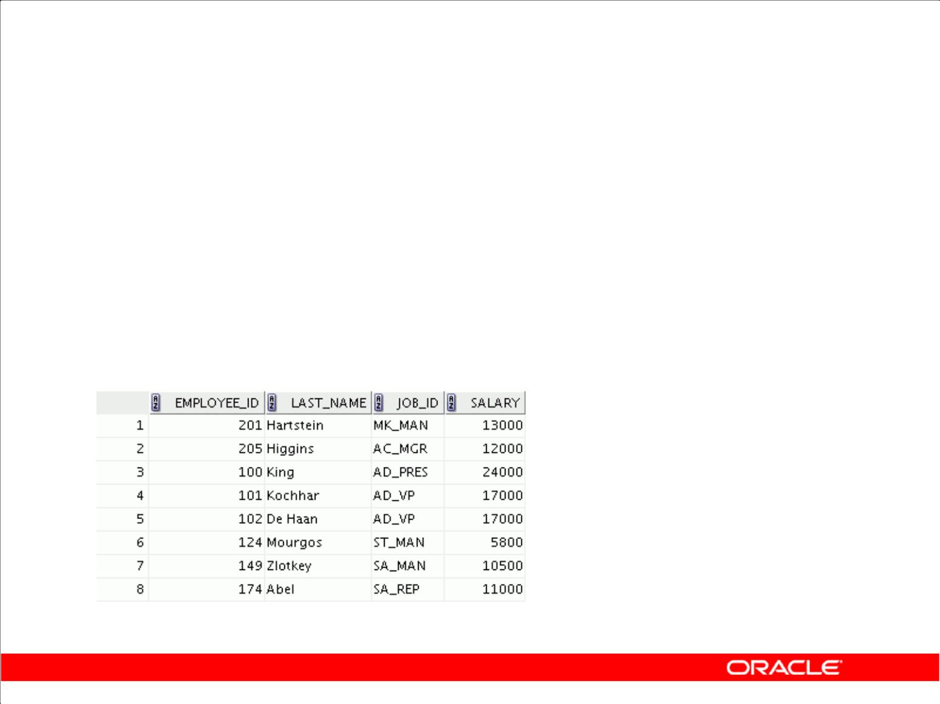**Using the OR Operator**

OR requires either condition to be true:

|  |  |  |  |
| --- | --- | --- | --- |
| **SELECT** | **employee_id, last_name, job_id, salary** | | |
| **FROM** | **employees** | | |
| **WHERE** | **salary >= 10000** |  |  |
| **OR** | **job_id LIKE '%MAN%'** | **;** |  |
|  |  |  |  |
|  |  |  |  |

Copyright © 2009, Oracle. All rights reserved.

**Using the OR Operator**

In the example, either condition can be true for any record to be selected. Therefore, any employee who has a job ID that contains the string ‘MAN’ *or* earns $10,000 or more is selected.

**OR Truth Table**

The following table shows the results of combining two expressions with OR:

|  |  |  |  |
| --- | --- | --- | --- |
| **OR** | **TRUE** | **FALSE** | **NULL** |
| **TRUE** | TRUE | TRUE | TRUE |
| **FALSE** | TRUE | FALSE | NULL |
| **NULL** | TRUE | NULL | NULL |

|  |
| --- |
| Oracle Internal & Oracle Academy Use Only |

**Oracle Database 10*g*: SQL Fundamentals I 2 - 16**

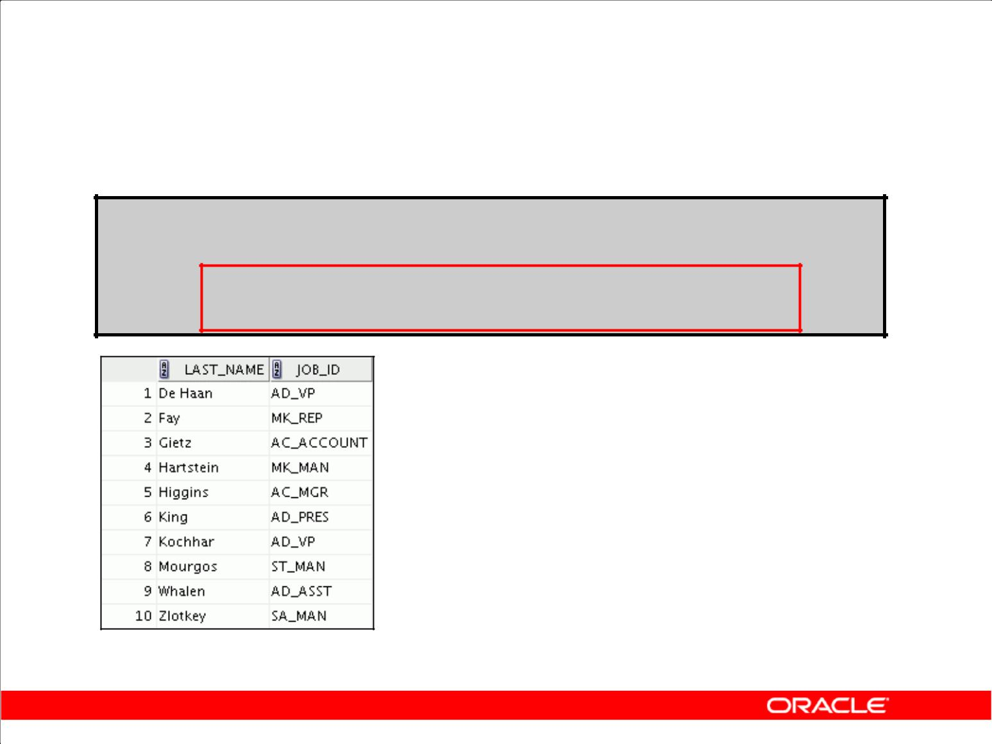**Using the NOT Operator**

**SELECT last_name, job_id**

**FROM employees**

**WHERE** **job_id**

**NOT IN ('IT_PROG', 'ST_CLERK', 'SA_REP') ;**

Copyright © 2009, Oracle. All rights reserved.

**Using the NOT Operator**

The slide example displays the last name and job ID of all employees whose job ID *is not* IT_PROG, ST_CLERK, or SA_REP.

**NOT Truth Table**

The following table shows the result of applying the NOT operator to a condition:

|  |  |  |  |
| --- | --- | --- | --- |
| **NOT** | **TRUE** | **FALSE** | **NULL** |
|  | FALSE | TRUE | NULL |

**Note:** TheNOToperator can also be used with other SQL operators, such asBETWEEN,LIKE, andNULL.

|  |  |  |  |  |  |
| --- | --- | --- | --- | --- | --- |
| ... WHERE | job_id | NOT | IN ('AC_ACCOUNT', 'AD_VP') | | |
| ... WHERE | salary | NOT | BETWEEN | | 10000 AND 15000 |
| ... WHERE | last_name NOT | | LIKE '%A%' | | |
| ... WHERE | commission_pct | | IS | NOT | NULL |

|  |
| --- |
| Oracle Internal & Oracle Academy Use Only |

**Oracle Database 10*g*: SQL Fundamentals I 2 - 17**

**Rules of Precedence**

|  |  |
| --- | --- |
| **Operator** | **Meaning** |
|  |  |
| 1 | Arithmetic operators |
| 2 | Concatenation operator |
|  |  |
| 3 | Comparison conditions |
| 4 | IS [NOT] NULL, LIKE, [NOT] IN |
| 5 | [NOT] BETWEEN |
| 6 | Not equal to |
| 7 | NOT logical condition |
| 8 | AND logical condition |
| 9 | OR logical condition |
|  |  |

**You can use parentheses to override rules of precedence.**

Copyright © 2009, Oracle. All rights reserved.

**Rules of Precedence**

The rules of precedence determine the order in which expressions are evaluated and calculated. The table lists the default order of precedence. You can override the default order by using parentheses around the expressions that you want to calculate first.

|  |
| --- |
| Oracle Internal & Oracle Academy Use Only |

**Oracle Database 10*g*: SQL Fundamentals I 2 - 18**

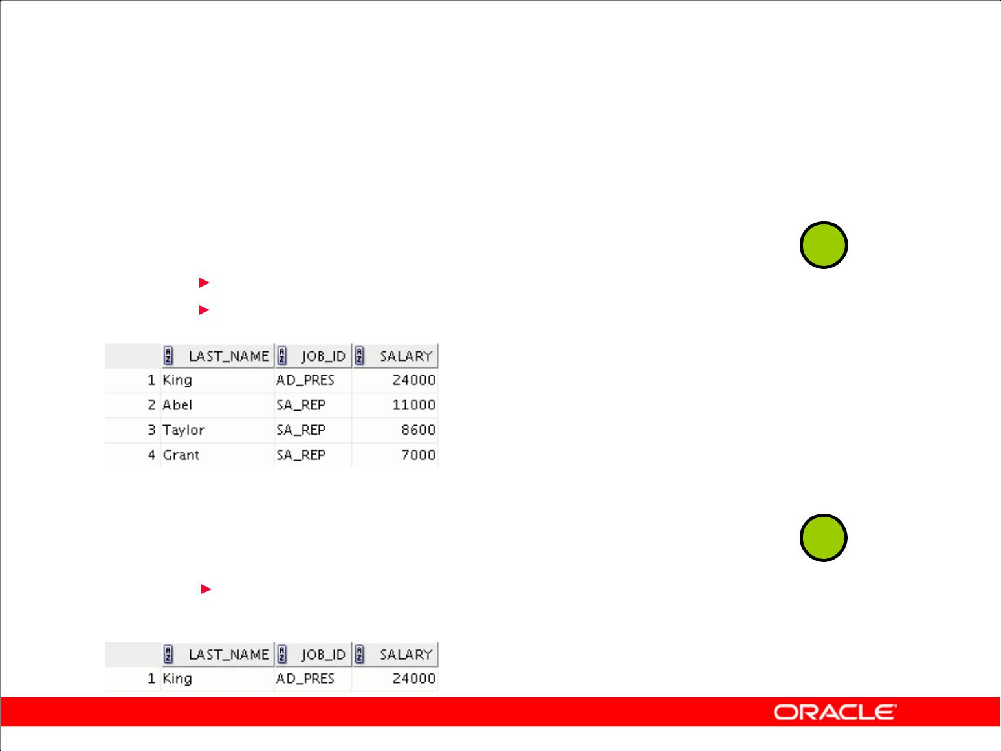**Rules of Precedence**

|  |  |  |  |  |  |  |  |
| --- | --- | --- | --- | --- | --- | --- | --- |
|  | **SELECT** | |  | **last_name, job_id, salary** | |  |  |
|  | **FROM** | |  | **employees** | | **1** |  |
|  | **WHERE** | |  | **job_id = 'SA_REP'** | |  |
|  | **OR** |  |  | **job_id = 'AD_PRES'** | |  |  |
|  |  |  |
|  | **AND** |  |  | **salary > 15000;** | |  |  |
|  |  |  |  |
|  |  |  |  |  |  |  |  |
|  |  |  |  |  |  |  |  |

|  |  |  |  |  |  |  |  |  |
| --- | --- | --- | --- | --- | --- | --- | --- | --- |
|  | **SELECT** | | | | **last_name, job_id, salary** | |  |  |
|  | **FROM** | | | | **employees** | | **2** |  |
|  | **WHERE** | |  |  | **(job_id = 'SA_REP'** | |  |
|  |  |  |  |  | **job_id = 'AD_PRES')** | |  |  |
|  | **OR** |  |  |  |  |  |
|  |  |  |  |  |
|  | **AND** |  | | | **salary > 15000;** | |  |  |
|  |  |  |  |  |  |  |  |  |
|  |  |  |  |  |  |  |  |  |

Copyright © 2009, Oracle. All rights reserved.

**Rules of Precedence (continued)**

**1. Example of the Precedence of the AND Operator**

In this example, there are two conditions:

* The first condition is that the job ID is AD_PRES *and* the salary is greater than $15,000.
* The second condition is that the job ID is SA_REP.

Therefore, the SELECT statement reads as follows:

“Select the row if an employee is a president *and* earns more than $15,000, *or* if the employee is a sales representative.”

**2. Example of Using Parentheses**

In this example, there are two conditions:

* The first condition is that the job ID is AD_PRES *or* SA_REP.
* The second condition is that salary is greater than $15,000.

Therefore, the SELECT statement reads as follows:

“Select the row if an employee is a president *or* a sales representative, *and* if the employee earns more than $15,000.”

|  |
| --- |
| Oracle Internal & Oracle Academy Use Only |

**Oracle Database 10*g*: SQL Fundamentals I 2 - 19**

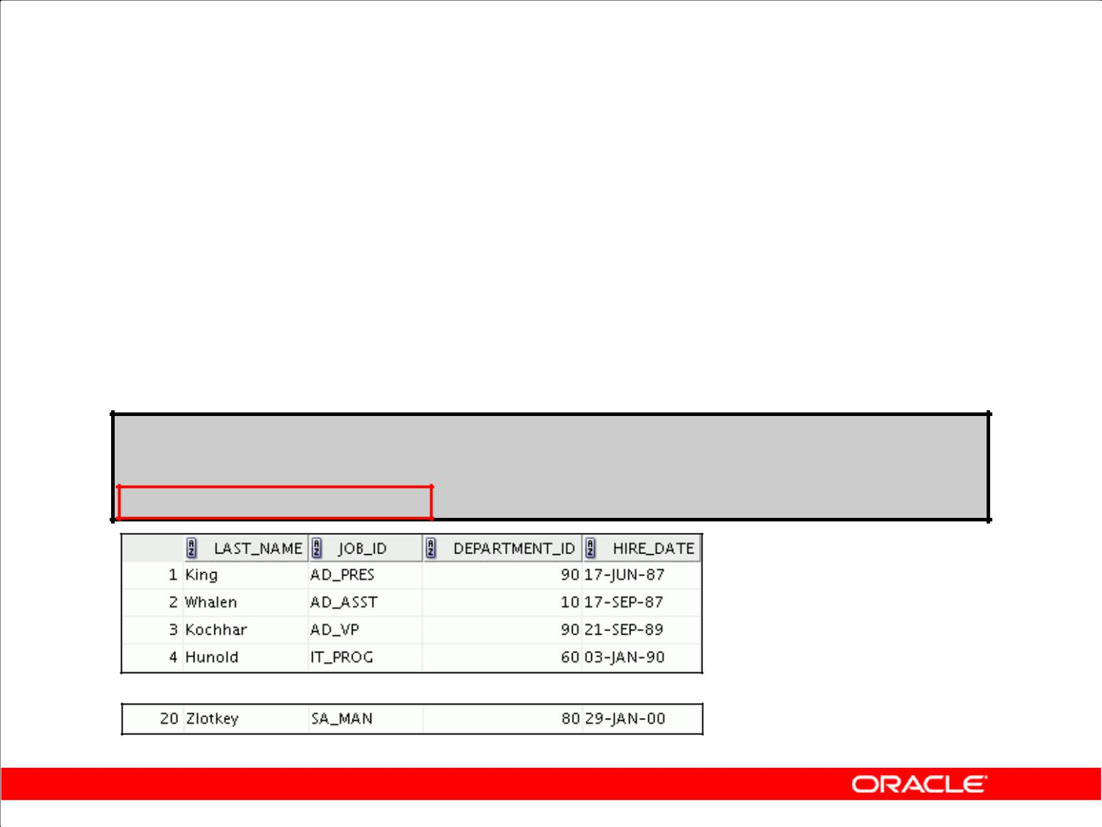**Using the ORDER BY Clause**

* Sort retrieved rows with the ORDER BY clause:

– ASC: ascending order, default

– DESC: descending order

* The ORDER BY clause comes last in the SELECT statement:

**SELECT** **last_name, job_id, department_id, hire_date**

**FROM** **employees**

**ORDER BY hire_date ;**

**…**

Copyright © 2009, Oracle. All rights reserved.

**Using the ORDER BY Clause**

The order of rows that are returned in a query result is undefined. The ORDER BY clause can be used to sort the rows. If you use the ORDER BY clause, it must be the last clause of the SQL statement. You can specify an expression, an alias, or a column position as the sort condition.

**Syntax**

|  |  |  |
| --- | --- | --- |
| SELECT | *expr* |  |
| FROM | *table* |  |
| [WHERE | *condition(s)*] |  |
| [ORDER BY | {*column*, *expr, numeric_position*} [ASC|DESC]]; |  |
| In the syntax: | specifies the order in which the retrieved rows are displayed |  |
| ORDER BY |  |
| ASC | orders the rows in ascending order (this is the default order) |  |
| DESC | orders the rows in descending order |  |

If the ORDER BY clause is not used, the sort order is undefined, and the Oracle server may not fetch rows in the same order for the same query twice. Use the ORDER BY clause to display the rows in a specific order.

|  |
| --- |
| Oracle Internal & Oracle Academy Use Only |

**Oracle Database 10*g*: SQL Fundamentals I 2 - 20**

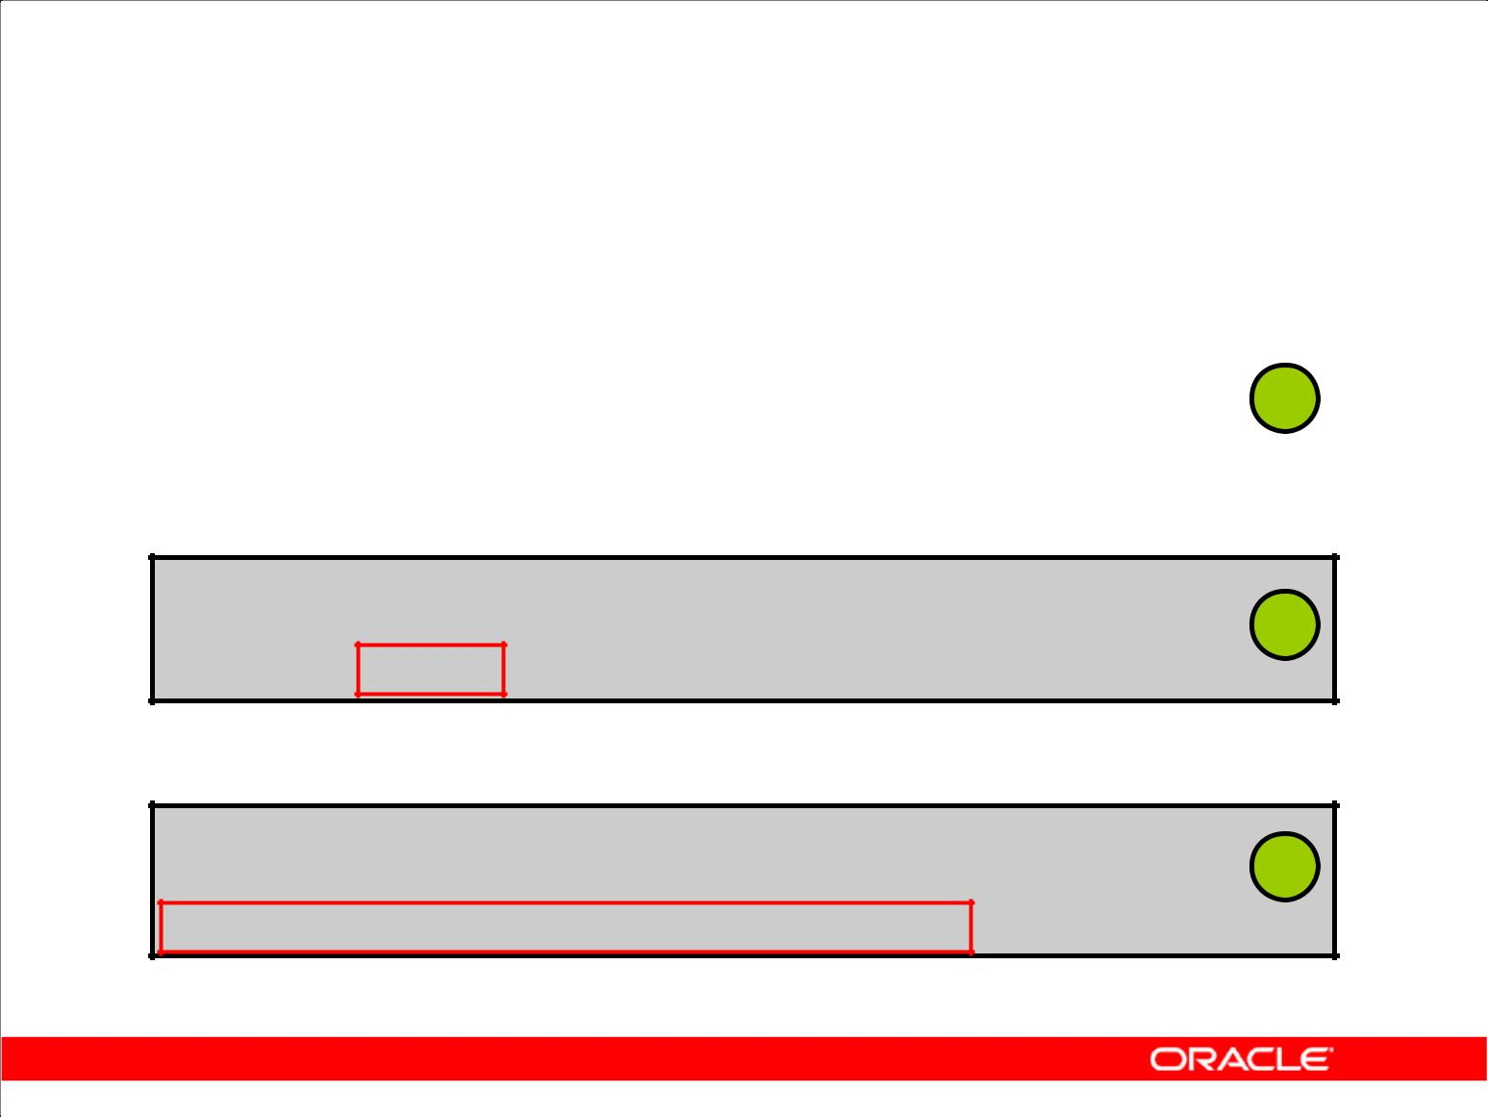**Sorting**

* Sorting in descending order:

|  |  |  |  |  |  |
| --- | --- | --- | --- | --- | --- |
| **SELECT** | **last_name, job_id, department_id, hire_date** | | | |  |
| **FROM** | **employees** | | | **1** |  |
| **ORDER BY hire_date** | | **DESC** | **;** |  |
|  |  |
|  |  |  |  |  |  |

* Sorting by column alias:

|  |  |  |  |  |
| --- | --- | --- | --- | --- |
| **SELECT** | **employee_id, last_name, salary*12** | **annsal** | **2** |  |
| **FROM** | **employees** |  |  |
|  |  |

**ORDER BY annsal ;**

* Sorting by multiple columns:

|  |  |  |  |
| --- | --- | --- | --- |
| **SELECT** | **last_name, department_id, salary** | **3** |  |
| **FROM** | **employees** |  |

**ORDER BY department_id, salary DESC;**

Copyright © 2009, Oracle. All rights reserved.

**Default Ordering of Data**

The default sort order is ascending:

* Numeric values are displayed with the lowest values first (for example, 1 to 999).
* Date values are displayed with the earliest value first (for example, 01-JAN-92 before 01-JAN-95).
* Character values are displayed in alphabetical order (for example, *A* first and *Z* last).
* Null values are displayed last for ascending sequences and first for descending sequences.
* You can sort by a column that is not in the SELECT list.

**Examples**

1. To reverse the order in which rows are displayed, specify the DESC keyword after the column name in the ORDER BY clause. The slide example sorts the result by the most recently hired employee.
2. You can use a column alias in the ORDER BY clause. The slide example sorts the data by annual salary.
3. You can sort query results by more than one column. The sort limit is the number of columns in the given table. In the ORDER BY clause, specify the columns and separate the column names using commas. If you want to reverse the order of a column, specify DESC after its name.

|  |
| --- |
| Oracle Internal & Oracle Academy Use Only |

**Oracle Database 10*g*: SQL Fundamentals I 2 - 21**

**Substitution Variables**

**... salary = ? …**

**… department_id = ? …**

**... last_name = ? ...**

**I want**

**to query**

**different**

**values.**

Copyright © 2009, Oracle. All rights reserved.

**Substitution Variables**

The examples so far have been hard-coded. In a finished application, the user would trigger the report, and the report would run without further prompting. The range of data would be predetermined by the fixed WHERE clause in the script file.

Using SQL Developer, you can create reports that prompt users to supply their own values to restrict the range of data returned by using substitution variables. You can embed *substitution variables* in a command file or in a single SQL statement. A variable can be thought of as a container in which the values are temporarily stored. When the statement is run, the value is substituted.

|  |
| --- |
| Oracle Internal & Oracle Academy Use Only |

**Oracle Database 10*g*: SQL Fundamentals I 2 - 22**

**Substitution Variables**

* Use substitution variables to:

– Temporarily store values with single-ampersand (&) and double-ampersand (&&) substitution

* Use substitution variables to supplement the following:

– WHERE conditions

– ORDER BY clauses

– Column expressions

– Table names

– Entire SELECT statements

Copyright © 2009, Oracle. All rights reserved.

**Substitution Variables (continued)**

You can use single-ampersand (&) substitution variables to temporarily store values.

You can predefine variables in by using the DEFINE command. DEFINE creates and assigns a value to a variable.

**Examples of Restricted Ranges of Data**

* Reporting figures only for the current quarter or specified date range
* Reporting on data relevant only to the user requesting the report
* Displaying personnel only within a given department

**Other Interactive Effects**

Interactive effects are not restricted to direct user interaction with the WHERE clause. The same principles can be used to achieve other goals, such as:

* Obtaining input values from a file rather than from a person
* Passing values from one SQL statement to another

**Note:** Both SQL Developer and SQL* Plus support the substitution variables and theDEFINE/UNDEFINE commands. However SQL Developer and SQL* Plus do not support

validation checks (except for data type) on user input.

|  |
| --- |
| Oracle Internal & Oracle Academy Use Only |

**Oracle Database 10*g*: SQL Fundamentals I 2 - 23**

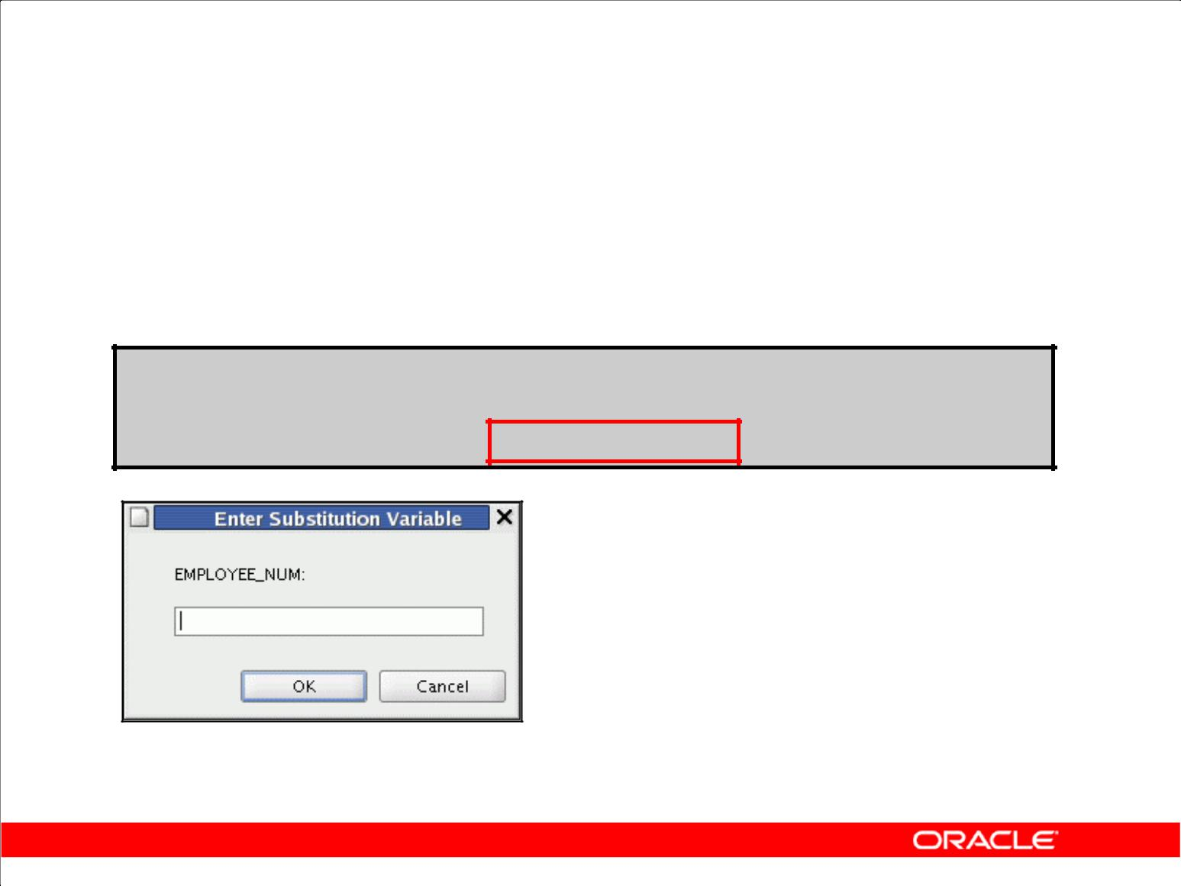**Using the & Substitution Variable**

Use a variable prefixed with an ampersand (&) to prompt the user for a value:

**SELECT employee_id, last_name, salary, department_id FROM employees**

**WHERE** **employee_id = &employee_num ;**

Copyright © 2009, Oracle. All rights reserved.

**Single-Ampersand Substitution Variable**

When running a report, users often want to restrict the data that is returned dynamically. SQL*Plus or SQL Developer provides this flexibility with user variables. Use an ampersand (&) to identify each

variable in your SQL statement. You do not need to define the value of each variable.

|  |  |
| --- | --- |
| **Notation** | **Description** |
|  |  |
| *&user_variable* | Indicates a variable in a SQL statement; if the variable does not |
|  | exist, SQL*Plus or SQL Developer prompts the user for a value |
|  | (the new variable is discarded after it is used.) |
|  |  |

The example in the slide creates a SQL Developer substitution variable for an employee number. When the statement is executed, SQL Developer prompts the user for an employee number and then displays the employee number, last name, salary, and department number for that employee.

With the single ampersand, the user is prompted every time the command is executed, if the variable does not exist.

|  |
| --- |
| Oracle Internal & Oracle Academy Use Only |

**Oracle Database 10*g*: SQL Fundamentals I 2 - 24**

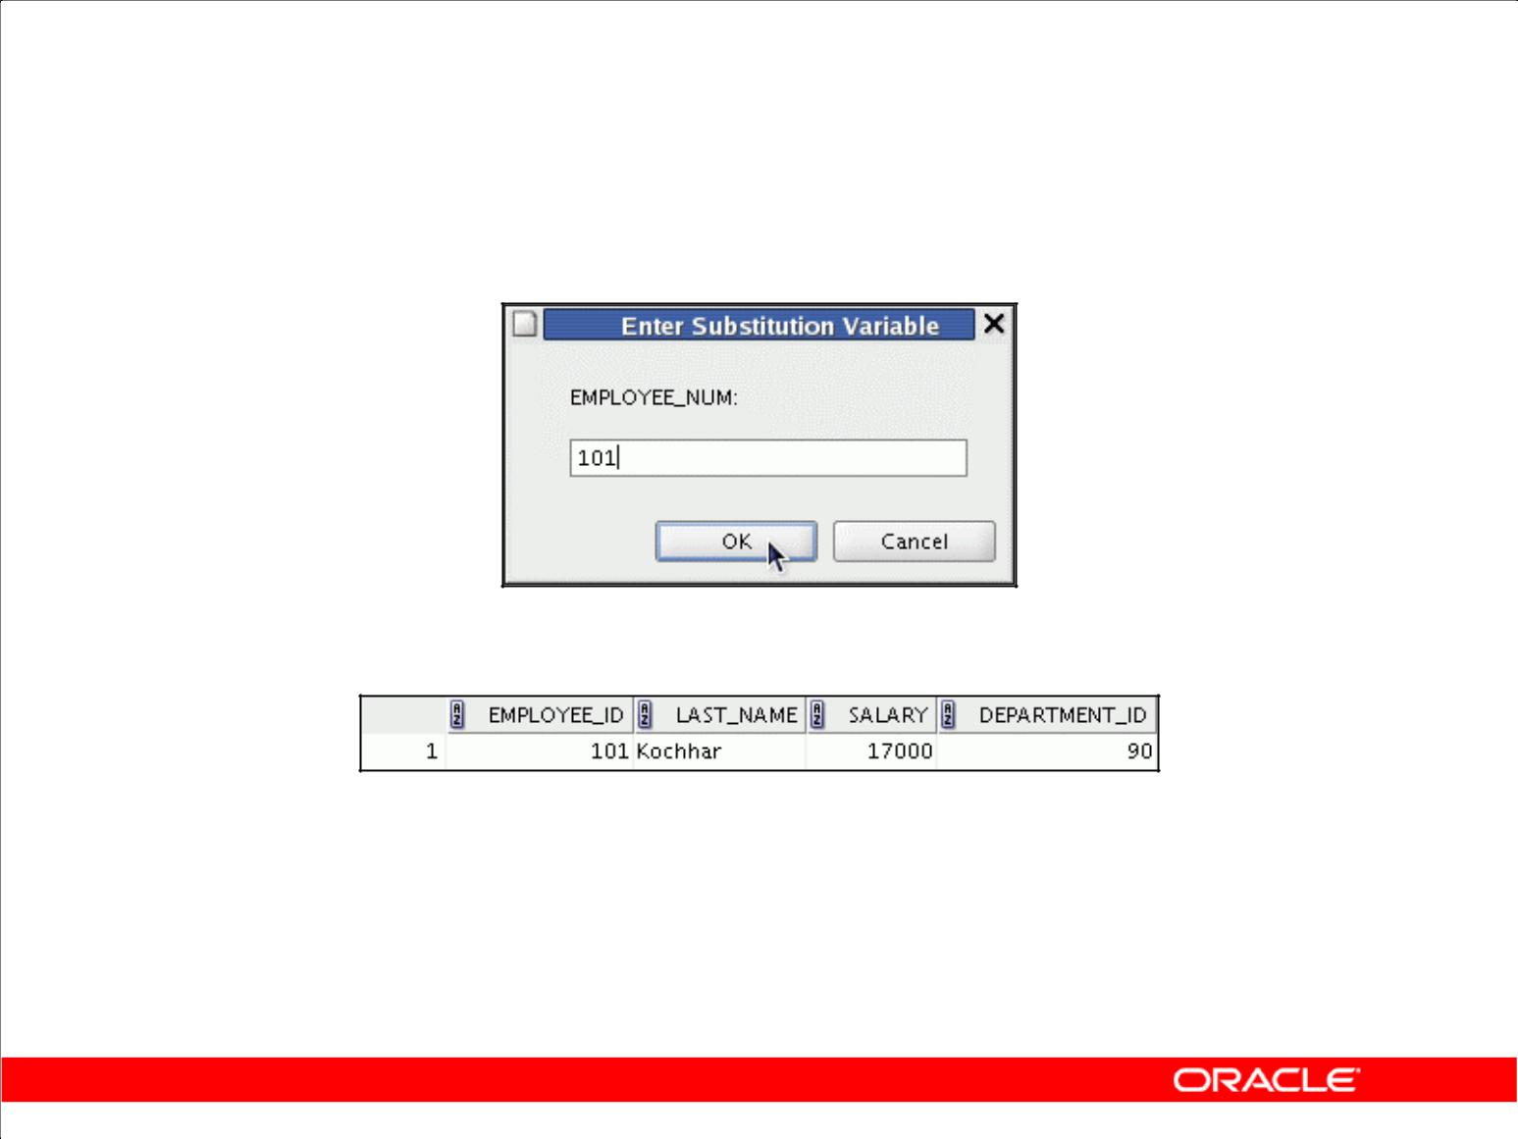**Using the & Substitution Variable**

**101**

Copyright © 2009, Oracle. All rights reserved.

**Single-Ampersand Substitution Variable (continued)**

When SQL Developer detects that the SQL statement contains an ampersand, you are prompted to enter a value for the substitution variable that is named in the SQL statement.

After you enter a value and click the OK button, the results are displayed in the Results tab of the SQL Developer session.

|  |
| --- |
| Oracle Internal & Oracle Academy Use Only |

**Oracle Database 10*g*: SQL Fundamentals I 2 - 25**

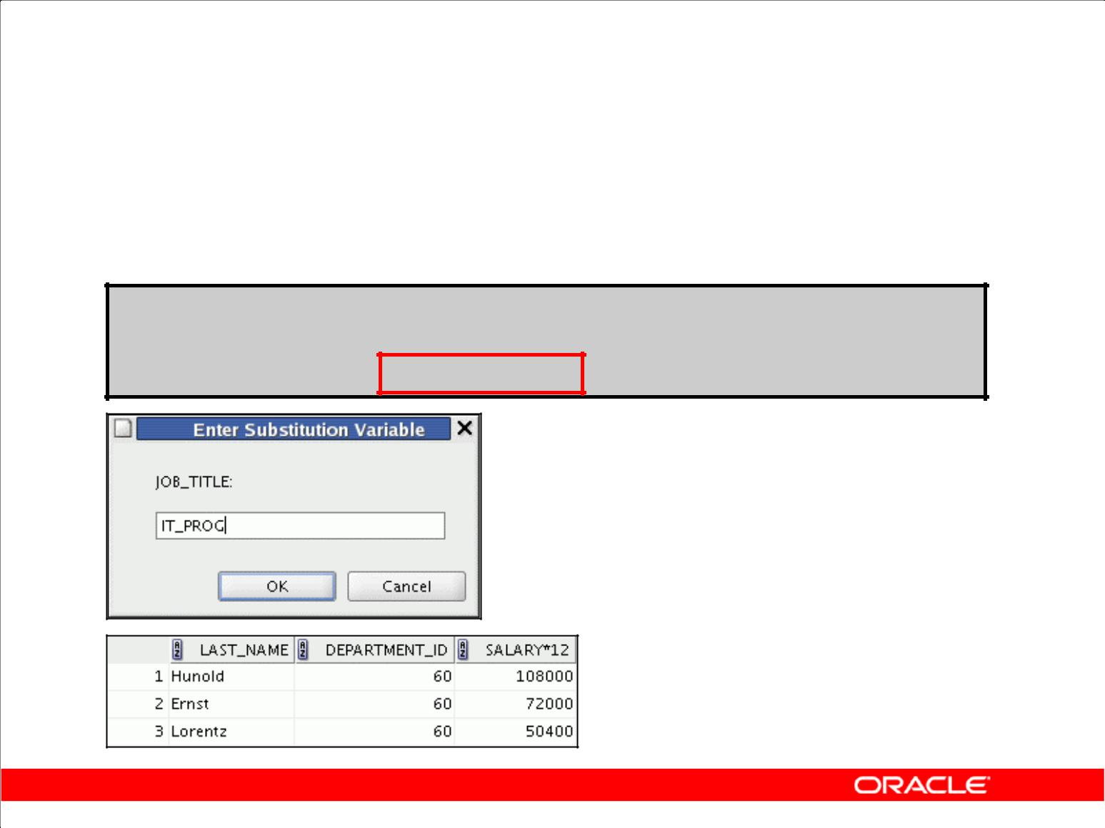**Character and Date Values**

**with Substitution Variables**

Use single quotation marks for date and character values:

**SELECT last_name, department_id, salary*12**

**FROM employees**

**WHERE** **job_id = '&job_title' ;**

Copyright © 2009, Oracle. All rights reserved.

**Specifying Character and Date Values with Substitution Variables**

In a WHERE clause, date and character values must be enclosed in single quotation marks. The same rule applies to the substitution variables.

Enclose the variable in single quotation marks within the SQL statement itself.

The slide shows a query to retrieve the employee names, department numbers, and annual salaries of all employees based on the job title value of the SQL Developer substitution variable.

|  |
| --- |
| Oracle Internal & Oracle Academy Use Only |

**Oracle Database 10*g*: SQL Fundamentals I 2 - 26**

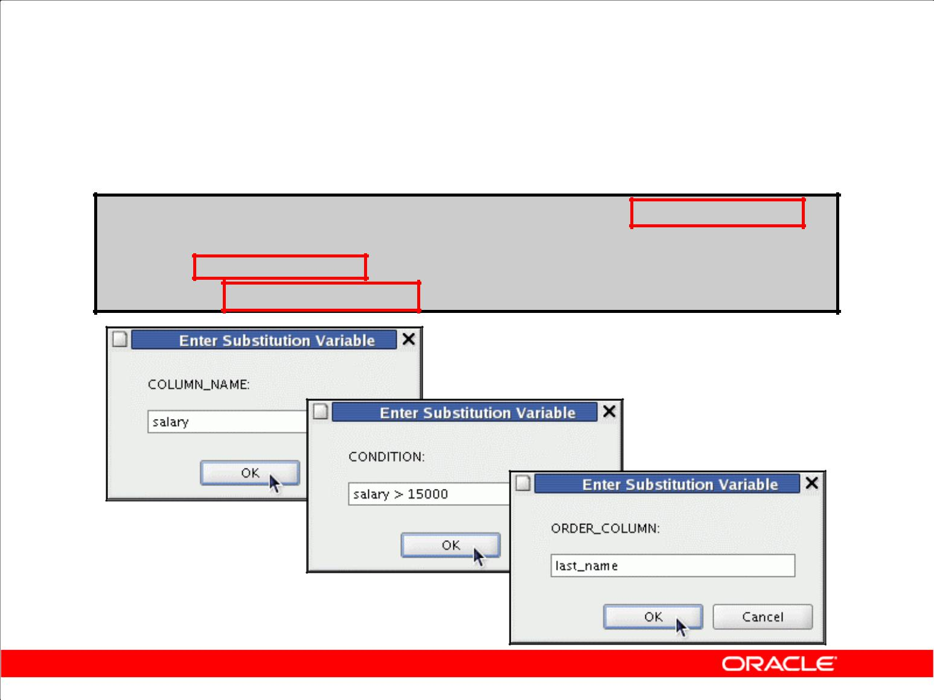**Specifying Column Names,**

**Expressions, and Text**

**SELECT employee_id, last_name, job_id,&column_name**

**FROM employees**

**WHERE** **&condition**

**ORDER BY &order_column ;**

Copyright © 2009, Oracle. All rights reserved.

**Specifying Column Names, Expressions, and Text**

Not only can you use the substitution variables in the WHERE clause of a SQL statement, but these variables can also be used to substitute for column names, expressions, or text.

**Example**

The slide example displays the employee number, name, job title, and any other column that is specified by the user at run time, from the EMPLOYEES table. For each substitution variable in the SELECT statement, you are prompted to enter a value, and you then click the OK button to proceed.

If you do not enter a value for the substitution variable, you get an error when you execute the preceding statement.

**Note:** A substitution variable can be used anywhere in theSELECTstatement, except as the firstword entered at the command prompt.

|  |
| --- |
| Oracle Internal & Oracle Academy Use Only |

**Oracle Database 10*g*: SQL Fundamentals I 2 - 27**

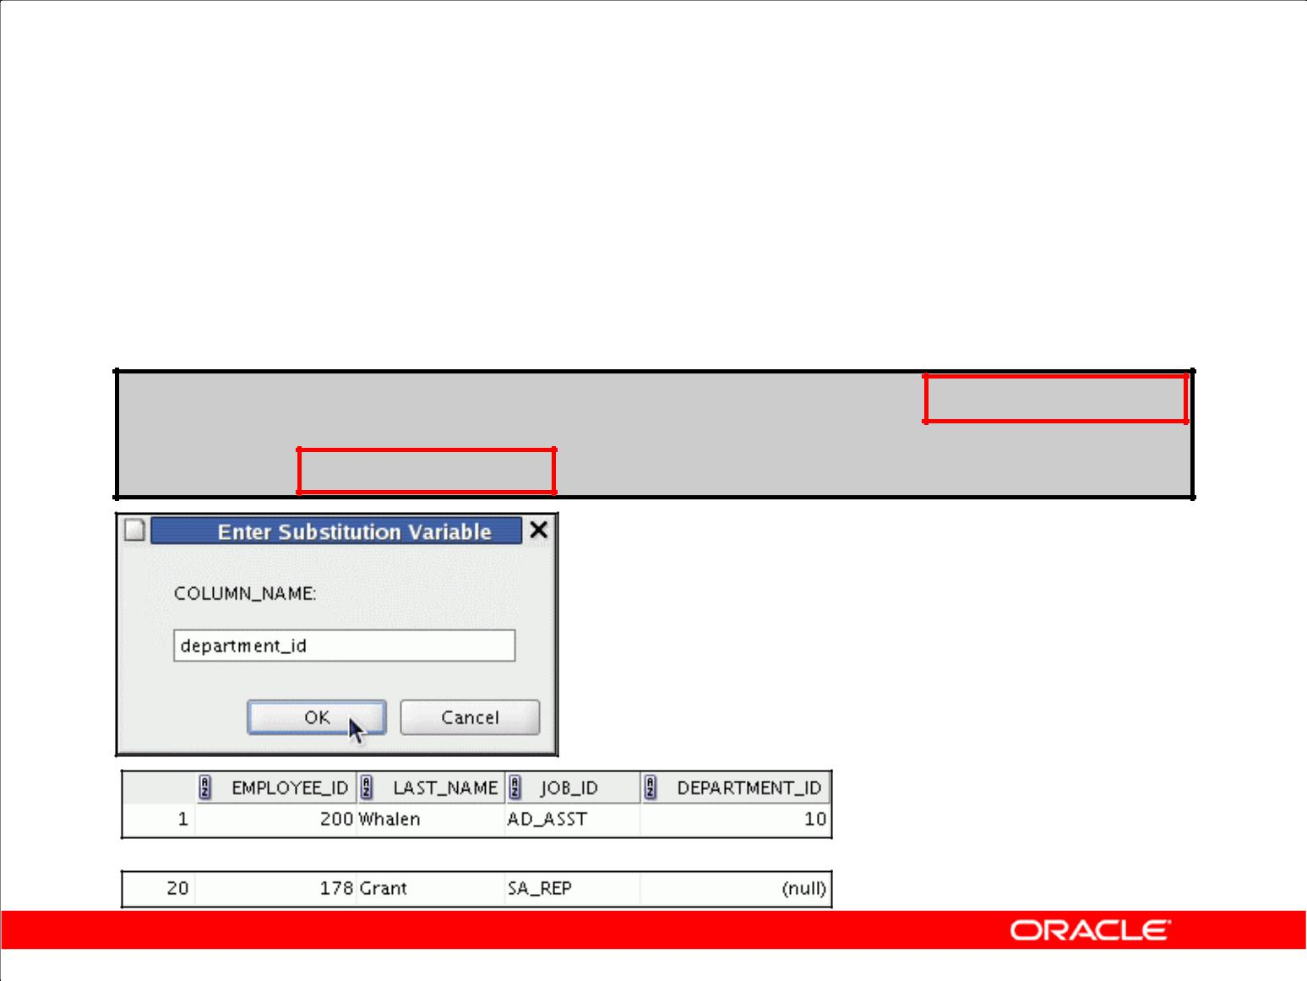**Using the && Substitution Variable**

Use the double ampersand (&&) if you want to reuse the variable value without prompting the user each time:

**SELECT** **employee_id, last_name, job_id, &&column_name**

**FROM** **employees**

**ORDER BY &column_name ;**

**…**

Copyright © 2009, Oracle. All rights reserved.

**Double-Ampersand Substitution Variable**

You can use the double-ampersand (&&) substitution variable if you want to reuse the variable value

without prompting the user each time. The user sees the prompt for the value only once. In the example in the slide, the user is asked to give the value for variable column_name only once. The value that is supplied by the user (department_id) is used for both display and ordering of data.

SQL Developer stores the value that is supplied by using the DEFINE command; it uses it again

whenever you reference the variable name. After a user variable is in place, you need to use the

UNDEFINE command to delete it as follows:

UNDEFINE column_name

|  |
| --- |
| Oracle Internal & Oracle Academy Use Only |

**Oracle Database 10*g*: SQL Fundamentals I 2 - 28**

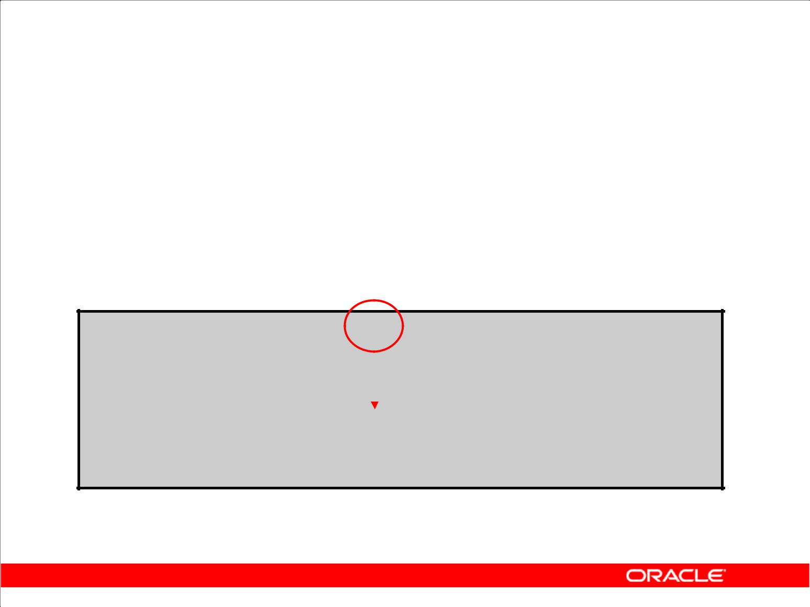**Using the DEFINE Command**

* Use the DEFINE command to create and assign a value to a variable.
* Use the UNDEFINE command to remove a variable.

|  |  |  |  |  |  |  |  |
| --- | --- | --- | --- | --- | --- | --- | --- |
| **DEFINE** | **employee_num** | **= 200** | | | |  |  |
|  |  |  |  |  |  |  |  |
|  |  | | | | | |  |
| **SELECT** | **employee_id, last** | | |  | **_name, salary, department_id** | |  |
| **FROM** | **employees** | | |  |  | |  |
|  |  |
| **WHERE** | **employee_id =** | | **&employee_num** | | | **;** |  |

**UNDEFINE employee_num**

Copyright © 2009, Oracle. All rights reserved.

**Using the DEFINE Command**

The example shown creates a substitution variable for an employee number by using the DEFINE command. At run time, this displays the employee number, name, salary, and department number for that employee.

Because the variable is created using the SQL Developer DEFINE command, the user is not

prompted to enter a value for the employee number. Instead, the defined variable value is automatically substituted in the SELECT statement.

The EMPLOYEE_NUM substitution variable is present in the session until the user undefines it or exits the SQL Developer session.

|  |
| --- |
| Oracle Internal & Oracle Academy Use Only |

**Oracle Database 10*g*: SQL Fundamentals I 2 - 29**

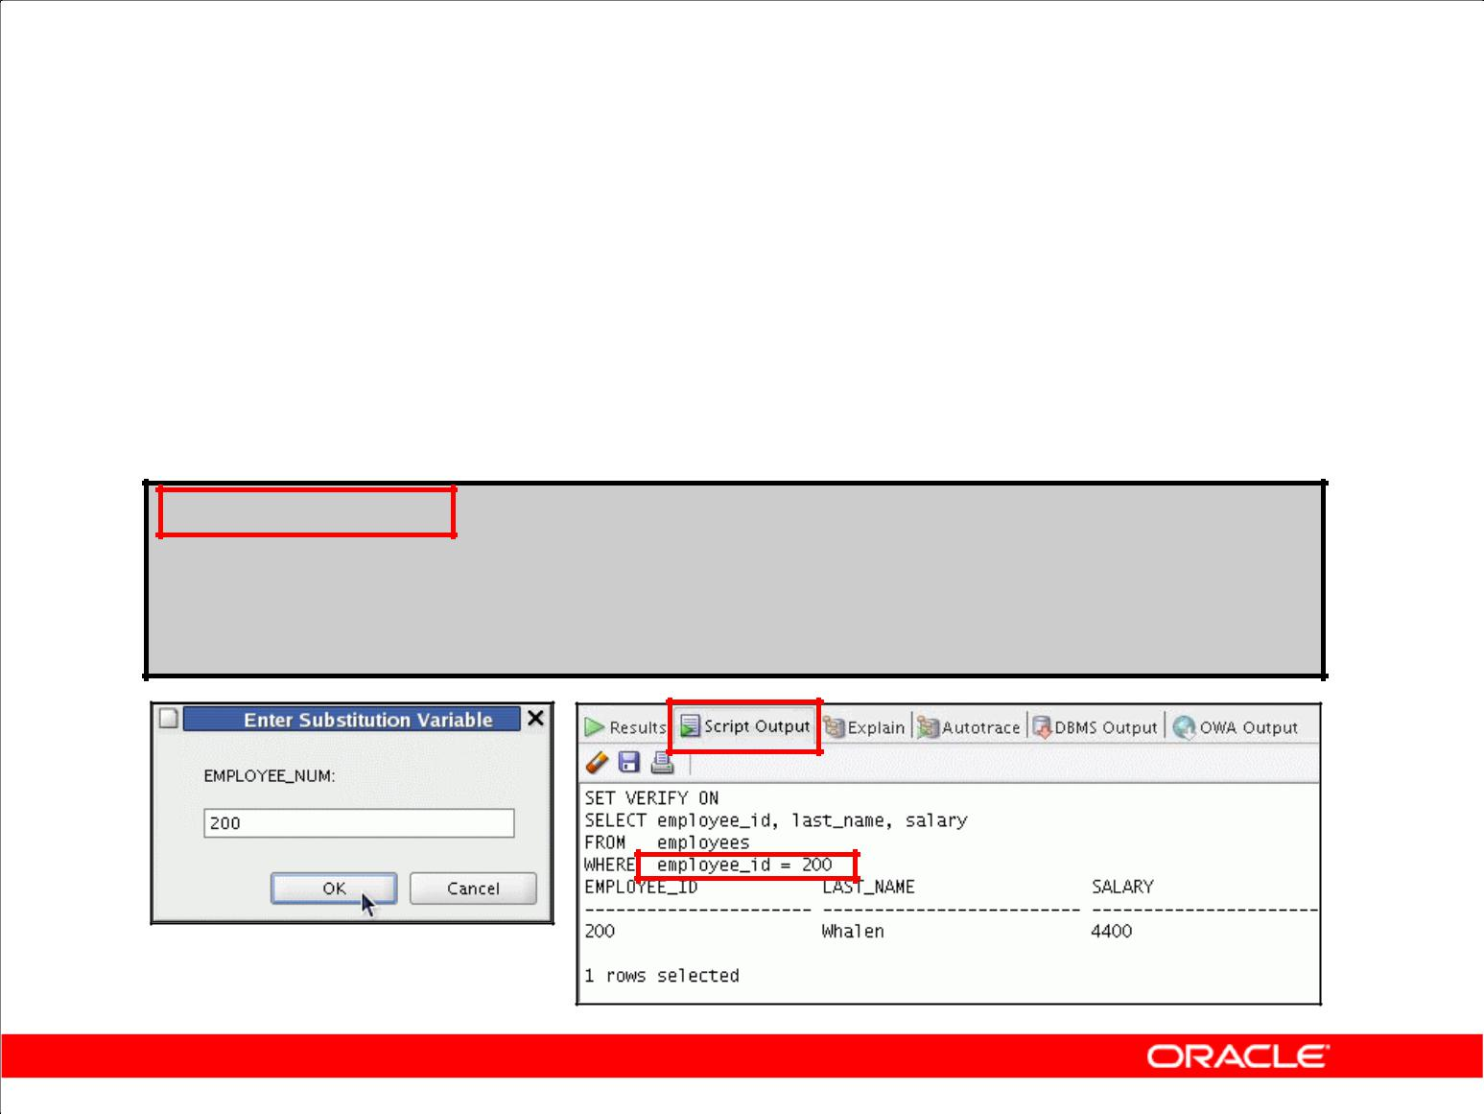**Using the VERIFY Command**

Use the VERIFY command to toggle the display of the substitution variable, both before and after SQL Developer replaces substitution variables with values:

**SET VERIFY ON**

**SELECT employee_id, last_name, salary**

**FROM employees**

**WHERE** **employee_id = &employee_num;**

Copyright © 2009, Oracle. All rights reserved.

**Using the VERIFY Command**

To confirm the changes in the SQL statement, use the VERIFY command. Setting SET VERIFY ON

forces SQL Developer to display the text of a command after it replaces substitution variables with values. To see the VERIFY output, you should use the Run Script (F5) icon in the SQL Worksheet.

SQL Developer displays the text of a command after it replaces substitution variables with values**,** in the Script Output tab as shown in the slide.

The example in the slide displays the new value of the EMPLOYEE_ID column in the SQL statement followed by the output.

**SQL*Plus System Variables**

SQL*Plus uses various system variables that control the working environment. One of the variables is VERIFY. To obtain a complete list of all the system variables, you can issue the SHOW ALL

command on the SQL*Plus command prompt.

|  |
| --- |
| Oracle Internal & Oracle Academy Use Only |

**Oracle Database 10*g*: SQL Fundamentals I 2 - 30**

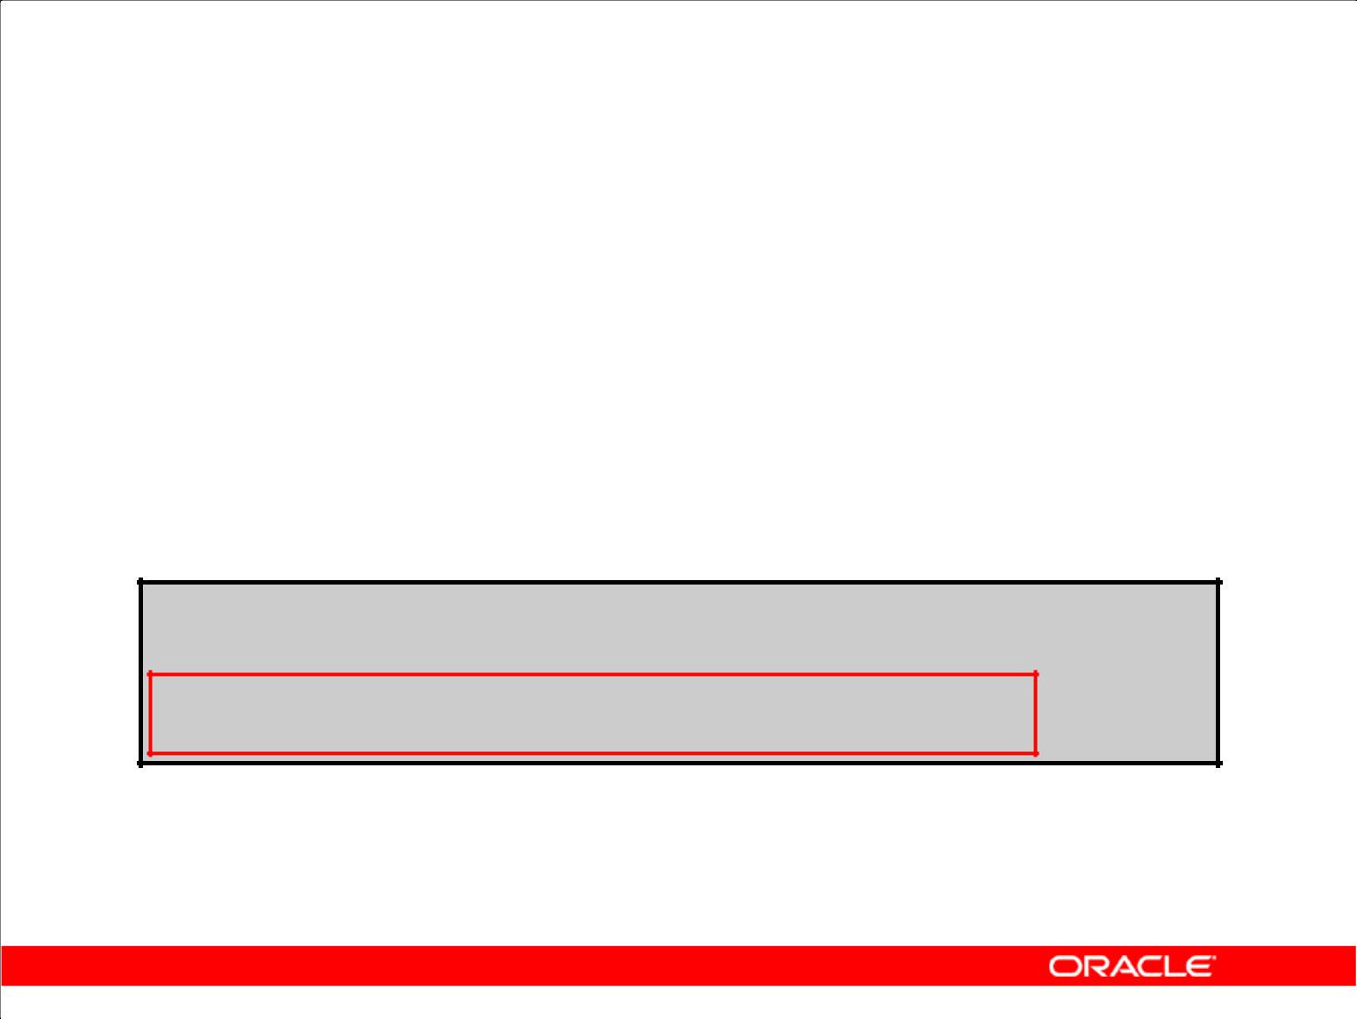**Summary**

In this lesson, you should have learned how to:

* Use the WHERE clause to restrict rows of output:

– Use the comparison conditions

– Use the BETWEEN, IN, LIKE, and NULL conditions

– Apply the logical AND, OR, and NOT operators

* Use the ORDER BY clause to sort rows of output:

**SELECT** **\*|{[DISTINCT] *column|expression* [*alias*],...}**

**FROM** ***table***

**[WHERE** ***condition(s)*]**

**[ORDER BY {*column, expr, alias*} [ASC|DESC]] ;**

* Use ampersand substitution to restrict and sort output at run time

Copyright © 2009, Oracle. All rights reserved.

**Summary**

In this lesson, you should have learned about restricting and sorting rows that are returned by the SELECT statement. You should also have learned how to implement various operators and

conditions.

By using the substitution variables, you can add flexibility to your SQL statements. You can query users at run time and enable them to specify criteria.

|  |
| --- |
| Oracle Internal & Oracle Academy Use Only |

**Oracle Database 10*g*: SQL Fundamentals I 2 - 31**

**Practice 2: Overview**

This practice covers the following topics:

* Selecting data and changing the order of the rows that are displayed
* Restricting rows by using the WHERE clause
* Sorting rows by using the ORDER BY clause
* Using substitution variables to add flexibility to your SQL SELECT statements

Copyright © 2009, Oracle. All rights reserved.

**Practice 2: Overview**

In this practice, you build more reports, including statements that use the WHERE clause and the ORDER BY clause. You make the SQL statements more reusable and generic by including ampersand substitution.

|  |
| --- |
| Oracle Internal & Oracle Academy Use Only |

**Oracle Database 10*g*: SQL Fundamentals I 2 - 32**

**Practice 2**

The HR department needs your assistance with creating some queries.

1. Because of budget issues, the HR department needs a report that displays the last name and salary of employees who earn more than $12,000. Place your SQL statement in a text file named lab_02_01.sql. Run your query.
2. Create a report that displays the last name and department number for employee 176.
3. The HR department needs to find high-salary and low-salary employees. Modify

lab_02_01.sql to display the last name and salary for any employee whose salary is not in the $5,000–$12,000 range. Place your SQL statement in a text file named lab_02_03.sql.

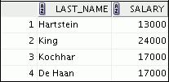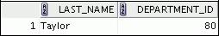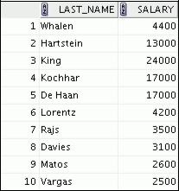

1. Create a report to display the last name, job ID, and start date for the employees whose last names are Matos and Taylor. Order the query in ascending order by start date.

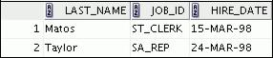

|  |
| --- |
| Oracle Internal & Oracle Academy Use Only |

**Oracle Database 10*g*: SQL Fundamentals I 2 - 33**

**Practice 2 (continued)**

1. Display the last name and department number of all employees in departments 20 or 50 in ascending alphabetical order by name.

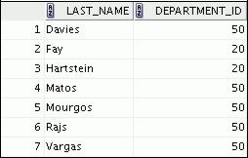

1. Modify lab_02_03.sql to display the last name and salary of employees who earn between $5,000 and $12,000, and are in department 20 or 50. Label the columns Employee and

Monthly Salary, respectively. Resave lab_02_03.sql as lab_02_06.sql. Run the statement in lab_02_06.sql.

1. The HR department needs a report that displays the last name and hire date for all employees who were hired in 1994.
2. Create a report to display the last name and job title of all employees who do not have a manager.
3. Create a report to display the last name, salary, and commission of all employees who earn commissions. Sort the data in descending order of salary and commissions.

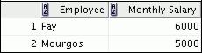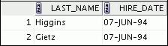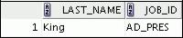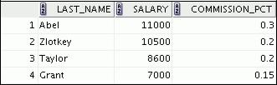

|  |
| --- |
| Oracle Internal & Oracle Academy Use Only |

**Oracle Database 10*g*: SQL Fundamentals I 2 - 34**

**Practice 2 (continued)**

1. Members of the HR department want to have more flexibility with the queries that you are writing. They would like a report that displays the last name and salary of employees who earn more than an amount that the user specifies after a prompt. (You can use the query that you created in practice exercise 1 and modify it.) Save this query to a file named lab_02_10.sql. If you enter 12000 when prompted, the report displays the following results:

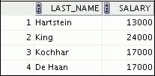

1. The HR department wants to run reports based on a manager. Create a query that prompts the user for a manager ID and generates the employee ID, last name, salary, and department for that manager’s employees. The HR department wants the ability to sort the report on a selected column. You can test the data with the following values:

manager ID = 103, sorted by employee last name:

manager ID = 201, sorted by salary:

manager ID = 124, sorted by employee ID:

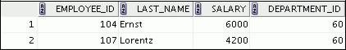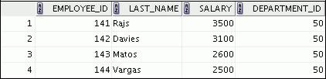

|  |
| --- |
| Oracle Internal & Oracle Academy Use Only |

**Oracle Database 10*g*: SQL Fundamentals I 2 - 35**

**Practice 2 (continued)**

If you have time, complete the following exercises:

1. Display all employee last names in which the third letter of the name is “*a*.”
2. Display the last names of all employees who have both an *a* and an *e* in their last name.

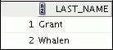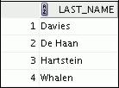

If you want an extra challenge, complete the following exercises:

1. Display the last name, job, and salary for all employees whose jobs are either that of a sales representative or a stock clerk, and whose salaries are not equal to $2,500, $3,500, or $7,000.

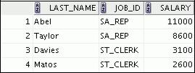

1. Modify lab_02_06.sql to display the last name, salary, and commission for all employees whose commission amount is 20%. Resave lab_02_06.sql as lab_02_15.sql. Rerun the statement in lab_02_15.sql.

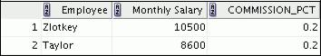

|  |
| --- |
| Oracle Internal & Oracle Academy Use Only |

**Oracle Database 10*g*: SQL Fundamentals I 2 - 36**



**Using Single-Row Functions to**

**Customize Output**

Copyright © 2009, Oracle. All rights reserved.

|  |
| --- |
| Oracle Internal & Oracle Academy Use Only |

**Objectives**

After completing this lesson, you should be able to do the following:

* Describe various types of functions that are available in

SQL

* Use character, number, and date functions in SELECT statements
* Describe the use of conversion functions

Copyright © 2009, Oracle. All rights reserved.

**Objectives**

Functions make the basic query block more powerful, and they are used to manipulate data values. This is the first of two lessons that explore functions. It focuses on single-row character, number, and date functions, as well as those functions that convert data from one type to another (for example, conversion from character data to numeric data).

|  |
| --- |
| Oracle Internal & Oracle Academy Use Only |

**Oracle Database 10*g*: SQL Fundamentals I 3 - 2**

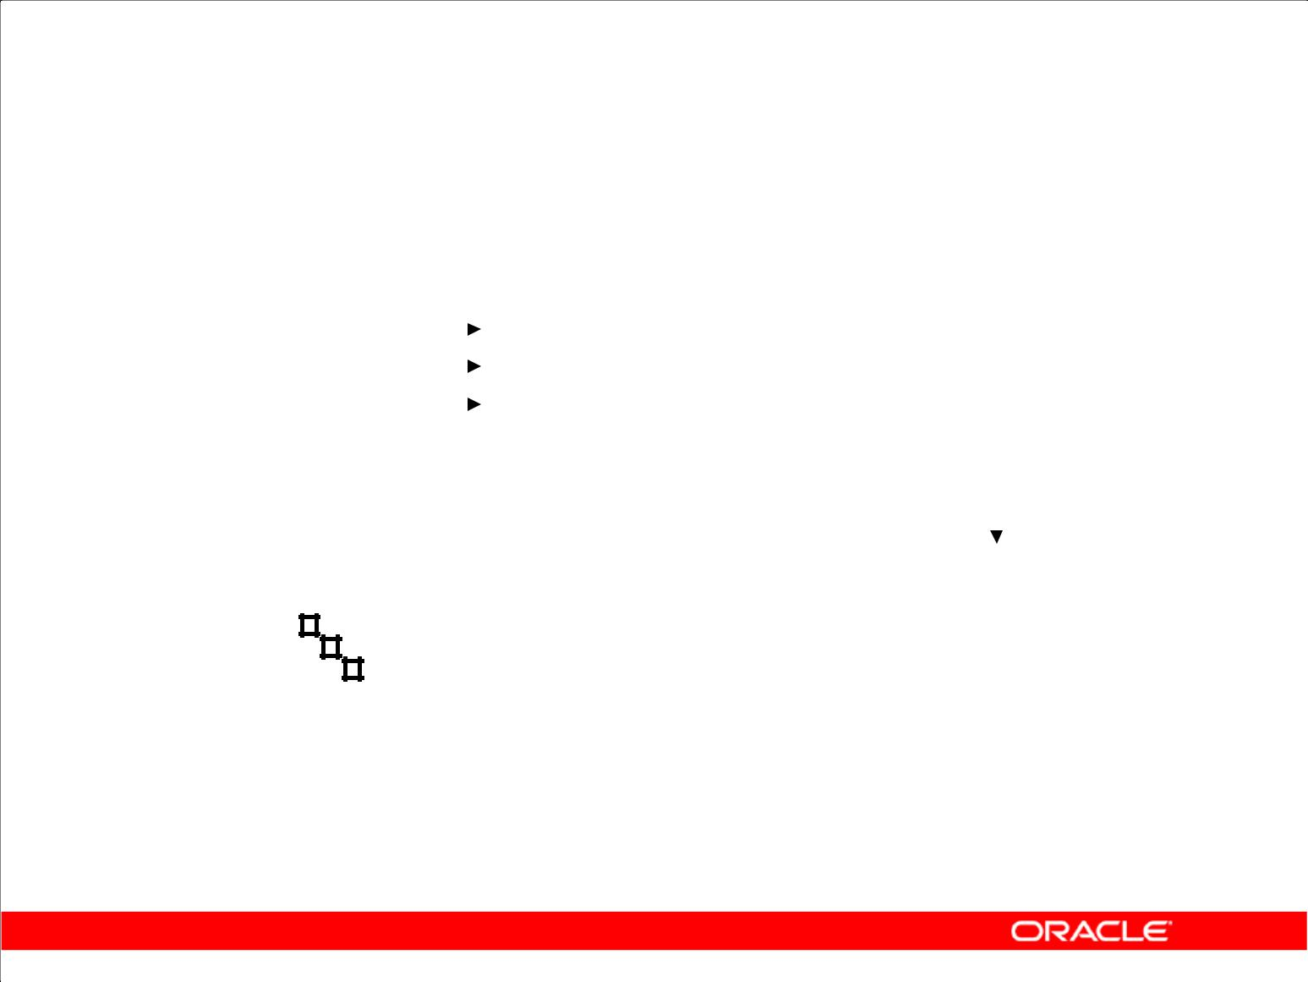**SQL Functions**

|  |  |  |  |  |  |  |  |  |  |  |  |  |  |  |  |  |
| --- | --- | --- | --- | --- | --- | --- | --- | --- | --- | --- | --- | --- | --- | --- | --- | --- |
| **Input** | | | | | | | | | | | |  |  | **Output** | |  |
|  |  |  |  |  |  |  |  |  |  |  |  | **Function** |  |  |  |  |
|  |  |  |  |  |  |  |  |  |  |  |  |  |  |  |  |
|  |  |  |  |  |  |  |  |  |  |  |  |  |  |  |  |
|  |  |  |  |  |  |  |  |  |  |  |  |  |  |  |  |  |
|  |  |  |  |  |  |  |  |  |  |  |  |  |  |  |  |  |
| **arg 1** | | |  |  |  |  |  |  |  |  | | **Function performs** |  | |  |  |
|  |  |  |  |  |  |  |  |  |  |  |  | **action** | | |  |  |
|  |  |  |  |  |  |  |  |  |  |  |  |  |
|  |  | **arg 2** | | | | | |  |  |  |  |  |  |  |  |  |
|  |  |  |  |  |  |  |  | **Result** | |  |
|  |  |  |  |  |  |  |  |  |  |  |  |  |  |  |
|  |  |  |  |  |  |  |  |  |  |  |  |  |  |
|  |  |  |  |  |  |  |  |  |  |  |  |  |  | **value** | |  |
|  |  |  |  |  |  |  |  |  |  |  |  |  |  |
|  |  |  |  |  |  |  |  |  |  |  |  |  |  |
|  |  |  |  |  |  |  |  |  |  |  |  |  |  |
|  |  |  |  |  |  |  |  |  |  |  |  |  |  |  |  |  |
|  |  |  |  |  |  |  |  |  |  |  |  |  |  |  |  |  |
|  |  |  |  |  |  |  |  |  |  |  |  |  |  |  |  |  |
|  |  |  |  |  | **arg n** | | | | |  | |  |  |  |  |  |
|  |  |  |  |  |  |  |  |  |  |  |  |  |  |  |  |  |

Copyright © 2009, Oracle. All rights reserved.

**SQL Functions**

Functions are a very powerful feature of SQL. They can be used to do the following:

* Perform calculations on data
* Modify individual data items
* Manipulate output for groups of rows
* Format dates and numbers for display
* Convert column data types

SQL functions sometimes take arguments and always return a value.

**Note:** Most of the functions that are described in this lesson are specific to the Oracle version ofSQL.

|  |
| --- |
| Oracle Internal & Oracle Academy Use Only |

**Oracle Database 10*g*: SQL Fundamentals I 3 - 3**

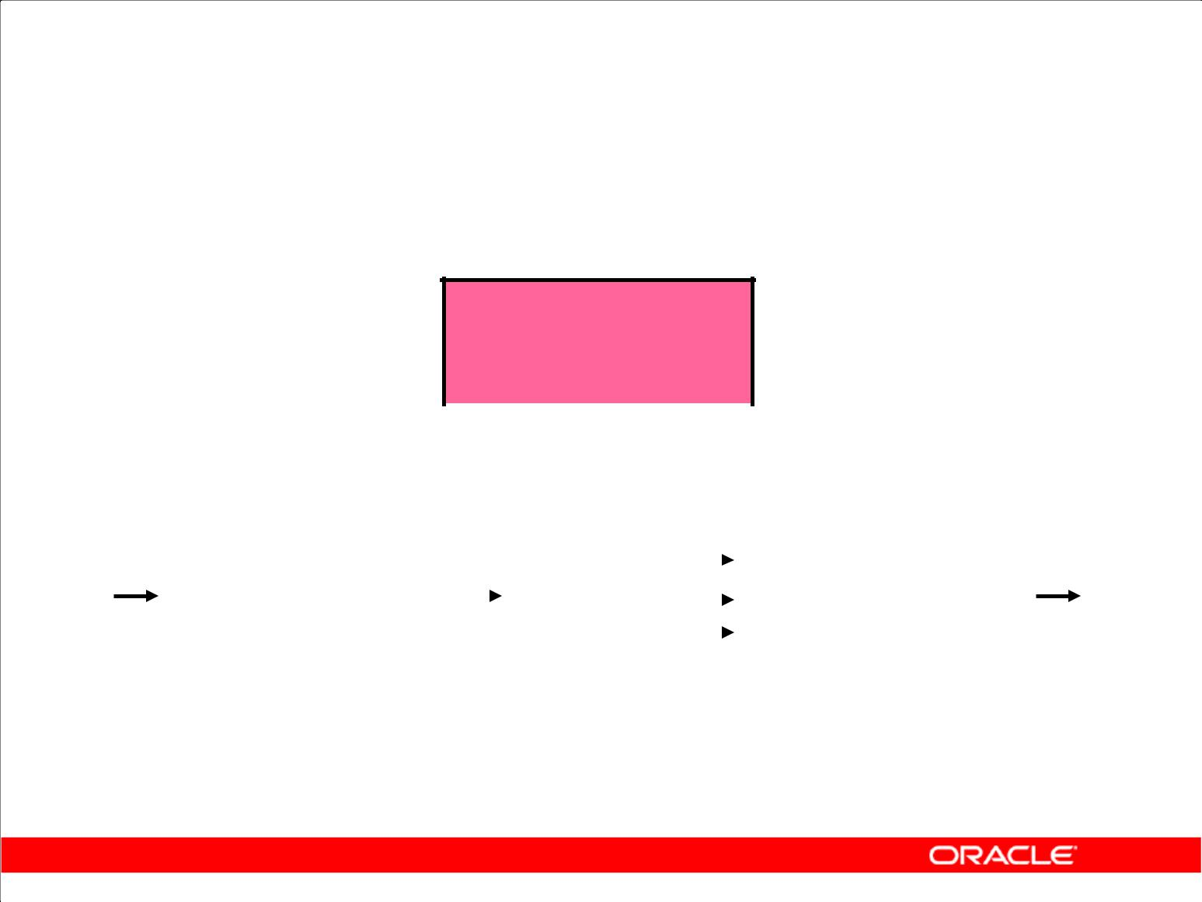**Two Types of SQL Functions**

**Functions**

|  |  |  |  |  |  |  |  |  |  |  |  |
| --- | --- | --- | --- | --- | --- | --- | --- | --- | --- | --- | --- |
|  |  |  |  |  |  |  |  |  |  |  |  |
|  |  |  |  |  |  |  |  |  |  |  |  |
| **Single-row** | | |  |  |  |  |  |  | **Multiple-row** | |  |
|  |  |  |  |  |  |  |
| **functions** | | |  |  |  |  |  |  | **functions** | |  |
|  |  |  |  |  |  |  |  |  |  |  |  |
| **Return one result** | | |  |  |  |  |  |  | **Return one result** | |  |
| **per row** | | |  |  |  |  |  |  | **per set of rows** | |  |

Copyright © 2009, Oracle. All rights reserved.

**SQL Functions (continued)**

There are two types of functions:

* Single-row functions
* Multiple-row functions

**Single-Row Functions**

These functions operate on single rows only and return one result per row. There are different types of single-row functions. This lesson covers the following ones:

* Character
* Number
* Date
* Conversion
* General

**Multiple-Row Functions**

Functions can manipulate groups of rows to give one result per group of rows. These functions are also known as *group functions* (covered in lesson 4).

**Note:** For more information and a complete list of available functions and their syntax, see*Oracle**SQL Reference*.

|  |
| --- |
| Oracle Internal & Oracle Academy Use Only |

**Oracle Database 10*g*: SQL Fundamentals I 3 - 4**

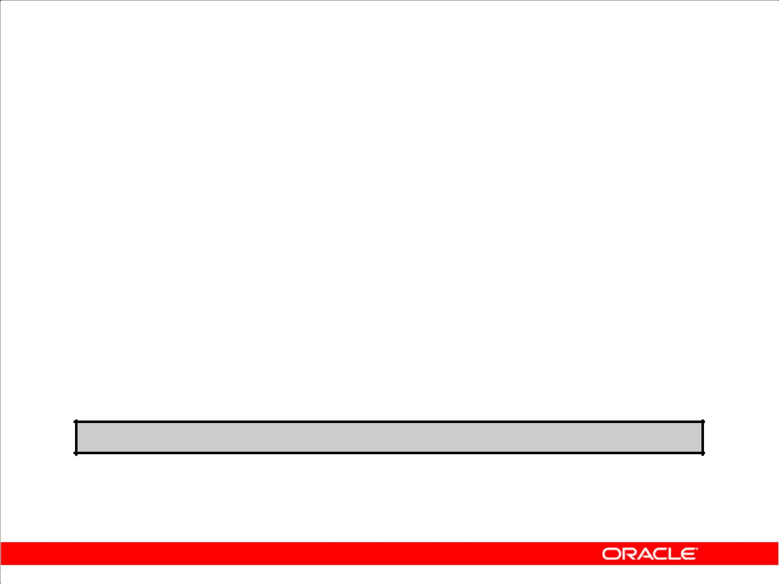**Single-Row Functions**

Single-row functions:

* Manipulate data items
* Accept arguments and return one value
* Act on each row that is returned
* Return one result per row
* May modify the data type
* Can be nested
* Accept arguments that can be a column or an expression

***function_name* [(*arg1, arg2,...*)]**

Copyright © 2009, Oracle. All rights reserved.

**Single-Row Functions**

Single-row functions are used to manipulate data items. They accept one or more arguments and return one value for each row that is returned by the query. An argument can be one of the following:

* User-supplied constant
* Variable value
* Column name
* Expression

Features of single-row functions include:

* Acting on each row that is returned in the query
* Returning one result per row
* Possibly returning a data value of a different type than the one that is referenced
* Possibly expecting one or more arguments
* Can be used in SELECT, WHERE, and ORDER BY clauses; can be nested

In the syntax:

*function_name* is the name of the function

*arg1, arg2* is any argument to be used by the function. This can be represented by a column name or expression.

|  |
| --- |
| Oracle Internal & Oracle Academy Use Only |

**Oracle Database 10*g*: SQL Fundamentals I 3 - 5**

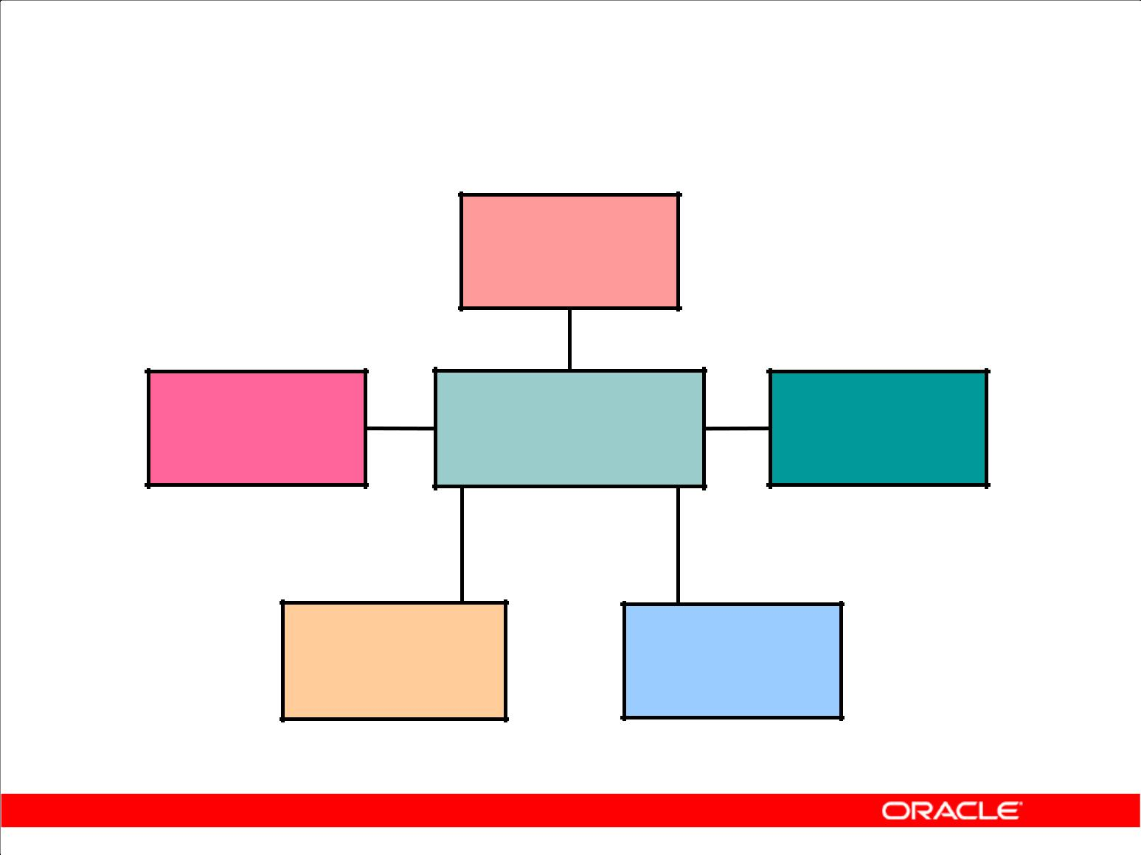**Single-Row Functions**

**Character**

**Single-row**

**General** **Number**

**functions**

**Conversion** **Date**

Copyright © 2009, Oracle. All rights reserved.

**Single-Row Functions (continued)**

This lesson covers the following single-row functions:

* **Character functions:** Αccept character input and can return both character and number values
* **Number functions:** Accept numeric input and return numeric values
* **Date functions:** Operate on values of theDATEdata type (All date functions return a value ofDATE data type except the MONTHS_BETWEEN function, which returns a number.)
* **Conversion functions:** Convert a value from one data type to another
* **General functions:**
  + NVL
  + NVL2
  + NULLIF
  + COALESCE
  + CASE
  + DECODE

|  |
| --- |
| Oracle Internal & Oracle Academy Use Only |

**Oracle Database 10*g*: SQL Fundamentals I 3 - 6**

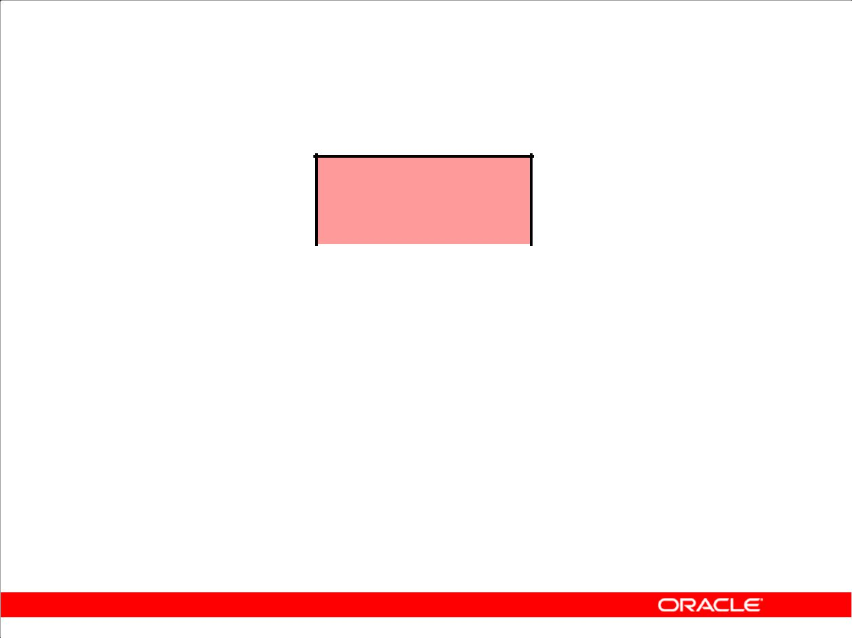**Character Functions**

**Character**

**functions**

|  |  |  |  |  |  |  |  |
| --- | --- | --- | --- | --- | --- | --- | --- |
|  |  |  |  |  |  |  |  |
|  |  |  |  |  |  |  |  |
| **Case-manipulation** | | |  |  | **Character-manipulation** | | |
| **functions** | | |  |  |  | **functions** | |
|  |  |  |  |  |  |  |  |
| **LOWER** | | |  |  |  | **CONCAT** | |
| **UPPER** | | |  |  |  | **SUBSTR** | |
| **INITCAP** | | |  |  |  | **LENGTH** | |
|  |  |  |  |  |  | **INSTR** | |
|  |  |  |  |  |  | **LPAD | RPAD** | |
|  |  |  |  |  |  | **TRIM** | |
|  |  |  |  |  |  | **REPLACE** | |

Copyright © 2009, Oracle. All rights reserved.

**Character Functions**

Single-row character functions accept character data as input and can return both character and numeric values. Character functions can be divided into the following:

* Case-manipulation functions
* Character-manipulation functions

|  |  |
| --- | --- |
| **Function** | **Purpose** |
|  |  |
| LOWER(*column|expression*) | Converts alpha character values to lowercase |
|  |  |
| UPPER(*column|expression*) | Converts alpha character values to uppercase |
|  |  |
| INITCAP(*column|expression*) | Converts alpha character values to uppercase for the first |
|  | letter of each word; all other letters in lowercase |
|  |  |
| CONCAT(*column1|expression1,* | Concatenates the first character value to the second |
| *column2|expression2*) | character value; equivalent to concatenation operator (||) |
|  |  |
| SUBSTR(*column|expression,m[* | Returns specified characters from character value starting at |
| *,n]*) | character position *m, n* characters long (If *m* is negative, the |
|  | count starts from the end of the character value. If *n* is |
|  | omitted, all characters to the end of the string are returned.) |
|  |  |

**Note:** The functions discussed in this lesson are only some of the available functions.

|  |
| --- |
| Oracle Internal & Oracle Academy Use Only |

**Oracle Database 10*g*: SQL Fundamentals I 3 - 7**

**Character Functions (continued)**

|  |  |  |  |
| --- | --- | --- | --- |
| **Function** | **Purpose** |  |  |
|  |  |  |  |
| LENGTH(*column|expression*) | Returns the number of characters in the expression |  |  |
|  |  |  |  |
| INSTR(*column|expression,* | Returns the numeric position of a named string. Optionally, |  |  |
| *’string’, [,m], [n]* ) | you can provide a position *m* to start searching, and the |  |  |
|  | occurrence *n* of the string. *m* and *n* default to 1, meaning |  |  |
|  | start the search at the beginning of the search and report the |  |  |
|  | first occurrence. |  |  |
| LPAD(*column*|*expression*, *n*, | Pads the character value right-justified to a total width of *n* |  |  |
| **'***string***'**) | character positions |  |  |
| RPAD(*column*|*expression*, *n*, | Pads the character value left-justified to a total width of *n* |  |  |
| **'***string***'**) | character positions | Only |  |
| TRIM(*leading|trailing|both,* | Enables you to trim heading or trailing characters (or both) |  |
| *trim_character FROM* | from a character string. If *trim_character* or |  |
| *trim_source*) | *trim_source* is a character literal, you must enclose it in |  |
|  | single quotation marks. | Use |  |
|  | This is a feature that is available in Oracle8*i* and later |  |
|  | versions. | OracleInternal&OracleAcademy |  |
| REPLACE(*text,* | Searches a text expression for a character string and, if |  |
|  |  |
| *search_string,* | found, replaces it with a specified replacement string |  |  |
| *replacement_string*) |  |  |  |
|  |  |  |  |

**Oracle Database 10*g*: SQL Fundamentals I 3 - 8**

**Case-Manipulation Functions**

These functions convert case for character strings:

|  |  |
| --- | --- |
| **Function** | **Result** |
| LOWER('SQL Course') | sql course |
|  |  |
| UPPER('SQL Course') | SQL COURSE |
|  |  |
| INITCAP('SQL Course') | Sql Course |
|  |  |

Copyright © 2009, Oracle. All rights reserved.

**Case-Manipulation Functions**

LOWER, UPPER, and INITCAP are the three case-conversion functions.

* **LOWER:** Converts mixed-case or uppercase character strings to lowercase
* **UPPER:** Converts mixed-case or lowercase character strings to uppercase
* **INITCAP:** Converts the first letter of each word to uppercase and remaining letters to lowercase

SELECT 'The job id for '||UPPER(last_name)||' is ' ||LOWER(job_id) AS "EMPLOYEE DETAILS"

FROM employees;

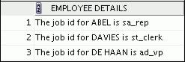

|  |
| --- |
| Oracle Internal & Oracle Academy Use Only |

**…**

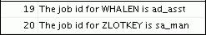

**Oracle Database 10*g*: SQL Fundamentals I 3 - 9**

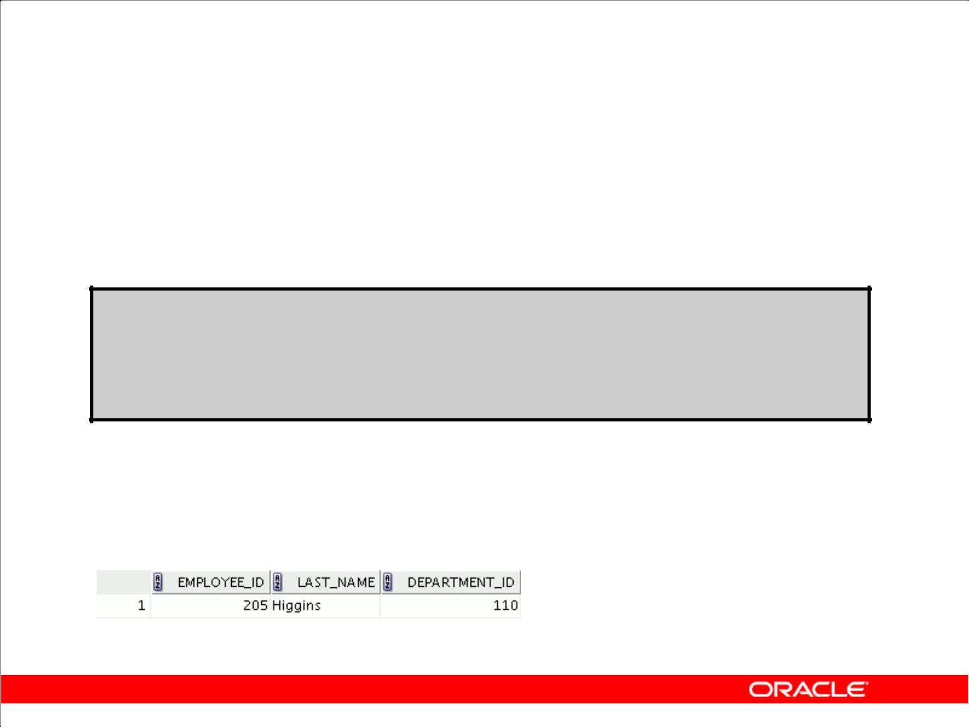**Using Case-Manipulation Functions**

Display the employee number, name, and department number for employee Higgins:

**SELECT employee_id, last_name, department_id FROM employees**

**WHERE** **last_name = 'higgins';**

**no rows selected**

|  |  |  |  |  |
| --- | --- | --- | --- | --- |
|  | **SELECT** | **employee_id, last_name, department_id** | | |
|  | **FROM** | **employees** | | |
|  | **WHERE** | **LOWER(last_name) = 'higgins';** | |  |
|  |  |  |  |  |
|  |  |  |  |  |
|  |  |  |  |  |

Copyright © 2009, Oracle. All rights reserved.

**Using Case-Manipulation Functions**

The slide example displays the employee number, name, and department number of employee Higgins.

The WHERE clause of the first SQL statement specifies the employee name as higgins. Because all the data in the EMPLOYEES table is stored in proper case, the name higgins does not find a match in the table, and no rows are selected.

The WHERE clause of the second SQL statement specifies that the employee name in the EMPLOYEES table is compared to higgins, converting the LAST_NAME column to lowercase for

comparison purposes. Because both names are now lowercase, a match is found and one row is selected. The WHERE clause can be rewritten in the following manner to produce the same result:

...WHERE last_name = 'Higgins'

The name in the output appears as it was stored in the database. To display the name in uppercase, use the UPPER function in the SELECT statement.

SELECT employee_id, UPPER(last_name), department_id

FROM employees

WHERE INITCAP(last_name) = 'Higgins';

|  |
| --- |
| Oracle Internal & Oracle Academy Use Only |

**Oracle Database 10*g*: SQL Fundamentals I 3 - 10**

**Character-Manipulation Functions**

These functions manipulate character strings:

|  |  |
| --- | --- |
| **Function** | **Result** |
|  |  |
| CONCAT('Hello', 'World') | HelloWorld |
|  |  |
| SUBSTR('HelloWorld',1,5) | Hello |
|  |  |
| LENGTH('HelloWorld') | 10 |
| INSTR('HelloWorld', 'W') | 6 |
| LPAD(salary,10,'*') | *****24000 |
| RPAD(salary, 10, '*') | 24000***** |
| REPLACE | BLACK and BLUE |
| ('JACK and JUE','J','BL') |  |
| TRIM('H' FROM 'HelloWorld') | elloWorld |
|  |  |

Copyright © 2009, Oracle. All rights reserved.

**Character-Manipulation Functions**

CONCAT, SUBSTR, LENGTH, INSTR, LPAD, RPAD, and TRIM are the character-manipulation functions that are covered in this lesson.

* **CONCAT:** Joins values together (You are limited to using two parameters withCONCAT.)
* **SUBSTR:** Extracts a string of determined length
* **LENGTH:** Shows the length of a string as a numeric value
* **INSTR:** Finds the numeric position of a named character
* **LPAD:** Pads the character value right-justified
* **RPAD:** Pads the character value left-justified
* **TRIM:** Trims heading or trailing characters (or both) from a character string (If

*trim_character* or *trim_source* is a character literal, you must enclose it in singlequotation marks.)

**Note:** You can use functions such asUPPERandLOWERwith ampersand substitution. For example,use UPPER('&job_title') so that the user does not have to enter the job title in a specific case.

|  |
| --- |
| Oracle Internal & Oracle Academy Use Only |

**Oracle Database 10*g*: SQL Fundamentals I 3 - 11**

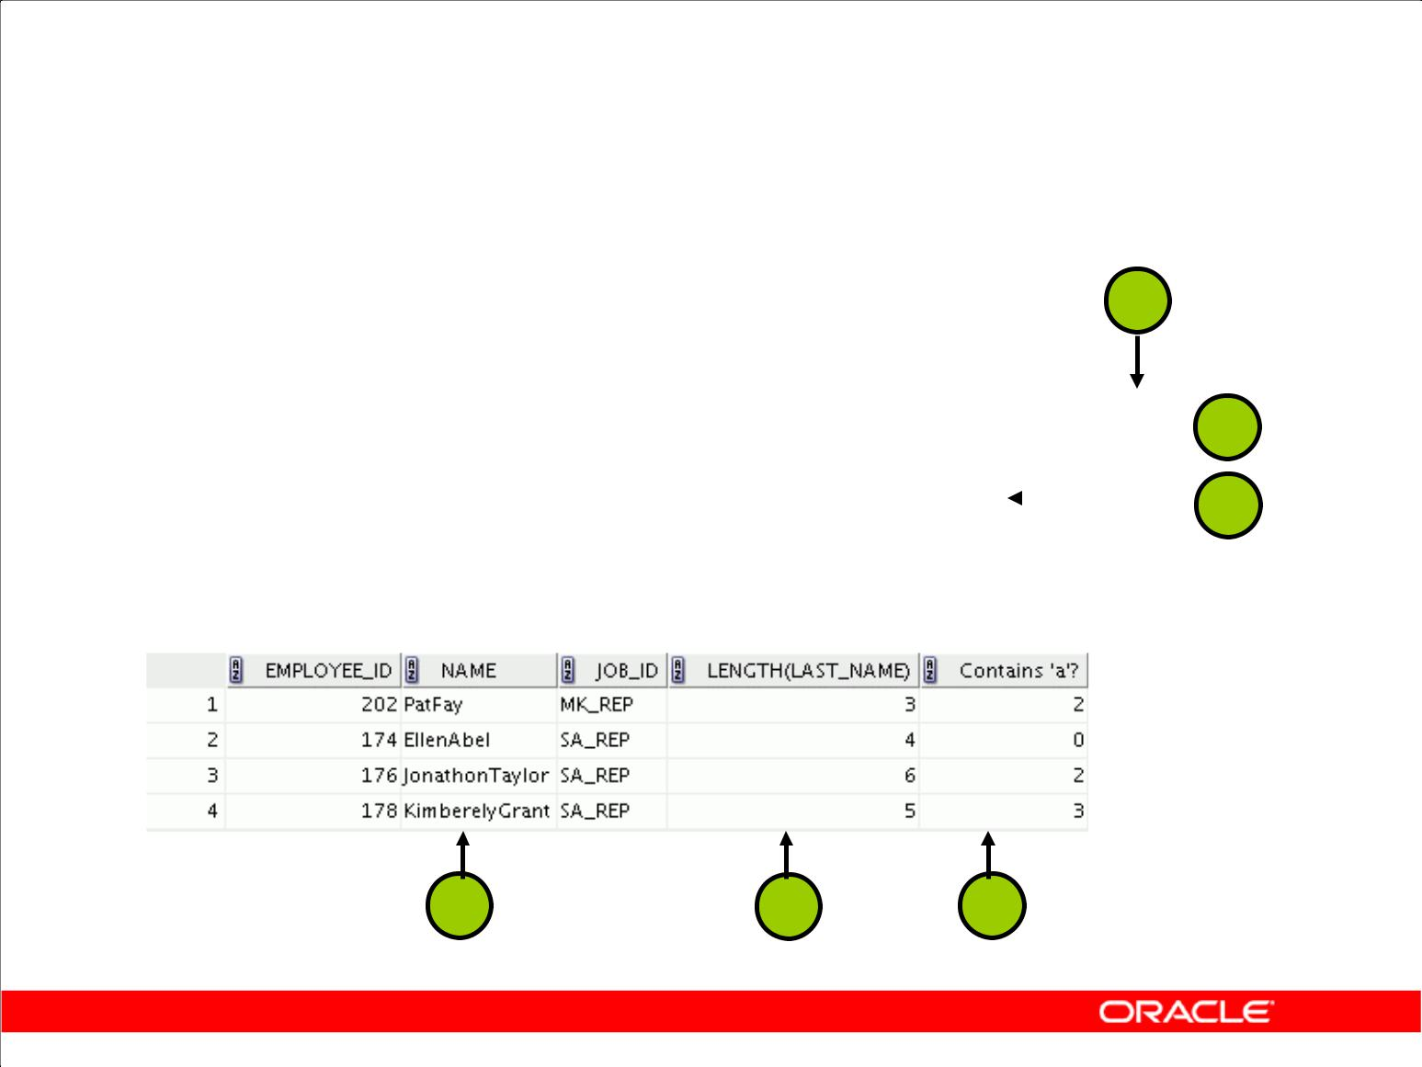**Using the Character-Manipulation Functions**

**1**

|  |  |  |  |  |  |  |  |  |  |  |  |  |  |  |  |  |  |  |  |
| --- | --- | --- | --- | --- | --- | --- | --- | --- | --- | --- | --- | --- | --- | --- | --- | --- | --- | --- | --- |
|  |  |  |  |  |  |  |  |  |  |  |  |  |  |  |  |  |  |  |  |
|  | **SELECT** | **employee_id, CONCAT(first_name, last_name)** | | | | | | | | | | | | **NAME,** |  | **2** | |  |  |
|  |  | **job_id,** | | **LENGTH (last_name),** | | | |  |  |  |  |  |  |  |  |  |
|  |  |  |  |  |  |  |  |  |  |  |  |  |  |
|  |  | **INSTR(last_name, 'a')** | | | | | **"Contains 'a'?"** | | | |  |  | | | |  |  |  |  |
|  |  |  |  |  |  |  | **3** | |  |  |
|  | **FROM** | **employees** | | | | | | | | | | | | | |  |  |
|  |  |  |  |  |
|  | **WHERE** | **SUBSTR(job_id, 4) = 'REP';** | | | | | | | | | | | | | |  |  |  |  |
|  |  |  |  |  |  |  |  |  |  |  |  |  |  |  |  |  |  |  |  |
|  |  |  |  |  |  |  |  |  |  |  |  |  |  |  |  |  |  |  |  |
|  |  |  |  |  |  |  |  |  |  |  |  |  |  |  |  |  |  |  |  |

**1** **2** **3**

Copyright © 2009, Oracle. All rights reserved.

**Using the Character-Manipulation Functions**

The slide example displays employee first names and last names joined together, the length of the employee last name, and the numeric position of the letter *a* in the employee last name for all employees who have the string REP contained in the job ID starting at the fourth position of the job ID.

**Example**

Modify the SQL statement in the slide to display the data for those employees whose last names end with the letter *n*.

|  |  |  |
| --- | --- | --- |
| SELECT | | employee_id, CONCAT(first_name, last_name) NAME, |
| LENGTH | | (last_name), INSTR(last_name, 'a') "Contains 'a'?" |
| FROM | | employees |
| WHERE | | SUBSTR(last_name, -1, 1) = 'n'; |
|  |  |  |
|  |  |  |

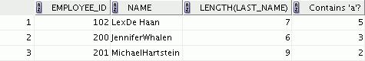

|  |
| --- |
| Oracle Internal & Oracle Academy Use Only |

**Oracle Database 10*g*: SQL Fundamentals I 3 - 12**

**Number Functions**

* ROUND: Rounds value to specified decimal
* TRUNC: Truncates value to specified decimal
* MOD: Returns remainder of division

|  |  |  |  |  |  |  |  |  |  |  |  |
| --- | --- | --- | --- | --- | --- | --- | --- | --- | --- | --- | --- |
|  |  |  | **Function** |  |  | **Result** |  | |  |  |  |
|  |  |  |  | |  |  |  |  | Only | |  |
|  |  |  | ROUND(45.926, 2) | |  | 45.93 |  |  |  |
|  |  |  |  | |  |  |  |  |  |
|  |  |  | TRUNC(45.926, 2) | |  | 45.92 |  |  |  |
|  |  |  |  |  |  |  |  |  |  |
|  |  |  | MOD(1600, | 300) |  | 100 |  |  | Academy Use | |  |
|  |  |  |  |  |  |  |  |  |  |
|  |  |  |  | Copyright © 2009, Oracle. All rights reserved. | | | |  | & Oracle | |  |
| **Number Functions** | | | |  |  |  |  |  |  |
|  |  |  |  |  | Internal | |  |
|  | Number functions accept numeric input and return numeric values. This section describes some of | | | | | | | |  |
|  | the number functions. | | |  |  |  |  |  |  |
|  |  |  |  |  |  |  |  |  |  |
|  |  | **Function** | |  | **Purpose** | | | |  |  |  |
|  |  |  | | |  | | | |  |  |  |
|  |  | ROUND(*column*|*expression*, *n*) | | | Rounds the column, expression, or value to *n* decimal | | | | Oracle | |  |
|  |  |  |  |  | places or, if *n* is omitted, no decimal places (If *n* is | | | |  |
|  |  |  |  |  | negative, numbers to left of the decimal point are rounded.) | | | | | |  |
|  |  | TRUNC(*column*|*expression*, *n*) | | | Truncates the column, expression, or value to *n* decimal | | | |  |  |  |
|  |  |  |  |  | places or, if *n* is omitted, *n* defaults to zero | | | |  |  |  |
|  |  | MOD(*m*,*n*) | |  | Returns the remainder of *m* divided by *n* | | | |  |  |  |
|  |  |  |  |  |  |  |  |  |  |  |  |

**Note:** This list contains only some of the available number functions.

For more information, see “Number Functions” in *Oracle SQL Reference.*

**Oracle Database 10*g*: SQL Fundamentals I 3 - 13**

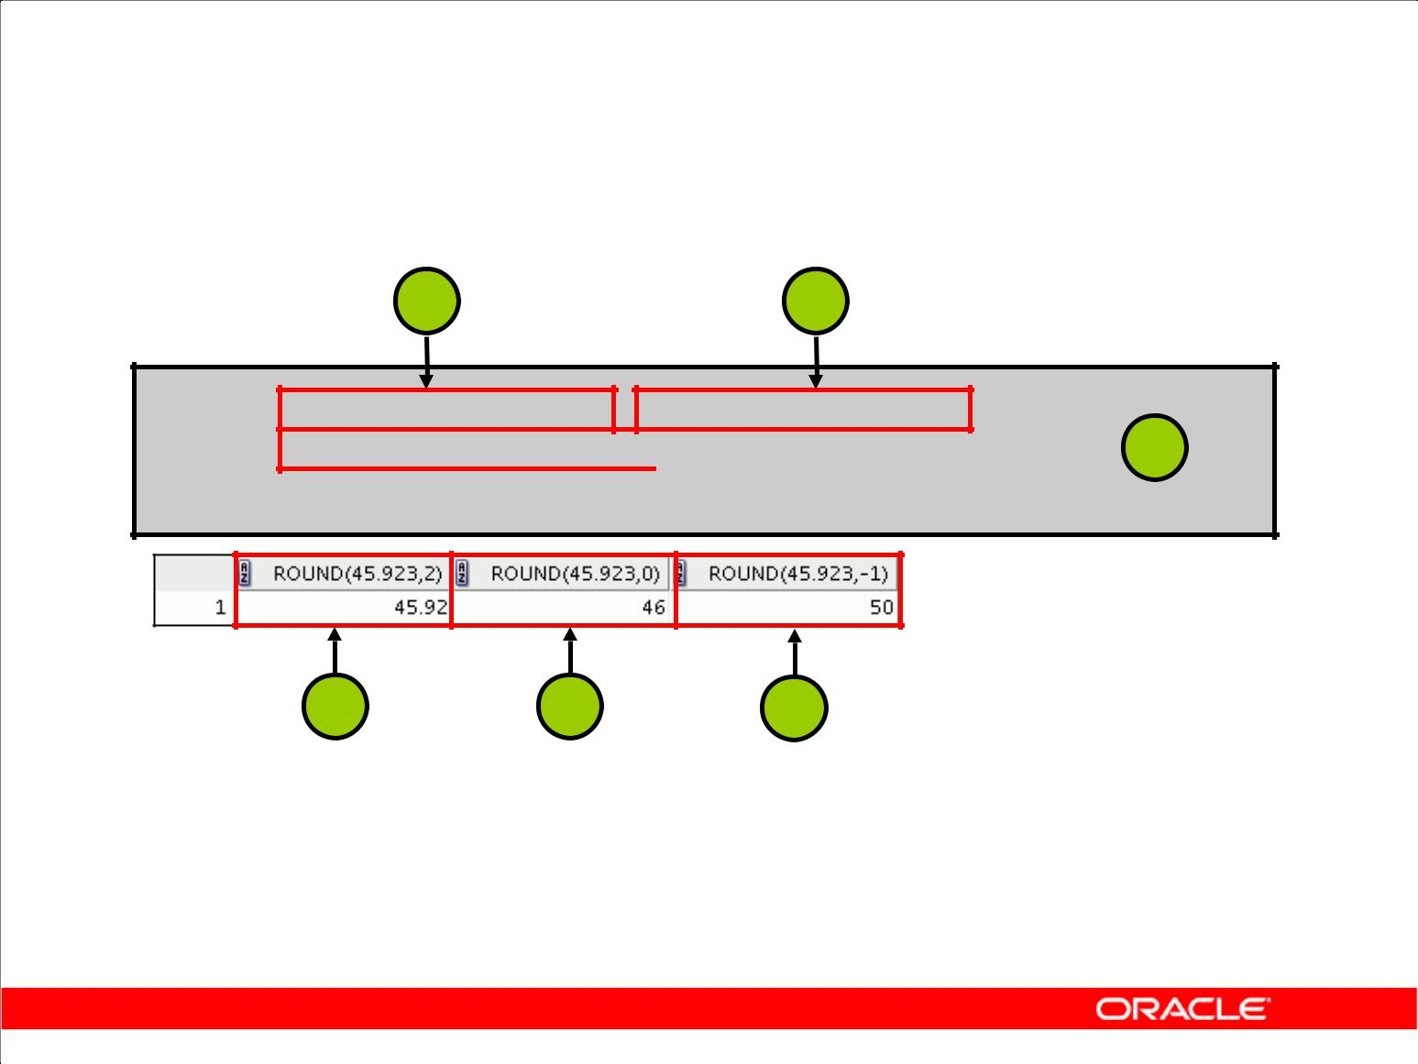**Using the ROUND Function**

**1** **2**

**SELECT ROUND(45.923,2), ROUND(45.923,0),**

**ROUND(45.923,-1)**  **3**

**FROM DUAL;**

**1** **2** **3**

**DUAL is a dummy table that you can use to view results from functions and calculations.**

Copyright © 2009, Oracle. All rights reserved.

**ROUND Function**

The ROUND function rounds the column, expression, or value to *n* decimal places. If the second argument is 0 or is missing, the value is rounded to zero decimal places. If the second argument is 2, the value is rounded to two decimal places. Conversely, if the second argument is –2, the value is rounded to two decimal places to the left (rounded to the nearest unit of 10).

The ROUND function can also be used with date functions. You will see examples later in this lesson. **DUAL Table**

The DUAL table is owned by the user SYS and can be accessed by all users. It contains one column, DUMMY, and one row with the value X. The DUAL table is useful when you want to return a value

once only (for example, the value of a constant, pseudocolumn, or expression that is not derived from a table with user data). The DUAL table is generally used for SELECT clause syntax completeness, because both SELECT and FROM clauses are mandatory, and several calculations do not need to select from actual tables.

|  |
| --- |
| Oracle Internal & Oracle Academy Use Only |

**Oracle Database 10*g*: SQL Fundamentals I 3 - 14**

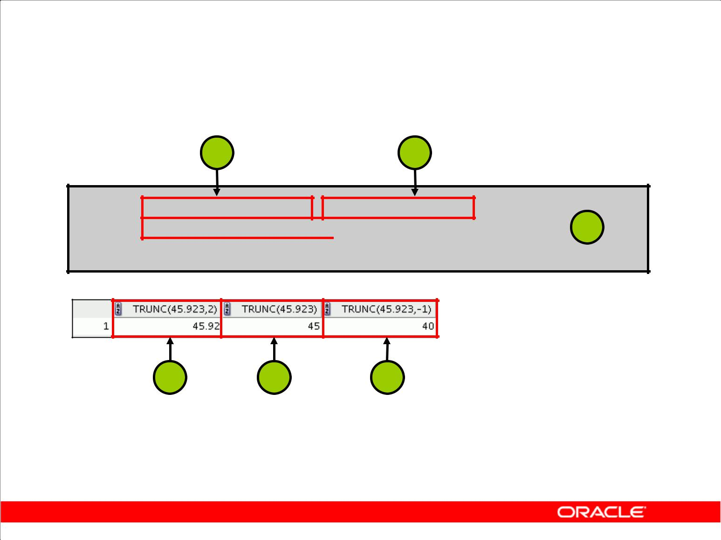**Using the TRUNC Function**

**1** **2**

**SELECT TRUNC(45.923,2), TRUNC(45.923),**

**TRUNC(45.923,-1)**  **3**

**FROM DUAL;**

**1** **2** **3**

Copyright © 2009, Oracle. All rights reserved.

**TRUNC Function**

The TRUNC function truncates the column, expression, or value to *n* decimal places.

The TRUNC function works with arguments similar to those of the ROUND function. If the second argument is 0 or is missing, the value is truncated to zero decimal places. If the second argument is 2, the value is truncated to two decimal places. Conversely, if the second argument is –2, the value is truncated to two decimal places to the left. If the second argument is –1, the value is truncated to one decimal place to the left.

Like the ROUND function, the TRUNC function can be used with date functions.

|  |
| --- |
| Oracle Internal & Oracle Academy Use Only |

**Oracle Database 10*g*: SQL Fundamentals I 3 - 15**

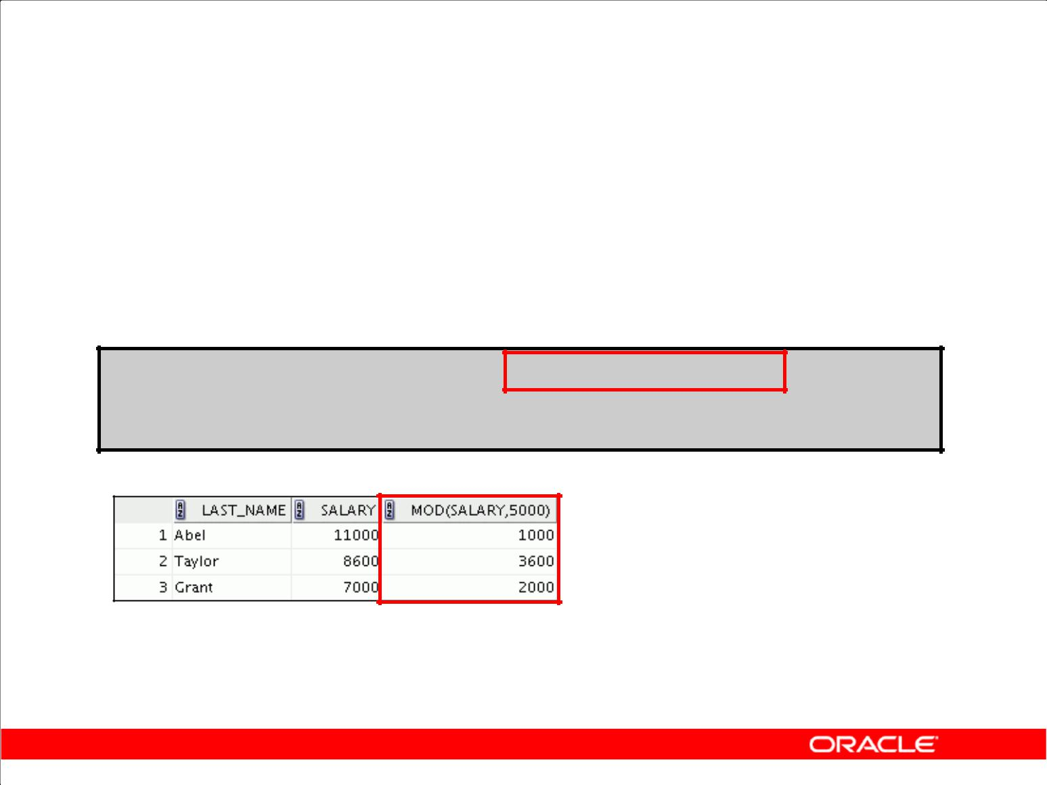**Using the MOD Function**

For all employees with job title of Sales Representative, calculate the remainder of the salary after it is divided by 5,000.

**SELECT last_name, salary, MOD(salary, 5000)**

**FROM employees**

**WHERE** **job_id = 'SA_REP';**

Copyright © 2009, Oracle. All rights reserved.

**MOD Function**

The MOD function finds the remainder of the first argument divided by the second argument. The slide example calculates the remainder of the salary after dividing it by 5,000 for all employees whose job ID is SA_REP.

**Note:** TheMODfunction is often used to determine if a value is odd or even.

|  |
| --- |
| Oracle Internal & Oracle Academy Use Only |

**Oracle Database 10*g*: SQL Fundamentals I 3 - 16**

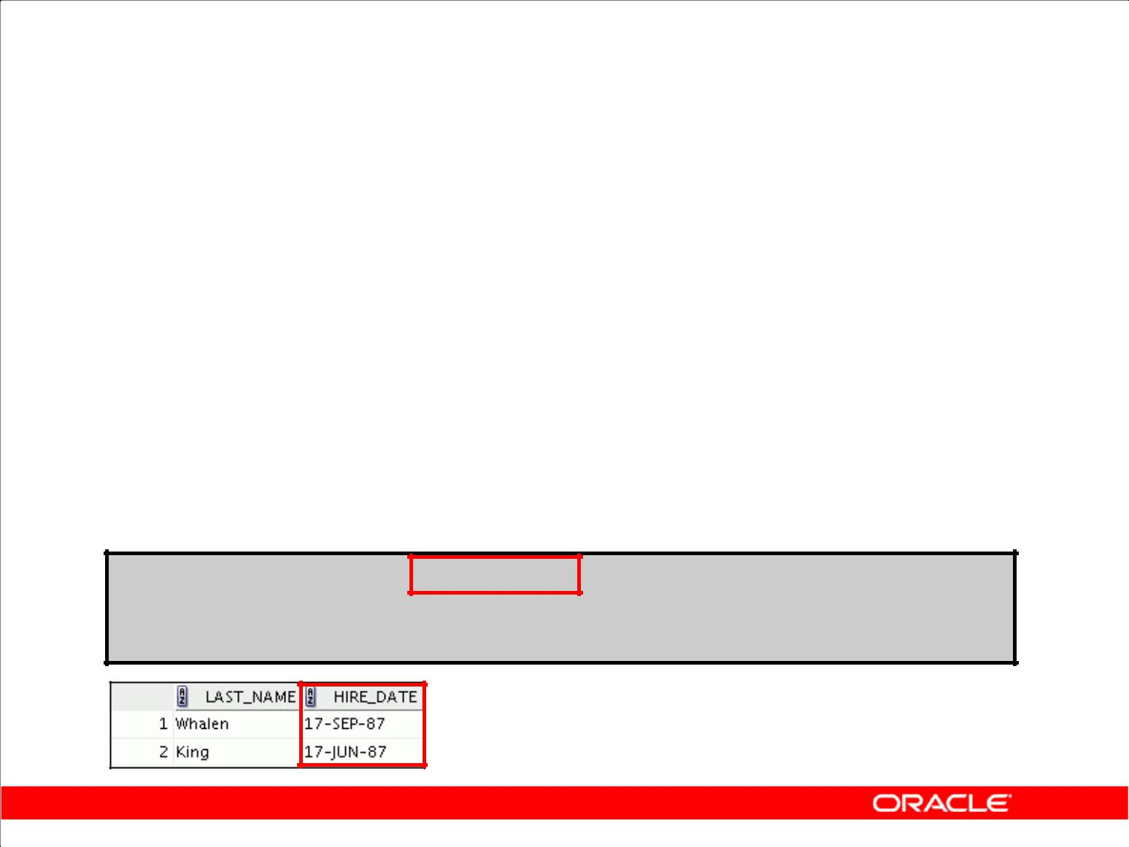**Working with Dates**

* The Oracle Database stores dates in an internal numeric format: century, year, month, day, hours, minutes, and seconds.
* The default date display format is DD-MON-RR.

– Enables you to store 21st-century dates in the

20th century by specifying only the last two digits of the year

– Enables you to store 20th-century dates in the 21st century in the same way

**SELECT last_name, hire_date**

**FROM employees**

**WHERE** **hire_date < '01-FEB-88';**

Copyright © 2009, Oracle. All rights reserved.

**Oracle Date Format**

The Oracle Database stores dates in an internal numeric format, representing the century, year, month, day, hours, minutes, and seconds.

The default display and input format for any date is DD-MON-RR. Valid Oracle dates are between January 1, 4712 B.C., and December 31, 9999 A.D.

In the example in the slide, the HIRE_DATE column output is displayed in the default format DD-

MON-RR. However, dates are not stored in the database in this format. All the components of the date and time are stored. So, although a HIRE_DATE such as 17-JUN-87 is displayed as day, month,

and year, there is also *time* and *century* information associated with the date. The complete data might be June 17, 1987, 5:10:43 p.m.

|  |
| --- |
| Oracle Internal & Oracle Academy Use Only |

**Oracle Database 10*g*: SQL Fundamentals I 3 - 17**

**Oracle Date Format (continued)**

This data is stored internally as follows:

CENTURY YEAR MONTH DAY HOUR MINUTE SECOND

19 87 06 17 17 10 43

**Centuries and the Year 2000**

When a record with a date column is inserted into a table, the *century* information is picked up from the SYSDATE function. However, when the date column is displayed on the screen, the century

component is not displayed (by default).

The DATE data type always stores year information as a four-digit number internally: two digits for the century and two digits for the year. For example, the Oracle Database stores the year as 1987 or 2004, and not just as 87 or 04.

|  |
| --- |
| Oracle Internal & Oracle Academy Use Only |

**Oracle Database 10*g*: SQL Fundamentals I 3 - 18**

**Working with Dates**

SYSDATE is a function that returns:

* Date
* Time

Copyright © 2009, Oracle. All rights reserved.

**SYSDATE Function**

SYSDATE is a date function that returns the current database server date and time. You can use SYSDATE just as you would use any other column name. For example, you can display the current date by selecting SYSDATE from a table. It is customary to select SYSDATE from a dummy table called DUAL.

**Example**

Display the current date using the DUAL table.

SELECT SYSDATE

FROM DUAL;

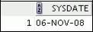

|  |
| --- |
| Oracle Internal & Oracle Academy Use Only |

**Oracle Database 10*g*: SQL Fundamentals I 3 - 19**

**Arithmetic with Dates**

* Add or subtract a number to or from a date for a resultant date value.
* Subtract two dates to find the number of days between those dates.
* Add hours to a date by dividing the number of hours by 24.

Copyright © 2009, Oracle. All rights reserved.

**Arithmetic with Dates**

Because the database stores dates as numbers, you can perform calculations using arithmetic operators such as addition and subtraction. You can add and subtract number constants as well as dates.

You can perform the following operations:

|  |  |  |
| --- | --- | --- |
| **Operation** | **Result** | **Description** |
|  |  |  |
| date + number | Date | Adds a number of days to a date |
|  |  |  |
| date – number | Date | Subtracts a number of days from a date |
|  |  |  |
| date – date | Number of days | Subtracts one date from another |
|  |  |  |
| date + number/24 | Date | Adds a number of hours to a date |
|  |  |  |

|  |
| --- |
| Oracle Internal & Oracle Academy Use Only |

**Oracle Database 10*g*: SQL Fundamentals I 3 - 20**

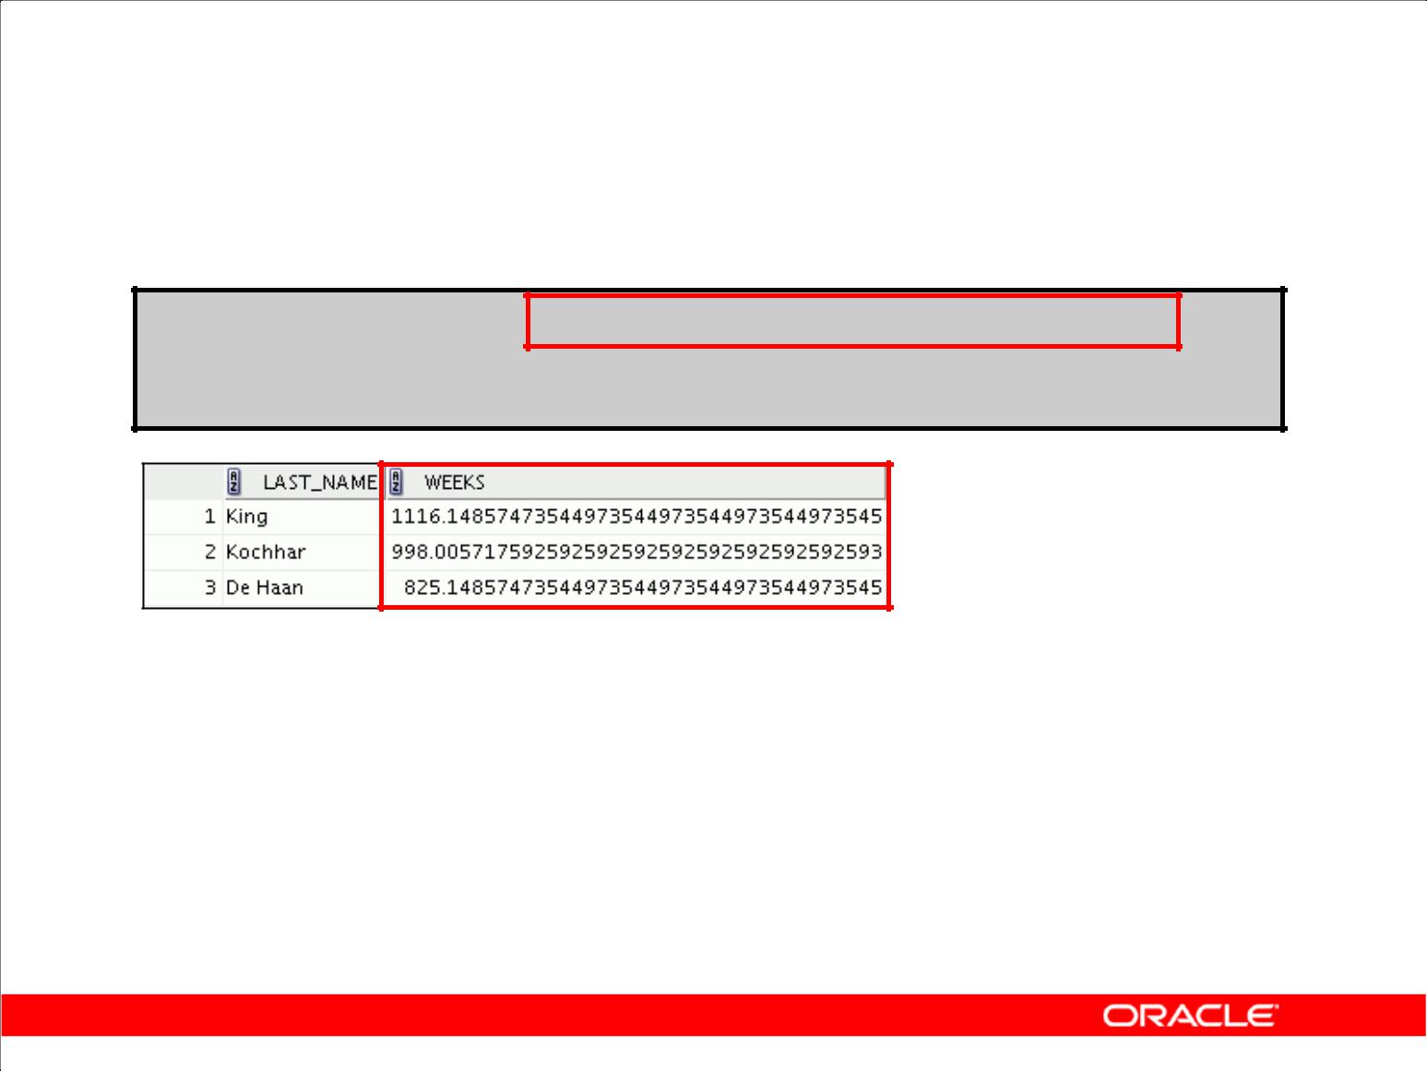**Using Arithmetic Operators**

**with Dates**

**SELECT last_name, (SYSDATE-hire_date)/7 AS WEEKS**

**FROM employees**

**WHERE** **department_id = 90;**

Copyright © 2009, Oracle. All rights reserved.

**Using Arithmetic Operators with Dates**

The example in the slide displays the last name and the number of weeks employed for all employees

in department 90. It subtracts the date on which the employee was hired from the current date

(SYSDATE) and divides the result by 7 to calculate the number of weeks that a worker has been

employed.

**Note:** SYSDATEis a SQL function that returns the current date and time. Your results may differfrom the example.

If a more current date is subtracted from an older date, the difference is a negative number.

|  |
| --- |
| Oracle Internal & Oracle Academy Use Only |

**Oracle Database 10*g*: SQL Fundamentals I 3 - 21**

**Date Functions**

|  |  |
| --- | --- |
| **Function** | **Result** |
|  |  |
| MONTHS_BETWEEN | Number of months between two dates |
|  |  |
| ADD_MONTHS | Add calendar months to date |
|  |  |
| NEXT_DAY | Next day of the date specified |
| LAST_DAY | Last day of the month |
|  |  |
| ROUND | Round date |
| TRUNC | Truncate date |

Copyright © 2009, Oracle. All rights reserved.

**Date Functions**

Date functions operate on Oracle dates. All date functions return a value of DATE data type except MONTHS_BETWEEN, which returns a numeric value.

* **MONTHS_BETWEEN(*date1, date2*):** Finds the number of months between*date1*and*date2*. The result can be positive or negative. If *date1* is later than *date2*, the result ispositive; if *date1* is earlier than *date2*, the result is negative. The noninteger part of the result represents a portion of the month.
* **ADD_MONTHS(*date, n*):** Adds*n*number of calendar months to*date*. The value of*n*mustbe an integer and can be negative.
* **NEXT_DAY(*date,* '*char*'):** Finds the date of the next specified day of the week

('*char*') following *date*. The value of *char* may be a number representing a day or a character string.

* **LAST_DAY(*date*):** Finds the date of the last day of the month that contains*date*
* **ROUND(*date*[,'*fmt*']):** Returns*date*rounded to the unit that is specified by the formatmodel *fmt.* If the format model *fmt* is omitted, *date* is rounded to the nearest day.
* **TRUNC(*date*[, '*fmt*']):** Returns*date*with the time portion of the day truncated to theunit that is specified by the format model *fmt*. If the format model *fmt* is omitted, *date* is truncated to the nearest day.

This list is a subset of the available date functions. The format models are covered later in this lesson.

Examples of format models are month and year.

|  |
| --- |
| Oracle Internal & Oracle Academy Use Only |

**Oracle Database 10*g*: SQL Fundamentals I 3 - 22**

**Using Date Functions**

|  |  |  |
| --- | --- | --- |
| **Function** |  | **Result** |
|  | |  |
| MONTHS_BETWEEN | | 19.6774194 |
|  | ('01-SEP-95','11-JAN-94') |  |
| ADD_MONTHS | ('11-JAN-94',6) | '11-JUL-94' |
|  |  |  |
| NEXT_DAY | ('01-SEP-95','FRIDAY') | '08-SEP-95' |
| LAST_DAY | ('01-FEB-95') | '28-FEB-95' |
|  |  |  |

Copyright © 2009, Oracle. All rights reserved.

**Date Functions (continued)**

For example, display the employee number, hire date, number of months employed, six-month review date, first Friday after hire date, and last day of the hire month for all employees who have been employed for fewer than 120 months.

SELECT employee_id, hire_date,

MONTHS_BETWEEN (SYSDATE, hire_date) TENURE,

ADD_MONTHS (hire_date, 6) REVIEW,

NEXT_DAY (hire_date, 'FRIDAY'), LAST_DAY(hire_date)

FROM employees

WHERE MONTHS_BETWEEN (SYSDATE, hire_date) < 120;

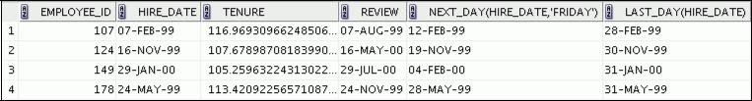

|  |
| --- |
| Oracle Internal & Oracle Academy Use Only |

**Oracle Database 10*g*: SQL Fundamentals I 3 - 23**

**Using Date Functions**

Assume SYSDATE = '25-JUL-03':

|  |  |
| --- | --- |
| **Function** | **Result** |
|  |  |
| ROUND(SYSDATE,'MONTH') | 01-AUG-03 |
|  |  |
| ROUND(SYSDATE ,'YEAR') | 01-JAN- 04 |
|  |  |
| TRUNC(SYSDATE ,'MONTH') | 01-JUL-03 |
| TRUNC(SYSDATE ,'YEAR') | 01-JAN-03 |
|  |  |

Copyright © 2009, Oracle. All rights reserved.

**Date Functions (continued)**

The ROUND and TRUNC functions can be used for number and date values. When used with dates, these functions round or truncate to the specified format model. Therefore, you can round dates to the nearest year or month.

**Example**

Compare the hire dates for all employees who started in 1997. Display the employee number, hire date, and start month using the ROUND and TRUNC functions.

SELECT employee_id, hire_date,

ROUND(hire_date, 'MONTH'), TRUNC(hire_date, 'MONTH')

FROM employees

WHERE hire_date LIKE '%97';

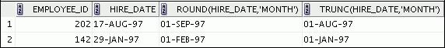

|  |
| --- |
| Oracle Internal & Oracle Academy Use Only |

**Oracle Database 10*g*: SQL Fundamentals I 3 - 24**

**Practice 3: Overview of Part 1**

This practice covers the following topics:

* Writing a query that displays the current date
* Creating queries that require the use of the numeric, character, and date functions
* Performing calculations of years and months of service for an employee

Copyright © 2009, Oracle. All rights reserved.

**Practice 3: Overview of Part 1**

Part 1 of this lesson’s practice provides a variety of exercises that use the different functions that are available for the character, number, and date data types.

For Part 1, complete questions 1–6 at the end of this lesson.

|  |
| --- |
| Oracle Internal & Oracle Academy Use Only |

**Oracle Database 10*g*: SQL Fundamentals I 3 - 25**

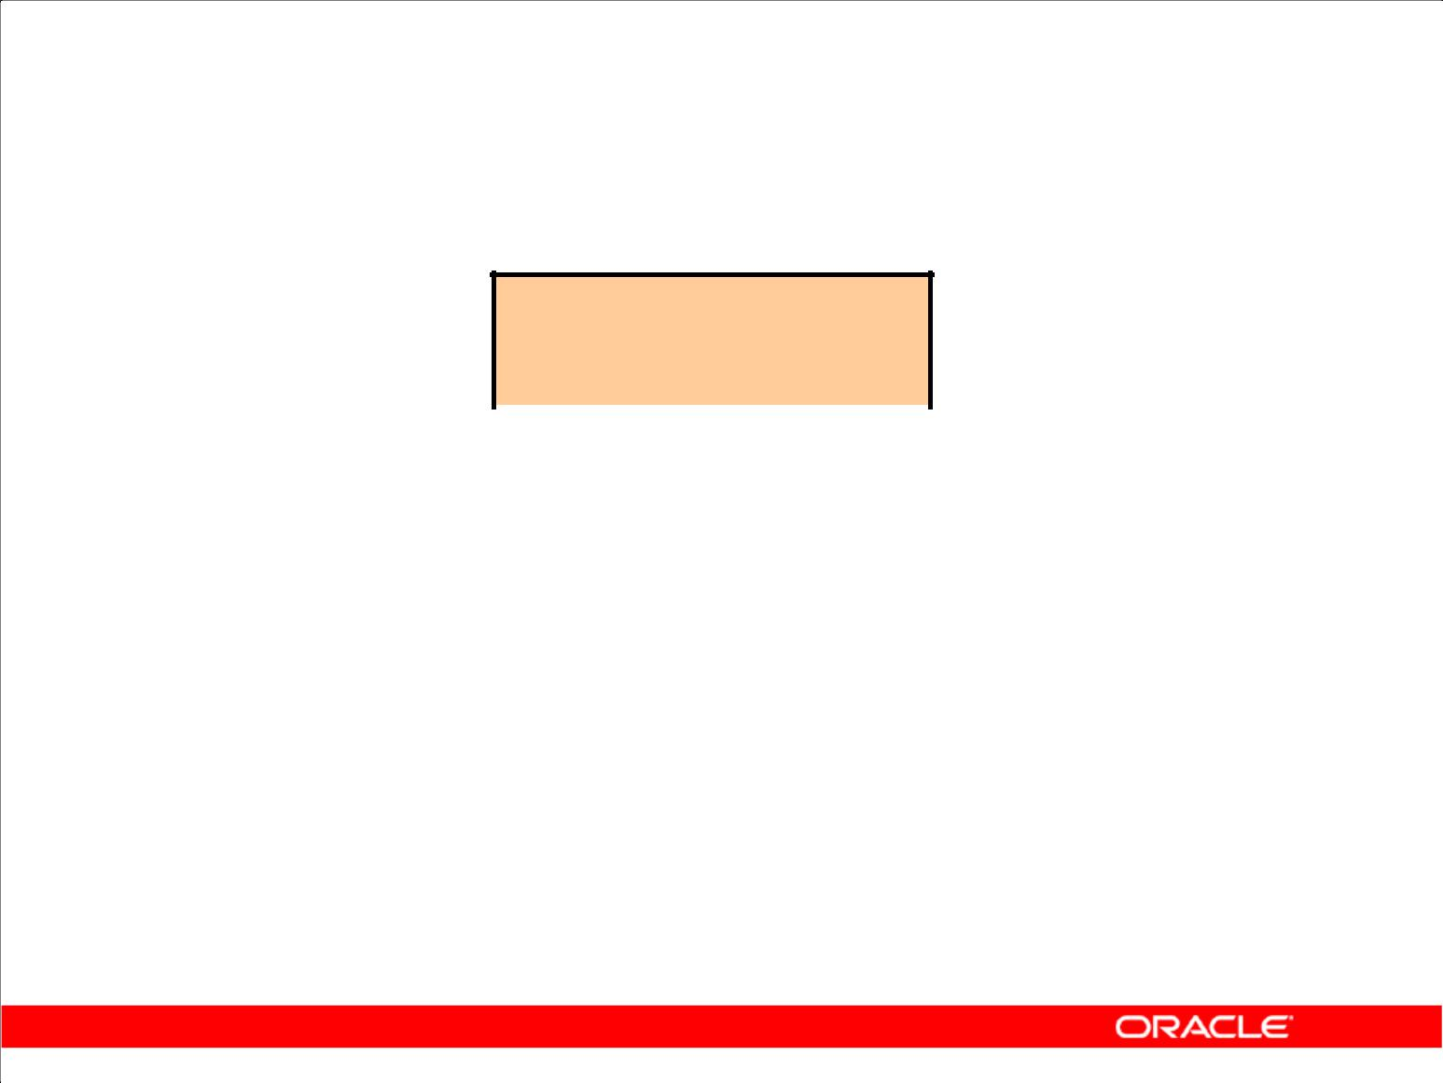**Conversion Functions**

**Data type**

**conversion**

|  |  |  |  |  |  |  |  |
| --- | --- | --- | --- | --- | --- | --- | --- |
|  |  |  |  |  |  |  |  |
|  |  |  |  |  |  |  |  |
| **Implicit data type** | | |  |  | **Explicit data type** | | |
| **conversion** | | |  |  | **conversion** | | |
|  |  |  |  |  |  |  |  |

Copyright © 2009, Oracle. All rights reserved.

**Conversion Functions**

In addition to Oracle data types, columns of tables in an Oracle Database can be defined using ANSI, DB2, and SQL/DS data types. However, the Oracle server internally converts such data types to Oracle data types.

In some cases, the Oracle server uses data of one data type where it expects data of a different data

type. When this happens, the Oracle server can automatically convert the data to the expected data

type. This data type conversion can be done *implicitly* by the Oracle server or *explicitly* by the user.

Implicit data type conversions work according to the rules that are explained in the next two slides.

Explicit data type conversions are done by using the conversion functions. Conversion functions convert a value from one data type to another. Generally, the form of the function names follows the convention *data type* TO *data type*. The first data type is the input data type; the second data type is the output.

**Note:** Although implicit data type conversion is available, it is recommended that you do explicitdata type conversion to ensure the reliability of your SQL statements.

|  |
| --- |
| Oracle Internal & Oracle Academy Use Only |

**Oracle Database 10*g*: SQL Fundamentals I 3 - 26**

**Implicit Data Type Conversion**

For assignments, the Oracle server can automatically convert the following:

|  |  |
| --- | --- |
| **From** | **To** |
|  |  |
| VARCHAR2 or CHAR | NUMBER |
|  |  |
| VARCHAR2 or CHAR | DATE |
|  |  |
| NUMBER | VARCHAR2 |
| DATE | VARCHAR2 |
|  |  |

Copyright © 2009, Oracle. All rights reserved.

**Implicit Data Type Conversion**

The assignment succeeds if the Oracle server can convert the data type of the value used in the assignment to that of the assignment target.

For example, the expression hire_date > '01-JAN-90' results in the implicit conversion from the string '01-JAN-90' to a date.

|  |
| --- |
| Oracle Internal & Oracle Academy Use Only |

**Oracle Database 10*g*: SQL Fundamentals I 3 - 27**

**Implicit Data Type Conversion**

For expression evaluation, the Oracle Server can automatically convert the following:

|  |  |
| --- | --- |
| **From** | **To** |
|  |  |
| VARCHAR2 or CHAR | NUMBER |
|  |  |
| VARCHAR2 or CHAR | DATE |
|  |  |

Copyright © 2009, Oracle. All rights reserved.

**Implicit Data Type Conversion (continued)**

In general, the Oracle server uses the rule for expressions when a data type conversion is needed in places that are not covered by a rule for assignment conversions.

For example, the expression salary = '20000' results in the implicit conversion of the string '20000' to the number 20000.

**Note:** CHARtoNUMBERconversions succeed only if the character string represents a valid number.

|  |
| --- |
| Oracle Internal & Oracle Academy Use Only |

**Oracle Database 10*g*: SQL Fundamentals I 3 - 28**

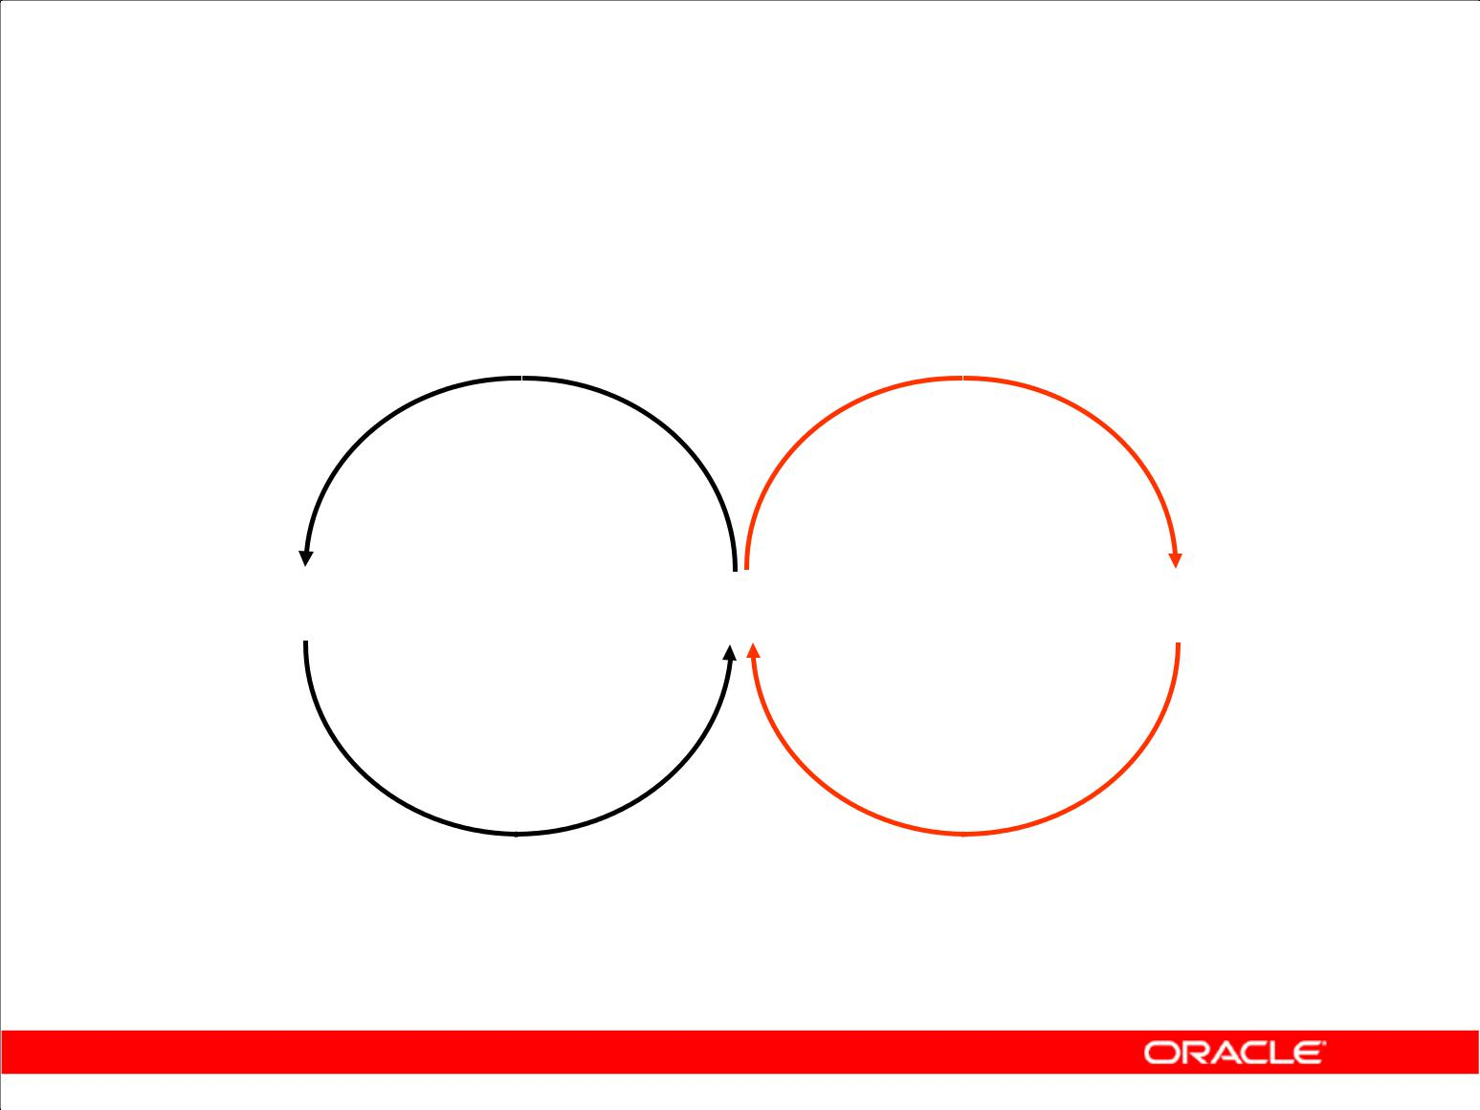**Explicit Data Type Conversion**

**TO_NUMBER** **TO_DATE**

**NUMBER** **CHARACTER** **DATE**

**TO_CHAR** **TO_CHAR**

Copyright © 2009, Oracle. All rights reserved.

**Explicit Data Type Conversion**

SQL provides three functions to convert a value from one data type to another:

|  |  |  |  |
| --- | --- | --- | --- |
| **Function** | **Purpose** | |  |
|  |  | |  |
| TO_CHAR(*number*|*date*,[ *fmt*], | Converts a number or date value to a VARCHAR2 | |  |
| *[nlsparams*]) | character string with format model *fmt* | |  |
|  |  |
|  | **Number conversion:** Thenlsparams | |  |
|  | parameter specifies the following characters, | |  |
|  | which are returned by number format elements: | |  |
|  | • | Decimal character |  |
|  | • | Group separator |  |
|  | • | Local currency symbol |  |
|  | • | International currency symbol |  |
|  | If nlsparams or any other parameter is omitted, | |  |
|  | this function uses the default parameter values for | |  |
|  | the session. | |  |

|  |
| --- |
| Oracle Internal & Oracle Academy Use Only |

**Oracle Database 10*g*: SQL Fundamentals I 3 - 29**

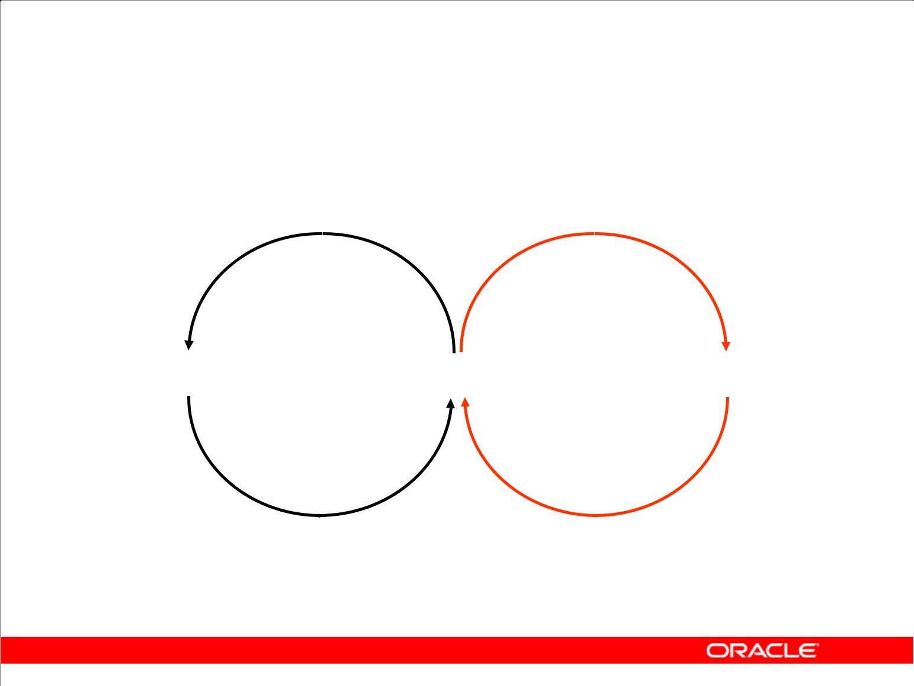**Explicit Data Type Conversion**

**TO_NUMBER** **TO_DATE**

**NUMBER** **CHARACTER** **DATE**

**TO_CHAR** **TO_CHAR**

|  |  |  |  |  |  |  |  |  |
| --- | --- | --- | --- | --- | --- | --- | --- | --- |
|  |  |  | Copyright © 2009, Oracle. All rights reserved. | |  |  |  |  |
| **Explicit Data Type Conversion (continued)** | | | | |  |  |  |  |
|  |  |  |  |  |  |  |  |  |
|  |  | **Function** |  | **Purpose** |  |  |  |  |
|  |  |  |  |  |  |  |  |  |
|  |  | TO_CHAR(*number*|*date*,[ | *fmt*], | **Date conversion:** Thenlsparamsparameter specifies | |  |  |  |
|  |  | [*nlsparams*]) |  |  |  |  |
|  |  |  | the language in which month and day names and |  |  |  |  |
|  |  |  |  |  |  |  |  |
|  |  |  |  | abbreviations are returned. If this parameter is omitted, | |  |  |  |
|  |  |  |  | this function uses the default date languages for the |  |  |  |  |
|  |  |  |  | session. |  |  |  |  |
|  |  |  |  |  |  |  |  |  |
|  |  | TO_NUMBER(*char,[fmt],* |  | Converts a character string containing digits to a number | |  |  |  |
|  |  | *[nlsparams]*) |  |  |  |  |
|  |  |  | in the format specified by the optional format model | *fmt* | . |  |  |
|  |  |  |  |  |  |  |
|  |  |  |  | The nlsparams parameter has the same purpose in this | |  |  |  |
|  |  |  |  | function as in the TO_CHAR function for number |  |  |  |  |
|  |  |  |  | conversion. |  |  |  |  |
|  |  |  | |  |  |  |  |  |
|  |  | TO_DATE(c*har*,[*fmt*],[*nlspara* | | Converts a character string representing a date to a date | |  |  |  |
|  |  | *ms*]) |  |  |  |  |
|  |  |  | value according to the *fmt* that is specified. If *fmt* is | |  |  |  |
|  |  |  |  |  |  |  |
|  |  |  |  | omitted, the format is DD-MON-YY. |  |  |  |  |
|  |  |  |  | The nlsparams parameter has the same purpose in this | |  |  |  |
|  |  |  |  | function as in the TO_CHAR function for date conversion. | | |  |  |
|  |  |  |  |  |  |  |  |  |

|  |
| --- |
| Oracle Internal & Oracle Academy Use Only |

**Oracle Database 10*g*: SQL Fundamentals I 3 - 30**

**Explicit Data Type Conversion (continued)**

**Note:** The list of functions mentioned in this lesson includes only some of the available conversionfunctions.

For more information, see “Conversion Functions” in *Oracle SQL Reference*.

|  |
| --- |
| Oracle Internal & Oracle Academy Use Only |

**Oracle Database 10*g*: SQL Fundamentals I 3 - 31**

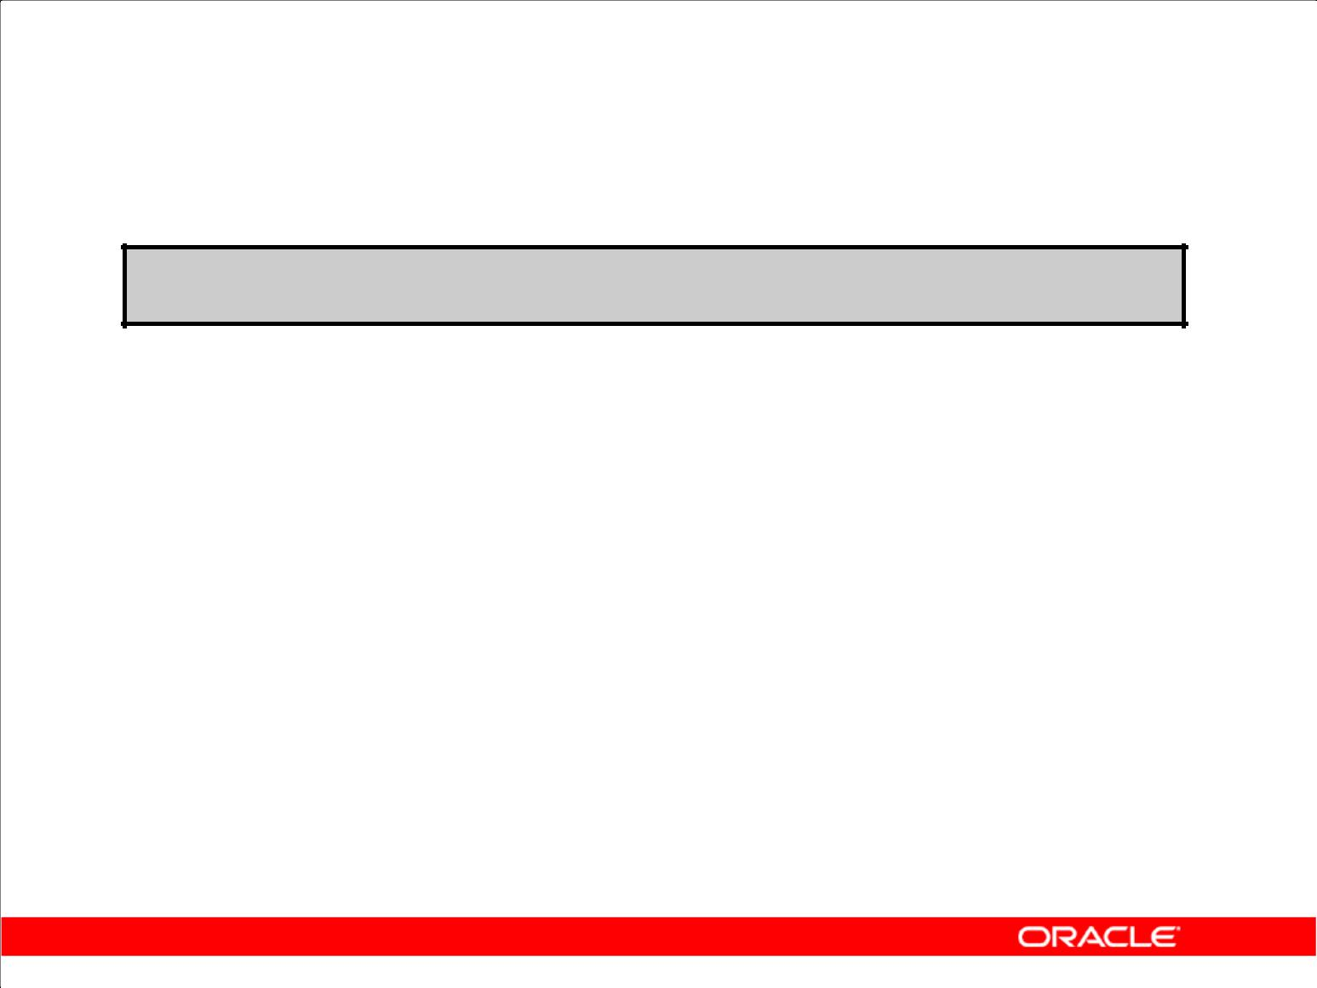**Using the TO_CHAR Function with Dates**

**TO_CHAR(*date,* '*format_model*')**

The format model:

* Must be enclosed by single quotation marks
* Is case sensitive
* Can include any valid date format element
* Has an fm element to remove padded blanks or suppress leading zeros
* Is separated from the date value by a comma

Copyright © 2009, Oracle. All rights reserved.

**Displaying a Date in a Specific Format**

Previously, all Oracle date values were displayed in the DD-MON-YY format. You can use the TO_CHAR function to convert a date from this default format to one that you specify.

**Guidelines**

* The format model must be enclosed by single quotation marks and is case sensitive.
* The format model can include any valid date format element. Be sure to separate the date value from the format model by a comma.
* The names of days and months in the output are automatically padded with blanks.
* To remove padded blanks or to suppress leading zeros, use the fill mode *fm* element.

SELECT employee_id, TO_CHAR(hire_date, 'MM/YY') Month_Hired FROM employees

WHERE last_name = 'Higgins';

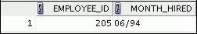

|  |
| --- |
| Oracle Internal & Oracle Academy Use Only |

**Oracle Database 10*g*: SQL Fundamentals I 3 - 32**

**Elements of the Date Format Model**

|  |  |
| --- | --- |
| **Element** | **Result** |
|  |  |
| YYYY | Full year in numbers |
|  |  |
| YEAR | Year spelled out (in English) |
|  |  |
| MM | Two-digit value for month |
| MONTH | Full name of the month |
|  |  |
| MON | Three-letter abbreviation of the month |
| DY | Three-letter abbreviation of the day of the week |
| DAY | Full name of the day of the week |
| DD | Numeric day of the month |

Copyright © 2009, Oracle. All rights reserved.

|  |
| --- |
| Oracle Internal & Oracle Academy Use Only |

**Oracle Database 10*g*: SQL Fundamentals I 3 - 33**

**Sample Format Elements of Valid Date Formats**

|  |  |  |  |
| --- | --- | --- | --- |
| **Element** | **Description** |  |  |
| SCC or CC | Century; server prefixes B.C. date with - |  |  |
| Years in dates YYYY or SYYYY | Year; server prefixes B.C. date with - |  |  |
| YYY or YY or Y | Last three, two, or one digits of year |  |  |
| Y,YYY | Year with comma in this position |  |  |
| IYYY, IYY, IY, I | Four-, three-, two-, or one-digit year based on the ISO |  |  |
|  | standard |  |  |
| SYEAR or YEAR | Year spelled out; server prefixes B.C. date with - |  |  |
| BC or AD | Indicates B.C. or A.D. year |  |  |
| B.C. or A.D. | Indicates B.C. or A.D. year using periods | Only |  |
| Q | Quarter of year |  |
|  |  |
| MM | Month: two-digit value | Use |  |
| MONTH | Name of month padded with blanks to length of nine |  |
|  |  |
|  | characters | Academy |  |
| MON | Name of month, three-letter abbreviation |  |
|  |  |
| RM | Roman numeral month |  |  |
| WW or W | Week of year or month |  |  |
| DDD or DD or D | Day of year, month, or week | &Oracle |  |
| DY | Name of day; three-letter abbreviation |  |
| DAY | Name of day padded with blanks to a length of nine |  |  |
|  | characters |  |  |
|  |  | OracleInternal |  |
| J | Julian day; the number of days since December 31, 4713 |  |
|  | B.C. |  |
|  |  |  |

**Oracle Database 10*g*: SQL Fundamentals I 3 - 34**

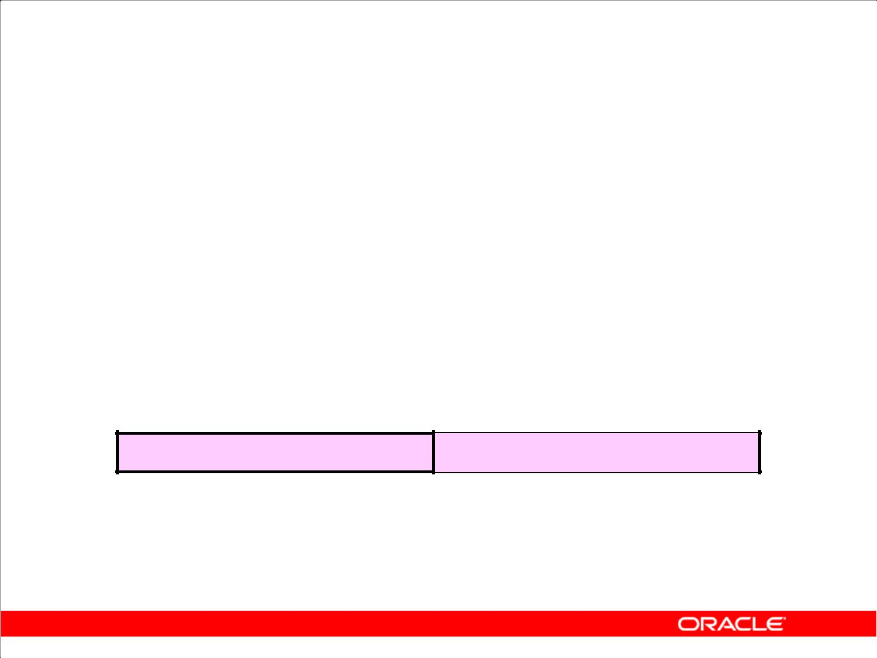**Elements of the Date Format Model**

* Time elements format the time portion of the date:

|  |  |
| --- | --- |
| **HH24:MI:SS AM** | **15:45:32 PM** |
|  |  |

* Add character strings by enclosing them in double quotation marks:

|  |  |
| --- | --- |
| **DD "of" MONTH** | **12 of OCTOBER** |
|  |  |

* Number suffixes spell out numbers:

**ddspth** **fourteenth**

Copyright © 2009, Oracle. All rights reserved.

**Date Format Elements: Time Formats**

Use the formats that are listed in the following tables to display time information and literals and to change numerals to spelled numbers.

|  |  |
| --- | --- |
| **Element** | **Description** |
| AM or PM | Meridian indicator |
| A.M. or P.M. | Meridian indicator with periods |
| HH or HH12 or HH24 | Hour of day, or hour (1–12), or hour (0–23) |
| MI | Minute (0–59) |
| SS | Second (0–59) |
| SSSSS | Seconds past midnight (0–86399) |

|  |
| --- |
| Oracle Internal & Oracle Academy Use Only |

**Oracle Database 10*g*: SQL Fundamentals I 3 - 35**

**Other Formats**

|  |  |  |  |  |  |
| --- | --- | --- | --- | --- | --- |
|  |  | **Element** | **Description** | |  |
|  | / . , | | Punctuation is reproduced in the result. | |  |
|  |  | “of the” | Quoted string is reproduced in the result. | |  |
| **Specifying Suffixes to Influence Number Display** | | | | |  |
|  |  |  |  |  |  |
|  |  | **Element** | **Description** |  |
|  |  | TH | Ordinal number (for example, DDTH for 4TH) |  |  |
|  |  | SP | Spelled-out number (for example, DDSP for FOUR) |  |  |
|  |  | SPTH or THSP | Spelled-out ordinal numbers (for example, DDSPTH for | |  |
|  |  |  | FOURTH) | |  |

|  |
| --- |
| Oracle Internal & Oracle Academy Use Only |

**Oracle Database 10*g*: SQL Fundamentals I 3 - 36**

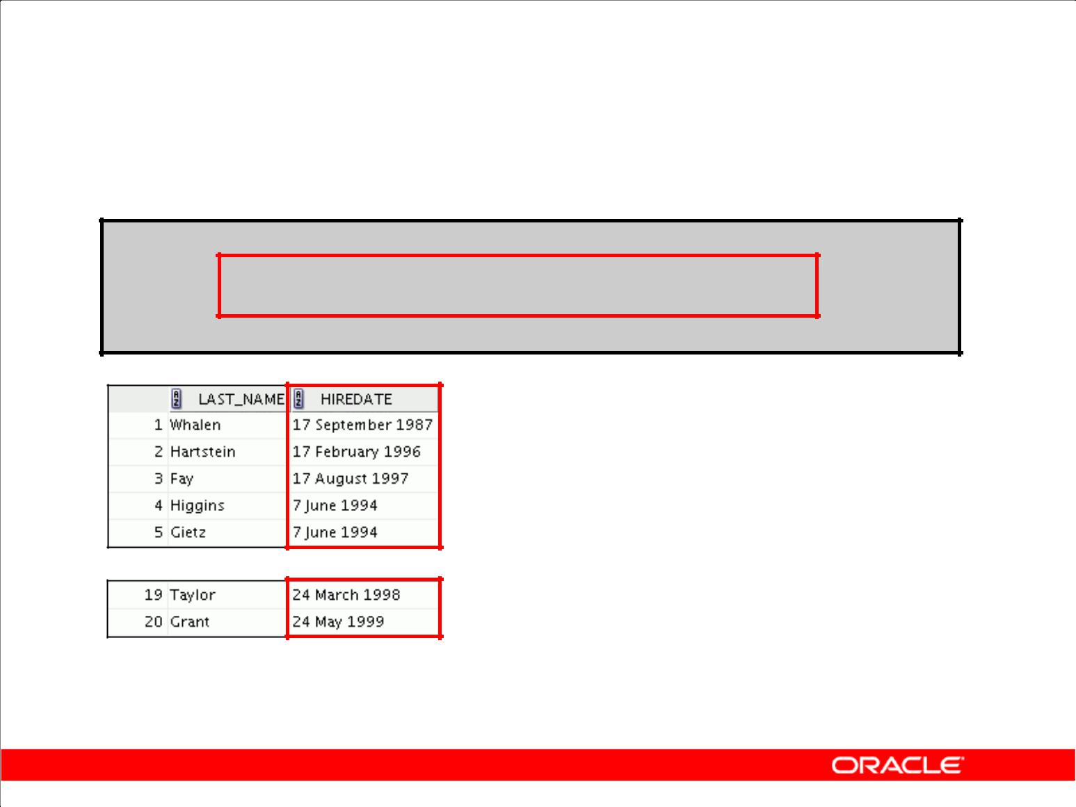**Using the TO_CHAR Function with Dates**

**SELECT last_name,**

**TO_CHAR(hire_date, 'fmDD Month YYYY')**

**AS HIREDATE**

**FROM employees;**

**…**

Copyright © 2009, Oracle. All rights reserved.

**Using the TO_CHAR Function with Dates**

The SQL statement in the slide displays the last names and hire dates for all the employees. The hire date appears as 17 June 1987.

**Example**

Modify the slide example to display the dates in a format that appears as “Seventeenth of June 1987 12:00:00 AM.”

SELECT last_name,

TO_CHAR(hire_date,

'fmDdspth "of" Month YYYY fmHH:MI:SS AM')

HIREDATE

FROM employees;

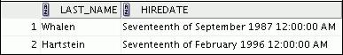

|  |
| --- |
| Oracle Internal & Oracle Academy Use Only |

**…**



Notice that the month follows the format model specified; in other words, the first letter is capitalized and the rest are lowercase.

**Oracle Database 10*g*: SQL Fundamentals I 3 - 37**

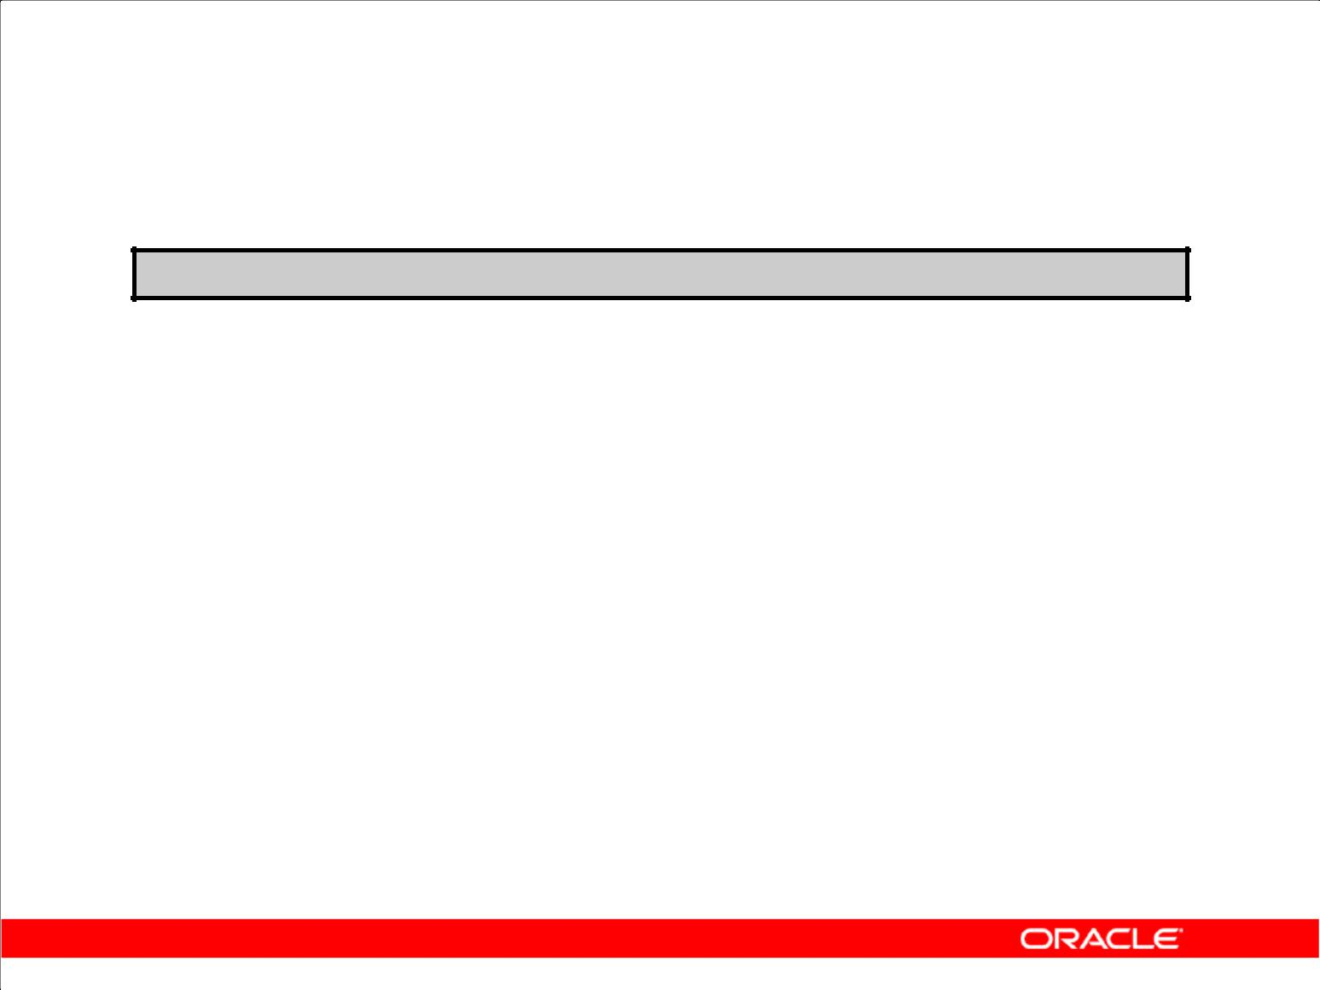**Using the TO_CHAR Function with Numbers**

**TO_CHAR(*number,* '*format_model*')**

These are some of the format elements that you can use with the TO_CHAR function to display a number value as a

character:

|  |  |
| --- | --- |
| **Element** | **Result** |
|  |  |
| 9 | Represents a number |
|  |  |
| 0 | Forces a zero to be displayed |
|  |  |
| $ | Places a floating dollar sign |
| L | Uses the floating local currency symbol |
| . | Prints a decimal point |
| , | Prints a comma as thousands indicator |

Copyright © 2009, Oracle. All rights reserved.

**Using the TO_CHAR Function with Numbers**

When working with number values such as character strings, you should convert those numbers to the character data type using the TO_CHAR function, which translates a value of NUMBER data type to VARCHAR2 data type. This technique is especially useful with concatenation.

|  |
| --- |
| Oracle Internal & Oracle Academy Use Only |

**Oracle Database 10*g*: SQL Fundamentals I 3 - 38**

**Using the TO_CHAR Function with Numbers (continued)**

**Number Format Elements**

If you are converting a number to the character data type, you can use the following format elements:

|  |  |  |  |  |  |
| --- | --- | --- | --- | --- | --- |
| **Element** | **Description** | **Example** | **Result** |  |  |
| 9 | Numeric position (number of 9s determine display | 999999 | 1234 |  |  |
|  | width) |  |  |  |  |
| 0 | Display leading zeros | 099999 | 001234 |  |  |
| $ | Floating dollar sign | $999999 | $1234 |  |  |
| L | Floating local currency symbol | L999999 | FF1234 |  |  |
| D | Returns in the specified position the decimal | 99D99 | 99.99 | Only |  |
|  | character. The default is a period (.). |  |  |  |
|  |  |  |  |  |
| . | Decimal point in position specified | 999999.99 | 1234.00 | Use |  |
| G | Returns the group separator in the specified | 9,999 | 9G999 |  |
|  |  |
|  | position. You can specify multiple group |  |  | Academy |  |
|  | separators in a number format model. |  |  |  |
|  |  |  |  |  |
|  |  |  |  |  |  |
| , | Comma in position specified | 999,999 | 1,234 |  |  |
| MI | Minus signs to right (negative values) | 999999MI | 1234- |  |  |
| PR | Parenthesize negative numbers | 999999PR | <1234> | Oracle |  |
| U | Returns in the specified position the "Euro" (or | U9999 | €1234 |  |
| EEEE | Scientific notation (format must specify four Es) | 99.999EEEE | 1.234E+03 |  |  |
|  | other) dual currency |  |  | & |  |
|  |  |  |  | Internal |  |
| V | Multiply by 10 *n* times (*n* = number of 9s after V) | 9999V99 | +1234 |  |
| 123400 |  |  |
| S | Returns the negative or positive value | S9999 | -1234 or |  |  |
|  |  |  |  | Oracle |  |
| B | Display zero values as blank, not 0 | B9999.99 | 1234.00 |  |
|  |  |

**Oracle Database 10*g*: SQL Fundamentals I 3 - 39**

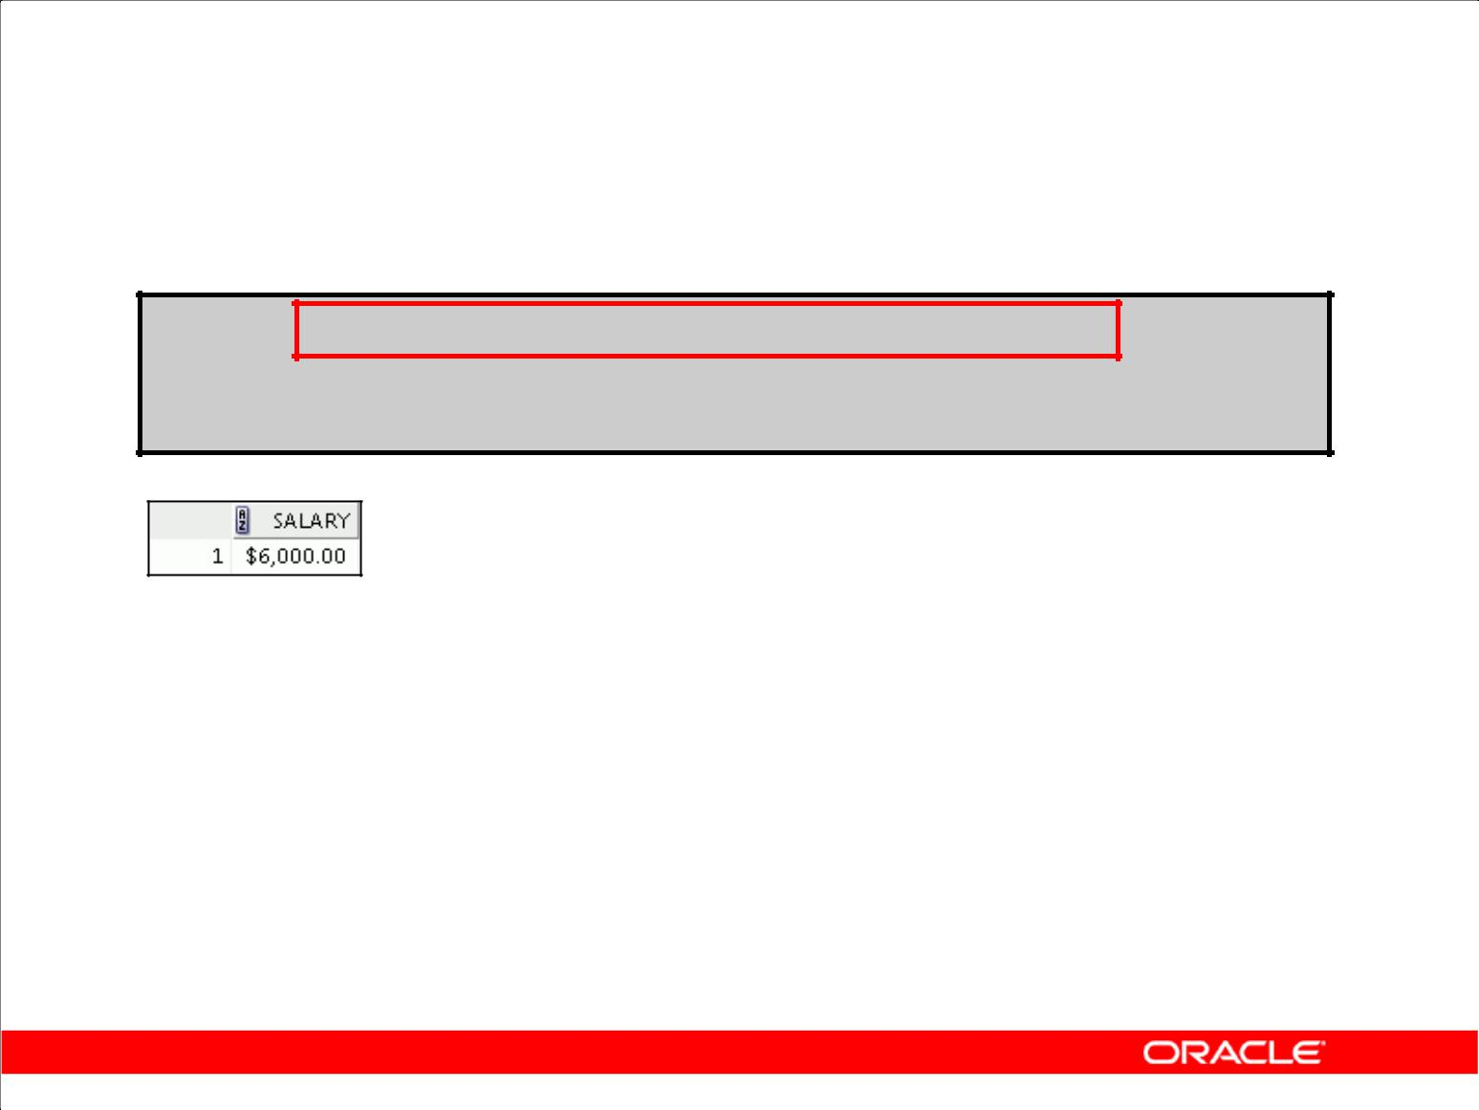**Using the TO_CHAR Function with Numbers**

**SELECT TO_CHAR(salary, '$99,999.00') SALARY**

**FROM employees**

**WHERE** **last_name = 'Ernst';**

Copyright © 2009, Oracle. All rights reserved.

**Guidelines**

* The Oracle server displays a string of number signs (#) in place of a whole number whose digits exceed the number of digits that is provided in the format model.
* The Oracle server rounds the stored decimal value to the number of decimal places that is provided in the format model.

|  |
| --- |
| Oracle Internal & Oracle Academy Use Only |

**Oracle Database 10*g*: SQL Fundamentals I 3 - 40**

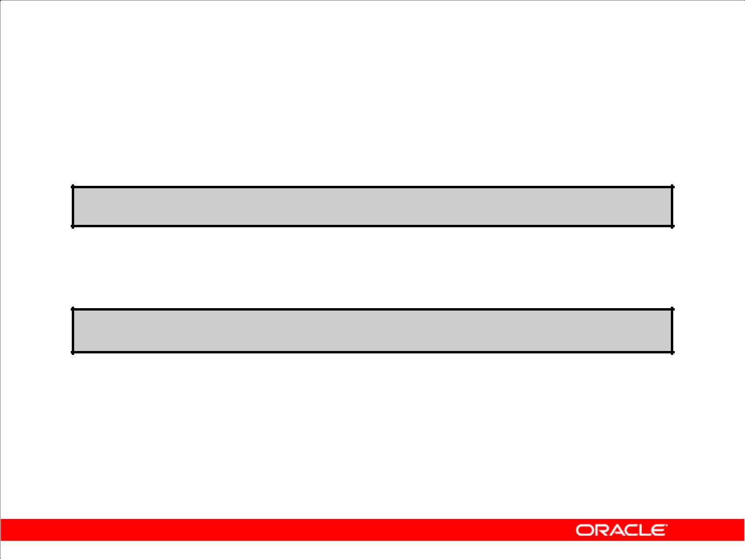**Using the TO_NUMBER and TO_DATE Functions**

* Convert a character string to a number format using the

TO_NUMBER function:

**TO_NUMBER(*char*[*,* '*format_model*'])**

* Convert a character string to a date format using the TO_DATE function:

**TO_DATE(*char*[, '*format_model*'])**

* These functions have an fx modifier. This modifier specifies the exact matching for the character argument and date format model of a TO_DATE function.

Copyright © 2009, Oracle. All rights reserved.

**Using the TO_NUMBER and TO_DATE Functions**

You may want to convert a character string to either a number or a date. To accomplish this task, use the TO_NUMBER or TO_DATE functions. The format model that you choose is based on the

previously demonstrated format elements.

The fx modifier specifies exact matching for the character argument and date format model of a

TO_DATE function:

* Punctuation and quoted text in the character argument must exactly match (except for case) the corresponding parts of the format model.
* The character argument cannot have extra blanks. Without fx, Oracle ignores extra blanks.
* Numeric data in the character argument must have the same number of digits as the corresponding element in the format model. Without fx, numbers in the character argument can omit leading zeros.

|  |
| --- |
| Oracle Internal & Oracle Academy Use Only |

**Oracle Database 10*g*: SQL Fundamentals I 3 - 41**

**Using the TO_NUMBER and TO_DATE Functions (continued)**

**Example**

Display the name and hire date for all employees who started on May 24, 1999. There are two spaces after the month *May* and the number *24* in the following example. Because the fx modifier is used,

an exact match is required and the spaces after the word *May* are not recognized:

SELECT last_name, hire_date

FROM employees

WHERE hire_date = TO_DATE('May 24, 1999', 'fxMonth DD, YYYY');

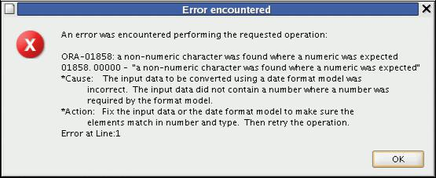

To fix the above error, change fx to fm in the query.

SELECT last_name, hire_date

FROM employees

WHERE hire_date = TO_DATE('May 24, 1999', 'fmMonth DD, YYYY');

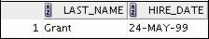

|  |
| --- |
| Oracle Internal & Oracle Academy Use Only |

**Oracle Database 10*g*: SQL Fundamentals I 3 - 42**

1. 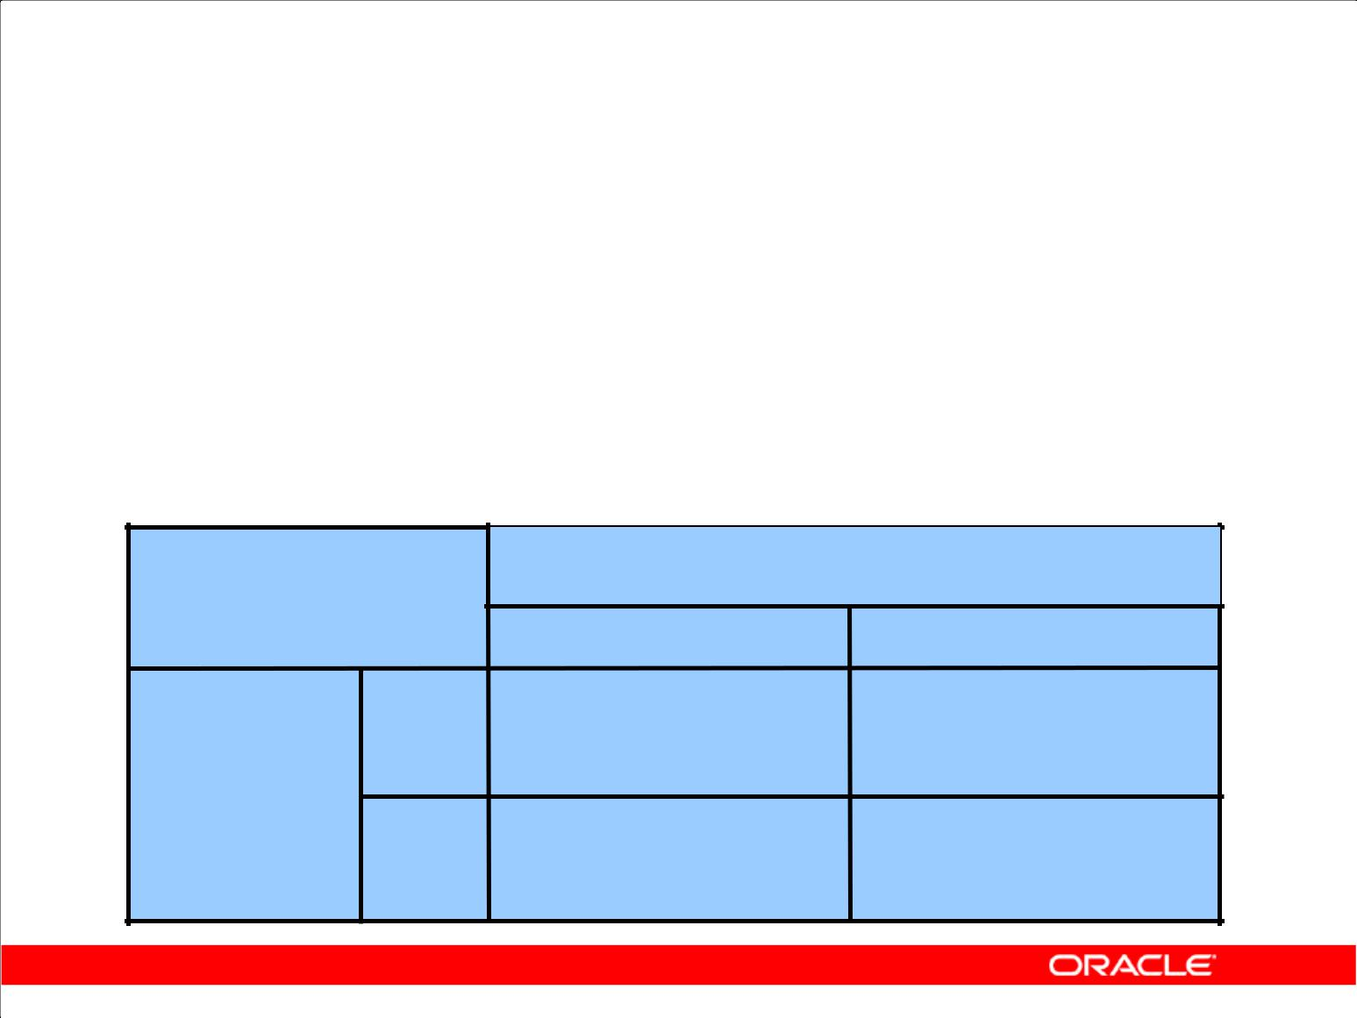**Date Format**

|  |  |  |  |
| --- | --- | --- | --- |
| **Current Year** | **Specified Date** | **RR Format** | **YY Format** |
| **1995** | **27-OCT-95** | **1995** | **1995** |
| **1995** | **27-OCT-17** | **2017** | **1917** |
| **2001** | **27-OCT-17** | **2017** | **2017** |
| **2001** | **27-OCT-95** | **1995** | **2095** |
|  |  |  |  |

**If the specified two-digit year is:**

**0–49** **50–99**

|  |
| --- |
| Only |

**If two digits**

**of the** **0–49**

**current**

**year are:**

**50–99**

**The return date is in the current century**

**The return date is in the century after the current one**

**The return date is in the century before the current one The return date is in the current century**

|  |
| --- |
| Oracle Academy Use |

Copyright © 2009, Oracle. All rights reserved.

1. **Date Format Element**

The RR date format is similar to the YY element, but you can use it to specify different centuries. Use the RR date format element instead of YY so that the century of the return value varies according to

the specified two-digit year and the last two digits of the current year. The table in the slide summarizes the behavior of the RR element.

|  |  |  |  |
| --- | --- | --- | --- |
| **Current Year** | **Given Date** | **Interpreted (RR)** | **Interpreted (YY)** |
|  |  |  |  |
| 1994 | 27-OCT-95 | 1995 | 1995 |
|  |  |  |  |
| 1994 | 27-OCT-17 | 2017 | 1917 |
|  |  |  |  |
| 2001 | 27-OCT-17 | 2017 | 2017 |
|  |  |  |  |

|  |
| --- |
| Oracle Internal & |

**Oracle Database 10*g*: SQL Fundamentals I 3 - 43**

1. 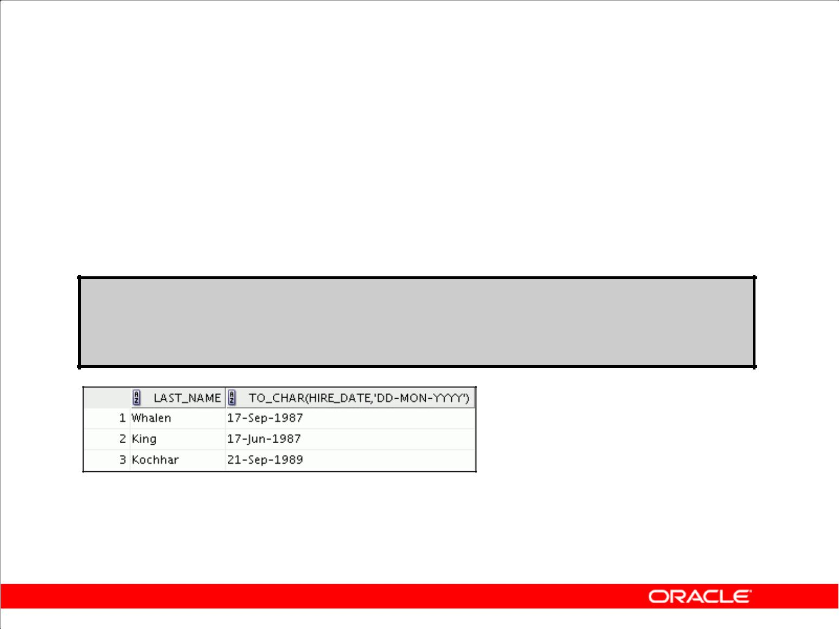**Date Format: Example**

To find employees hired before 1990, use the RR date format, which produces the same results whether the command is run in 1999 or now:

**SELECT last_name, TO_CHAR(hire_date, 'DD-Mon-YYYY')**

**FROM** **employees**

**WHERE hire_date < TO_DATE('01-Jan-90','DD-Mon-RR');**

Copyright © 2009, Oracle. All rights reserved.

1. **Date Format: Example**

To find employees who were hired before 1990, the RR format can be used. Because the current year is greater than 1999, the RR format interprets the year portion of the date from 1950 to 1999.

The following command, on the other hand, results in no rows being selected because the YY format interprets the year portion of the date in the current century (2090).

SELECT last_name, TO_CHAR(hire_date, 'DD-Mon-yyyy')

FROM employees

WHERE TO_DATE(hire_date, 'DD-Mon-yy') < '01-Jan-1990';

|  |
| --- |
| Oracle Internal & Oracle Academy Use Only |

**Oracle Database 10*g*: SQL Fundamentals I 3 - 44**

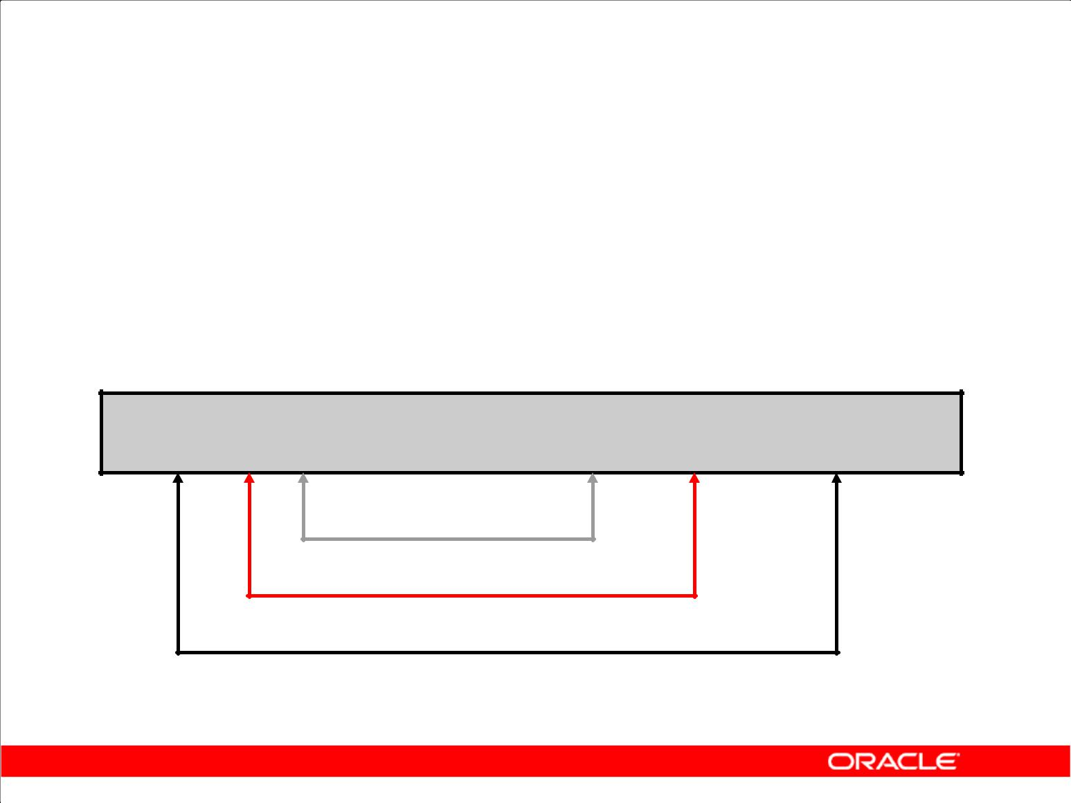**Nesting Functions**

* Single-row functions can be nested to any level.
* Nested functions are evaluated from the deepest level to the least deep level.

**F3(F2(F1(col,arg1),arg2),arg3)**

**Step 1 = Result 1**

**Step 2 = Result 2**

**Step 3 = Result 3**

Copyright © 2009, Oracle. All rights reserved.

**Nesting Functions**

Single-row functions can be nested to any depth. Nested functions are evaluated from the innermost level to the outermost level. Some examples follow to show you the flexibility of these functions.

|  |
| --- |
| Oracle Internal & Oracle Academy Use Only |

**Oracle Database 10*g*: SQL Fundamentals I 3 - 45**

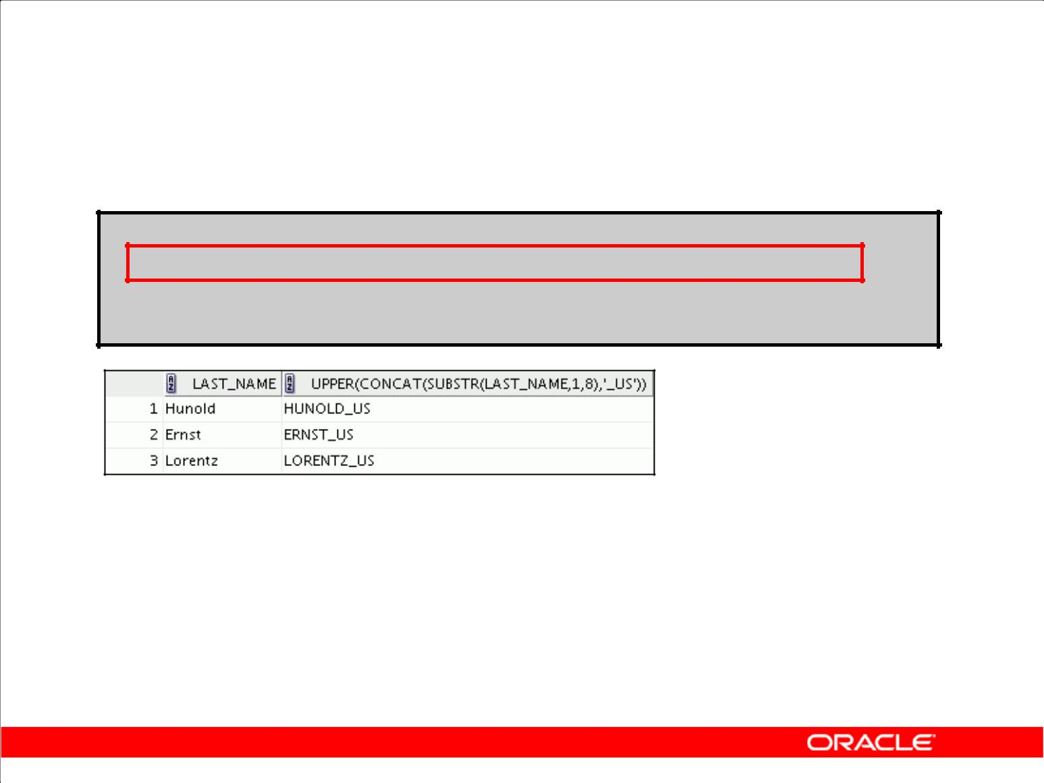**Nesting Functions**

**SELECT last_name,**

**UPPER(CONCAT(SUBSTR (LAST_NAME, 1, 8), '_US'))**

**FROM employees**

**WHERE** **department_id = 60;**

Copyright © 2009, Oracle. All rights reserved.

**Nesting Functions (continued)**

The slide example displays the last names of employees in department 60. The evaluation of the SQL statement involves three steps:

1. The inner function retrieves the first eight characters of the last name.

Result1 = SUBSTR (LAST_NAME, 1, 8)

2. The outer function concatenates the result with _US.

Result2 = CONCAT(Result1, '_US')

3. The outermost function converts the results to uppercase.

The entire expression becomes the column heading because no column alias was given.

**Example**

Display the date of the next Friday that is six months from the hire date. The resulting date should appear as Friday, August 13th, 1999. Order the results by hire date.

SELECT TO_CHAR(NEXT_DAY(ADD_MONTHS

(hire_date, 6), 'FRIDAY'),

'fmDay, Month DDth, YYYY')

"Next 6 Month Review"

FROM employees

ORDER BY hire_date;

|  |
| --- |
| Oracle Internal & Oracle Academy Use Only |

**Oracle Database 10*g*: SQL Fundamentals I 3 - 46**

**General Functions**

The following functions work with any data type and pertain to using nulls:

* NVL (expr1, expr2)
* NVL2 (expr1, expr2, expr3)
* NULLIF (expr1, expr2)
* COALESCE (expr1, expr2, ..., exprn)

Copyright © 2009, Oracle. All rights reserved.

**General Functions**

These functions work with any data type and pertain to the use of null values in the expression list.

**Function** **Description**

|  |  |
| --- | --- |
| NVL | Converts a null value to an actual value |

NVL2 If expr1 is not null, NVL2 returns expr2. If expr1 is null, NVL2 returns expr3. The argument expr1 can have any data type.

NULLIF Compares two expressions and returns null if they are equal; returns the first expression if they are not equal

COALESCE Returns the first non-null expression in the expression list

**Note:** For more information about the hundreds of functions available, see “Functions” in*Oracle**SQL Reference*.

|  |
| --- |
| Oracle Internal & Oracle Academy Use Only |

**Oracle Database 10*g*: SQL Fundamentals I 3 - 47**

**NVL Function**

Converts a null value to an actual value:

* Data types that can be used are date, character, and number.
* Data types must match:

– NVL(commission_pct,0)

– NVL(hire_date,'01-JAN-97')

– NVL(job_id,'No Job Yet')

Copyright © 2009, Oracle. All rights reserved.

**NVL Function**

To convert a null value to an actual value, use the NVL function.

**Syntax**

NVL (*expr1*, *expr2*)

In the syntax:

* *expr1* is the source value or expression that may contain a null
* *expr2* is the target value for converting the null

You can use the NVL function to convert any data type, but the return value is always the same as the data type of *expr1*.

**NVL Conversions for Various Data Types**

|  |  |
| --- | --- |
| **Data Type** | **Conversion Example** |
|  |  |
| NUMBER | NVL(*number_column*,9) |
|  |  |
| DATE | NVL(*date_column,* '01-JAN-95') |
|  |  |
| CHAR or VARCHAR2 | NVL(*character_column*, 'Unavailable') |
|  |  |

|  |
| --- |
| Oracle Internal & Oracle Academy Use Only |

**Oracle Database 10*g*: SQL Fundamentals I 3 - 48**

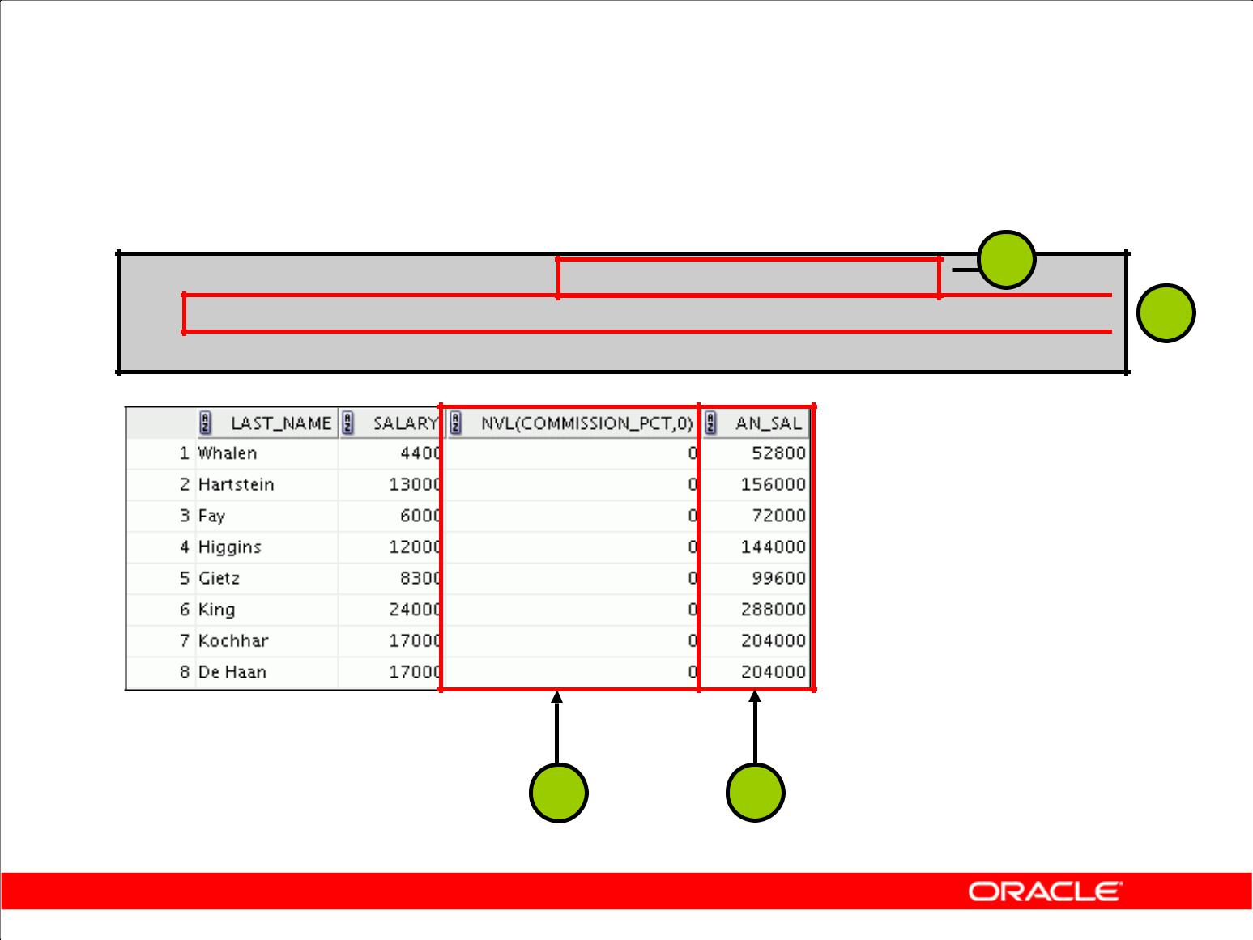**Using the NVL Function**

**1**

**SELECT last_name, salary, NVL(commission_pct, 0),**

**(salary*12) + (salary*12*NVL(commission_pct, 0)) AN_SAL** **2**

**FROM employees;**

**…**

**1** **2**

Copyright © 2009, Oracle. All rights reserved.

**Using the NVL Function**

To calculate the annual compensation of all employees, you need to multiply the monthly salary by

12 and then add the commission percentage to the result:

SELECT last_name, salary, commission_pct, (salary*12) + (salary*12*commission_pct) AN_SAL FROM employees;

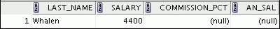

**…**

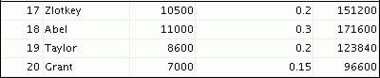

Notice that the annual compensation is calculated for only those employees who earn a commission. If any column value in an expression is null, the result is null. To calculate values for all employees, you must convert the null value to a number before applying the arithmetic operator. In the example in the slide, the NVL function is used to convert null values to zero.

|  |
| --- |
| Oracle Internal & Oracle Academy Use Only |

**Oracle Database 10*g*: SQL Fundamentals I 3 - 49**

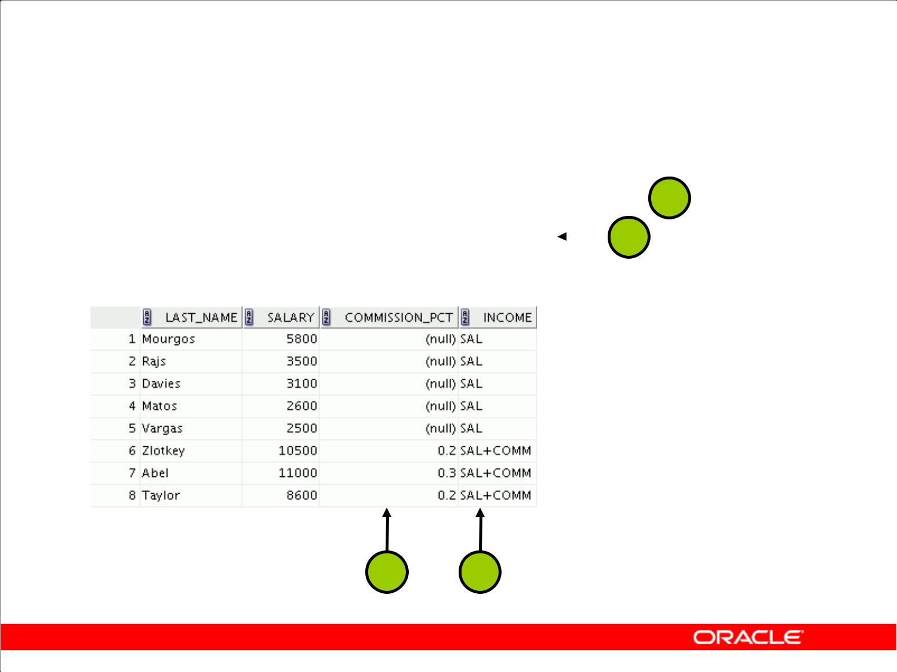**Using the NVL2 Function**

|  |  |  |  |  |  |  |  |  |  |  |  |  |  |
| --- | --- | --- | --- | --- | --- | --- | --- | --- | --- | --- | --- | --- | --- |
|  | **SELECT** | **last_name, salary,** | |  |  |  |  |  |  |  |  | **1** |  |
|  | **commission_pct,** | | | | |  |
|  |  |  |  |  |
|  |  | **NVL2(commission_pct,** | | | | |  |  | |  | **2** |  |  |
|  | **FROM** | **'SAL+COMM', 'SAL') income** | | | | |  |  |  |  |  |  |
|  | **employees WHERE department_id IN (50, 80);** | | | | | | | | | | |  |
|  |  |  |  |  |  |  |  |  |  |  |  |  |  |
|  |  |  |  |  |  |  |  |  |  |  |  |  |  |

**1** **2**

Copyright © 2009, Oracle. All rights reserved.

**Using the NVL2 Function**

The NVL2 function examines the first expression. If the first expression is not null, then the NVL2 function returns the second expression. If the first expression is null, then the third expression is returned.

**Syntax**

NVL2(*expr1*, *expr2, expr3*)

In the syntax:

* *expr1* is the source value or expression that may contain null
* *expr2* is the value that is returned if *expr1* is not null
* *expr3* is the value that is returned if *expr1* is null

In the example shown in the slide, the COMMISSION_PCT column is examined. If a value is detected, the second expression of SAL+COMM is returned. If the COMMISSION_PCT column holds a null value, the third expression of SAL is returned.

The argument *expr1* can have any data type. The arguments *expr2* and *expr3* can have any data types except LONG. If the data types of *expr2* and *expr3* are different, the Oracle server converts *expr3* to the data type of *expr2* before comparing them unless *expr3* is a null constant. In the

latter case, a data type conversion is not necessary. The data type of the return value is always the same as the data type of *expr2*, unless *expr2* is character data, in which case the return value’s data type is VARCHAR2.

|  |
| --- |
| Oracle Internal & Oracle Academy Use Only |

**Oracle Database 10*g*: SQL Fundamentals I 3 - 50**

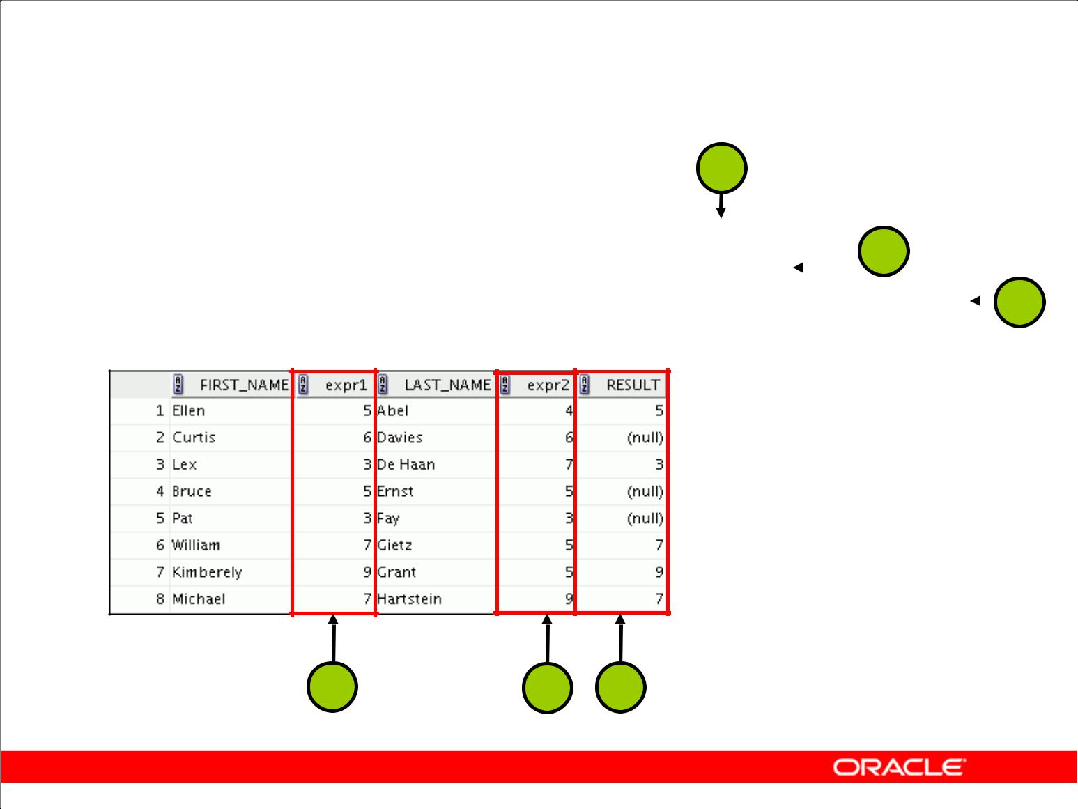**Using the NULLIF Function**

|  |  |  |  |  |  |  |  |  |  |
| --- | --- | --- | --- | --- | --- | --- | --- | --- | --- |
|  | **1** | |  |  |  |  |  |  |  |
|  |  |  |  |  |  |  |  |  |  |
| **SELECT** | **first_name,** | **LENGTH(first_name) "expr1",** | **2** | | |  |  |  |  |
|  | **last_name,** | **LENGTH(last_name) "expr2",** | **3** | | |  |
|  |  |  |  |  |
| **FROM** | **NULLIF(LENGTH(first_name), LENGTH(last_name)) result** | | | | |  |
|  |  |  |  |
| **employees;** | |  |  |  |  |  |  |  |
|  |  |  |  |  |  |  |  |  |  |

**…**

**1** **2** **3**

Copyright © 2009, Oracle. All rights reserved.

**Using the NULLIF Function**

The NULLIF function compares two expressions. If they are equal, the function returns null. If they are not equal, the function returns the first expression. You cannot specify the literal NULL for the first expression.

**Syntax**

NULLIF (*expr1*, *expr2*)

In the syntax:

* *expr1* is the source value compared to *expr2*
* *expr2* is the source value compared with *expr1* (If it is not equal to *expr1*, *expr1* isreturned.)

In the example shown in the slide, the length of the first name in the EMPLOYEES table is compared to the length of the last name in the EMPLOYEES table. When the lengths of the names are equal, a null value is displayed. When the lengths of the names are not equal, the length of the first name is displayed.

**Note:** TheNULLIFfunction is logically equivalent to the followingCASEexpression. TheCASEexpression is discussed on a subsequent page:

CASE WHEN expr1 = expr 2 THEN NULL ELSE expr1 END

|  |
| --- |
| Oracle Internal & Oracle Academy Use Only |

**Oracle Database 10*g*: SQL Fundamentals I 3 - 51**

**Using the COALESCE Function**

* The advantage of the COALESCE function over the NVL function is that the COALESCE function can take multiple alternate values.
* If the first expression is not null, the COALESCE function returns that expression; otherwise, it does a COALESCE of the remaining expressions.

Copyright © 2009, Oracle. All rights reserved.

**Using the COALESCE Function**

The COALESCE function returns the first non-null expression in the list.

**Syntax**

COALESCE (*expr1*, *expr2, ... exprn*)

In the syntax:

* *expr1* returns this expression if it is not null
* *expr2* returns this expression if the first expression is null and this expression is not null
* *exprn* returns this expression if the preceding expressions are null

All expressions must be of the same data type.

|  |
| --- |
| Oracle Internal & Oracle Academy Use Only |

**Oracle Database 10*g*: SQL Fundamentals I 3 - 52**

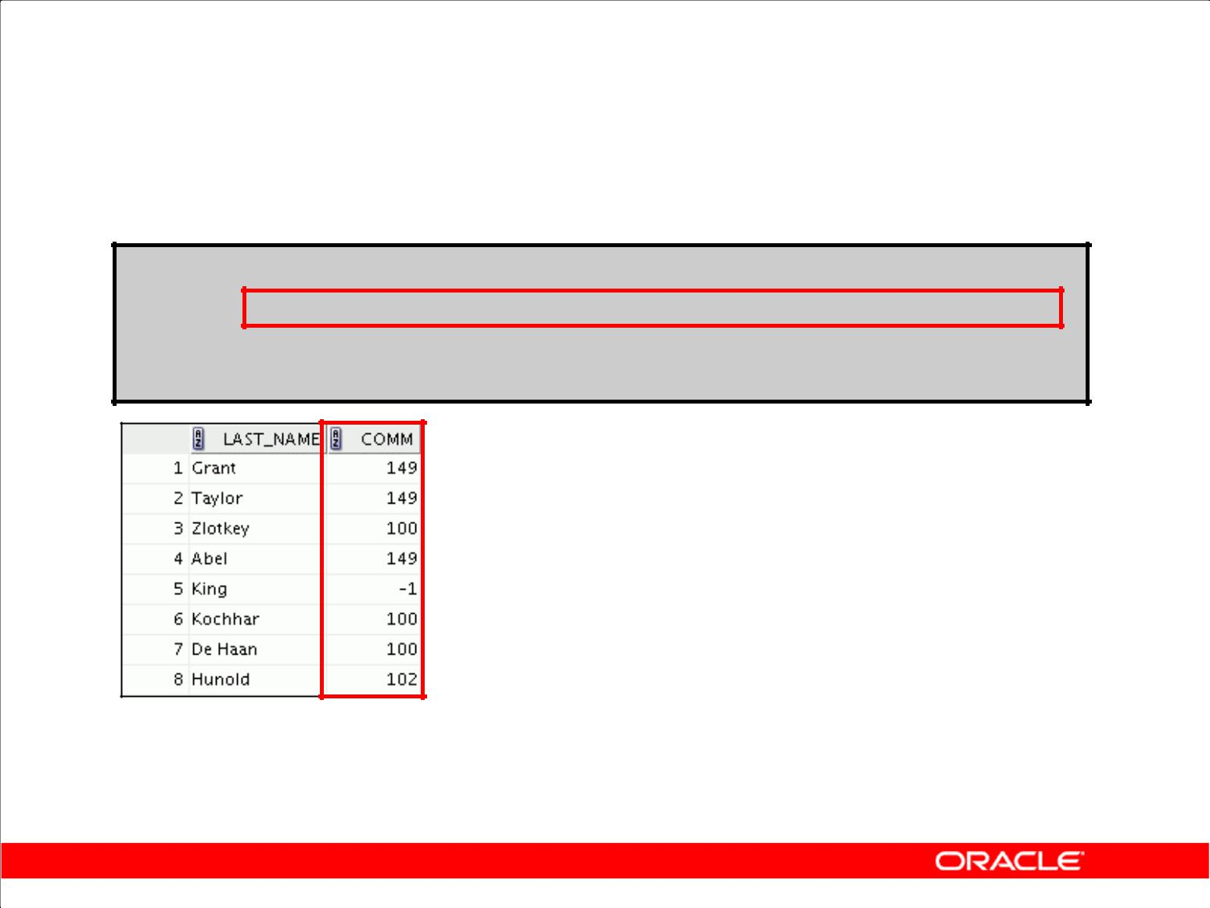**Using the COALESCE Function**

**SELECT last_name,**

**COALESCE(manager_id,commission_pct, -1) comm**

**FROM employees**

**ORDER BY commission_pct;**

**…**

Copyright © 2009, Oracle. All rights reserved.

**Using the COALESCE Function (continued)**

In the example shown in the slide, if the MANAGER_ID value is not null, it is displayed. If the MANAGER_ID value is null, then the COMMISSION_PCT is displayed. If the MANAGER_ID and COMMISSION_PCT values are null, then the value –1 is displayed.

|  |
| --- |
| Oracle Internal & Oracle Academy Use Only |

**Oracle Database 10*g*: SQL Fundamentals I 3 - 53**

**Conditional Expressions**

* Provide the use of IF-THEN-ELSE logic within a SQL statement
* Use two methods:

– CASE expression

– DECODE function

Copyright © 2009, Oracle. All rights reserved.

**Conditional Expressions**

Two methods used to implement conditional processing (IF-THEN-ELSE logic) in a SQL statement are the CASE expression and the DECODE function.

**Note:** TheCASEexpression complies with ANSI SQL. TheDECODEfunction is specific to Oraclesyntax.

|  |
| --- |
| Oracle Internal & Oracle Academy Use Only |

**Oracle Database 10*g*: SQL Fundamentals I 3 - 54**

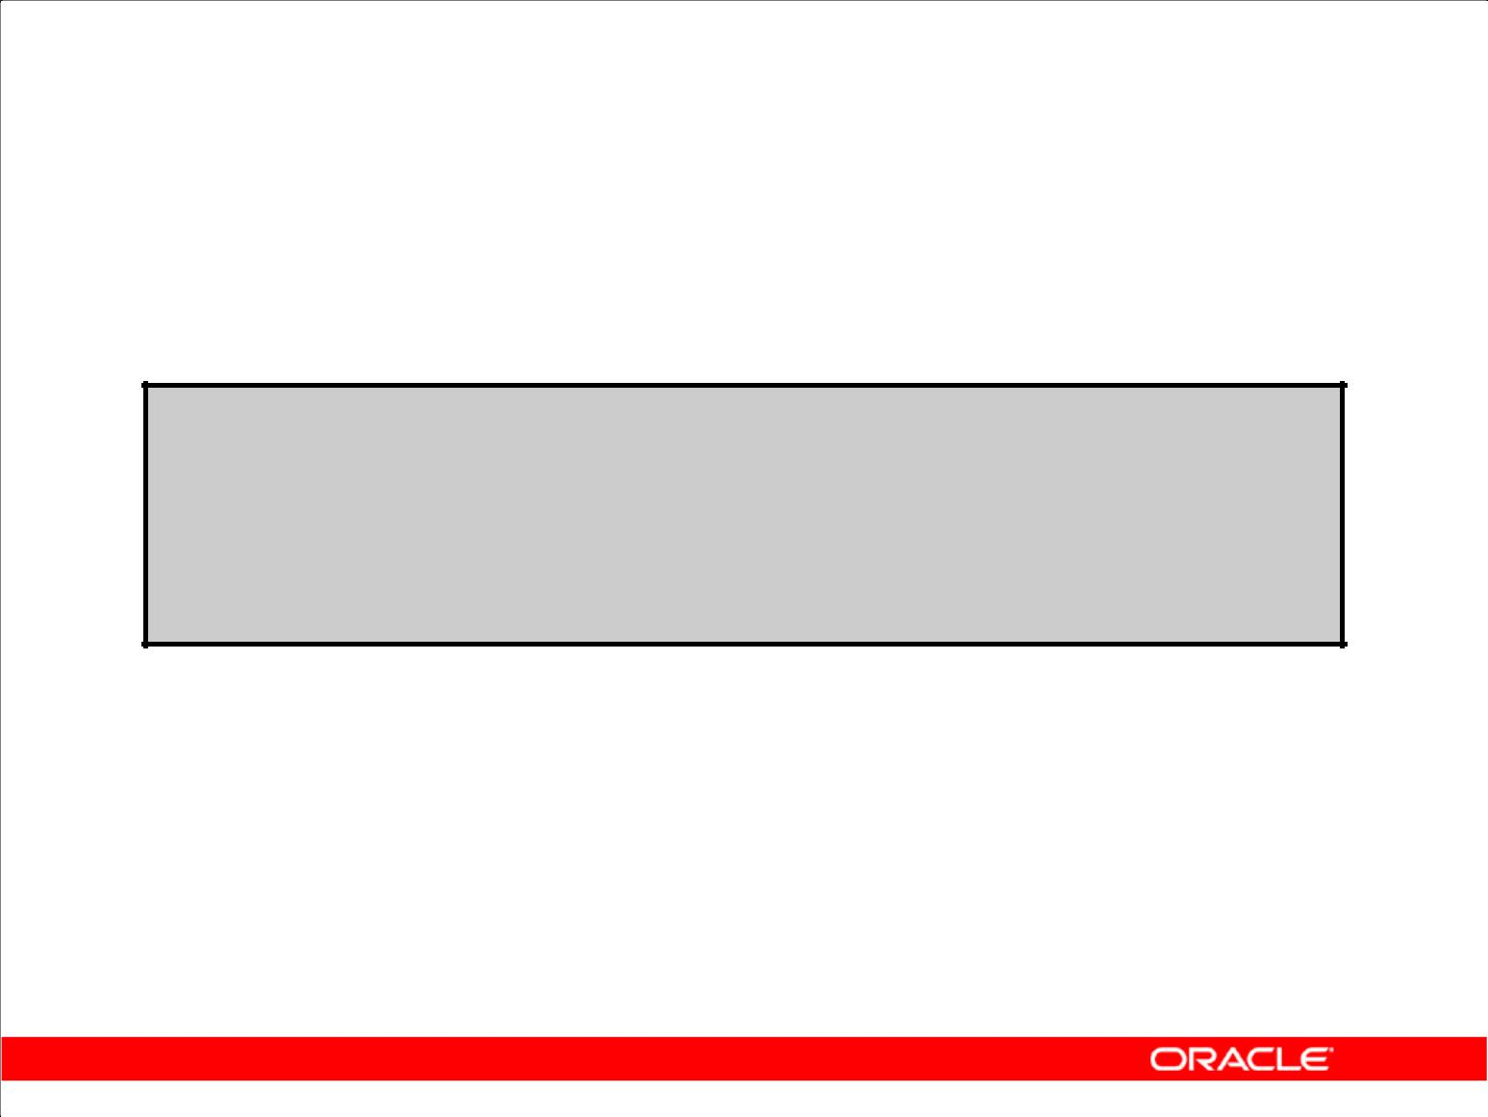**CASE Expression**

Facilitates conditional inquiries by doing the work of an

IF-THEN-ELSE statement:

**CASE *expr* WHEN *comparison_expr1* THEN *return_expr1***

**[WHEN *comparison_expr2* THEN *return_expr2***

**WHEN *comparison_exprn* THEN *return_exprn***

**ELSE *else_expr*]**

**END**

Copyright © 2009, Oracle. All rights reserved.

**CASE Expression**

CASE expressions let you use IF-THEN-ELSE logic in SQL statements without having to invoke procedures.

In a simple CASE expression, the Oracle server searches for the first WHEN ... THEN pair for which expr is equal to comparison_expr and returns return_expr. If none of the WHEN

... THEN pairs meet this condition, and if an ELSE clause exists, then the Oracle server returns else_expr. Otherwise, the Oracle server returns null. You cannot specify the literal NULL for all the return_exprs and the else_expr.

All of the expressions ( expr, comparison_expr, and return_expr) must be of the same data type, which can be CHAR, VARCHAR2, NCHAR, or NVARCHAR2.

|  |
| --- |
| Oracle Internal & Oracle Academy Use Only |

**Oracle Database 10*g*: SQL Fundamentals I 3 - 55**

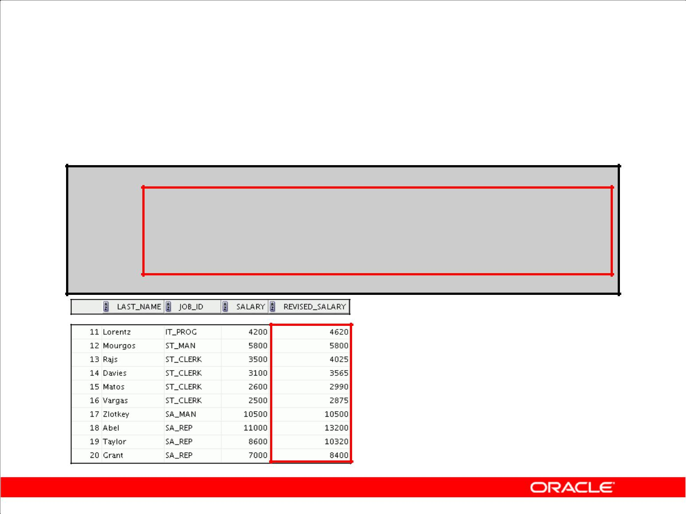**Using the CASE Expression**

Facilitates conditional inquiries by doing the work of an

IF-THEN-ELSE statement:

**SELECT last_name, job_id, salary,**

|  |  |  |  |  |
| --- | --- | --- | --- | --- |
| **CASE job_id WHEN** | | **'IT_PROG' THEN 1.10*salary** | | |
|  | **WHEN** | **'ST_CLERK' THEN** | | **1.15*salary** |
|  | **WHEN** | **'SA_REP'** | **THEN** | **1.20*salary** |
| **ELSE** | **salary** | **END** | **"REVISED_SALARY"** | |

**FROM employees;**

**…**

Copyright © 2009, Oracle. All rights reserved.

**Using the CASE Expression**

In the SQL statement in the slide, the value of JOB_ID is decoded. If JOB_ID is IT_PROG, the salary increase is 10%; if JOB_ID is ST_CLERK, the salary increase is 15%; if JOB_ID is SA_REP, the salary increase is 20%. For all other job roles, there is no increase in salary.

The same statement can be written with the DECODE function.

The following is an example of a searched CASE expression. In a searched CASE expression, the

search occurs from left to right until an occurrence of the listed condition is found, and then it returns the return expression. If no condition is found to be true, and if an ELSE clause exists, the return expression in the ELSE clause is returned; otherwise, NULL is returned.

SELECT last_name,salary,

(CASE WHEN salary<5000 THEN 'Low'

WHEN salary<10000 THEN 'Medium'

WHEN salary<20000 THEN 'Good'

ELSE 'Excellent'

END) qualified_salary

FROM employees;

|  |
| --- |
| Oracle Internal & Oracle Academy Use Only |

**Oracle Database 10*g*: SQL Fundamentals I 3 - 56**

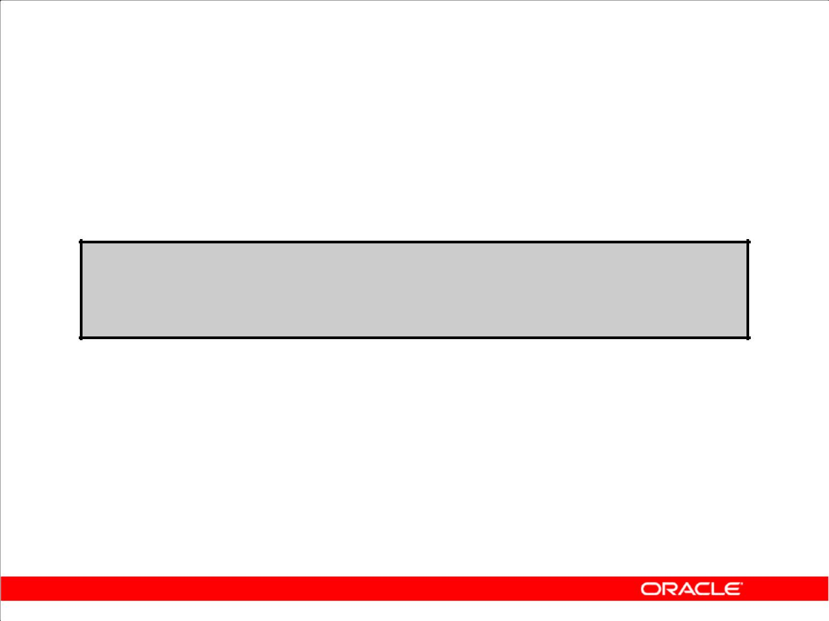**DECODE Function**

Facilitates conditional inquiries by doing the work of a CASE expression or an IF-THEN-ELSE statement:

**DECODE(*col|expression, search1, result1***

**[*, search2, result2,...,*]**

**[*, default*])**

Copyright © 2009, Oracle. All rights reserved.

**DECODE Function**

The DECODE function decodes an expression in a way similar to the IF-THEN-ELSE logic that is used in various languages. The DECODE function decodes *expression* after comparing it to each *search* value. If the expression is the same as *search*, *result* is returned.

If the default value is omitted, a null value is returned where a search value does not match any of the result values.

|  |
| --- |
| Oracle Internal & Oracle Academy Use Only |

**Oracle Database 10*g*: SQL Fundamentals I 3 - 57**

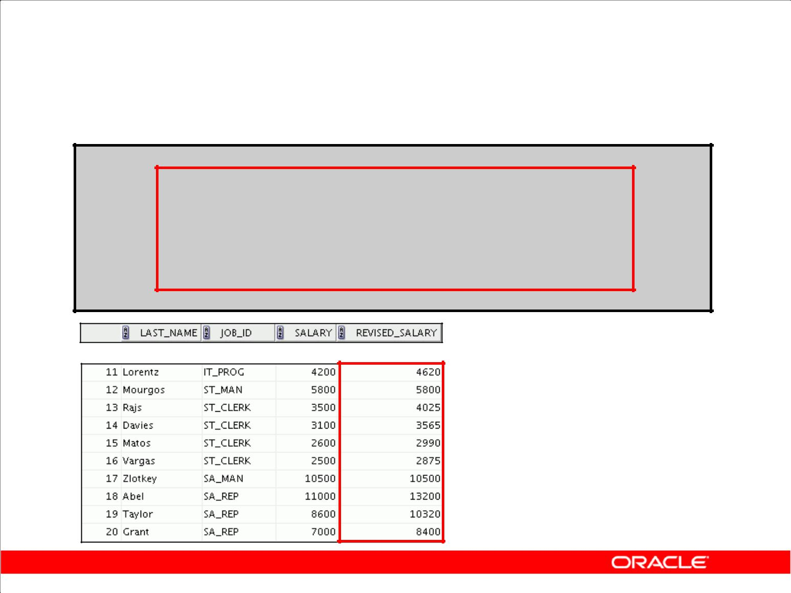**Using the DECODE Function**

**SELECT last_name, job_id, salary,**

**DECODE(job_id, 'IT_PROG',** **1.10*salary, 'ST_CLERK', 1.15*salary, 'SA_REP', 1.20*salary,**

**salary)**

**REVISED_SALARY**

**FROM employees;**

**…**

Copyright © 2009, Oracle. All rights reserved.

**Using the DECODE Function**

In the SQL statement in the slide, the value of JOB_ID is tested. If JOB_ID is IT_PROG, the salary increase is 10%; if JOB_ID is ST_CLERK, the salary increase is 15%; if JOB_ID is SA_REP, the salary increase is 20%. For all other job roles, there is no increase in salary.

The same statement can be expressed in pseudocode as an IF-THEN-ELSE statement:

|  |  |  |  |  |  |  |  |
| --- | --- | --- | --- | --- | --- | --- | --- |
| IF job_id = | | | 'IT_PROG' | THEN | salary = salary*1.10 | | |
| IF | job_id | = | 'ST_CLERK' | THEN | salary | = | salary*1.15 |
| IF | job_id | = | 'SA_REP' | THEN | salary | = | salary*1.20 |
| ELSE salary | | | = salary |  |  |  |  |

|  |
| --- |
| Oracle Internal & Oracle Academy Use Only |

**Oracle Database 10*g*: SQL Fundamentals I 3 - 58**

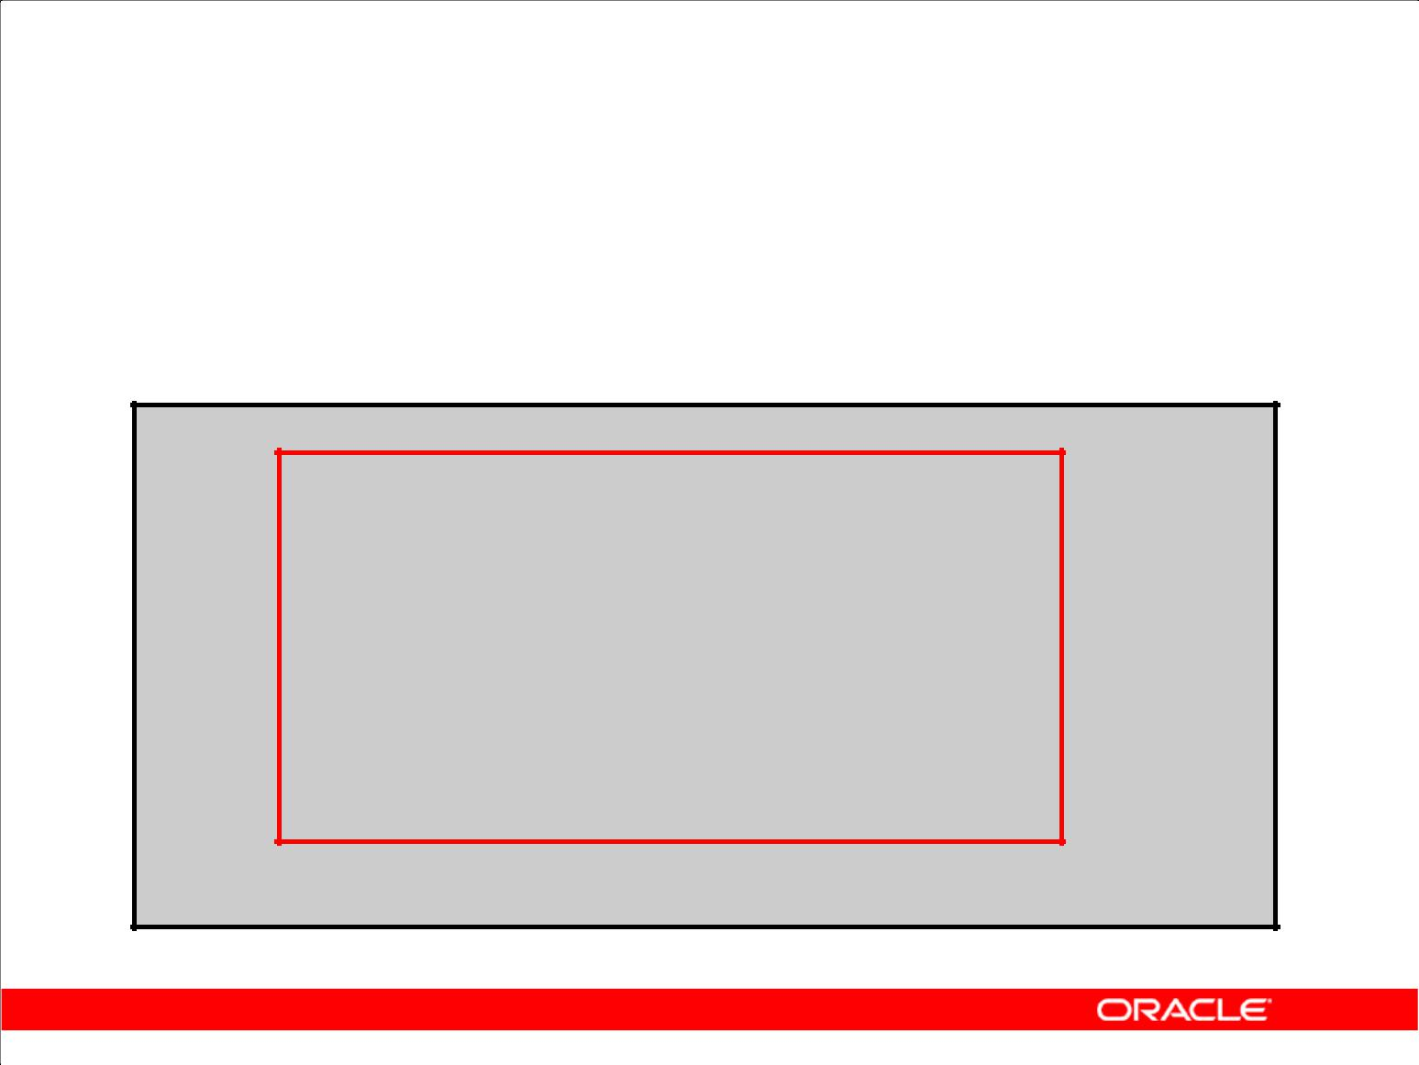**Using the DECODE Function**

Display the applicable tax rate for each employee in department 80:

**SELECT last_name, salary,**

**DECODE (TRUNC(salary/2000, 0),**

**0, 0.00,**

**1, 0.09,**

**2, 0.20,**

**3, 0.30,**

**4, 0.40,**

**5, 0.42,**

**6, 0.44,**

**0.45) TAX_RATE**

**FROM employees**

**WHERE** **department_id = 80;**

Copyright © 2009, Oracle. All rights reserved.

**Using the DECODE function (continued)**

This slide shows another example using the DECODE function. In this example, you determine the

tax rate for each employee in department 80 based on the monthly salary. The tax rates are as follows:

|  |  |  |
| --- | --- | --- |
| ***Monthly Salary Range*** | | ***Tax Rate*** |
| $0.00–1,999.99 | | 00% |
| $2,000.00–3,999.99 | | 09% |
| $4,000.00–5,999.99 | | 20% |
| $6,000.00–7,999.99 | | 30% |
| $8,000.00–9,999.99 | | 40% |
| $10,000.00–11,999.99 | | 42% |
| $12,200.00–13,999.99 | | 44% |
| $14,000.00 or greater | | 45% |
|  |  |  |
|  |  |  |

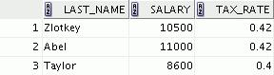

|  |
| --- |
| Oracle Internal & Oracle Academy Use Only |

**Oracle Database 10*g*: SQL Fundamentals I 3 - 59**

**Summary**

In this lesson, you should have learned how to:

* Perform calculations on data using functions
* Modify individual data items using functions
* Manipulate output for groups of rows using functions
* Alter date formats for display using functions
* Convert column data types using functions
* Use NVL functions
* Use IF-THEN-ELSE logic

Copyright © 2009, Oracle. All rights reserved.

**Summary**

Single-row functions can be nested to any level. Single-row functions can manipulate the following:

* Character data: LOWER, UPPER, INITCAP, CONCAT, SUBSTR, INSTR, LENGTH
* Number data: ROUND, TRUNC, MOD
* Date data: MONTHS_BETWEEN, ADD_MONTHS, NEXT_DAY, LAST_DAY, ROUND, TRUNC

Remember the following:

* Date values can also use arithmetic operators.
* Conversion functions can convert character, date, and numeric values: TO_CHAR, TO_DATE,

TO_NUMBER

* There are several functions that pertain to nulls, including NVL, NVL2, NULLIF, and

COALESCE.

* IF-THEN-ELSE logic can be applied within a SQL statement by using the CASE expression or the DECODE function.

**SYSDATE and DUAL**

SYSDATE is a date function that returns the current date and time. It is customary to select SYSDATE from a dummy table called DUAL.

|  |
| --- |
| Oracle Internal & Oracle Academy Use Only |

**Oracle Database 10*g*: SQL Fundamentals I 3 - 60**

**Practice 3: Overview of Part 2**

This practice covers the following topics:

* Creating queries that require the use of numeric, character, and date functions
* Using concatenation with functions
* Writing non-case-sensitive queries to test the usefulness of character functions
* Performing calculations of years and months of service for an employee
* Determining the review date for an employee

Copyright © 2009, Oracle. All rights reserved.

**Practice 3: Overview of Part 2**

Part 2 of this lesson’s practice provides a variety of exercises that use the different functions that are available for character, number, and date data types. For Part 2, complete exercises 7–14.

Remember that for nested functions, the results are evaluated from the innermost function to the outermost function.

|  |
| --- |
| Oracle Internal & Oracle Academy Use Only |

**Oracle Database 10*g*: SQL Fundamentals I 3 - 61**

**Practice 3**

**Part 1**

1. Write a query to display the current date. Label the column Date.
2. The HR department needs a report to display the employee number, last name, salary, and salary increased by 15.5% (expressed as a whole number) for each employee. Label the column New Salary. Place your SQL statement in a text file named lab_03_02.sql.
3. Run your query in the lab_03_02.sql file.

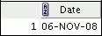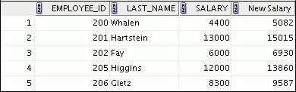

**…**



1. Modify your lab_03_02.sql query to add a column that subtracts the old salary from the new salary. Label the column Increase. Save the contents of the file as lab_03_04.sql. Run the revised query.

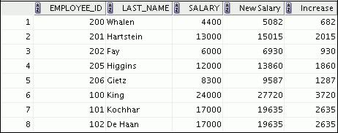

**…**



|  |
| --- |
| Oracle Internal & Oracle Academy Use Only |

**Oracle Database 10*g*: SQL Fundamentals I 3 - 62**

**Practice 3 (continued)**

1. Write a query that displays the last name (with the first letter uppercase and all other letters lowercase) and the length of the last name for all employees whose name starts with the letters *J, A,* or *M*. Give each column an appropriate label. Sort the results by the last names of theemployees.

Rewrite the query so that the user is prompted to enter a letter that starts the last name. For example, if the user enters H when prompted for a letter, the output should show all employees whose last name starts with the letter *H*.

1. The HR department wants to find the duration of employment for each employee. For each employee, display the last name and calculate the number of months between today and the date on which the employee was hired. Label the column MONTHS_WORKED. Order your results by the number of months employed. Round the number of months up to the closest whole number. **Note:** Your results will differ.

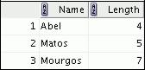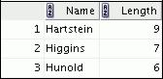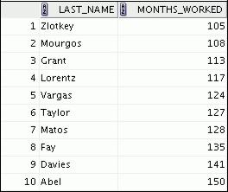

**…**



|  |
| --- |
| Oracle Internal & Oracle Academy Use Only |

**Oracle Database 10*g*: SQL Fundamentals I 3 - 63**

**Practice 3 (continued)**

**Part 2**

1. Create a report that produces the following for each employee:

<employee last name> earns <salary> monthly but wants <3 times salary>. Label the column Dream Salaries.

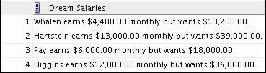

**…**

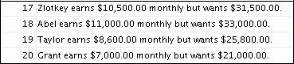

If you have time, complete the following exercises:

1. Create a query to display the last name and salary for all employees. Format the salary to be 15 characters long, left-padded with the $ symbol. Label the column SALARY.

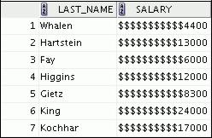

**…**

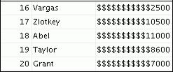

|  |
| --- |
| Oracle Internal & Oracle Academy Use Only |

**Oracle Database 10*g*: SQL Fundamentals I 3 - 64**

**Practice 3 (continued)**

1. Display each employee’s last name, hire date, and salary review date, which is the first Monday after six months of service. Label the column REVIEW. Format the dates to appear in the format similar to “Monday, the Thirty-First of July, 2000.”

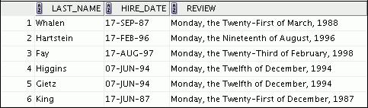

**…**

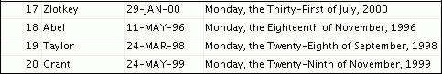

1. Display the last name, hire date, and day of the week on which an employee started. Label the column DAY. Order the results by the day of the week, starting with Monday.

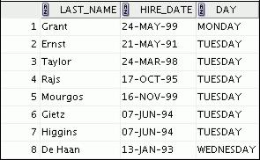

**…**

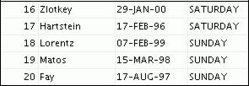

|  |
| --- |
| Oracle Internal & Oracle Academy Use Only |

**Oracle Database 10*g*: SQL Fundamentals I 3 - 65**

**Practice 3 (continued)**

If you want an extra challenge, complete the following exercises:

1. Create a query that displays the employees’ last names and commission amounts. If an employee does not earn a commission, show “No Commission.” Label the column COMM.

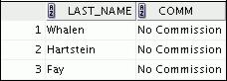

**…**

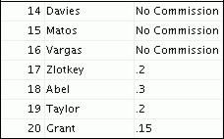

12.Create a query that displays the first eight characters of the employees’ last names and indicates the amounts of their salaries with asterisks. Each asterisk signifies a thousand dollars. Sort the data in descending order of salary. Label the column EMPLOYEES_AND_THEIR_SALARIES.

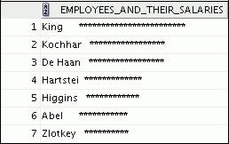

**…**

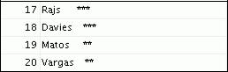

|  |
| --- |
| Oracle Internal & Oracle Academy Use Only |

**Oracle Database 10*g*: SQL Fundamentals I 3 - 66**

**Practice 3 (continued)**

1. Using the DECODE function, write a query that displays the grade of all employees based on the value of the JOB_ID column, using the following data:

***Job*** ***Grade***

AD_PRES A

ST_MAN B

IT_PROG C

SA_REP D

ST_CLERK E

|  |  |
| --- | --- |
| None of the above | 0 |

|  |
| --- |
| Oracle Internal & Oracle Academy Use Only |

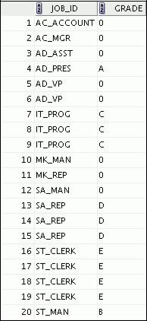

14. Rewrite the statement in the preceding exercise using the CASE syntax.

**Oracle Database 10*g*: SQL Fundamentals I 3 - 67**

Oracle Internal & Oracle Academy Use Only



**Reporting Aggregated Data**

**Using the Group Functions**

Copyright © 2009, Oracle. All rights reserved.

|  |
| --- |
| Oracle Internal & Oracle Academy Use Only |

**Objectives**

After completing this lesson, you should be able to do the following:

* Identify the available group functions
* Describe the use of group functions
* Group data by using the GROUP BY clause
* Include or exclude grouped rows by using the HAVING clause

Copyright © 2009, Oracle. All rights reserved.

**Objectives**

This lesson further addresses functions. It focuses on obtaining summary information (such as averages) for groups of rows. It discusses how to group rows in a table into smaller sets and how to specify search criteria for groups of rows.

|  |
| --- |
| Oracle Internal & Oracle Academy Use Only |

**Oracle Database 10*g*: SQL Fundamentals I 4 - 2**

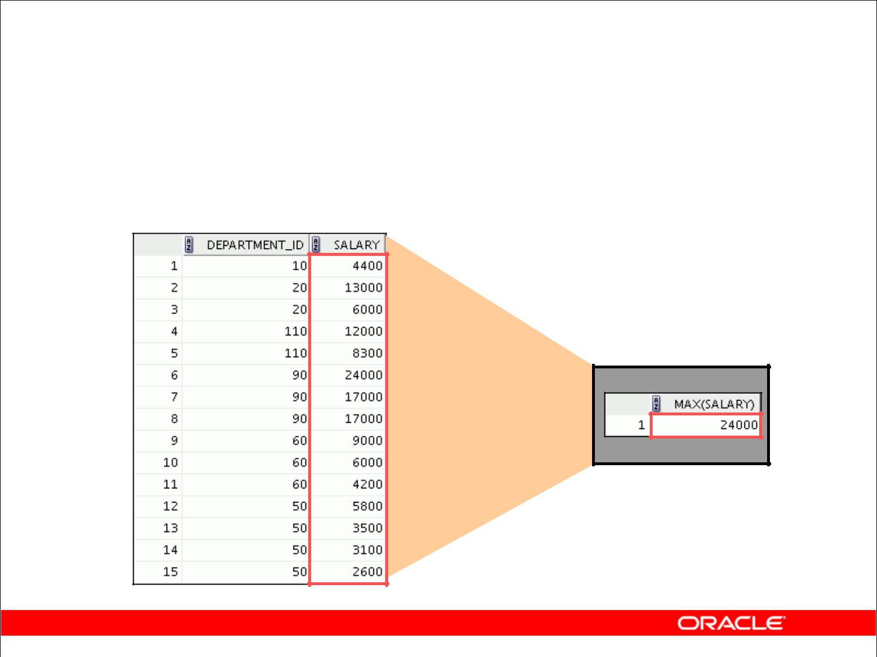**What Are Group Functions?**

Group functions operate on sets of rows to give one result per group.

**EMPLOYEES**

**Maximum salary in EMPLOYEES table**

**…**

Copyright © 2009, Oracle. All rights reserved.

**Group Functions**

Unlike single-row functions, group functions operate on sets of rows to give one result per group. These sets may comprise the entire table or the table split into groups.

|  |
| --- |
| Oracle Internal & Oracle Academy Use Only |

**Oracle Database 10*g*: SQL Fundamentals I 4 - 3**

|  |  |  |  |  |  |  |
| --- | --- | --- | --- | --- | --- | --- |
|  |  | **Types of Group Functions** | | | |  |
| • | AVG |  |  |  |  |  |
| • | COUNT |  |  |  |  |  |
| • | MAX |  |  |  |  |  |
|  |  |  | **Group** |  |
|  |  |  |  |
| • | MIN |  |  |  |  |
|  |  |  | **functions** |  |

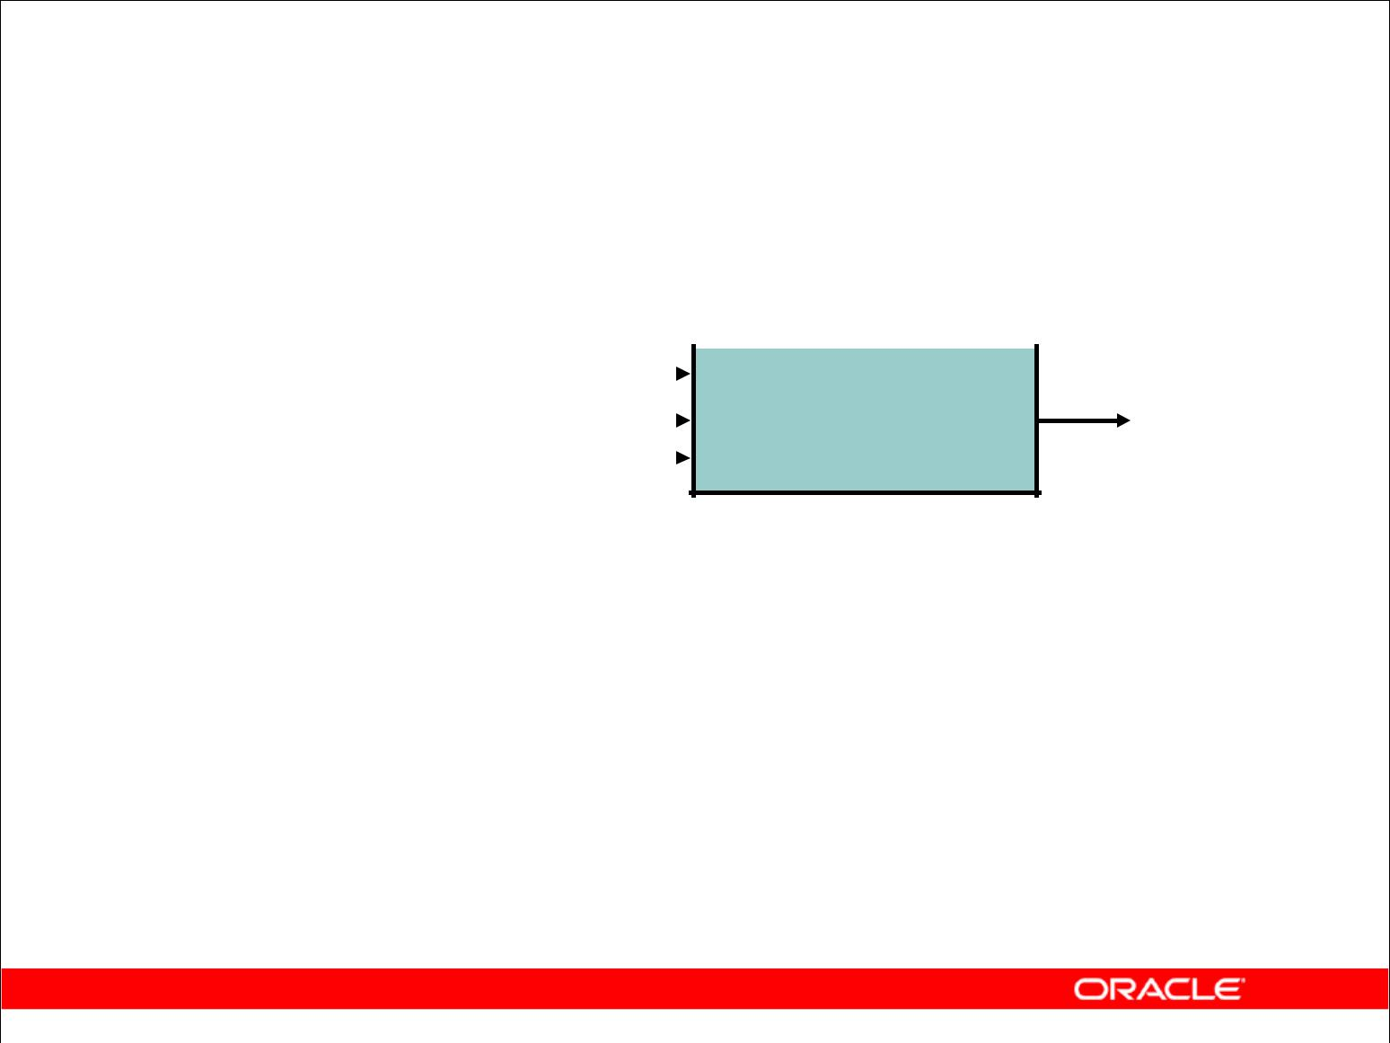

* STDDEV
* SUM
* VARIANCE

Copyright © 2009, Oracle. All rights reserved.

**Types of Group Functions**

Each of the functions accepts an argument. The following table identifies the options that you can use in the syntax:

|  |  |  |  |  |  |  |
| --- | --- | --- | --- | --- | --- | --- |
| **Function** | | | | | | **Description** |
|  | | |  |  |  |  |
| AVG([DISTINCT|ALL]*n*) | | | | | | Average value of *n*, ignoring null values |
|  |  |  | |  | |  |
| COUNT({*|[DISTINCT|ALL]*expr* | | | | | | Number of rows, where *expr* evaluates to |
| }) |  |  |  |  |  | something other than null (count all selected |
|  |  |  |  |  |  | rows using *, including duplicates and rows |
|  |  |  |  |  |  | with nulls) |
| MAX([DISTINCT|ALL]*expr*) | | | | | | Maximum value of *expr*, ignoring null values |
|  |  |  | |  | |  |
| MIN([DISTINCT|ALL]*expr*) | | | | | | Minimum value of *expr*, ignoring null values |
|  |  |  | | | |  |
| STDDEV([DISTINCT|ALL]*x*) | | | | | | Standard deviation of *n*, ignoring null values |
|  | |  | |  | |  |
| SUM([DISTINCT|ALL]*n*) | | | | | | Sum values of *n*, ignoring null values |
|  |  |  | | | |  |
| VARIANCE([DISTINCT|ALL]*x*) | | | | | | Variance of *n*, ignoring null values |
|  |  |  |  |  |  |  |

|  |
| --- |
| Oracle Internal & Oracle Academy Use Only |

**Oracle Database 10*g*: SQL Fundamentals I 4 - 4**

**Group Functions: Syntax**

|  |  |  |  |
| --- | --- | --- | --- |
|  |  |  |  |
| **SELECT** | **[*column*,]** | ***group_function(column),*** | ***...*** |
| **FROM** | ***table*** |  |  |
| **[WHERE** | ***condition*]** | | |
| **[GROUP BY** | ***column*]** | | |
| **[ORDER BY** | ***column*];** | | |
|  |  |  |  |

Copyright © 2009, Oracle. All rights reserved.

**Guidelines for Using Group Functions**

* DISTINCT makes the function consider only nonduplicate values; ALL makes it consider every value, including duplicates. The default is ALL and therefore does not need to be specified.
* The data types for the functions with an expr argument may be CHAR, VARCHAR2,

NUMBER, or DATE.

* All group functions ignore null values. To substitute a value for null values, use the NVL, NVL2, or COALESCE functions.

|  |
| --- |
| Oracle Internal & Oracle Academy Use Only |

**Oracle Database 10*g*: SQL Fundamentals I 4 - 5**

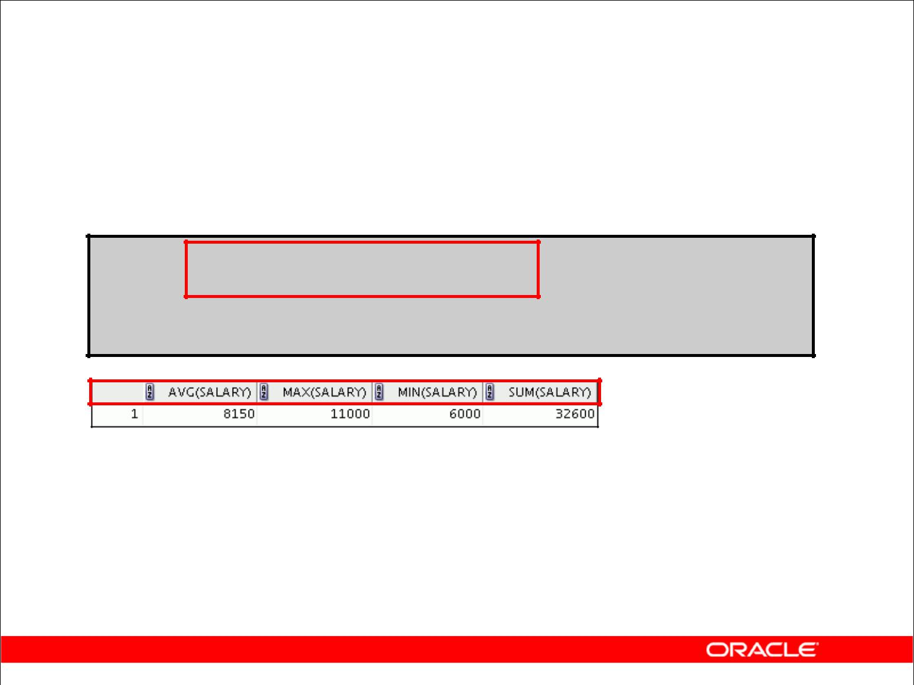**Using the AVG and SUM Functions**

You can use AVG and SUM for numeric data.

**SELECT AVG(salary), MAX(salary),**

**MIN(salary), SUM(salary)**

**FROM employees**

**WHERE** **job_id LIKE '%REP%';**

Copyright © 2009, Oracle. All rights reserved.

**Using the Group Functions**

You can use AVG, SUM, MIN, and MAX functions against columns that can store numeric data. The example in the slide displays the average, highest, lowest, and sum of monthly salaries for all sales representatives.

|  |
| --- |
| Oracle Internal & Oracle Academy Use Only |

**Oracle Database 10*g*: SQL Fundamentals I 4 - 6**

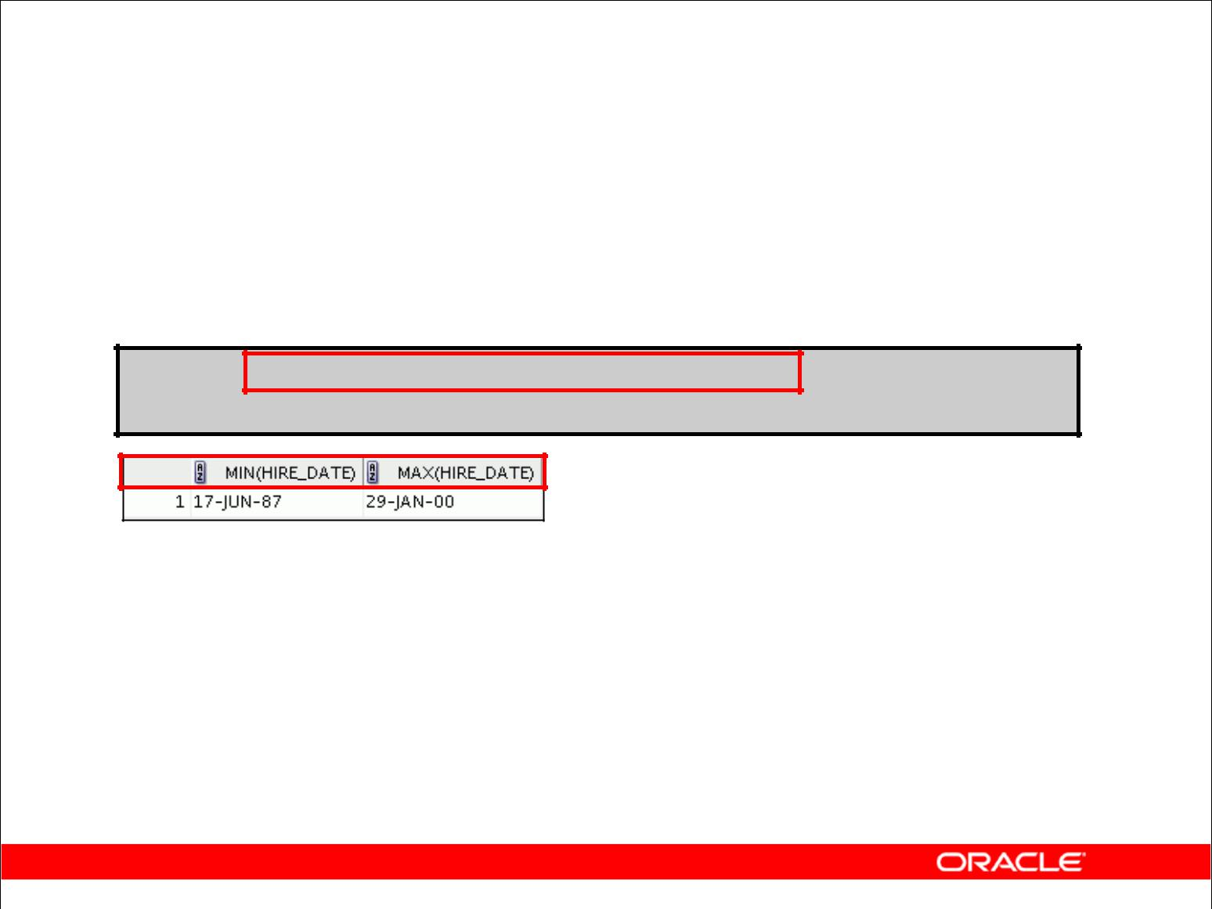**Using the MIN and MAX Functions**

You can use MIN and MAX for numeric, character, and date data types.

**SELECT MIN(hire_date), MAX(hire_date)**

**FROM** **employees;**

Copyright © 2009, Oracle. All rights reserved.

**Using the Group Functions (continued)**

You can use the MAX and MIN functions for numeric, character, and date data types. The slide example displays the most junior and most senior employees.

The following example displays the employee last name that is first and the employee last name that is last in an alphabetized list of all employees:

SELECT MIN(last_name), MAX(last_name)

FROM employees;

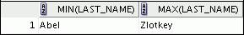

**Note:** TheAVG,SUM,VARIANCE, andSTDDEVfunctions can be used only with numeric datatypes. MAX and MIN cannot be used with LOB or LONG data types.

|  |
| --- |
| Oracle Internal & Oracle Academy Use Only |

**Oracle Database 10*g*: SQL Fundamentals I 4 - 7**

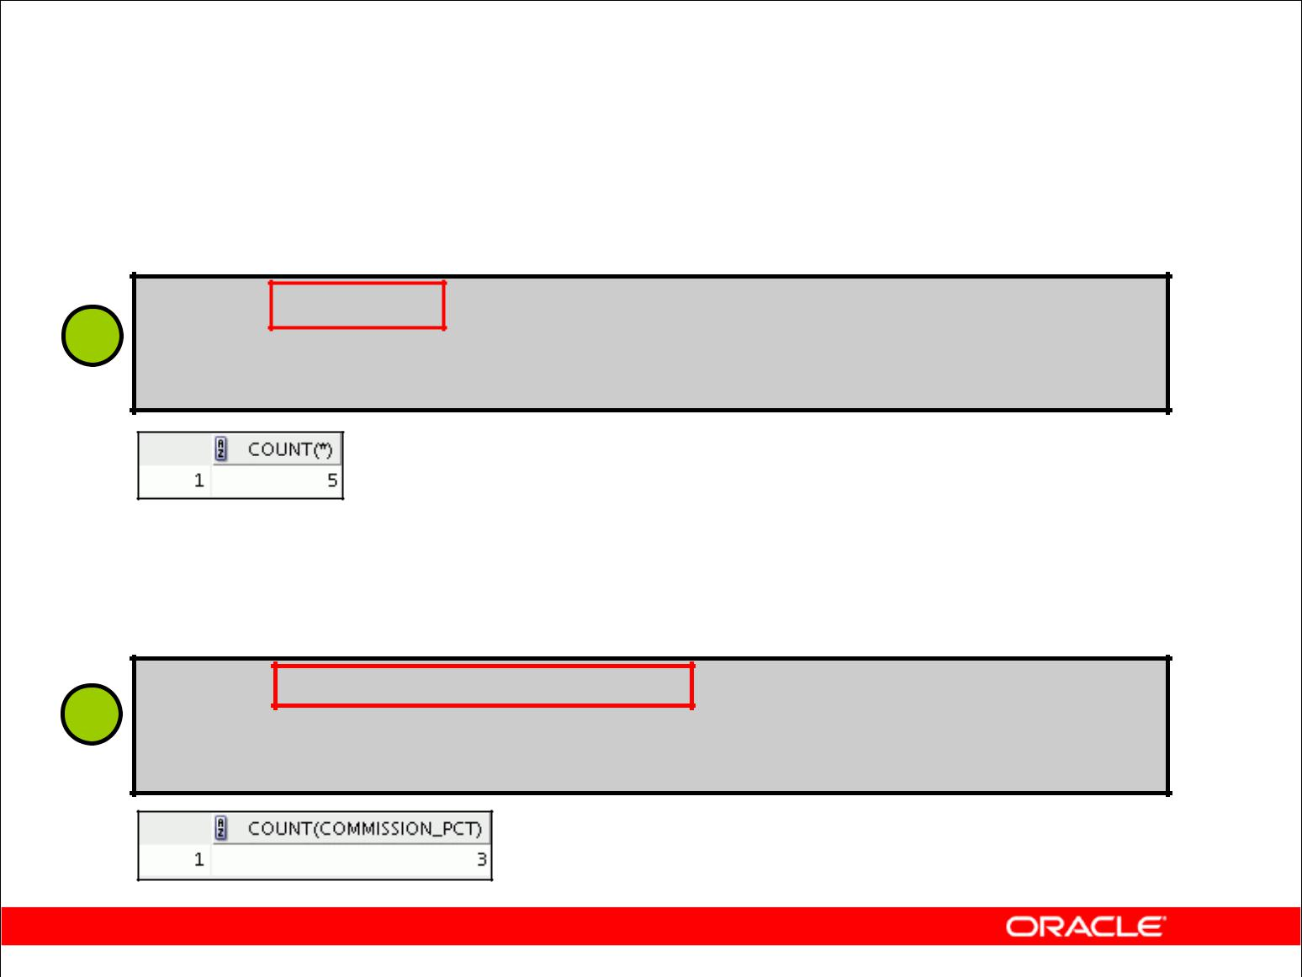**Using the COUNT Function**

COUNT(*) returns the number of rows in a table:

**SELECT COUNT(*)**

**1** **FROM** **employees**

**WHERE** **department_id = 50;**

COUNT(expr) returns the number of rows with non-null values for expr:

**SELECT COUNT(commission_pct)**

**2** **FROM** **employees**

**WHERE** **department_id = 80;**

Copyright © 2009, Oracle. All rights reserved.

**COUNT Function**

The COUNT function has three formats:

* COUNT(*)
* COUNT(*expr*)
* COUNT(DISTINCT *expr*)

COUNT(*) returns the number of rows in a table that satisfy the criteria of the SELECT statement, including duplicate rows and rows containing null values in any of the columns. If a WHERE clause is included in the SELECT statement, COUNT(*) returns the number of rows that satisfy the condition in the WHERE clause.

In contrast, COUNT(*expr*) returns the number of non-null values that are in the column identified by *expr*.

COUNT(DISTINCT *expr*) returns the number of unique, non-null values that are in the column identified by *expr*.

**Examples**

1. The slide example displays the number of employees in department 50.
2. The slide example displays the number of employees in department 80 who can earn a commission.

|  |
| --- |
| Oracle Internal & Oracle Academy Use Only |

**Oracle Database 10*g*: SQL Fundamentals I 4 - 8**

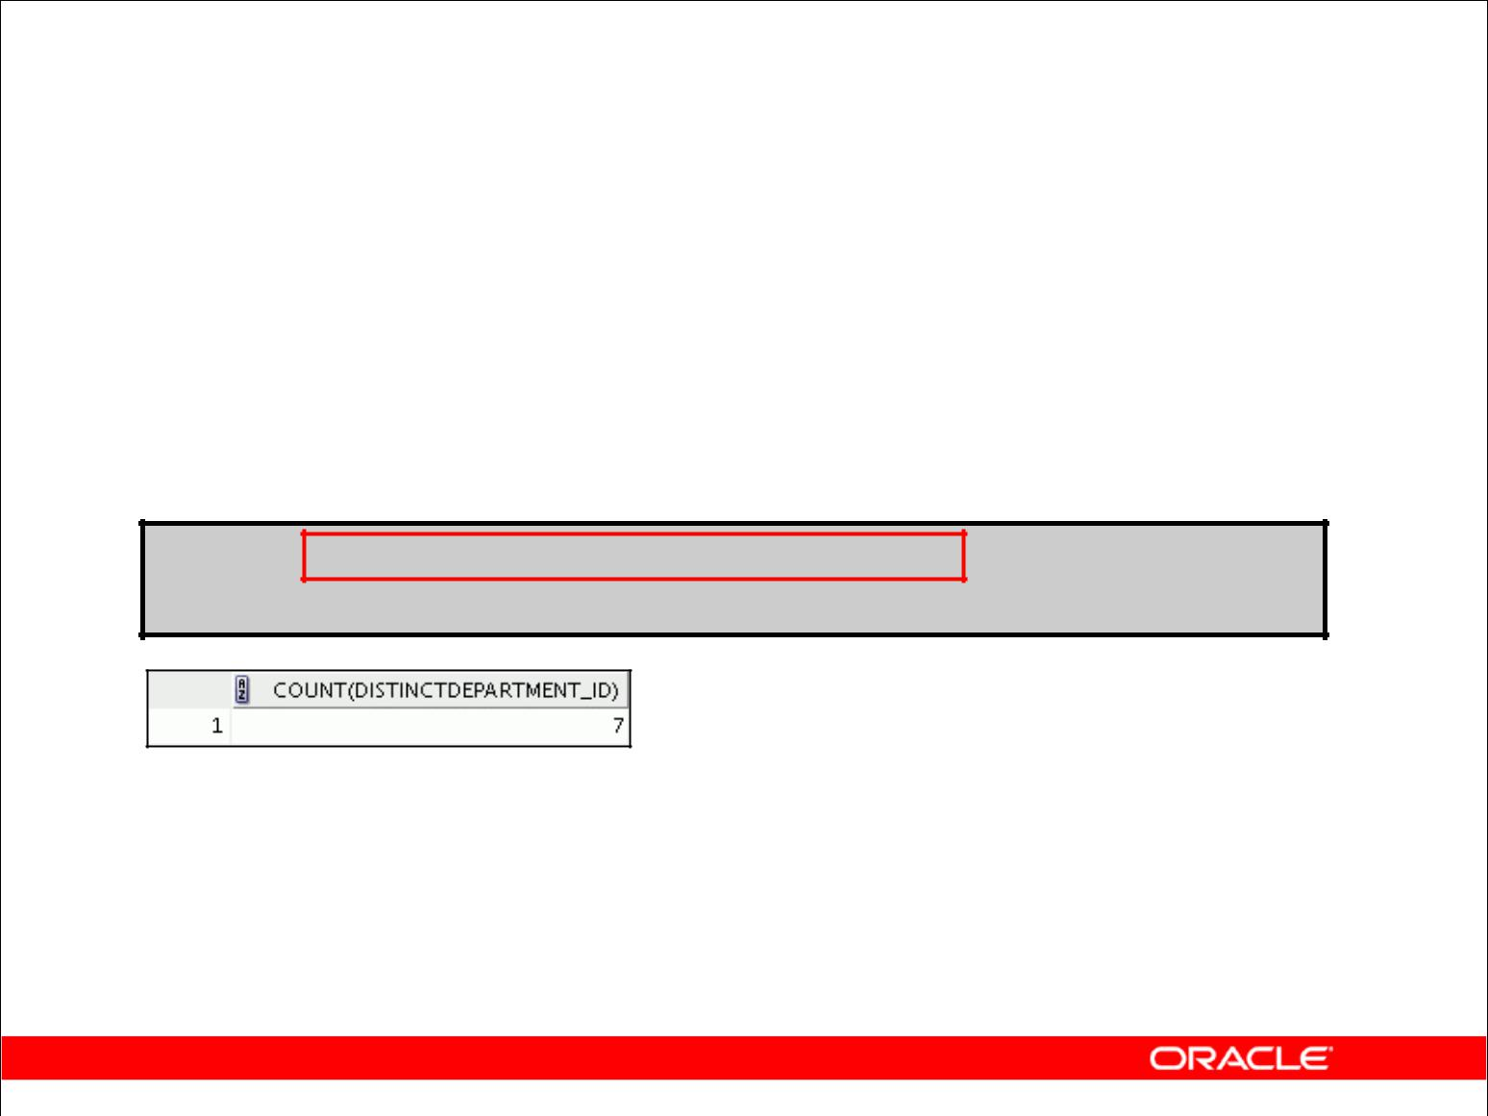**Using the DISTINCT Keyword**

* COUNT(DISTINCT expr) returns the number of distinct non-null values of *expr*.
* To display the number of distinct department values in the

EMPLOYEES table:

**SELECT COUNT(DISTINCT department_id)**

**FROM employees;**

Copyright © 2009, Oracle. All rights reserved.

**DISTINCT Keyword**

Use the DISTINCT keyword to suppress the counting of any duplicate values in a column.

The example in the slide displays the number of distinct department values that are in the EMPLOYEES table.

|  |
| --- |
| Oracle Internal & Oracle Academy Use Only |

**Oracle Database 10*g*: SQL Fundamentals I 4 - 9**

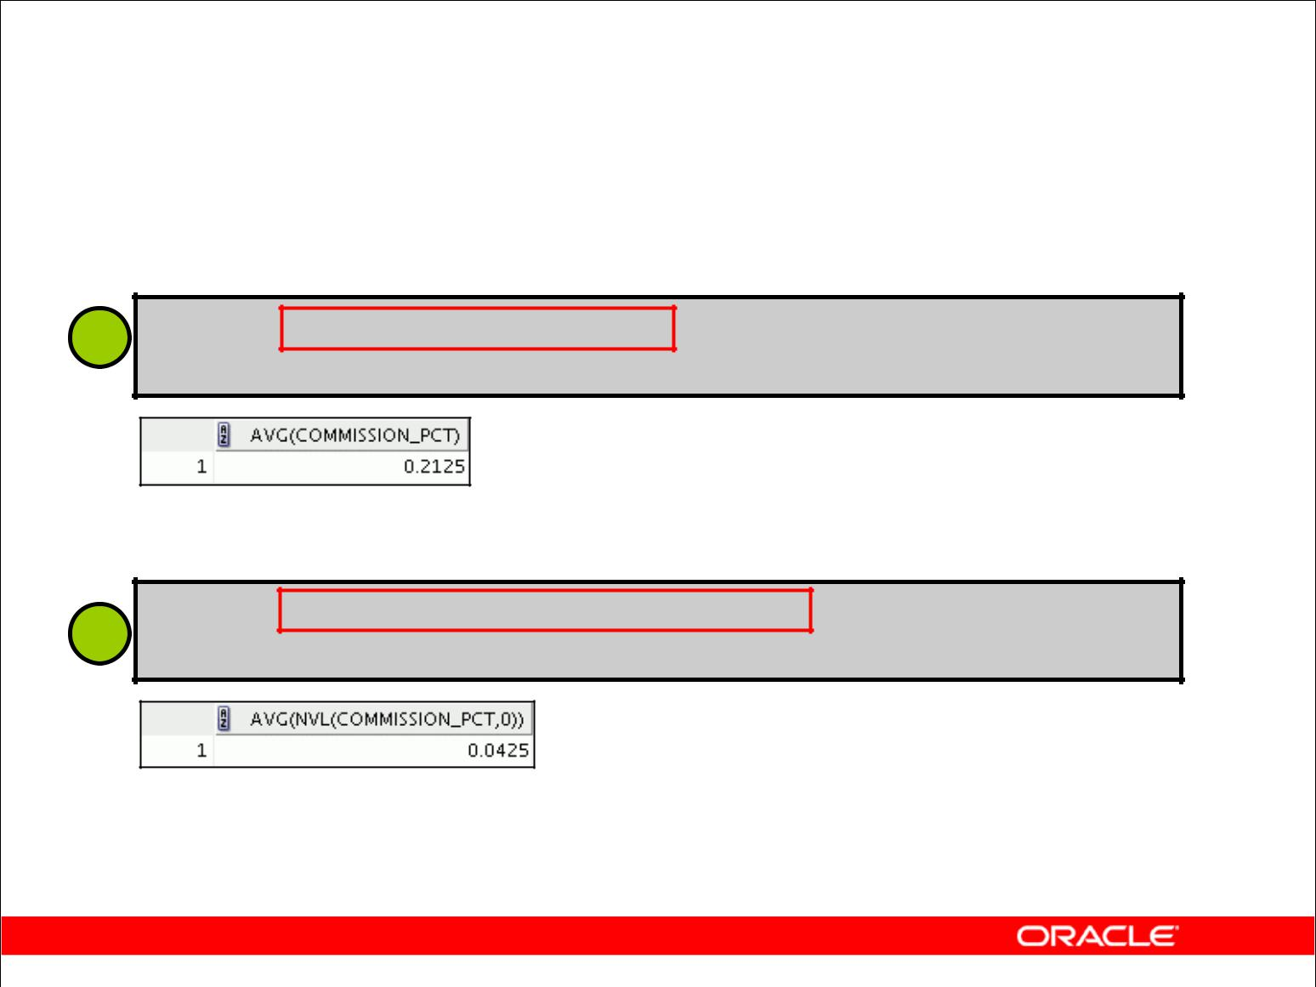**Group Functions and Null Values**

Group functions ignore null values in the column:

1. **SELECT AVG(commission_pct) FROM employees;**

The NVL function forces group functions to include null values:

**SELECT AVG(NVL(commission_pct, 0))**

**2 FROM** **employees;**

Copyright © 2009, Oracle. All rights reserved.

**Group Functions and Null Values**

All group functions ignore null values in the column.

The NVL function forces group functions to include null values.

**Examples**

1. The average is calculated based on *only* those rows in the table where a valid value is stored in the COMMISSION_PCT column. The average is calculated as the total commission that is paid to all employees divided by the number of employees receiving a commission (four).
2. The average is calculated based on *all* rows in the table, regardless of whether null values are stored in the COMMISSION_PCT column. The average is calculated as the total commission that is paid to all employees divided by the total number of employees in the company (20).

|  |
| --- |
| Oracle Internal & Oracle Academy Use Only |

**Oracle Database 10*g*: SQL Fundamentals I 4 - 10**

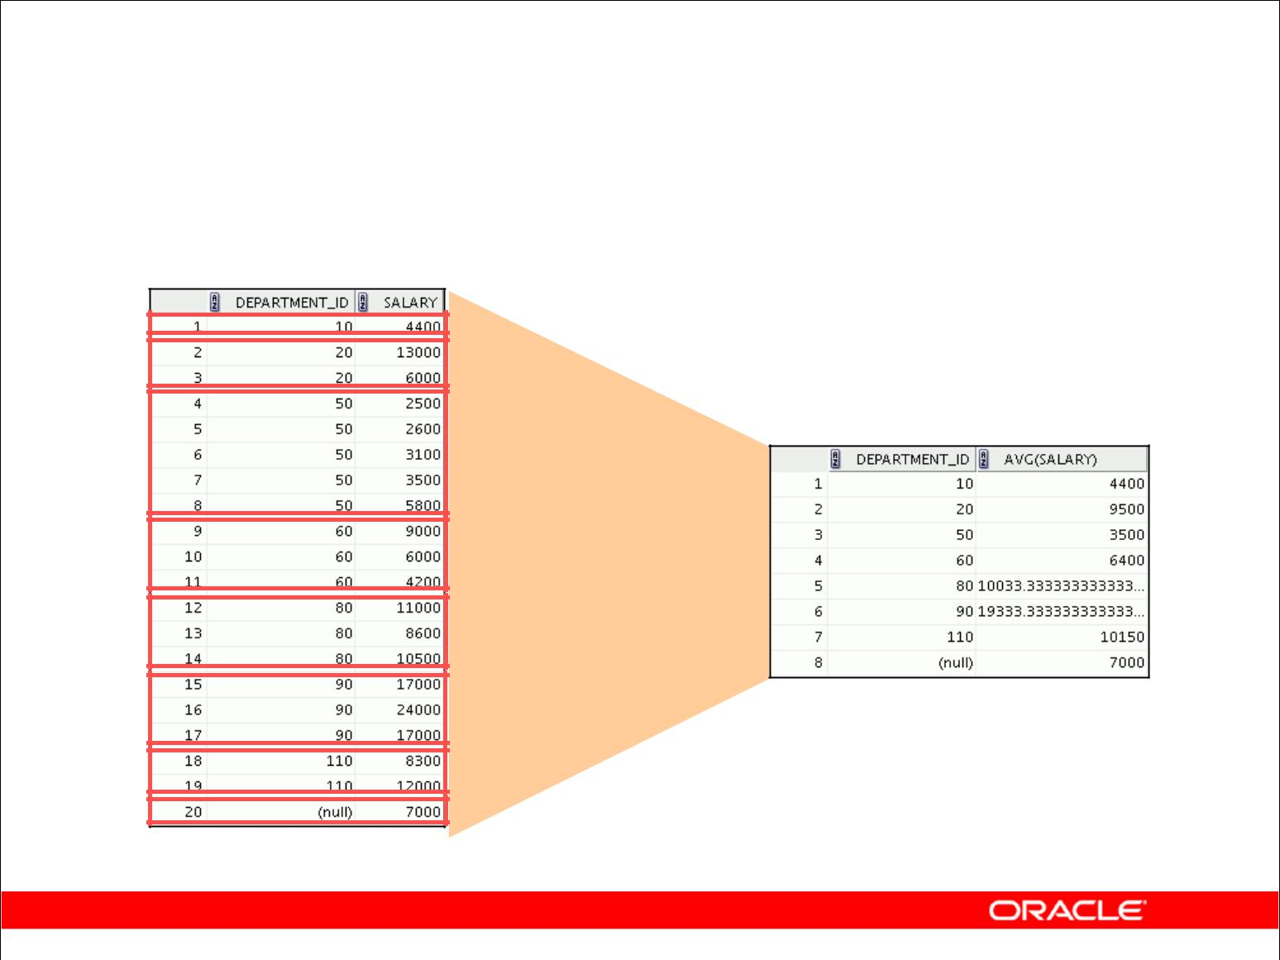**Creating Groups of Data**

**EMPLOYEES**

**4400**

**9500**

**3500** **Average**

**salary in the**

**6400** **EMPLOYEES**

**table for each**

**10033** **department**

**19333**

**10150**

**7000**

Copyright © 2009, Oracle. All rights reserved.

**Creating Groups of Data**

Until this point in our discussion, all group functions have treated the table as one large group of information.

At times, however, you need to divide the table of information into smaller groups. You can do this by using the GROUP BY clause.

|  |
| --- |
| Oracle Internal & Oracle Academy Use Only |

**Oracle Database 10*g*: SQL Fundamentals I 4 - 11**

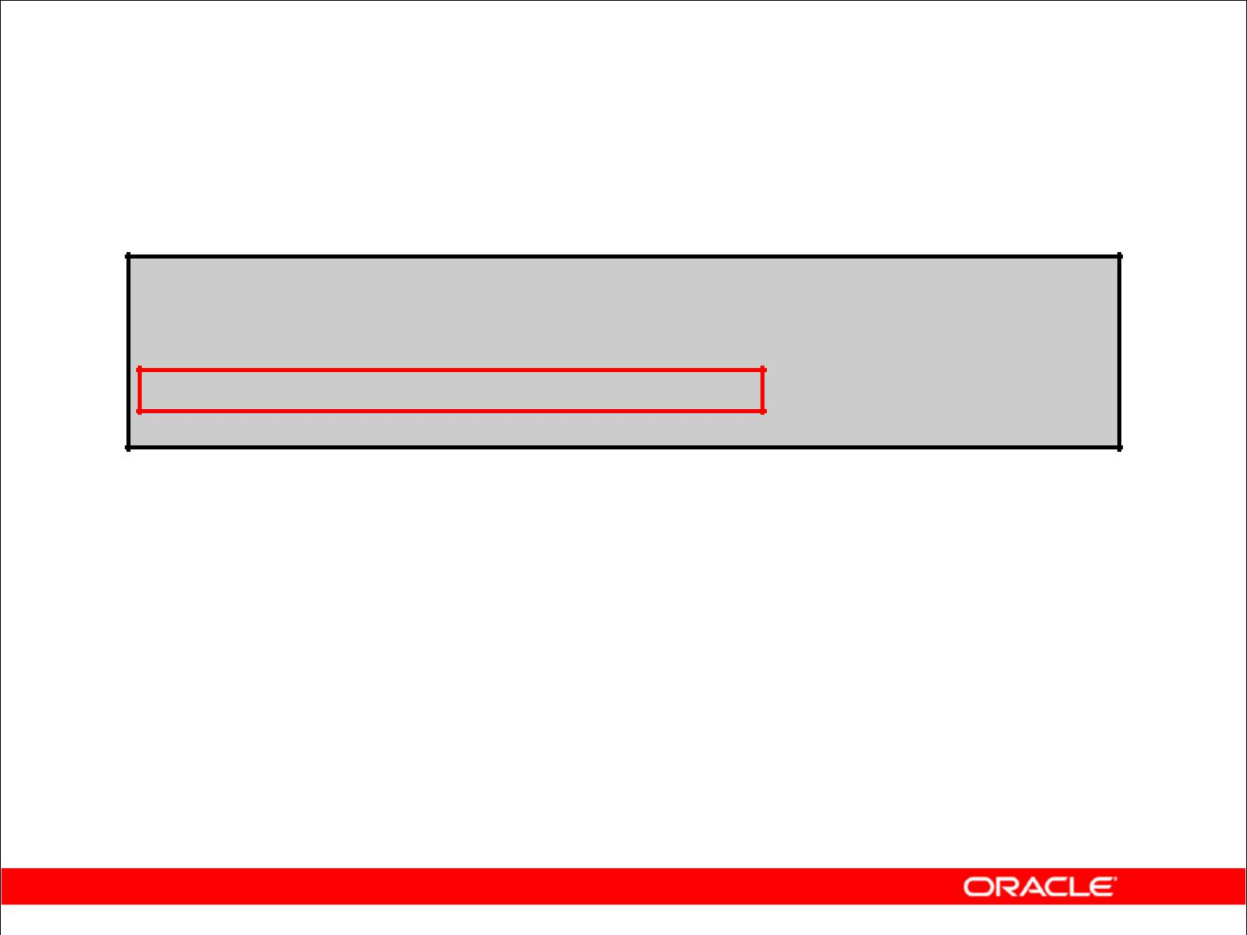**Creating Groups of Data:**

**GROUP BY Clause Syntax**

**SELECT** ***column*, *group_function(column)***

**FROM** ***table***

**[WHERE** ***condition*]**

**[GROUP BY *group_by_expression*]**

**[ORDER BY *column*];**

You can divide rows in a table into smaller groups by using the GROUP BY clause.

Copyright © 2009, Oracle. All rights reserved.

**GROUP BY Clause**

You can use the GROUP BY clause to divide the rows in a table into groups. You can then use the group functions to return summary information for each group.

In the syntax:

*group_by_expression* specifies columns whose values determine the basis for grouping rows

**Guidelines**

* If you include a group function in a SELECT clause, you cannot select individual results as well, *unless* the individual column appears in the GROUP BY clause. You receive an error message if you fail to include the column list in the GROUP BY clause.
* Using a WHERE clause, you can exclude rows before dividing them into groups.
* You must include the *columns* in the GROUP BY clause.
* You cannot use a column alias in the GROUP BY clause.

|  |
| --- |
| Oracle Internal & Oracle Academy Use Only |

**Oracle Database 10*g*: SQL Fundamentals I 4 - 12**

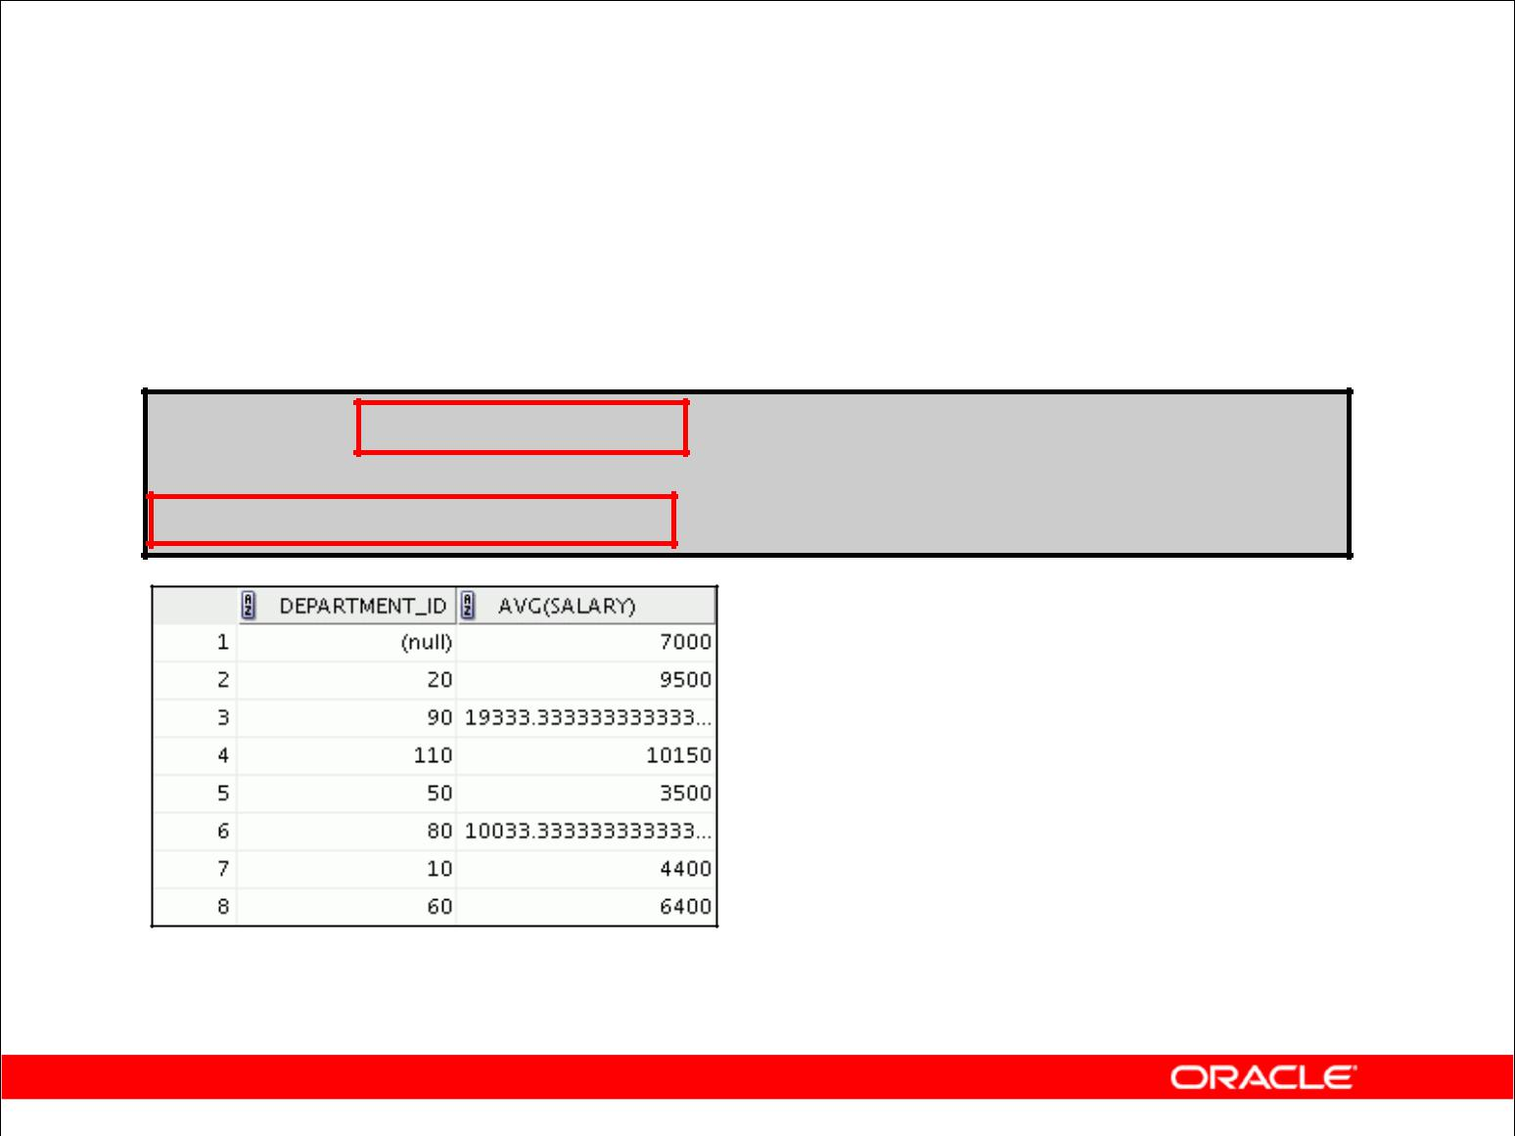**Using the GROUP BY Clause**

All columns in the SELECT list that are not in group functions must be in the GROUP BY clause.

**SELECT department_id, AVG(salary)**

**FROM** **employees**

**GROUP BY department_id ;**

Copyright © 2009, Oracle. All rights reserved.

**Using the GROUP BY Clause**

When using the GROUP BY clause, make sure that all columns in the SELECT list that are not group functions are included in the GROUP BY clause. The example in the slide displays the department number and the average salary for each department. Here is how this SELECT statement, containing a GROUP BY clause, is evaluated:

* The SELECT clause specifies the columns to be retrieved, as follows:
  + Department number column in the EMPLOYEES table
  + The average of all the salaries in the group that you specified in the GROUP BY clause
* The FROM clause specifies the tables that the database must access: the EMPLOYEES table.
* The WHERE clause specifies the rows to be retrieved. Because there is no WHERE clause, all rows are retrieved by default.
* The GROUP BY clause specifies how the rows should be grouped. The rows are grouped by department number, so the AVG function that is applied to the salary column calculates the *average salary for each department.*

|  |
| --- |
| Oracle Internal & Oracle Academy Use Only |

**Oracle Database 10*g*: SQL Fundamentals I 4 - 13**

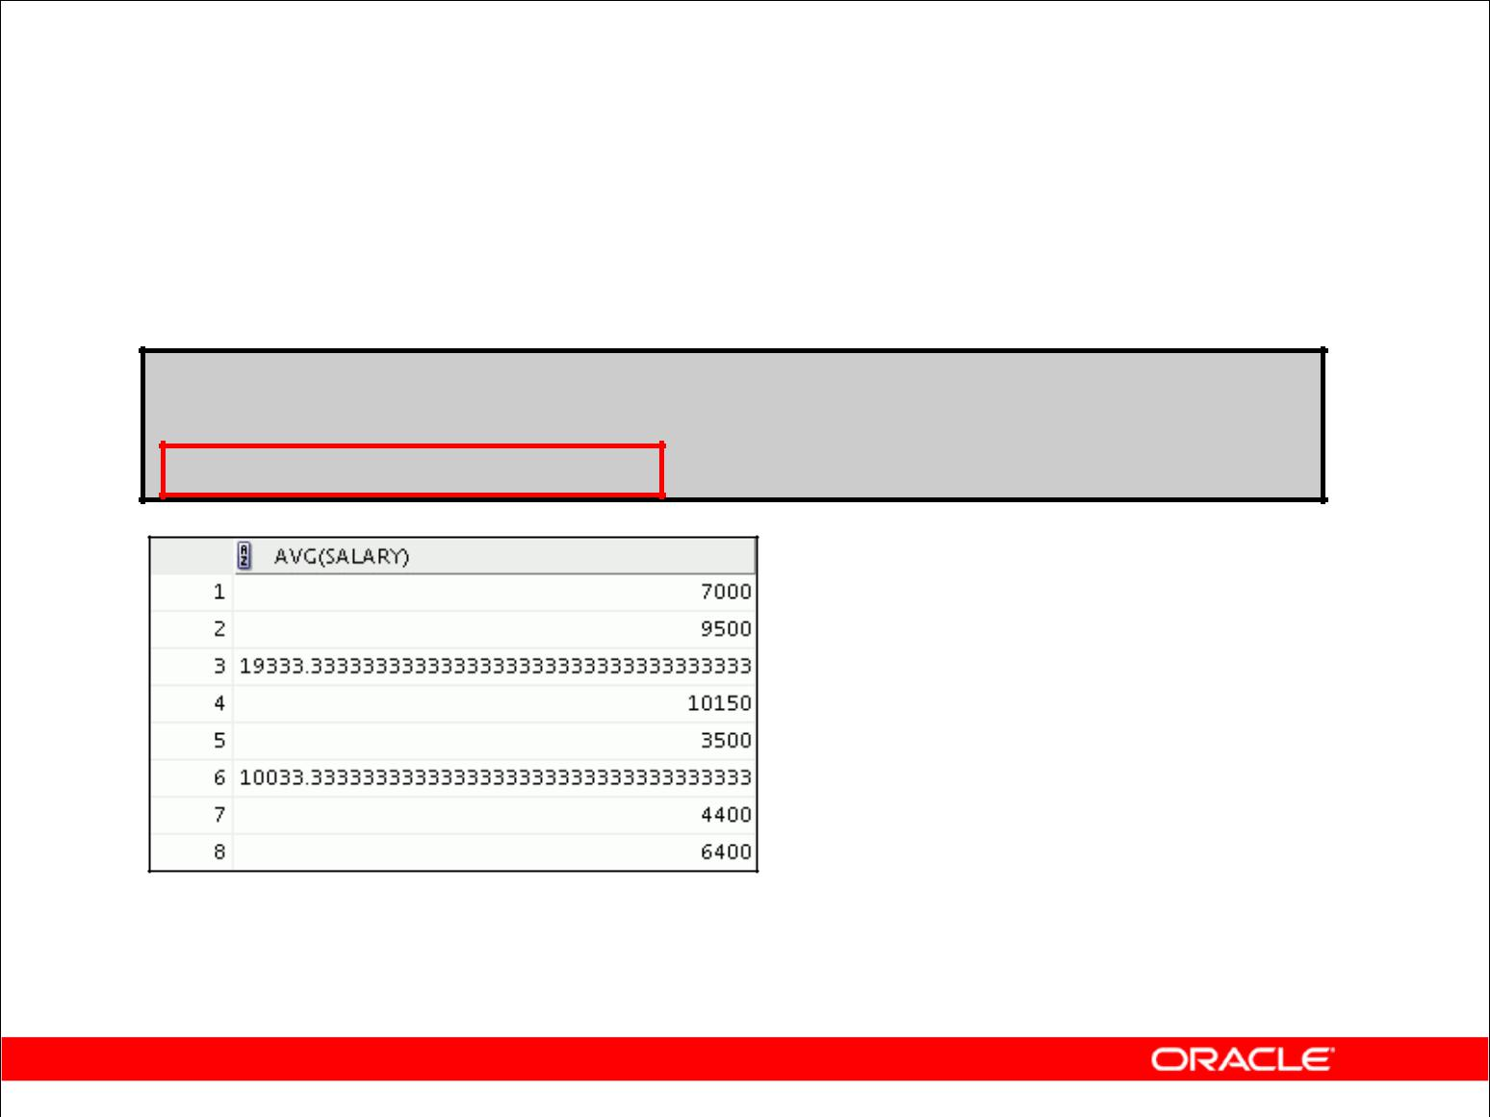**Using the GROUP BY Clause**

The GROUP BY column does not have to be in the SELECT list.

**SELECT AVG(salary)**

**FROM** **employees**

**GROUP BY department_id ;**

Copyright © 2009, Oracle. All rights reserved.

**Using the GROUP BY Clause (continued)**

The GROUP BY column does not have to be in the SELECT clause. For example, the SELECT statement in the slide displays the average salaries for each department without displaying the respective department numbers. Without the department numbers, however, the results do not look meaningful.

You can use the group function in the ORDER BY clause:

SELECT department_id, AVG(salary)

FROM employees

GROUP BY department_id

ORDER BY AVG(salary);

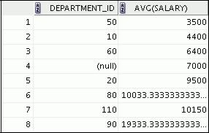

|  |
| --- |
| Oracle Internal & Oracle Academy Use Only |

**Oracle Database 10*g*: SQL Fundamentals I 4 - 14**

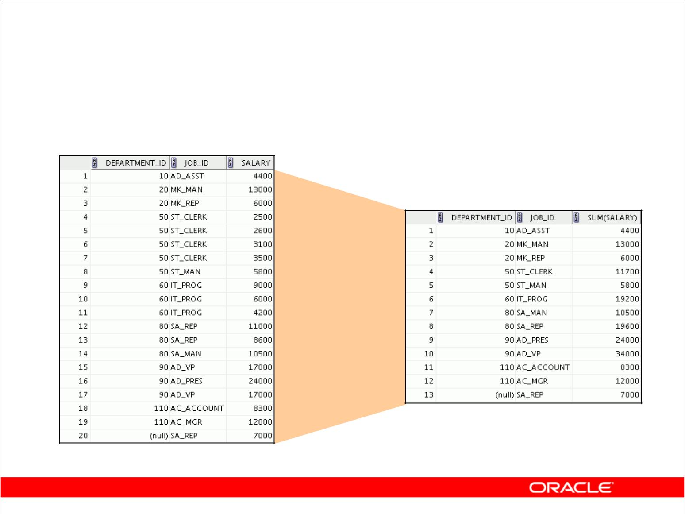**Grouping by More Than One Column**

**EMPLOYEES**

**Add the**

**salaries in**

**the EMPLOYEES**

**table for each job, grouped by department**

Copyright © 2009, Oracle. All rights reserved.

**Groups Within Groups**

Sometimes you need to see results for groups within groups. The slide shows a report that displays the total salary that is paid to each job title in each department.

The EMPLOYEES table is grouped first by department number and then by job title within that grouping. For example, the four stock clerks in department 50 are grouped together, and a single result (total salary) is produced for all stock clerks in the group.

|  |
| --- |
| Oracle Internal & Oracle Academy Use Only |

**Oracle Database 10*g*: SQL Fundamentals I 4 - 15**

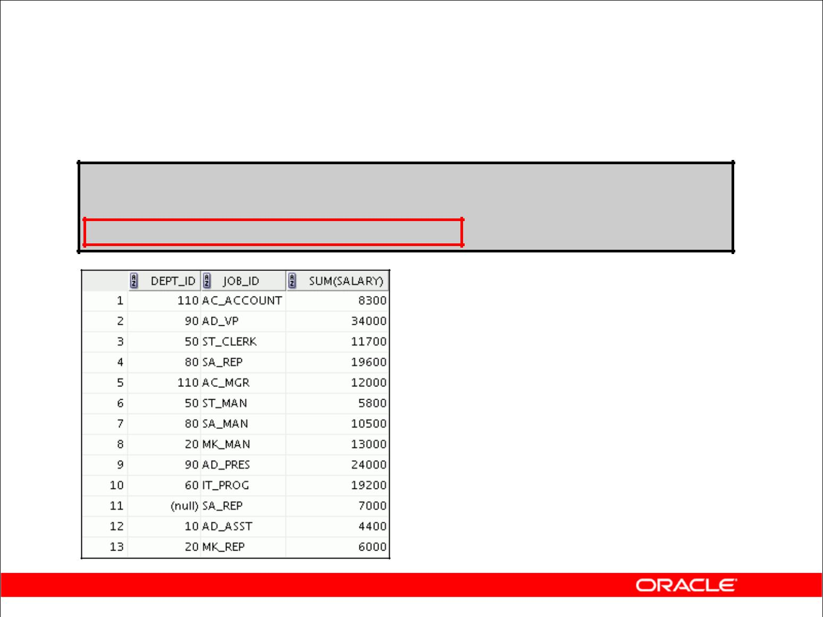**Using the GROUP BY Clause**

**on Multiple Columns**

**SELECT department_id dept_id, job_id, SUM(salary)**

**FROM** **employees**

**GROUP BY department_id, job_id ;**

Copyright © 2009, Oracle. All rights reserved.

**Groups Within Groups (continued)**

You can return summary results for groups and subgroups by listing more than one GROUP BY column. You can determine the default sort order of the results by the order of the columns in the GROUP BY clause. In the slide example, the SELECT statement containing a GROUP BY clause is evaluated as follows:

* The SELECT clause specifies the column to be retrieved:
  + Department number in the EMPLOYEES table
  + Job ID in the EMPLOYEES table
  + The sum of all the salaries in the group that you specified in the GROUP BY clause
* The FROM clause specifies the tables that the database must access: the EMPLOYEES table.
* The GROUP BY clause specifies how you must group the rows:
  + First, the rows are grouped by department number.
  + Second, the rows are grouped by job ID in the department number groups.

So the SUM function is applied to the salary column for all job IDs in each department number group.

|  |
| --- |
| Oracle Internal & Oracle Academy Use Only |

**Oracle Database 10*g*: SQL Fundamentals I 4 - 16**

**Oracle Database 10*g*: SQL Fundamentals I 4 - 17**

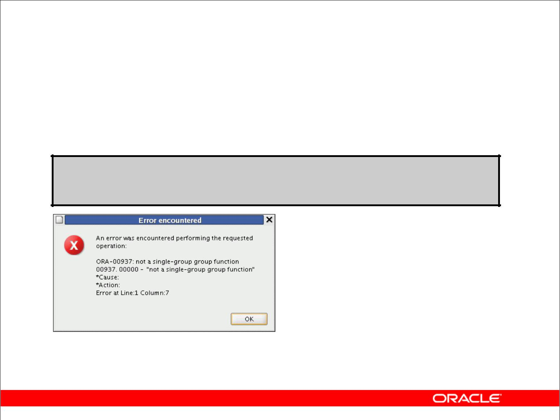**Illegal Queries**

**Using Group Functions**

Any column or expression in the SELECT list that is not an aggregate function must be in the GROUP BY clause:

**SELECT department_id, COUNT(last_name)**

**FROM employees;**

**Column missing in the GROUP BY clause**

Copyright © 2009, Oracle. All rights reserved.

**Illegal Queries Using Group Functions**

Whenever you use a mixture of individual items (DEPARTMENT_ID) and group functions

(COUNT) in the same SELECT statement, you must include a GROUP BY clause that specifies the individual items (in this case, DEPARTMENT_ID). If the GROUP BY clause is missing, then

the error message “not a single-group group function” appears. You can correct the error in the slide by adding the GROUP BY clause:

SELECT department_id, count(last_name)

FROM employees

GROUP BY department_id;

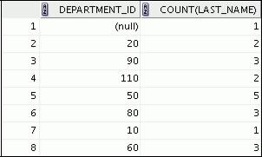

Any column or expression in the SELECT list that is not an aggregate function must be in the GROUP BY clause.

|  |
| --- |
| Oracle Internal & Oracle Academy Use Only |

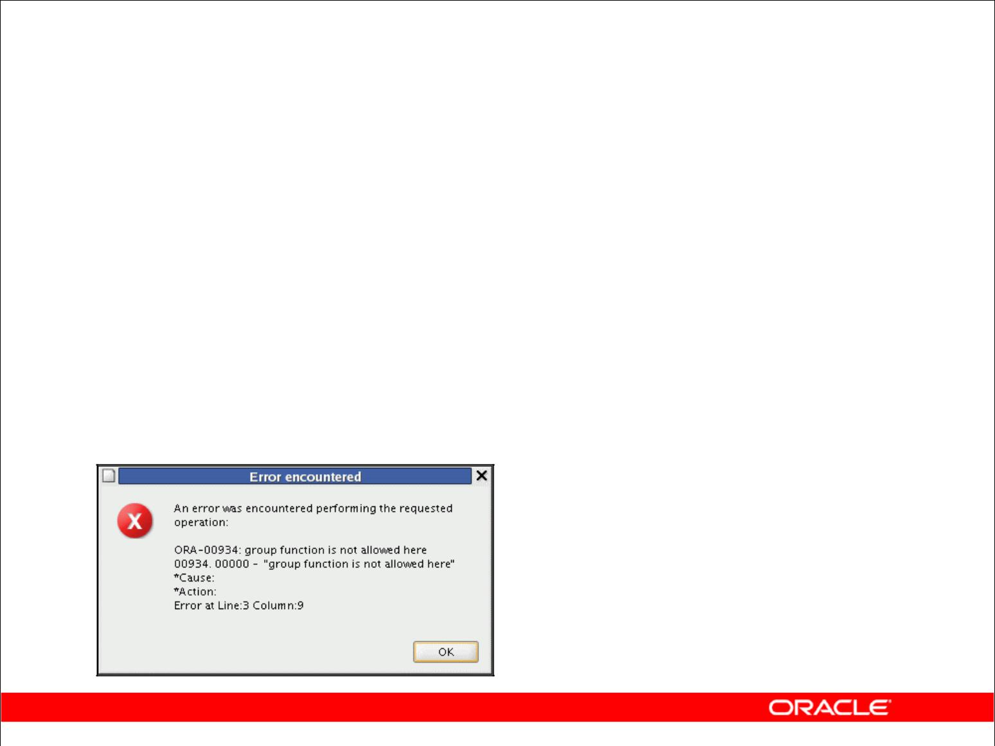**Illegal Queries**

**Using Group Functions**

* You cannot use the WHERE clause to restrict groups.
* You use the HAVING clause to restrict groups.
* You cannot use group functions in the WHERE clause.

|  |  |
| --- | --- |
| **SELECT** | **department_id, AVG(salary)** |
| **FROM** | **employees** |
| **WHERE** | **AVG(salary) > 8000** |
| **GROUP BY** | **department_id;** |
|  |  |

**Cannot use the WHERE clause**

**to restrict groups**

Copyright © 2009, Oracle. All rights reserved.

**Illegal Queries Using Group Functions (continued)**

The WHERE clause cannot be used to restrict groups. The SELECT statement in the slide example results in an error because it uses the WHERE clause to restrict the display of average salaries of those departments that have an average salary greater than $8,000.

You can correct the error in the example by using the HAVING clause to restrict groups:

SELECT department_id, AVG(salary)

FROM employees

HAVING AVG(salary) > 8000

GROUP BY department_id;

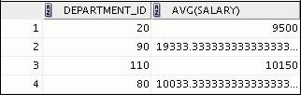

|  |
| --- |
| Oracle Internal & Oracle Academy Use Only |

**Oracle Database 10*g*: SQL Fundamentals I 4 - 18**

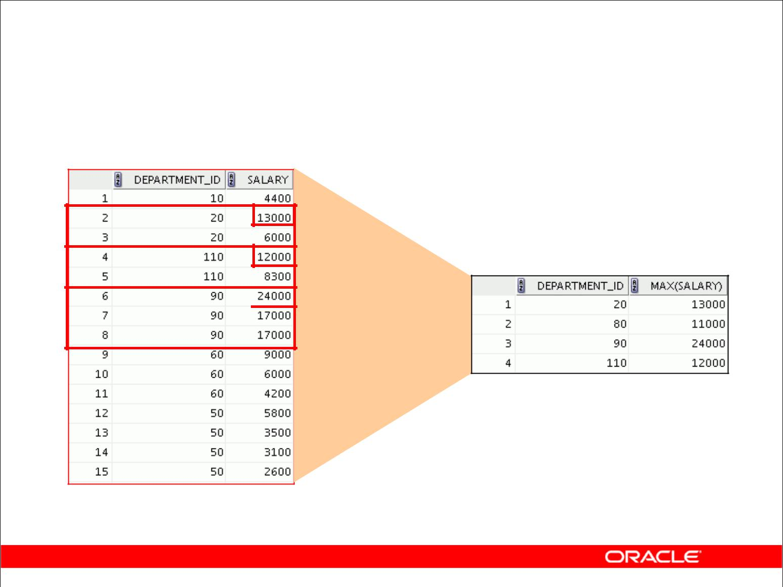**Restricting Group Results**

**EMPLOYEES**

**The maximum**

**salary**

**per department when it is greater than $10,000**

**…**

Copyright © 2009, Oracle. All rights reserved.

**Restricting Group Results**

In the same way that you use the WHERE clause to restrict the rows that you select, you use the HAVING clause to restrict groups. To find the maximum salary in each of the departments that have a maximum salary greater than $10,000, you need to do the following:

1. Find the average salary for each department by grouping by department number.
2. Restrict the groups to those departments with a maximum salary greater than $10,000.

|  |
| --- |
| Oracle Internal & Oracle Academy Use Only |

**Oracle Database 10*g*: SQL Fundamentals I 4 - 19**

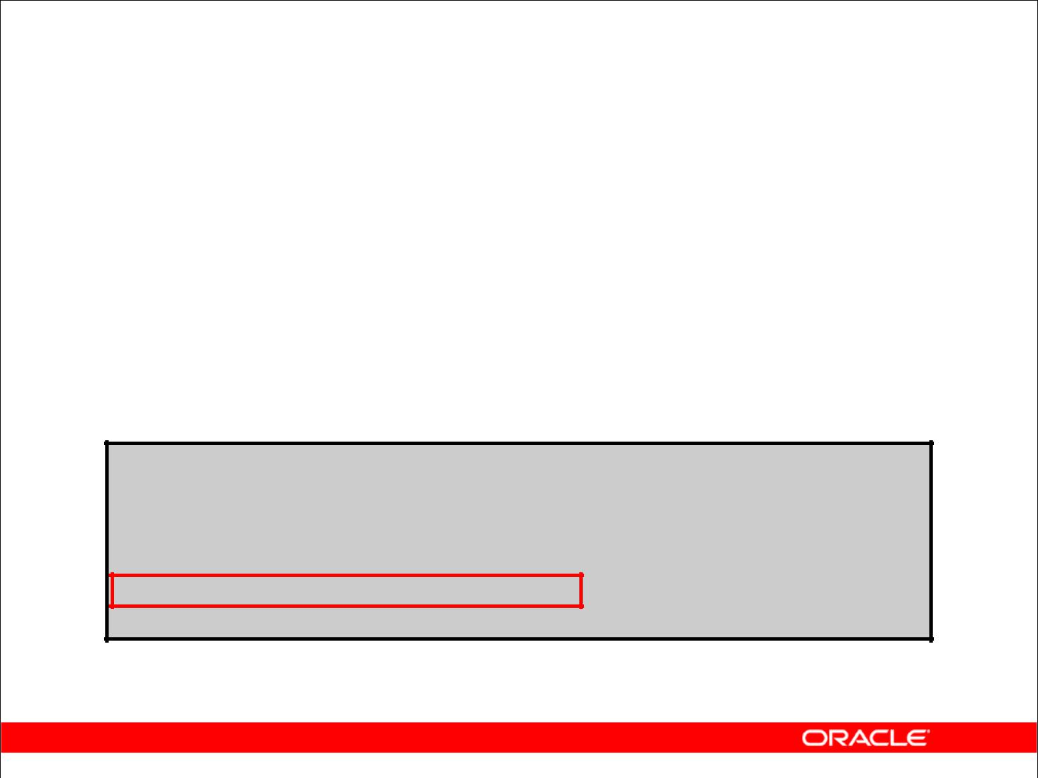**Restricting Group Results**

**with the HAVING Clause**

When you use the HAVING clause, the Oracle server restricts groups as follows:

* Rows are grouped.
* The group function is applied.
* Groups matching the HAVING clause are displayed.

**SELECT** ***column*, *group_function***

**FROM** ***table***

**[WHERE** ***condition*]**

**[GROUP BY *group_by_expression*]**

**[HAVING** ***group_condition*]**

**[ORDER BY *column*];**

Copyright © 2009, Oracle. All rights reserved.

**Restricting Group Results with the HAVING Clause**

You use the HAVING clause to specify which groups are to be displayed, thus further restricting the groups on the basis of aggregate information.

In the syntax, *group_condition* restricts the groups of rows returned to those groups for which the specified condition is true.

The Oracle server performs the following steps when you use the HAVING clause:

1. Rows are grouped.
2. The group function is applied to the group.
3. The groups that match the criteria in the HAVING clause are displayed.

The HAVING clause can precede the GROUP BY clause, but it is recommended that you place the GROUP BY clause first because that is more logical. Groups are formed and group functions are calculated before the HAVING clause is applied to the groups in the SELECT list.

|  |
| --- |
| Oracle Internal & Oracle Academy Use Only |

**Oracle Database 10*g*: SQL Fundamentals I 4 - 20**

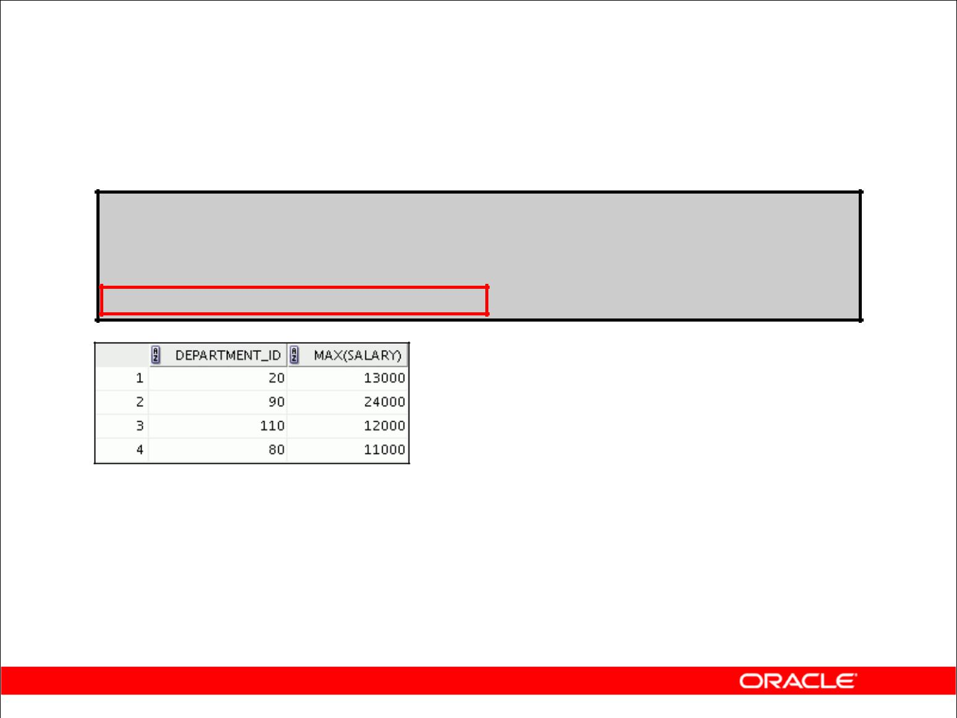**Using the HAVING Clause**

**SELECT department_id, MAX(salary)**

**FROM** **employees**

**GROUP BY department_id**

**HAVING MAX(salary)>10000 ;**

Copyright © 2009, Oracle. All rights reserved.

**Using the HAVING Clause**

The slide example displays department numbers and maximum salaries for those departments with a maximum salary that is greater than $10,000.

You can use the GROUP BY clause without using a group function in the SELECT list.

If you restrict rows based on the result of a group function, you must have a GROUP BY clause as well as the HAVING clause.

The following example displays the department numbers and average salaries for those departments with a maximum salary that is greater than $10,000:

SELECT department_id, AVG(salary)

FROM employees

GROUP BY department_id

HAVING max(salary)>10000;

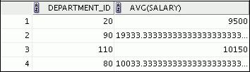

|  |
| --- |
| Oracle Internal & Oracle Academy Use Only |

**Oracle Database 10*g*: SQL Fundamentals I 4 - 21**

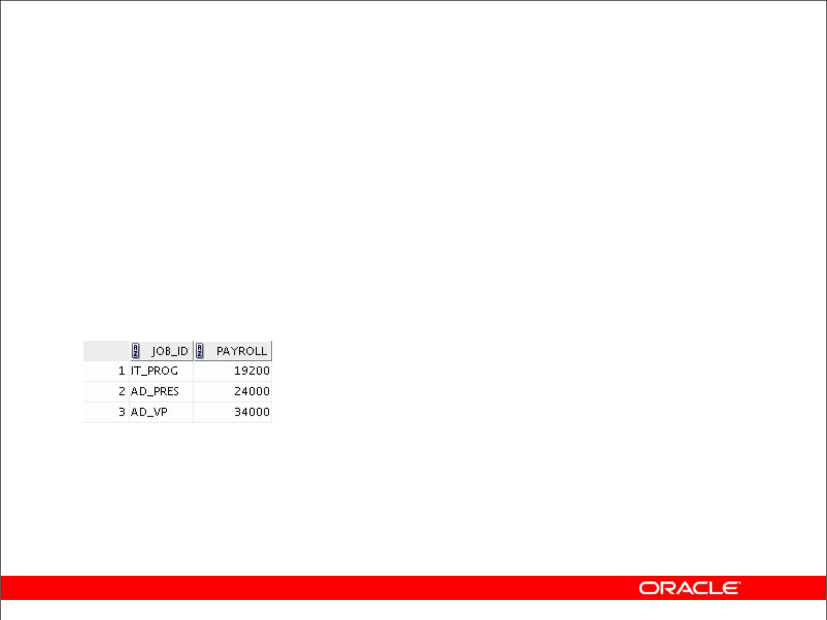**Using the HAVING Clause**

|  |  |  |  |  |
| --- | --- | --- | --- | --- |
|  | **SELECT** | **job_id, SUM(salary) PAYROLL** | | |
|  | **FROM** | **employees** | | |
|  | **WHERE** | **job_id NOT LIKE '%REP%'** | | |
|  | **GROUP BY** | **job_id** | | |
|  | **HAVING** | **SUM(salary) > 13000** | |  |
|  | **ORDER BY** | **SUM(salary);** | | |
|  |  |  |  |  |
|  |  |  |  |  |

Copyright © 2009, Oracle. All rights reserved.

**Using the HAVING Clause (continued)**

The slide example displays the job ID and total monthly salary for each job that has a total payroll exceeding $13,000. The example excludes sales representatives and sorts the list by the total monthly salary.

|  |
| --- |
| Oracle Internal & Oracle Academy Use Only |

**Oracle Database 10*g*: SQL Fundamentals I 4 - 22**

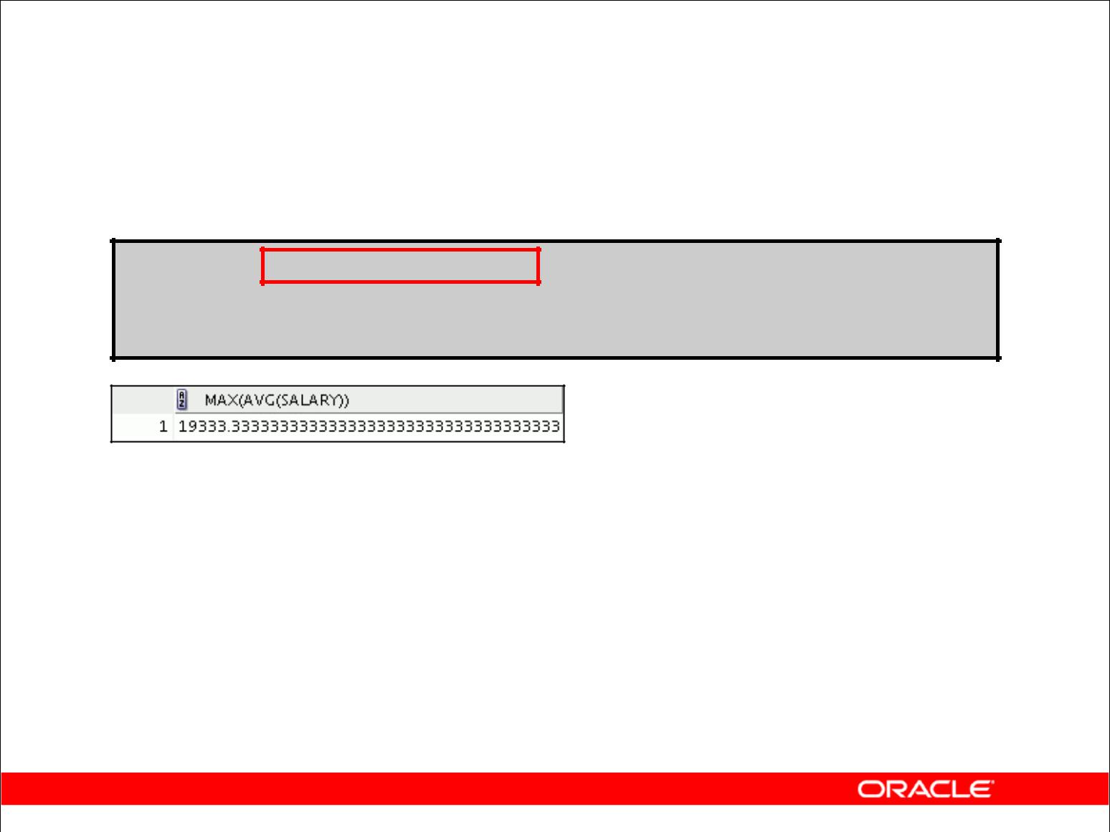**Nesting Group Functions**

Display the maximum average salary:

**SELECT MAX(AVG(salary))**

**FROM** **employees**

**GROUP BY department_id;**

Copyright © 2009, Oracle. All rights reserved.

**Nesting Group Functions**

Group functions can be nested to a depth of two. The slide example displays the maximum average salary.

|  |
| --- |
| Oracle Internal & Oracle Academy Use Only |

**Oracle Database 10*g*: SQL Fundamentals I 4 - 23**

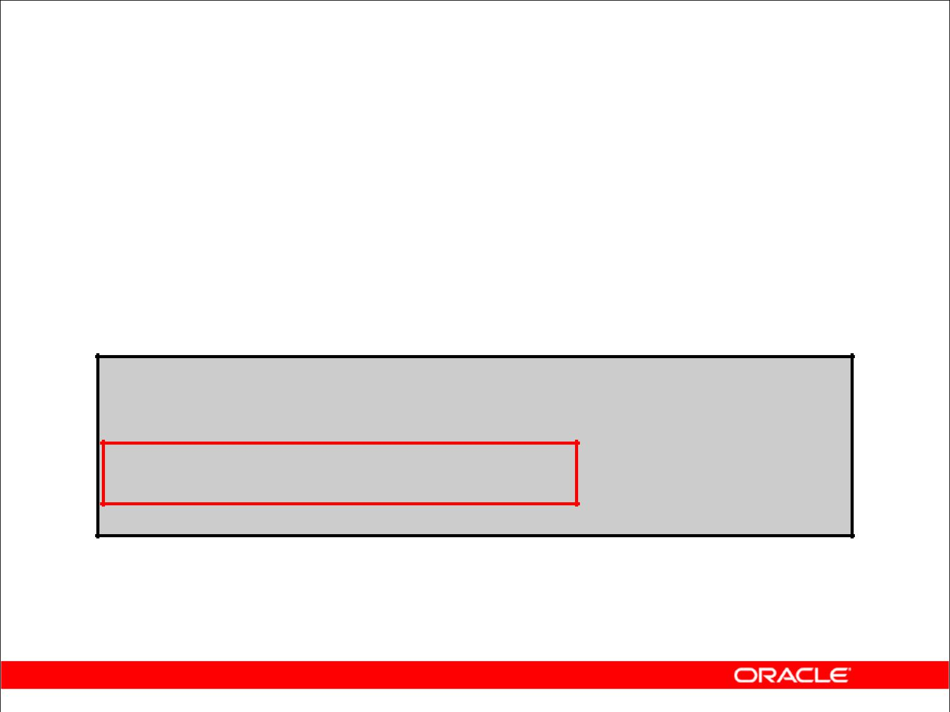**Summary**

In this lesson, you should have learned how to:

* Use the group functions COUNT, MAX, MIN, and AVG
* Write queries that use the GROUP BY clause
* Write queries that use the HAVING clause

**SELECT** ***column*, *group_function***

**FROM** ***table***

**[WHERE** ***condition*]**

**[GROUP BY *group_by_expression*]**

**[HAVING** ***group_condition*]**

**[ORDER BY *column*];**

Copyright © 2009, Oracle. All rights reserved.

**Summary**

Several group functions are available in SQL, such as the following:

AVG, COUNT, MAX, MIN, SUM, STDDEV, and VARIANCE

You can create subgroups by using the GROUP BY clause. Groups can be restricted using the HAVING clause.

Place the HAVING and GROUP BY clauses after the WHERE clause in a statement. The order of the HAVING and GROUP clauses following the WHERE clause is not important. Place the ORDER BY clause last.

The Oracle server evaluates the clauses in the following order:

1. If the statement contains a WHERE clause, the server establishes the candidate rows.
2. The server identifies the groups that are specified in the GROUP BY clause.
3. The HAVING clause further restricts result groups that do not meet the group criteria in the HAVING clause.

**Note:** For a complete list of the group functions, see*Oracle SQL Reference*.

|  |
| --- |
| Oracle Internal & Oracle Academy Use Only |

**Oracle Database 10*g*: SQL Fundamentals I 4 - 24**

**Practice 4: Overview**

This practice covers the following topics:

* Writing queries that use the group functions
* Grouping by rows to achieve multiple results
* Restricting groups by using the HAVING clause

Copyright © 2009, Oracle. All rights reserved.

**Practice 4: Overview**

After completing this practice, you should be familiar with using group functions and selecting groups of data.

|  |
| --- |
| Oracle Internal & Oracle Academy Use Only |

**Oracle Database 10*g*: SQL Fundamentals I 4 - 25**

**Practice 4**

Determine the validity of the following three statements. Circle either True or False.

1. Group functions work across many rows to produce one result per group. True/False
2. Group functions include nulls in calculations.

True/False

1. The WHERE clause restricts rows before inclusion in a group calculation. True/False

The HR department needs the following reports:

1. Find the highest, lowest, sum, and average salary of all employees. Label the columns Maximum, Minimum, Sum, and Average, respectively. Round your results to the nearest whole number. Place your SQL statement in a text file named lab_04_04.sql.
2. Modify the query in lab_04_04.sql to display the minimum, maximum, sum, and average salary for each job type. Resave lab_04_04.sql as lab_04_05.sql. Run the statement in lab_04_05.sql.

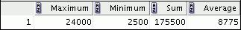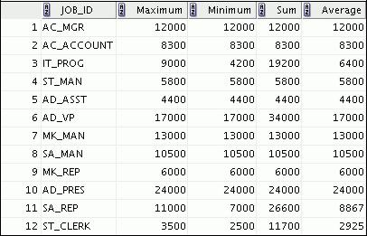

|  |
| --- |
| Oracle Internal & Oracle Academy Use Only |

**Oracle Database 10*g*: SQL Fundamentals I 4 - 26**

**Practice 4 (continued)**

6. Write a query to display the number of people with the same job.

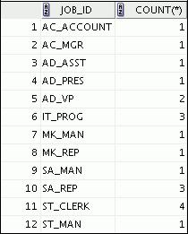

Generalize the query so that the user in the HR department is prompted for a job title. Save the script to a file named lab_04_06.sql.

1. Determine the number of managers without listing them. Label the column Number of Managers. *Hint: Use the* *MANAGER_ID* *column to determine the number of managers.*
2. Find the difference between the highest and the lowest salaries. Label the column

DIFFERENCE.

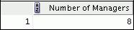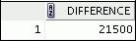

If you have time, complete the following exercises:

1. Create a report to display the manager number and the salary of the lowest-paid employee for that manager. Exclude anyone whose manager is not known. Exclude any groups where the minimum salary is $6,000 or less. Sort the output in descending order of salary.

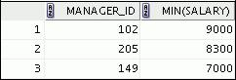

|  |
| --- |
| Oracle Internal & Oracle Academy Use Only |

**Oracle Database 10*g*: SQL Fundamentals I 4 - 27**

**Practice 4 (continued)**

If you want an extra challenge, complete the following exercises:

1. Create a query to display the total number of employees and, of that total, the number of employees hired in 1995, 1996, 1997, and 1998. Create appropriate column headings.
2. Create a matrix query to display the job, the salary for that job based on the department number, and the total salary for that job, for departments 20, 50, 80, and 90, giving each column an appropriate heading.

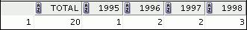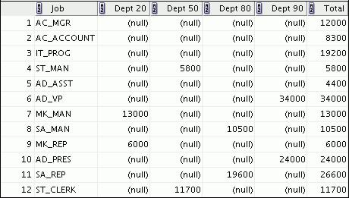

|  |
| --- |
| Oracle Internal & Oracle Academy Use Only |

**Oracle Database 10*g*: SQL Fundamentals I 4 - 28**



**Displaying Data**

**from Multiple Tables**

Copyright © 2009, Oracle. All rights reserved.

|  |
| --- |
| Oracle Internal & Oracle Academy Use Only |

**Objectives**

After completing this lesson, you should be able to do the following:

* Write SELECT statements to access data from more than one table using equijoins and nonequijoins
* Join a table to itself by using a self-join
* View data that generally does not meet a join condition by using outer joins
* Generate a Cartesian product of all rows from two or more tables

Copyright © 2009, Oracle. All rights reserved.

**Objectives**

This lesson explains how to obtain data from more than one table. A *join* is used to view information from multiple tables. Therefore, you can *join* tables together to view information from more than one table.

**Note:** Information on joins is found in “SQL Queries and Subqueries: Joins” in*Oracle SQL Reference*.

|  |
| --- |
| Oracle Internal & Oracle Academy Use Only |

**Oracle Database 10*g*: SQL Fundamentals I 5 - 2**

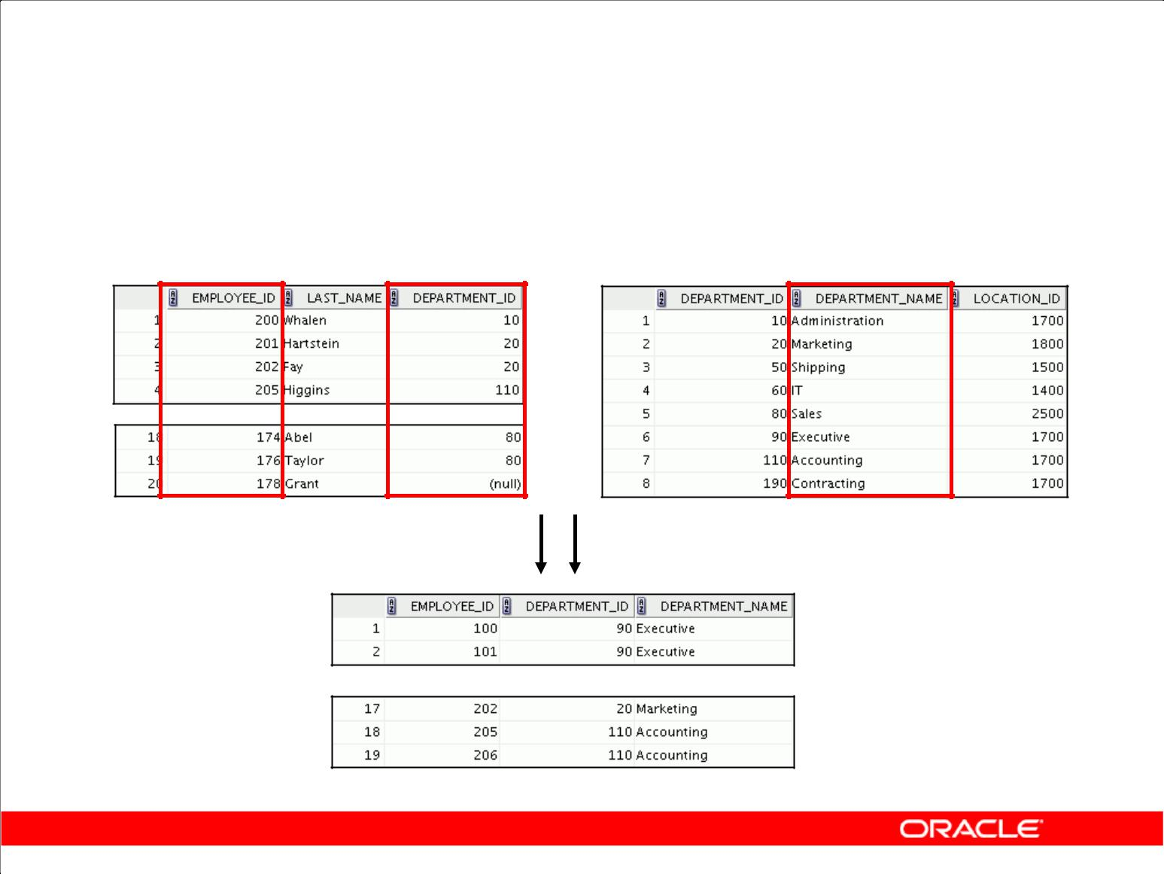**Obtaining Data from Multiple Tables**

**EMPLOYEES** **DEPARTMENTS**

**…**

**…**

Copyright © 2009, Oracle. All rights reserved.

**Obtaining Data from Multiple Tables**

Sometimes you need to use data from more than one table. In the slide example, the report displays data from two separate tables:

* Employee IDs exist in the EMPLOYEES table.
* Department IDs exist in both the EMPLOYEES and DEPARTMENTS tables.
* Department names exist in the DEPARTMENTS table.

To produce the report, you need to link the EMPLOYEES and DEPARTMENTS tables and access data from both of them.

|  |
| --- |
| Oracle Internal & Oracle Academy Use Only |

**Oracle Database 10*g*: SQL Fundamentals I 5 - 3**

**Types of Joins**

Joins that are compliant with the SQL:1999 standard include the following:

* Cross joins
* Natural joins
* USING clause
* Full (or two-sided) outer joins
* Arbitrary join conditions for outer joins

Copyright © 2009, Oracle. All rights reserved.

**Types of Joins**

To join tables, you can use join syntax that is compliant with the SQL:1999 standard.

**Note:** Before the Oracle9*i*release, the join syntax was different from the ANSI standards. TheSQL:1999–compliant join syntax does not offer any performance benefits over the Oracle-proprietary join syntax that existed in prior releases. For detailed information about the proprietary join syntax, see Appendix C.

|  |
| --- |
| Oracle Internal & Oracle Academy Use Only |

**Oracle Database 10*g*: SQL Fundamentals I 5 - 4**

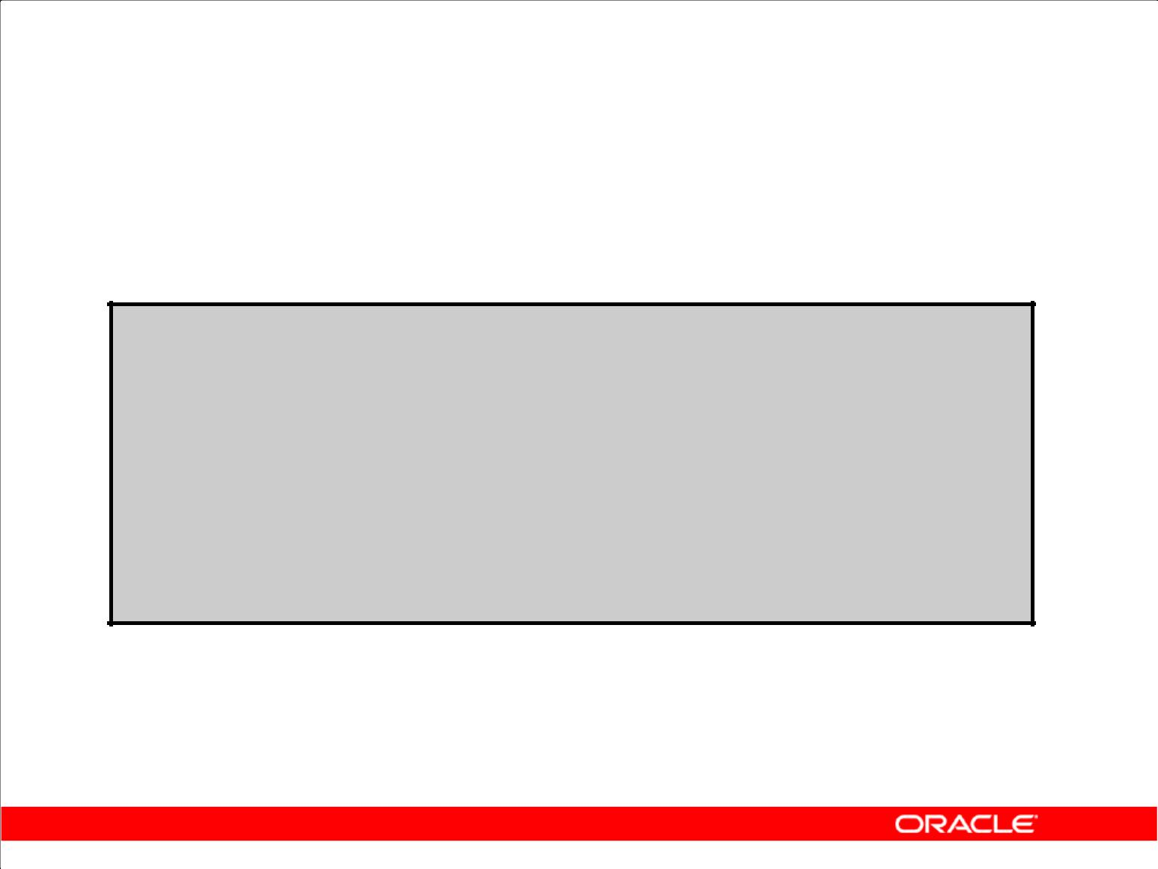**Joining Tables Using SQL:1999 Syntax**

Use a join to query data from more than one table:

**SELECT** ***table1.column, table2.column***

**FROM** ***table1***

**[NATURAL JOIN *table2*] |**

**[JOIN *table2* USING (*column_name*)] | [JOIN *table2***

**ON (*table1.column_name* = *table2.column_name*)]| [LEFT|RIGHT|FULL OUTER JOIN *table2***

**ON (*table1.column_name* = *table2.column_name*)]| [CROSS JOIN *table2*];**

Copyright © 2009, Oracle. All rights reserved.

**Defining Joins**

In the syntax:

*table1.column* denotes the table and column from which data is retrievedNATURAL JOIN joins two tables based on the same column name

JOIN *table* USING *column_name* performs an equijoin based on the column name

JOIN *table ON table1.column_name* performs an equijoin based on the condition in the ON clause, = *table2.column_name*

*LEFT/RIGHT/FULL OUTER* is used to perform outer joins

CROSS JOIN returns a Cartesian product from the two tables

For more information, see “SELECT” in *Oracle SQL Reference*.

|  |
| --- |
| Oracle Internal & Oracle Academy Use Only |

**Oracle Database 10*g*: SQL Fundamentals I 5 - 5**

**Creating Natural Joins**

* The NATURAL JOIN clause is based on all columns in the two tables that have the same name.
* It selects rows from the two tables that have equal values in all matched columns.
* If the columns having the same names have different data types, an error is returned.

Copyright © 2009, Oracle. All rights reserved.

**Creating Natural Joins**

You can join tables automatically based on columns in the two tables that have matching data types and names. You do this by using the keywords NATURAL JOIN.

**Note:** The join can happen on only those columns that have the same names and data types in bothtables. If the columns have the same name but different data types, then the NATURAL JOIN syntax

causes an error.

|  |
| --- |
| Oracle Internal & Oracle Academy Use Only |

**Oracle Database 10*g*: SQL Fundamentals I 5 - 6**

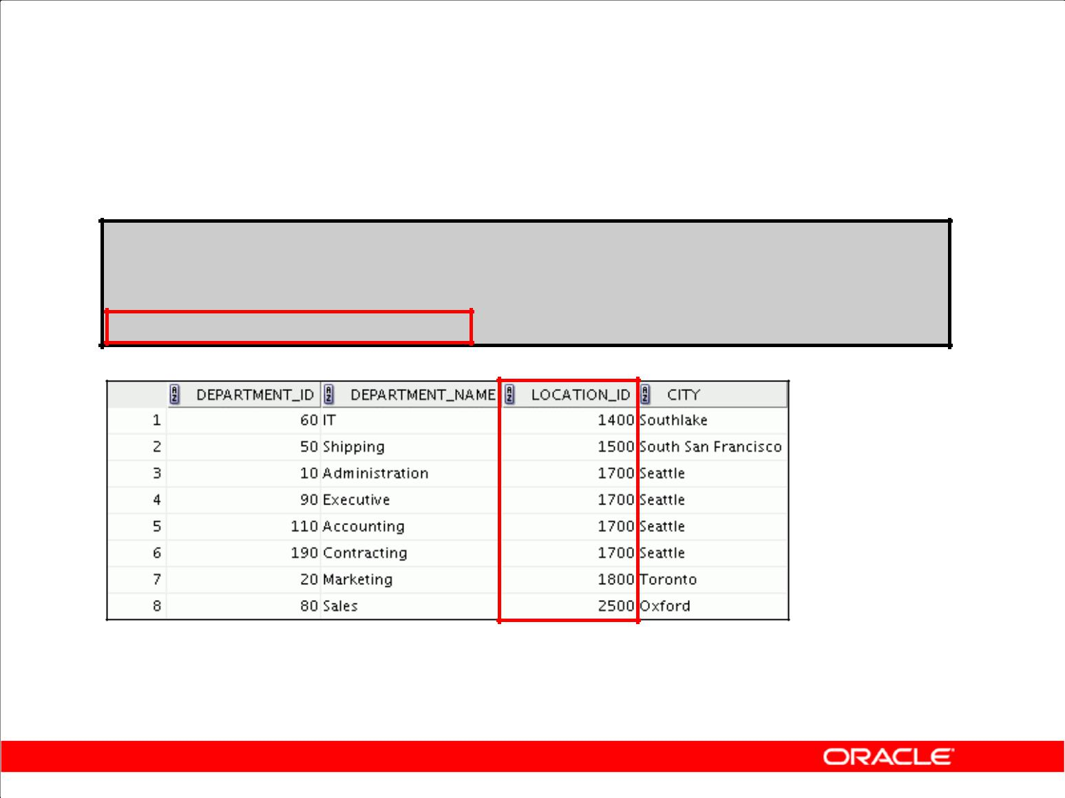**Retrieving Records with Natural Joins**

**SELECT department_id, department_name, location_id, city**

**FROM departments**

**NATURAL JOIN locations ;**

Copyright © 2009, Oracle. All rights reserved.

**Retrieving Records with Natural Joins**

In the example in the slide, the LOCATIONS table is joined to the DEPARTMENT table by the LOCATION_ID column, which is the only column of the same name in both tables. If other common columns were present, the join would have used them all.

**Natural Joins with a WHERE Clause**

Additional restrictions on a natural join are implemented by using a WHERE clause. The following example limits the rows of output to those with a department ID equal to 20 or 50:

SELECT department_id, department_name,

location_id, city

FROM departments

NATURAL JOIN locations

WHERE department_id IN (20, 50);

|  |
| --- |
| Oracle Internal & Oracle Academy Use Only |

**Oracle Database 10*g*: SQL Fundamentals I 5 - 7**

**Creating Joins with the USING Clause**

* If several columns have the same names but the data types do not match, natural join can be applied by using the USING clause to specify the columns that should be used for an equijoin.
* Use the USING clause to match only one column when more than one column matches.
* Do not use a table name or alias in the referenced columns.
* The NATURAL JOIN and USING clauses are mutually exclusive.

Copyright © 2009, Oracle. All rights reserved.

**USING Clause**

Natural joins use all columns with matching names and data types to join the tables. The USING

clause can be used to specify only those columns that should be used for an equijoin. The columns that are referenced in the USING clause should not have a qualifier (table name or alias) anywhere in

the SQL statement.

For example, the following statement is valid:

SELECT l.city, d.department_name

FROM locations l JOIN departments d USING (location_id)

WHERE location_id = 1400;

The following statement is invalid because the LOCATION_ID is qualified in the WHERE clause:

SELECT l.city, d.department_name

FROM locations l JOIN departments d USING (location_id)

WHERE d.location_id = 1400;

ORA-25154: column part of USING clause cannot have qualifier

The same restriction also applies to NATURAL joins. Therefore, columns that have the same name in both tables must be used without any qualifiers.

|  |
| --- |
| Oracle Internal & Oracle Academy Use Only |

**Oracle Database 10*g*: SQL Fundamentals I 5 - 8**

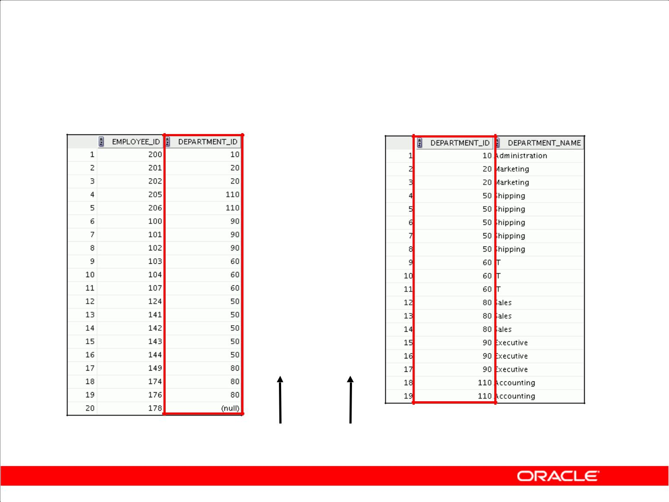**Joining Column Names**

**EMPLOYEES** **DEPARTMENTS**

**Foreign key** **Primary key**

Copyright © 2009, Oracle. All rights reserved.

**The USING Clause for Equijoins**

To determine an employee’s department name, you compare the value in the DEPARTMENT_ID column in the EMPLOYEES table with the DEPARTMENT_ID values in the DEPARTMENTS table. The relationship between the EMPLOYEES and DEPARTMENTS tables is an *equijoin;* that is, values in the DEPARTMENT_ID column in both tables must be equal. Frequently, this type of join involves primary and foreign key complements.

**Note:** Equijoins are also called*simple joins*or*inner joins*.

|  |
| --- |
| Oracle Internal & Oracle Academy Use Only |

**Oracle Database 10*g*: SQL Fundamentals I 5 - 9**

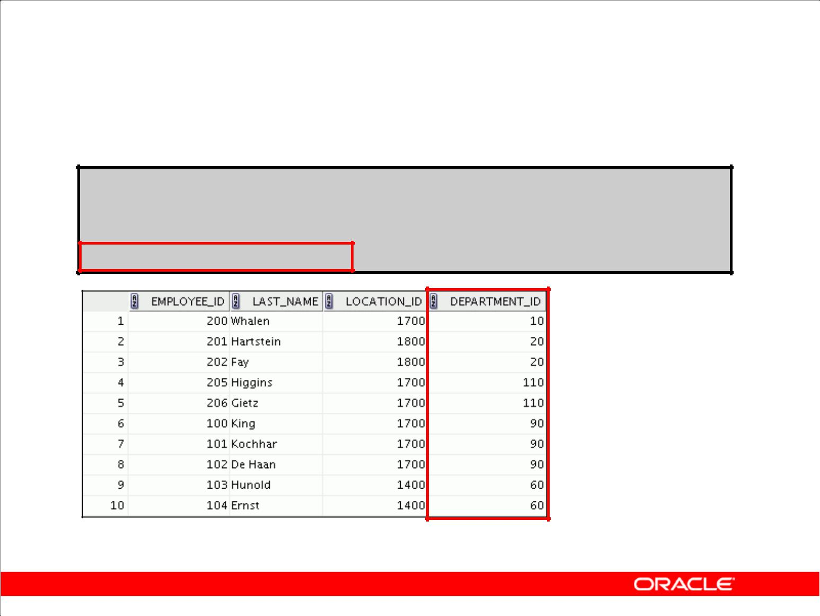**Retrieving Records with the USING Clause**

**SELECT employees.employee_id, employees.last_name, departments.location_id, department_id**

**FROM employees JOIN departments**

**USING (department_id) ;**

**…**

Copyright © 2009, Oracle. All rights reserved.

**Retrieving Records with the USING Clause**

The slide example joins the DEPARTMENT_ID column in the EMPLOYEES and DEPARTMENTS tables, and thus shows the location where an employee works.

|  |
| --- |
| Oracle Internal & Oracle Academy Use Only |

**Oracle Database 10*g*: SQL Fundamentals I 5 - 10**

**Qualifying Ambiguous**

**Column Names**

* Use table prefixes to qualify column names that are in multiple tables.
* Use table prefixes to improve performance.
* Use column aliases to distinguish columns that have identical names but reside in different tables.
* Do not use aliases on columns that are identified in the USING clause and listed elsewhere in the SQL statement.

Copyright © 2009, Oracle. All rights reserved.

**Qualifying Ambiguous Column Names**

You need to qualify the names of the columns with the table name to avoid ambiguity. Without the table prefixes, the DEPARTMENT_ID column in the SELECT list could be from either the DEPARTMENTS table or the EMPLOYEES table. It is necessary to add the table prefix to execute your query:

SELECT employees.employee_id, employees.last_name,

departments.department_id, departments.location_id

FROM employees JOIN departments

ON employees.department_id = departments.department_id;

If there are no common column names between the two tables, there is no need to qualify the columns. However, using the table prefix improves performance, because you tell the Oracle server exactly where to find the columns.

**Note:** When joining with theUSINGclause, you cannot qualify a column that is used in theUSINGclause itself. Furthermore, if that column is used anywhere in the SQL statement, you cannot alias it.

|  |
| --- |
| Oracle Internal & Oracle Academy Use Only |

**Oracle Database 10*g*: SQL Fundamentals I 5 - 11**

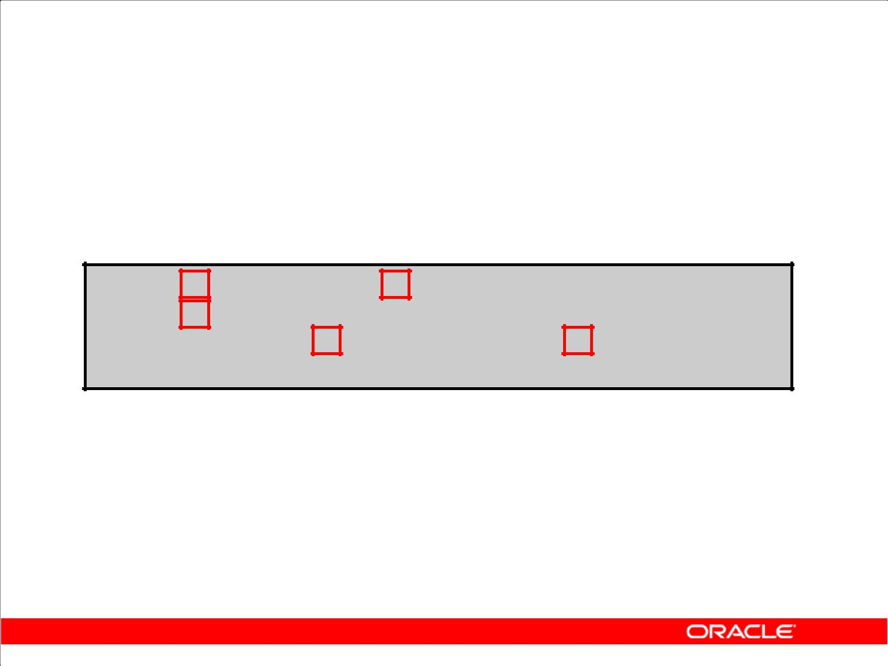**Using Table Aliases**

* Use table aliases to simplify queries.
* Use table aliases to improve performance.

**SELECT e.employee_id, e.last_name, d.location_id, department_id**

**FROM employees e JOIN departments d USING (department_id) ;**

Copyright © 2009, Oracle. All rights reserved.

**Using Table Aliases**

Qualifying column names with table names can be very time consuming, particularly if table names are lengthy. You can use *table aliases* instead of table names. Just as a column alias gives a column another name, a table alias gives a table another name. Table aliases help to keep SQL code smaller, therefore using less memory.

Notice how table aliases are identified in the FROM clause in the example. The table name is specified in full, followed by a space and then the table alias. The EMPLOYEES table has been given an alias of e, and the DEPARTMENTS table an alias of d.

**Guidelines**

* Table aliases can be up to 30 characters in length, but shorter aliases are better than longer ones.
* If a table alias is used for a particular table name in the FROM clause, then that table alias must be substituted for the table name throughout the SELECT statement.
* Table aliases should be meaningful.
* The table alias is valid for only the current SELECT statement.

|  |
| --- |
| Oracle Internal & Oracle Academy Use Only |

**Oracle Database 10*g*: SQL Fundamentals I 5 - 12**

**Creating Joins with the ON Clause**

* The join condition for the natural join is basically an equijoin of all columns with the same name.
* Use the ON clause to specify arbitrary conditions or specify columns to join.
* The join condition is separated from other search conditions.
* The ON clause makes code easy to understand.

Copyright © 2009, Oracle. All rights reserved.

**ON Clause**

Use the ON clause to specify a join condition. This lets you specify join conditions separate from any search or filter conditions in the WHERE clause.

|  |
| --- |
| Oracle Internal & Oracle Academy Use Only |

**Oracle Database 10*g*: SQL Fundamentals I 5 - 13**

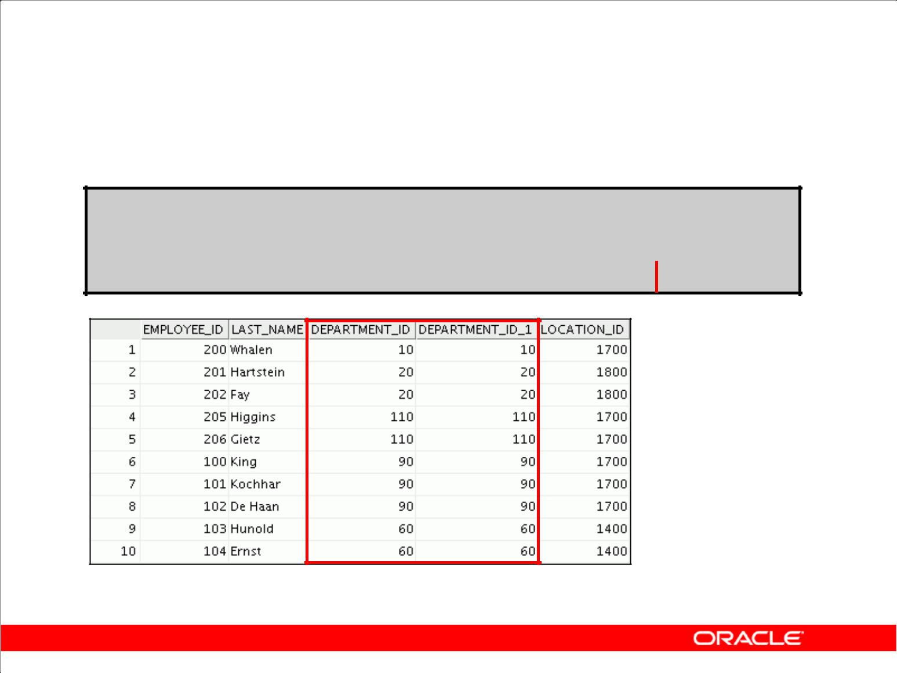**Retrieving Records with the ON Clause**

**SELECT e.employee_id, e.last_name, e.department_id,**

|  |  |  |
| --- | --- | --- |
|  | **d.department_id, d.location_id** | |
| **FROM** | **employees e JOIN departments d** |  |
| **ON** | **(e.department_id = d.department_id);** | |
|  |  |  |

**…**

Copyright © 2009, Oracle. All rights reserved.

**Creating Joins with the ON Clause**

In this example, the DEPARTMENT_ID columns in the EMPLOYEES and DEPARTMENTS table are joined using the ON clause. Wherever a department ID in the EMPLOYEES table equals a department ID in the DEPARTMENTS table, the row is returned.

You can also use the ON clause to join columns that have different names.

|  |
| --- |
| Oracle Internal & Oracle Academy Use Only |

**Oracle Database 10*g*: SQL Fundamentals I 5 - 14**

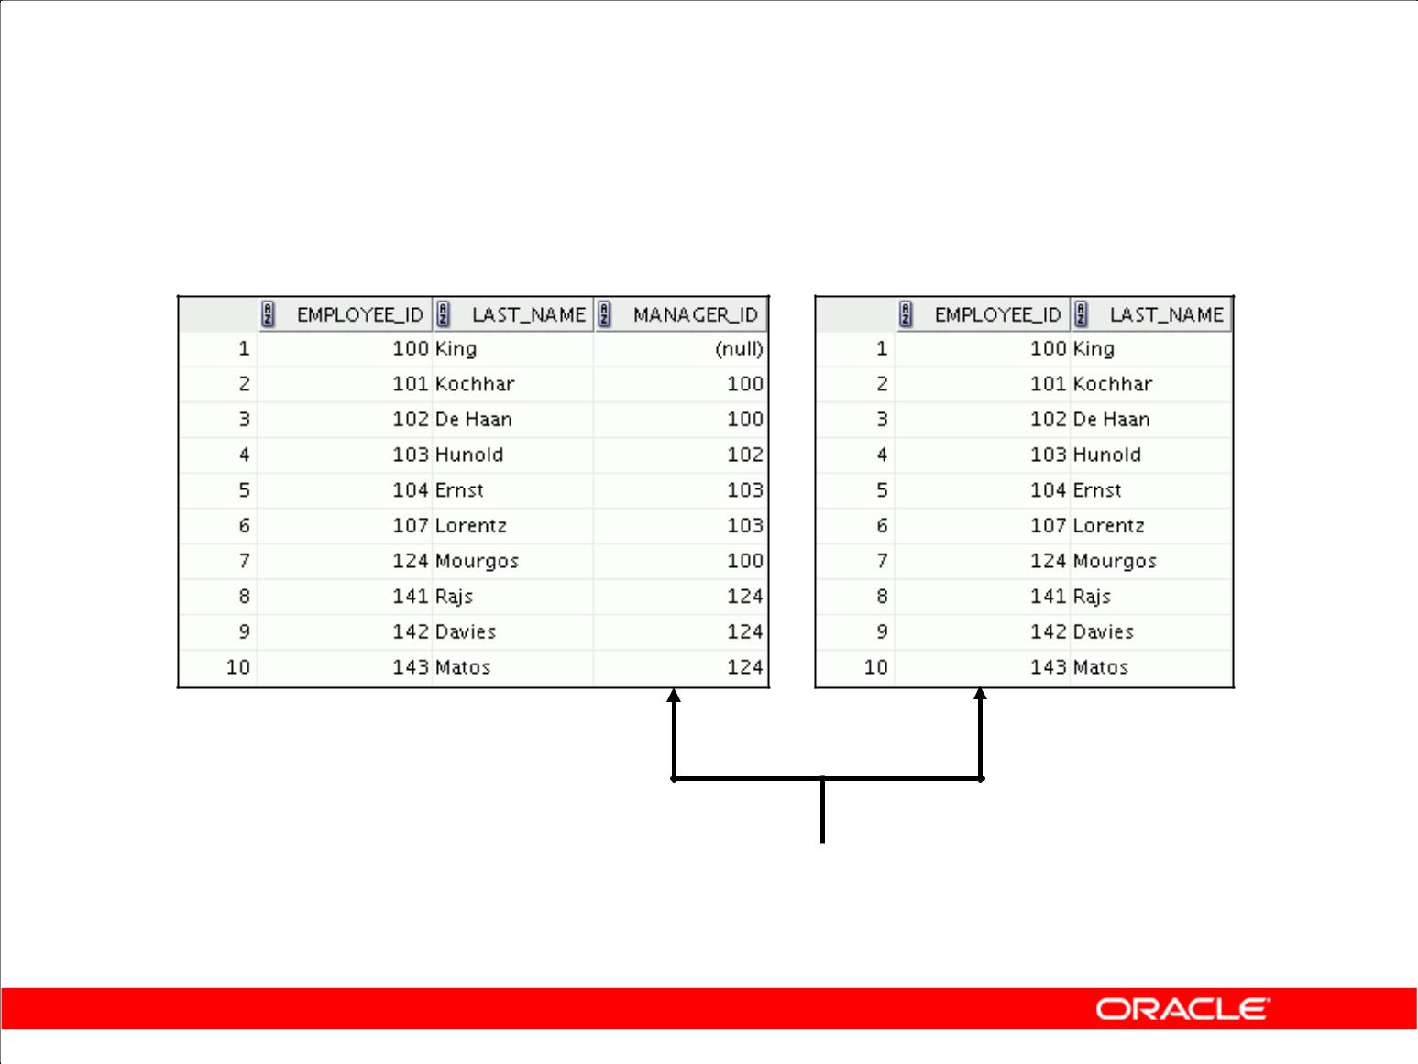**Self-Joins Using the ON Clause**

**EMPLOYEES (WORKER)** **EMPLOYEES (MANAGER)**

|  |  |
| --- | --- |
| **…** | **…** |

**MANAGER_ID in the WORKER table is equal to**

**EMPLOYEE_ID in the MANAGER table.**

Copyright © 2009, Oracle. All rights reserved.

**Joining a Table to Itself**

Sometimes you need to join a table to itself. To find the name of each employee’s manager, you need to join the EMPLOYEES table to itself, or perform a self join. For example, to find the name of

Lorentz’s manager, you need to:

* Find Lorentz in the EMPLOYEES table by looking at the LAST_NAME column
* Find the manager number for Lorentz by looking at the MANAGER_ID column. Lorentz’s manager number is 103.
* Find the name of the manager with EMPLOYEE_ID 103 by looking at the LAST_NAME column. Hunold’s employee number is 103, so Hunold is Lorentz’s manager.

In this process, you look in the table twice. The first time you look in the table to find Lorentz in the LAST_NAME column and MANAGER_ID value of 103. The second time you look in the EMPLOYEE_ID column to find 103 and the LAST_NAME column to find Hunold.

|  |
| --- |
| Oracle Internal & Oracle Academy Use Only |

**Oracle Database 10*g*: SQL Fundamentals I 5 - 15**

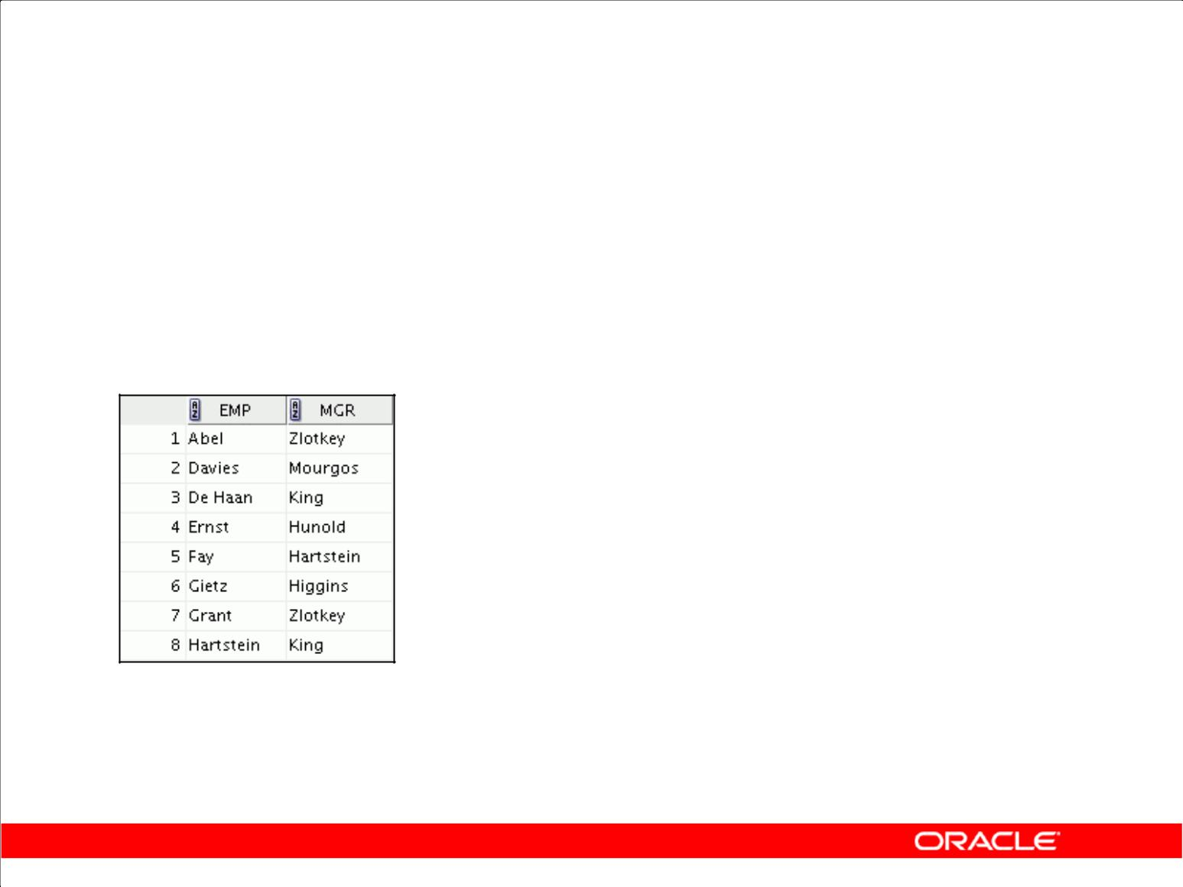**Self-Joins Using the ON Clause**

|  |  |
| --- | --- |
| **SELECT** | **e.last_name emp, m.last_name mgr** |
| **FROM** | **employees e JOIN employees m** |
| **ON** | **(e.manager_id = m.employee_id);** |
|  |  |

**…**

Copyright © 2009, Oracle. All rights reserved.

**Joining a Table to Itself (continued)**

The ON clause can also be used to join columns that have different names, within the same table or in a different table.

The example shown is a self-join of the EMPLOYEES table, based on the EMPLOYEE_ID and MANAGER_ID columns.

|  |
| --- |
| Oracle Internal & Oracle Academy Use Only |

**Oracle Database 10*g*: SQL Fundamentals I 5 - 16**

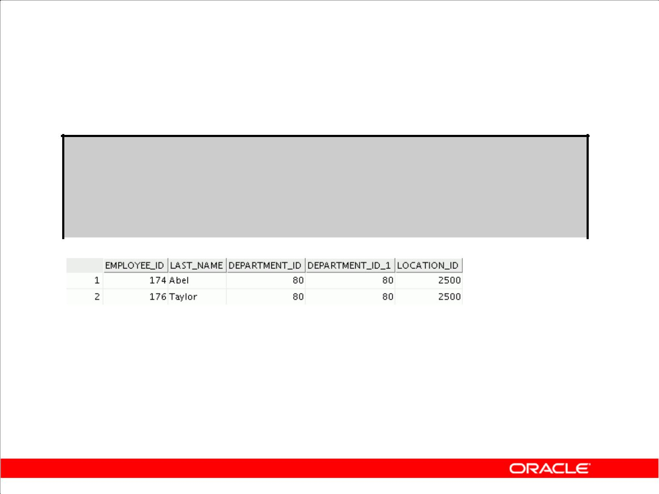**Applying Additional Conditions**

**to a Join**

**SELECT e.employee_id, e.last_name, e.department_id,**

|  |  |  |  |  |
| --- | --- | --- | --- | --- |
|  |  | **d.department_id, d.location_id** | | |
|  | **FROM** | **employees e JOIN departments d** | | |
|  | **ON** | **(e.department_id = d.department_id)** | | |
|  | **AND** | **e.manager_id = 149** | **;** |  |
|  |  |  |  |  |
|  |  |  |  |  |

Copyright © 2009, Oracle. All rights reserved.

**Applying Additional Conditions to a Join**

You can apply additional conditions to the join.

The example shown performs a join on the EMPLOYEES and DEPARTMENTS tables and, in

addition, displays only employees who have a manager ID of 149. To add additional conditions to the ON clause, you can add AND clauses. Alternatively, you can use a WHERE clause to apply

additional conditions:

|  |  |  |  |
| --- | --- | --- | --- |
| SELECT | e.employee_id, | e.last_name, e.department_id, | |
|  | d.department_id, | | d.location_id |
| FROM | employees e JOIN | | departments d |
| ON | (e.department_id = d.department_id) | | |
| WHERE | e.manager_id = | 149; | |

|  |
| --- |
| Oracle Internal & Oracle Academy Use Only |

**Oracle Database 10*g*: SQL Fundamentals I 5 - 17**

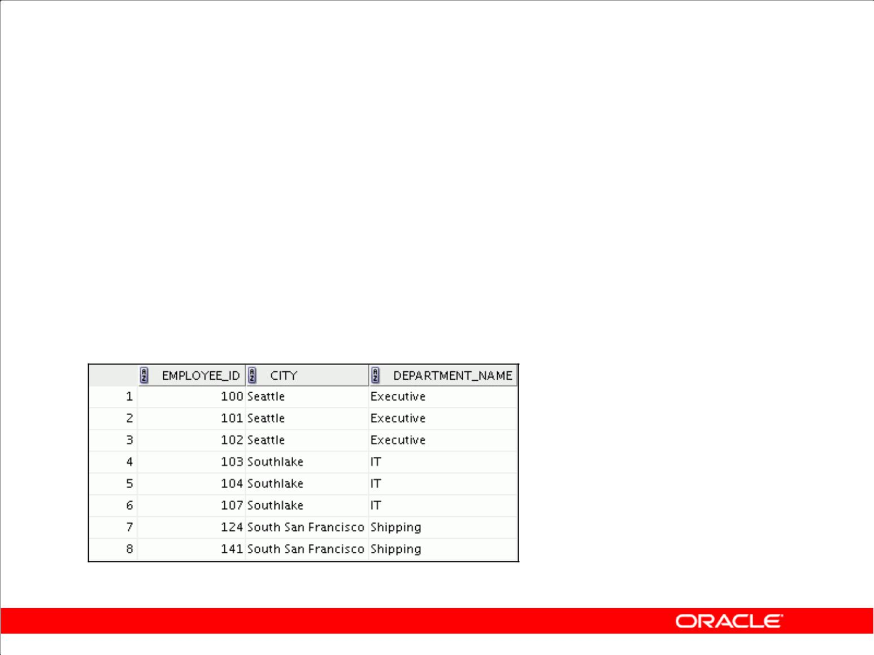**Creating Three-Way Joins with the**

**ON Clause**

|  |  |  |  |
| --- | --- | --- | --- |
|  | **SELECT** | **employee_id, city, department_name** | |
|  | **FROM** | **employees e** | |
|  | **JOIN** | **departments d** |  |
|  | **ON** | **d.department_id = e.department_id** |  |
|  | **JOIN** | **locations l** |  |
|  | **ON** | **d.location_id = l.location_id;** |  |
|  |  |  |  |

**…**

Copyright © 2009, Oracle. All rights reserved.

**Three-Way Joins**

A three-way join is a join of three tables. In SQL:1999–compliant syntax, joins are performed from left to right. So, the first join to be performed is EMPLOYEES JOIN DEPARTMENTS. The first join condition can reference columns in EMPLOYEES and DEPARTMENTS but cannot reference columns in LOCATIONS. The second join condition can reference columns from all three tables.

|  |
| --- |
| Oracle Internal & Oracle Academy Use Only |

**Oracle Database 10*g*: SQL Fundamentals I 5 - 18**

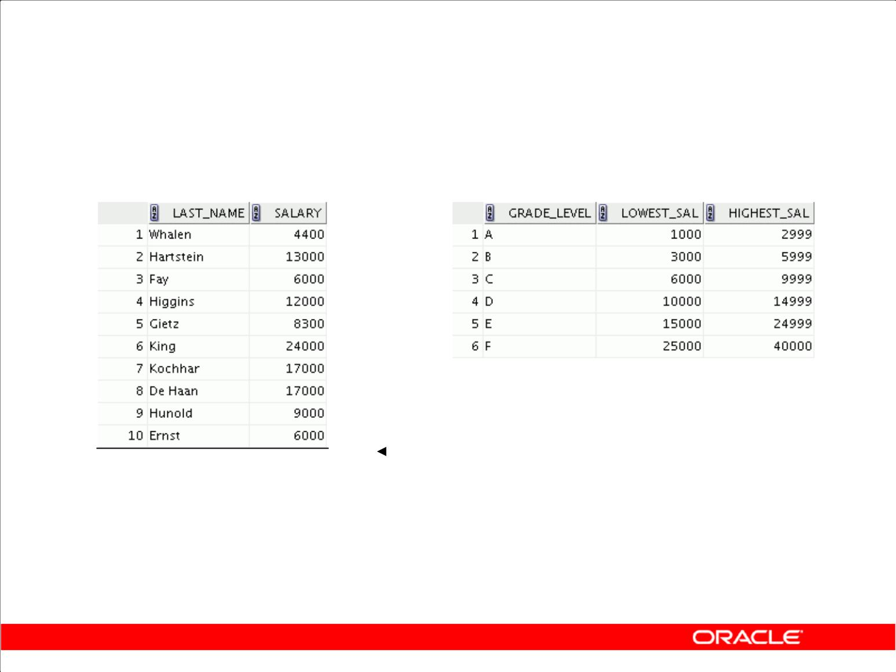**Nonequijoins**

**EMPLOYEES** **JOB_GRADES**

|  |  |  |  |  |  |  |  |  |
| --- | --- | --- | --- | --- | --- | --- | --- | --- |
|  | **…** |  |  |  |  |  |  |  |
|  |  |  |  |  | **Salary in the EMPLOYEES** | |  |
|  |  |  |  |  |  |
|  |  |  |  |  |  | **table must be between** | |  |
|  |  |  |  |  |  | **lowest salary and highest** | |  |
|  |  |  |  |  |  | **salary in the JOB_GRADES** | |  |
|  |  |  |  |  |  | **table.** | |  |

Copyright © 2009, Oracle. All rights reserved.

**Nonequijoins**

A nonequijoin is a join condition containing something other than an equality operator.

The relationship between the EMPLOYEES table and the JOB_GRADES table is an example of a nonequijoin. A relationship between the two tables is that the SALARY column in the EMPLOYEES table must be between the values in the LOWEST_SALARY and HIGHEST_SALARY columns of the JOB_GRADES table. The relationship is obtained using an operator other than equality (=).

|  |
| --- |
| Oracle Internal & Oracle Academy Use Only |

**Oracle Database 10*g*: SQL Fundamentals I 5 - 19**

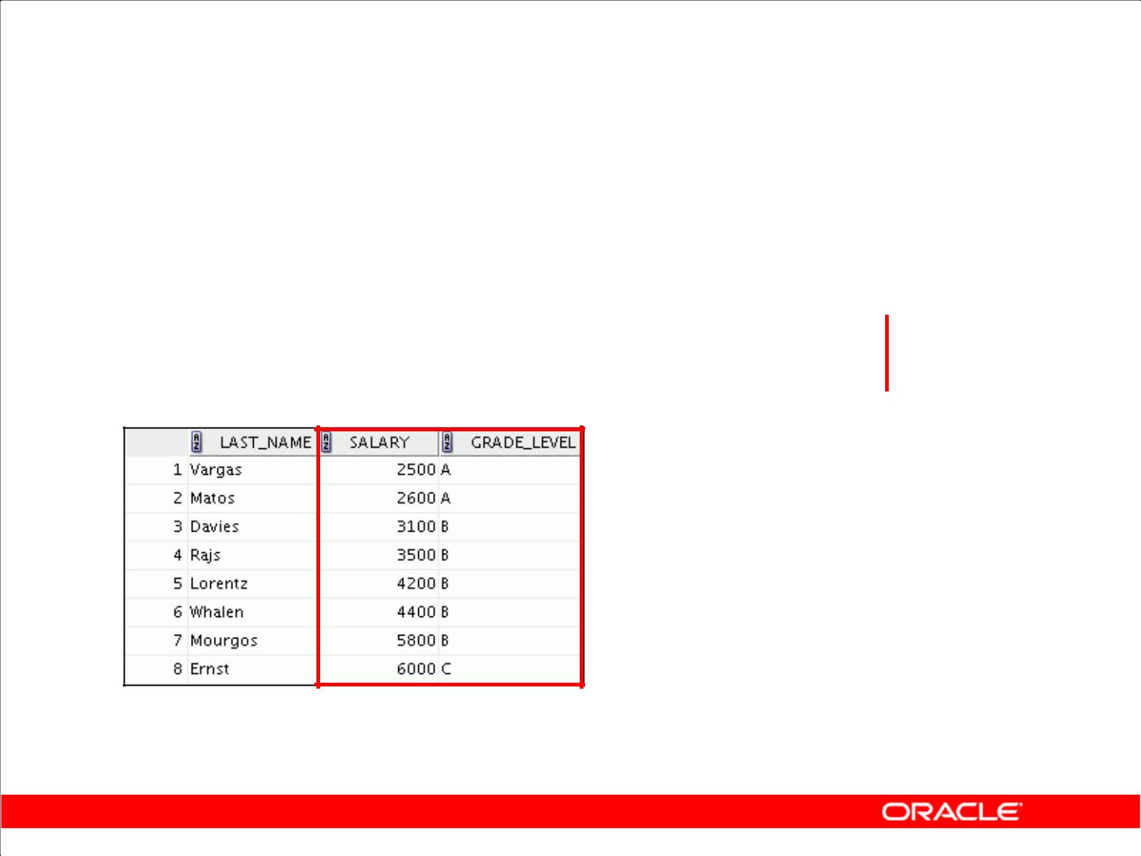**Retrieving Records**

**with Nonequijoins**

|  |  |  |
| --- | --- | --- |
| **SELECT** | **e.last_name, e.salary, j.grade_level** | |
| **FROM** | **employees e JOIN job_grades j** | |
| **ON** | **e.salary** |  |
|  | **BETWEEN j.lowest_sal AND j.highest_sal;** |  |
|  |  |  |

**…**

Copyright © 2009, Oracle. All rights reserved.

**Nonequijoins (continued)**

The slide example creates a nonequijoin to evaluate an employee’s salary grade. The salary must be *between* any pair of the low and high salary ranges.

It is important to note that all employees appear exactly once when this query is executed. No employee is repeated in the list. There are two reasons for this:

* None of the rows in the job grade table contain grades that overlap. That is, the salary value for an employee can lie only between the low salary and high salary values of one of the rows in the salary grade table.
* All of the employees’ salaries lie within the limits that are provided by the job grade table. That is, no employee earns less than the lowest value contained in the LOWEST_SAL column or more than the highest value contained in the HIGHEST_SAL column.

**Note:** Other conditions (such as<=and>=)can be used, butBETWEENis the simplest. Rememberto specify the low value first and the high value last when using BETWEEN.

Table aliases have been specified in the slide example for performance reasons, not because of possible ambiguity.

|  |
| --- |
| Oracle Internal & Oracle Academy Use Only |

**Oracle Database 10*g*: SQL Fundamentals I 5 - 20**

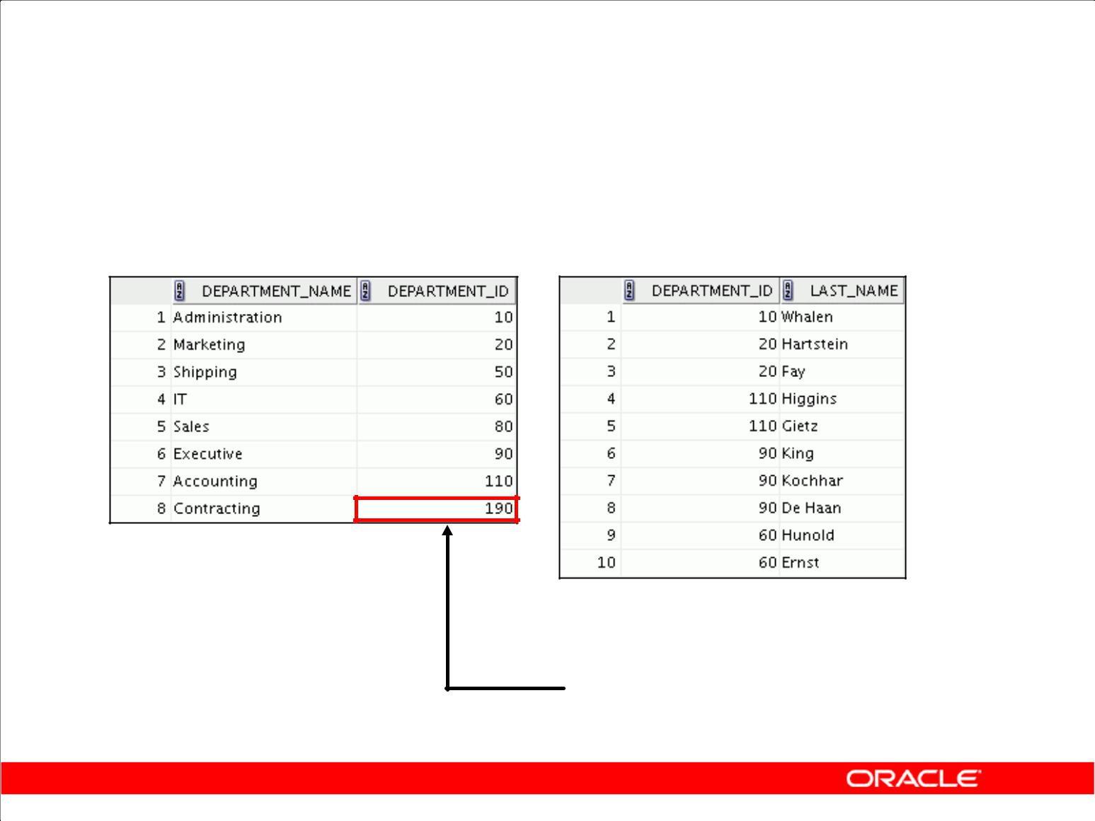**Outer Joins**

**DEPARTMENTS** **EMPLOYEES**

**…**

**There are no employees in**

**department 190.**

Copyright © 2009, Oracle. All rights reserved.

**Returning Records with No Direct Match with Outer Joins**

If a row does not satisfy a join condition, the row does not appear in the query result. For example, in the equijoin condition of EMPLOYEES and DEPARTMENTS tables, department ID 190 does not appear because there are no employees with that department ID recorded in the EMPLOYEES table. Instead of seeing 20 employees in the result set, you see 19 records.

To return the department record that does not have any employees, you can use an outer join.

|  |
| --- |
| Oracle Internal & Oracle Academy Use Only |

**Oracle Database 10*g*: SQL Fundamentals I 5 - 21**

**INNER Versus OUTER Joins**

* In SQL:1999, the join of two tables returning only matched rows is called an inner join.
* A join between two tables that returns the results of the inner join as well as the unmatched rows from the left (or right) tables is called a left (or right) outer join.
* A join between two tables that returns the results of an inner join as well as the results of a left and right join is a full outer join.

Copyright © 2009, Oracle. All rights reserved.

**INNER Versus OUTER Joins**

Joining tables with the NATURAL JOIN, USING, or ON clauses results in an inner join. Any unmatched rows are not displayed in the output. To return the unmatched rows, you can use an outer join. An outer join returns all rows that satisfy the join condition and also returns some or all of those rows from one table for which no rows from the other table satisfy the join condition.

There are three types of outer joins:

* LEFT OUTER
* RIGHT OUTER
* FULL OUTER

|  |
| --- |
| Oracle Internal & Oracle Academy Use Only |

**Oracle Database 10*g*: SQL Fundamentals I 5 - 22**

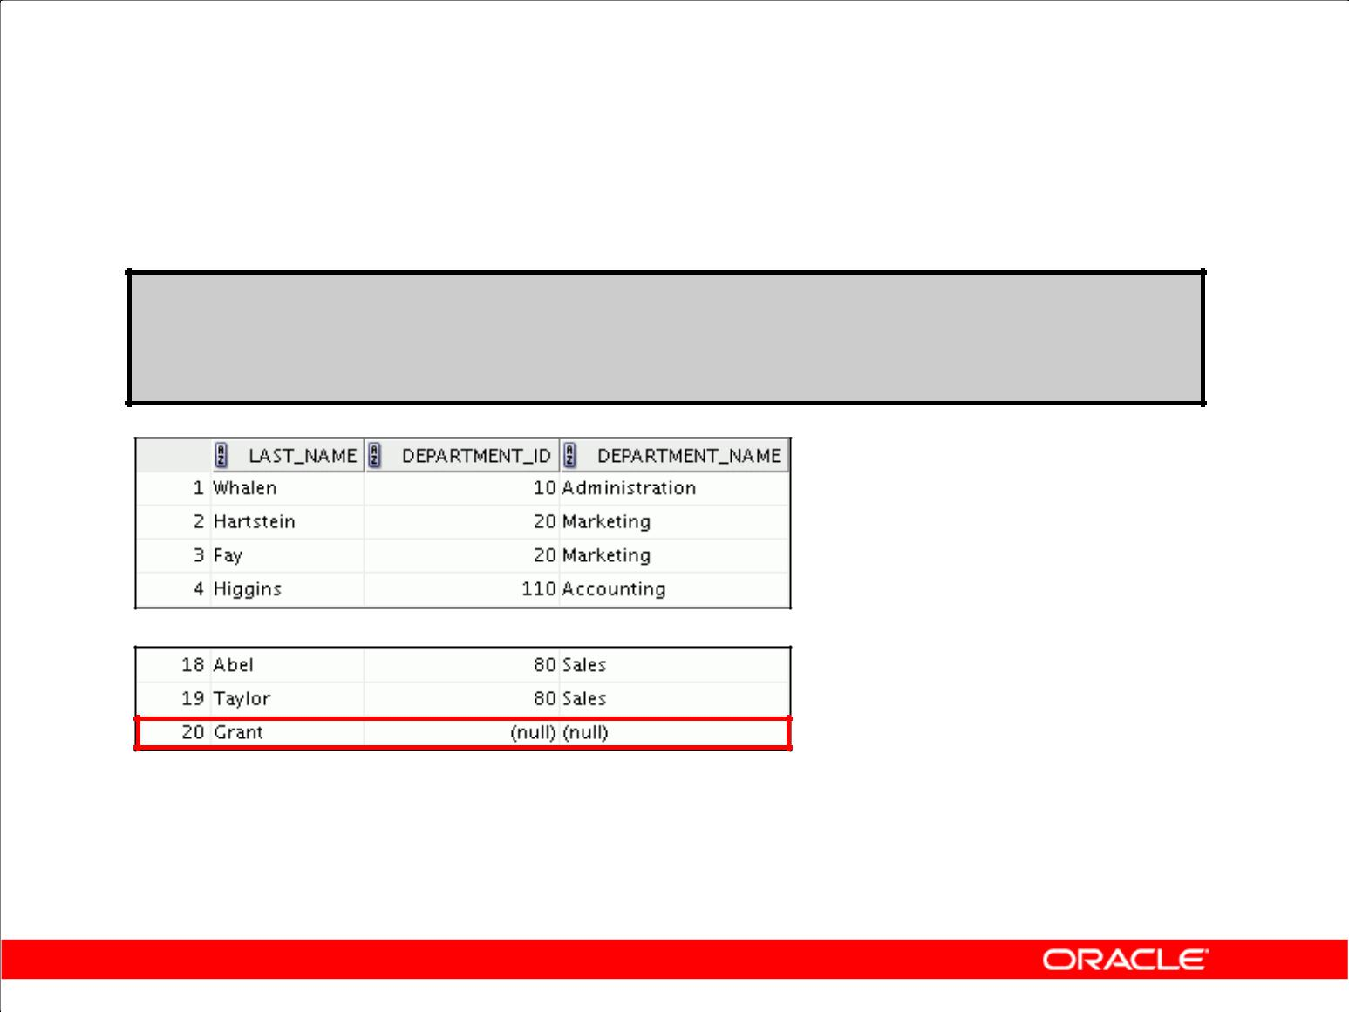**LEFT OUTER JOIN**

**SELECT e.last_name, e.department_id, d.department_name**

|  |  |  |  |
| --- | --- | --- | --- |
| **FROM** | **employees e** | **LEFT** | **OUTER JOIN departments d** |
| **ON** | **(e.department_id =** | | **d.department_id) ;** |

**…**

Copyright © 2009, Oracle. All rights reserved.

**Example of LEFT OUTER JOIN**

This query retrieves all rows in the EMPLOYEES table, which is the table on the left even if there is no match in the DEPARTMENTS table.

|  |
| --- |
| Oracle Internal & Oracle Academy Use Only |

**Oracle Database 10*g*: SQL Fundamentals I 5 - 23**

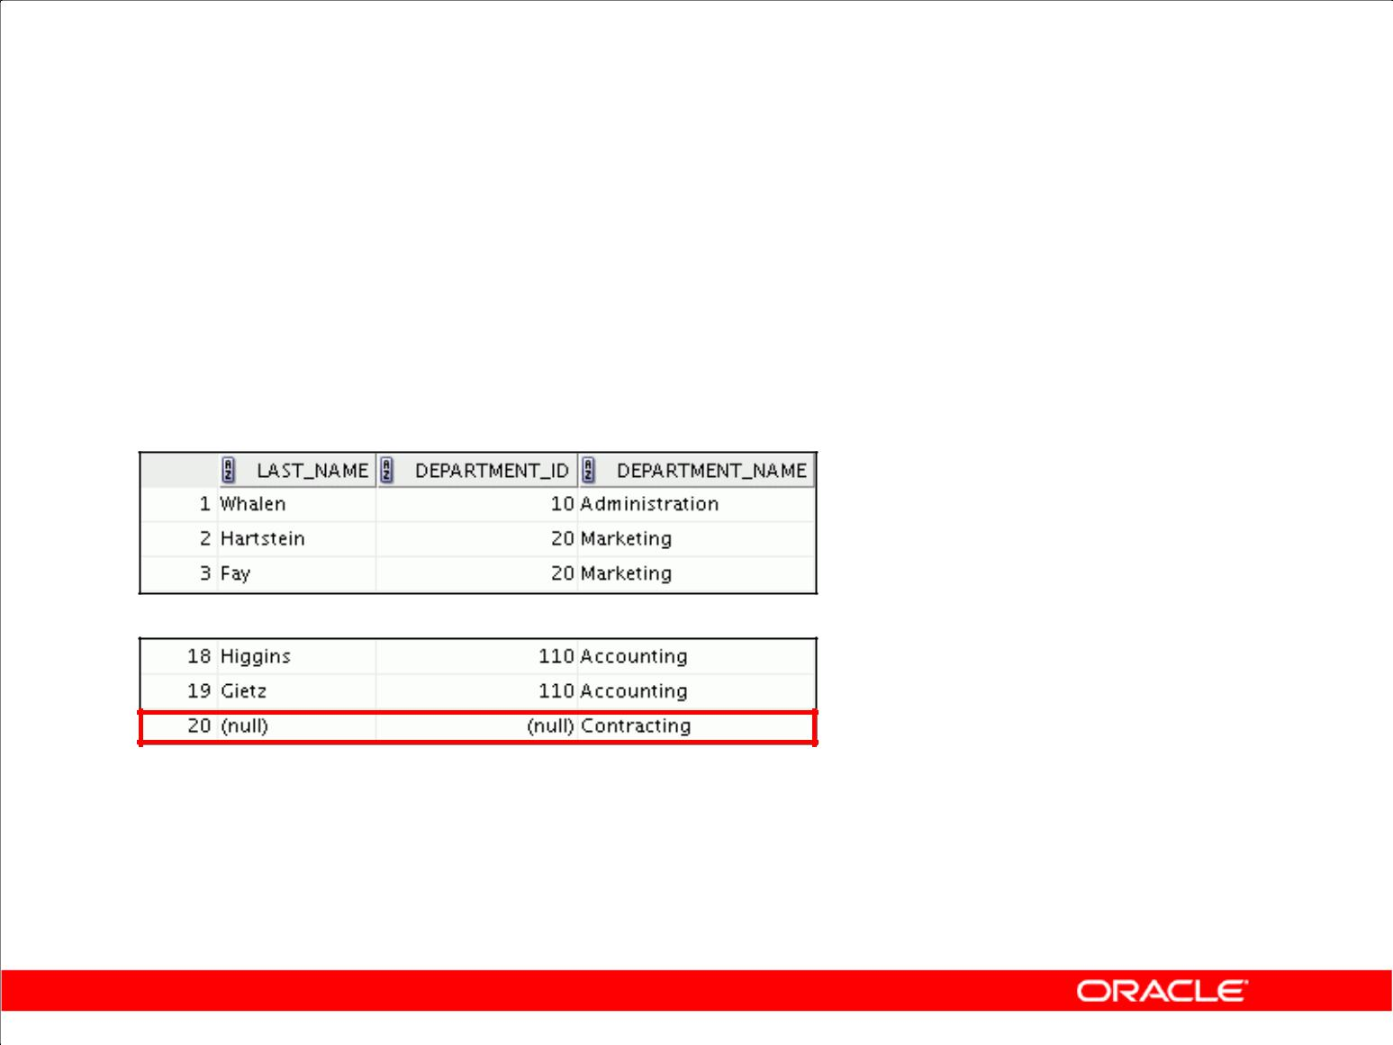**RIGHT OUTER JOIN**

|  |  |  |  |
| --- | --- | --- | --- |
| **SELECT** | **e.last_name, e.department_id, d.department_name** | | |
| **FROM** | **employees e** | **RIGHT OUTER JOIN departments d** |  |
| **ON** | **(e.department_id = d.department_id) ;** | | |
|  |  |  |  |

**…**

Copyright © 2009, Oracle. All rights reserved.

**Example of RIGHT OUTER JOIN**

This query retrieves all rows in the DEPARTMENTS table, which is the table on the right even if there is no match in the EMPLOYEES table.

|  |
| --- |
| Oracle Internal & Oracle Academy Use Only |

**Oracle Database 10*g*: SQL Fundamentals I 5 - 24**

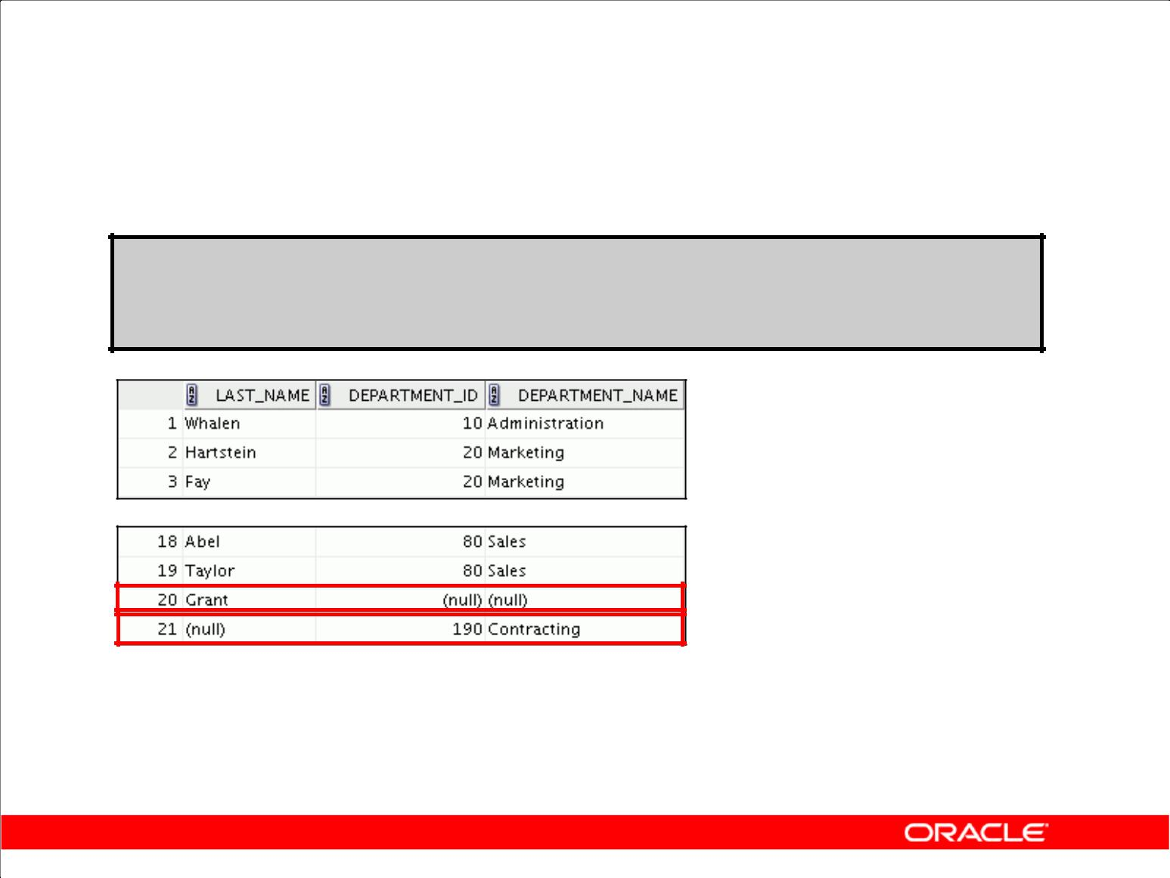**FULL OUTER JOIN**

**SELECT e.last_name, d.department_id, d.department_name**

|  |  |  |  |
| --- | --- | --- | --- |
| **FROM** | **employees e** | **FULL** | **OUTER JOIN departments d** |
| **ON** | **(e.department_id =** | | **d.department_id) ;** |

**…**

Copyright © 2009, Oracle. All rights reserved.

**Example of FULL OUTER JOIN**

This query retrieves all rows in the EMPLOYEES table, even if there is no match in the DEPARTMENTS table. It also retrieves all rows in the DEPARTMENTS table, even if there is no match in the EMPLOYEES table.

|  |
| --- |
| Oracle Internal & Oracle Academy Use Only |

**Oracle Database 10*g*: SQL Fundamentals I 5 - 25**

**Cartesian Products**

* A Cartesian product is formed when:

– A join condition is omitted

– A join condition is invalid

– All rows in the first table are joined to all rows in the second table

* To avoid a Cartesian product, always include a valid join condition.

Copyright © 2009, Oracle. All rights reserved.

**Cartesian Products**

When a join condition is invalid or omitted completely, the result is a *Cartesian product*, in which all combinations of rows are displayed. All rows in the first table are joined to all rows in the second table.

A Cartesian product tends to generate a large number of rows, and the result is rarely useful. You should always include a valid join condition unless you have a specific need to combine all rows from all tables.

Cartesian products are useful for some tests when you need to generate a large number of rows to simulate a reasonable amount of data.

|  |
| --- |
| Oracle Internal & Oracle Academy Use Only |

**Oracle Database 10*g*: SQL Fundamentals I 5 - 26**

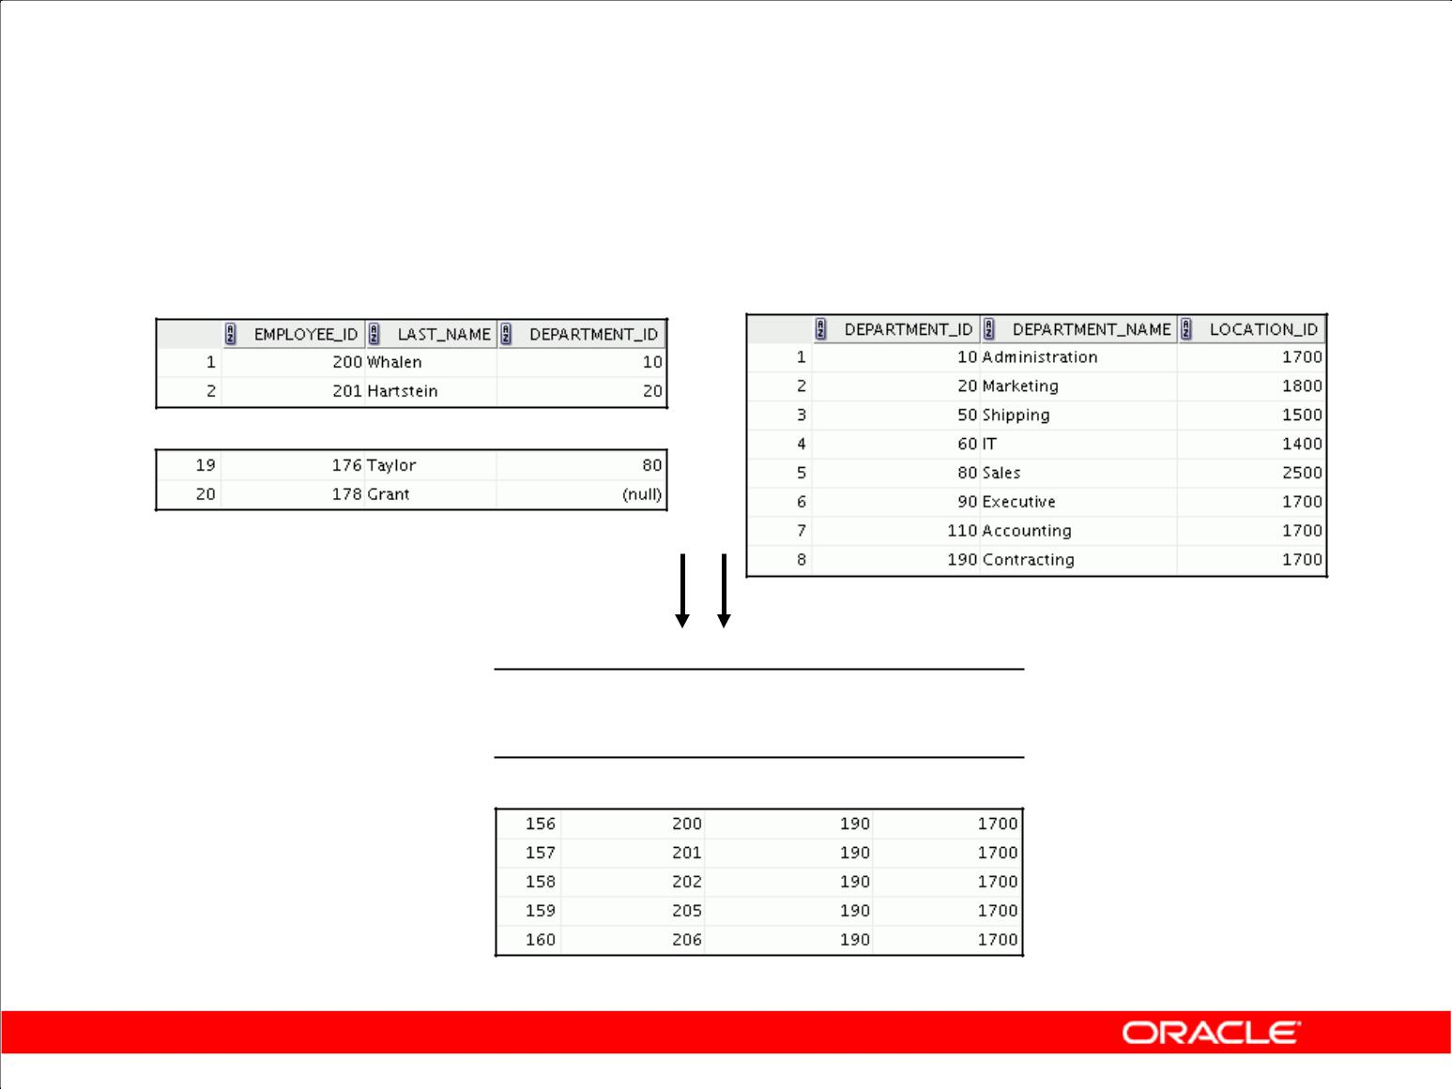**Generating a Cartesian Product**

**EMPLOYEES (20 rows)** **DEPARTMENTS (8 rows)**

**…**

**Cartesian product: 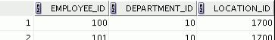 20 x 8 = 160 rows …**

Copyright © 2009, Oracle. All rights reserved.

**Cartesian Products (continued)**

A Cartesian product is generated if a join condition is omitted. The example in the slide shows employee last name and department name from the EMPLOYEES and DEPARTMENTS tables. Because no join condition has been specified, all rows (20 rows) from the EMPLOYEES table are joined with all rows (8 rows) in the DEPARTMENTS table, thereby generating 160 rows in the output.

|  |
| --- |
| Oracle Internal & Oracle Academy Use Only |

**Oracle Database 10*g*: SQL Fundamentals I 5 - 27**

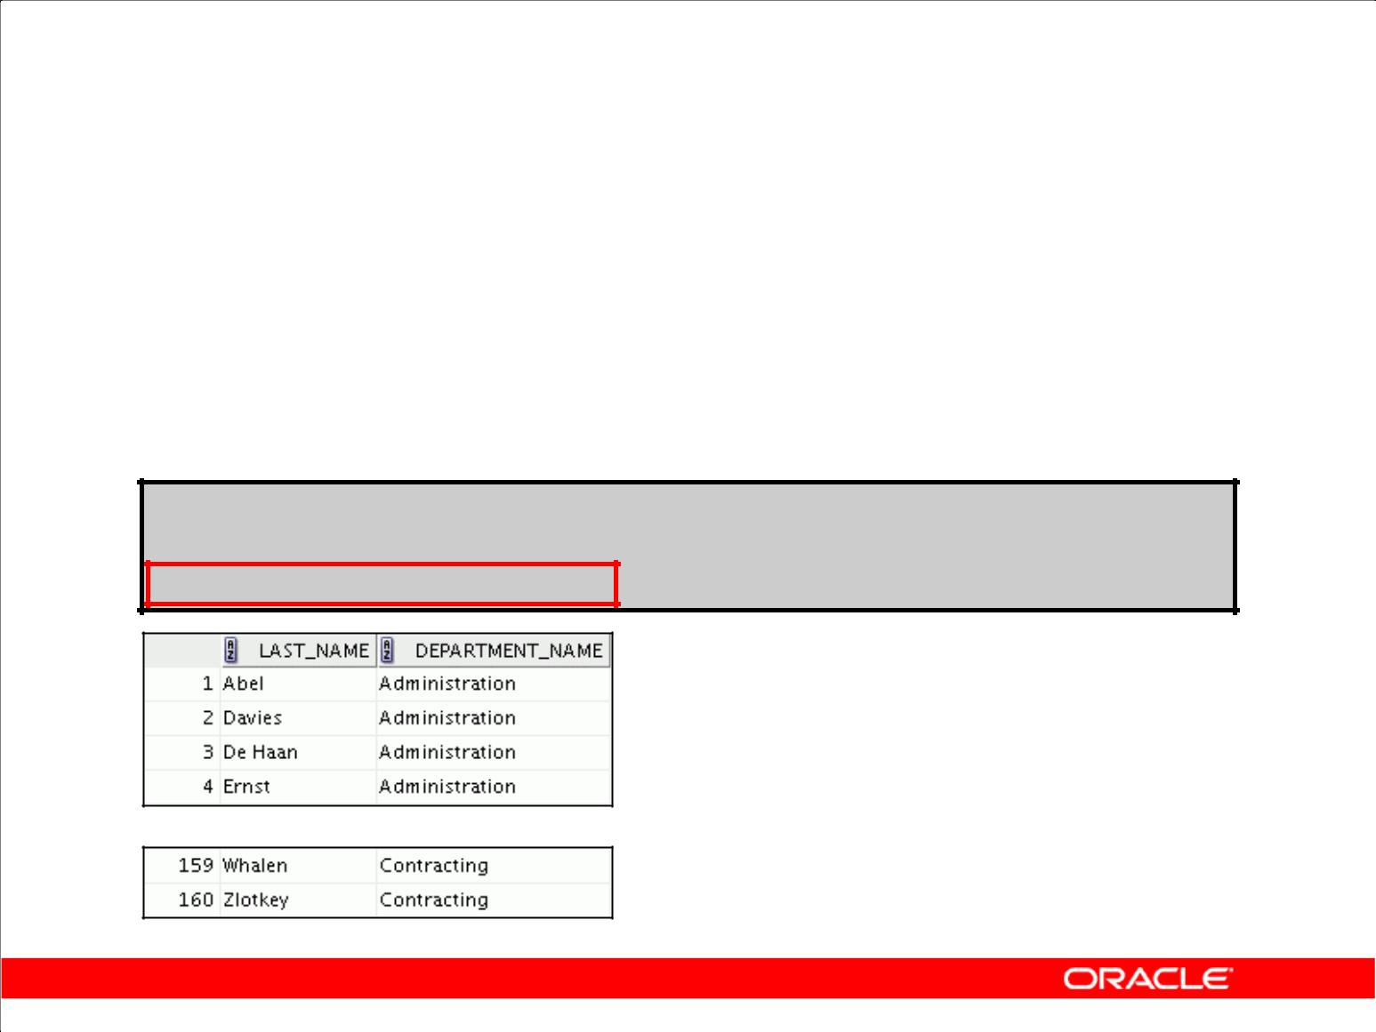**Creating Cross Joins**

* The CROSS JOIN clause produces the cross-product of two tables.
* This is also called a Cartesian product between the two tables.

**SELECT last_name, department_name**

**FROM employees**

**CROSS JOIN departments ;**

**…**

Copyright © 2009, Oracle. All rights reserved.

**Creating Cross Joins**

The example in the slide produces a Cartesian product of the EMPLOYEES and DEPARTMENTS tables.

|  |
| --- |
| Oracle Internal & Oracle Academy Use Only |

**Oracle Database 10*g*: SQL Fundamentals I 5 - 28**

**Summary**

In this lesson, you should have learned how to use joins to display data from multiple tables by using:

* Equijoins
* Nonequijoins
* Outer joins
* Self-joins
* Cross joins
* Natural joins
* Full (or two-sided) outer joins

Copyright © 2009, Oracle. All rights reserved.

**Summary**

There are multiple ways to join tables.

**Types of Joins**

* Equijoins
* Nonequijoins
* Outer joins
* Self-joins
* Cross joins
* Natural joins
* Full (or two-sided) outer joins

**Cartesian Products**

A Cartesian product results in a display of all combinations of rows. This is done by either omitting the WHERE clause or specifying the CROSS JOIN clause.

**Table Aliases**

* Table aliases speed up database access.
* Table aliases can help to keep SQL code smaller by conserving memory.

|  |
| --- |
| Oracle Internal & Oracle Academy Use Only |

**Oracle Database 10*g*: SQL Fundamentals I 5 - 29**

**Practice 5: Overview**

This practice covers the following topics:

* Joining tables using an equijoin
* Performing outer and self-joins
* Adding conditions

Copyright © 2009, Oracle. All rights reserved.

**Practice 5: Overview**

This practice is intended to give you practical experience in extracting data from multiple tables using the SQL:1999–compliant joins.

|  |
| --- |
| Oracle Internal & Oracle Academy Use Only |

**Oracle Database 10*g*: SQL Fundamentals I 5 - 30**

**Practice 5**

1. Write a query for the HR department to produce the addresses of all the departments. Use the LOCATIONS and COUNTRIES tables. Show the location ID, street address, city, state or province, and country in the output. Use a NATURAL JOIN to produce the results.
2. The HR department needs a report of all employees. Write a query to display the last name, department number, and department name for all employees.

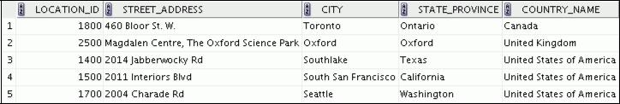

|  |
| --- |
| Oracle Internal & Oracle Academy Use Only |

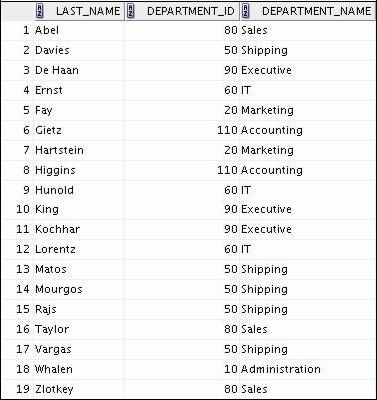

**Oracle Database 10*g*: SQL Fundamentals I 5 - 31**

**Practice 5 (continued)**

1. The HR department needs a report of employees in Toronto. Display the last name, job, department number, and department name for all employees who work in Toronto.
2. Create a report to display the last name and employee number of employees along with their manager’s last name and manager number. Label the columns Employee, Emp#, Manager, and Mgr#, respectively. Place your SQL statement in a text file named lab_05_04.sql.

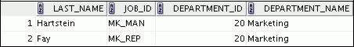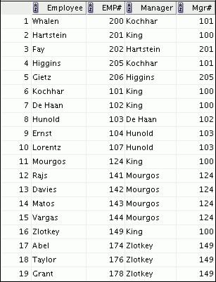

|  |
| --- |
| Oracle Internal & Oracle Academy Use Only |

**Oracle Database 10*g*: SQL Fundamentals I 5 - 32**

**Practice 5 (continued)**

1. Modify lab_05_04.sql to display all employees, including King, who has no manager. Order the results by the employee number. Place your SQL statement in a text file named lab_05_05.sql. Run the query in lab_05_05.sql.

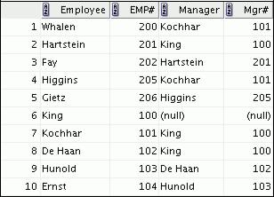

**…**



1. Create a report for the HR department that displays employee last names, department numbers, and all the employees who work in the same department as a given employee. Give each column an appropriate label. Save the script to a file named lab_05_06.sql.

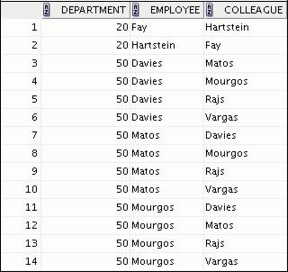

**…**



|  |
| --- |
| Oracle Internal & Oracle Academy Use Only |

**Oracle Database 10*g*: SQL Fundamentals I 5 - 33**

**Practice 5 (continued)**

1. The HR department needs a report on job grades and salaries. To familiarize yourself with the JOB_GRADES table, first show the structure of the JOB_GRADES table. Then create a query that displays the name, job, department name, salary, and grade for all employees.

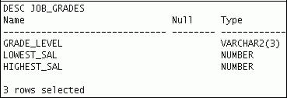

|  |
| --- |
| Oracle Internal & Oracle Academy Use Only |

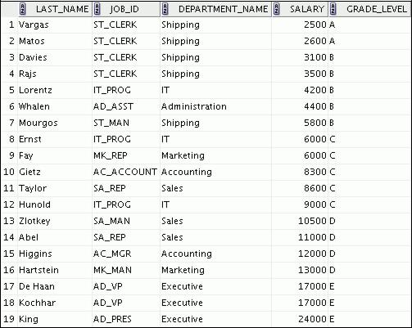

**Oracle Database 10*g*: SQL Fundamentals I 5 - 34**

**Practice 5 (continued)**

If you want an extra challenge, complete the following exercises:

1. The HR department wants to determine the names of all employees who were hired after Davies. Create a query to display the name and hire date of any employee hired after employee Davies.

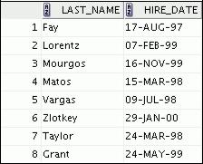

1. The HR department needs to find the names and hire dates for all employees who were hired before their managers, along with their managers’ names and hire dates. Save the script to a file named lab5_09.sql.

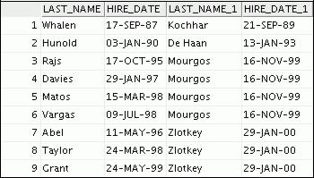

|  |
| --- |
| Oracle Internal & Oracle Academy Use Only |

**Oracle Database 10*g*: SQL Fundamentals I 5 - 35**

Oracle Internal & Oracle Academy Use Only



**Using Subqueries to Solve Queries**

Copyright © 2009, Oracle. All rights reserved.

|  |
| --- |
| Oracle Internal & Oracle Academy Use Only |

**Objectives**

After completing this lesson, you should be able to do the following:

* Define subqueries
* Describe the types of problems that subqueries can solve
* List the types of subqueries
* Write single-row and multiple-row subqueries

Copyright © 2009, Oracle. All rights reserved.

**Objectives**

In this lesson, you learn about more advanced features of the SELECT statement. You can write subqueries in the WHERE clause of another SQL statement to obtain values based on an unknown conditional value. This lesson covers single-row subqueries and multiple-row subqueries.

|  |
| --- |
| Oracle Internal & Oracle Academy Use Only |

**Oracle Database 10*g*: SQL Fundamentals I 6 - 2**

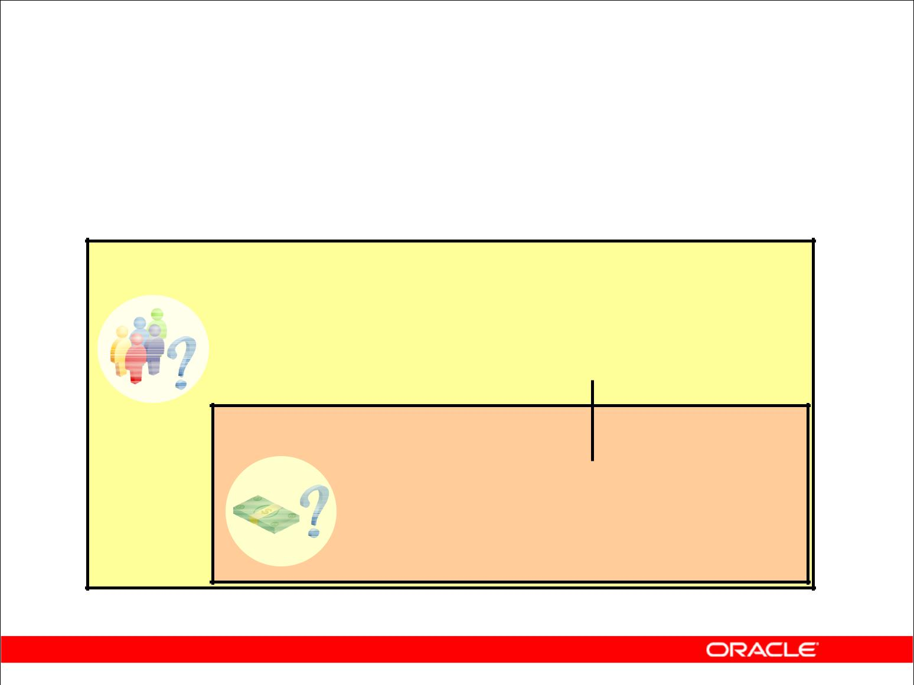**Using a Subquery**

**to Solve a Problem**

Who has a salary greater than Abel’s?

**Main query:**

**Which employees have salaries greater than Abel’s salary?** 

**Subquery:**

**What is Abel’s salary?**

Copyright © 2009, Oracle. All rights reserved.

**Using a Subquery to Solve a Problem**

Suppose you want to write a query to find out who earns a salary greater than Abel’s salary.

To solve this problem, you need *two* queries: one to find how much Abel earns, and a second query to find who earns more than that amount.

You can solve this problem by combining the two queries, placing one query *inside* the other query.

The inner query (or *subquery*) returns a value that is used by the outer query (or *main query*). Using a subquery is equivalent to performing two sequential queries and using the result of the first query as the search value in the second query.

|  |
| --- |
| Oracle Internal & Oracle Academy Use Only |

**Oracle Database 10*g*: SQL Fundamentals I 6 - 3**

**Subquery Syntax**

|  |  |  |  |  |
| --- | --- | --- | --- | --- |
| **SELECT** | ***select_list*** | |  |  |
| **FROM** | ***table*** | |  |  |
| **WHERE** | ***expr operator*** | |  |  |
|  |  | **(SELECT** | ***select_list*** |  |
|  |  | **FROM** | ***table*);** |  |
|  |  |  |  |  |

* The subquery (inner query) executes once before the main query (outer query).
* The result of the subquery is used by the main query.

Copyright © 2009, Oracle. All rights reserved.

**Subquery Syntax**

A subquery is a SELECT statement that is embedded in a clause of another SELECT statement. You can build powerful statements out of simple ones by using subqueries. They can be very useful when you need to select rows from a table with a condition that depends on the data in the table itself.

You can place the subquery in a number of SQL clauses, including the following:

* WHERE clause
* HAVING clause
* FROM clause

In the syntax:

*operator* includes a comparison condition such as >, =, orIN

**Note:** Comparison conditions fall into two classes: single-row operators(>, =, >=, <, <>, <=) and multiple-row operators (IN, ANY, ALL).

The subquery is often referred to as a nested SELECT, sub-SELECT, or inner SELECT statement. The subquery generally executes first, and its output is used to complete the query condition for the main (or outer) query.

|  |
| --- |
| Oracle Internal & Oracle Academy Use Only |

**Oracle Database 10*g*: SQL Fundamentals I 6 - 4**

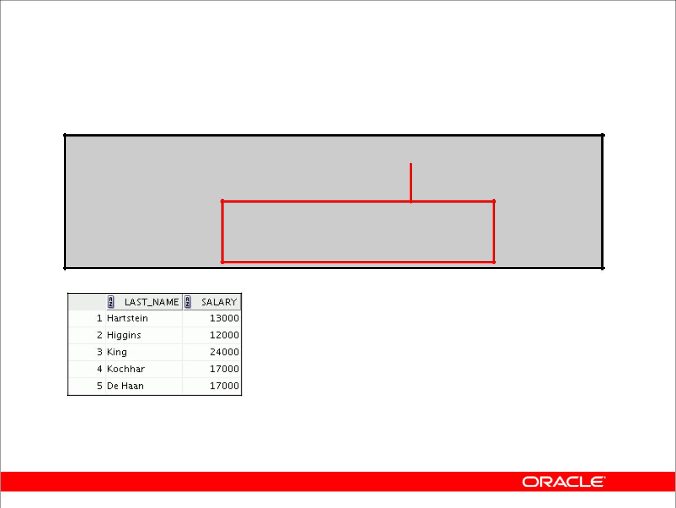**Using a Subquery**

**SELECT last_name, salary**

**FROM employees** **11000**

**WHERE** **salary >**

**(SELECT salary**

**FROM employees**

**WHERE** **last_name = 'Abel');**

Copyright © 2009, Oracle. All rights reserved.

**Using a Subquery**

In the slide, the inner query determines the salary of employee Abel. The outer query takes the result of the inner query and uses this result to display all the employees who earn more than this amount.

|  |
| --- |
| Oracle Internal & Oracle Academy Use Only |

**Oracle Database 10*g*: SQL Fundamentals I 6 - 5**

**Guidelines for Using Subqueries**

* Enclose subqueries in parentheses.
* Place subqueries on the right side of the comparison condition.
* The ORDER BY clause in the subquery is not needed unless you are performing Top-N analysis.
* Use single-row operators with single-row subqueries, and use multiple-row operators with

multiple-row subqueries.

Copyright © 2009, Oracle. All rights reserved.

**Guidelines for Using Subqueries**

* A subquery must be enclosed in parentheses.
* Place the subquery on the right side of the comparison condition for readability.
* With Oracle8*i* and later releases, an ORDER BY clause can be used and is required in the subquery to perform Top-N analysis.
  + Before Oracle8*i*, however, subqueries could not contain an ORDER BY clause. Only one ORDER BY clause could be used for a SELECT statement; if specified, it had to be the last clause in the main SELECT statement.
* Two classes of comparison conditions are used in subqueries: single-row operators and multiple-row operators.

|  |
| --- |
| Oracle Internal & Oracle Academy Use Only |

**Oracle Database 10*g*: SQL Fundamentals I 6 - 6**

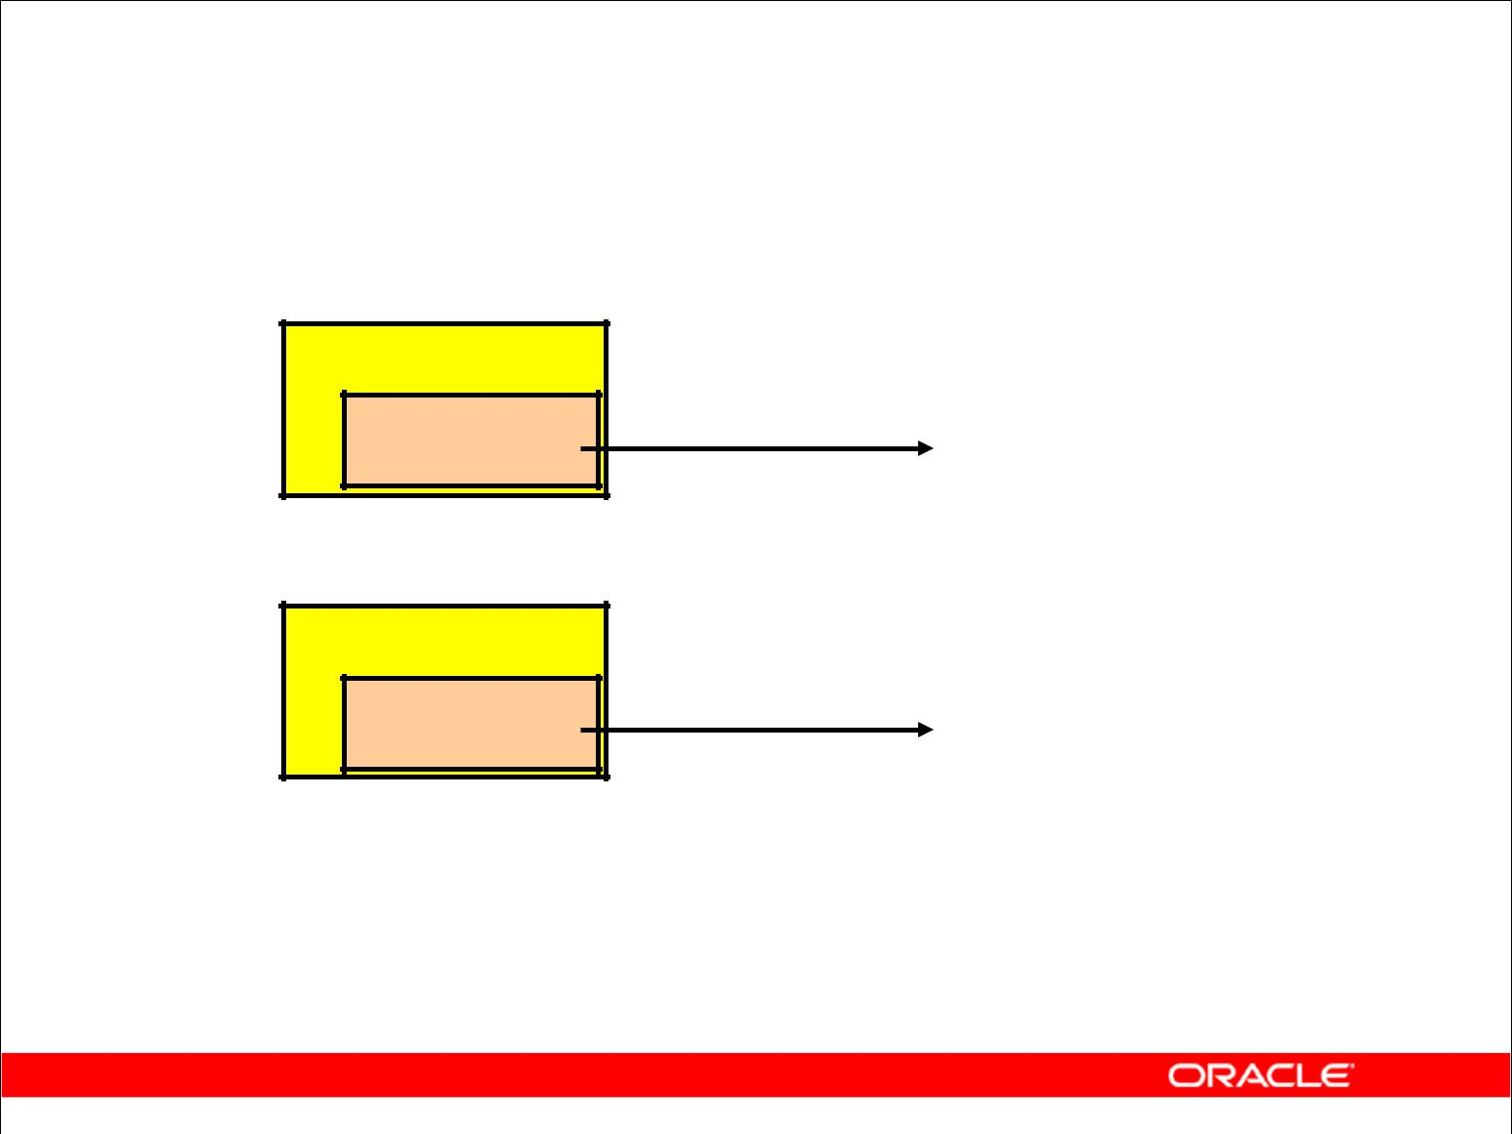**Types of Subqueries**

* Single-row subquery

**Main query**

**returns**

**Subquery** **ST_CLERK**

* Multiple-row subquery

**Main query**

**Subquery** **returns** **ST_CLERK**

**SA_MAN**

Copyright © 2009, Oracle. All rights reserved.

**Types of Subqueries**

* **Single-row subqueries:** Queries that return only one row from the innerSELECTstatement
* **Multiple-row subqueries:** Queries that return more than one row from the innerSELECTstatement

**Note:** There are also multiple-column subqueries, which are queries that return more than one

column from the inner SELECT statement. These are covered in the *Oracle Database 10g: SQL*

*Fundamentals II* course.

|  |
| --- |
| Oracle Internal & Oracle Academy Use Only |

**Oracle Database 10*g*: SQL Fundamentals I 6 - 7**

**Single-Row Subqueries**

* Return only one row
* Use single-row comparison operators

|  |  |
| --- | --- |
| **Operator** | **Meaning** |
|  |  |
| **=** | Equal to |
| **>** | Greater than |
| **>=** | Greater than or equal to |
| **<** | Less than |
| **<=** | Less than or equal to |
| **<>** | Not equal to |
|  |  |

Copyright © 2009, Oracle. All rights reserved.

**Single-Row Subqueries**

A single-row subquery is one that returns one row from the inner SELECT statement. This type of subquery uses a single-row operator. The slide gives a list of single-row operators.

**Example**

Display the employees whose job ID is the same as that of employee 141:

SELECT last_name, job_id

FROM employees

WHERE job_id =

(SELECT job_id

FROM employees

WHERE employee_id = 141);

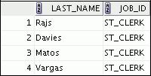

|  |
| --- |
| Oracle Internal & Oracle Academy Use Only |

**Oracle Database 10*g*: SQL Fundamentals I 6 - 8**

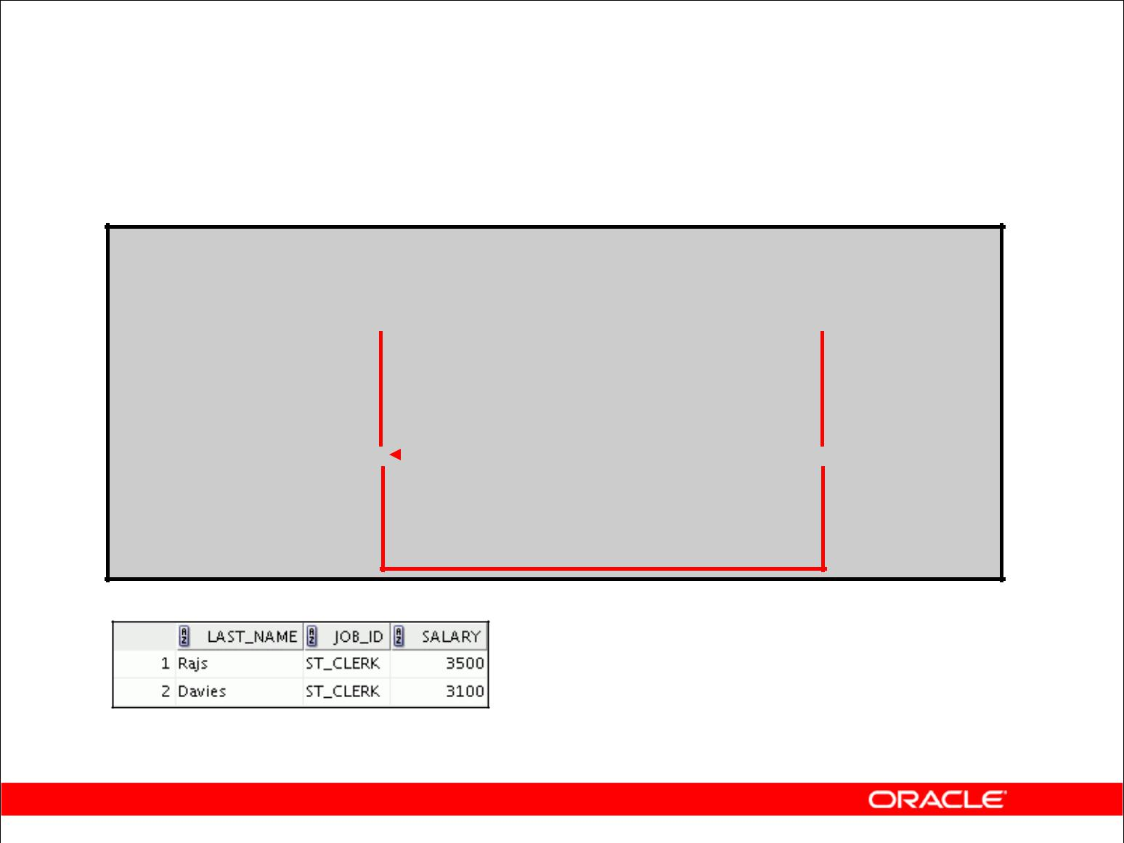**Executing Single-Row Subqueries**

|  |  |  |  |  |  |
| --- | --- | --- | --- | --- | --- |
| **SELECT** | **last_name, job_id, salary** | | | |  |
| **FROM** | **employees** | |  | **ST_CLERK** |  |
| **WHERE** | **job_id =** |  |  |  |
|  |  |

**(SELECT job_id**

**FROM employees**

**WHERE** **employee_id = 141)**

|  |  |  |  |  |  |  |  |
| --- | --- | --- | --- | --- | --- | --- | --- |
| **AND** | **salary >** |  | |  | **2600** |  |  |
|  |  |  |  |  |

**(SELECT salary**

**FROM employees**

**WHERE** **employee_id = 143);**

Copyright © 2009, Oracle. All rights reserved.

**Executing Single-Row Subqueries**

A SELECT statement can be considered as a query block. The example in the slide displays employees whose job ID is the same as that of employee 141 and whose salary is greater than that of employee 143.

The example consists of three query blocks: the outer query and two inner queries. The inner query blocks are executed first, producing the query results ST_CLERK and 2600, respectively. The outer query block is then processed and uses the values that were returned by the inner queries to complete its search conditions.

Both inner queries return single values (ST_CLERK and 2600, respectively), so this SQL statement is called a single-row subquery.

**Note:** The outer and inner queries can get data from different tables.

|  |
| --- |
| Oracle Internal & Oracle Academy Use Only |

**Oracle Database 10*g*: SQL Fundamentals I 6 - 9**

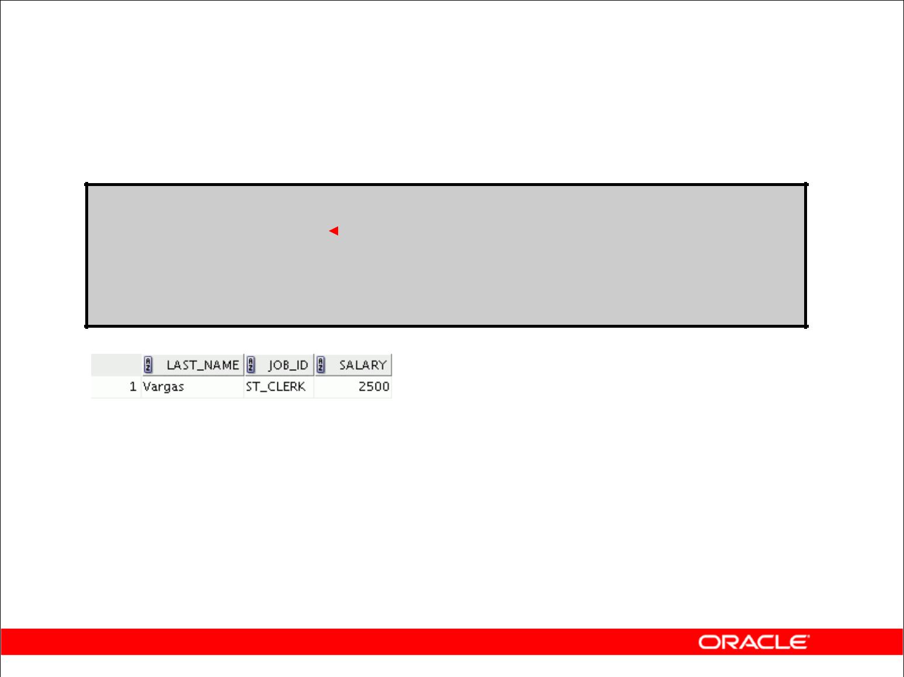**Using Group Functions in a Subquery**

**SELECT last_name, job_id, salary**

|  |  |  |  |  |  |  |
| --- | --- | --- | --- | --- | --- | --- |
| **FROM** | **employees** | |  |  | **2500** |  |
|  |  |  |
| **WHERE** | **salary =** |  |  |  |  |  |
| **(SELECT MIN(salary)** | | | |  |
|  |  |  |
|  |  | **FROM** | | **employees);** | |  |
|  |  |  |  |  |  |  |
|  |  |  |  |  |  |  |

Copyright © 2009, Oracle. All rights reserved.

**Using Group Functions in a Subquery**

You can display data from a main query by using a group function in a subquery to return a single row. The subquery is in parentheses and is placed after the comparison condition.

The example in the slide displays the employee last name, job ID, and salary of all employees whose salary is equal to the minimum salary. The MIN group function returns a single value (2500) to the outer query.

|  |
| --- |
| Oracle Internal & Oracle Academy Use Only |

**Oracle Database 10*g*: SQL Fundamentals I 6 - 10**

**The HAVING Clause with Subqueries**

* The Oracle server executes subqueries first.
* The Oracle server returns results into the HAVING clause of the main query.

|  |  |  |  |  |  |  |  |  |  |  |
| --- | --- | --- | --- | --- | --- | --- | --- | --- | --- | --- |
|  | **SELECT** | **department_id, MIN(salary)** | | | | | | | |  |
|  | **FROM** | **employees** | | | |  |  |  |  |  |
|  | **GROUP BY department_id** | | | | | **2500** |  |  |  |  |
|  | **HAVING** | **MIN(salary)** | **>** | |  |  |  |  |  |
|  |  |  |  |  |  |  |
|  |  |  |  | **(SELECT MIN(salary)** | | | |  |  |  |
|  |  |  |  | **FROM** | | **employees** | |  |  |  |
|  |  |  |  | **WHERE** | | **department_id = 50);** | | | |  |

Copyright © 2009, Oracle. All rights reserved.

**The HAVING Clause with Subqueries**

You can use subqueries not only in the WHERE clause but also in the HAVING clause. The Oracle server executes the subquery, and the results are returned into the HAVING clause of the main query. The SQL statement in the slide displays all the departments that have a minimum salary greater than that of department 50.

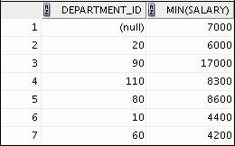

**Example :** Find the job with the lowest average salary.

SELECT job_id, AVG(salary)

FROM employees

GROUP BY job_id

HAVING AVG(salary) = (SELECT MIN(AVG(salary))

FROM employees

GROUP BY job_id);

**Oracle Database 10*g*: SQL Fundamentals I 6 - 11**

|  |
| --- |
| Oracle Internal & Oracle Academy Use Only |

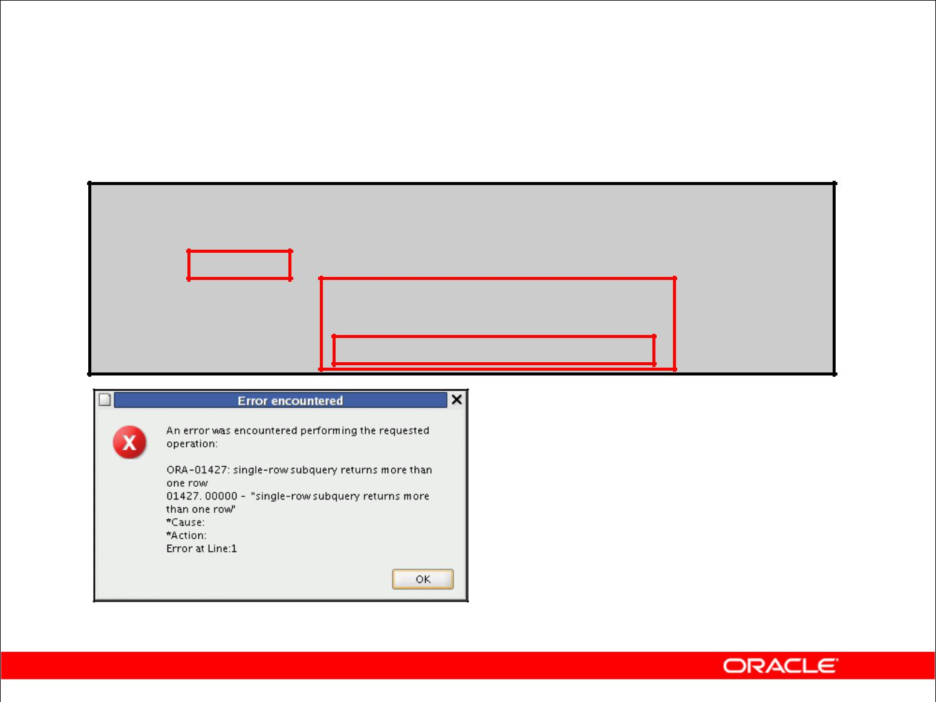**What Is Wrong with This Statement?**

**SELECT employee_id, last_name**

**FROM employees**

**WHERE** **salary =**

**(SELECT MIN(salary)**

**FROM** **employees**

**GROUP BY department_id);**

**Single-row operator with multiple-row subquery**

Copyright © 2009, Oracle. All rights reserved.

**Errors with Subqueries**

One common error with subqueries occurs when more than one row is returned for a single-row subquery.

In the SQL statement in the slide, the subquery contains a GROUP BY clause, which implies that the subquery will return multiple rows, one for each group that it finds. In this case, the result of the subquery are 4400, 6000, 2500, 4200, 7000, 17000, and 8300.

The outer query takes those results and uses them in its WHERE clause. The WHERE clause contains an equal (=) operator, a single-row comparison operator that expects only one value. The = operator cannot accept more than one value from the subquery and, therefore, generates the error.

To correct this error, change the = operator to IN.

|  |
| --- |
| Oracle Internal & Oracle Academy Use Only |

**Oracle Database 10*g*: SQL Fundamentals I 6 - 12**

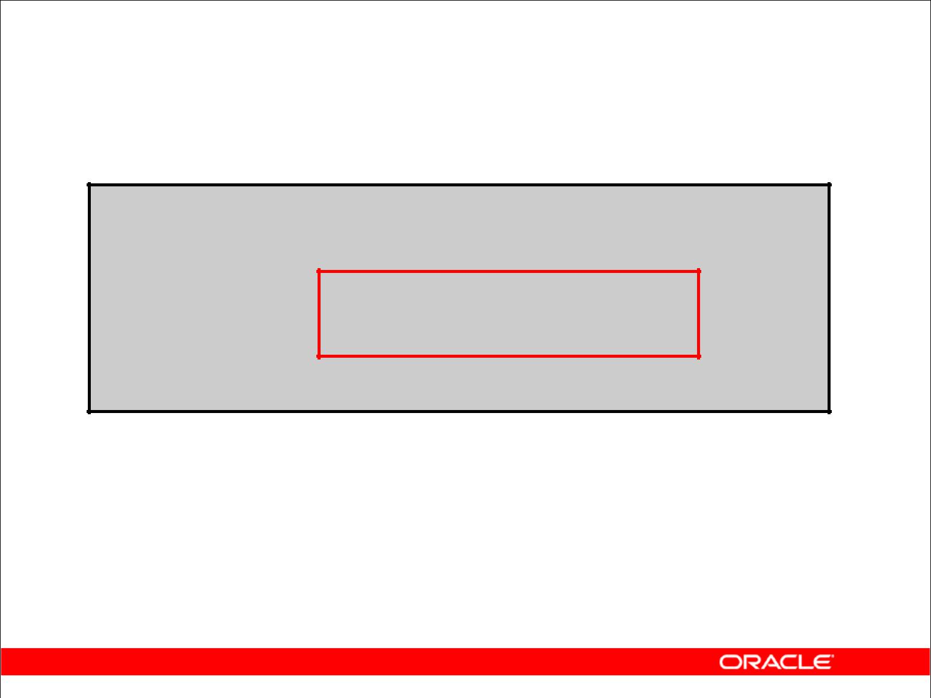**Will This Statement Return Rows?**

**SELECT last_name, job_id**

**FROM employees**

**WHERE** **job_id =**

**(SELECT job_id**

**FROM employees**

**WHERE** **last_name = 'Haas');**

**0 rows selected**

**Subquery returns no values.**

Copyright © 2009, Oracle. All rights reserved.

**Problems with Subqueries**

A common problem with subqueries occurs when no rows are returned by the inner query. In the SQL statement in the slide, the subquery contains a WHERE clause. Presumably, the intention is to find the employee whose name is Haas. The statement is correct but selects no rows when executed.

There is no employee named Haas. So the subquery returns no rows. The outer query takes the results of the subquery (null) and uses these results in its WHERE clause. The outer query finds no employee with a job ID equal to null, and so returns no rows. If a job existed with a value of null, the row is not returned because comparison of two null values yields a null; therefore, the WHERE condition is not true.

|  |
| --- |
| Oracle Internal & Oracle Academy Use Only |

**Oracle Database 10*g*: SQL Fundamentals I 6 - 13**

**Multiple-Row Subqueries**

* Return more than one row
* Use multiple-row comparison operators

|  |  |
| --- | --- |
| **Operator** | **Meaning** |
|  |  |
| IN | Equal to any member in the list |
| ANY | Compare value to each value returned by the |
|  | subquery |
| ALL | Compare value to every value returned by the |
|  | subquery |
|  |  |

Copyright © 2009, Oracle. All rights reserved.

**Multiple-Row Subqueries**

Subqueries that return more than one row are called multiple-row subqueries. You use a multiple-row operator, instead of a single-row operator, with a multiple-row subquery. The multiple-row operator expects one or more values:

SELECT last_name, salary, department_id

FROM employees

WHERE salary IN (SELECT MIN(salary)

FROM employees

GROUP BY department_id);

**Example**

Find the employees who earn the same salary as the minimum salary for each department.

The inner query is executed first, producing a query result. The main query block is then processed and uses the values that were returned by the inner query to complete its search condition. In fact, the main query appears to the Oracle server as follows:

SELECT last_name, salary, department_id FROM employees

WHERE salary IN (2500, 4200, 4400, 6000, 7000, 8300, 8600, 17000);

**Oracle Database 10*g*: SQL Fundamentals I 6 - 14**

|  |
| --- |
| Oracle Internal & Oracle Academy Use Only |

**Using the ANY Operator**

**in Multiple-Row Subqueries**

**SELECT employee_id, last_name, job_id, salary**

**FROM employees**

**9000, 6000, 4200**

**WHERE salary < ANY (SELECT salary**

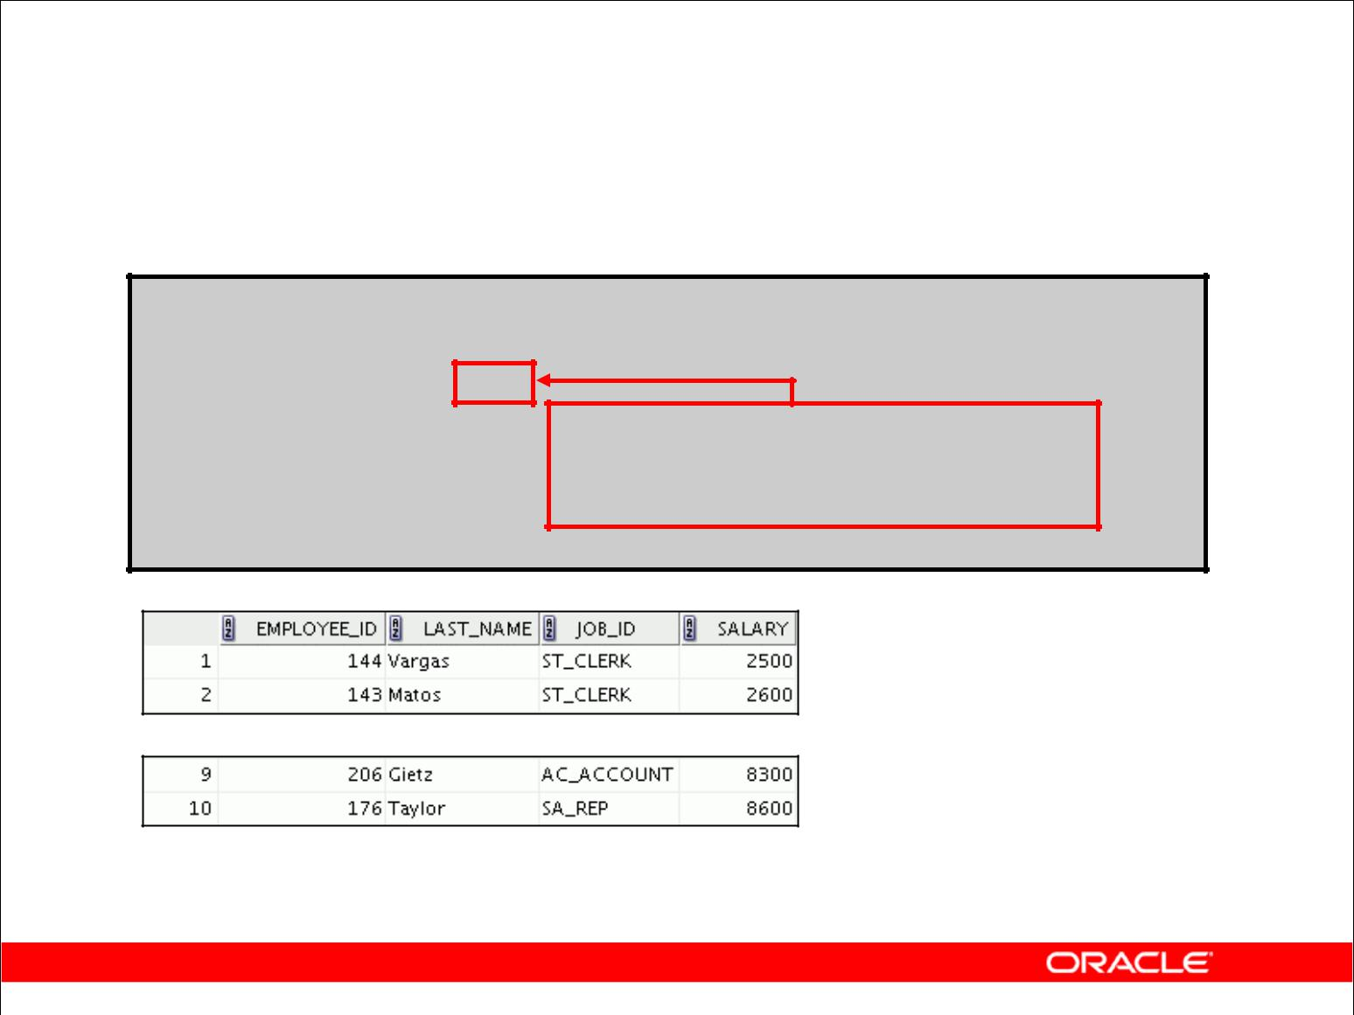

**FROM employees**

**WHERE** **job_id = 'IT_PROG')**

**AND** **job_id <> 'IT_PROG';**

**…**

Copyright © 2009, Oracle. All rights reserved.

**Multiple-Row Subqueries (continued)**

The ANY operator (and its synonym, the SOME operator) compares a value to *each* value returned by a subquery. The slide example displays employees who are not IT programmers and whose salary is less than that of any IT programmer. The maximum salary that a programmer earns is $9,000.

<ANY means less than the maximum. >ANY means more than the minimum. =ANY is equivalent to IN.

**Oracle Database 10*g*: SQL Fundamentals I 6 - 15**

|  |
| --- |
| Oracle Internal & Oracle Academy Use Only |

**Using the ALL Operator**

**in Multiple-Row Subqueries**

**SELECT employee_id, last_name, job_id, salary**

**FROM employees**

**9000, 6000, 4200**

**WHERE salary < ALL (SELECT salary**

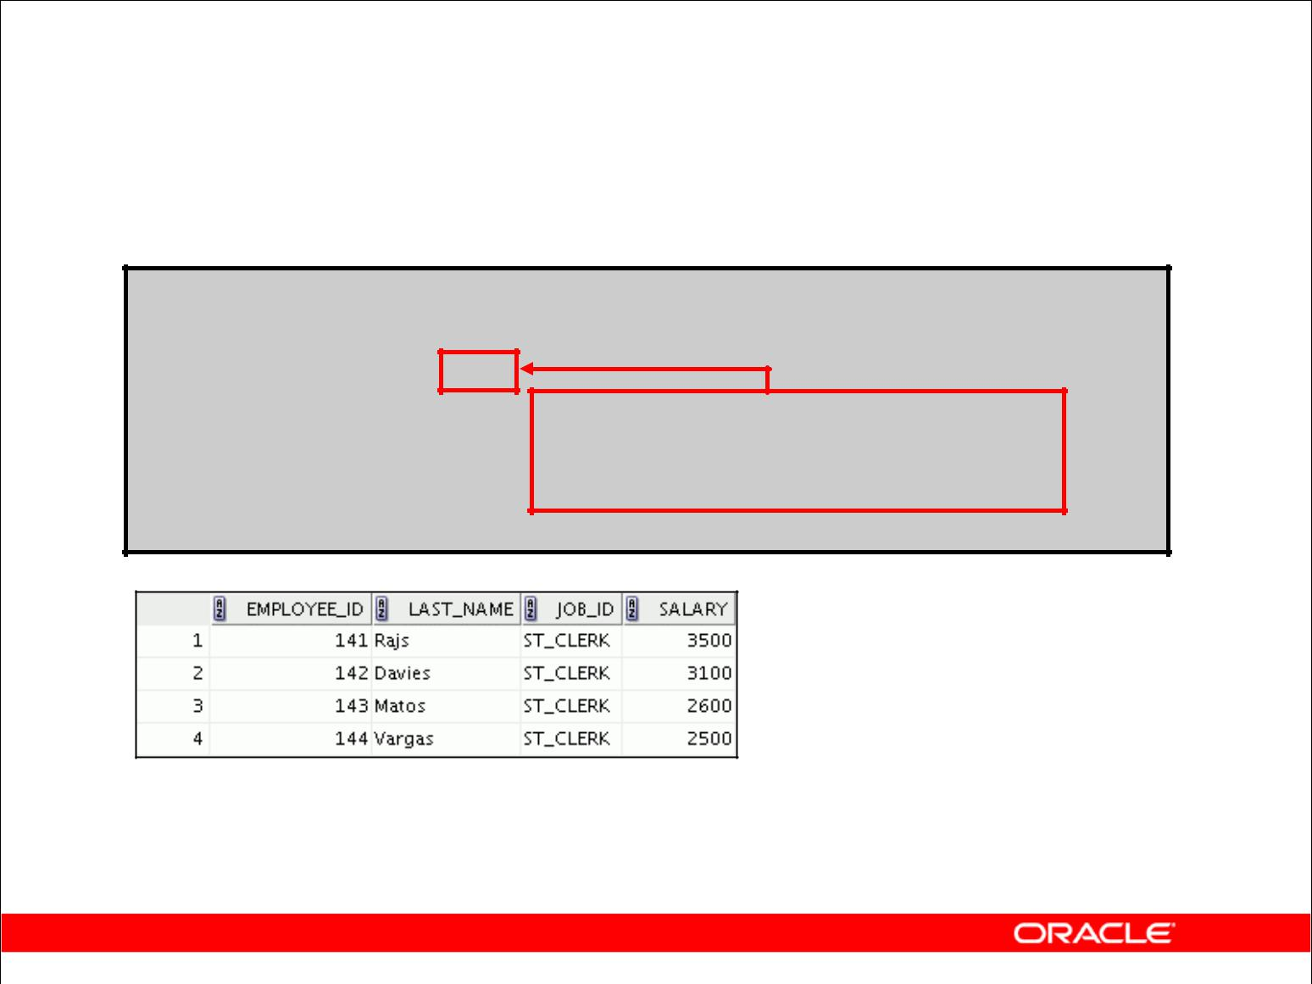

**FROM employees**

**WHERE** **job_id = 'IT_PROG')**

**AND** **job_id <> 'IT_PROG';**

Copyright © 2009, Oracle. All rights reserved.

**Multiple-Row Subqueries (continued)**

The ALL operator compares a value to *every* value returned by a subquery. The slide example displays employees whose salary is less than the salary of all employees with a job ID of IT_PROG and whose job is not IT_PROG.

>ALL means more than the maximum, and <ALL means less than the minimum.

The NOT operator can be used with IN, ANY, and ALL operators.

**Oracle Database 10*g*: SQL Fundamentals I 6 - 16**

|  |
| --- |
| Oracle Internal & Oracle Academy Use Only |

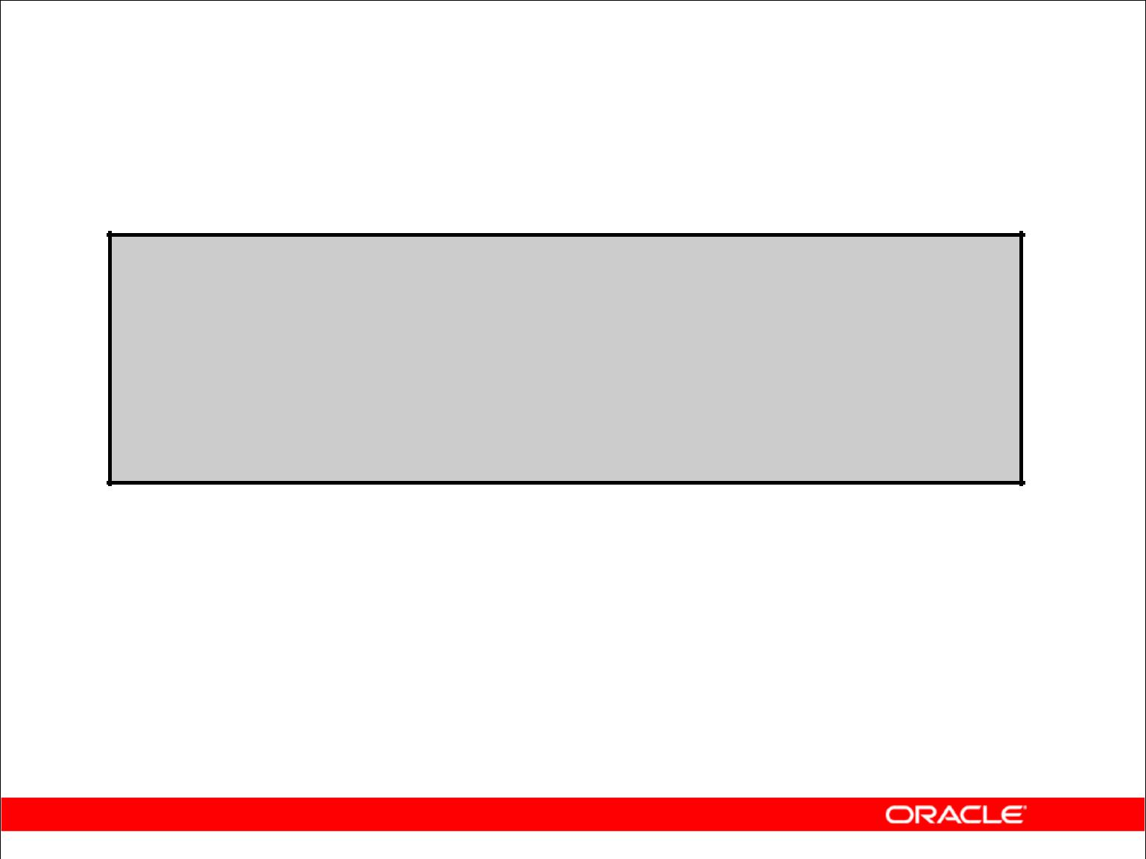**Null Values in a Subquery**

**SELECT emp.last_name**

**FROM employees emp**

**WHERE** **emp.employee_id NOT IN**

**(SELECT mgr.manager_id**

**FROM employees mgr);**

**0 rows selected**

Copyright © 2009, Oracle. All rights reserved.

**Returning Nulls in the Resulting Set of a Subquery**

The SQL statement in the slide attempts to display all the employees who do not have any subordinates. Logically, this SQL statement should have returned 12 rows. However, the SQL statement does not return any rows. One of the values returned by the inner query is a null value, and, therefore, the entire query returns no rows.

The reason is that all conditions that compare a null value result in a null. So whenever null values are likely to be part of the results set of a subquery, do not use the NOT IN operator. The NOT IN operator is equivalent to <> ALL.

Notice that the null value as part of the results set of a subquery is not a problem if you use the IN operator. The IN operator is equivalent to =ANY. For example, to display the employees who have subordinates, use the following SQL statement:

SELECT emp.last_name

FROM employees emp

WHERE emp.employee_id IN

(SELECT mgr.manager_id

FROM employees mgr);

|  |
| --- |
| Oracle Internal & Oracle Academy Use Only |

**Oracle Database 10*g*: SQL Fundamentals I 6 - 17**

**Returning Nulls in the Resulting Set of a Subquery (continued)**

Alternatively, a WHERE clause can be included in the subquery to display all employees who do not have any subordinates:

SELECT last_name FROM employees

WHERE employee_id NOT IN

(SELECT manager_id

FROM employees

WHERE manager_id IS NOT NULL);

|  |
| --- |
| Oracle Internal & Oracle Academy Use Only |

**Oracle Database 10*g*: SQL Fundamentals I 6 - 18**

**Summary**

In this lesson, you should have learned how to:

* Identify when a subquery can help solve a question
* Write subqueries when a query is based on unknown values

|  |  |  |  |  |
| --- | --- | --- | --- | --- |
| **SELECT** | ***select_list*** | |  |  |
| **FROM** | ***table*** | |  |  |
| **WHERE** | ***expr operator*** | |  |  |
|  |  | **(SELECT *select_list*** | |  |
|  |  | **FROM** | ***table*);** |  |
|  |  |  |  |  |

Copyright © 2009, Oracle. All rights reserved.

**Summary**

In this lesson, you should have learned how to use subqueries. A subquery is a SELECT statement that is embedded in a clause of another SQL statement. Subqueries are useful when a query is based on a search criterion with unknown intermediate values.

Subqueries have the following characteristics:

* Can pass one row of data to a main statement that contains a single-row operator, such as =, <>, >, >=, <, or <=
* Can pass multiple rows of data to a main statement that contains a multiple-row operator, such as IN
* Are processed first by the Oracle server, after which the WHERE or HAVING clause uses the results
* Can contain group functions

|  |
| --- |
| Oracle Internal & Oracle Academy Use Only |

**Oracle Database 10*g*: SQL Fundamentals I 6 - 19**

**Practice 6: Overview**

This practice covers the following topics:

* Creating subqueries to query values based on unknown criteria
* Using subqueries to find out which values exist in one set of data and not in another

Copyright © 2009, Oracle. All rights reserved.

**Practice 6: Overview**

In this practice, you write complex queries using nested SELECT statements.

**Paper-Based Questions**

You may want to create the inner query first for these questions. Make sure that it runs and produces the data that you anticipate before you code the outer query.

|  |
| --- |
| Oracle Internal & Oracle Academy Use Only |

**Oracle Database 10*g*: SQL Fundamentals I 6 - 20**

**Practice 6**

1. The HR department needs a query that prompts users for an employee last name. The query then displays the last name and hire date of any employee in the same department as the employee whose name they supply (excluding that employee). For example, if the user enters Zlotkey, find all employees who work with Zlotkey (excluding Zlotkey).
2. Create a report that displays the employee number, last name, and salary of all employees who earn more than the average salary. Sort the results in ascending order by salary.

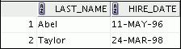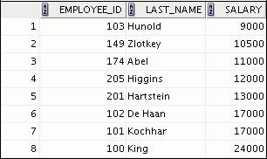

1. Write a query that displays the employee number and last name of all employees who work in a department with any employee whose last name contains a *u*. Place your SQL statement in a text file named lab_06_03.sql. Run your query.

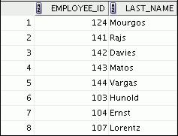

|  |
| --- |
| Oracle Internal & Oracle Academy Use Only |

**Oracle Database 10*g*: SQL Fundamentals I 6 - 21**

**Practice 6 (continued)**

1. The HR department needs a report that displays the last name, department number, and job ID of all employees whose department location ID is 1700.

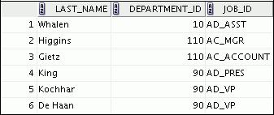

Modify the query so that users are prompted for a location ID. Save this to a file named lab_06_04.sql.

1. Create a report for the HR department that displays the last name and salary of every employee who reports to King.

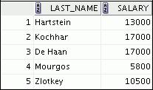

1. Create a report for the HR department that displays the department number, last name, and job ID for every employee in the Executive department.

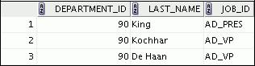

If you have time, complete the following exercise:

1. Modify the query in lab_06_03.sql to display the employee number, last name, and salary of all the employees who earn more than the average salary and who work in a department with any employee whose last name contains a *u*. Resave lab_06_03.sql as lab_06_07.sql. Run the statement in lab_06_07.sql.

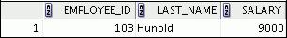

|  |
| --- |
| Oracle Internal & Oracle Academy Use Only |

**Oracle Database 10*g*: SQL Fundamentals I 6 - 22**



**Using the Set Operators**

Copyright © 2009, Oracle. All rights reserved.

|  |
| --- |
| Oracle Internal & Oracle Academy Use Only |

**Objectives**

After completing this lesson, you should be able to do the following:

* Describe set operators
* Use a set operator to combine multiple queries into a single query
* Control the order of rows returned

Copyright © 2009, Oracle. All rights reserved.

**Objectives**

In this lesson, you learn how to write queries by using set operators.

|  |
| --- |
| Oracle Internal & Oracle Academy Use Only |

**Oracle Database 10*g*: SQL Fundamentals I 7 - 2**

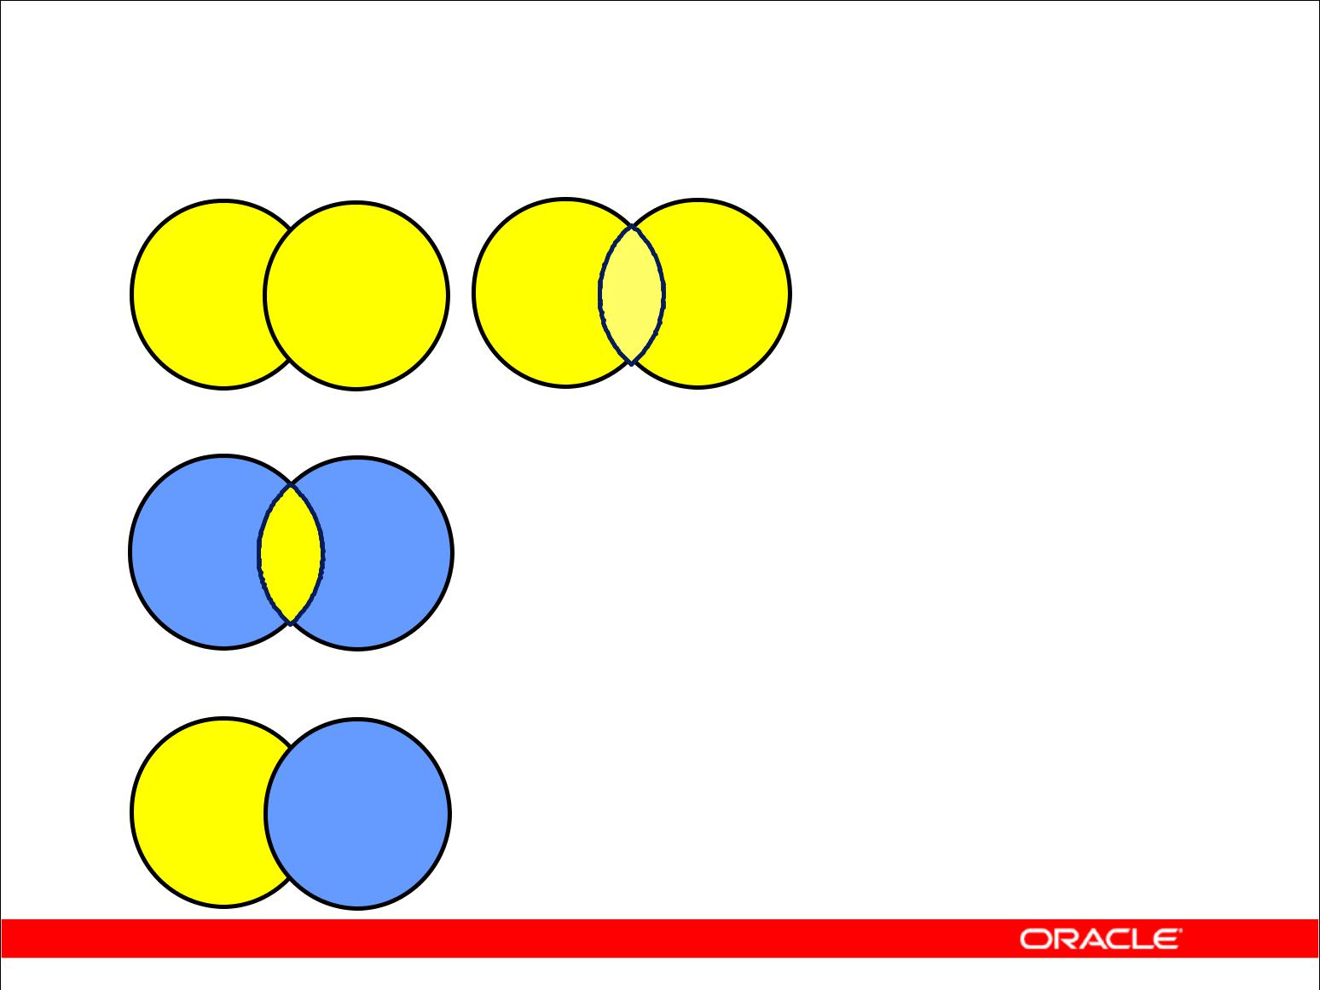**Set Operators**

**A** **B** **A** **B**

**UNION/UNION ALL**

**A** **B**

**INTERSECT**

**A** **B**

**MINUS**

Copyright © 2009, Oracle. All rights reserved.

**Set Operators**

Set operators combine the results of two or more component queries into one result. Queries containing set operators are called *compound queries*.

|  |  |  |
| --- | --- | --- |
| **Operator** | **Returns** |  |
|  |
|  |  |  |
| UNION | All distinct rows selected by either query |  |
|  |  |  |
| UNION ALL | All rows selected by either query, including all duplicates |  |
|  |  |  |
| INTERSECT | All distinct rows selected by both queries |  |
|  |  |  |
| MINUS | All distinct rows that are selected by the first SELECT |  |
|  | statement and not selected in the second SELECT statement |  |
|  |  |  |

All set operators have equal precedence. If a SQL statement contains multiple set operators, the Oracle server evaluates them from left (top) to right (bottom) if no parentheses explicitly specify another order. You should use parentheses to specify the order of evaluation explicitly in queries that use the INTERSECT operator with other set operators.

|  |
| --- |
| Oracle Internal & Oracle Academy Use Only |

**Oracle Database 10*g*: SQL Fundamentals I 7 - 3**

**Tables Used in This Lesson**

The tables used in this lesson are:

* EMPLOYEES: Provides details regarding all current employees
* JOB_HISTORY: Records the details of the start date and end date of the former job, and the job identification number and department when an employee switches jobs

Copyright © 2009, Oracle. All rights reserved.

**Tables Used in This Lesson**

Two tables are used in this lesson. They are the EMPLOYEES table and the JOB_HISTORY table.

The EMPLOYEES table stores the employee details. For the human resource records, this table stores a unique identification number and e-mail address for each employee. The details of the employee’s job identification number, salary, and manager are also stored. Some of the employees earn a commission in addition to their salary; this information is tracked, too. The company organizes the roles of employees into jobs. Some of the employees have been with the company for a long time and have switched to different jobs. This is monitored using the JOB_HISTORY table. When an employee switches jobs, the details of the start date and end date of the former job, the job identification number, and the department are recorded in the JOB_HISTORY table.

The structure and data from the EMPLOYEES and JOB_HISTORY tables are shown on the following pages.

|  |
| --- |
| Oracle Internal & Oracle Academy Use Only |

**Oracle Database 10*g*: SQL Fundamentals I 7 - 4**

**Tables Used in This Lesson (continued)**

There have been instances in the company of people who have held the same position more than once during their tenure with the company. For example, consider the employee Taylor, who joined the company on 24-MAR-1998. Taylor held the job title SA_REP for the period 24-MAR-98 to 31-DEC-98 and the job title SA_MAN for the period 01-JAN-99 to 31-DEC-99. Taylor moved back into the job title of SA_REP, which is his current job title.

Similarly, consider the employee Whalen, who joined the company on 17-SEP-1987. Whalen

held the job title AD_ASST for the period 17-SEP-87 to 17-JUN-93 and the job title

AC_ACCOUNT for the period 01-JUL-94 to 31-DEC-98. Whalen moved back into the job title of

AD_ASST, which is his current job title.

DESCRIBE employees

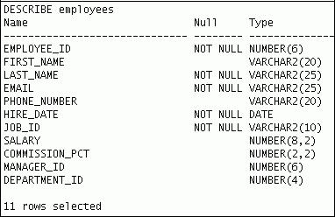

|  |
| --- |
| Oracle Internal & Oracle Academy Use Only |

**Oracle Database 10*g*: SQL Fundamentals I 7 - 5**

**Tables Used in This Lesson (continued)**

SELECT employee_id, last_name, job_id, hire_date, department_id FROM employees;

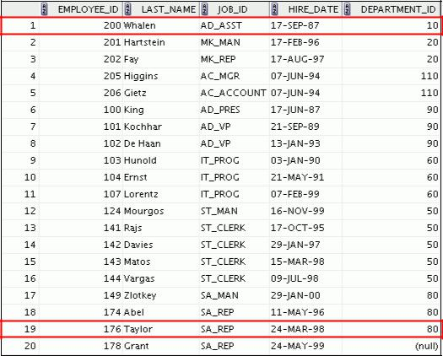

DESCRIBE job_history

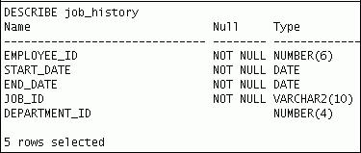

|  |
| --- |
| Oracle Internal & Oracle Academy Use Only |

**Oracle Database 10*g*: SQL Fundamentals I 7 - 6**

**Tables Used in This Lesson (continued)**

SELECT * FROM job_history;

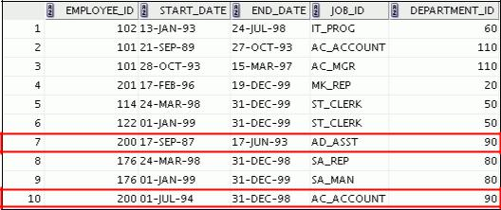

|  |
| --- |
| Oracle Internal & Oracle Academy Use Only |

**Oracle Database 10*g*: SQL Fundamentals I 7 - 7**

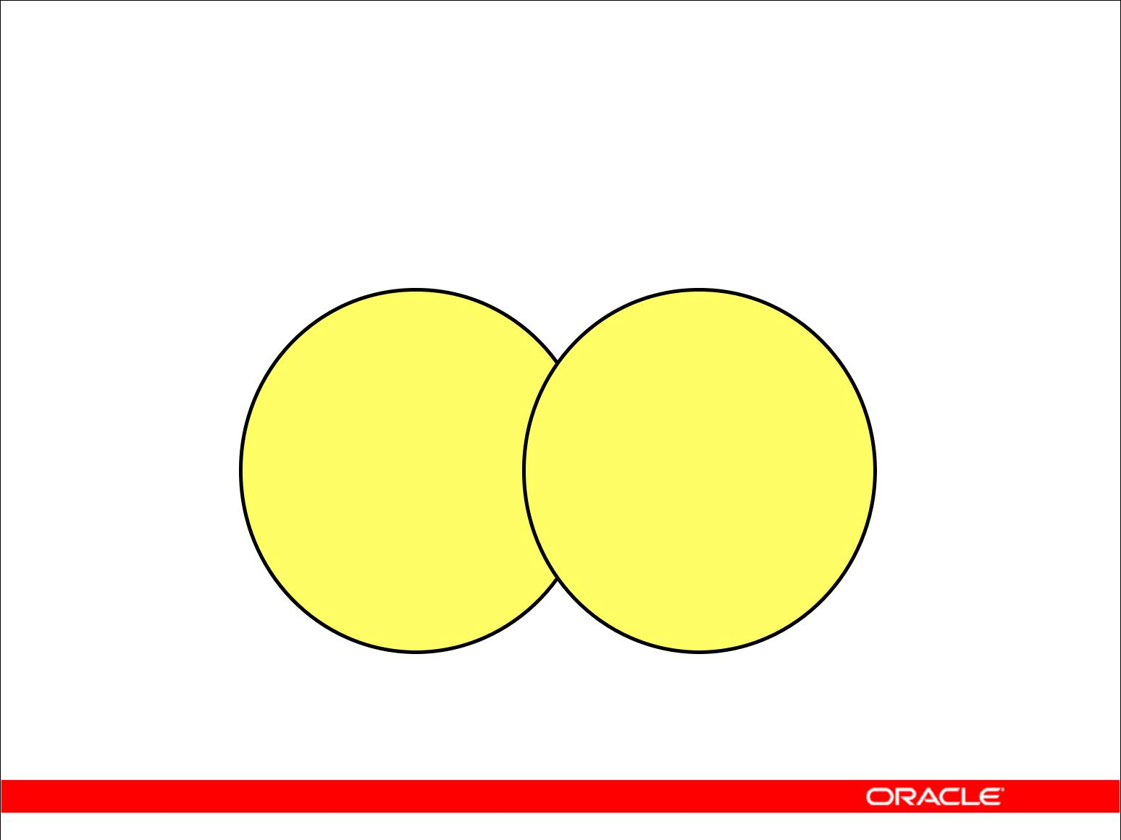**UNION Operator**

**A** **B**

**The UNION operator returns results from both**

**queries after eliminating duplications.**

Copyright © 2009, Oracle. All rights reserved.

**UNION Operator**

The UNION operator returns all rows that are selected by either query. Use the UNION operator to return all rows from multiple tables and eliminate any duplicate rows.

**Guidelines**

* The number of columns and the data types of the columns being selected must be identical in all the SELECT statements used in the query. The names of the columns need not be identical.
* UNION operates over all of the columns being selected.
* NULL values are not ignored during duplicate checking.
* The IN operator has a higher precedence than the UNION operator.
* By default, the output is sorted in ascending order of the first column of the SELECT clause.

|  |
| --- |
| Oracle Internal & Oracle Academy Use Only |

**Oracle Database 10*g*: SQL Fundamentals I 7 - 8**

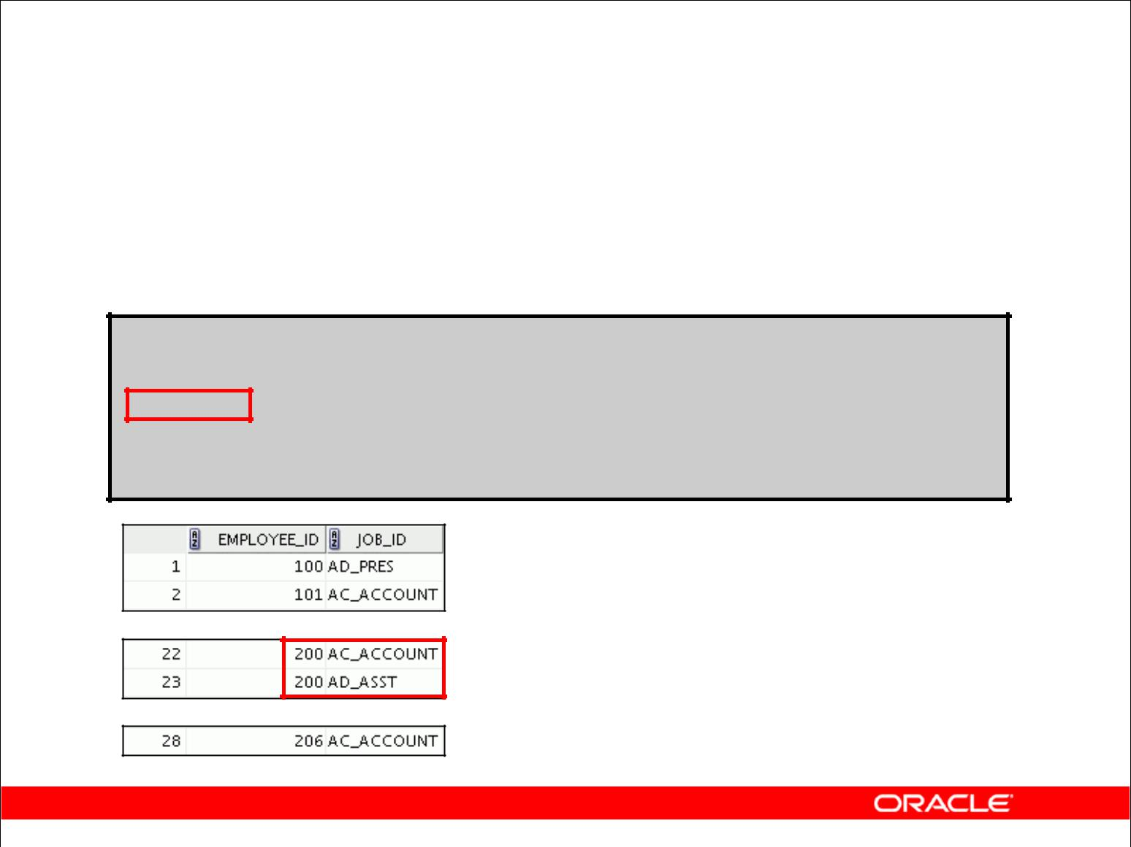**Using the UNION Operator**

Display the current and previous job details of all employees.

Display each combination only once.

**SELECT employee_id, job_id**

**FROM employees**

**UNION**

**SELECT employee_id, job_id**

**FROM job_history;**

**…**

**…**

Copyright © 2009, Oracle. All rights reserved.

**Using the UNION Operator**

The UNION operator eliminates any duplicate records. If records that occur in both the EMPLOYEES and the JOB_HISTORY tables are identical, the records are displayed only once. Observe in the output shown in the slide that the record for the employee with the EMPLOYEE_ID 200 appears twice because the JOB_ID is different in each row.

Consider the following example:

SELECT employee_id, job_id, department_id

FROM employees

UNION

SELECT employee_id, job_id, department_id

FROM job_history;



**…**

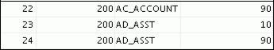

**…**

|  |
| --- |
| Oracle Internal & Oracle Academy Use Only |

**Oracle Database 10*g*: SQL Fundamentals I 7 - 9**

**Using the UNION Operator (continued)**

In the preceding output, employee 200 appears three times. Why? Notice the DEPARTMENT_ID values for employee 200. One row has a DEPARTMENT_ID of 90, another 10, and the third 90. Because of these unique combinations of job IDs and department IDs, each row for employee 200 is unique and therefore not considered to be a duplicate. Observe that the output is sorted in ascending order of the first column of the SELECT clause (in this case, EMPLOYEE_ID).

|  |
| --- |
| Oracle Internal & Oracle Academy Use Only |

**Oracle Database 10*g*: SQL Fundamentals I 7 - 10**

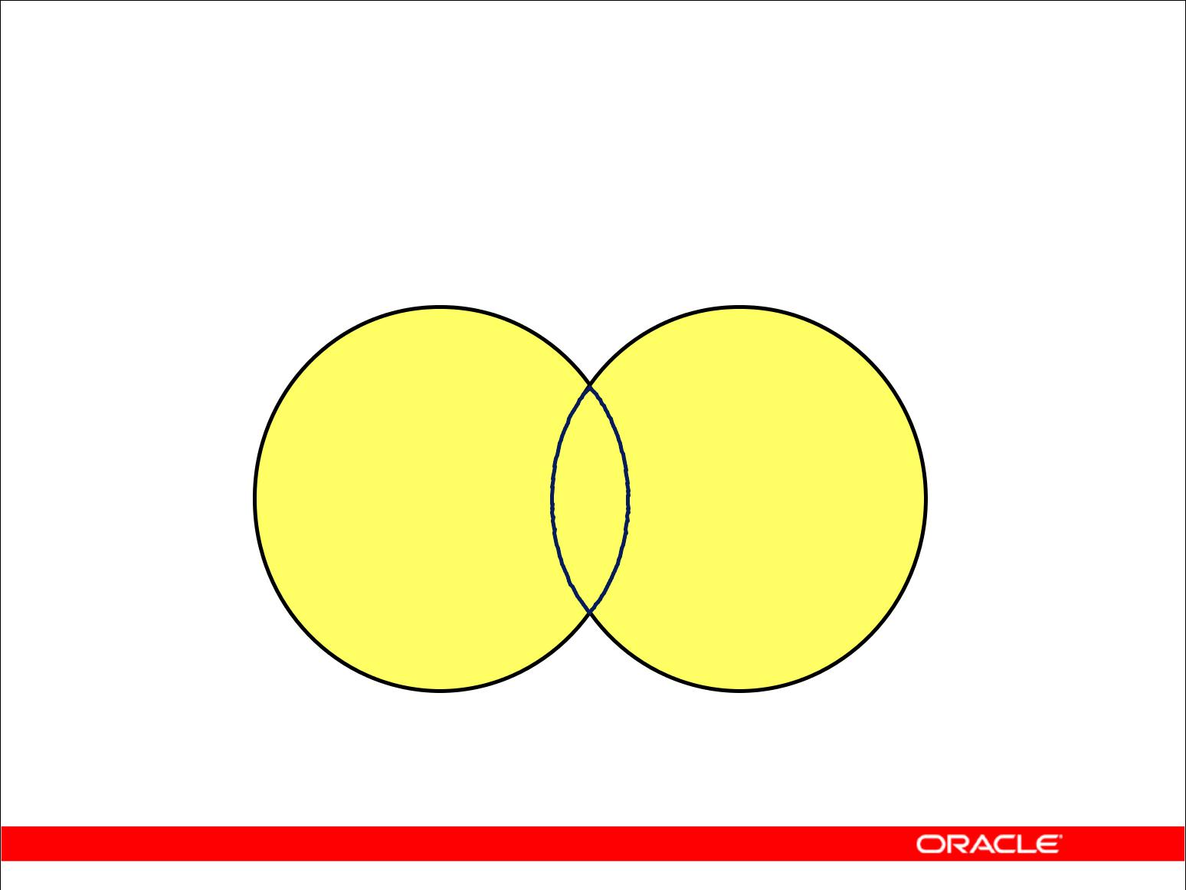**UNION ALL Operator**

**A** **B**

**The UNION ALL operator returns results from both**

**queries, including all duplications.**

Copyright © 2009, Oracle. All rights reserved.

**UNION ALL Operator**

Use the UNION ALL operator to return all rows from multiple queries.

**Guidelines**

The guidelines for UNION and UNION ALL are the same, with the following two exceptions that pertain to UNION ALL:

* Unlike UNION, duplicate rows are not eliminated and the output is not sorted by default.
* The DISTINCT keyword cannot be used.

|  |
| --- |
| Oracle Internal & Oracle Academy Use Only |

**Oracle Database 10*g*: SQL Fundamentals I 7 - 11**

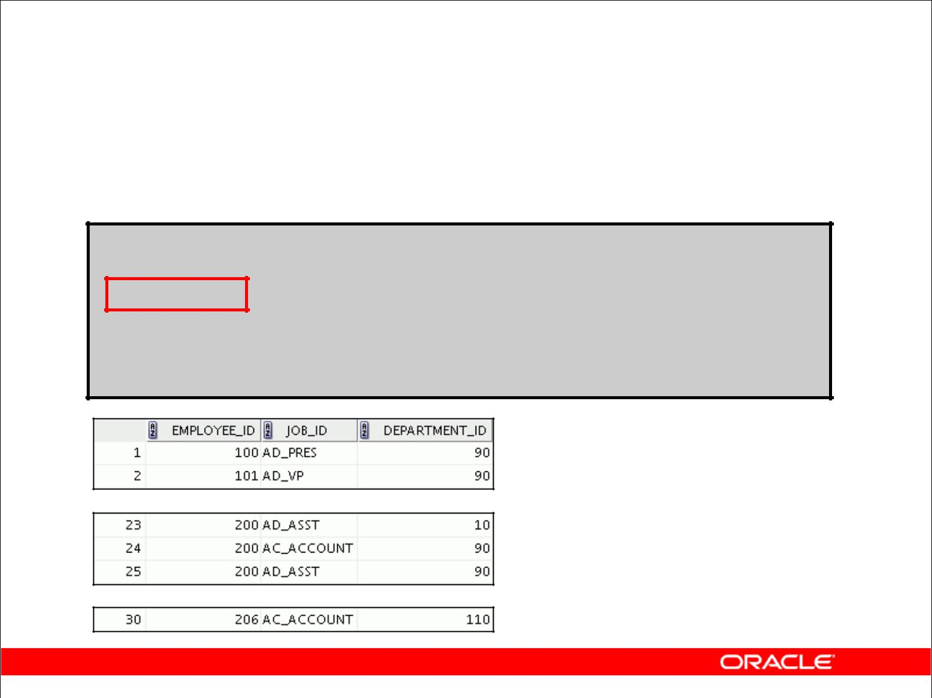**Using the UNION ALL Operator**

Display the current and previous departments of all employees.

**SELECT employee_id, job_id, department_id**

**FROM employees**

**UNION ALL**

**SELECT employee_id, job_id, department_id**

**FROM job_history**

**ORDER BY** **employee_id;**

**…**

**…**

Copyright © 2009, Oracle. All rights reserved.

**UNION ALL Operator (continued)**

In the example, 30 rows are selected. The combination of the two tables totals to 30 rows. The UNION ALL operator does not eliminate duplicate rows. UNION returns all distinct rows selected by either query. UNION ALL returns all rows selected by either query, including all duplicates. Consider the query on the slide, now written with the UNION clause:

SELECT employee_id, job_id,department_id

FROM employees

UNION

SELECT employee_id, job_id,department_id

FROM job_history

ORDER BY employee_id;

The preceding query returns 29 rows. This is because it eliminates the following row (because it is a duplicate):



**…**



**…**



|  |
| --- |
| Oracle Internal & Oracle Academy Use Only |

**Oracle Database 10*g*: SQL Fundamentals I 7 - 12**

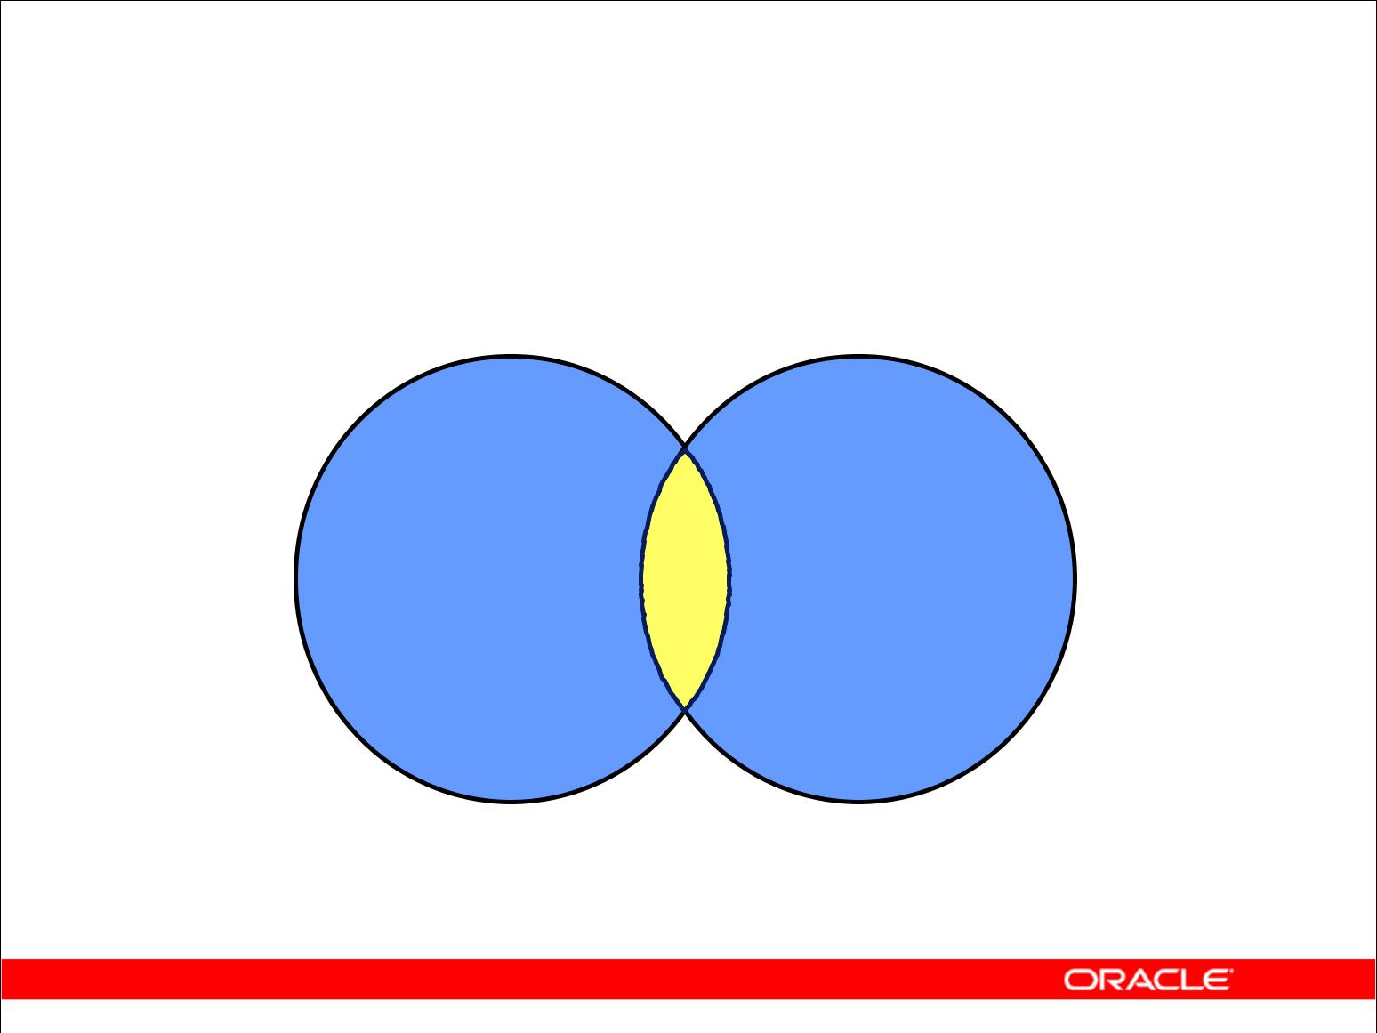**INTERSECT Operator**

**A** **B**

**The INTERSECT operator returns rows that are**

**common to both queries.**

Copyright © 2009, Oracle. All rights reserved.

**INTERSECT Operator**

Use the INTERSECT operator to return all rows that are common to multiple queries.

**Guidelines**

* The number of columns and the data types of the columns being selected by the SELECT statements in the queries must be identical in all the SELECT statements used in the query. The names of the columns need not be identical.
* Reversing the order of the intersected tables does not alter the result.
* INTERSECT does not ignore NULL values.

|  |
| --- |
| Oracle Internal & Oracle Academy Use Only |

**Oracle Database 10*g*: SQL Fundamentals I 7 - 13**

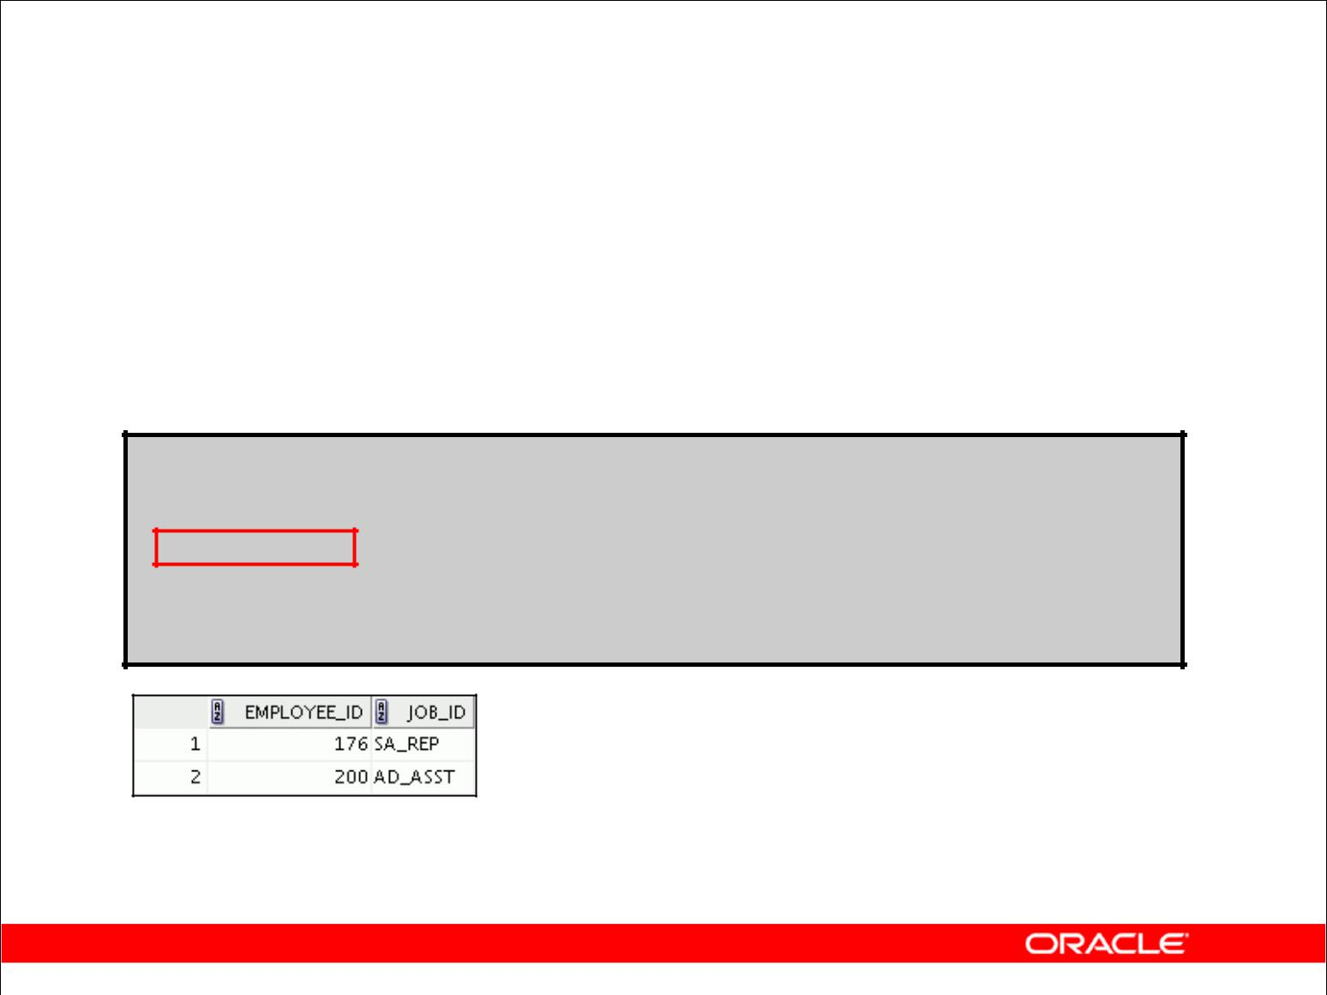**Using the INTERSECT Operator**

Display the employee IDs and job IDs of those employees who currently have a job title that is the same as a previous job title.

**SELECT employee_id, job_id**

**FROM employees**

**INTERSECT**

**SELECT employee_id, job_id**

**FROM job_history;**

Copyright © 2009, Oracle. All rights reserved.

**INTERSECT Operator (continued)**

In the example in this slide, the query returns only the records that have the same values in the selected columns in both tables.

What will be the results if you add the DEPARTMENT_ID column to the SELECT statement from the EMPLOYEES table and add the DEPARTMENT_ID column to the SELECT statement from the JOB_HISTORY table and run this query? The results may be different because of the introduction of another column whose values may or may not be duplicates.

**Example**

SELECT employee_id, job_id, department_id

FROM employees

INTERSECT

SELECT employee_id, job_id, department_id

FROM job_history;

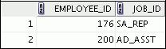

|  |
| --- |
| Oracle Internal & Oracle Academy Use Only |

Employee 200 is no longer part of the results because the EMPLOYEES.DEPARTMENT_ID value is different from the JOB_HISTORY.DEPARTMENT_ID value.

**Oracle Database 10*g*: SQL Fundamentals I 7 - 14**

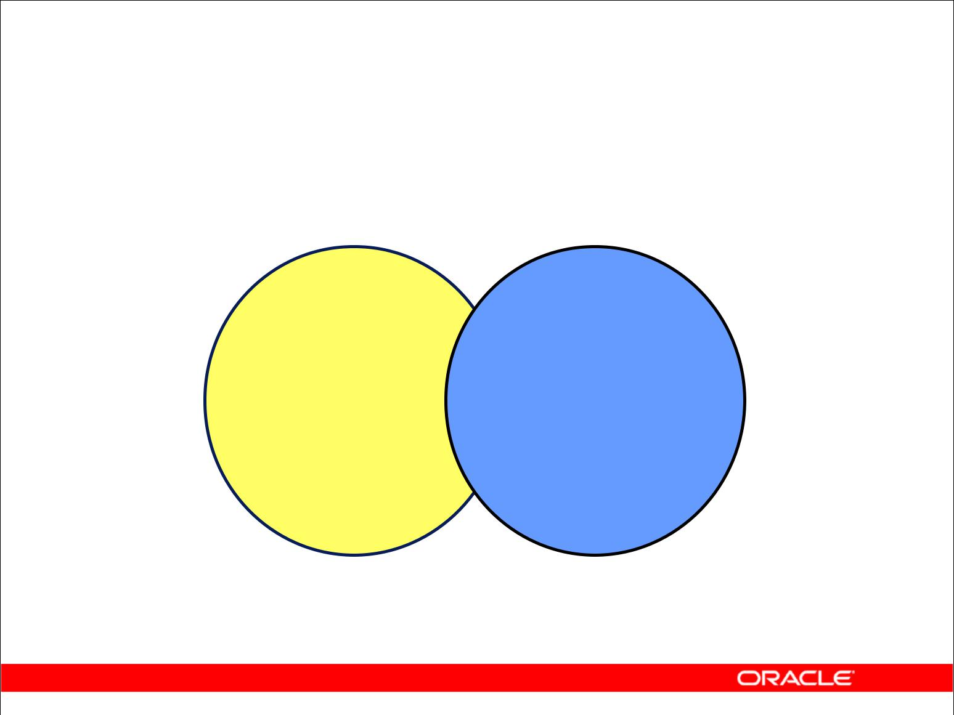**MINUS Operator**

**A** **B**

**The MINUS operator returns rows in the first query**

**that are not present in the second query.**

Copyright © 2009, Oracle. All rights reserved.

**MINUS Operator**

Use the MINUS operator to return rows returned by the first query that are not present in the second query (the first SELECT statement MINUS the second SELECT statement).

**Note:** The number of columns and the data types of the columns being selected by theSELECTstatements in the queries must be identical in all the SELECT statements used in the query. The names of the columns need not be identical.

|  |
| --- |
| Oracle Internal & Oracle Academy Use Only |

**Oracle Database 10*g*: SQL Fundamentals I 7 - 15**

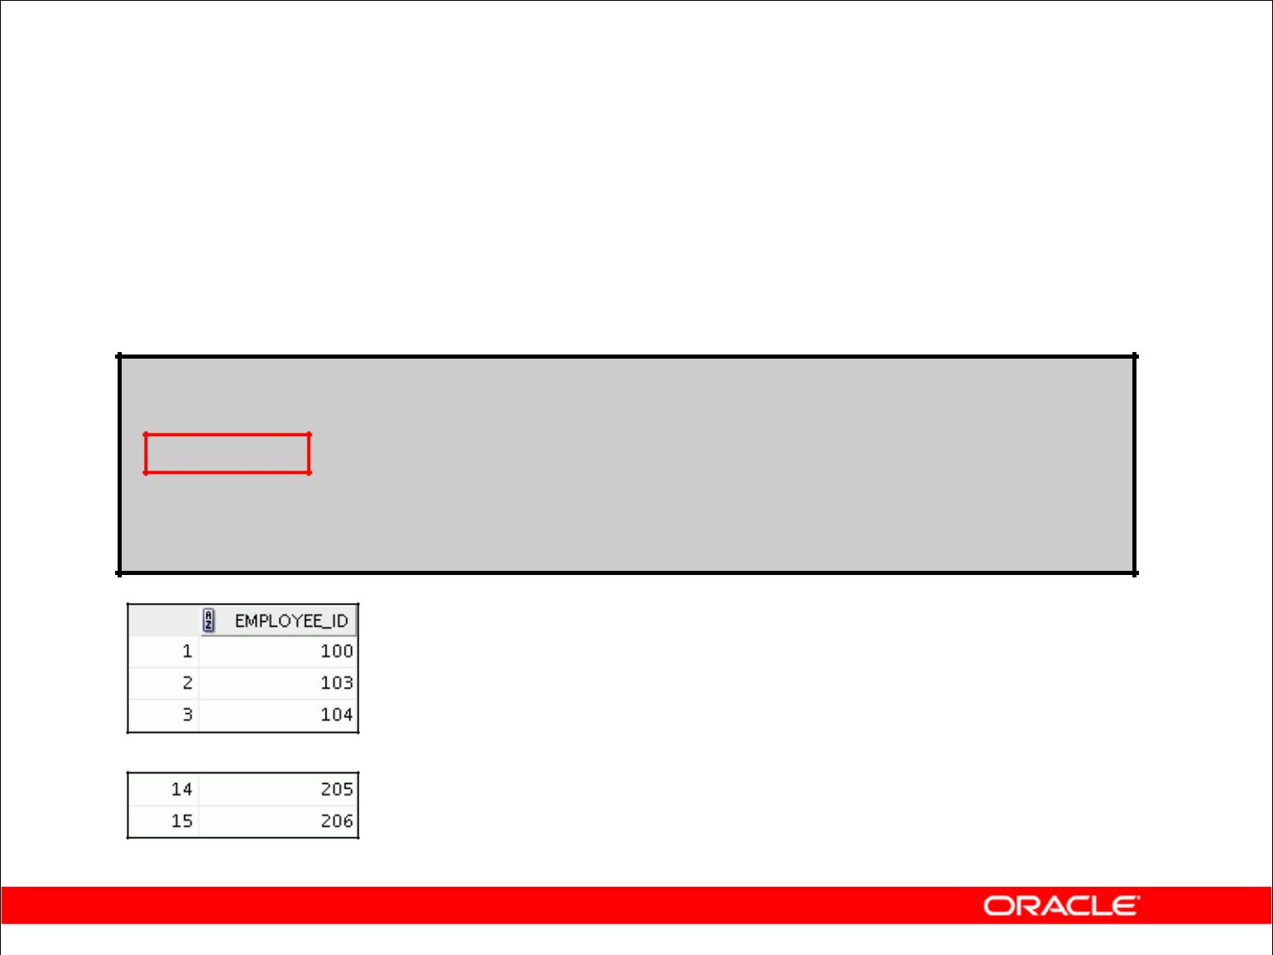**MINUS Operator**

Display the employee IDs of those employees who have not changed their jobs even once.

**SELECT employee_id**

**FROM employees**

**MINUS**

**SELECT employee_id**

**FROM job_history;**

**…**

Copyright © 2009, Oracle. All rights reserved.

**MINUS Operator (continued)**

In the example in the slide, the employee IDs in the JOB_HISTORY table are subtracted from those in the EMPLOYEES table. The results set displays the employees remaining after the subtraction; they are represented by rows that exist in the EMPLOYEES table but do not exist in the JOB_HISTORY table. These are the records of the employees who have not changed their jobs even once.

|  |
| --- |
| Oracle Internal & Oracle Academy Use Only |

**Oracle Database 10*g*: SQL Fundamentals I 7 - 16**

**Set Operator Guidelines**

* The expressions in the SELECT lists must match in number and data type.
* Parentheses can be used to alter the sequence of execution.
* The ORDER BY clause:

– Can appear only at the very end of the statement

– Will accept the column name, aliases from the first SELECT statement, or the positional notation

Copyright © 2009, Oracle. All rights reserved.

**Set Operator Guidelines**

* The expressions in the select lists of the queries must match in number and data type. Queries that use UNION, UNION ALL, INTERSECT, and MINUS operators in their WHERE clause must have the same number and type of columns in their SELECT list. For example:

SELECT employee_id, department_id

FROM employees

WHERE (employee_id, department_id)

IN (SELECT employee_id, department_id

FROM employees

UNION

SELECT employee_id, department_id

FROM job_history);

* The ORDER BY clause:
  + Can appear only at the very end of the statement
  + Will accept the column name, an alias, or the positional notation
* The column name or alias, if used in an ORDER BY clause, must be from the first SELECT list.
* Set operators can be used in subqueries.

|  |
| --- |
| Oracle Internal & Oracle Academy Use Only |

**Oracle Database 10*g*: SQL Fundamentals I 7 - 17**

**Oracle Server and Set Operators**

* Duplicate rows are automatically eliminated except in

UNION ALL.

* Column names from the first query appear in the result.
* The output is sorted in ascending order by default except in UNION ALL.

Copyright © 2009, Oracle. All rights reserved.

**Oracle Server and Set Operators**

When a query uses set operators, the Oracle server eliminates duplicate rows automatically except in the case of the UNION ALL operator. The column names in the output are decided by the column list in the first SELECT statement. By default, the output is sorted in ascending order of the first column of the SELECT clause.

The corresponding expressions in the select lists of the component queries of a compound query must match in number and data type. If component queries select character data, the data type of the return values is determined as follows:

* If both queries select values of data type CHAR, the returned values have data type CHAR.
* If either or both of the queries select values of data type VARCHAR2, the returned values have data type VARCHAR2.

|  |
| --- |
| Oracle Internal & Oracle Academy Use Only |

**Oracle Database 10*g*: SQL Fundamentals I 7 - 18**

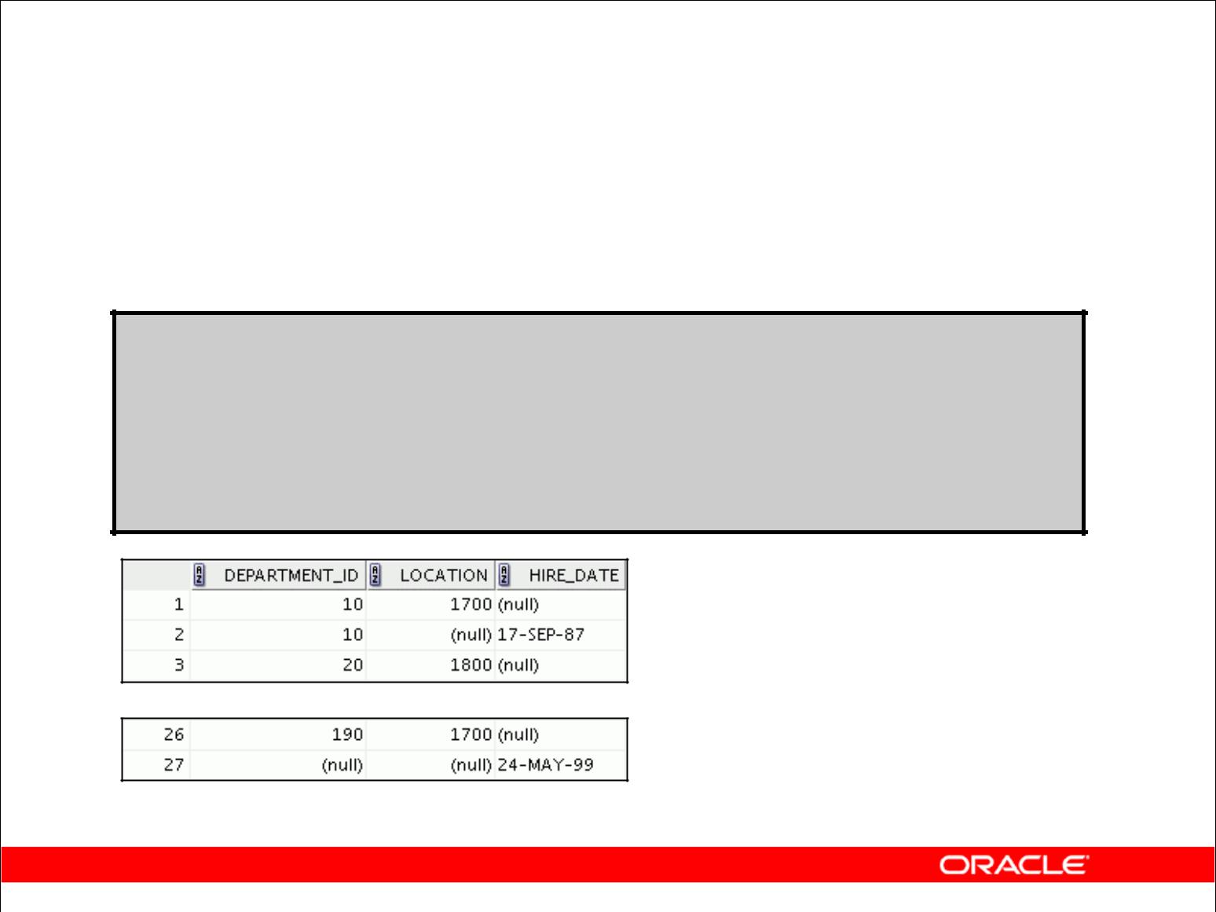**Matching the SELECT Statements**

Using the UNION operator, display the department ID, location, and hire date for all employees.

**SELECT department_id, TO_NUMBER(null)**

**location, hire_date**

**FROM employees**

**UNION**

**SELECT department_id, location_id,** **TO_DATE(null)**

**FROM departments;**

**…**

Copyright © 2009, Oracle. All rights reserved.

**Matching the SELECT Statements**

Because the expressions in the select lists of the queries must match in number, you can use dummy columns and the data type conversion functions to comply with this rule. In the slide, the name location is given as the dummy column heading. The TO_NUMBER function is used in the first query to match the NUMBER data type of the LOCATION_ID column retrieved by the second query. Similarly, the TO_DATE function in the second query is used to match the DATE data type of the HIRE_DATE column retrieved by the first query.

|  |
| --- |
| Oracle Internal & Oracle Academy Use Only |

**Oracle Database 10*g*: SQL Fundamentals I 7 - 19**

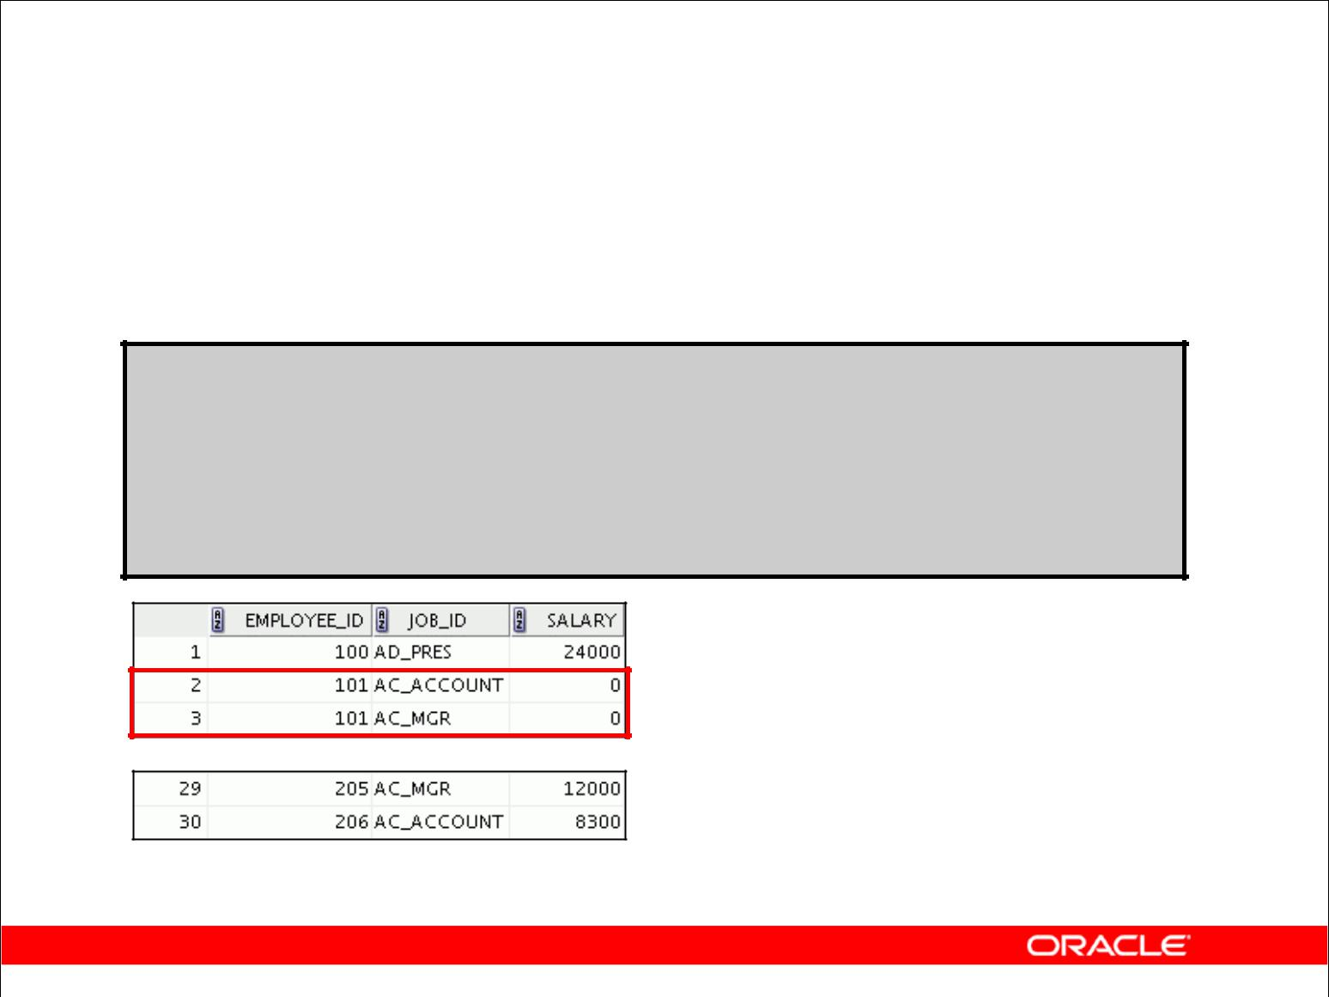**Matching the SELECT Statement:**

**Example**

Using the UNION operator, display the employee ID, job ID, and salary of all employees.

**SELECT employee_id, job_id,salary**

**FROM employees**

**UNION**

**SELECT employee_id, job_id,0**

**FROM job_history;**

**…**

Copyright © 2009, Oracle. All rights reserved.

**Matching the SELECT Statement: Example**

The EMPLOYEES and JOB_HISTORY tables have several columns in common (for example, EMPLOYEE_ID, JOB_ID, and DEPARTMENT_ID). But what if you want the query to display the employee ID, job ID, and salary using the UNION operator, knowing that the salary exists only in the EMPLOYEES table?

The code example in the slide matches the EMPLOYEE_ID and JOB_ID columns in the EMPLOYEES and JOB_HISTORY tables. A literal value of 0 is added to the JOB_HISTORY SELECT statement to match the numeric SALARY column in the EMPLOYEES SELECT statement.

In the preceding results, each row in the output that corresponds to a record from the JOB_HISTORY table contains a 0 in the SALARY column.

|  |
| --- |
| Oracle Internal & Oracle Academy Use Only |

**Oracle Database 10*g*: SQL Fundamentals I 7 - 20**

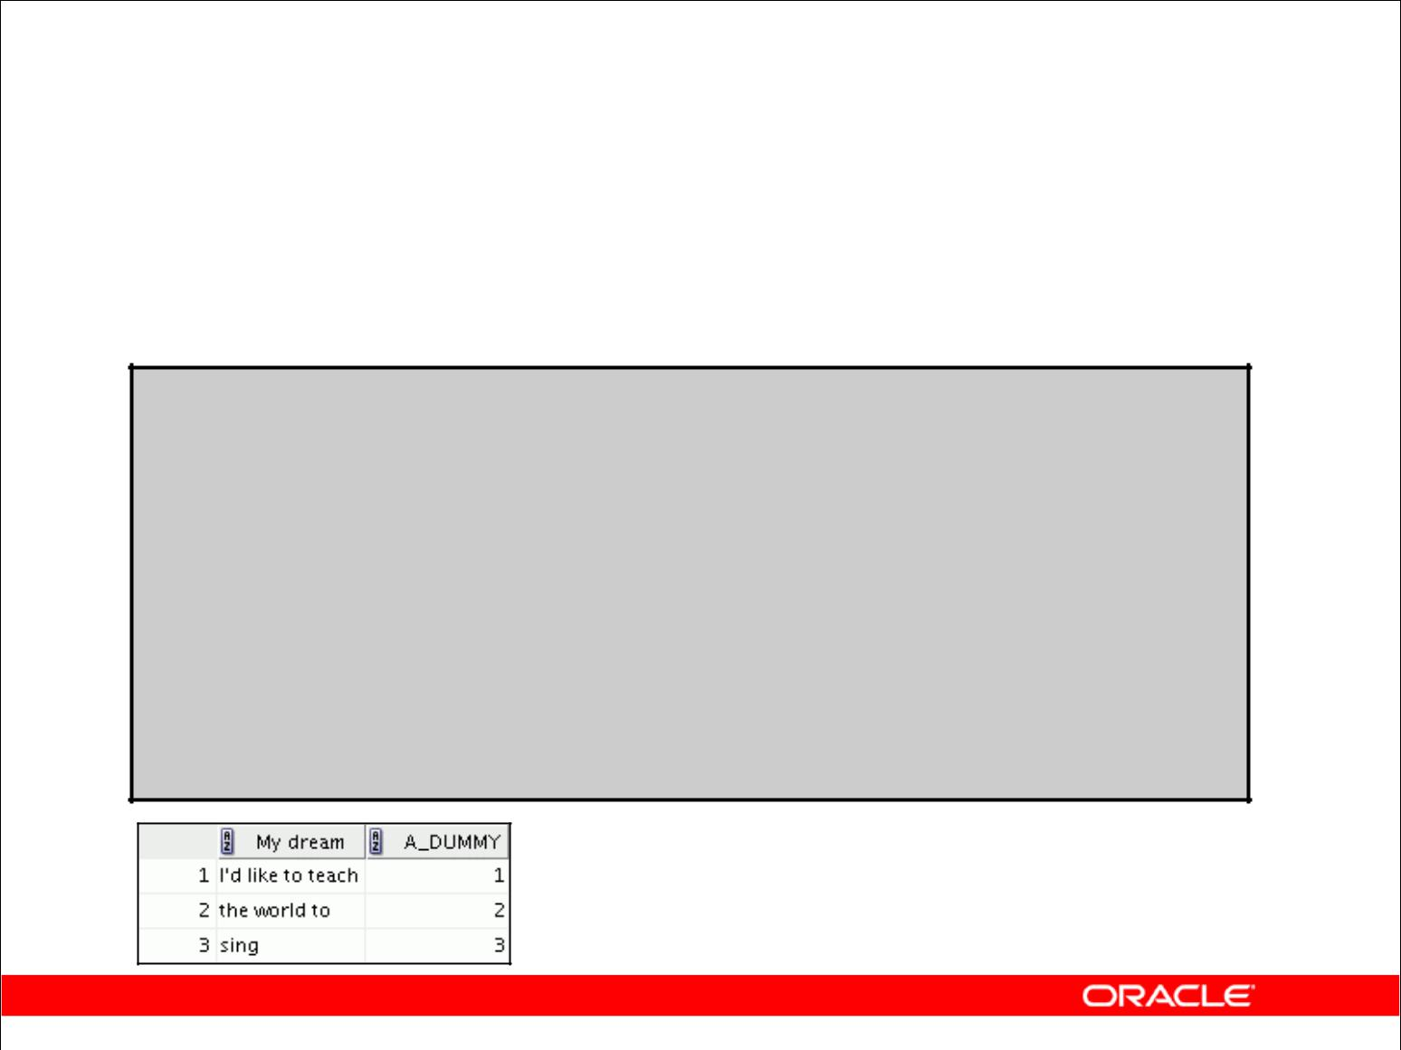**Controlling the Order of Rows**

Produce an English sentence using two UNION operators.

**COLUMN a_dummy NOPRINT**

**SELECT 'sing' AS "My dream", 3 a_dummy**

**FROM dual**

**UNION**

**SELECT 'I''d like to teach', 1 a_dummy**

**FROM dual**

**UNION**

**SELECT 'the world to', 2 a_dummy**

**FROM dual**

**ORDER BY a_dummy;**

Copyright © 2009, Oracle. All rights reserved.

**Controlling the Order of Rows**

By default, the output is sorted in ascending order on the first column. You can use the ORDER BY clause to change this.

The ORDER BY clause can be used only once in a compound query. If used, the ORDER BY clause must be placed at the end of the query. The ORDER BY clause accepts the column name or an alias. Without the ORDER BY clause, the code example in the slide produces the following output in the alphabetical order of the first column:

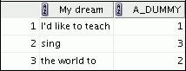

**Note:** Consider a compound query where theUNIONset operator is used more than once. In thiscase, the ORDER BY clause can use only positions rather than explicit expressions.

|  |
| --- |
| Oracle Internal & Oracle Academy Use Only |

**Oracle Database 10*g*: SQL Fundamentals I 7 - 21**

**Summary**

In this lesson, you should have learned how to use:

* UNION to return all distinct rows
* UNION ALL to return all rows, including duplicates
* INTERSECT to return all rows that are shared by both queries
* MINUS to return all distinct rows that are selected by the first query but not by the second
* ORDER BY only at the very end of the statement

Copyright © 2009, Oracle. All rights reserved.

**Summary**

* The UNION operator returns all rows selected by either query. Use the UNION operator to return all rows from multiple tables and eliminate any duplicate rows.
* Use the UNION ALL operator to return all rows from multiple queries. Unlike the case with the UNION operator, duplicate rows are not eliminated and the output is not sorted by default.
* Use the INTERSECT operator to return all rows that are common to multiple queries.
* Use the MINUS operator to return rows returned by the first query that are not present in the second query.
* Remember to use the ORDER BY clause only at the very end of the compound statement.
* Make sure that the corresponding expressions in the SELECT lists match in number and data type.

|  |
| --- |
| Oracle Internal & Oracle Academy Use Only |

**Oracle Database 10*g*: SQL Fundamentals I 7 - 22**

**Practice 7: Overview**

In this practice, you use the following set operators to create reports:

* UNION operator
* INTERSECTION operator
* MINUS operator

Copyright © 2009, Oracle. All rights reserved.

**Practice 7: Overview**

In this practice, you write queries using the set operators.

|  |
| --- |
| Oracle Internal & Oracle Academy Use Only |

**Oracle Database 10*g*: SQL Fundamentals I 7 - 23**

**Practice 7**

1. The HR department needs a list of department IDs for departments that do not contain the job ID ST_CLERK. Use set operators to create this report.

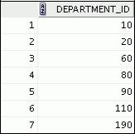

1. The HR department needs a list of countries that have no departments located in them. Display the country ID and the name of the countries. Use set operators to create this report.
2. Produce a list of jobs for departments 10, 50, and 20, in that order. Display the job ID and department ID using set operators.

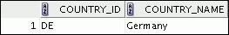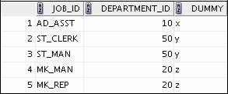

1. Create a report that lists the employee ID and job ID of those employees who currently have a job title that is the same as their job title when they were initially hired by the company (that is, they changed jobs but have now gone back to doing their original job).

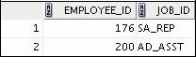

|  |
| --- |
| Oracle Internal & Oracle Academy Use Only |

**Oracle Database 10*g*: SQL Fundamentals I 7 - 24**

**Practice 7 (continued)**

1. The HR department needs a report with the following specifications:
   * The last name and department ID of all employees from the EMPLOYEES table, regardless of whether or not they belong to a department
   * The department ID and department name of all departments from the DEPARTMENTS

table, regardless of whether or not they have employees working in them Write a compound query to accomplish this.

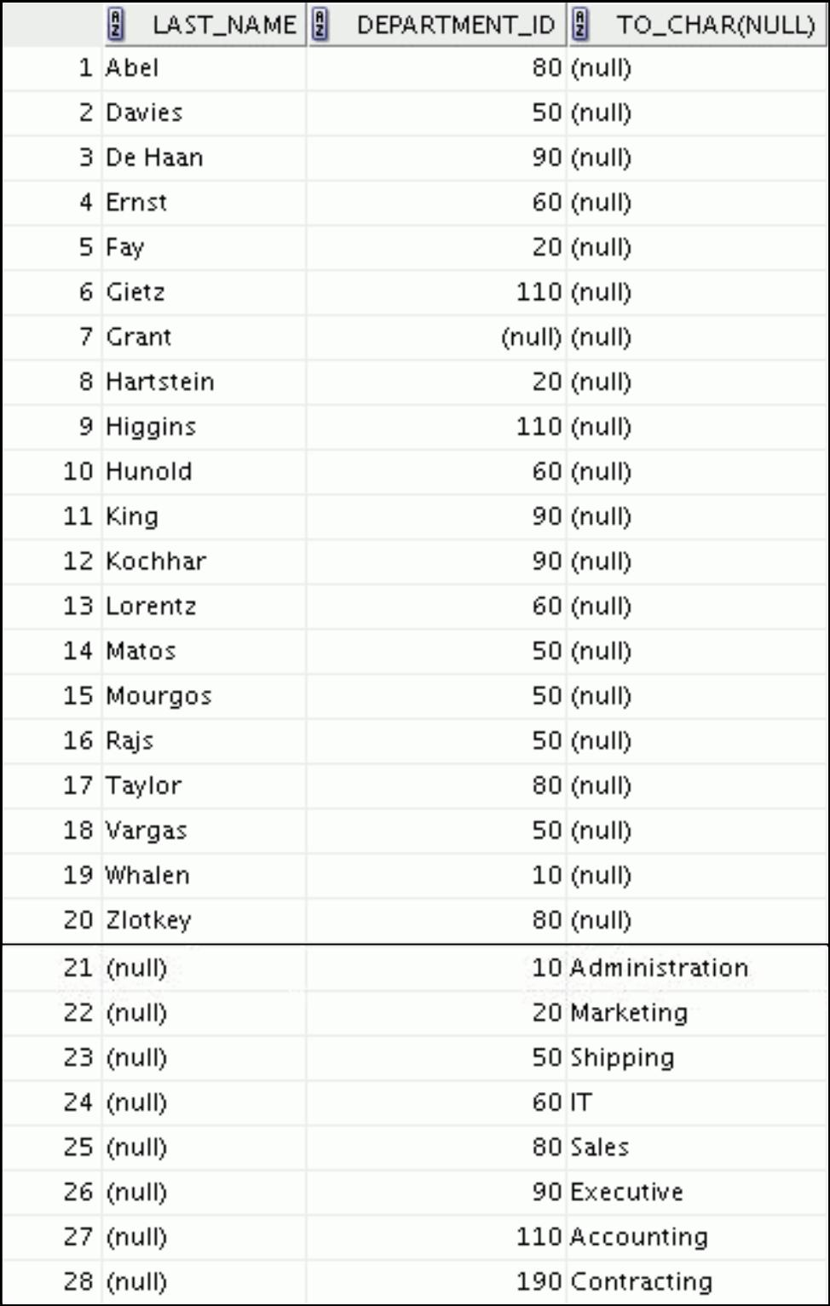

|  |
| --- |
| Oracle Internal & Oracle Academy Use Only |

**Oracle Database 10*g*: SQL Fundamentals I 7 - 25**

Oracle Internal & Oracle Academy Use Only



**Manipulating Data**

Copyright © 2009, Oracle. All rights reserved.

|  |
| --- |
| Oracle Internal & Oracle Academy Use Only |

**Objectives**

After completing this lesson, you should be able to do the following:

* Describe each data manipulation language (DML) statement
* Insert rows into a table
* Update rows in a table
* Delete rows from a table
* Control transactions

Copyright © 2009, Oracle. All rights reserved.

**Objective**

In this lesson, you learn how to use DML statements to insert rows into a table, update existing rows in a table, and delete existing rows from a table. You also learn how to control transactions with the COMMIT, SAVEPOINT, and ROLLBACK statements.

|  |
| --- |
| Oracle Internal & Oracle Academy Use Only |

**Oracle Database 10*g*: SQL Fundamentals I 8 - 2**

**Data Manipulation Language**

* A DML statement is executed when you:

– Add new rows to a table

– Modify existing rows in a table

– Remove existing rows from a table

* A *transaction* consists of a collection of DML statements that form a logical unit of work.

Copyright © 2009, Oracle. All rights reserved.

**Data Manipulation Language**

Data manipulation language (DML) is a core part of SQL. When you want to add, update, or delete data in the database, you execute a DML statement. A collection of DML statements that form a logical unit of work is called a *transaction*.

Consider a banking database. When a bank customer transfers money from a savings account to a checking account, the transaction might consist of three separate operations: decrease the savings account, increase the checking account, and record the transaction in the transaction journal. The Oracle server must guarantee that all three SQL statements are performed to maintain the accounts in proper balance. When something prevents one of the statements in the transaction from executing, the other statements of the transaction must be undone.

|  |
| --- |
| Oracle Internal & Oracle Academy Use Only |

**Oracle Database 10*g*: SQL Fundamentals I 8 - 3**

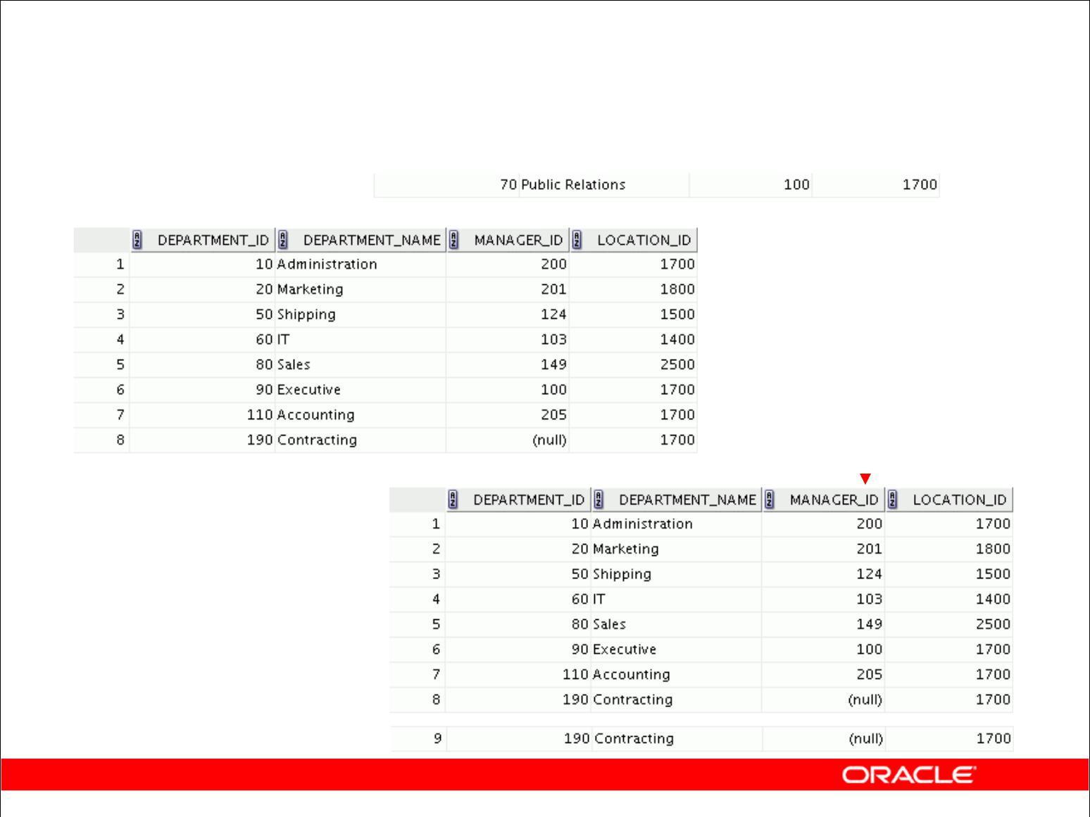**Adding a New Row to a Table**

|  |  |  |  |  |  |  |  |
| --- | --- | --- | --- | --- | --- | --- | --- |
|  |  |  |  |  |  | **New** |  |
|  |  |  |  |  |  |  |
| **DEPARTMENTS** |  |  |  |  |  | **row** |  |
|  |  |  |  |  |  |
|  |  |  |  | **Insert new row** | | |  |
|  |  |  |  |  |
|  |  |  |  | **into the** | | |  |
|  |  |  |  | **DEPARTMENTS table** | | |  |
|  |  |  |  |  |  |  |  |
|  |  |  |  |  |  |  |  |
|  |  |  |  |  |  |  |  |
|  |  |  |  |  |  |  |  |
|  |  |  |  |  |  |  |  |
|  |  |  |  |  |  |  |  |
|  |  |  |  |  |  |  |  |

Copyright © 2009, Oracle. All rights reserved.

**Adding a New Row to a Table**

The graphic in the slide illustrates adding a new department to the DEPARTMENTS table.

|  |
| --- |
| Oracle Internal & Oracle Academy Use Only |

**Oracle Database 10*g*: SQL Fundamentals I 8 - 4**

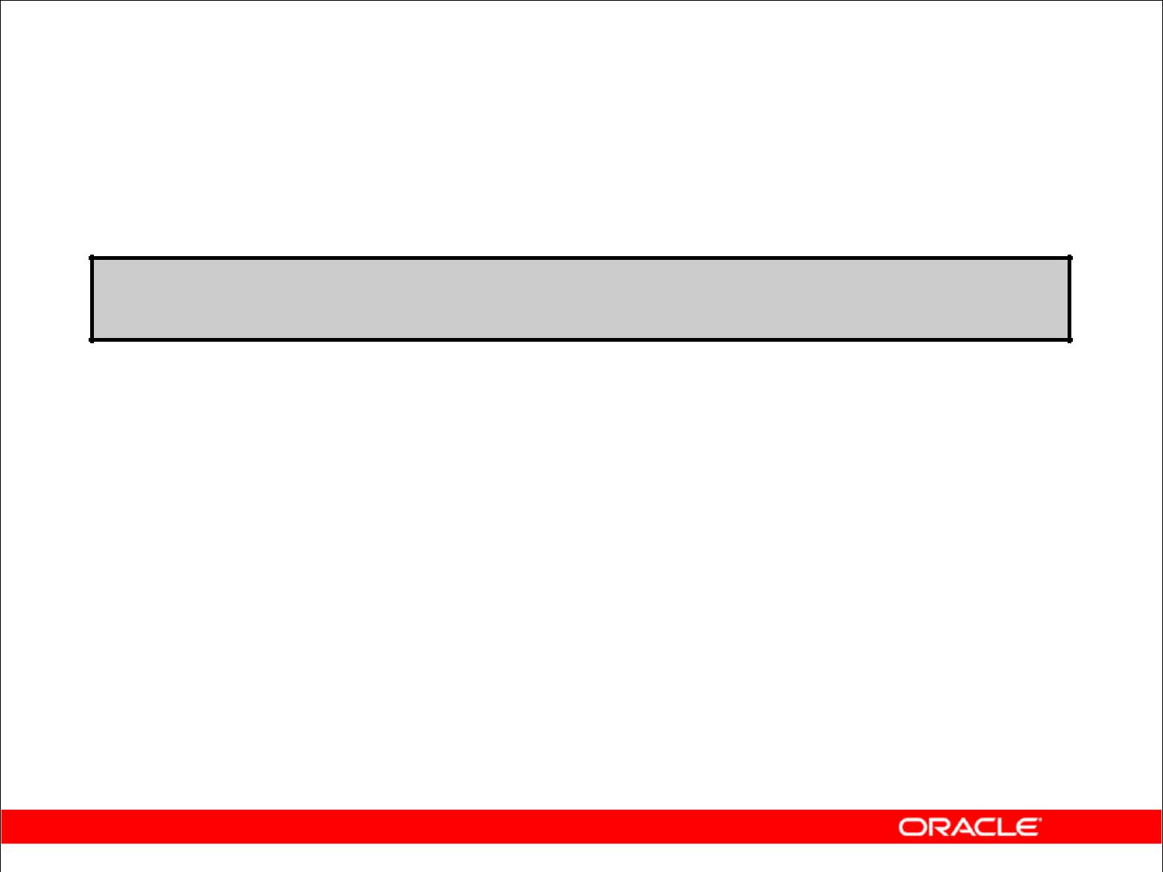**INSERT Statement Syntax**

* Add new rows to a table by using the INSERT statement:

**INSERT INTO** ***table* [(*column* [*, column...*])]**

**VALUES** ***(value* [*, value...*]);**

* With this syntax, only one row is inserted at a time.

Copyright © 2009, Oracle. All rights reserved.

**Adding a New Row to a Table (continued)**

You can add new rows to a table by issuing the INSERT statement.

In the syntax:

*table* is the name of the table

*column* is the name of the column in the table to populate

*value* is the corresponding value for the column

**Note:** This statement with theVALUESclause adds only one row at a time to a table.

|  |
| --- |
| Oracle Internal & Oracle Academy Use Only |

**Oracle Database 10*g*: SQL Fundamentals I 8 - 5**

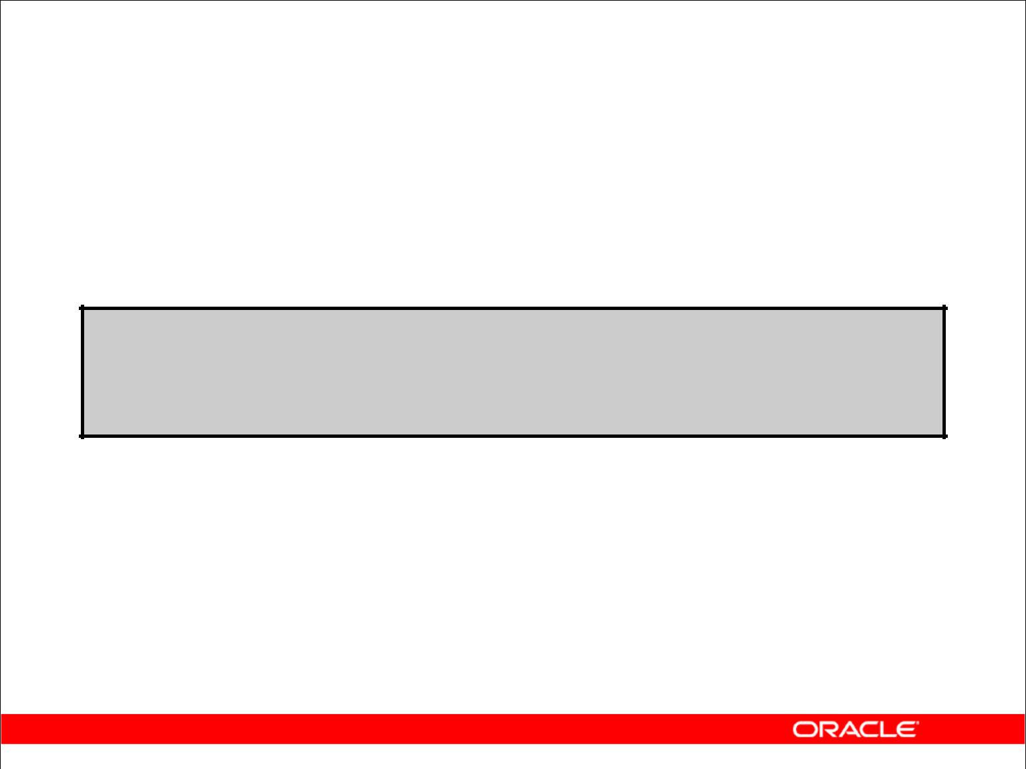**Inserting New Rows**

* Insert a new row containing values for each column.
* List values in the default order of the columns in the table.
* Optionally, list the columns in the INSERT clause.

**INSERT INTO departments(department_id, department_name, manager_id, location_id)**

**VALUES (70, 'Public Relations', 100, 1700); 1 rows inserted**

* Enclose character and date values in single quotation marks.

Copyright © 2009, Oracle. All rights reserved.

**Adding a New Row to a Table (continued)**

Because you can insert a new row that contains values for each column, the column list is not required in the INSERT clause. However, if you do not use the column list, the values must be

listed according to the default order of the columns in the table, and a value must be provided for each column.

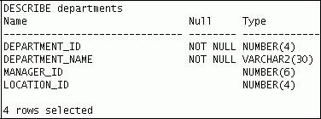

For clarity, use the column list in the INSERT clause.

Enclose character and date values in single quotation marks; it is not recommended that you enclose numeric values in single quotation marks.

Number values should not be enclosed in single quotation marks, because implicit conversion may take place for numeric values that are assigned to NUMBER data type columns if single quotation marks are included.

|  |
| --- |
| Oracle Internal & Oracle Academy Use Only |

**Oracle Database 10*g*: SQL Fundamentals I 8 - 6**

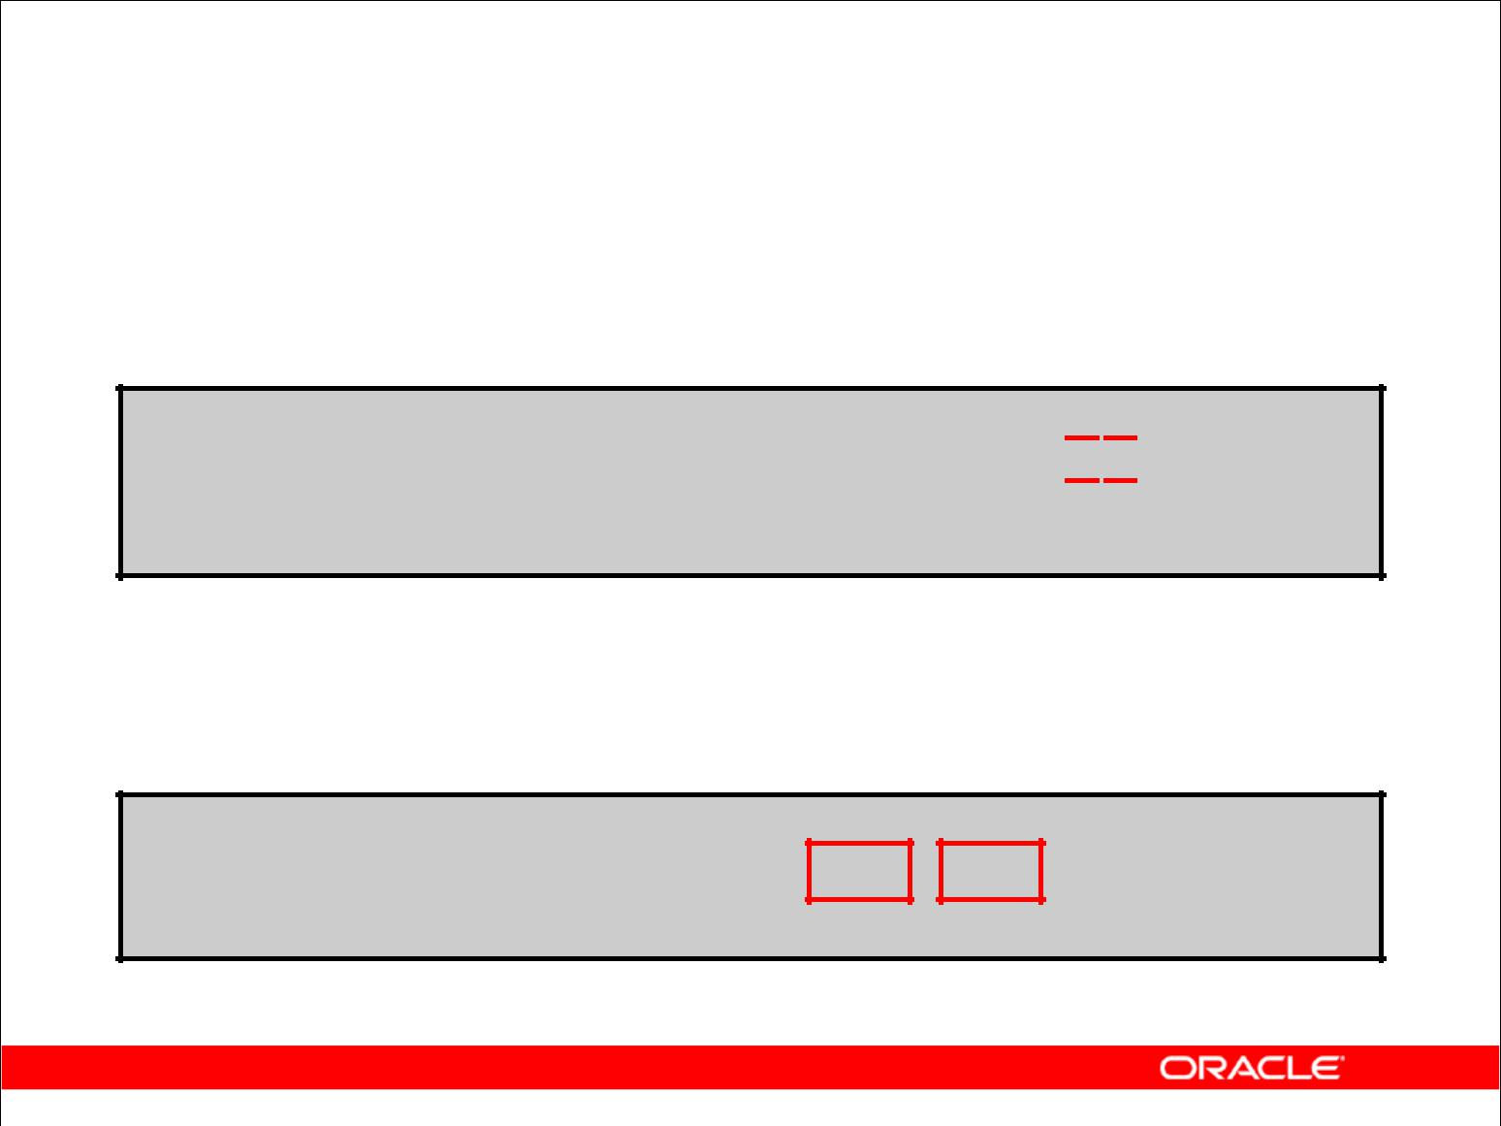**Inserting Rows with Null Values**

* Implicit method: Omit the column from the column list.

**INSERT INTO** **departments (department_id,**

**department_name**  **)**

**VALUES** **(30, 'Purchasing');**

**1 rows inserted**

* Explicit method: Specify the NULL keyword in the VALUES clause.

**INSERT INTO** **departments**

**VALUES (100, 'Finance', NULL, NULL); 1 rows inserted**

Copyright © 2009, Oracle. All rights reserved.

**Methods for Inserting Null Values**

|  |  |
| --- | --- |
| **Method** | **Description** |
|  |  |
| Implicit | Omit the column from the column list. |
|  |  |
| Explicit | Specify the NULL keyword in the VALUES list; |
|  | specify the empty string ('') in the VALUES list for character strings |
|  | and dates. |

Be sure that you can use null values in the targeted column by verifying the Null? status with the DESCRIBE command.

The Oracle server automatically enforces all data types, data ranges, and data integrity constraints. Any column that is not listed explicitly obtains a null value in the new row.

Common errors that can occur during user input:

* Mandatory value missing for a NOT NULL column
* Duplicate value violates uniqueness constraint
* Foreign key constraint violated
* CHECK constraint violated
* Data type mismatch
* Value too wide to fit in column

|  |
| --- |
| Oracle Internal & Oracle Academy Use Only |

**Oracle Database 10*g*: SQL Fundamentals I 8 - 7**

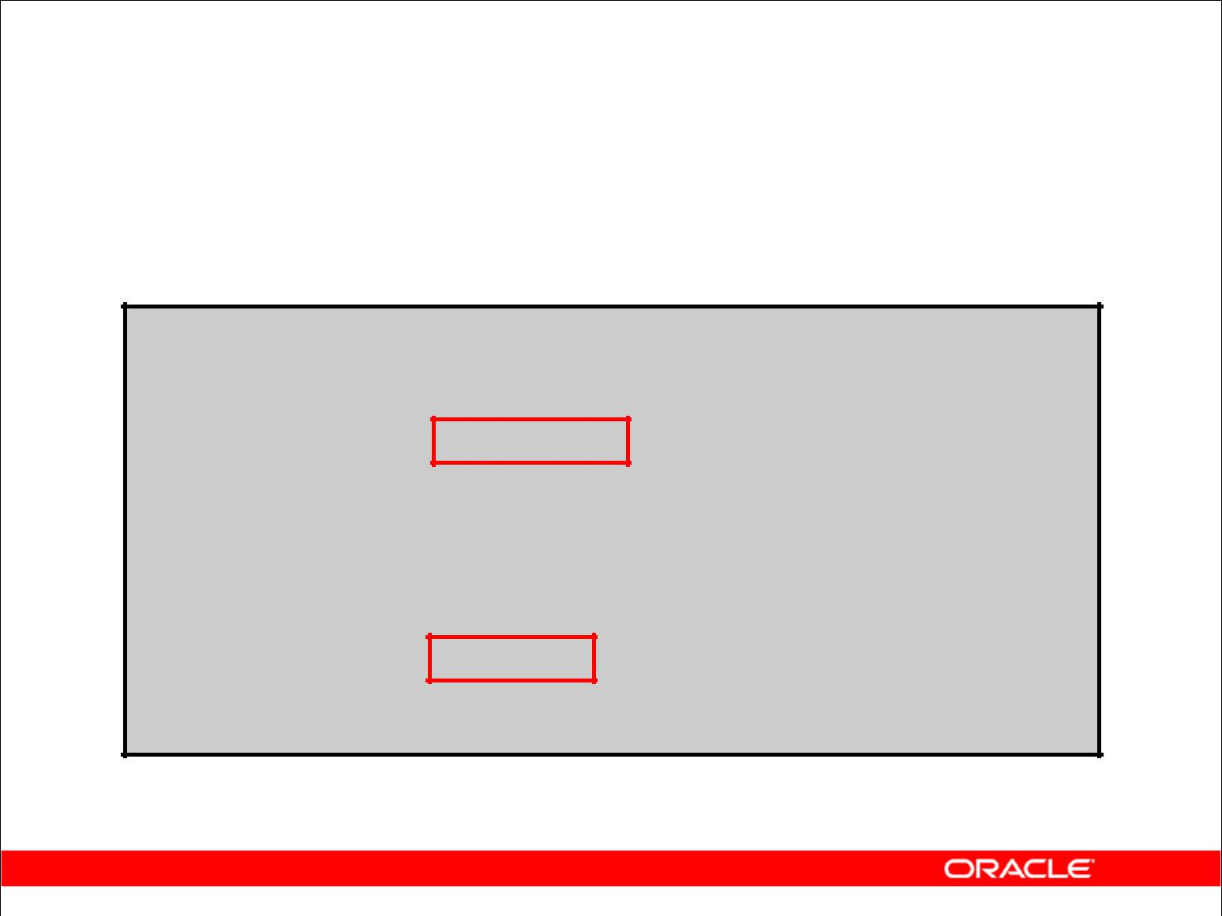**Inserting Special Values**

The SYSDATE function records the current date and time.

**INSERT INTO employees (employee_id,**

**first_name, last_name,**

**email, phone_number,**

**hire_date, job_id, salary,**

**commission_pct, manager_id,**

**department_id)**

**VALUES** **(113,**

**'Louis', 'Popp',**

**'LPOPP', '515.124.4567',**

**SYSDATE, 'AC_ACCOUNT', 6900,**

**NULL, 205, 100);**

**1 rows inserted**

Copyright © 2009, Oracle. All rights reserved.

**Inserting Special Values by Using SQL Functions**

You can use functions to enter special values in your table.

The slide example records information for employee Popp in the EMPLOYEES table. It supplies the current date and time in the HIRE_DATE column. It uses the SYSDATE function for current date and time.

You can also use the USER function when inserting rows in a table. The USER function records the current username.

**Confirming Additions to the Table**

SELECT employee_id, last_name, job_id, hire_date, commission_pct FROM employees

WHERE employee_id = 113;



|  |
| --- |
| Oracle Internal & Oracle Academy Use Only |

**Oracle Database 10*g*: SQL Fundamentals I 8 - 8**

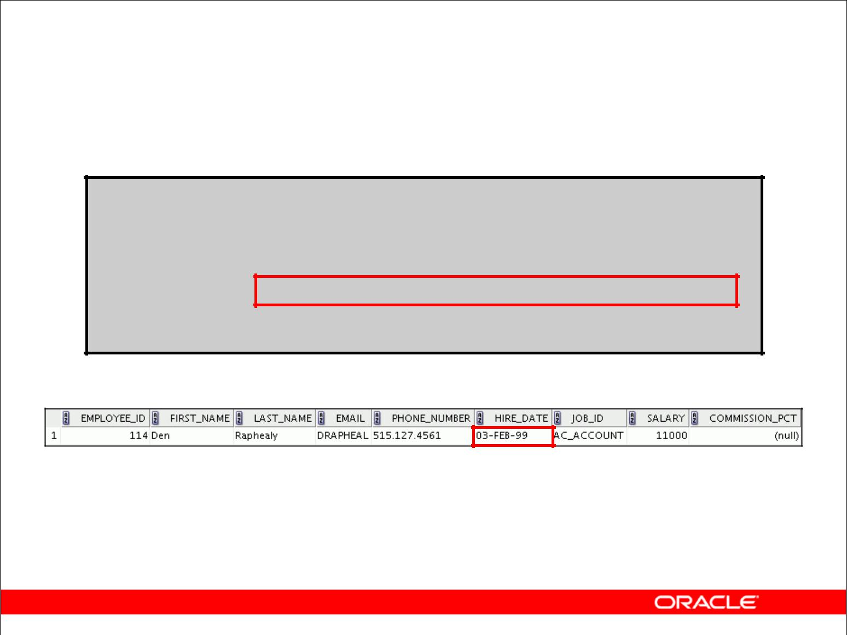**Inserting Specific Date Values**

* Add a new employee.

**INSERT INTO employees**

**VALUES** **(114,**

**'Den', 'Raphealy',**

**'DRAPHEAL', '515.127.4561',**

**TO_DATE('FEB 3, 1999', 'MON DD, YYYY'), 'AC_ACCOUNT', 11000, NULL, 100, 30);**

**1 rows inserted**

* Verify your addition.

Copyright © 2009, Oracle. All rights reserved.

**Inserting Specific Date and Time Values**

The DD-MON-YY format is usually used to insert a date value. With this format, recall that the century defaults to the current century. Because the date also contains time information, the default time is midnight (00:00:00).

If a date must be entered in a format other than the default format (for example, with another century or a specific time), you must use the TO_DATE function.

The example in the slide records information for employee Raphealy in the EMPLOYEES table. It sets the HIRE_DATE column to be February 3, 1999. If you use the following statement instead of the one shown in the slide, the year of the hire date is interpreted as 2099.

INSERT INTO employees

VALUES (114,

'Den', 'Raphealy',

'DRAPHEAL', '515.127.4561',

'03-FEB-99',

'AC_ACCOUNT', 11000, NULL, 100, 30);

If the RR format is used, the system provides the correct century automatically, even if it is not the current one.

|  |
| --- |
| Oracle Internal & Oracle Academy Use Only |

**Oracle Database 10*g*: SQL Fundamentals I 8 - 9**

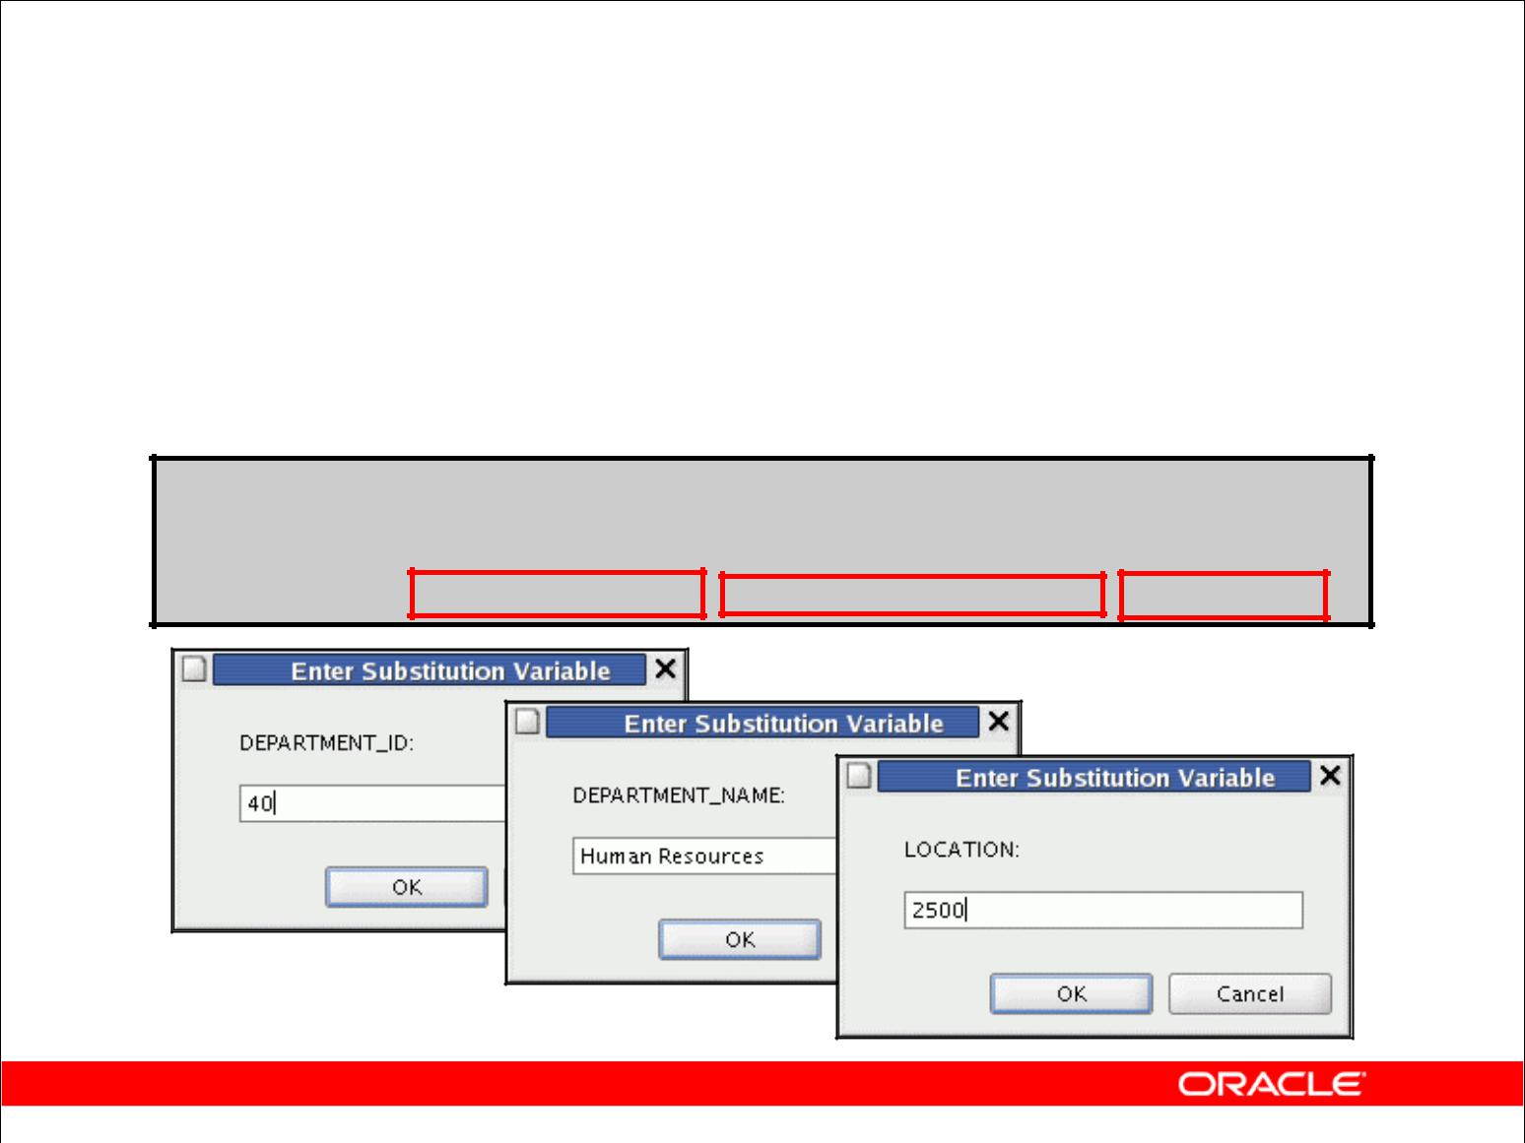**Creating a Script**

* Use & substitution in a SQL statement to prompt for values.
* & is a placeholder for the variable value.

**INSERT INTO departments**

**(department_id, department_name, location_id)**

**VALUES** **(&department_id, '&department_name',&location);**

Copyright © 2009, Oracle. All rights reserved.

**Creating a Script to Manipulate Data**

You can save commands with substitution variables to a file and execute the commands in the file. The slide example records information for a department in the DEPARTMENTS table.

Run the script file and you are prompted for input for each of the & substitution variables. After entering a value for the substitution variable, click the Continue button. The values that you input are then substituted into the statement. This enables you to run the same script file over and over but supply a different set of values each time you run it.

|  |
| --- |
| Oracle Internal & Oracle Academy Use Only |

**Oracle Database 10*g*: SQL Fundamentals I 8 - 10**

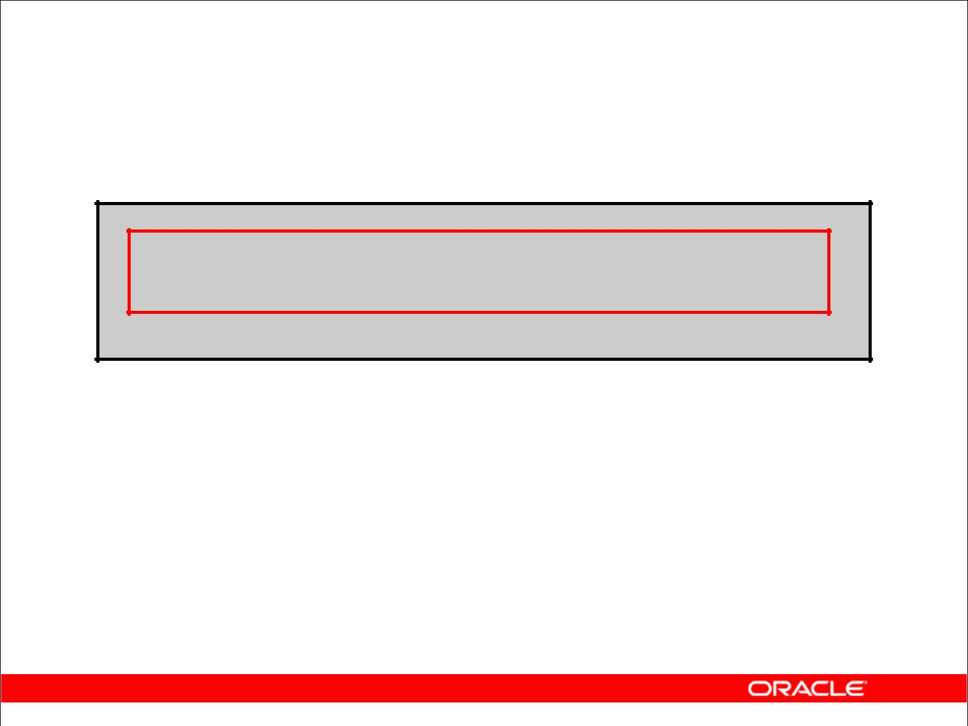**Copying Rows**

**from Another Table**

* Write your INSERT statement with a subquery:

**INSERT INTO sales_reps(id, name, salary, commission_pct)**

**SELECT employee_id, last_name, salary, commission_pct**

**FROM** **employees**

**WHERE job_id LIKE '%REP%';**

**4 rows inserted**

* Do not use the VALUES clause.
* Match the number of columns in the INSERT clause to those in the subquery.

Copyright © 2009, Oracle. All rights reserved.

**Copying Rows from Another Table**

You can use the INSERT statement to add rows to a table where the values are derived from existing tables. In place of the VALUES clause, you use a subquery. In the slide example, for the INSERT INTO statement to work, you must have already created the sales_reps table using the CREATE TABLE statement. CREATE TABLE is discussed in the next lesson titled “Using DDL Statements to Create and Manage Tables.”

**Syntax**

INSERT INTO *table* [ *column* (, *column*) ] *subquery;*

|  |  |  |
| --- | --- | --- |
| In the syntax: | is the table name |  |
| *table* |  |
| *column* | is the name of the column in the table to populate |  |
| *subquery* | is the subquery that returns rows to the table |  |

The number of columns and their data types in the column list of the INSERT clause must

match the number of values and their data types in the subquery. To create a copy of the rows of a table, use SELECT * in the subquery:

INSERT INTO copy_emp

SELECT *

FROM employees;

|  |
| --- |
| Oracle Internal & Oracle Academy Use Only |

**Oracle Database 10*g*: SQL Fundamentals I 8 - 11**

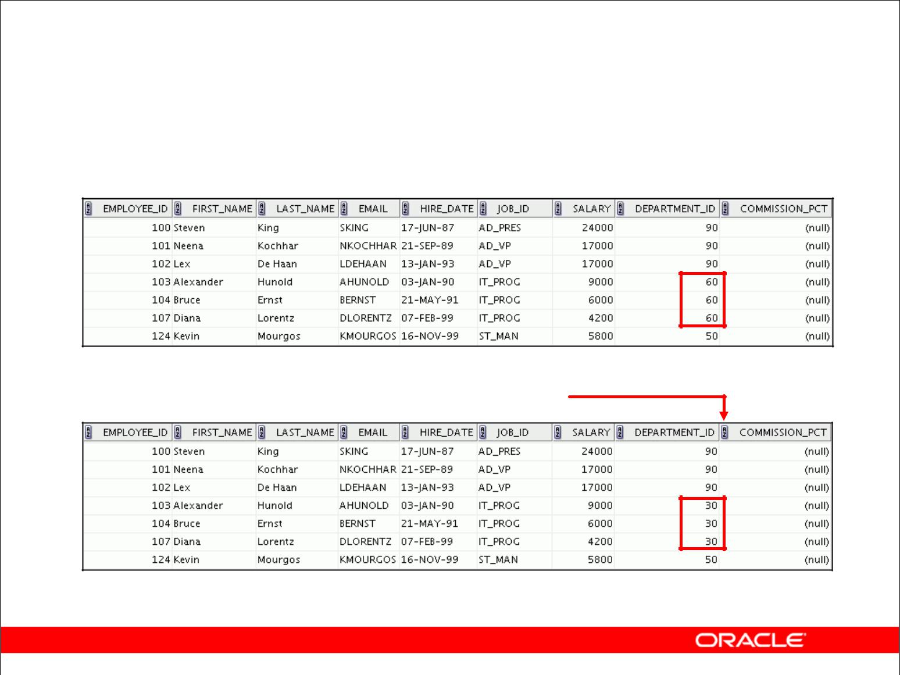**Changing Data in a Table**

**EMPLOYEES**

**Update rows in the EMPLOYEES table:**

Copyright © 2009, Oracle. All rights reserved.

**Changing Data in a Table**

The slide illustrates changing the department number for employees in department 60 to department 30.

|  |
| --- |
| Oracle Internal & Oracle Academy Use Only |

**Oracle Database 10*g*: SQL Fundamentals I 8 - 12**

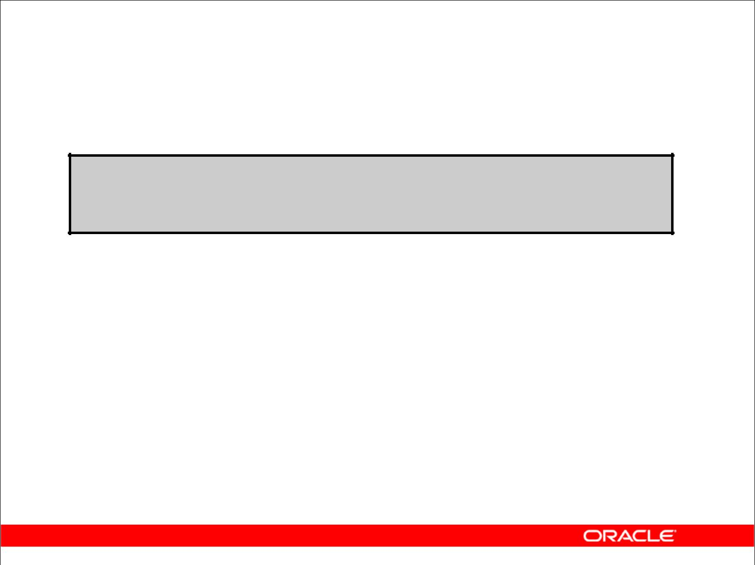**UPDATE Statement Syntax**

* Modify existing rows with the UPDATE statement:

**UPDATE** ***table***

**SET** ***column* = *value* [, *column* = *value, ...*]**

**[WHERE** ***condition*];**

* Update more than one row at a time (if required).

Copyright © 2009, Oracle. All rights reserved.

**Updating Rows**

You can modify existing rows by using the UPDATE statement.

|  |  |  |
| --- | --- | --- |
| In the syntax: | is the name of the table |  |
| *table* |  |
| *column* | is the name of the column in the table to populate |  |
| *value* | is the corresponding value or subquery for the column |  |
| *condition* | identifies the rows to be updated and is composed of column names, |  |
|  | expressions, constants, subqueries, and comparison operators |  |

Confirm the update operation by querying the table to display the updated rows.

For more information, see “UPDATE” in the *Oracle Database SQL Reference*.

**Note:** In general, use the primary key to identify a single row. Using other columns canunexpectedly cause several rows to be updated. For example, identifying a single row in the EMPLOYEES table by name is dangerous, because more than one employee may have the same name.

|  |
| --- |
| Oracle Internal & Oracle Academy Use Only |

**Oracle Database 10*g*: SQL Fundamentals I 8 - 13**

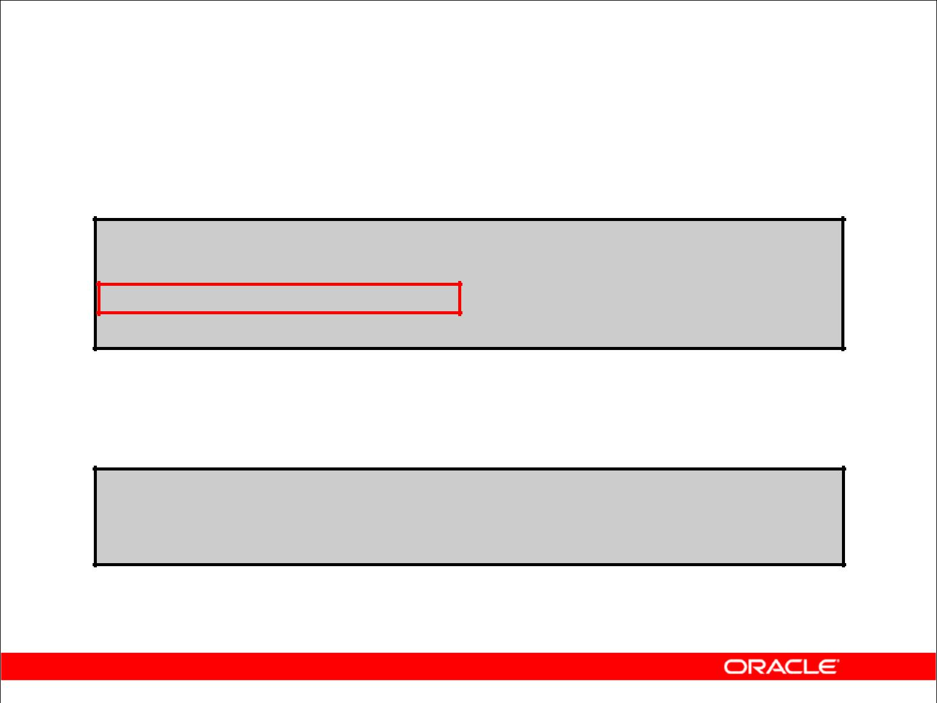**Updating Rows in a Table**

* Specific row or rows are modified if you specify the WHERE

clause:

**UPDATE employees**

**SET** **department_id = 70**

**WHERE** **employee_id = 113;**

**1 rows updated**

* All rows in the table are modified if you omit the WHERE clause:

**UPDATE copy_emp**

**SET** **department_id = 110;**

**22 rows updated**

Copyright © 2009, Oracle. All rights reserved.

**Updating Rows (continued)**

The UPDATE statement modifies specific rows if the WHERE clause is specified. The slide example transfers employee 113 (Popp) to department 70.

If you omit the WHERE clause, all the rows in the table are modified.

SELECT last_name, department_id

FROM copy_emp;

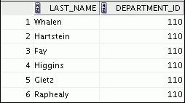

**…**

**Note:** TheCOPY_EMPtable has the same data as theEMPLOYEEStable.

|  |
| --- |
| Oracle Internal & Oracle Academy Use Only |

**Oracle Database 10*g*: SQL Fundamentals I 8 - 14**

**Updating Two Columns with a Subquery**

Update employee 114’s job and salary to match that of employee 205.

|  |  |  |  |  |  |  |  |
| --- | --- | --- | --- | --- | --- | --- | --- |
| **UPDATE** | **employees** | | |  |  |  |  |
| **SET** | **job_id** | **=** | **(SELECT** | | **job_id** |  |  |
|  |  |  |  | **FROM** | **employees** |  |  |
|  |  |  |  | **WHERE** | **employee_id = 205),** |  |  |
|  | **salary** | **=** | **(SELECT** | | **salary** |  |  |
|  |  |  |  | **FROM** | **employees** |  |  |
|  |  |  |  | **WHERE** | **employee_id = 205)** |  |  |
| **WHERE** |  |  |  |  |  |  |  |
| **employee_id** | | | **=** | **114;** |  |  |
| **1 rows updated** | |  |  |  |  |  |  |
|  |  |  |  |  |  |  |  |

Copyright © 2009, Oracle. All rights reserved.

**Updating Two Columns with a Subquery**

You can update multiple columns in the SET clause of an UPDATE statement by writing multiple subqueries.

**Syntax**

UPDATE *table*

SET *column* =

(SELECT *column*

FROM *table*

WHERE *condition*)

[ ,

*column* =

(SELECT *column*

FROM *table*

WHERE *condition*)]

[WHERE *condition* ] ;

**Note:** If no rows are updated, the message “0 rows updated” is returned.

|  |
| --- |
| Oracle Internal & Oracle Academy Use Only |

**Oracle Database 10*g*: SQL Fundamentals I 8 - 15**

**Updating Rows Based**

**on Another Table**

Use subqueries in UPDATE statements to update rows in a table based on values from another table:

|  |  |  |  |  |  |  |  |
| --- | --- | --- | --- | --- | --- | --- | --- |
|  |  |  |  |  |  |  |  |
| **UPDATE** | **copy_emp** |  |  |  |  |  |  |
| **SET** |  | **_id** | **=** | **(SELECT department_id** | | |  |
| **department** |  |
|  |  |  |  | **FROM** | **employees** |  |  |
|  |  |  |  | **WHERE** | **employee** | **_id = 100)** |  |
| **WHERE** | **job_id** | | **=** | **(SELECT job_id** | | |  |
|  |  |  |  | **FROM** | **employees** |  |  |
|  |  |  |  | **WHERE employee_id = 200);** | | |  |
| **1 rows updated** | | |  |  |  |  |  |
|  |  |  |  |  |  |  |  |

Copyright © 2009, Oracle. All rights reserved.

**Updating Rows Based on Another Table**

You can use subqueries in UPDATE statements to update rows in a table. The example in the slide updates the COPY_EMP table based on the values from the EMPLOYEES table. It changes the department number of all employees with employee 200’s job ID to employee 100’s current department number.

|  |
| --- |
| Oracle Internal & Oracle Academy Use Only |

**Oracle Database 10*g*: SQL Fundamentals I 8 - 16**

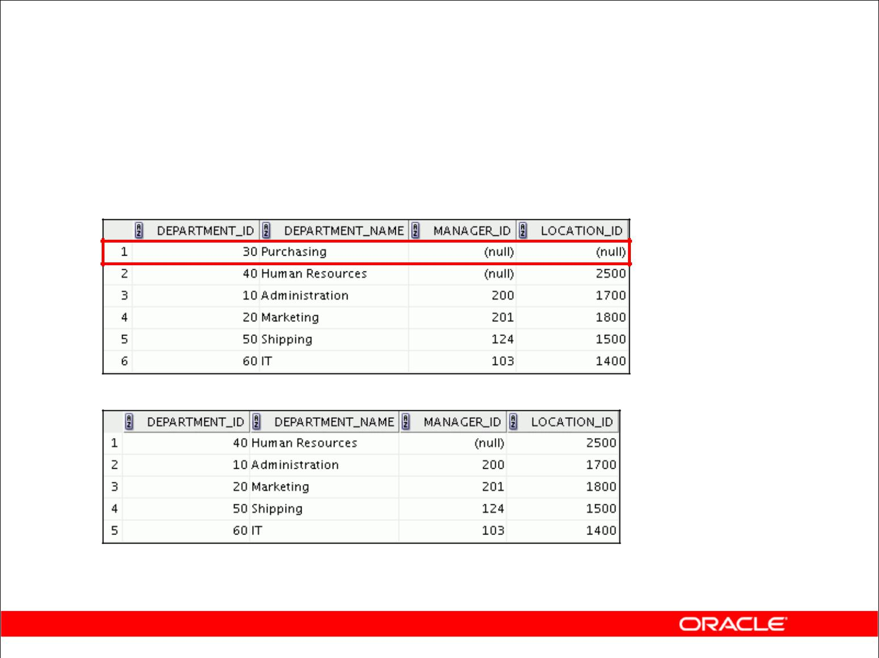**Removing a Row from a Table**

**DEPARTMENTS**

**Delete a row from the DEPARTMENTS table:**

Copyright © 2009, Oracle. All rights reserved.

**Removing a Row from a Table**

The graphic in the slide removes the Purchasing department from the DEPARTMENTS table (assuming that there are no constraints defined on the DEPARTMENTS table).

|  |
| --- |
| Oracle Internal & Oracle Academy Use Only |

**Oracle Database 10*g*: SQL Fundamentals I 8 - 17**

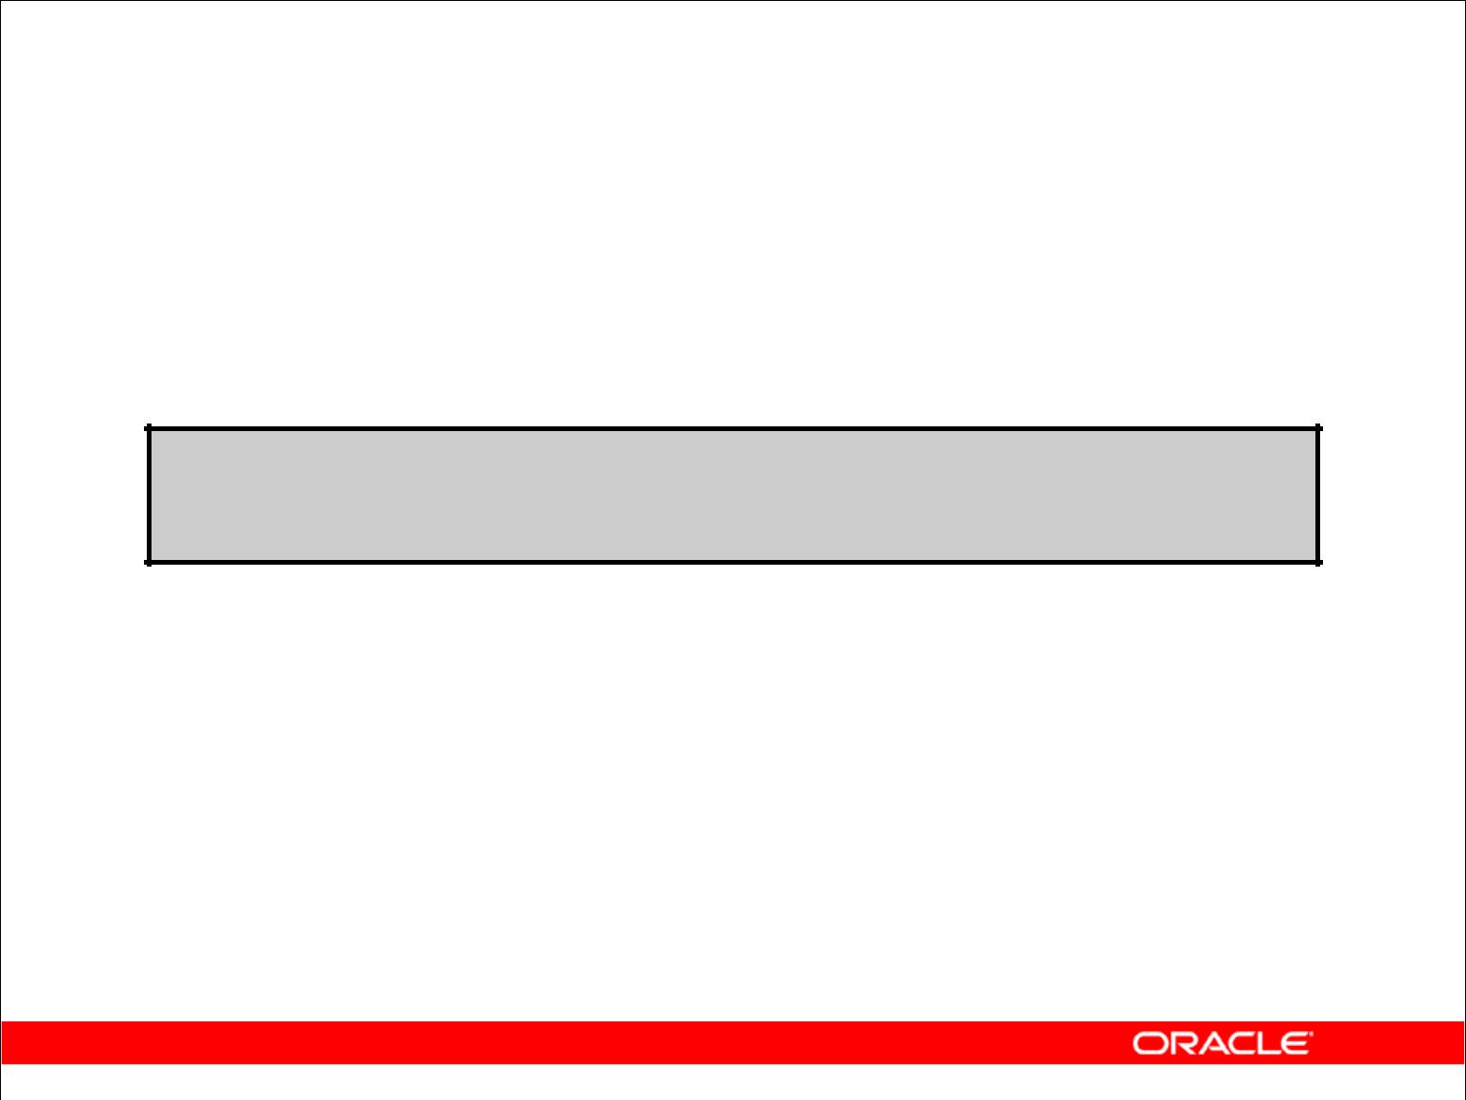**DELETE Statement**

You can remove existing rows from a table by using the

DELETE statement:

**DELETE [FROM]** ***table***

**[WHERE** ***condition*];**

Copyright © 2009, Oracle. All rights reserved.

**Deleting Rows**

You can remove existing rows by using the DELETE statement.

|  |  |  |
| --- | --- | --- |
| In the syntax: | is the table name |  |
| *table* |  |
| *condition* | identifies the rows to be deleted and is composed of column names, |  |
|  | expressions, constants, subqueries, and comparison operators |  |

**Note:** If no rows are deleted, the message “0 rows deleted” is returned.

For more information, see “DELETE” in the *Oracle Database SQL Reference*.

|  |
| --- |
| Oracle Internal & Oracle Academy Use Only |

**Oracle Database 10*g*: SQL Fundamentals I 8 - 18**

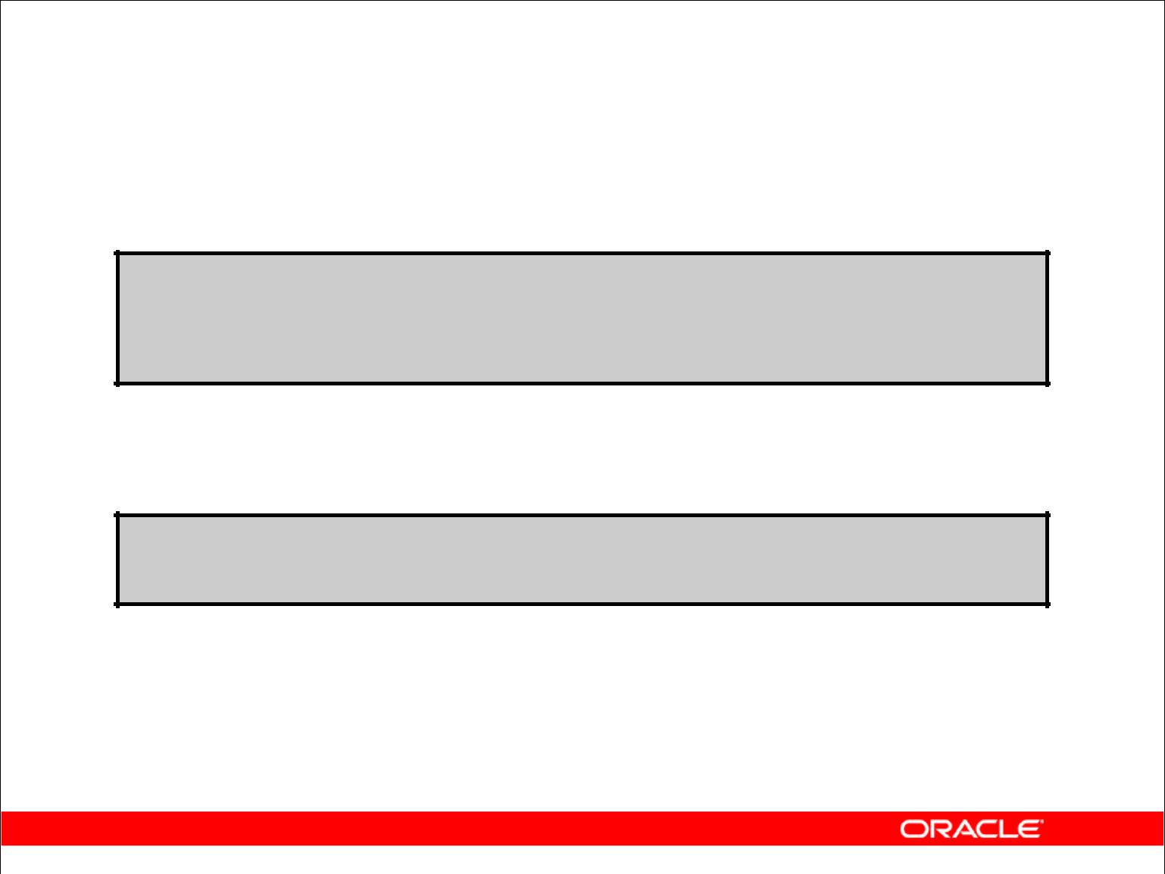**Deleting Rows from a Table**

* Specific rows are deleted if you specify the WHERE clause:

**DELETE FROM departments**

**WHERE department_name = 'Finance'; 1 rows deleted**

* All rows in the table are deleted if you omit the WHERE clause:

**DELETE FROM** **copy_emp;**

**22 rows deleted**

Copyright © 2009, Oracle. All rights reserved.

**Deleting Rows (continued)**

You can delete specific rows by specifying the WHERE clause in the DELETE statement. The slide example deletes the Finance department from the DEPARTMENTS table. You can confirm the delete operation by displaying the deleted rows using the SELECT statement.

SELECT *

FROM departments

WHERE department_name = 'Finance';

0 rows selected.

If you omit the WHERE clause, all rows in the table are deleted. The second example in the slide deletes all the rows from the COPY_EMP table, because no WHERE clause has been specified.

**Example**

Remove rows identified in the WHERE clause.

DELETE FROM employees WHERE employee_id = 114; 1 rows deleted.

DELETE FROM departments WHERE department_id IN (30, 40); 2 rows deleted.

|  |
| --- |
| Oracle Internal & Oracle Academy Use Only |

**Oracle Database 10*g*: SQL Fundamentals I 8 - 19**

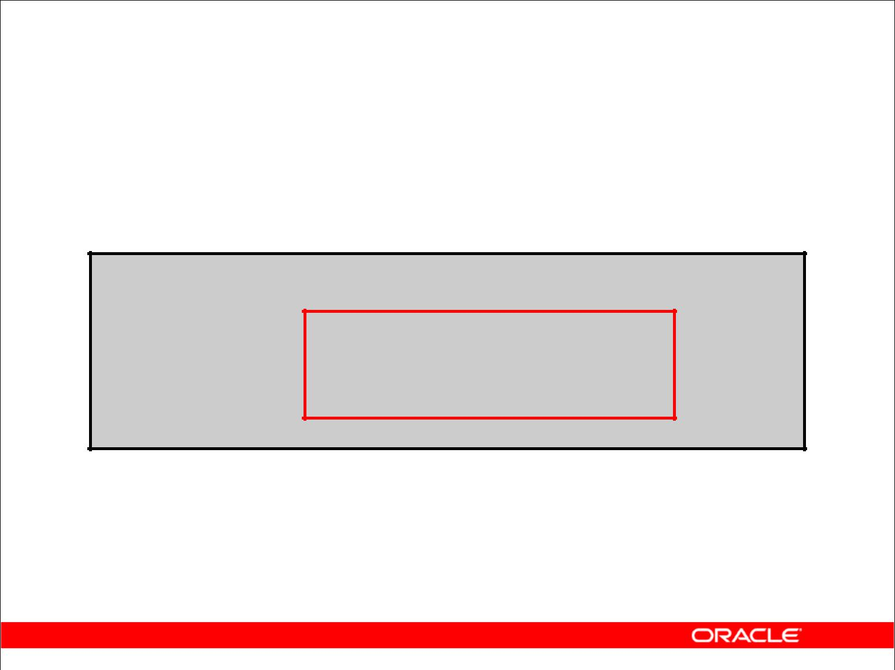**Deleting Rows Based**

**on Another Table**

Use subqueries in DELETE statements to remove rows from a table based on values from another table:

**DELETE FROM employees**

**WHERE** **department_id =**

**(SELECT department_id**

**FROM departments**

**WHERE** **department_name**

**LIKE '%Public%');**

**1 rows deleted**

Copyright © 2009, Oracle. All rights reserved.

**Deleting Rows Based on Another Table**

You can use subqueries to delete rows from a table based on values from another table. The example in the slide deletes all the employees who are in a department where the department name contains the string Public. The subquery searches the DEPARTMENTS table to find the department number based on the department name containing the string Public. The subquery then feeds the department number to the main query, which deletes rows of data from the EMPLOYEES table based on this department number.

|  |
| --- |
| Oracle Internal & Oracle Academy Use Only |

**Oracle Database 10*g*: SQL Fundamentals I 8 - 20**

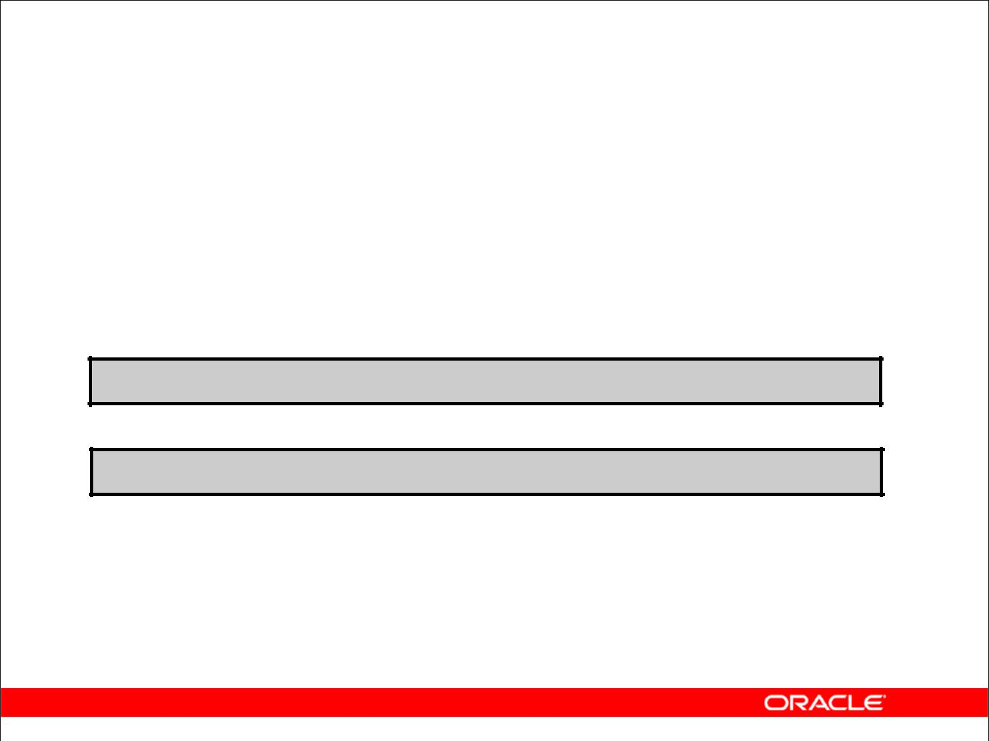**TRUNCATE Statement**

* Removes all rows from a table, leaving the table empty and the table structure intact
* Is a data definition language (DDL) statement rather than a DML statement; cannot easily be undone
* Syntax:

**TRUNCATE TABLE *table_name*;**

* Example:

**TRUNCATE TABLE copy_emp;**

Copyright © 2009, Oracle. All rights reserved.

**TRUNCATE Statement**

A more efficient method of emptying a table is with the TRUNCATE statement.

You can use the TRUNCATE statement to quickly remove all rows from a table or cluster. Removing rows with the TRUNCATE statement is faster than removing them with the DELETE statement for the following reasons:

* The TRUNCATE statement is a data definition language (DDL) statement and generates no rollback information. Rollback information is covered later in this lesson.
* Truncating a table does not fire the delete triggers of the table.
* If the table is the parent of a referential integrity constraint, you cannot truncate the table. You need to disable the constraint before issuing the TRUNCATE statement. Disabling constraints is covered in a subsequent lesson.

|  |
| --- |
| Oracle Internal & Oracle Academy Use Only |

**Oracle Database 10*g*: SQL Fundamentals I 8 - 21**

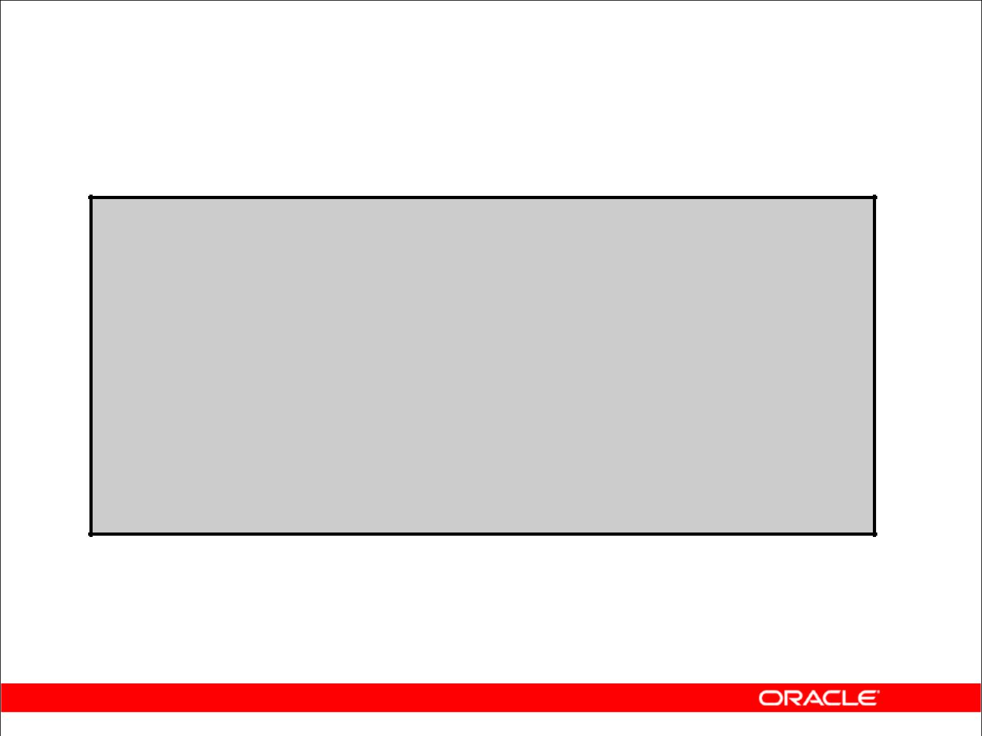**Using a Subquery in an INSERT Statement**

**INSERT INTO**

**(SELECT employee_id, last_name,**

**email, hire_date, job_id, salary,**

**department_id**

**FROM employees**

**WHERE department_id = 50) VALUES (99999, 'Taylor', 'DTAYLOR',**

**TO_DATE('07-JUN-99', 'DD-MON-RR'),**

**'ST_CLERK', 5000, 50);**

**1 rows inserted**

Copyright © 2009, Oracle. All rights reserved.

**Using a Subquery in an INSERT Statement**

You can use a subquery in place of the table name in the INTO clause of the INSERT statement.

The select list of this subquery must have the same number of columns as the column list of the VALUES clause. Any rules on the columns of the base table must be followed if the INSERT statement is to work successfully. For example, you could not put in a duplicate employee ID or omit a value for a mandatory not-null column.

|  |
| --- |
| Oracle Internal & Oracle Academy Use Only |

**Oracle Database 10*g*: SQL Fundamentals I 8 - 22**

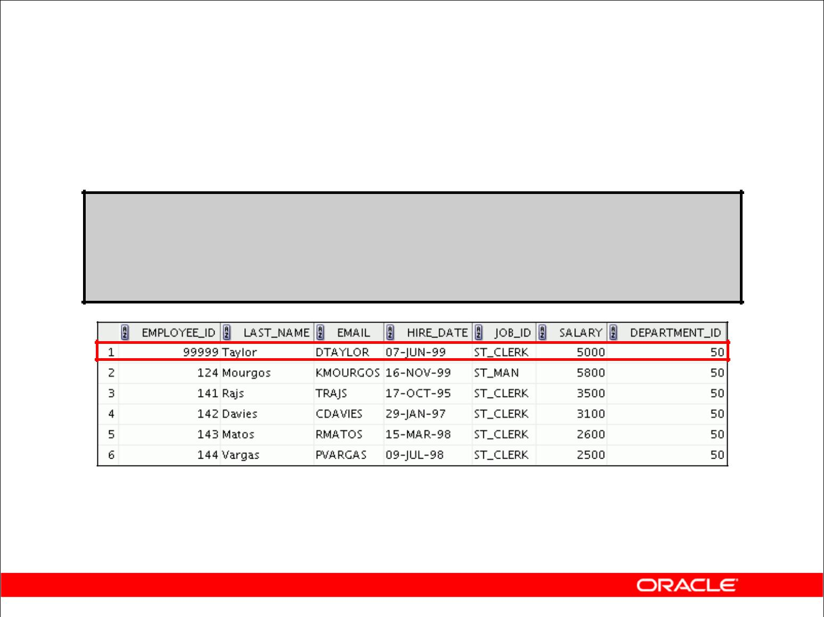**Using a Subquery in an INSERT Statement**

Verify the results:

**SELECT employee_id, last_name, email, hire_date, job_id, salary, department_id**

**FROM employees**

**WHERE** **department_id = 50;**

Copyright © 2009, Oracle. All rights reserved.

**Using a Subquery in an INSERT Statement (continued)**

The example shows the results of the subquery that was used to identify the table for the INSERT statement.

|  |
| --- |
| Oracle Internal & Oracle Academy Use Only |

**Oracle Database 10*g*: SQL Fundamentals I 8 - 23**

**Database Transactions**

A database transaction consists of one of the following:

* DML statements that constitute one consistent change to the data
* One DDL statement
* One data control language (DCL) statement

Copyright © 2009, Oracle. All rights reserved.

**Database Transactions**

The Oracle server ensures data consistency based on transactions. Transactions give you more flexibility and control when changing data, and they ensure data consistency in the event of user process failure or system failure.

Transactions consist of DML statements that make up one consistent change to the data. For example, a transfer of funds between two accounts should include the debit to one account and the credit to another account in the same amount. Both actions should either fail or succeed together; the credit should not be committed without the debit.

**Transaction Types**

|  |  |
| --- | --- |
| **Type** | **Description** |
|  |  |
| Data manipulation | Consists of any number of DML statements that the Oracle |
| language (DML) | server treats as a single entity or a logical unit of work |
|  |  |
| Data definition | Consists of only one DDL statement |
| language (DDL) |  |
|  |  |
| Data control language | Consists of only one DCL statement |
| (DCL) |  |
|  |  |

|  |
| --- |
| Oracle Internal & Oracle Academy Use Only |

**Oracle Database 10*g*: SQL Fundamentals I 8 - 24**

**Database Transactions**

* Begin when the first DML SQL statement is executed
* End with one of the following events:

– A COMMIT or ROLLBACK statement is issued.

– A DDL or DCL statement executes (automatic commit).

– The user exits SQL Developer or SQL*Plus.

– The system crashes.

Copyright © 2009, Oracle. All rights reserved.

**When Does a Transaction Start and End?**

A transaction begins when the first DML statement is encountered and ends when one of the following occurs:

* A COMMIT or ROLLBACK statement is issued.
* A DDL statement, such as CREATE, is issued.
* A DCL statement is issued.
* The user exits SQL Developer or SQL*Plus.
* A machine fails or the system crashes.

After one transaction ends, the next executable SQL statement automatically starts the next transaction.

A DDL statement or a DCL statement is automatically committed and therefore implicitly ends a transaction.

|  |
| --- |
| Oracle Internal & Oracle Academy Use Only |

**Oracle Database 10*g*: SQL Fundamentals I 8 - 25**

**Advantages of COMMIT**

**and ROLLBACK Statements**

With COMMIT and ROLLBACK statements, you can:

* Ensure data consistency
* Preview data changes before making changes permanent
* Group logically related operations

Copyright © 2009, Oracle. All rights reserved.

**Advantages of COMMIT and ROLLBACK**

With the COMMIT and ROLLBACK statements, you have control over making changes to the data permanent.

|  |
| --- |
| Oracle Internal & Oracle Academy Use Only |

**Oracle Database 10*g*: SQL Fundamentals I 8 - 26**

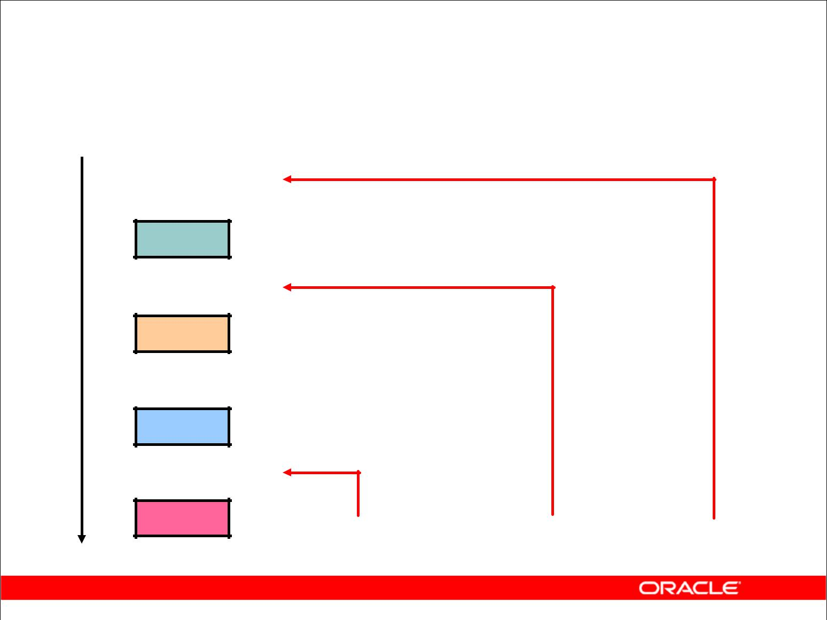**Controlling Transactions**

***Time*** ***COMMIT***

**Transaction**

**DELETE**

**SAVEPOINT A**

**INSERT**

|  |  |  |  |  |
| --- | --- | --- | --- | --- |
| **UPDATE** |  |  |  |  |
| **SAVEPOINT B** |  |  |  |  |
| **INSERT** | **ROLLBACK** | **ROLLBACK** | **ROLLBACK** |  |
|  |  |
|  | **to SAVEPOINT B** | **to SAVEPOINT A** |  |  |

Copyright © 2009, Oracle. All rights reserved.

**Explicit Transaction Control Statements**

You can control the logic of transactions by using the COMMIT, SAVEPOINT, and ROLLBACK statements.

|  |  |  |
| --- | --- | --- |
| **Statement** | **Description** |  |
|  |
|  |  |  |
| COMMIT | Ends the current transaction by making all pending data |  |
|  | changes permanent |  |
|  |  |  |
| SAVEPOINT *name* | Marks a savepoint within the current transaction |  |
|  |  |  |
| ROLLBACK | ROLLBACK ends the current transaction by discarding all |  |
|  | pending data changes. |  |
| ROLLBACK TO | ROLLBACK TO SAVEPOINT rolls back the current |  |
| *SAVEPOINT name* | transaction to the specified savepoint, thereby discarding any |  |
|  | changes and or savepoints that were created after the |  |
|  | savepoint to which you are rolling back. If you omit the TO |  |
|  | SAVEPOINT clause, the ROLLBACK statement rolls back the |  |
|  | entire transaction. Because savepoints are logical, there is no |  |
|  | way to list the savepoints that you have created. |  |

**Note:** SAVEPOINTis not ANSI standard SQL.

|  |
| --- |
| Oracle Internal & Oracle Academy Use Only |

**Oracle Database 10*g*: SQL Fundamentals I 8 - 27**

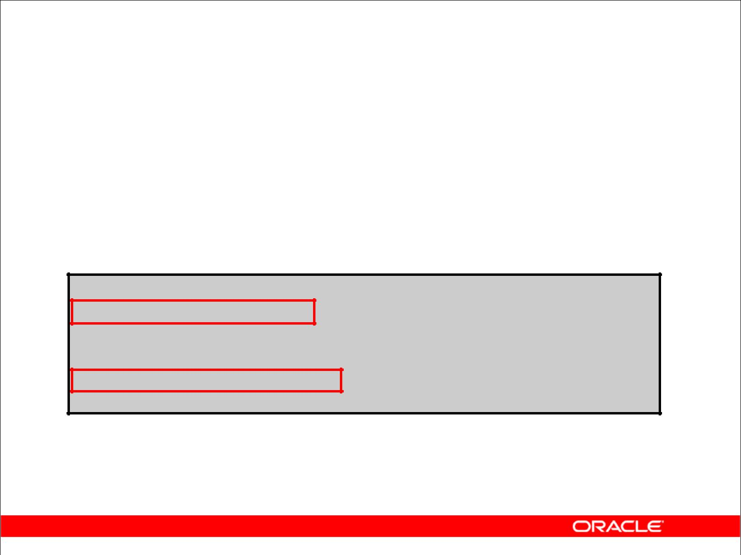**Rolling Back Changes to a Marker**

* Create a marker in a current transaction by using the SAVEPOINT statement.
* Roll back to that marker by using the ROLLBACK TO SAVEPOINT statement.

**UPDATE...**

**SAVEPOINT update_done;**

**SAVEPOINT update_done succeeded**

**INSERT...**

**ROLLBACK TO update_done;**

**ROLLBACK TO succeeded**

Copyright © 2009, Oracle. All rights reserved.

**Rolling Back Changes to a Marker**

You can create a marker in the current transaction by using the SAVEPOINT statement, which divides the transaction into smaller sections. You can then discard pending changes up to that marker by using the ROLLBACK TO SAVEPOINT statement.

If you create a second savepoint with the same name as an earlier savepoint, the earlier savepoint is deleted.

|  |
| --- |
| Oracle Internal & Oracle Academy Use Only |

**Oracle Database 10*g*: SQL Fundamentals I 8 - 28**

**Implicit Transaction Processing**

* An automatic commit occurs under the following circumstances:

– DDL statement is issued

– DCL statement is issued

– Normal exit from SQL Developer or SQL*Plus, without explicitly issuing COMMIT or ROLLBACK statements

* An automatic rollback occurs under an abnormal termination of SQL Developer or SQL*Plus or a system failure.

Copyright © 2009, Oracle. All rights reserved.

**Implicit Transaction Processing**

|  |  |  |
| --- | --- | --- |
| **Status** | **Circumstances** |  |
|  |
| Automatic commit | DDL statement or DCL statement is issued. SQL Developer |  |
|  | or SQL*Plus exited normally, without explicitly issuing |  |
|  | COMMIT or ROLLBACK commands. |  |
| Automatic rollback | Abnormal termination of SQL Developer or SQL*Plus or |  |
|  | system failure |  |

**Note:** In SQL*Plus, theAUTOCOMMITcommand can be toggled ON or OFF. If set to ON, each

individual DML statement is committed as soon as it is executed. You cannot roll back the changes. If set to OFF, the COMMIT statement can still be issued explicitly. Also, the COMMIT statement is issued when a DDL statement is issued or when you exit SQL*Plus. The SET AUTOCOMMIT ON/OFF command is skipped in SQL Developer. DML is committed on a normal exit from SQL Developer only if you have the Autocommit preference enabled. To enable Autocommit, perform the following:

* In the Tools menu, select Preferences. In the Preferences dialog box, expand Database and select Worksheet Parameters.
* On the right pane, check the Autocommit in SQL Worksheet option. Click OK.

|  |
| --- |
| Oracle Internal & Oracle Academy Use Only |

**Oracle Database 10*g*: SQL Fundamentals I 8 - 29**

**Implicit Transaction Processing (continued)**

**System Failures**

When a transaction is interrupted by a system failure, the entire transaction is automatically rolled back. This prevents the error from causing unwanted changes to the data and returns the tables to their state at the time of the last commit. In this way, the Oracle server protects the integrity of the tables.

In SQL Developer, a normal exit from the session is accomplished by selecting Exit from the File menu. In SQL*Plus, a normal exit is accomplished by entering the EXIT command at the prompt.

Closing the window is interpreted as an abnormal exit.

|  |
| --- |
| Oracle Internal & Oracle Academy Use Only |

**Oracle Database 10*g*: SQL Fundamentals I 8 - 30**

**State of the Data**

**Before COMMIT or ROLLBACK**

* The previous state of the data can be recovered.
* The current user can review the results of the DML operations by using the SELECT statement.
* Other users *cannot* view the results of the DML statements by the current user.
* The affected rows are *locked*; other users cannot change the data in the affected rows.

Copyright © 2009, Oracle. All rights reserved.

**Committing Changes**

Every data change made during the transaction is temporary until the transaction is committed. The state of the data before COMMIT or ROLLBACK statements are issued can be described as follows:

* Data manipulation operations primarily affect the database buffer; therefore, the previous state of the data can be recovered.
* The current user can review the results of the data manipulation operations by querying the tables.
* Other users cannot view the results of the data manipulation operations made by the current user. The Oracle server institutes read consistency to ensure that each user sees data as it existed at the last commit.
* The affected rows are locked; other users cannot change the data in the affected rows.

|  |
| --- |
| Oracle Internal & Oracle Academy Use Only |

**Oracle Database 10*g*: SQL Fundamentals I 8 - 31**

**State of the Data After COMMIT**

* Data changes are made permanent in the database.
* The previous state of the data is permanently lost.
* All users can view the results.
* Locks on the affected rows are released; those rows are available for other users to manipulate.
* All savepoints are erased.

Copyright © 2009, Oracle. All rights reserved.

**Committing Changes (continued)**

Make all pending changes permanent by using the COMMIT statement. Here is what happens after a COMMIT statement:

* Data changes are written to the database.
* The previous state of the data is no longer available with normal SQL queries.
* All users can view the results of the transaction.
* The locks on the affected rows are released; the rows are now available for other users to perform new data changes.
* All savepoints are erased.

|  |
| --- |
| Oracle Internal & Oracle Academy Use Only |

**Oracle Database 10*g*: SQL Fundamentals I 8 - 32**

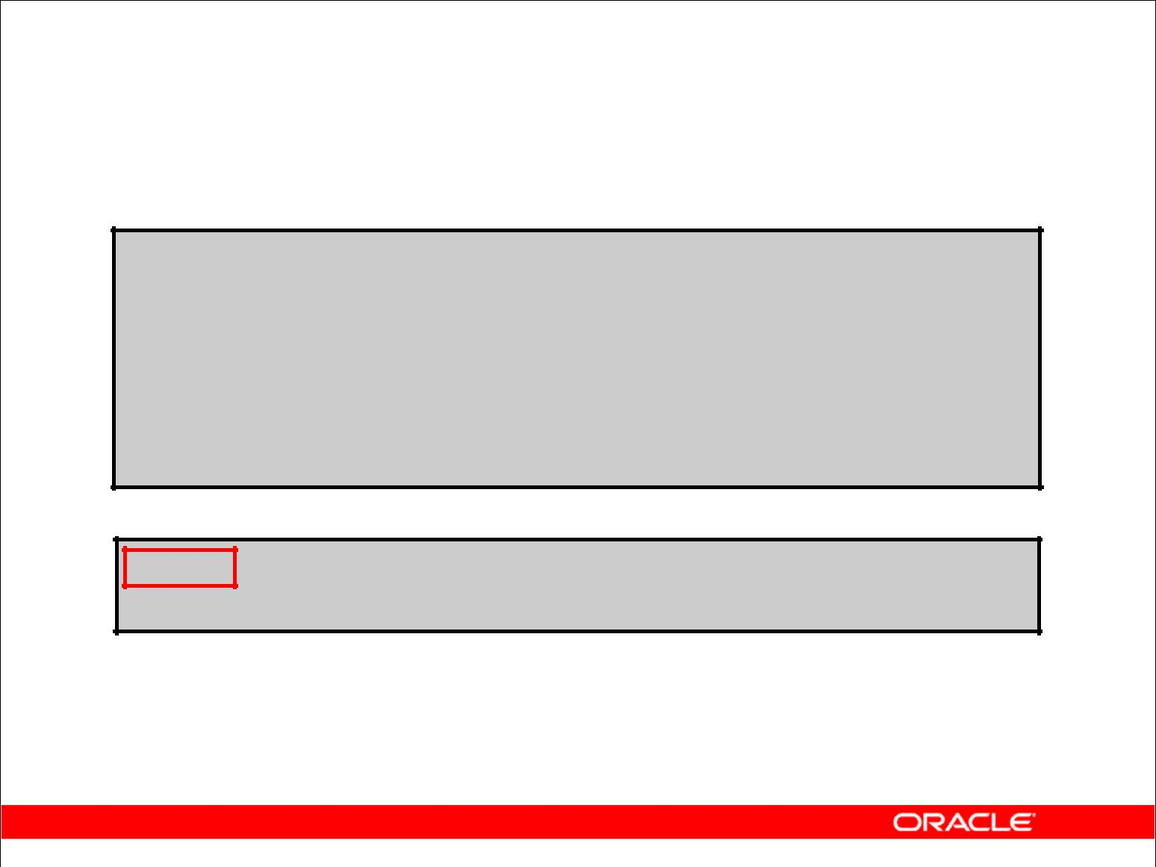**Committing Data**

* Make the changes:

**DELETE FROM employees**

**WHERE** **employee_id = 99999;**

**1 rows deleted**

**INSERT INTO departments**

**VALUES (290, 'Corporate Tax', NULL, 1700); 1 rows inserted**

* Commit the changes:

**COMMIT;**

**Commit complete**

Copyright © 2009, Oracle. All rights reserved.

**Committing Changes (continued)**

The slide example deletes a row from the EMPLOYEES table and inserts a new row into the DEPARTMENTS table. It then makes the change permanent by issuing the COMMIT statement.

**Example**

Remove departments 290 and 300 in the DEPARTMENTS table, and update a row in the EMPLOYEES table. Make the data change permanent.

DELETE FROM departments

WHERE department_id IN (290, 300);

1 rows deleted.

UPDATE employees

SET department_id = 80

WHERE employee_id = 206;

1 rows updated.

COMMIT;

Commit Complete.

|  |
| --- |
| Oracle Internal & Oracle Academy Use Only |

**Oracle Database 10*g*: SQL Fundamentals I 8 - 33**

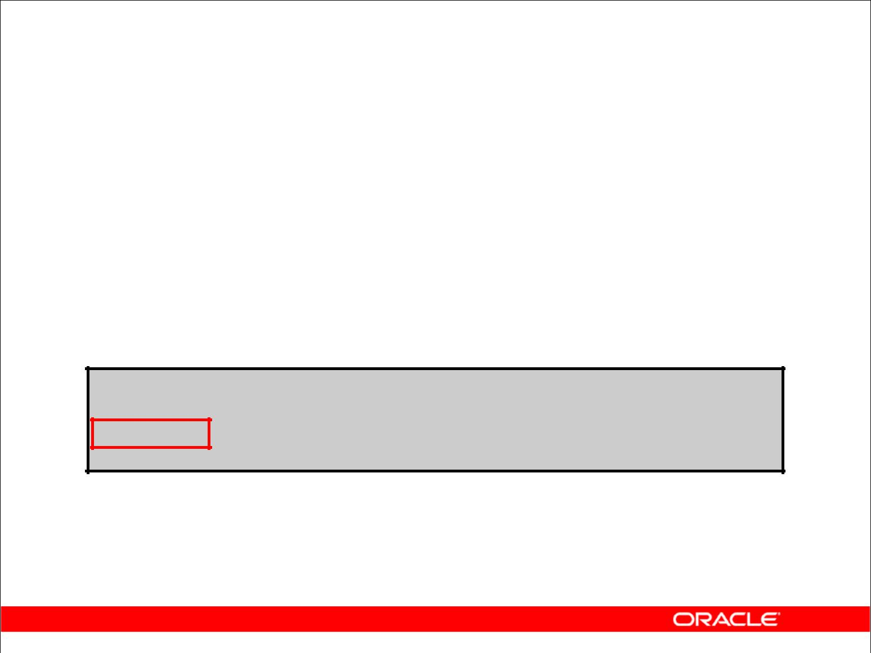**State of the Data After ROLLBACK**

Discard all pending changes by using the ROLLBACK statement:

* Data changes are undone.
* Previous state of the data is restored.
* Locks on the affected rows are released.

**DELETE FROM copy_emp;**

**20 rows deleted**

**ROLLBACK ;**

**Rollback complete**

Copyright © 2009, Oracle. All rights reserved.

**Rolling Back Changes**

Discard all pending changes by using the ROLLBACK statement, which results in the following:

* Data changes are undone.
* The previous state of the data is restored.
* Locks on the affected rows are released.

|  |
| --- |
| Oracle Internal & Oracle Academy Use Only |

**Oracle Database 10*g*: SQL Fundamentals I 8 - 34**

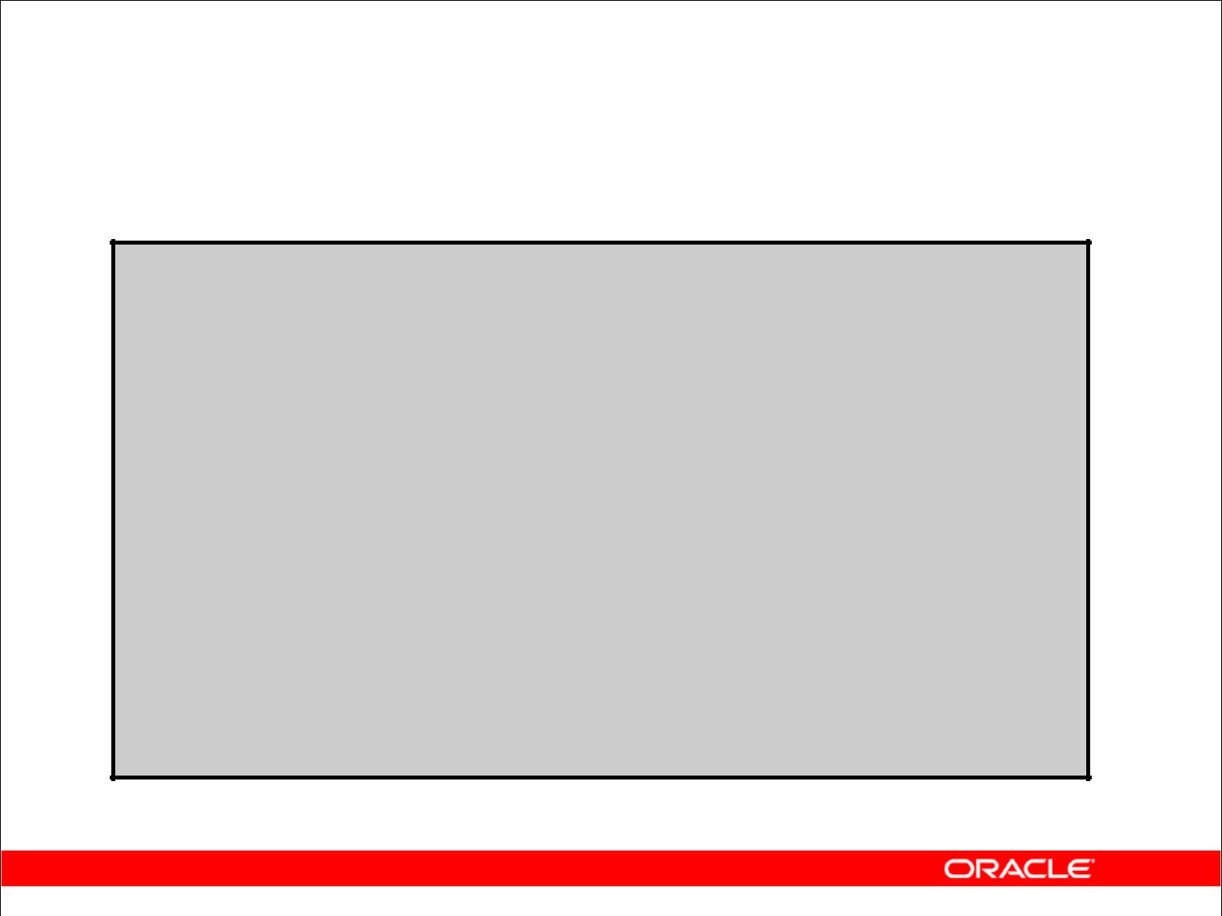**State of the Data After ROLLBACK**

**DELETE FROM test;**

**25,000 rows deleted**

**ROLLBACK;**

**Rollback complete**

**DELETE FROM test WHERE** **id = 100;**

**1 rows deleted**

**SELECT * FROM test WHERE** **id = 100;**

**No rows selected**

**COMMIT;**

**Commit complete**

Copyright © 2009, Oracle. All rights reserved.

**Example**

While attempting to remove a record from the TEST table, you can accidentally empty the table.

You can correct the mistake, reissue the proper statement, and make the data change permanent.

|  |
| --- |
| Oracle Internal & Oracle Academy Use Only |

**Oracle Database 10*g*: SQL Fundamentals I 8 - 35**

**Statement-Level Rollback**

* If a single DML statement fails during execution, only that statement is rolled back.
* The Oracle server implements an implicit savepoint.
* All other changes are retained.
* The user should terminate transactions explicitly by executing a COMMIT or ROLLBACK statement.

Copyright © 2009, Oracle. All rights reserved.

**Statement-Level Rollback**

Part of a transaction can be discarded by an implicit rollback if a statement execution error is detected. If a single DML statement fails during execution of a transaction, its effect is undone by a statement-level rollback, but the changes made by the previous DML statements in the transaction are not discarded. They can be committed or rolled back explicitly by the user.

The Oracle server issues an implicit commit before and after any DDL statement. So, even if your DDL statement does not execute successfully, you cannot roll back the previous statement because the server issued a commit.

Terminate your transactions explicitly by executing a COMMIT or ROLLBACK statement.

|  |
| --- |
| Oracle Internal & Oracle Academy Use Only |

**Oracle Database 10*g*: SQL Fundamentals I 8 - 36**

**Read Consistency**

* Read consistency guarantees a consistent view of the data at all times.
* Changes made by one user do not conflict with changes made by another user.
* Read consistency ensures that on the same data:

– Readers do not wait for writers

– Writers do not wait for readers

Copyright © 2009, Oracle. All rights reserved.

**Read Consistency**

Database users access the database in two ways:

* Read operations (SELECT statement)
* Write operations (INSERT, UPDATE, DELETE statements)

You need read consistency so that the following occur:

* The database reader and writer are ensured a consistent view of the data.
* Readers do not view data that is in the process of being changed.
* Writers are ensured that the changes to the database are done in a consistent way.
* Changes made by one writer do not disrupt or conflict with changes that another writer is making.

The purpose of read consistency is to ensure that each user sees data as it existed at the last commit, before a DML operation started.

|  |
| --- |
| Oracle Internal & Oracle Academy Use Only |

**Oracle Database 10*g*: SQL Fundamentals I 8 - 37**

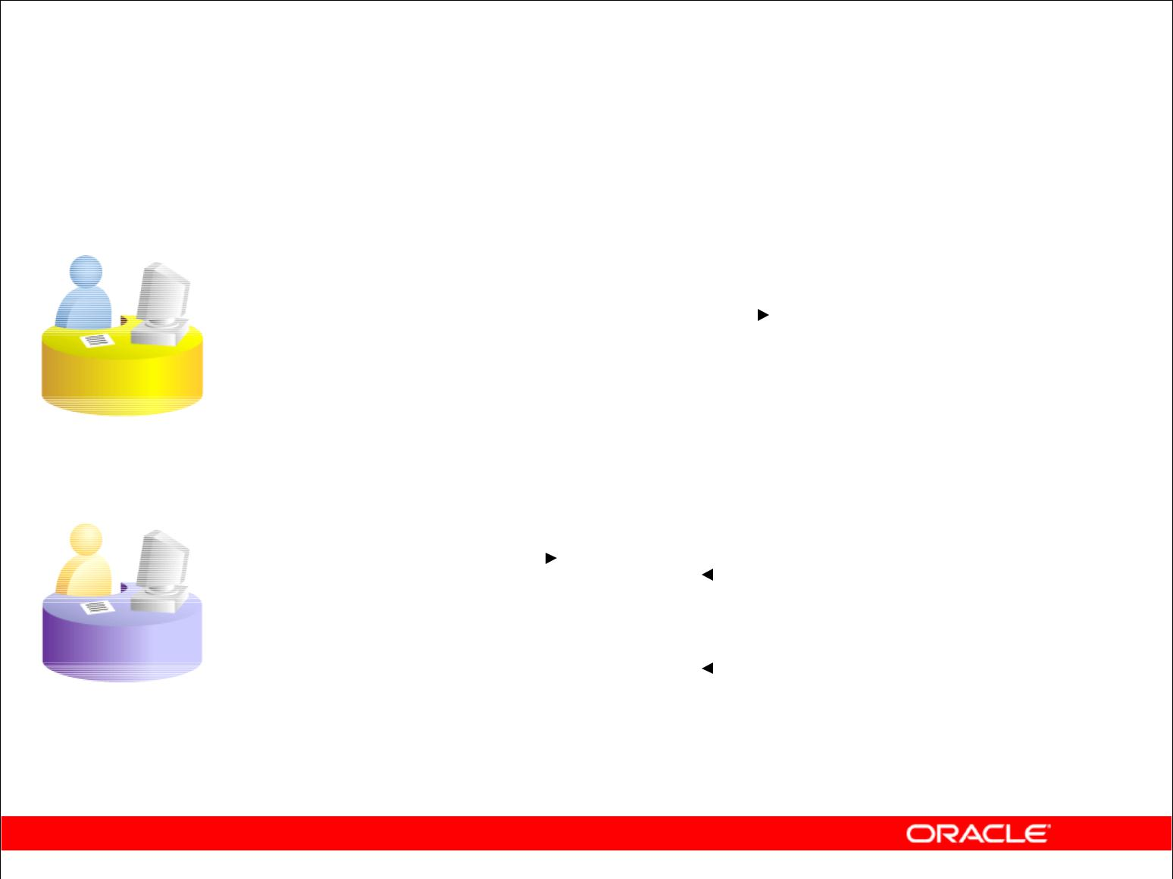**Implementation of Read Consistency**

**User A**

|  |  |  |  |  |  |  |  |  |  |  |  |  |  |
| --- | --- | --- | --- | --- | --- | --- | --- | --- | --- | --- | --- | --- | --- |
| **UPDATE** | **employees** | | | | | |  |  |  |  |  | **Data** |  |
|  |  |  |  |  |  |
|  |  |  |  |  |  |
| **SET** | **salary = 7000** | | | |  |  |  |  |  |  |  | **blocks** |  |
|  |  |  |  |  |  |  |  |
| **WHERE** | **last_name = 'Grant';** | | | | | |  |  |  |  |  | **Undo** |  |
|  |  |  |  |  |  |
|  |  |  |  |  |  |
|  |  |  |  |  |  |  |  |  |  |  |  |  |
|  |  |  |  |  |  |  |  |  |  |  |  |  |
|  |  |  |  |  |  |  |  |  |  |  |  |  |
|  |  |  |  |  |  |  |  |  |  |  |  |  |
|  |  |  |  |  |  |  |  |  |  |  |  | **segments** |  |
|  |  |  |  |  |  |  |  |  |  |  |  |  |
|  |  |  |  |  |  |  |  |  |  |  |  |  |  |
|  |  |  |  |  |  |  |  |  |  |  |  |  |  |
|  |  |  |  |  |  |  |  |  |  |  |  | **Changed** |  |
|  |  |  |  |  |  |  |  |  |  |  |  |  |
| **SELECT** | **\*** |  |  |  |  |  |  |  |  |  |  | **and** |  |
| **FROM userA.employees;** | | |  | **Read-** | |  |  |  |  |  |  | **unchanged** |  |
|  |  |  |  | **consistent** | | |  |  |  |  |  | **data** |  |
|  |  |  |  |  |  |  |  |  |  |
|  |  |  |  | **image** | | |  |  |  |  |  | **Before** |  |
|  |  |  |  |  |  |  |  |  |  |  |  | **change** |  |
| **User B** |  |  |  |  |  |  |  |  |  |  |  | **(“old” data)** |  |
|  |  |  |  |  |  |  |  |  |  |  |  |

Copyright © 2009, Oracle. All rights reserved.

**Implementation of Read Consistency**

Read consistency is an automatic implementation. It keeps a partial copy of the database in undo segments. The read-consistent image is constructed from committed data from the table and old data being changed and not yet committed from the undo segment.

When an insert, update, or delete operation is made to the database, the Oracle server takes a copy of the data before it is changed and writes it to an *undo segment*.

All readers, except the one who issued the change, still see the database as it existed before the changes started; they view the undo segment’s “snapshot” of the data.

Before changes are committed to the database, only the user who is modifying the data sees the database with the alterations. Everyone else sees the snapshot in the undo segment. This guarantees that readers of the data read consistent data that is not currently undergoing change.

When a DML statement is committed, the change made to the database becomes visible to anyone issuing a select statement *after* the commit is done. The space occupied by the *old* data in the undo segment file is freed for reuse.

If the transaction is rolled back, the changes are undone:

* The original, older version of the data in the undo segment is written back to the table.
* All users see the database as it existed before the transaction began.

|  |
| --- |
| Oracle Internal & Oracle Academy Use Only |

**Oracle Database 10*g*: SQL Fundamentals I 8 - 38**

**Summary**

In this lesson, you should have learned how to use the following statements:

|  |  |
| --- | --- |
| **Function** | **Description** |
|  |  |
| INSERT | Adds a new row to the table |
| UPDATE | Modifies existing rows in the table |
| DELETE | Removes existing rows from the table |
| COMMIT | Makes all pending changes permanent |
| SAVEPOINT | Is used to roll back to the savepoint marker |
| ROLLBACK | Discards all pending data changes |

Copyright © 2009, Oracle. All rights reserved.

**Summary**

In this lesson, you should have learned how to manipulate data in the Oracle Database by using the INSERT, UPDATE, and DELETE statements, as well as how to control data changes by using the COMMIT, SAVEPOINT, and ROLLBACK statements.

The Oracle server guarantees a consistent view of data at all times.

|  |
| --- |
| Oracle Internal & Oracle Academy Use Only |

**Oracle Database 10*g*: SQL Fundamentals I 8 - 39**

**Practice 8: Overview**

This practice covers the following topics:

* Inserting rows into tables
* Updating and deleting rows in a table
* Controlling transactions

Copyright © 2009, Oracle. All rights reserved.

**Practice 8: Overview**

In this practice, you add rows to the MY_EMPLOYEE table, update and delete data from the table, and control your transactions.

|  |
| --- |
| Oracle Internal & Oracle Academy Use Only |

**Oracle Database 10*g*: SQL Fundamentals I 8 - 40**

**Practice 8**

The HR department wants you to create SQL statements to insert, update, and delete employee data. As a prototype, you use the MY_EMPLOYEE table before giving the statements to the HR

department.

**Insert data into the MY_EMPLOYEE table.**

1. Run the statement in the lab_08_01.sql script to build the MY_EMPLOYEE table to be used for the lab.
2. Describe the structure of the MY_EMPLOYEE table to identify the column names.

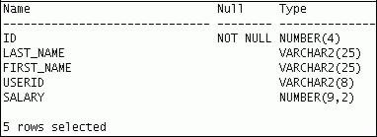

1. Create an INSERT statement to add *the first row* of data to the MY_EMPLOYEE table from the following sample data. Do not list the columns in the INSERT clause. *Do not enter all* *rows yet.*

|  |  |  |  |  |
| --- | --- | --- | --- | --- |
| **ID** | **LAST_NAME** | **FIRST_NAME** | **USERID** | **SALARY** |
|  |  |  |  |  |
| 1 | Patel | Ralph | rpatel | 895 |
|  |  |  |  |  |
| 2 | Dancs | Betty | bdancs | 860 |
|  |  |  |  |  |
| 3 | Biri | Ben | bbiri | 1100 |
|  |  |  |  |  |
| 4 | Newman | Chad | cnewman | 750 |
|  |  |  |  |  |
| 5 | Ropeburn | Audrey | aropebur | 1550 |
|  |  |  |  |  |

1. Populate the MY_EMPLOYEE table with the second row of sample data from the preceding list. This time, list the columns explicitly in the INSERT clause.
2. Confirm your addition to the table.
3. Write an INSERT statement in a dynamic reusable script file named loademp.sql to load rows into the MY_EMPLOYEE table. Concatenate the first letter of the first name and the first seven characters of the last name to produce the user ID. Save this script to a file named lab_08_06.sql.
4. Populate the table with the next two rows of sample data listed in step 3 by running the INSERT statement in the script that you created.

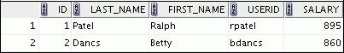

|  |
| --- |
| Oracle Internal & Oracle Academy Use Only |

**Oracle Database 10*g*: SQL Fundamentals I 8 - 41**

**Practice 8 (continued)**

1. Confirm your additions to the table.
2. Make the data additions permanent.

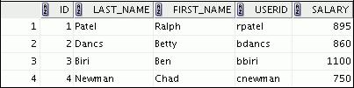

**Update and delete data in the MY_EMPLOYEE table.**

1. Change the last name of employee 3 to Drexler.
2. Change the salary to $1,000 for all employees who have a salary less than $900.
3. Verify your changes to the table.
4. Delete Betty Dancs from the MY_EMPLOYEE table.
5. Confirm your changes to the table.
6. Commit all pending changes.

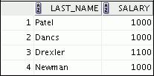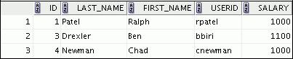

|  |
| --- |
| Oracle Internal & Oracle Academy Use Only |

**Oracle Database 10*g*: SQL Fundamentals I 8 - 42**

**Practice 8 (continued)**

**Control data transaction to the MY_EMPLOYEE table.**

1. Populate the table with the last row of sample data listed in step 3 by using the statements in the script that you created in step 6. Run the statements in the script.
2. Confirm your addition to the table.

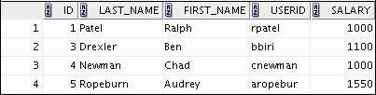

1. Mark an intermediate point in the processing of the transaction.
2. Empty the entire table.
3. Confirm that the table is empty.
4. Discard the most recent DELETE operation without discarding the earlier INSERT operation.
5. Confirm that the new row is still intact.
6. Make the data addition permanent.



|  |
| --- |
| Oracle Internal & Oracle Academy Use Only |

**Oracle Database 10*g*: SQL Fundamentals I 8 - 43**

Oracle Internal & Oracle Academy Use Only